T-5004

Packed Tower Design and Principles

**Packed Tower Data Input**

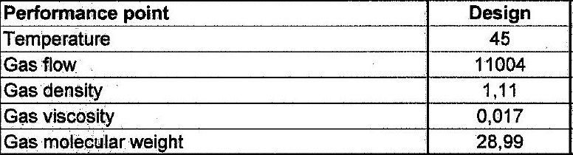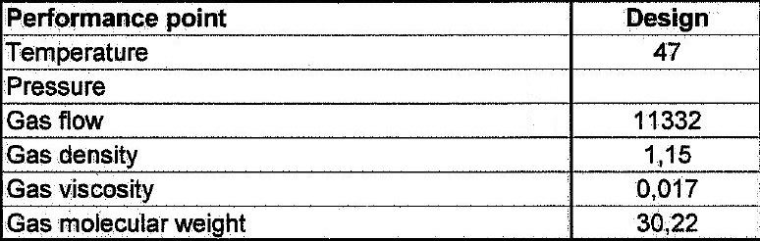 Vapor inlet Vapor Outlet

Liquid Inlet Liquid Outlet

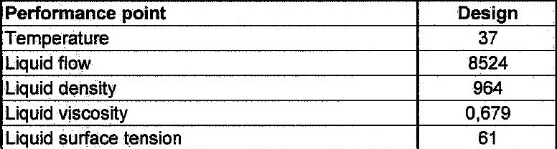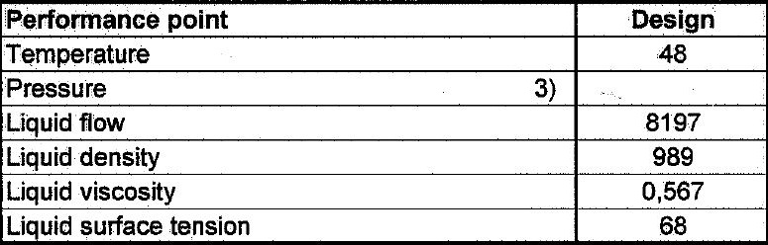

**Packed Tower ID Sizing**

1.Determine the capacity term value

Choose a ΔP value and calculate the flow parameter

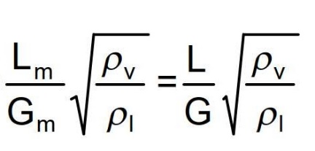

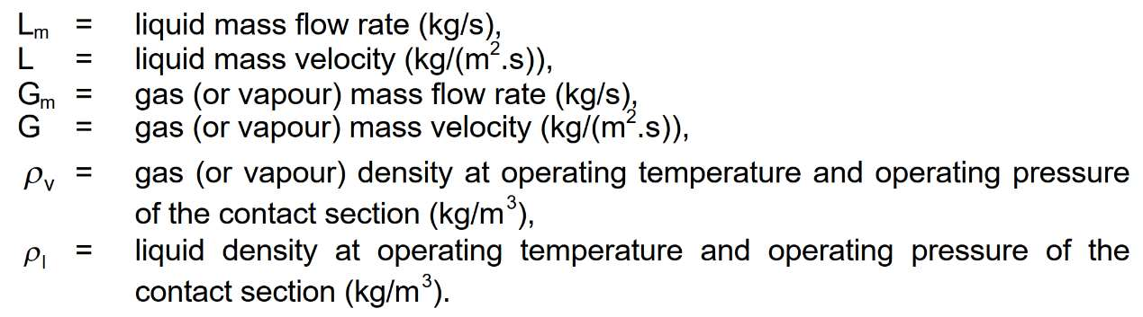

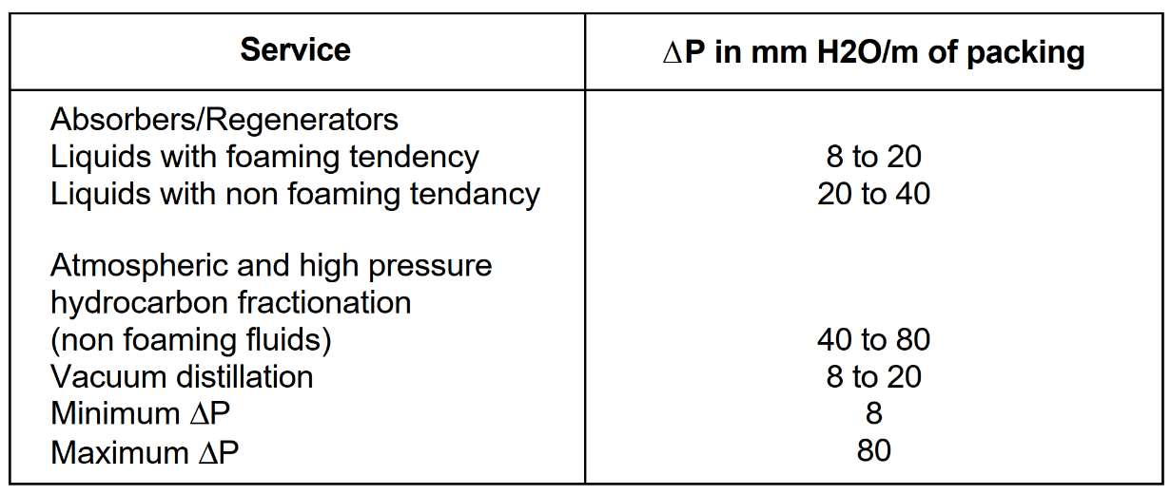

Calculation for this step

|  |  |
| --- | --- |
| **Inlet** | **Value** |
| **L** | **8197** |
| **G** | **11332** |
| **Lm** | **2.2769** |
| **Gm** | **3.14** |
| **F** | **0.024** |

|  |  |
| --- | --- |
| **Outlet** | **Value** |
| **L** | **8524** |
| **G** | **11004** |
| **Lm** | **2.36** |
| **Gm** | **3.05** |
| **F** | **0.026** |

2. Determine Capacity term or C from diagram below

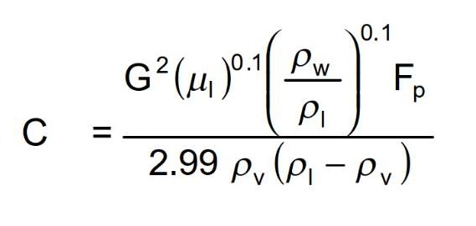



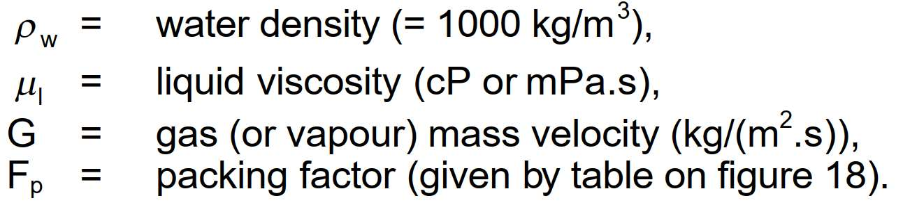

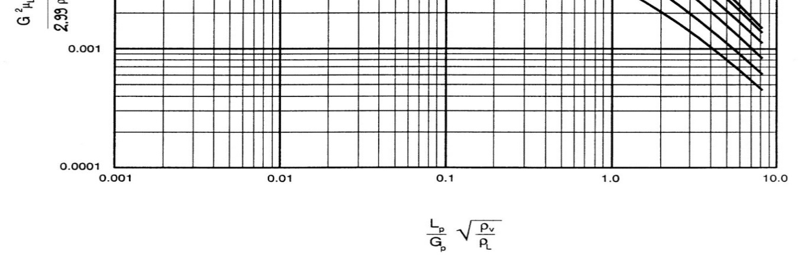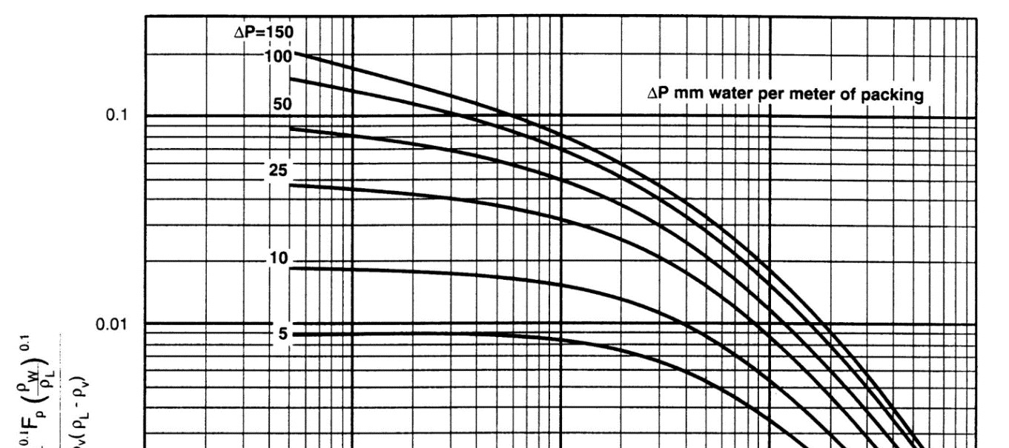Packed Column Pressure Drop Correlation

Calculation for this step

Note that according to licensor requirement a dp of 10 mbar is chosen

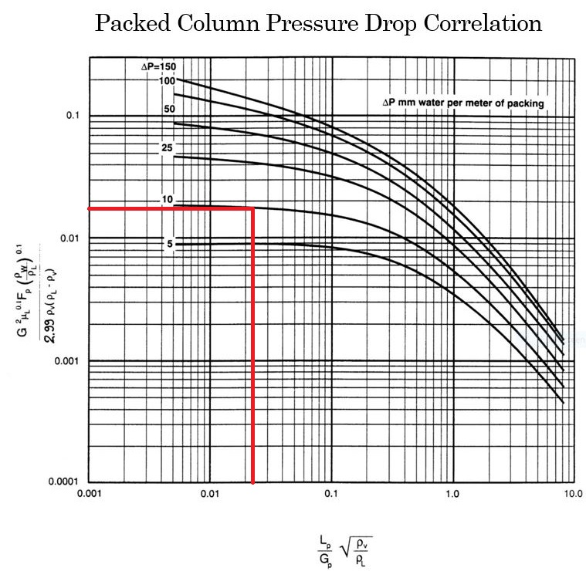

3.

3. Choose a packing type and determine the packing factor (Fp)

* The packing factors for various packings are shown in figure 18.
* Usually packings smaller than 25 mm (1 in) size are intended for column diameters of 300 mm or

smaller, packings of 25 mm to 37 mm (1 in to 1½ in) in size for column diameters from 300

mm to 900 mm, and packings from 50 mm to 75 mm (2 in to 3 in) in size for column diameters

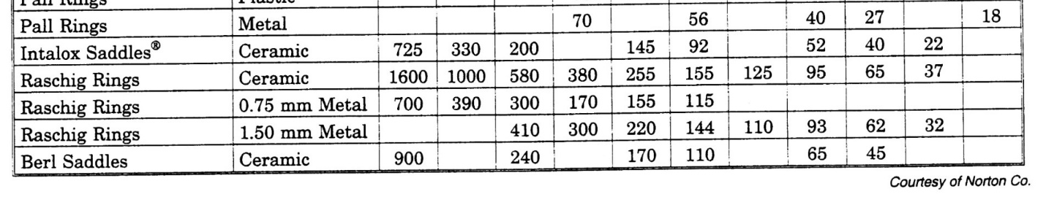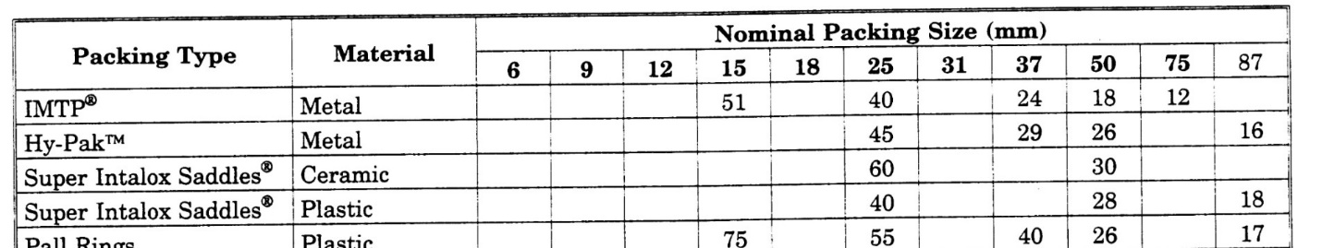 of 900 mm and more.

Calculation for this step

We select IMTP because of its wide applicability and suppose that ID is more than 900mm; as

a result, a 2-inch (50mm) IMPT is selected with packing factor of 18 according to the table

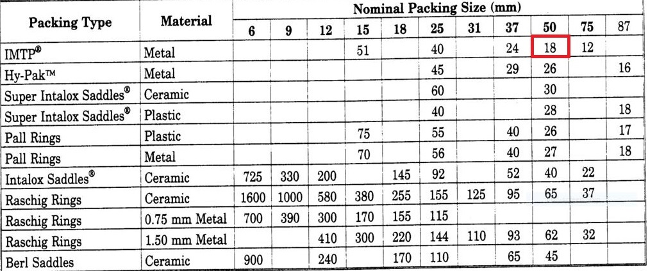below.

4. Calculate the gas (or vapour) mass velocity G with the capacity term C value determined in

previous step.

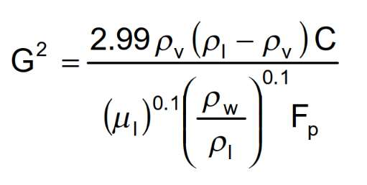

5. Determine minimum inside diameter using following formula

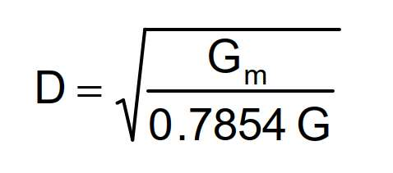

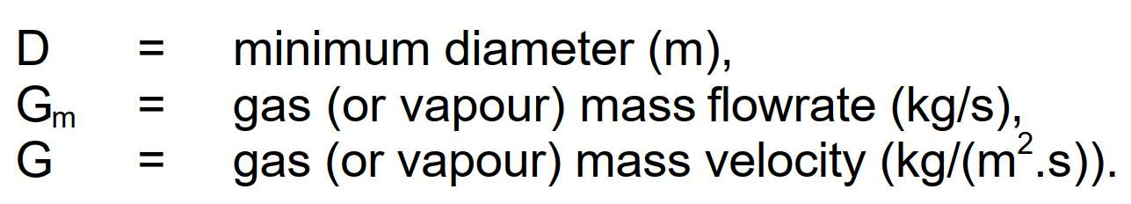

Calculation for this step

|  |  |
| --- | --- |
| **Inlet Parameter** | **Value** |
| **ρl** | **989 kg/m3** |
| **ρv** | **1.15 kg/m3** |
| **C** | **0.0175** |
| **Fp** | **18** |
| **G^2** | **3.49** |
| **G** | **1.86** |
| **D** | **1464 mm** |

|  |  |
| --- | --- |
| **Outlet Parameter** | **Value** |
| **ρl** | **964kg/m3** |
| **ρv** | **1.11 kg/m3** |
| **C** | **0.0175** |
| **Fp** | **18** |
| **G^2** | **3.27** |
| **G** | **1.81** |
| **D** | **1466 mm** |

6. KG TOWER Confirmation

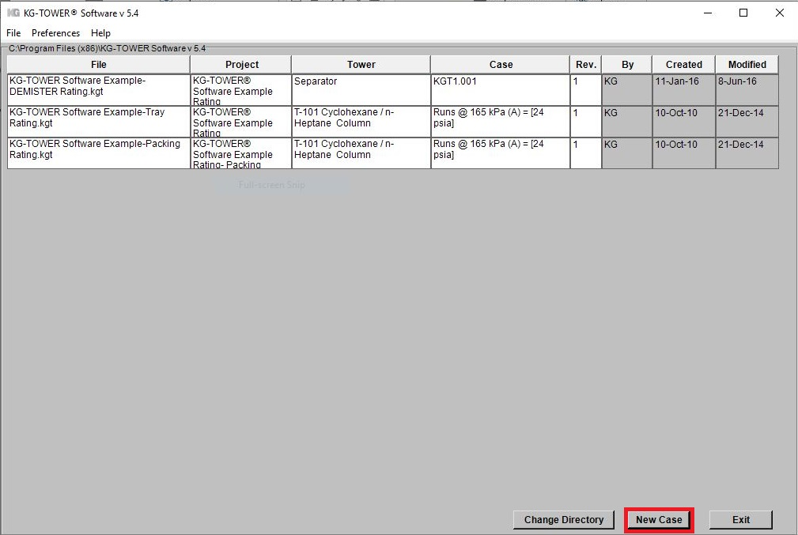Open the software and select a new case

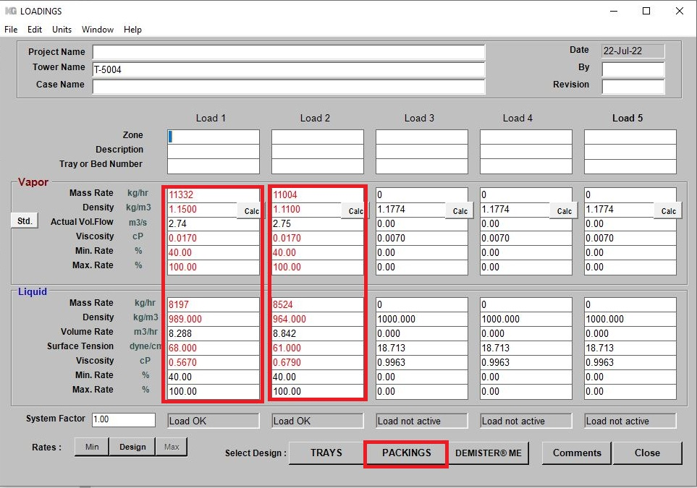Fill-up box 1 and 2 and then click ***Packing***

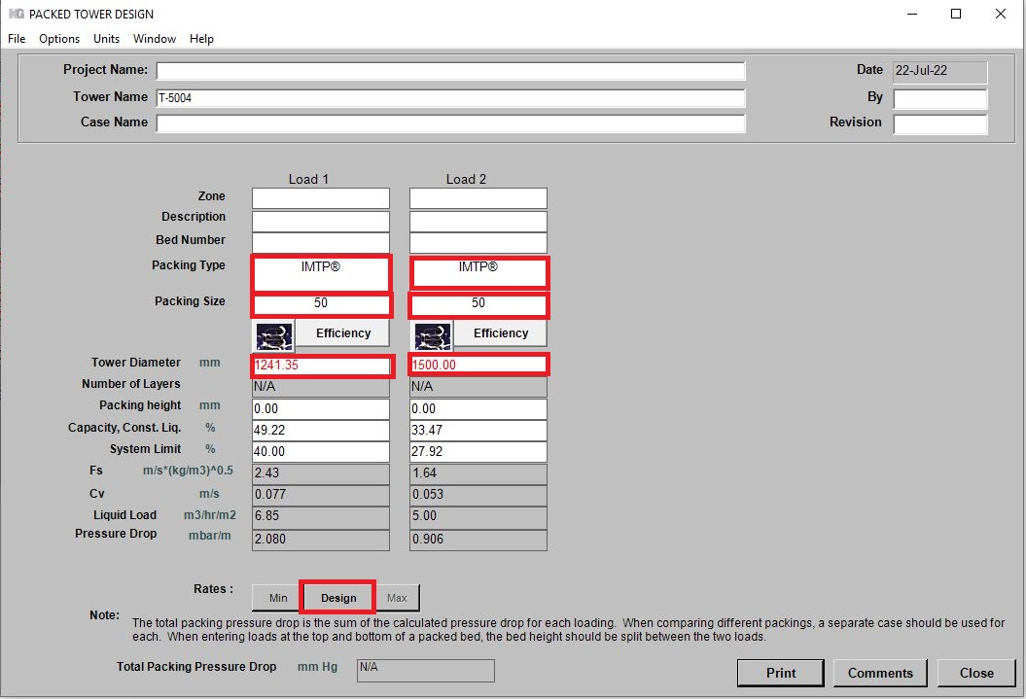Fill-up the box accordingly and Click ***Options*** and select ***Constant liquid***

Comparison

|  |  |  |
| --- | --- | --- |
| **Haldor Topsoe** | **Excel Sheet** | **KG Tower** |
| **1500** | **1465** | **1250** |

Notice that if the height of the tower is 5 m then the total dp according to KG Tower is 10 mbar it means that the minimum ID for the packed tower is 1250.