Tower Design

**Tower Data Input**

Maximum Load in different Zones

Vapor Load in Zone 1 Vapor Load in Zone 1 Vapor Load in Zone 1

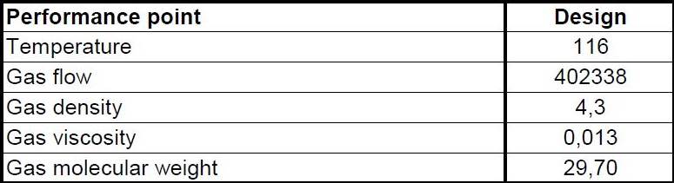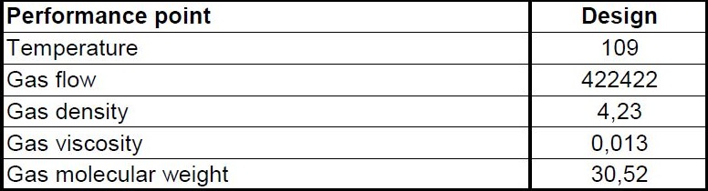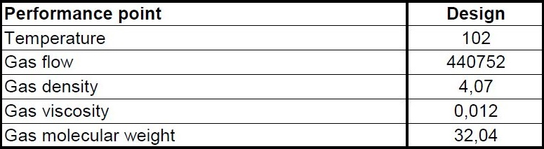

Liquid Load in Zone 1 Liquid Load in Zone 1 Liquid Load in Zone 1

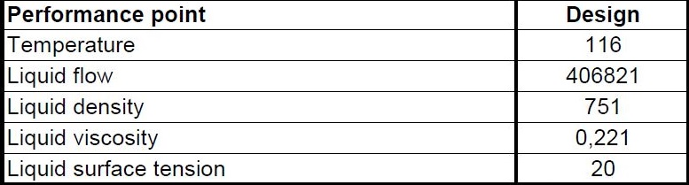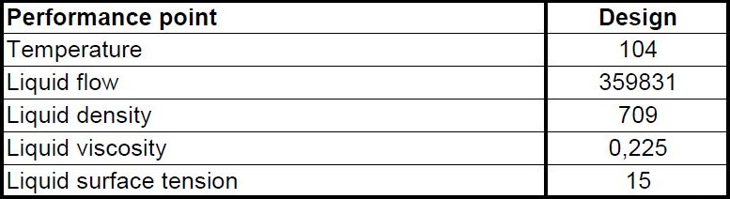

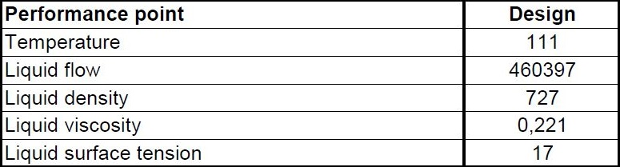

**Tower ID Sizing**

1. **Use C-factor method or Koch-Glitsch diagram for first estimation of Diameter**

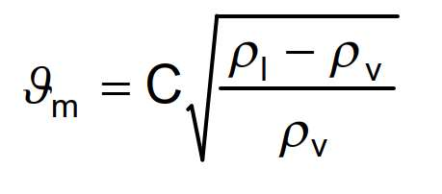

* Vm = maximum acceptable vapor velocity in the space below one tray, (m/h),
* ρl = liquid density at operating temp. and pressure of the tray (kg/m3),
* ρv = vapor density at operating temp. and pressure of the tray (kg/m3),
* C = Souders-Brown factor given by figure 12, in m/h versus tray spacing in cm and liquid

surface tension in N/m,

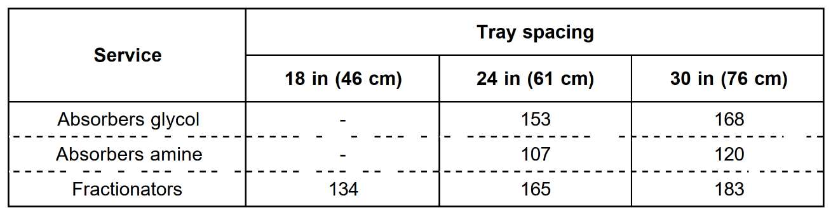

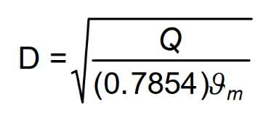

* D = inside diameter of the column in meters,
* Q = vapor flowrate at actual tray conditions (m3/h),
* This method was originally developed for bubble cap trays and gives a rough diameter

value, especially for other types of trays.

* Koch-Glitsch diagram

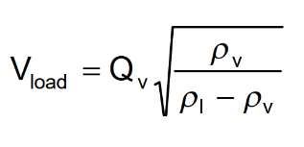

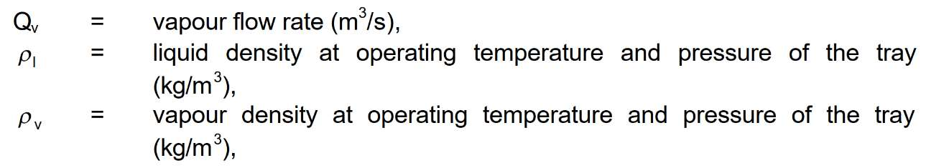

Results for C-factor Method for T-5003

|  |  |  |  |  |  |
| --- | --- | --- | --- | --- | --- |
| **Tray Spacing** | **C** | **V-max** | **Diameter** | **V-Load** | **V-Liquid** |
| 600 mm | 165 | 2156.8 | 7.67 m | 2.12 | 10.54 |

**2. Determine Flow Path Length**

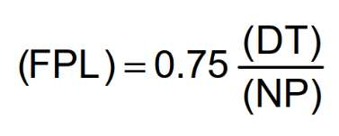

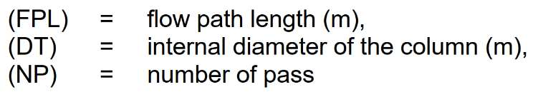

**3. Determination of Vapor Capacity Factor (CAF)**

Figure 14 allows to determine the vapour capacity factor (CAFo) in meter per second, versus

vapor density and tray spacing for nonfoaming fluids. For foaming fluids this vapour capacity

factor must be corrected by the system factor value indicated in the table of figure 15.

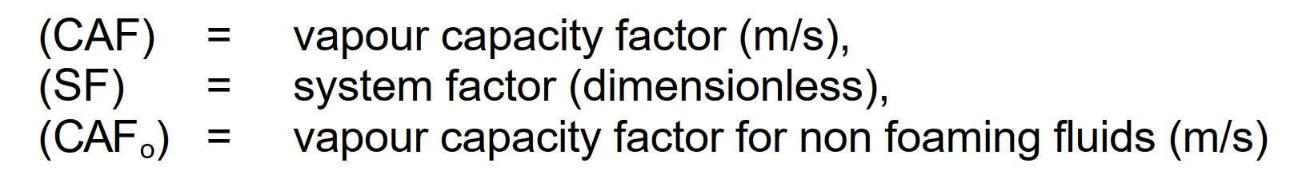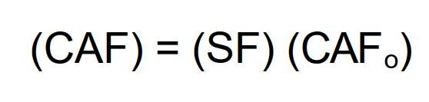

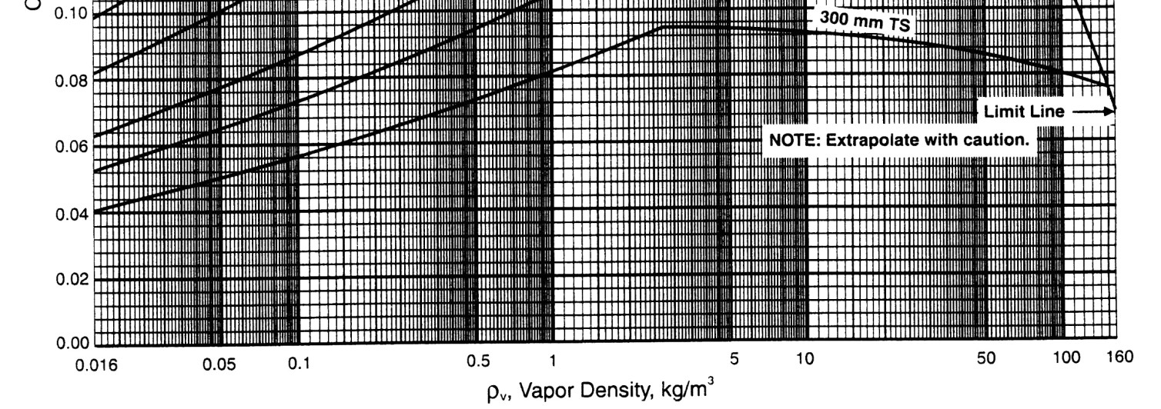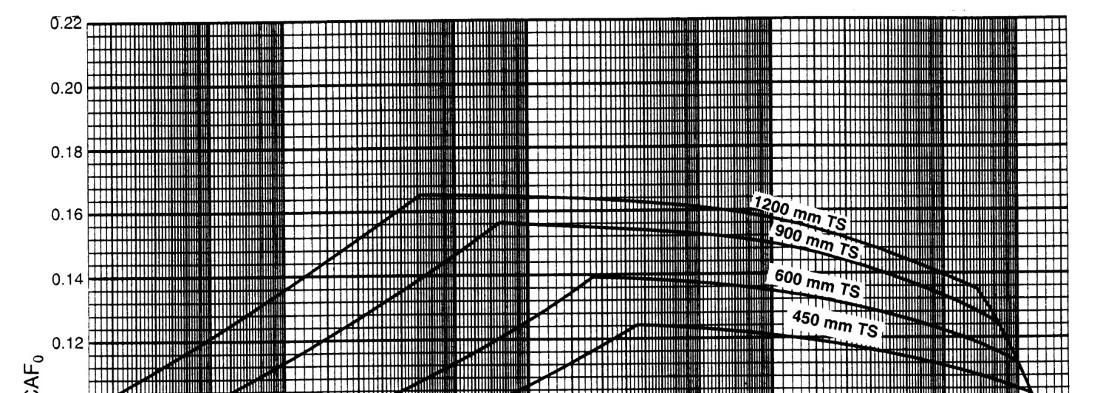

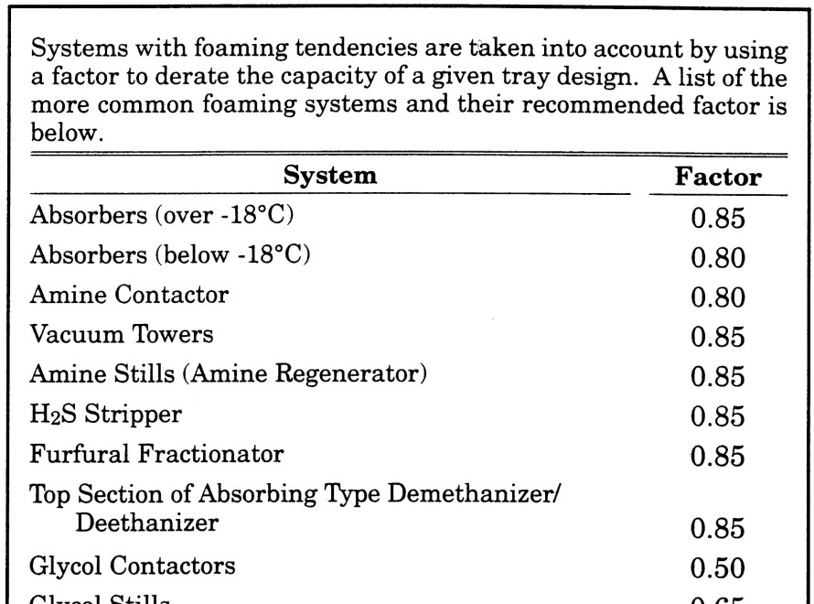

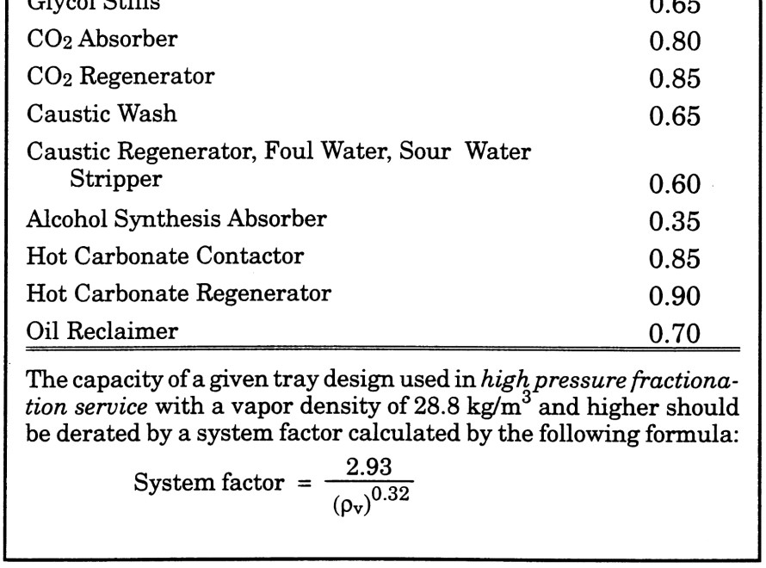

Results for FPL and CAF

FPL = 0.75 * 7.67 / 2 = 2.87

Note that 2 pass has been selected

CAF = CAF0 * SF = 0.14 * 1 = 0.14

Note that CAF0 is determined by Diagram on last page

3. Determination of the Downcomer Velocity (VDdsg)

The procedure used in this method for establishing downcomer area is based on a "design “

velocity in meter per hour given by figure 16 for non-foaming fluid or by equation as follows:

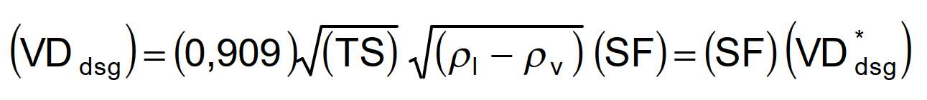

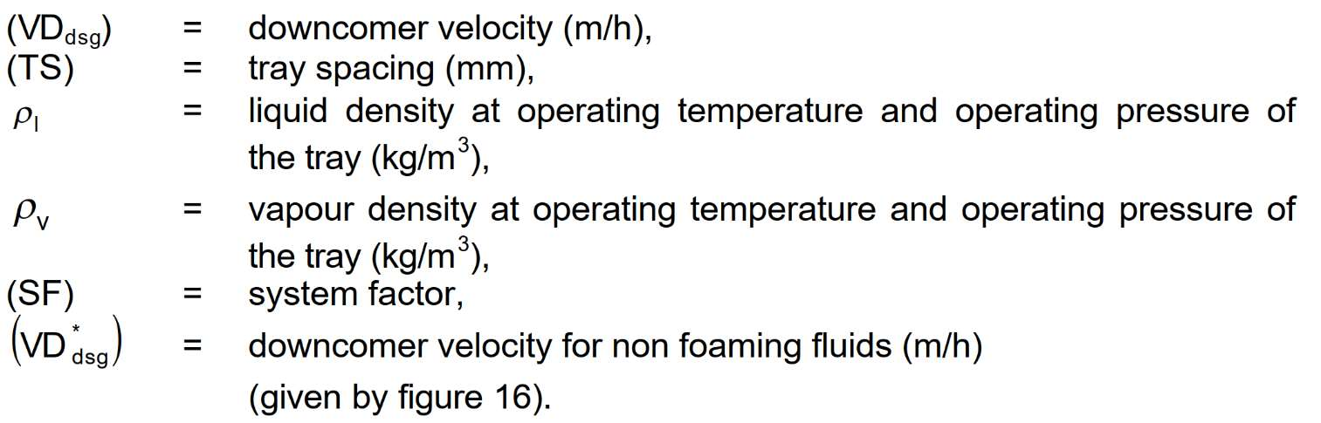

4. Determination of Active Area (AAM)

* The minimum active area is a function of vapor and liquid loads, system properties, flood

factor and flow path length.

* The flood factor (FF) is used in certain equations for purpose of estimating column size.

It is the “design percent of flood" expressed as a fraction.

* A value of not more than 0.77 is normally used for vacuum columns and a value not

more than 0.82 is used for other services.

* For demethanisers and near critical point values, it is recommended to adopt a value in

the range 0.6 to 0.7.

* These values are intended to give not more than approximately 10 % entrainment.
* Higher flood factors may result in excessive entrainment and/or a column sized too small

for effective operation.

* Flood factor of 0.65 to 0.75 should be used for column diameters under 36" (90 cm).
* The minimum active area is determined with equation as follows:

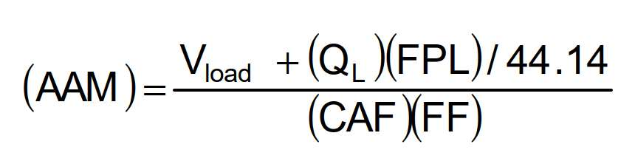

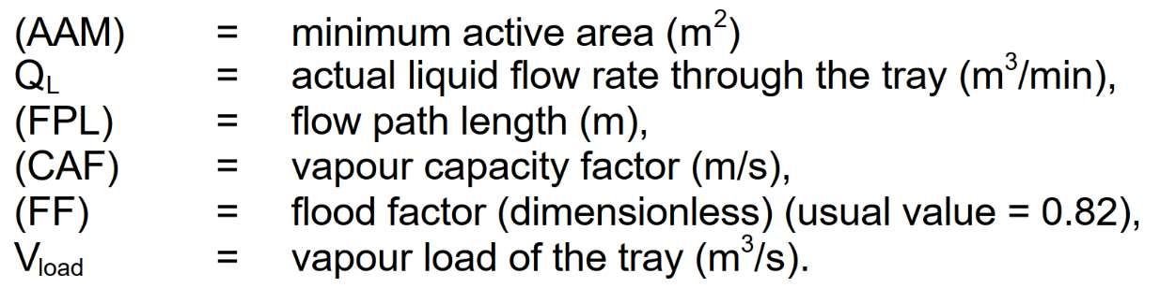

5. Determination of the Downcomer area (ADM)

The minimum downcomer area is a function of liquid rate, downcomer design velocity and flood

factor.

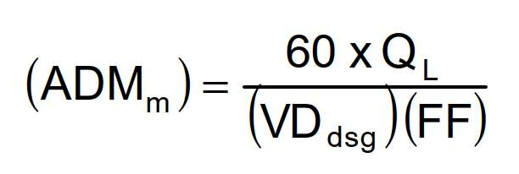

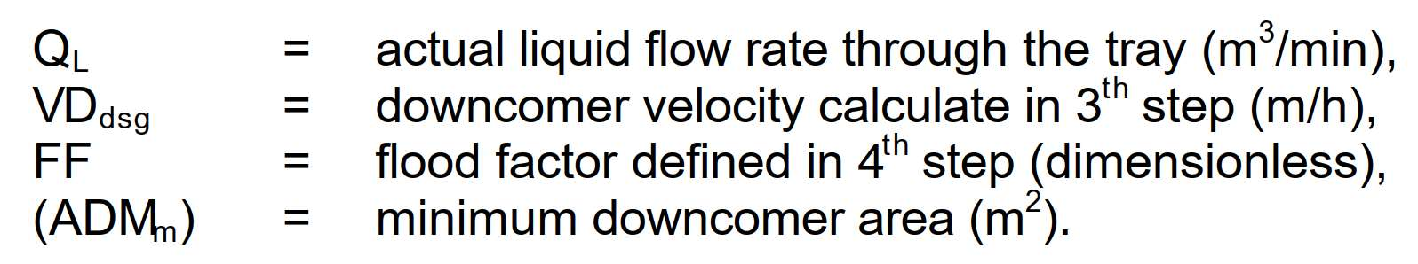

If the downcomer area calculated by this equation is less than 11 % of the active area (AAM)

adopt for (ADM) the smaller value of relations as follows:

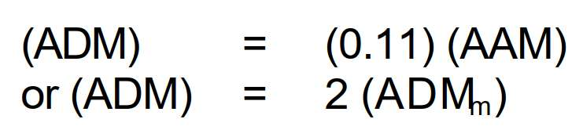

Results for Vd and AAM

|  |  |  |  |
| --- | --- | --- | --- |
| **Vd** | **AAM** | **ADMm** | **ADMsel** |
| 598.6 | 24.45 | 1.28 | 2.57 |

Note that FF = 82%

Note that since ADMm is less than 11% AAM, 2.57 has been selected

6. Determination of the minimum inside diameter (DC) of the column

The approximate column cross sectional area is calculated by equations as follows:

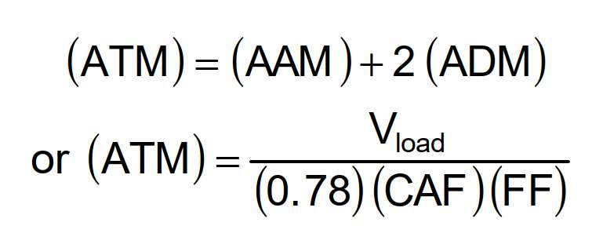

The higher value is adopted.

Minimum inside diameter of the column (DC) in meters is calculated with relation:

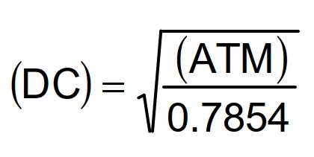

Results for calculated ATM and Tower Diameter

|  |  |
| --- | --- |
| **ATM** | **Diamater** |
| 29.61 | 6.15 |

Note that 2 ATM are calculated and the higher one is selected

7. KG TOWER Confirmation

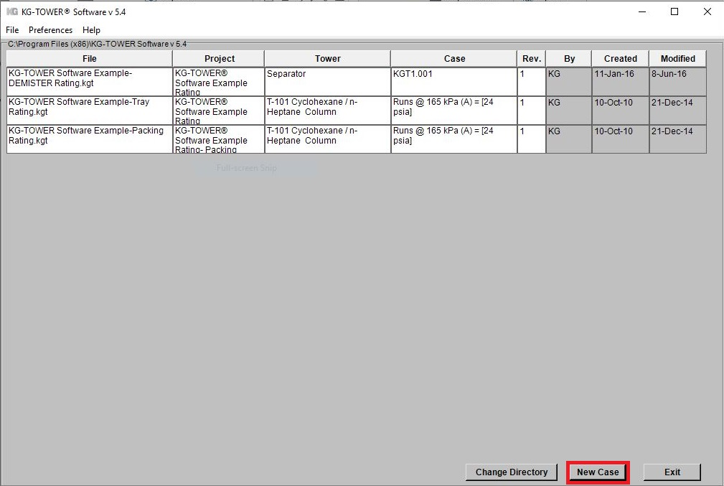Open the software and select a new case

* 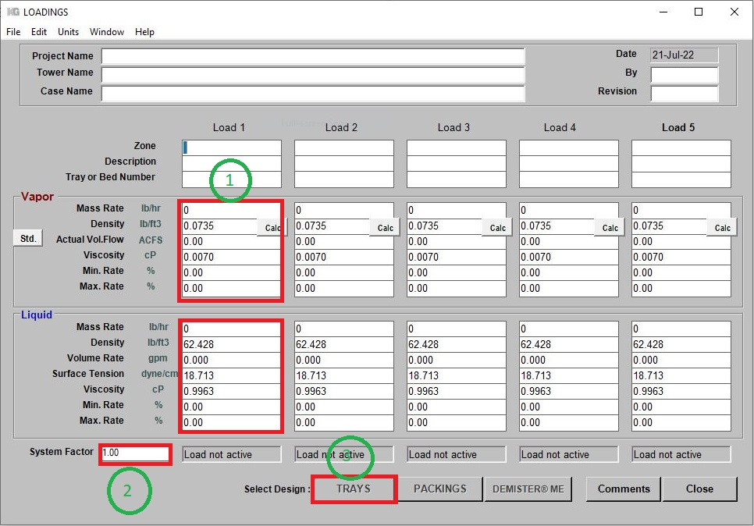Fill-up box 1 and 2 and then click ***Tray***

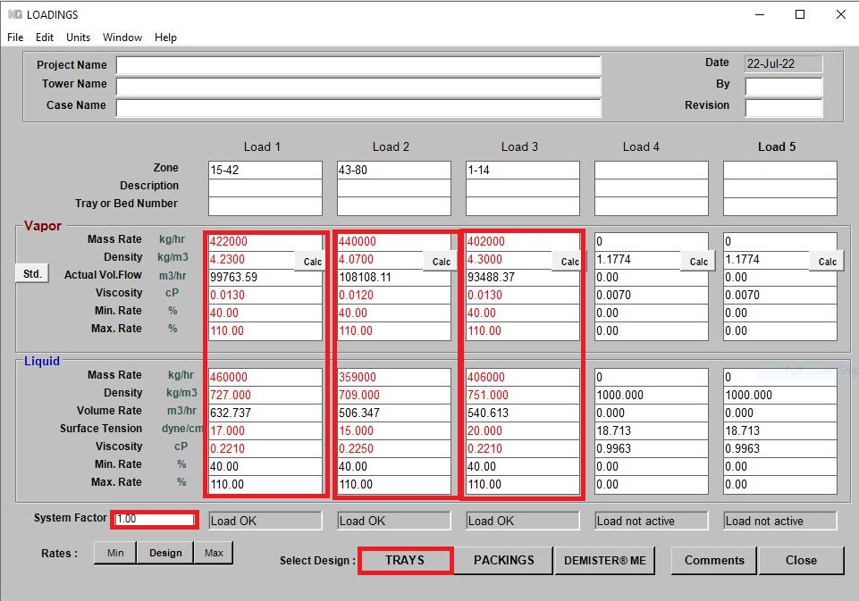 T-5003 Input

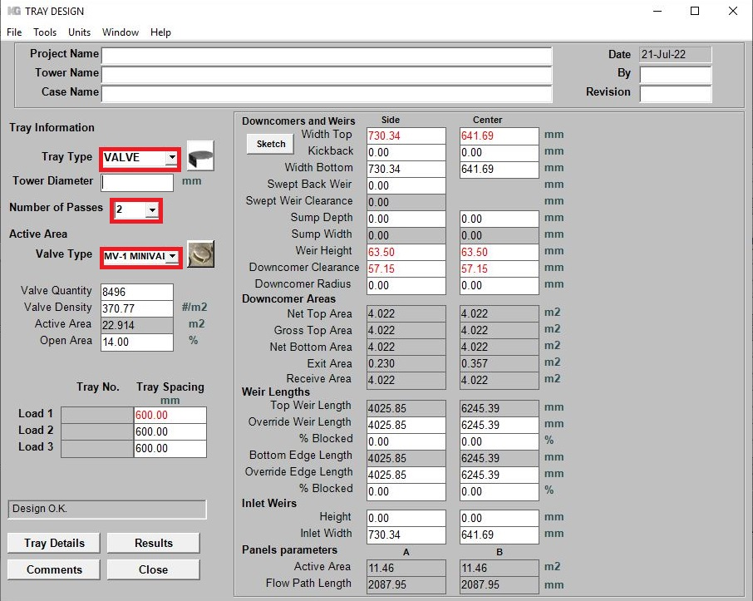Fill-up tray type, number of passes and Koch valve type

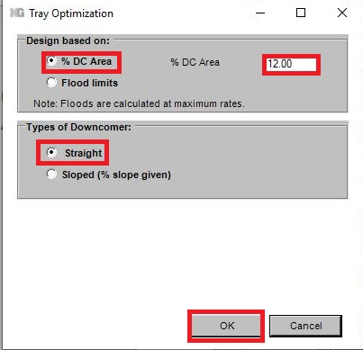Go to TOOL and select “Estimate Tower Diameter”

Check the Results

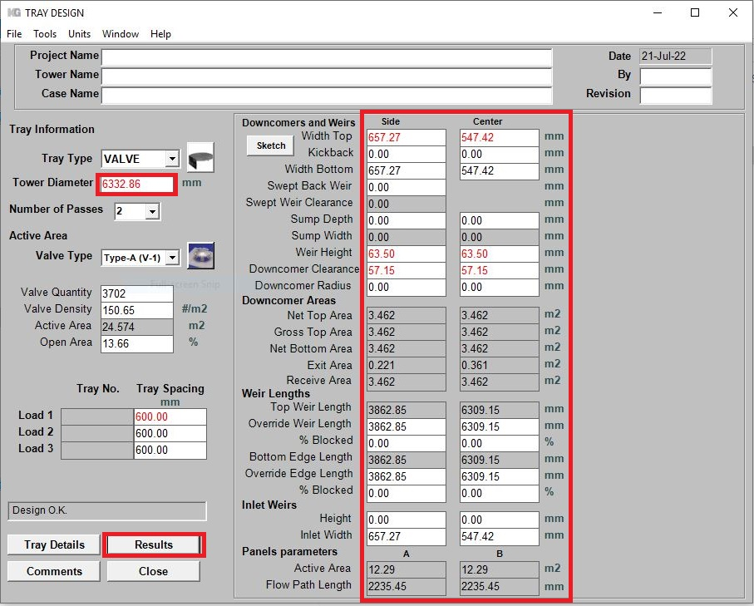

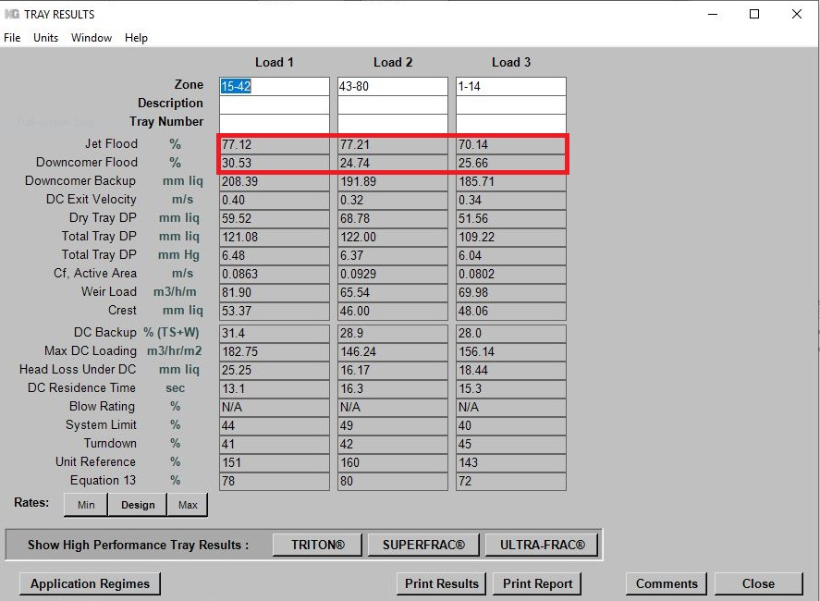

Comparison

|  |  |  |
| --- | --- | --- |
| **Haldor Topsoe** | **Koch-Glitsch Excell** | **KG Tower** |
| 6350 mm | 6140 mm | 6332 mm |