TWO-PHASE AND THREE-PHASE SEPARATOR

DESIGN AND OPERATING PRINCIPLES

**Content**

1. **Description**

1. **Design Procedure**
   1. Select proper Orientation
   2. Select and Size proper Inlet Device, Inlet and Outlet ID
   3. Calculate Vessel Diameter
   4. Calculate Vessel Height
   5. Select and Size Manholes, Vent, Drain, Vortex Breaker
   6. Select a well-designed mist eliminator pad

**TYPES OF COMMON GAS-LIQUID SEPARATORS**

**Vertical Separator — No Internals**

A vertical knock-out drum (Fig. 7-20) provides bulk separation of gas and liquid. It has unlimited

turndown, very low pressure drop, can handle slugs well, and is tolerant of fouling.

Overall efficiency depends on the application but typically will be no more than 90%-95% when

the vessel diameter is sized for gas flow. Separation efficiency typically decreases at higher

pressure due to the presence of smaller droplets than at low pressure. Knock-out drums without

internals are typically used for applications where there is little liquid present and a vertical

configuration is preferred, where no internals are allowed due to the service (i.e. flare knock-out

drums), fouling is a major consideration, when efficiency of separation is not a major

consideration and no internal are preferred They are not recommended for applications where

efficient separation is needed.

**Vertical Separator with Mesh Pad**

The addition of the mesh pad to the vertical separator improves the demisting capability of the

separator. Vertical separators with mesh pads have moderate capacity, high liquid droplet

removal efficiency, high turndown ratio, and low pressure drop. The overall efficiency of a

separator with a mesh pad is dependent on the liquid droplet size distribution and the liquid

load at the pad. A supplier can typically guarantee an overall efficiency of 99% at 7-10

microns for a conventional high efficiency wire mesh mist eliminator. For material balance

purposes, an overall liquid removal efficiency of greater than 99% can be assumed for most

applications. Vertical separators with mesh pads are recommended for applications where

vapor flow is the controlling condition. They can handle a moderate liquid load to the pad in

the form of droplets. The design K value can be affected by the liquid load to the device,

therefore, proper selection of the feed inlet device is essential. Vertical wire mesh separators

can be used when limited upstream pipe slugs are present, if sufficient liquid surge volume is

included. They are not recommended for fouling service and for highly viscous liquids

when the de-gassing requirement determines the vessel diameter.

Typical applications for vertical separators with mesh pads are compressor suction

scrubbers and intermediate scrubbers in non-fouling service, general service separators

of all types, production separators, inlet and outlet scrubbers for glycol/ amine

contactors, upstream of filter-separators, and inlet scrubbers for gas export pipelines.

Different styles of mesh elements are available metal, plastic, composite (wire and

fiber), compound (different wire diameter, and/or weave density, and special drainage)],

depending on the application. All of these factors will affect both the maximum gas

capacity and the droplet removal efficiency. For many gas treating applications,

however, conventional simple metal mesh mist eliminator are used. Mesh pads have a

low pressure drops, typically about 249 Pa, depending on the pressure and liquid

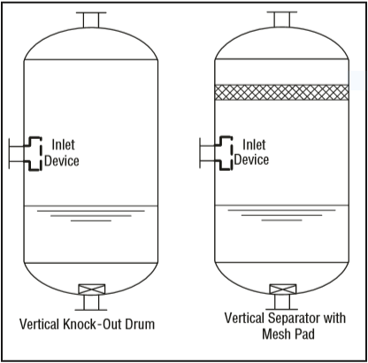loading.

**Vertical Separator with Vane Pack**

Vertical separators with vane packs can be used instead of wire mesh for the following

reasons: fear of fouling of the wire mesh, where corrosion and life of the demisting device

requires a more robust design than mesh pads, to reduce separator size and cost compared

to mesh, too high a liquid load for mesh.

Vertical separators with vane packs have a moderate turndown ratio, are suitable for slightly

fouling service (straight or some single-pocket vanes only). The typical droplet removal

efficiency for vane styles is provided in “Vane Separator Devices”, earlier in this Chapter.

Vane separators are less efficient overall than wire mesh in most applications. Vertical

separators with vanes are best utilized below 4825 kPa (ga). Higher efficiency can be

obtained at pressures above 4825 kPa (ga) by using double pocket vanes. Vanes can tolerate

higher liquid load than mesh pads. However, they are sensitive to slugs and require adequate

bulk separation upstream, similar to mesh pads. Vane elements have a relatively low pressure

drop typically 100 Pa to 1 kPa (ga)]. Vertical separators with vanes are a common alternative

to mesh mist eliminators for reciprocating compressors because of their more robust

mechanical design, which is advantageous in pulsating service.

Vanes packs may be supplied as part of a package which includes the pressure vessel and

internals, or as the vane element alone. Each supplier has proprietary vane pack styles and

design correlations.

There are several styles available: straight vanes, single pocket vanes for vertical and

horizontal flow, and double pocket vanes for horizontal flow. Pocket vanes are, however, more

prone to fouling. The liquid collected by the vanes is typically drained by a pipe(s) to the sump

of the separator and sealed.

The drain pipe(s) is submerged below the liquid level. Several different vane configurations

may be used in a vertical separator: vertical flow of gas through the vanes, horizontal flow,

inline separator with horizontal flow.

1.Vertical Flow Vane Separator

This configuration is similar to that of a vertical mesh separator. There is a liquid knockout

section below the vane section which can handle higher liquid loads during upsets or small

slugs. Vertical flow vane separators have the advantage that the gas flow path is vertical after

the inlet and does not have to change direction to pass through the vane pack.

2.Horizontal Flow Vane Separator

In this configuration the gas flows vertically up from the inlet section and then must make a

turn to flow horizontally through the vane pack, hence proper spacing must be allowed for

good gas distribution. Typically, the height of the vane pack is larger than the width, which

permits a smaller vessel diameter than the vertical flow vane design. In horizontal flow the

allowable K value is often higher depending on the style of vane used. The horizontal flow

vane separator is a common configuration for reciprocating compressors since it is compact

and lower in cost.

3.Horizontal Flow Vane Separator (In-Line)

This is the most compact vertical vessel using a vane pack. However, the design cannot

handle significant liquids or slugs during an upset.

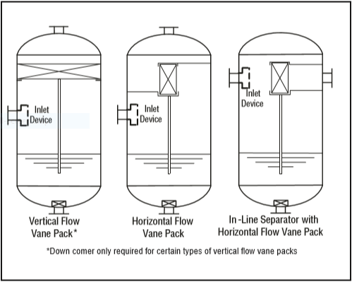

**Horizontal Separator — No Internals**

Horizontal separators-without internals provide bulk separation of gas and liquid. The design

is typically used for liquid surge applications where the vapor flow is very low, for fouling

services, or where internals are not desirable. The equipment has unlimited turndown, low

pressure drop, can handle slugs and high liquid fractions, and is insensitive to fouling. The

separation efficiency is dependent on the inlet droplet size distribution and Stokes’ Law

settling, based on the diameter, length, and liquid levels in the separator. Where gas flow

controls sizing knock-out drums are typically designed to remove 250–500-micron droplets.

Overall efficiency of 90-95% can be assumed. Where liquid holdup controls the vessel size

higher efficiency is possible. Separators-without internals are recommended where internals

must be kept to a minimum such as flare knock-out drums (no bolted internals of any kind)

and drums handling fouling fluids. They are not recommended where efficient demisting is

required.

Horizontal Separator Configurations

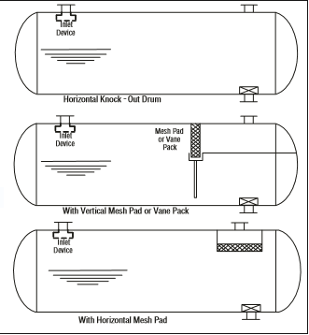

General Gas Separation Selection

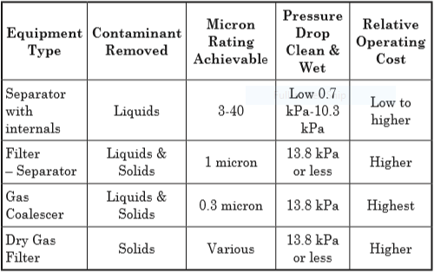

Factors that Determine Vessel Orientation

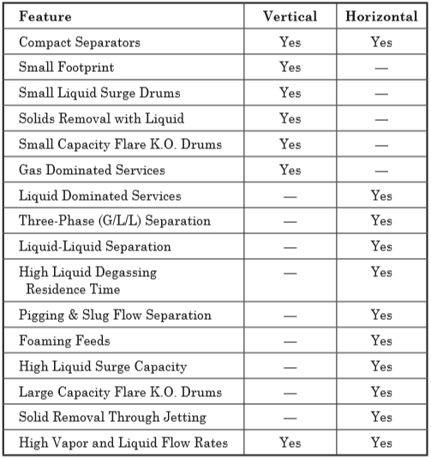

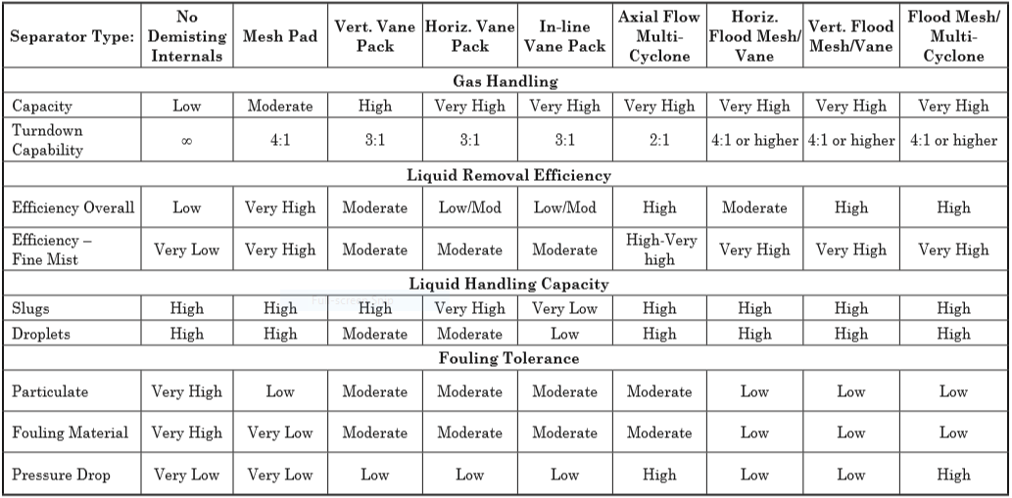Vertical Gas-Liquid Separator Comparison Chart

Gas-liquid separation vessels can typically be divided into four general regions

•Inlet Section

•Gravity Separation

•Gas Polishing Section

•Liquid Accumulation Section (Outlet Section)

The first stage, primary separation, uses an inlet diverter so that the momentum of liquid

entrained in the vapor causes the largest droplets to impinge on the diverter and then drop by

gravity. The next stage, secondary separation, is gravity separation of smaller droplets as the

vapor flows through the disengagement area. The final stage is mist elimination where the

smallest droplets are coalesced so that larger droplets are formed which will separate by

gravity. For secondary separation, the allowable velocity must be calculated so that the

disengagement area can be subsequently determined.

Performing a force balance on the liquid droplet settling out provides the necessary

C:\Users\markazi\Desktop\Capture.PNGrelationship. When the net gravity force balances the drag

C:\Users\markazi\Desktop\Capture.PNGforce . The heavier liquid droplets will settle at a constant

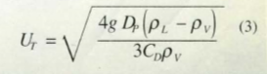terminal velocity. Equating these two forces results in

Here as long as Uv < UT  the liquid droplets will settle out. Typically, the allowable vertical

velocity Uv is set between 0.75 UT and UT. This could be rearranged to a Saunders-Brawn

equation.

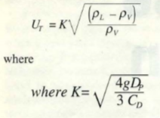

In vessels with no internals, gravity settling is the only mechanism of separation. Thus,

terminal velocity of the minimum particle size desired for separation is critical. For vertical

vessels, a liquid droplet will settle out of the gas phase when the vertical gas velocity is less

than the droplet’s terminal velocity. The terminal droplet velocity can be obtained by using the

appropriate settling law expression, or an industry experience K value. The K value can be

calculated by assuming a minimum droplet size that must be removed and equating Equation

7-11 and Equation 7-12. The target droplet diameter, or K value, is selected to prevent

excessive entrainment based on experience. In either case a target droplet size of about 250

to 500 microns is typically used for many gas-liquid gravity separator designs.

This approach has been found to be adequate to prevent substantial liquid carryover for most

applications. The maximum allowable K value used for design, for light hydrocarbon

applications, is frequently reduced further at elevated pressures from that calculated by

Equation 7-11. This is intended to account for the fact that as the pressure increases, the

surface tension for light hydrocarbons decreases, as well as the high gas density, resulting in

a higher likelihood of a smaller mean droplet size entering the separator.

If applied for a typical vessel L/D ratio of 3:1 or greater, would result in a effective axial flow K

factors (L/H *K) greater than 1.0. In practice, the effective K used has been limited by either

calculation of the incipient re-entrainment velocity, an empirical approach.

Liquid Gravity Separation Section For Vertical Separators with Downstream Mist Eliminators

The gravity separation section for a vertical separator should be designed to allow a majority

of the liquid to drop out upstream of the mist eliminator, to provide an even distribution of the

gas to the gas polishing section, and to minimize re-entrainment from the liquid surface below

the feed. This can be accomplished without over sizing the vessel diameter, if adequate space

is provided above and below the feed nozzle, and the Inlet Section is properly specified

(appropriate inlet piping configuration/size, and inlet device). In the past, it was common to

oversize the vessel diameter compared to the mist eliminator, in order to provide a more

conservative and flexible design. The appropriate approach for a new application depends on

the risk tolerance of the owner, and the nature of the application.

**Gas-Liquid Gravity Separation Section for Horizontal Separators with Downstream Mist**

**Eliminators**

The goal of the gravity separation section for a horizontal separator is to remove a majority of

the liquid droplets from the gas prior to the mist eliminator, to minimize surface re-entrainment

due to waves and droplet shear at the gas liquid interface, and to promote an even gas flow

distribution to the mist eliminator. To accomplish this, it is necessary to limit the gas velocity

through the vapor space. For most applications, an approach of applying Stokes’ Law to

establish a vertical terminal vertical velocity, and then designing for the gas flow velocity and

length to drop out say a 250–500-micron droplet would result in high horizontal velocity

(greater than that typically used commercially). As an alternative several different approaches

have been used: 1) base the design on the maximum velocity which will drop out a target drop

size in the length available, yet is below the calculated incipient re-entrainment velocity from

the liquid surface (See “Surface Re-entrainment” section earlier in this Chapter)5, 2) use an

empirical equation for maximum gas velocity based on the density expression ((ρl-ρg)/ρg)0.5,

times an factor based on a length ratio, and the height to the interface 3) limit the maximum

gas velocity based the gas and liquid density function times a constant, 4) a combination of

limiting maximum gas velocity based on an the density function times an empirical equation or

a value, combined with a check of incipient re-entrainment velocity. Several typical equations

for the maximum allowable horizontal velocity are provided in table below.

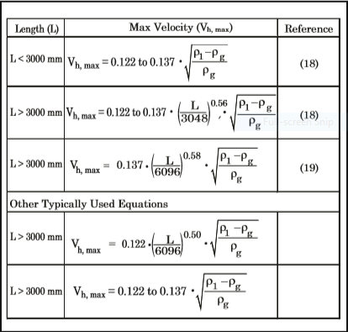Typical Equations for Maximum Gas Velocity for Horizontal Separators with Mist Eliminators

**Inlet Section**

The efficiency of a gas-liquid separator or a gas-liquid-liquid separator can be affected

significantly by the flow regime and piping configuration upstream of the separator. Flow

patterns that produce fine liquid droplets which are more difficult to separate are not desirable.

The inlet flow regime depends on the flow rates and physical properties of the phases

(including liquid surface tension), and on the feed pipe characteristics (diameter, length,

vertical/ horizontal, location of fittings). Certain flow regimes cause more small droplets to

form than others. Slug flow should be avoided and stratified-wavy and annular flows can form

small droplets in the feed pipe. The piping configuration to the separator should not hinder the

working of the separator. Piping bends should be avoided close to the inlet of separators

because they cause the flow to begin to rotate in the pipe. CFD modeling and field experience

have shown that generally the swirling flow cannot be effectively gravity separated until the

swirling is stopped, either by it dissipating with distance or by the use of straightening vane

devices in the separator inlet.

The following design considerations can greatly improve separator performance: avoid

the following configurations within 5-10 pipe diameters of the separator: elbows in the

horizontal plane, two out of plane elbows, valves and other flow disturbances, and high

pressure drop which may cause flashing and atomization. The inlet piping design

upstream should minimize low points and pockets. In addition, it is recommended that

inlet piping diameter match the velocity requirement of the inlet to the separator 10 pipe

diameters upstream of the separator to provide a flow regime which is fully developed

before entering the separator.

Inlet Devices — Proper selection of the inlet device is critical in separator design. Inlet

devices should reduce the momentum of the inlet stream, initiate gas-liquid separation

with minimum creation of fine droplets, and distribute gas flow evenly throughout the

inlet and gravity separation section of the vessel. Testing and CFD modeling have

shown that if the fluid is distributed poorly separation efficiency will suffer greatly. The

use of inlet diffusers for vertical separators and for horizontal separators with high gas

flow has become common in recent years.

A diffuser reduces droplet fracture as well as providing improved gas distribution inside the

separator.

A diffuser installed on separator feed with a high liquid to gas ratio can also help relieve the

downstream mist elimination device of more than 90% of the inlet liquid load.

There are several types of inlet devices used in the industry. The more common devices are

shown below.

Common vertical vessels inlet devices Common horizontal vessels inlet devices

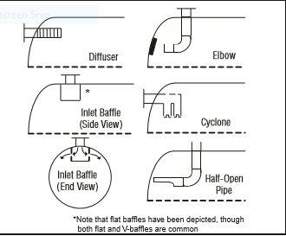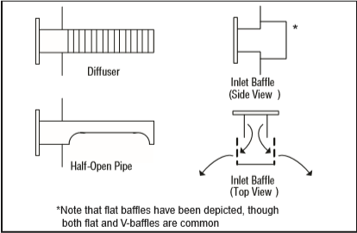

Typical inlet device performance

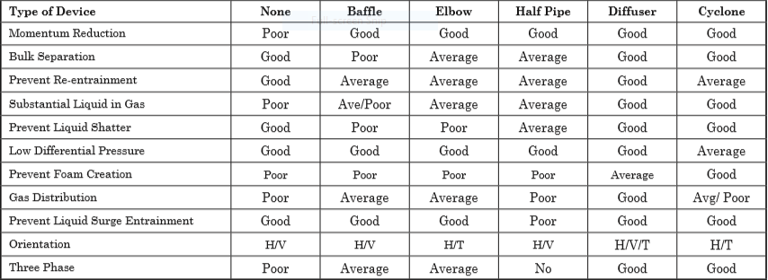

It is also necessary to maintain the inlet velocity head, J, within proper limits for the selected

inlet device to insure good gas distribution and minimum liquid shattering.

Where,

J = (ρV²) .

The maximum mixed phase velocity head range used in the industry guidelines varies for the

different inlet devices. Some typical maximums are:

•6000-9000 max. typ, up to 15 000 max kg/m s2 for diffuser distributor

•975-2250 max kg/m. s2 for no inlet distributor

•1500-3750 max kg/m. s2 for inlet half pipe or elbow distributor

•1500-3750 max kg/m. s2 for v-baffle or other simple inlet diverter designs

In addition, some users limit the inlet vapor phase velocity to 9 m/s or 18 m/s. The velocity

should always be below the erosion velocity for the service.

**Gas Polishing Section**

Selection of the appropriate device for gas polishing should be based on consideration of the

application, operating pressure, likely feed droplet size range, allowable downstream

carryover requirement, and the relative acceptability of the user for more compact and

complex solutions.

**Mechanism of Mist Carryover for Gas-Liquid Mist Eliminator Devices**

Mist eliminators are commonly used in gas-liquid separation to aid gravity separation in the

removal of liquid so that more efficient, smaller separators may be used. To be effective, a

mist eliminator must accomplish two basic functions. First, it must have a means to capture

liquid. Second, it must be able to drain the captured liquid without allowing re-entrainment into

the gas streams. There are two mechanisms of liquid carryover from a mist eliminator. In the

first mechanism, carryover is due to droplets of mist which are simply not captured by the

device. The droplets might be too small to be captured or velocities are too low, causing low

efficiency for impaction-type mist extractors. The second is re-entrainment of liquid after it has

already been captured in the mist eliminator.

The majority of separator failures are caused by re-entrainment. This is the mechanism that

occurs as the gas throughput is increased beyond the tolerable limit. Gas moving through the

mist extractor exerts a drag force on the liquid film of the mist eliminator, causing it to be

pulled toward the trailing edge of the device. If the drag is excessive, the liquid will be torn off

the element and carried away by the gas stream. As flow rate increases, the contact efficiency

of most mist eliminators improves.

Therefore, increasing gas flow yields improved droplet capture, but also increases re-

entrainment which results in liquid carryover and limits separation capacity.

The most common style of mesh mist eliminator used in gas processing is a 100 mm to 150

mm thick crimped wire mesh pad with 144 to 192 kg/m3 bulk density. High droplet removal

efficiency for droplets 10 microns and larger is common for the above design. Other designs

include fiber mesh, mixed wire and fiber mesh, multiple mesh density layers, and special

drainage channels. The goals are either to increase removal efficiency at lower droplet

diameters, promote better drainage and in turn less carryover, increase throughput for a given

mist eliminator area, reduce fouling, or a combination of the above. Manufacturers should be

contacted for specific designs. Mesh pads are not recommended for dirty or fouling service as

they tend to plug easily and can dislodge at high differential pressure.

Proper drainage of the mesh mist eliminator is essential to the operation of the unit. As the

gas velocity increases at a given inlet liquid loading, the liquid continues to drain until a

limiting load point is reached, at which point substantial liquid will carry over with the gas flow.

Most mesh mist eliminator designs are based on the load point velocity. The load point will

depend on the mist eliminator orientation, since the drainage mechanism is different as the

pad orientation changes.

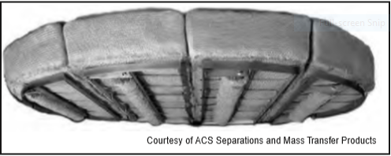Wire Mesh Mist Eliminator

**Vane Mist Eliminators**

Vane or chevron-type mist eliminators (vane-pack) use relatively closely spaced blades

arranged to provide sinusoidal or zig-zag gas flow paths. The changes in gas flow direction

combined with the inertia of the entrained liquid droplets cause impingement of the droplets

onto the plate surface, followed by coalescence and drainage of the liquid to the liquid

collection section of the separator. Vane packs may be installed in either horizontal or vertical

orientations. Various vane styles are available, including those with and without pockets (both

single and double pockets) to promote liquid drainage.

Vanes with pockets, allow a higher gas throughput per flow area due to enhanced drainage,

but are not typically used in highly fouling service. Fig. 7-11 shows a horizontal, pocketed

vane-type mist eliminator. Vane capacity is reduced for vertical up flow applications relative to

horizontal flow. Key performance parameters for vanes are droplet removal efficiency and gas

handling capacity. Capture efficiency for a given droplet size depends on the vane design, gas

velocity, gas viscosity and other parameters. Simple vanes with no pockets are typically

capable of capturing 40 microns droplets, pocketed vanes are capable of 20 microns, and

highly complex vanes of 10-20 microns at favorable operating conditions. Maximum vane

capacity is set to limit re-entrainment. The Souder-Brown equation (Equation 7-11) and the

load/sizing K factor are frequently used for describing the capacity of vane-type mist

eliminators. Manufactures provide typical K factors for the various styles. The capacity for a

particular vane service may be limited due to the liquid load to the device, liquid viscosity,

foaming tendency, liquid surface tension, gas mal-distribution, and flow surges. These factors

are not necessarily directly related to the Souders-Brown K value. Manufacturer guidance is

necessary for a Design.

Testing has shown that for mesh type mist eliminators the low pressure air-water droplet

removal efficiency experimental results correlate reasonably well with higher pressure gas-

hydrocarbon liquid systems. Vane packs on the other hand show a drop-off in removal

efficiency as pressure increases. This is primarily due to the decreased allowable design gas

velocity caused by the increased gas density. As gas velocity decreases, droplet inertia

decreases, and the droplets tend to follow the gas streamlines through the vane passages

more easily. As a result, droplets are able to exit the vane pack without being captured. Mesh

pads also rely on velocity/droplet inertia to remove liquid droplets via impingement, but they

are less susceptible to efficiency reduction than vane packs because mesh pads have far

more collection “targets”, i.e. wire/fiber filaments.

Turndown is generally more of a concern with vane-packs than wire mesh, with droplet

removal efficiency decreasing measurably as velocity decreases from design. Vane packs are

more tolerant to dirt and fouling than mesh due to the large passage size.

Cross-Section of Vane Element Mist Extractor and Typical Vane Pack

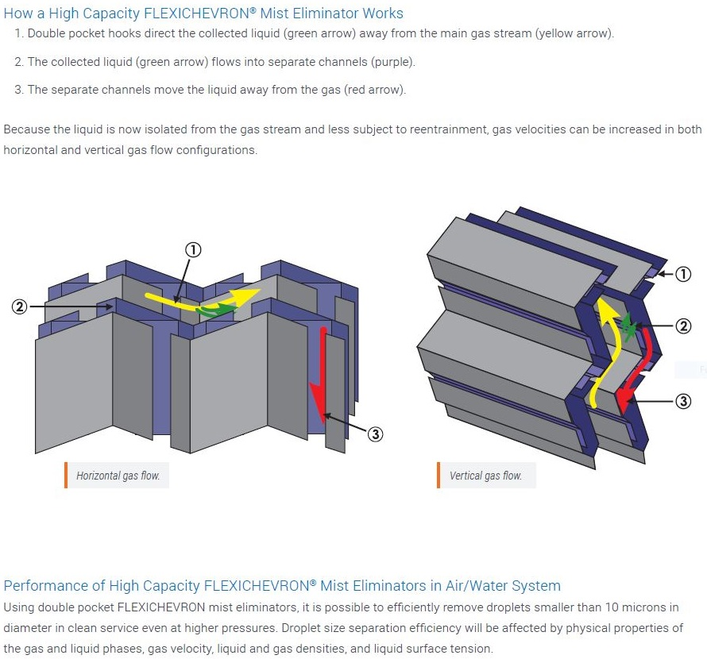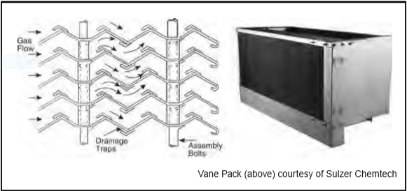

**Separation Efficiency and Sizing Considerations for Wire Mesh Mist Eliminators**

The work horse mist eliminator of the process industry for more than 60 years has been the

conventional crimped wire mesh mist eliminator (single wire filament, and density). This

design is still applicable for a wide variety of gas processing applications. Today however,

there is a wide variety of advanced designs using the concept of composites (polymer fibers

woven into the wire mesh), complex multi-layer (different density and or filament size in

layers), drainage channels, or other concepts. Each design will have its own characteristic

droplet removal efficiency at standard conditions, ability to tolerate liquid load, and throughput

capacity. Difficult applications in the gas treating industry are those with small droplet size

(low temperature treating separators, low surface tension high pressure light hydrocarbons),

high viscosity (glycols, sulfur) and stringent outlet specifications (low temperature treating,

amines and glycols). Internals suppliers should be consulted to provide the optimum

alternatives for these applications.

For any selected style, mist eliminator supplier can provide the d95 (droplet size for 95%

removal efficiency), and for a given an estimated inlet droplet size distribution, an overall

separation efficiency. Sizing for wire mesh mist eliminators is based on operating the mist

eliminator at a maximum flow rate which is a safe distance from the flood point at the

operating conditions. The Souders-Brown K value (Equation 7-11) has been found to be a

good correlating factor for determining this velocity. A conventional, 192 kg/m3, 0.3 mm

filament, crimped wire mesh mist eliminator, will typically have a design K value of 0.11 m/s,

for vertical flow to the mist eliminator, at low pressure, low liquid/ gas load, and liquid viscosity

of 1.0 mPa.s or lower. In horizontal gas flow, a design K value of 0.13 is typical for these

conditions. At other conditions, the design K value may be lower, due to the liquid/gas flow

parameter(Φ) to the device(Φ=Wg/Wl(ρg/ ρl)0.5), liquid viscosity, foaming tendency, liquid

surface tension, gas mal-distribution, and flow surges. Note, that the average droplet size to

the separator, the type of inlet distributor, and the device spacing in the vessel can affect the

gas/liquid flow parameter at the mist eliminator for a given set of inlet conditions to the

separator.

For gas treating applications, liquid viscosity is important mainly for high viscosity fluids, such

as glycols and sulfur. Surface tension is important for low surface tension light hydrocarbon

fluids, typically found in low temperature gas processing. Fabian10 proposed that it is prudent

to de-rate mist eliminators at pressures above 690 kPa (ga). This de-rating is not for pressure

per se, but rather for the potential for local high velocity areas, as the mist eliminator

becomes more compact at higher pressures. These de-rating factors are shown in Fig. 736.

Systems known to foam, such as amines and glycols should be de-rated, in a similar manner

to a system factor for trays or packing in these services. In addition, it is common to apply a

system factor to the gas design flow rate, which can vary from 1.05 to 1.2 depending on the

application (i.e. inlet production, steady state gas processing, gas compression). For many

services in the gas treating industry that handle light hydrocarbons gases and liquids at low

liquid load, with a conventional wire mesh mist eliminator, use of a K value of 0.11, de-rated

per Fig. 7-36, will provide an acceptable design.

The addition of the mesh pad to the vertical separator improves the demisting capability of the

separator. Vertical separators with mesh pads have moderate capacity, high liquid droplet

removal efficiency, high turndown ratio, and low pressure drop. The overall efficiency of a

separator with a mesh pad is dependent on the liquid droplet size distribution and the liquid

load at the pad. A supplier can typically guarantee an overall efficiency of 99% at 7-10

microns for a conventional high efficiency wire mesh mist eliminator. For material balance

purposes, an overall liquid removal efficiency of greater than 99% can be assumed for most

applications. Vertical separators with mesh pads are recommended for applications where

vapor flow is the controlling condition. They can handle a moderate liquid load to the pad in

the form of droplets. The design K value can be affected by the liquid load to the device,

therefore, proper selection of the feed inlet device is essential. Vertical wire mesh separators

can be used when limited upstream pipe slugs are present, if sufficient liquid surge volume is

included. They are not recommended for fouling service and for highly viscous liquids when

the de-gassing requirement determines the vessel diameter.

De-rating factor to K-value for pressure

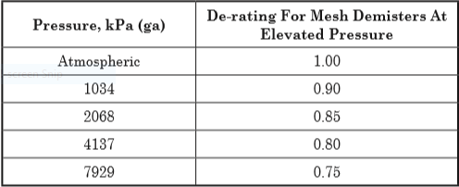

Typical Saunders Brown K values for mist-eliminator device

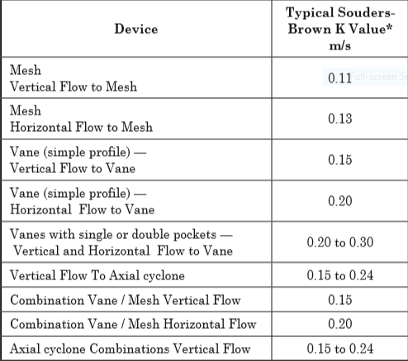

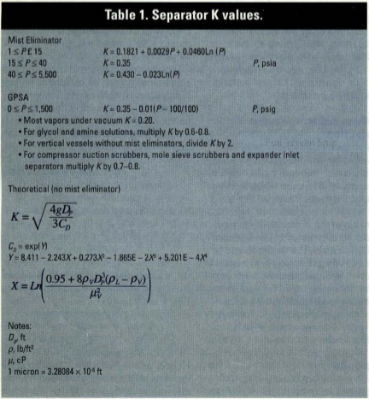

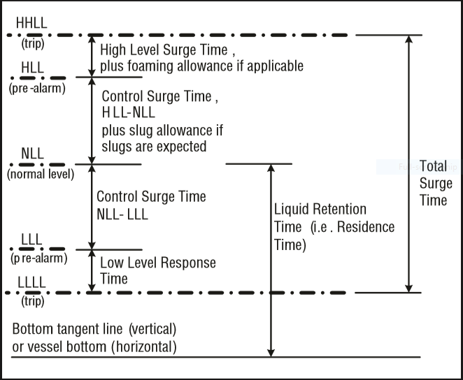Height Calculation

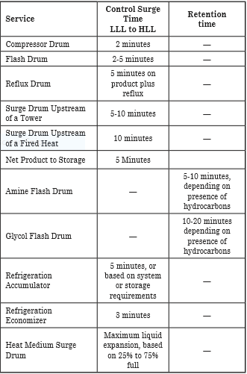

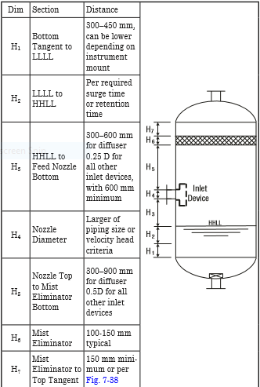

**Vapor Outlet Section**

The sizing of the vapor outlet nozzle should be such that given the above placement of the

mesh pad, the velocity is not high enough to cause channeling of the gas through the mesh

pad. The nozzle outlet size is typically based on the lesser of that required for piping pressure

drop, or a maximum velocity head criterion. Typical ranges for the maximum velocity head

allowed for the vapor outlet are 4500–5400 kg/m • s2. In addition, some users limit the

absolute velocity to 18 m/s. The pipe size can be decreased to the appropriate size based on

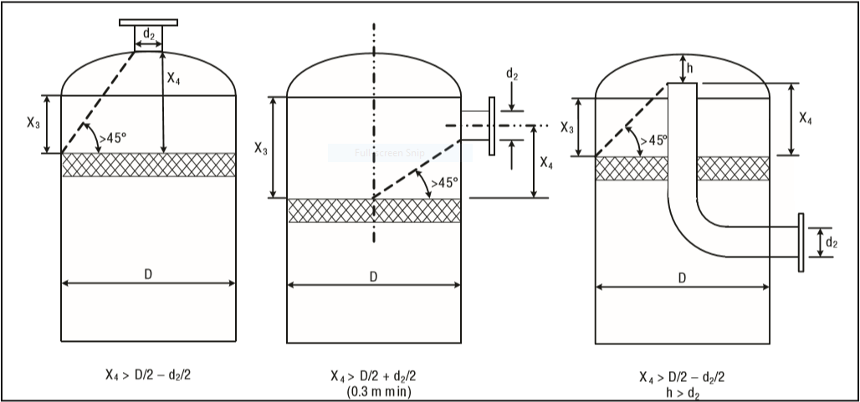pressure drop considerations, 5-10 pipe diameters downstream of the separator, as required.

**Liquid Outlet Nozzle**

Many users limit the liquid outlet nozzle velocity based on pump suction line criteria (i.e. 11

kPa/100 m for fluid at or near boil, 22 kPa/100 m otherwise) or other line sizing criteria. For

three phase separators, the velocity may be further reduced. Other users set a maximum

outlet nozzle velocity (i.e., 0.9–1.5 m/sec) regardless of the service.

The liquid accumulation section collects liquid from the inlet, gravity separation and the gas

polishing sections. This liquid accumulation section allows gas trapped in the liquid to escape

by providing sufficient liquid residence time. This is particularly important if the system is

foaming or highly viscous. The liquid accumulation section also provides sufficient volume to

allow for fluctuations in the liquid flow rate or to accommodate slugs of liquid in the inlet flow

**Additional Notes**

**Liquid Carry-Over Specification for Gas-Liquid Separators**

•0.0134 m3 / MMSm3 (absolute reference)

•Supplier guarantee based on % removal for a specified droplet size, (i.e. d95, or 99%

removal efficiency at 10 microns)

•98% overall liquid recovery

**Gas Carry-Under Specification**

A typical requirement for light hydrocarbons is minimal carry-under for gas bubbles 200

micron and larger. This is particularly important when the liquid is being pumped downstream

of the separator, since pumps are only tolerant of dispersed dissolved gas to a limited extent.

Gas volumes above 2% should be checked by the pump manufacturer.

**Vertical Vessel Diameter and Height Sizing Procedure**

1. Calculate the volumetric flow in m3/s
2. Select a proper K-value and de-rate it according to its pressure by using the table
3. Calculate UT and Uv. For Uv calculation, multiply UT by a correction factor

between 0.75-1.

1. Calculate D by using .

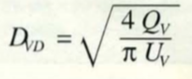

The reported D should be the calculated D + 150 mm

1. Calculate vessel Height according to Height Calculation

**Vertical Separator Without Internals Sizing Procedure**

A vertical separator without mist eliminating internals can be sized in a similar manner to that

used for separators with internals. For applications that are gas controlled, the diameter is

based on a maximum allowable terminal gas velocity. The K value used should be selected to

insure massive entrainment does not occur, and a reasonable separation efficiency is

achieved. The design terminal velocity can be based on the appropriate Stokes’ Law, and is

based on a droplet size of 250-500 micron, the gas and liquid properties, and the calculated

drag coefficient, plus a safety factor. An alternative approach which is common in the industry

is to base the design on a K value of approximately 0.046 m/s. For fluids with low surface

tension at high pressure, or in other circumstances where small droplets are expected, either

the target droplet size, or the design K, depending on the approach used, should be further

reduced.

**Horizontal Separator Without Internals Sizing Procedure**

1. Calculate the vapor volumetric flow rate.
2. Calculate the liquid volumetric flow rate.
3. Calculate the vertical terminal velocity.
4. Calculate the Hold-up volume, VH
5. Calculate the Surge volume, VS
6. Obtain an estimation of L/D ratio, using following table and subsequently

calculate D by following equation.

C:\Users\markazi\Desktop\Capture.PNG

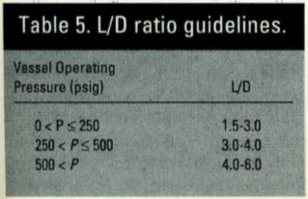

7. Calculate the total cross-sectional area

8. Calculate the low liquid level height using following table or HLLL = 0.5D + 7 in.

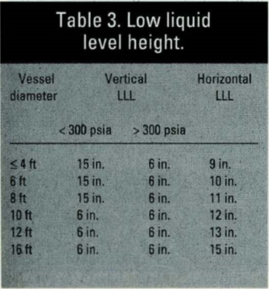

9. Calculate HLLL/D and use Goal-Seek function in Excel to find ALLL/AT and subsequently

ALLL.

10. Set HV to 0.2D or 1 ft. if there is no mist pad eliminator and set it to 0.2D or 2 ft. if

there is a mist pad eliminator. Then calculate HV/D and by using Goal-Seek function

calculate AV/AT

11. Calculate the minimum length to accommodate liquid holdup/surge, using following

equation:

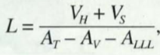

12. Calculate the liquid dropout time

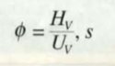

13. Calculate the actual vapor velocity

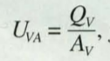

14. Calculate the minimum length required for vapor-liquid dis-engagement.

C:\Users\markazi\Desktop\Capture.PNG

