Horizontal Vessel

Without Mist Eliminator

D-5001

Design and Principles

**Content**

1. **Description**

1. **Design Procedure**
   1. Select proper Orientation
   2. Select and Size proper Inlet Device, Inlet and Outlet ID
   3. Calculate Vessel Diameter
   4. Calculate Vessel Height
   5. Select and Size Manholes, Vent, Drain, Vortex Breaker
   6. Select a well-designed mist eliminator pad

**Description**

The objective of this vessel is to accumulate purified methanol produced and reflux all

of it to the Stabilizer Column.

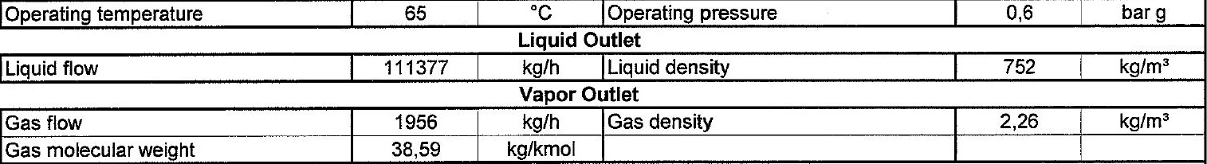Operating Parameters

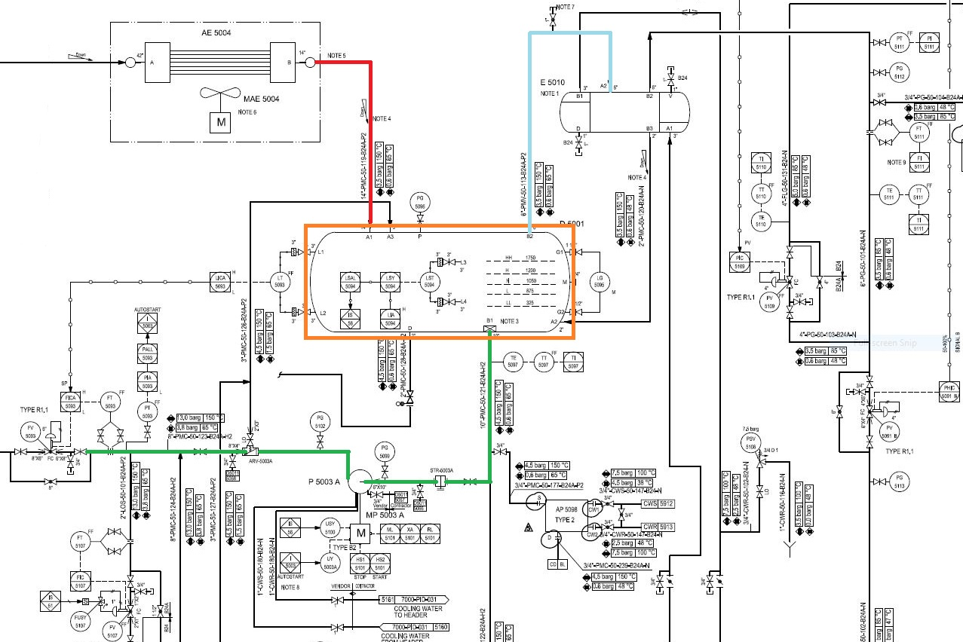

**Design Procedure**

1. Select proper Orientation

2. Select and Size proper Inlet Device, Inlet and Outlet ID

3.Calculate Vessel Diameter

4. Calculate Vessel Height

5.Select and Size Manholes, Vent, Drain, Vortex Breaker

**1st Step: Select proper orientation**

Since the application is liquid dominant, a horizontal vessel is selected since it is used

for accumulation purposes.

Horizontal separators-without internals provide bulk separation of gas and liquid. The

design is typically used for Liquid surge applications where the vapor flow is very low,

for fouling services, or where internals are not desirable. The equipment has unlimited

turndown, low pressure drop, can handle slugs and high liquid fractions, and is

insensitive to fouling. The separation efficiency is dependent on the inlet droplet size

distribution and Stokes’ Law settling, based on the diameter, length, and liquid levels in

the separator

**2nd Step: Select and Size proper Inlet Device**

It is also necessary to maintain the inlet velocity head, J, within proper limits for the selected

inlet device to insure good gas distribution and minimum liquid shattering.

Where, J = (ρV²)

The maximum mixed phase velocity head range used in the industry guidelines varies for the

different inlet devices. Some typical maximums are:

•6000-9000 max. typ, up to 15 000 max kg/m s2 for diffuser distributor

•975-2250 max kg/m. s2 for no inlet distributor

•1500-3750 max kg/m. s2 for inlet half pipe or elbow distributor

•1500-3750 max kg/m. s2 for v-baffle or other simple inlet diverter designs

In addition, some users limit the inlet vapor phase velocity to 9 m/s or 18 m/s. The velocity

should always be below the erosion velocity for the service.

However, in distillation section such rules do not apply.

**3rd Step: Calculate Vessel Diameter**

Each and every licensor and company has developed a design basis procedure for sizing

vessels. In this article, a Svercek-method and the Licensor method will be explored.

**Svercek**

1. Calculate the vapor volumetric flow rate, QV in m3/s

2. Calculate the liquid volumetric flow rate, QL in m3/min

3. Calculate the vertical terminal vapor velocity, UT and set UV = 0.75 UT

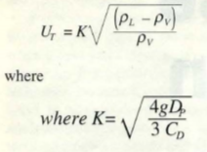

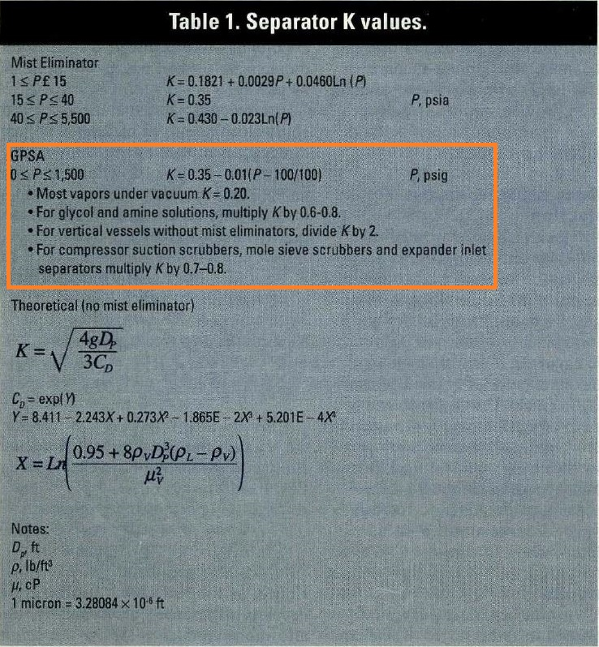

4. Select a hold-up time from next-page Table and calculate the hold-up volume, VH

5. Select a surge time from next-page Table and calculate the surge volume, VS

6. Estimate a L/D and initially calculate the diameter according to the following Equation:

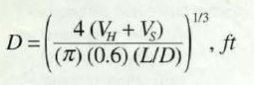

7. Calculate the total cross-sectional area.

8. Set HLLL and by using HLLL/D obtain ALLL/AT and calculate ALLL

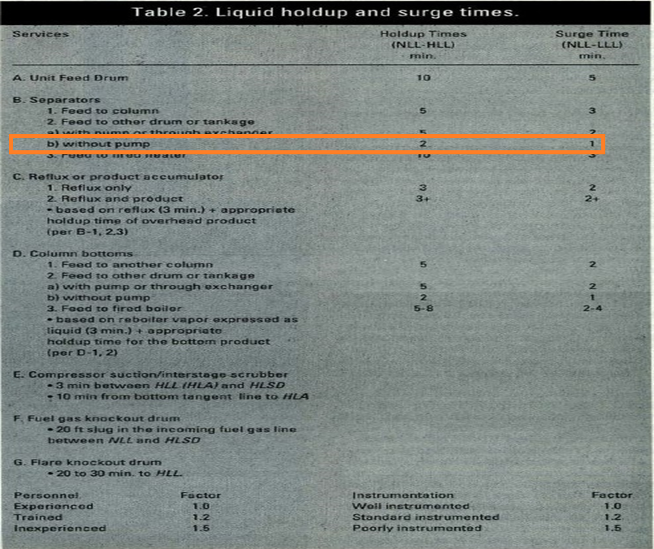

9. Set HV to 0.2D or 0.3048 m, whichever is greater; then by using HV/D, obtain AV/AT

10. Calculate the minimum length to accommodate the liquid hold-up/surge:

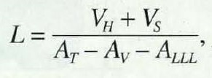

11. Calculate the liquid dropout time

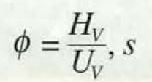

12. Calculate the actual vapor velocity

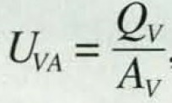

13. Calculate the minimum Length required for vapor-liquid disengagement, LMIN:

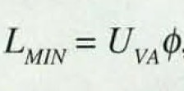

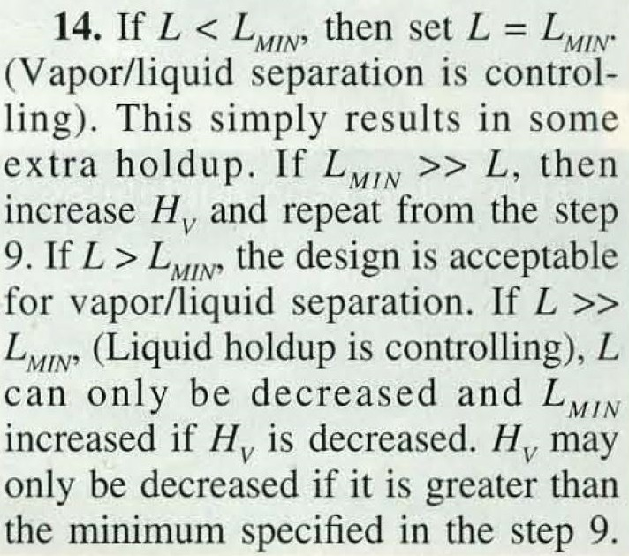

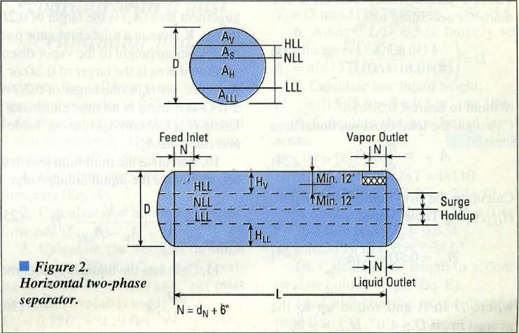

|  |  |
| --- | --- |
| **Steps** |  |
| **1** | **QV = $\frac{1956}{2.26 × 3600}$ = 0.24 m3/s** |
| **2** | **QL = $\frac{111377 }{752 × 60}$ = 2.46 m3/min** |
| **3** | **UT $=0.05 \sqrt{\frac{752-2.26 }{2.26}}$ = 0.91 m/s**  **UV = 0.91 $×0.58=0.68 m/s$** |
| **4,5** | **VH = 5 $×2.46=12.34 m3$** |
| **6** | **L/D = 3**  **D ${\text{=}(\frac{4 ×(12.34 )}{π ×0.6 ×3}\text{)}}^{\frac{1}{3}}$ = 2.05 m** |

|  |  |
| --- | --- |
| **Steps** |  |
| **7** | **AT = $\frac{ π}{4}$ $×2.05 ×2.05$ = 3.3 m2** |
| **8** | **HLLL = $0.875$ m**  **HLLL /D = 0.427 $ϴ$**  **= 2 $×$ ACOS(1-2 $×$ 0.327) = 2.83**  **ALLL/AT = (2.83-SIN(2.83))/2/ $π$ = 0.4**  **ALLL = 0.4 $×3.3=1.34 m2$** |
| **9** | **HV = $0.2×2.05=0.411$ m more than 0.3048 m**  **HV /D = 0.2 $ϴ$**  **= 2 $×$ ACOS(1-2 $×$ 0.2) = 1.85**  **AV/AT = (1.85-SIN(1.85))/2/ $π$ = 0.14**  **AV = 0.14** |

|  |  |
| --- | --- |
| **Steps** |  |
| **10** | **L = $\frac{12.34}{3.33-1.34-0.47}$ = 8.18 m** |
| **11** | $φ$**= $\frac{0.41 }{0.68}$ = 0.61** |
| **12** | **UVA = $\frac{0.24}{0.41}=0.58 m/s$** |
| **13** | **LMIN = 0.61 $×0.58=0.35$** |

Step 14: It is clear that L >> LMIN so Hv is reduced to minimum specified which is 0.3048 m

and in doing so, the vessel length reduces from 8.18 m to 7.36 m. The final results are provided

below:

|  |  |  |
| --- | --- | --- |
| **Parameter** | **Svercek** | **Licensor** |
| D | 2100 mm | 2100 mm |
| L | 7400 mm | 6500 mm |

Svercek D equals that of the licensor but in return, Svercek L is 800 mm

More than that of licensor which means both are correct.

A Question: do we really need to consider HV for vapor since we do not have actual vapor in

large amount? The licensor has accommodated a space for such purpose. In next page the

relationship between Hv and vessel Length is shown.

|  |  |
| --- | --- |
| **Hv** | **L** |
| **0.3048** | **7400** |
| **0.2** | **6800** |
| **0.1** | **6400** |
| **0.05** | **6300** |

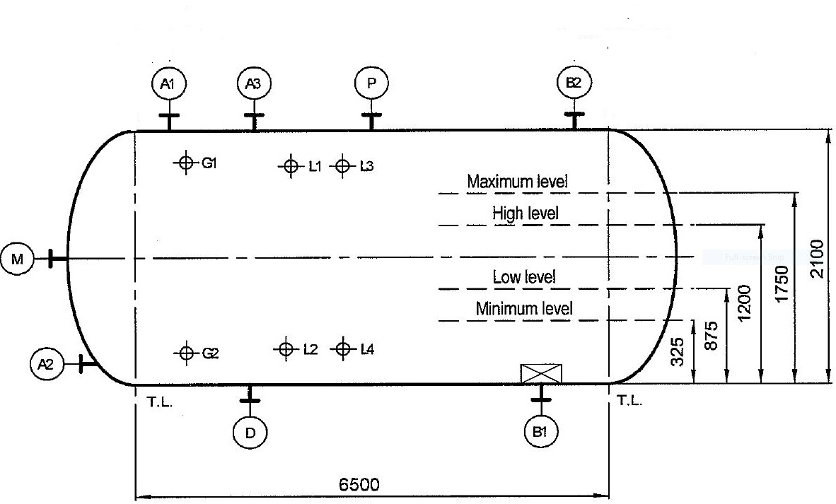

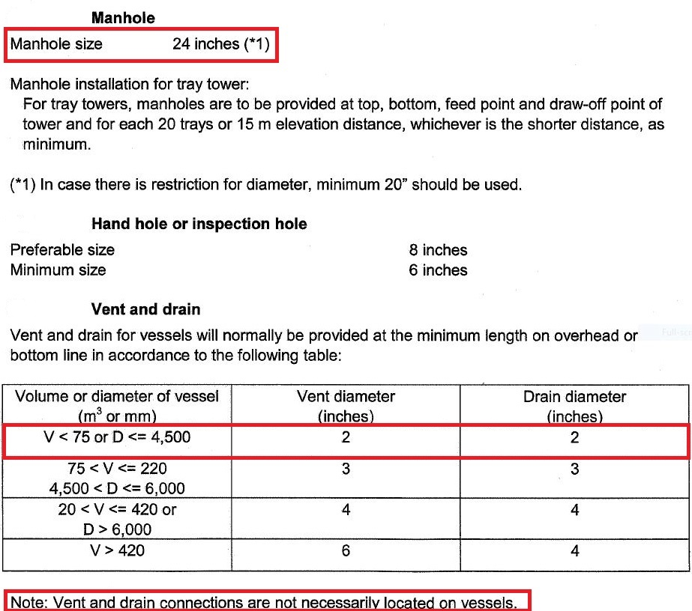Licensor Criteria

Comparison

1. The size of manhole for licensor is 24’.
2. There is no need to have Vent on this drum since there is a control valve to flare

system and if purging is required then by use of these means the task could be

performed.

1. The drain valve sized by licensor is 2’.

|  |  |
| --- | --- |
| **Parameter** | **Licensor** |
| **Manhole** | **24** |
| **Vent** | **Not required** |
| **Drain** | **2** |
| **Vortex Breaker** | **Yes** |