In -Line Separator with

Horizontal Flow Vane Pack

D-3012

Design and Principles

**Content**

1. **Description**

1. **Design Procedure**
   1. Select proper Orientation
   2. Select and Size proper Inlet Device, Inlet and Outlet ID
   3. Calculate Vessel Diameter
   4. Calculate Vessel Height
   5. Select and Size Manholes, Vent, Drain, Vortex Breaker
   6. Select a well-designed mist eliminator pad

**Description**

The objective of this vessel is to separate liquid particle from the gas. The vessel is located at

the Suction of a compressor so that maximum droplet size contained in gas stream to the

section should be max 10 micron. Efficiency of vane pack to be 98% and overall dp ≤ 50 mbar

Operating Parameters

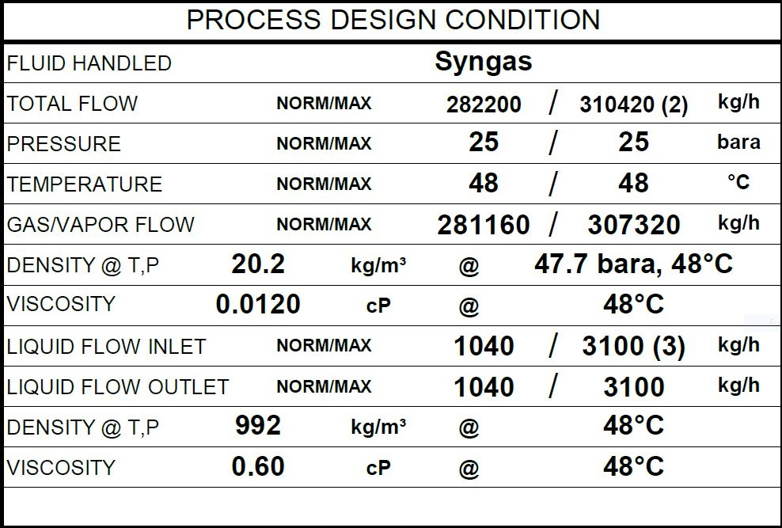

Max liquid flow rate at B.L. considered for separator design is equal to 1% of process gas flow

rate in rated condition.

**Design Procedure**

1. Select proper Orientation

2. Select and Size proper Inlet Device, Inlet and Outlet ID

3.Calculate Vessel Diameter

4. Calculate Vessel Height

5.Select and Size Manholes, Vent, Drain, Vortex Breaker

**1st Step: Select proper orientation**

Since the application is gas dominant a vertical vessel is selected.

Due to its being at the suction of a compressor, an internal eliminator should be installed.

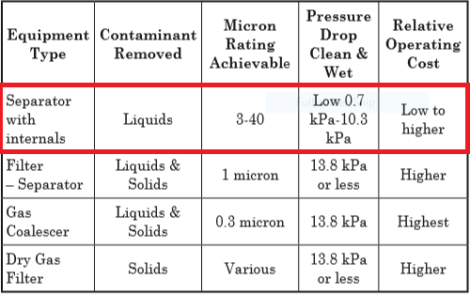

**Vertical Separator with Vane Pack**

Vertical separators with vane packs can be used instead of wire mesh for the following reasons:

fear of fouling of the wire mesh, where corrosion and life of the demisting device requires a

more robust design than mesh pads, to reduce separator size and cost compared to mesh, too

high a liquid load for mesh.

Vertical separators with vane packs have a moderate turndown ratio, are suitable for slightly

fouling service (straight or some single-pocket vanes only). The typical droplet removal

efficiency for vane styles is provided in “Vane Separator Devices”, earlier in this Chapter. Vane

separators are less efficient overall than wire mesh in most applications. Vertical separators with

vanes are best utilized below 4825 kPa (ga). Higher efficiency can be obtained at pressures

above 4825 kPa (ga) by using double pocket vanes. Vanes can tolerate higher liquid load than

mesh pads. However, they are sensitive to slugs and require adequate bulk separation

upstream, similar to mesh pads. Vane elements have a relatively low pressure drop typically

100 Pa to 1 kPa (ga)]. Vertical separators with vanes are a common alternative to mesh mist

eliminators for reciprocating compressors because of their more robust mechanical design,

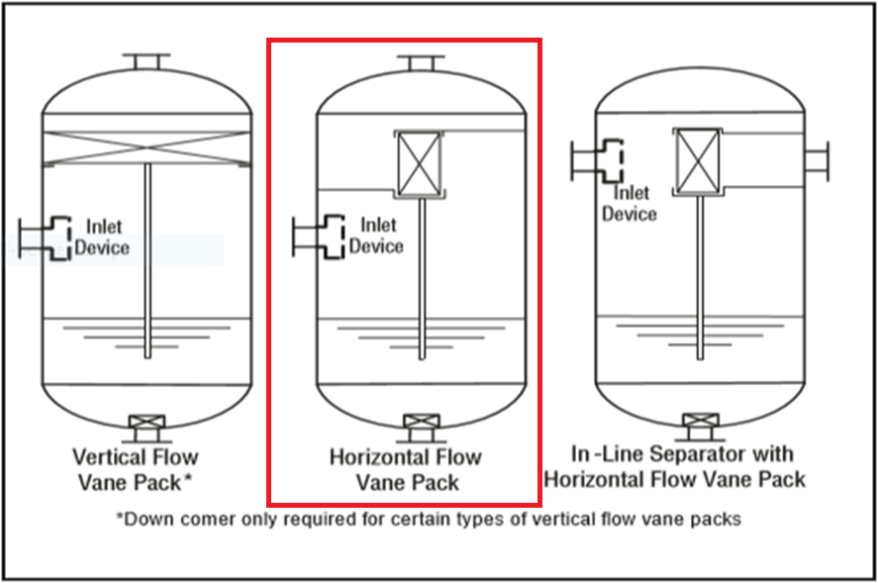which is advantageous in pulsating service.

This is the most compact vertical vessel using a vane pack. However, the design cannot

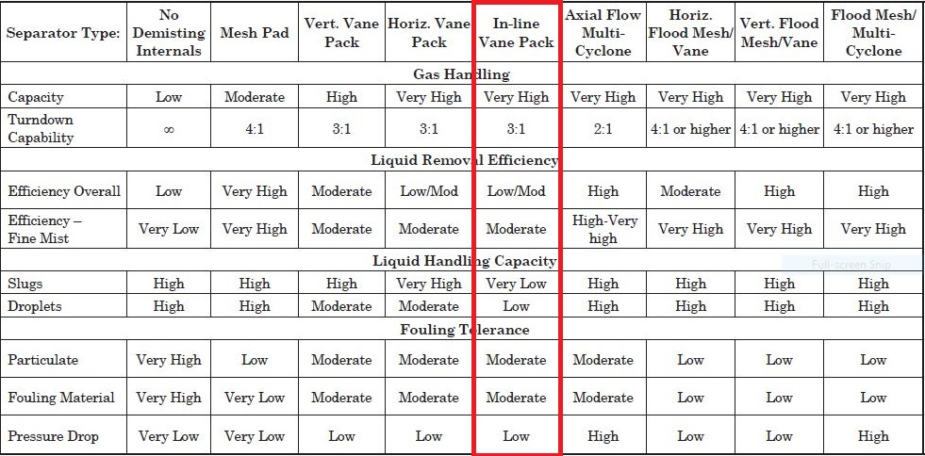handle significant liquids or Slugs during an upset.

**2nd Step: Select and Size proper Inlet Device**

Half Pipe has proven itself to be not only effective in large capacities but cost-effective as well

and in many applications is preferred to Diffuser whose performance is superior but too costly.

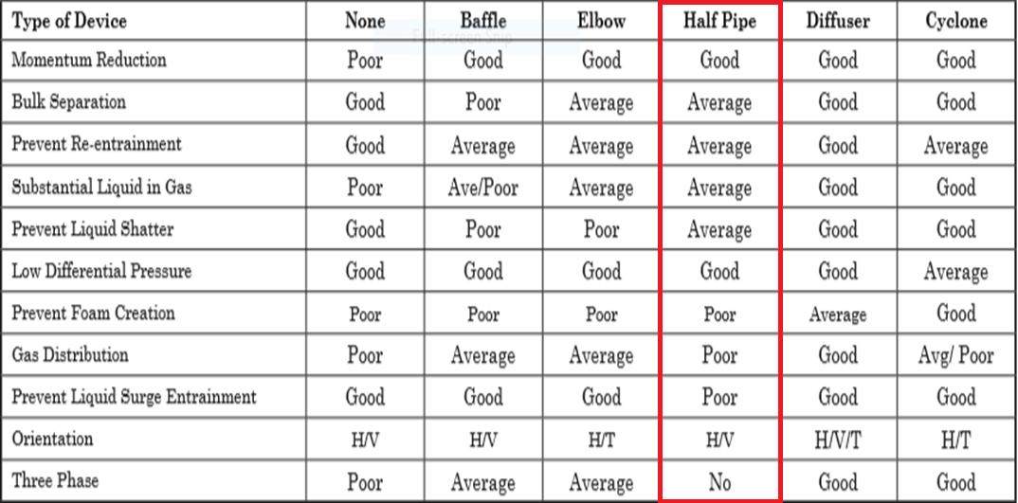

It is also necessary to maintain the inlet velocity head, J, within proper limits for the selected

inlet device to insure good gas distribution and minimum liquid shattering.

Where,

J = (ρV²)

|  |  |  |  |  |
| --- | --- | --- | --- | --- |
| **Parameter** | **Value** | **Value** | **Value** | **Unit** |
| **Estimated ID** | **26** | **28** | **30** | **inch** |
| **Nozzle Area** | **0.34** | **0.39** | **0.45** | **m2** |
| **ρmixture** | **20.39** | **20.39** | **20.39** | **kg/m3** |
| **Vmixture** | **12.34** | **10.64** | **9.26** | **m/s** |
| **J** | **3106** | **2309** | **1752** | **kg/m. s2** |
| **Criterion** | **2250** | **2250** | **2250** | **kg/m. s2** |

The maximum mixed phase velocity head range used in the industry guidelines varies for the

different inlet devices. Some typical maximums are:

•6000-9000 max. typ, up to 15 000 max kg/m s2 for diffuser distributor

•975-2250 max kg/m. s2 for no inlet distributor

•1500-3750 max kg/m. s2 for inlet half pipe or elbow distributor

•1500-3750 max kg/m. s2 for v-baffle or other simple inlet diverter designs

In addition, some users limit the inlet vapor phase velocity to 9 m/s or 18 m/s. The velocity

should always be below the erosion velocity for the service.

In order to calculate head velocity, at first, we need to perform the followings:

1. Estimation of inlet nozzle ID; Consider inlet pipe ID near the vessel as first and best

estimation.

2. Calculate ρmixture and subsequently Vmixture

3. Calculate J by multiplying ρmixture (Vmixture)^2 and compare it with the last-page criterion.

So, the inlet device sizing should at least be 28 inch to meet the momentum requirement but the

vendor has chosen to reduce the momentum to help the separation and taken recommended

practice that inlet piping diameter match the velocity requirement of the inlet to the separator 10

pipe diameters upstream of the separator to provide a flow regime which is fully developed

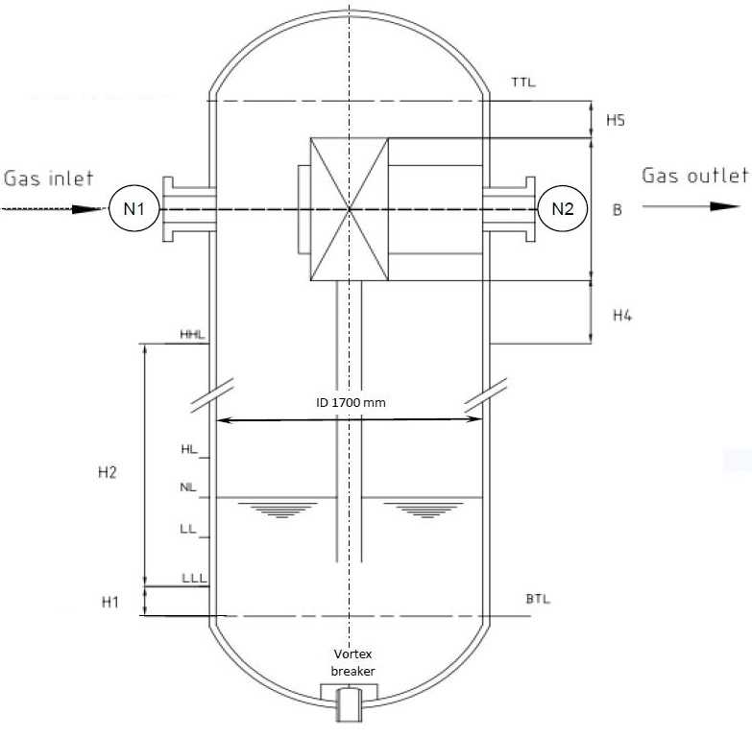before entering the separator. Thus 30 inch has been selected by vendor.

**Vapor Outlet Section**

The sizing of the vapor outlet nozzle should be such that given the above placement of the

mesh pad, the velocity is not high enough to cause channeling of the gas through the mesh

pad. The nozzle outlet size is typically based on the lesser of that required for piping pressure

drop, or a maximum velocity head criterion. Typical ranges for the maximum velocity head

allowed for the vapor outlet are 4500–5400 kg/m • s2. In addition, some users limit the

absolute velocity to 18 m/s. The pipe size can be decreased to the appropriate size based on

pressure drop considerations, 5-10 pipe diameters downstream of the separator, as required.

30 inch is selected.

|  |  |  |  |  |
| --- | --- | --- | --- | --- |
| **Parameter** | **Value** | **Value** | **Value** | **Unit** |
| Estimated ID | 22 | 26 | 30 | inch |
| Area | 0.24 | 0.34 | 0.45 | m2 |
| Vg | 17.23 | 12.33 | 9.26 | m/s |
| ρVg2 | 5998 | 3074 | 1734 | Kg/m. s2 |
| Criterion | 4500 | 4500 | 4500 | Kg/m. s2 |

|  |  |  |  |  |
| --- | --- | --- | --- | --- |
| **Parameter** | **Value** | **Value** | **Value** | **Unit** |
| **Estimated ID** | **2** | **3** | **4** | **inch** |
| **Area** | **0.002** | **0.004** | **0.008** | **m2** |
| **Vl** | **0.42** | **0.19** | **0.1** | **m/s** |
| **Criterion** | **Max 0.9** | **Max 1.2** | **Max 1.2** | **m/s** |

**Liquid Outlet Nozzle**

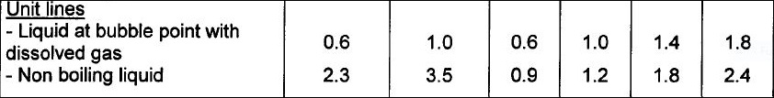Many users limit the liquid outlet nozzle velocity based on unit line criteria.



Surprisingly 3’ is selected

**3rd Step: Calculate Vessel Diameter**

Each and every licensor and company has developed a design basis procedure for sizing

vessels. In this article, a GPSA-based method, Foster-Wheeler-based method and the

Licensor method will be explored.

**GPSA**

1. Use the following equation and next-page K-values to calculate terminal velocity

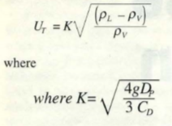

De-rating factor to K-value for pressure

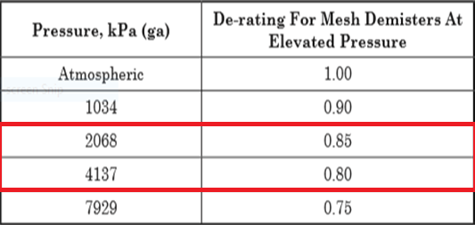

Typical Saunders Brown K values for mist eliminator devices

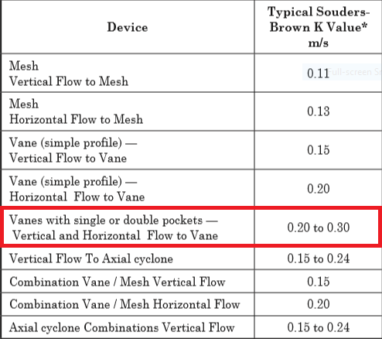

According to Saunders-Brown K-value , thanks to the fact that a vertical vessel with demister

pad has been chosen, a K value of 0.2 is selected. Furthermore, since the performance of

demister pad varies according to operating pressure, the selected K should be de-rated in

accord with last-page Table.

K de-rated = 0.2 $×0.80=0.16$

|  |  |  |
| --- | --- | --- |
| **Parameter** | **Value** | **Unit** |
| **ρl** | **992** | **kg/m3** |
| **ρv** | **20.2** | **kg/m3** |
| **K selected** | **0.16** |  |
| **Ug** | **1.1** | **m/s** |
| **Qg** | **4.22** | **m3/s** |
| **ID** | **2202** | **mm** |
| **Required-ID** | **2200** | **mm** |
| **Selected-ID** | **2200** | **mm** |

**Notes**

For ID calculation, the following equation has been utilized.

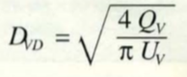

The vessel has been sized based on rated capacity and the resulting vessel diameter is 2200

mm. In comparison to vessel sizing based on normal capacity, the resulting vessel diameter is

2100 mm. The vendor has selected 1700 mm as vessel diameter which is due to in-line packed

vane.

**Foster-Wheeler**

The basis of sizing is the critical velocity Vc (m/s)

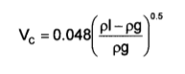

The maximum gas velocity is K $×$ Vc

K is a coefficient depending on the service, and the use or the absence of wire mesh.

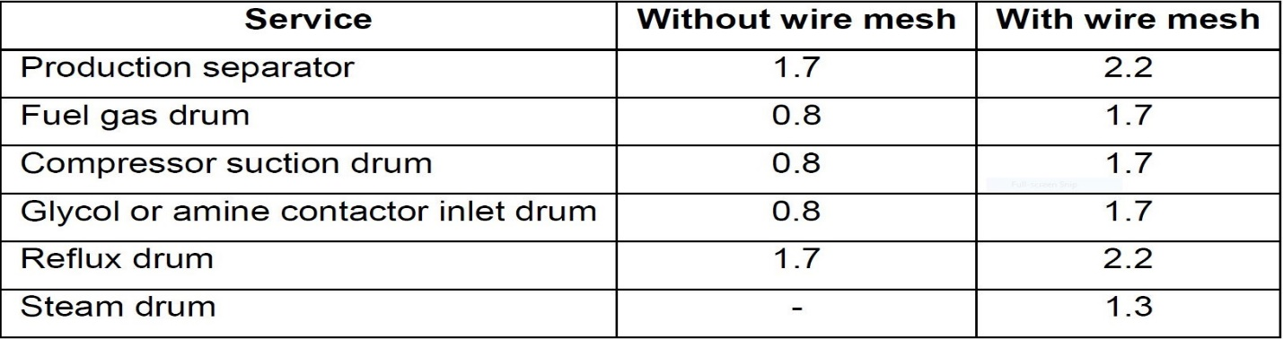Recommended K values are given hereafter for different services.

If a vane pack internal is used, the recommended K value is 3.3.

|  |  |  |
| --- | --- | --- |
| **Parameter** | **Value** | **Unit** |
| **ρl** | **992** | **kg/m3** |
| **ρv** | **20.2** | **kg/m3** |
| **K selected** | **3.3** |  |
| **Vc** | **0.33** | **m/s** |
| **Vmax** | **1.09** |  |
| **Qg** | **4.22** | **m3/s** |
| **ID** | **2215** | **mm** |
| **Required-ID** | **2215** | **mm** |
| **Selected-ID** | **2200** | **mm** |

**4th Step: Height Calculation**

Each and every licensor and company has developed a design basis procedure for sizing

vessels. In this article, a GPSA-based method, Foster-Wheeler-based method and the Licensor

method will be explored.

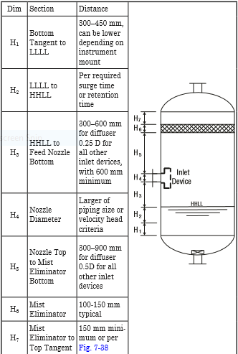GPSA

Retention/Surge Time

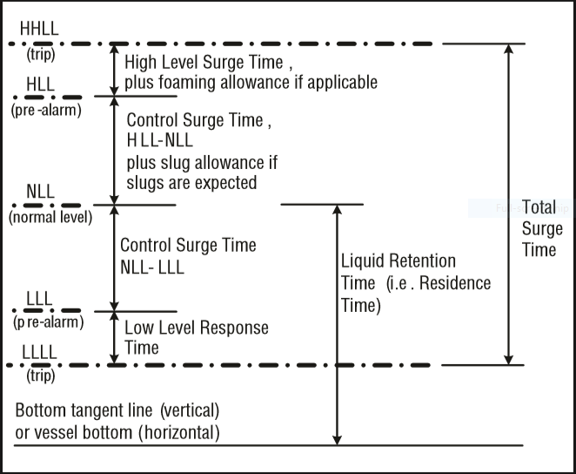

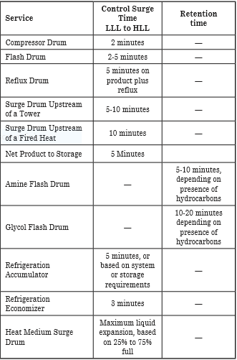



|  |  |  |  |
| --- | --- | --- | --- |
| **Height Elements** | **GPSA** | **Vendor** | **Unit** |
| H1 | 450 | 150 | mm |
| H2 | 150 | 650 | mm |
| H4 | 550 | 500 | mm |
| B | 2400* | 2400 | mm |
| H5 | 150 | 100 | mm |
|  |  |  | mm |
|  |  |  | mm |
| HT | 3725 | 3800 | mm |

**Calculation, Explanation, and Discussion**

H1 mostly depends on instrument mount position and the number of instrument devices used .

The Licensor for most of his vertical vessel has selected 500 mm in accord with his FCS and

ESD Control System, whereas in GPSA 450 mm is selected as the basis.

H2 is a function of retention time. Likewise, in GPSA a retention time of 2-5 minutes has been

selected for Flash drums.

H3 in GPSA for Half Open pipes is 0.25D and has been the basis for calculation.

H4 is the size of inlet Half Open pipe which is the same size of upstream pipe for both vendor

and GPSA.

H5 in GPSA for Half Open pipes is 0. 5D and has been the basis for calculation.

H6 is the Vane pack length, which is based on vendor data and varies vendor by vendor.

H7 in GPSA is minimum 150 mm but in other sketch in GPSA there is a formula for X4 which

connects the upper part of demister pad to outlet nozzle which cannot be used for comparison

here.

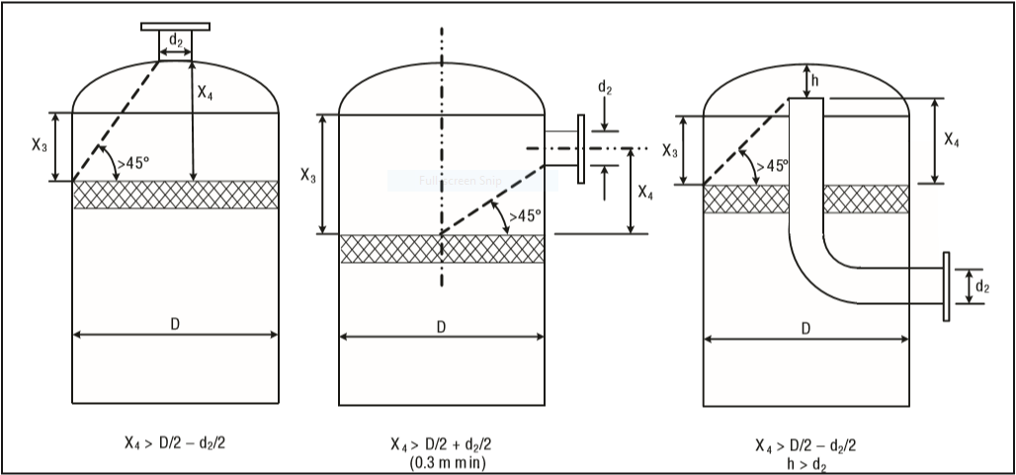

**Manholes, Drain and Vents**

**Foster-Wheeler**

Size of manholes

For vessel diameter < 1000 mm

Flanged vessel shall be considered if equipment contains internals

Otherwise, size of manholes = 18”

For vessel diameter ≥ 1000 mm

Toxic service size of manholes = 24”

Non-toxic service size of manholes = 20”

(Or up to 24” if internals need to be removable through

manhole.)

The drain of the vessel shall always be at the lowest point of a vessel. For vertical vessels they

shall be connected to the bottom outlet line at the low point. For horizontal vessels the drain

point shall be directly on the bottom of the drum at the lowest point ensured through vessel

slope (1:100).

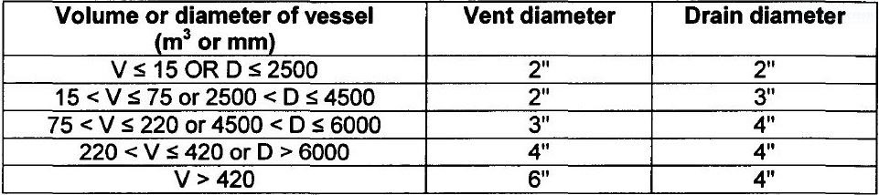

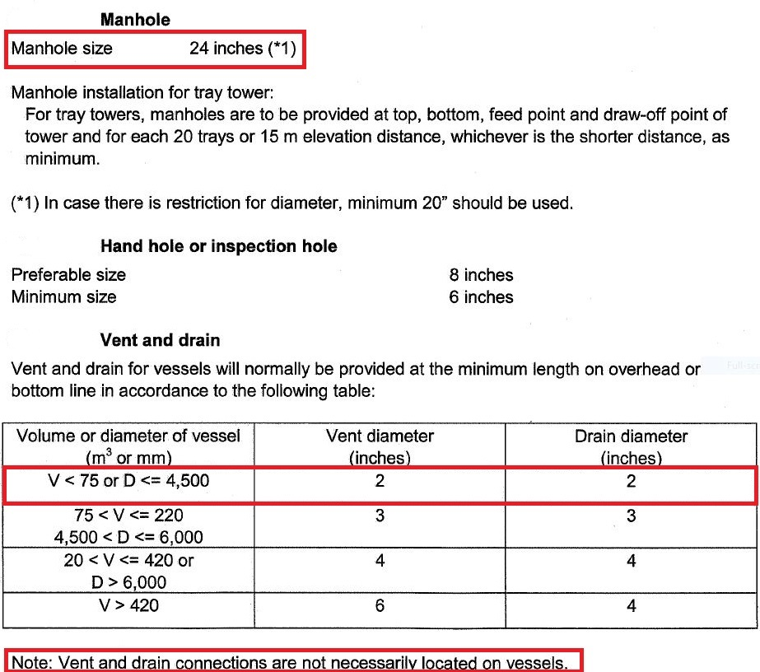Licensor Criteria

**Comparison**

The size of manhole for both Vendor and FW is 24’.

In site both vent and drain size are set to 3’

The Inspection handhole is sized to 8’ in site.

Vent sizing in site is 2’.

|  |  |  |
| --- | --- | --- |
| **Parameter** | **FW** | **Vendor** |
| **Manhole** | **20-24** | **24** |
| **Vent** | **2** | **2** |
| **Drain** | **2** | **2** |
| **Vortex Breaker** | **Yes** | **Yes** |
| **Inspection** |  | **8** |