Horizontal Vessel

Without Mist Eliminator

D-3002

Design and Principles

**Content**

1. **Description**

1. **Design Procedure**
   1. Select proper Orientation
   2. Select and Size proper Inlet Device, Inlet and Outlet ID
   3. Calculate Vessel Diameter
   4. Calculate Vessel Height
   5. Select and Size Manholes, Vent, Drain, Vortex Breaker
   6. Select a well-designed mist eliminator pad

**Description**

The objective of this vessel is to accumulate raw methanol produced and at the same time

create the space/area for dissolved gas to be separated.

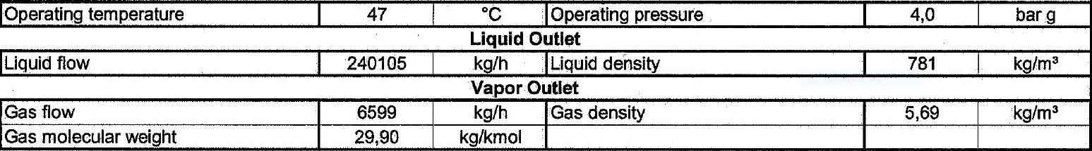Operating Parameters

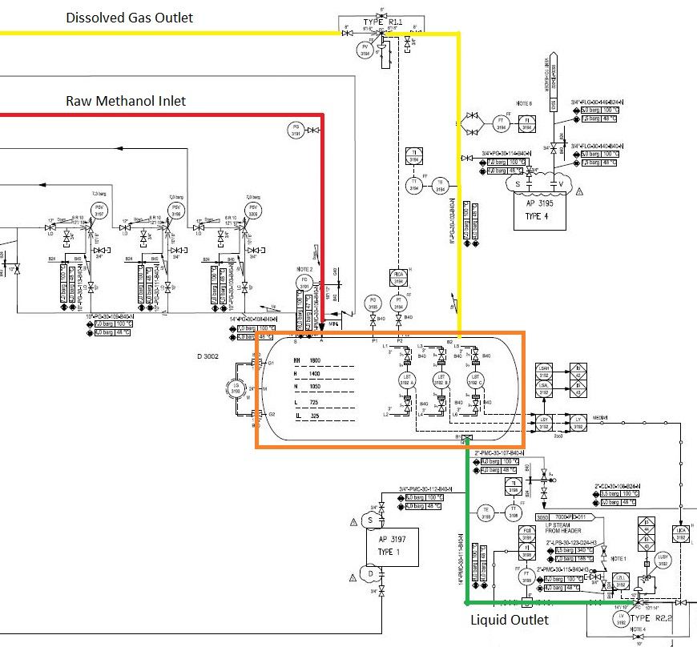

**Design Procedure**

1. Select proper Orientation

2. Select and Size proper Inlet Device, Inlet and Outlet ID

3.Calculate Vessel Diameter

4. Calculate Vessel Height

5.Select and Size Manholes, Vent, Drain, Vortex Breaker

**1st Step: Select proper orientation**

Since the application is liquid dominant, a horizontal vessel is selected since it provides more

surface area or spacing for dissolved gas to separate.

Horizontal separators-without internals provide bulk separation of gas and liquid. The design is

typically used for Liquid surge applications where the vapor flow is very low, for fouling services,

or where internals are not desirable. The equipment has unlimited turndown, low pressure drop,

can handle slugs and high liquid fractions, and is insensitive to fouling. The separation efficiency

is dependent on the inlet droplet size distribution and Stokes’ Law settling, based on the

diameter, length, and liquid levels in the separator

**2nd Step: Select and Size proper Inlet Device**

It is also necessary to maintain the inlet velocity head, J, within proper limits for the selected

inlet device to insure good gas distribution and minimum liquid shattering.

Where, J = (ρV²)

The maximum mixed phase velocity head range used in the industry guidelines varies for the

different inlet devices. Some typical maximums are:

•6000-9000 max. typ, up to 15 000 max kg/m s2 for diffuser distributor

•975-2250 max kg/m. s2 for no inlet distributor

•1500-3750 max kg/m. s2 for inlet half pipe or elbow distributor

•1500-3750 max kg/m. s2 for v-baffle or other simple inlet diverter designs

In addition, some users limit the inlet vapor phase velocity to 9 m/s or 18 m/s. The velocity

should always be below the erosion velocity for the service.

In order to calculate head velocity, at first, we need to perform the followings:

1. Estimation of inlet nozzle ID; Consider inlet pipe ID near the vessel as first and best

estimation.

2. Calculate ρmixture and subsequently Vmixture

3. Calculate J by multiplying ρmixture (Vmixture)^2 and compare it with the last-page criterion.

|  |  |  |  |  |
| --- | --- | --- | --- | --- |
| **Parameter** | **Value** | **Value** | **Value** | **Unit** |
| **Estimated ID** | **14** | **16** | **18** | **inch** |
| **Nozzle Area** | **0.1** | **0.13** | **0.16** | **m2** |
| **ρmixture** | **168** | **168** | **168** | **kg/m3** |
| **Vmixture** | **4.1** | **3.14** | **2.48** | **m/s** |
| **J** | **2831** | **1659** | **1036** | **kg/m. s2** |
| **Criterion** | **2250** | **2250** | **2250** | **kg/m. s2** |

So, the minimum sizing should at least be 16 inch to meet the requirement. The licensor has

chosen 18 inch to not only better control its momentum and as a result help the bulk

separation but also be more conservative and on the safe side.

**Vapor Outlet Section**

The sizing of the vapor outlet nozzle should be such that given the above placement of the

mesh pad, the velocity is not high enough to cause channeling of the gas through the mesh

pad. The nozzle outlet size is typically based on the lesser of that required for piping pressure

drop, or a maximum velocity head criterion. Typical ranges for the maximum velocity head

allowed for the vapor outlet are 4500–5400 kg/m • s2. In addition, some users limit the

absolute velocity to 18 m/s. The pipe size can be decreased to the appropriate size based on

pressure drop considerations, 5-10 pipe diameters downstream of the separator, as required.

|  |  |  |  |  |
| --- | --- | --- | --- | --- |
| **Parameter** | **Value** | **Value** | **Value** | **Unit** |
| **Estimated ID** | **8** | **6** | **4** | **inch** |
| **Area** | **0.032** | **0.018** | **0.008** | **m2** |
| **Vg** | **9.93** | **17.66** | **39.73** | **m/s** |
| **ρVg2** | **561** | **1774** | **8984** | **Kg/m. s2** |
| **Criterion** | **4500** | **4500** | **4500** | **Kg/m. s2** |

**Liquid Outlet Nozzle**

Since it is going to be discharged to another vessel, the maximum velocity should be 3 m/s and

the average velocity should be 2 m/s.

|  |  |  |  |  |
| --- | --- | --- | --- | --- |
| **Parameter** | **Value** | **Value** | **Value** | **Unit** |
| **Estimated ID** | **8** | **12** | **14** | **inch** |
| **Area** | **0.032** | **0.07** | **0.099** | **m2** |
| **Vl** | **2.63** | **1.17** | **0.85** | **m/s** |
| **Criterion** | **Max 3** | **Max 3** | **Max 3** | **m/s** |

The minimum sizing is 8 and 10, 12 and 14 are all acceptable but the licensor has selected 14

inch. The Licensor could have selected 12 inch but since there is a Coriolis flowmeter

downstream the drum the Licensor has selected 14 to control the velocity.

**3rd Step: Calculate Vessel Diameter**

Each and every licensor and company has developed a design basis procedure for sizing

vessels. In this article, a Svercek-method and the Licensor method will be explored.

**Svercek**

1. Calculate the vapor volumetric flow rate, QV in m3/s

2. Calculate the liquid volumetric flow rate, QL in m3/min

3. Calculate the vertical terminal vapor velocity, UT and set UV = 0.75 UT

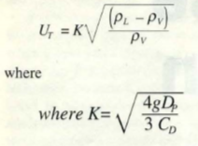

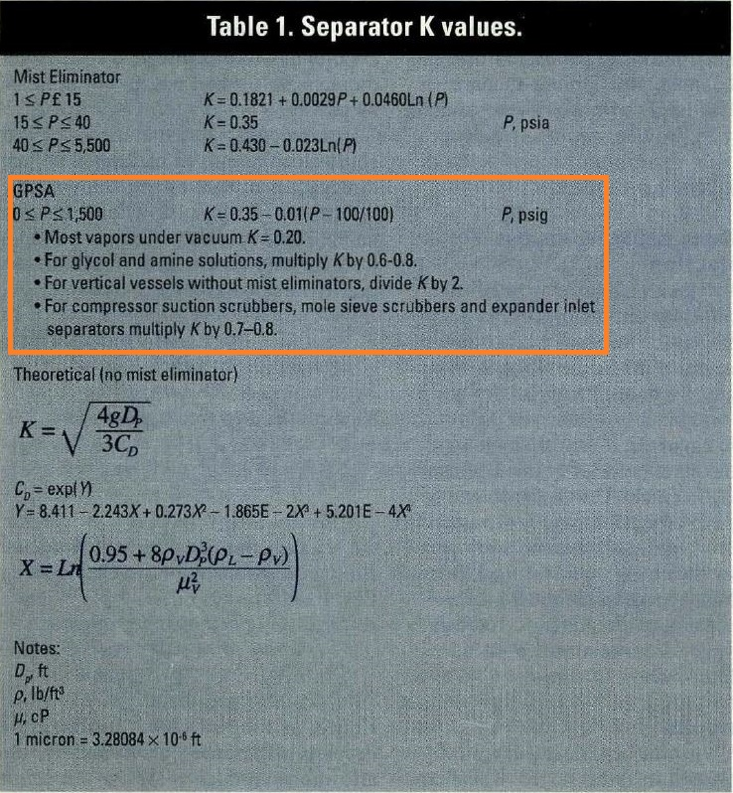

4. Select a hold-up time from next-page Table and calculate the hold-up volume, VH

5. Select a surge time from next-page Table and calculate the surge volume, VS

6. Estimate a L/D and initially calculate the diameter according to the following Equation:

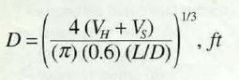

7. Calculate the total cross-sectional area.

8. Set HLLL and by using HLLL/D obtain ALLL/AT and calculate ALLL

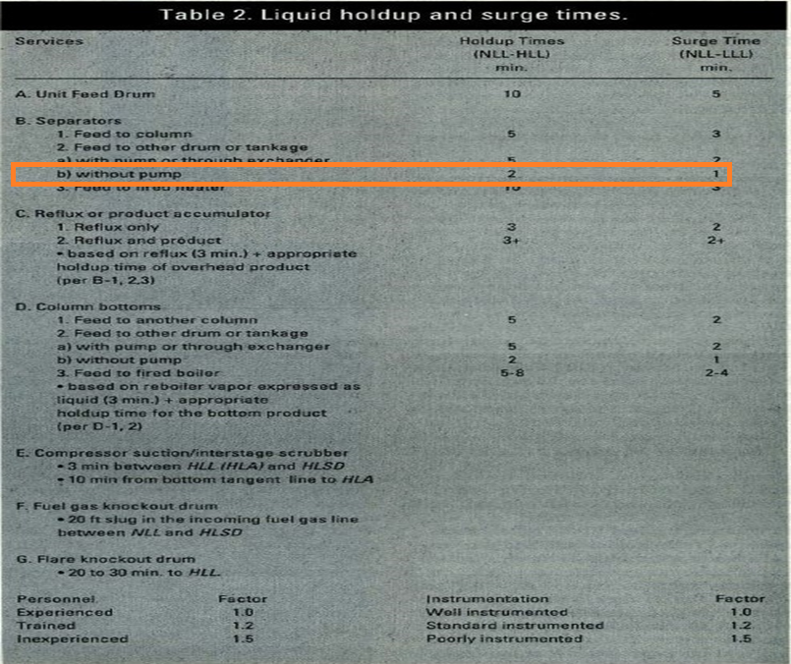

9. Set HV to 0.2D or 0.3048 m, whichever is greater; then by using HV/D, obtain AV/AT

10. Calculate the minimum length to accommodate the liquid hold-up/surge:

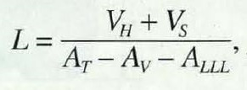

11. Calculate the liquid dropout time

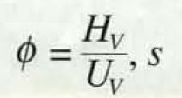

12. Calculate the actual vapor velocity

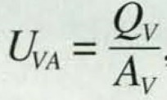

13. Calculate the minimum Length required for vapor-liquid disengagement, LMIN:

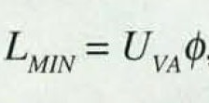

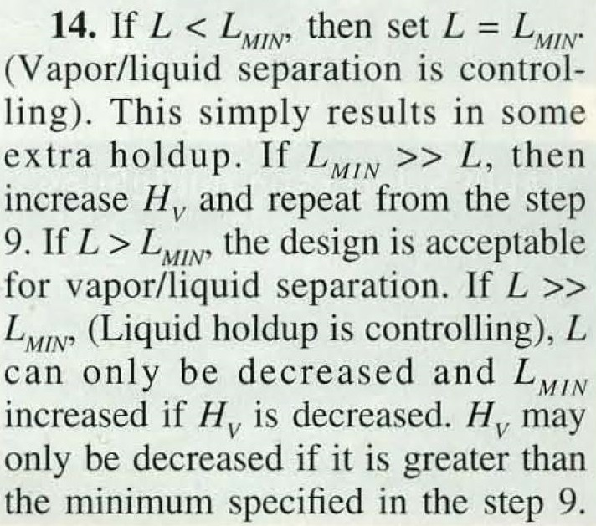

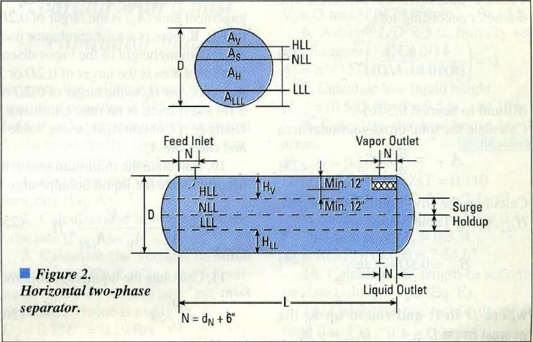

|  |  |
| --- | --- |
| **Steps** |  |
| **1** | **QV = = 0.322 m3/s** |
| **2** | **QL = = 5.12 m3/min** |
| **3** | **UT = 0.58 m/s**  **UV = 0.75 $×0.58=0.43 m/s$** |
| **4,5** | **VH = 2 $×5.12=10.24 m3$**  **VS = 1 $×5.12=5.12 m3$** |
| **6** | **L/D = 3**  **D ${\text{=}(\frac{4 ×(10.24+5.12 )}{π ×0.6 ×3}\text{)}}^{\frac{1}{3}}$ = 2.21 m** |

|  |  |
| --- | --- |
| **Steps** |  |
| **7** | **AT = = 3.85 m2** |
| **8** | **HLLL = m**  **HLLL /D = 0.327 $ϴ$**  **= 2 $×$ ACOS (1-2 $×$ 0.327) = 2.43**  **ALLL/AT = (2.43-SIN(2.43))/2/ $π$ = 0.284**  **ALLL = 0.28 $×3.85=1.09 m2$** |
| **9** | **HV = m more than 0.3048 m**  **HV /D = 0.2 $ϴ$**  **= 2 $×$ ACOS(1-2 $×$ 0.2) = 1.85**  **AV/AT = (1.85-SIN(1.85))/2/ $π$ = 0.14**  **AV = 0.14** |

|  |  |
| --- | --- |
| **10** | **L = $\frac{10.24+5.12}{3.85-1.09-0.54}$ = 6.95 m** |
| **11** | $φ$**= $\frac{0.44 }{0.43}$ = 1.01** |
| **12** | **UVA =** |
| **13** | **LMIN = 1.01 $×0.58=0.59$** |

Step 14: It is clear that L >> LMIN so Hv is reduced to minimum specified which is 0.3048 m

and in doing so, the vessel length reduces from 6.95 m to 6.3 m. The final results are

provided below:

|  |  |  |
| --- | --- | --- |
| **Parameter** | **Svercek** | **Licensor** |
| **D** | **2215 mm** | **2125 mm** |
| **L** | **6300 mm** | **6450 mm** |

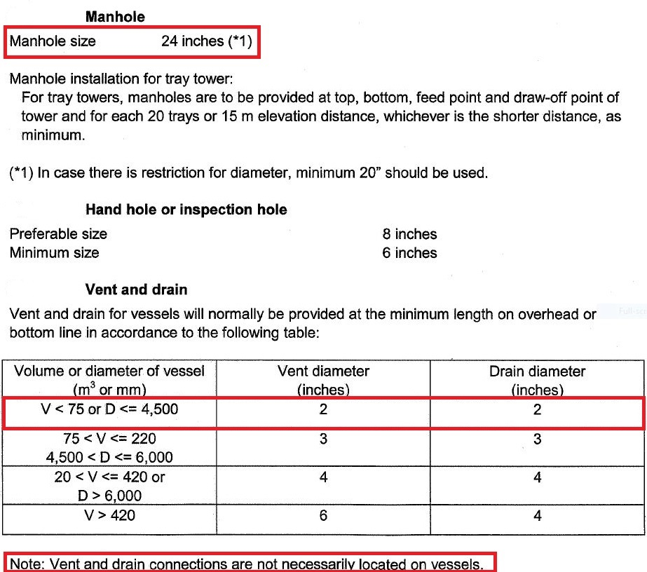Licensor Criteria

Comparison

The size of manhole for licensor is 24’.

There is no need to have Vent on this drum since there is a control valve to flare system

and if purging is required then by use of these means the task could be performed.

The drain valve sized by licensor is 2’.

|  |  |
| --- | --- |
| **Parameter** | **Licensor** |
| **Manhole** | **24** |
| **Vent** | **Not required** |
| **Drain** | **2** |
| **Vortex Breaker** | **Yes** |