Vertical Vessel

With Mesh Mist Eliminator

D-2005

Design and Principles

**Content**

1. **Description**

1. **Design Procedure**
   1. Select proper Orientation
   2. Select and Size proper Inlet Device, Inlet and Outlet ID
   3. Calculate Vessel Diameter
   4. Calculate Vessel Height
   5. Select and Size Manholes, Vent, Drain, Vortex Breaker
   6. Select a well-designed mist eliminator pad

**Description**

The objective of this vessel is to separate liquid particle from the gas. The vessel is located at

the suction of a centrifugal compressor so that maximum droplet size contained in gas stream

to compressor should be max 10 micron.

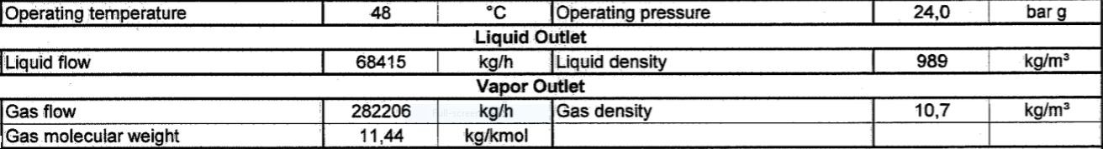Operating Parameters

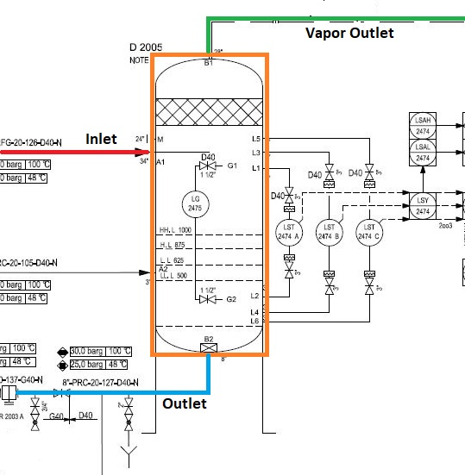

**Design Procedure**

1. Select proper Orientation

2. Select and Size proper Inlet Device, Inlet and Outlet ID

3.Calculate Vessel Diameter

4. Calculate Vessel Height

5.Select and Size Manholes, Vent, Drain, Vortex Breaker

6. Select a well-designed mist eliminator pad

**1st Step: Select proper orientation**

Since the application is gas dominant a vertical vessel is selected.

Due to its being at the suction of the compressor, a mesh mist eliminator should be installed

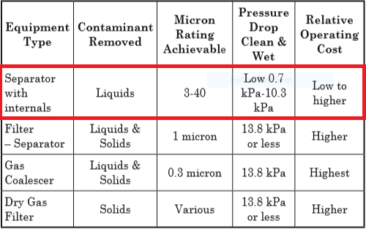

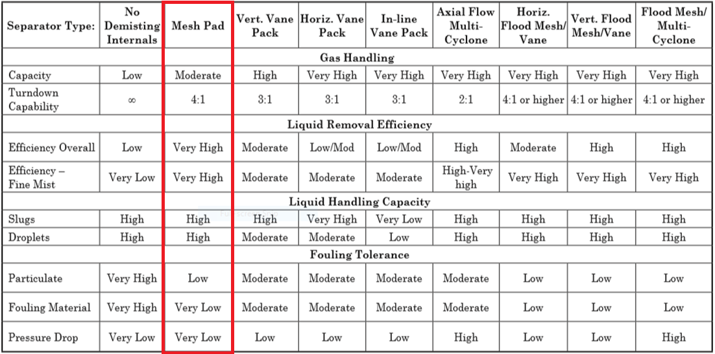

**2nd Step: Select and Size proper Inlet Device**

Half Pipe has proven itself to be not only effective in large capacities but cost-effective as well

and in many applications is preferred to Diffuser whose performance is superior but too costly.

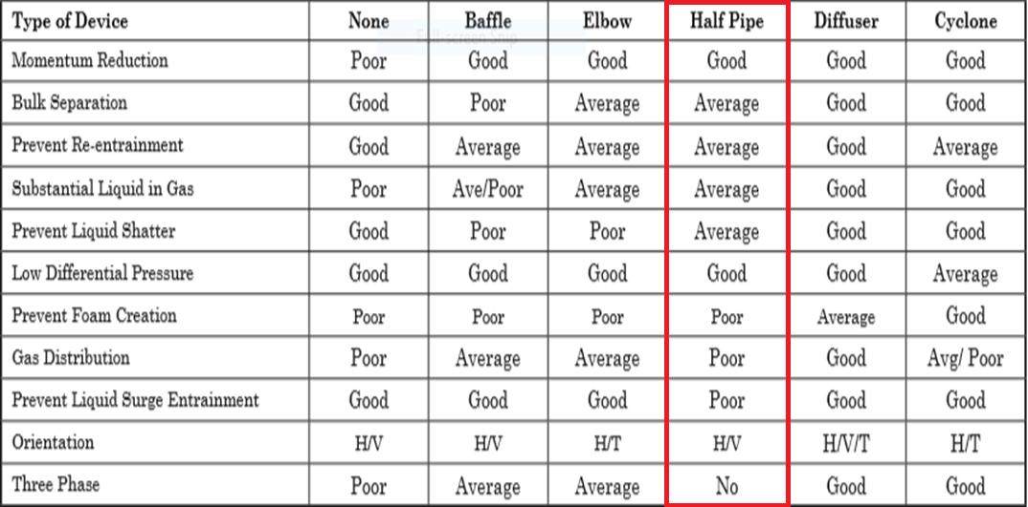

It is also necessary to maintain the inlet velocity head, J, within proper limits for the selected

inlet device to insure good gas distribution and minimum liquid shattering.

Where,

J = (ρV²)

The maximum mixed phase velocity head range used in the industry guidelines varies for the

different inlet devices. Some typical maximums are:

•6000-9000 max. typ, up to 15 000 max kg/m s2 for diffuser distributor

•975-2250 max kg/m. s2 for no inlet distributor

•1500-3750 max kg/m. s2 for inlet half pipe or elbow distributor

•1500-3750 max kg/m. s2 for v-baffle or other simple inlet diverter designs

In addition, some users limit the inlet vapor phase velocity to 9 m/s or 18 m/s. The velocity

should always be below the erosion velocity for the service.

In order to calculate head velocity, at first, we need to perform the followings:

1. Estimation of inlet nozzle ID; Consider inlet pipe ID near the vessel as first and best

estimation.

2. Calculate ρmixture and subsequently Vmixture

3. Calculate J by multiplying ρmixture (Vmixture)^2 and compare it with the last-page criterion.

|  |  |  |  |
| --- | --- | --- | --- |
| **Parameter** | **Value** | **Value** | **Unit** |
| **Estimated ID** | **34** | **30** | **inch** |
| **Nozzle Area** | **0.58** | **0.45** | **m2** |
| **ρmixture** | **13.25** | **13.25** | **kg/m3** |
| **Vmixture** | **12.5** | **16.1** | **m/s** |
| **J** | **2085** | **3439** | **kg/m. s2** |
| **Criterion** | **3750** | **3750** | **kg/m. s2** |

So, both 30 and 34 inches are accepted but it is recommended that inlet piping diameter

match the velocity requirement of the inlet to the separator 10 pipe diameters upstream of the

separator to provide a flow regime which is fully developed before entering the separator.

Thus, 34 inch is accepted.

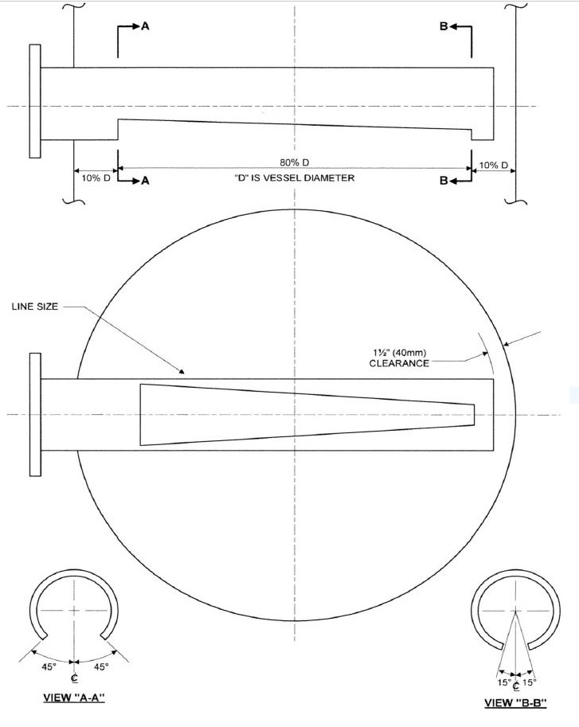

**Vapor Outlet Section**

The sizing of the vapor outlet nozzle should be such that given the above placement of the

mesh pad, the velocity is not high enough to cause channeling of the gas through the mesh

pad. The nozzle outlet size is typically based on the lesser of that required for piping pressure

drop, or a maximum velocity head criterion. Typical ranges for the maximum velocity head

allowed for the vapor outlet are 4500–5400 kg/m • s2. In addition, some users limit the

absolute velocity to 18 m/s. The pipe size can be decreased to the appropriate size based on

pressure drop considerations, 5-10 pipe diameters downstream of the separator, as required.

|  |  |  |
| --- | --- | --- |
| **Parameter** | **Value** | **Unit** |
| **Estimated ID** | **28** | **inch** |
| **Area** | **0.39** | **m2** |
| **Vg** | **18.44** | **m/s** |
| **ρVg2** | **3639** | **Kg/m. s2** |
| **Criterion** | **4500** | **Kg/m. s2** |

Liquid Outlet Nozzle

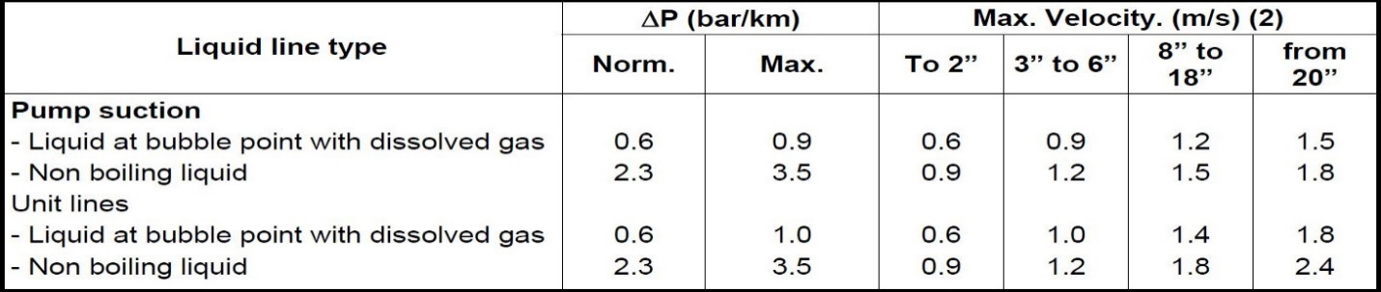Many users limit the liquid outlet nozzle velocity based on pump suction line criteria

|  |  |  |  |
| --- | --- | --- | --- |
| **Parameter** | **Value** | **Value** | **Unit** |
| **Estimated ID** | **6** | **8** | **inch** |
| **Area** | **0.018** | **0.032** | **m2** |
| **Vl** | **1.05** | **0.59** | **m/s** |
| **Criterion** | **Max 1.5** | **Max 1.5** | **m/s** |

**3rd Step: Calculate Vessel Diameter**

Each and every licensor and company has developed a design basis procedure for sizing

vessels. In this article, a GPSA-based method, Foster-Wheeler-based method and the

Licensor method will be explored.

**GPSA**

1. Use the following equation and next-page K-values to calculate terminal velocity

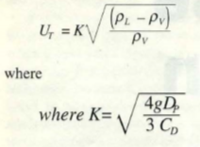

De-rating factor to K-value for pressure

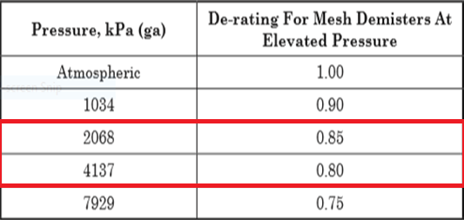

Typical Saunders Brown K values for mist eliminator devices

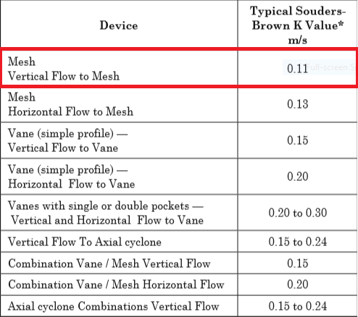

According to Saunders-Brown K-value, thanks to the fact that a vertical vessel with demister

pad has been chosen, a K value of 0.11 is selected. Furthermore, since the performance of

demister pad varies According to operating pressure, the selected K should be de-rated in

accord with last-page Table.

Kde-rated = 0.11 $×0.83=0.09$

|  |  |  |
| --- | --- | --- |
| **Parameter** | **Value** | **Unit** |
| **ρl** | **989** | **kg/m3** |
| **ρv** | **10.7** | **kg/m3** |
| **Kselected** | **0.09** |  |
| **Ug** | **0.86** | **m/s** |
| **Qg** | **7.32** | **m3/s** |
| **ID** | **3293** | **mm** |
| **Required-ID** | **3443** | **mm** |
| **Selected-ID** | **3500** | **mm** |

Notes

For ID calculation, the following equation has been utilized.

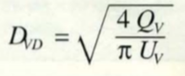

Also since the demister pad is mounted on a support ring , then 150 mm or 6 inch is added to

calculated ID, which results in 3293 + 150 = 3443 mm, which is regarded as the required ID.

The selected ID would be rounded to 3500 mm.

The selected ID is in complete harmony with the Licensor selected ID, which is 3500 mm.

**Foster-Wheeler**

The basis of sizing is the critical velocity Vc (m/s)

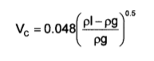

The maximum gas velocity is K $×$ Vc

K is a coefficient depending on the service, and the use or the absence of wire mesh.

Recommended K values are given hereafter for different services.

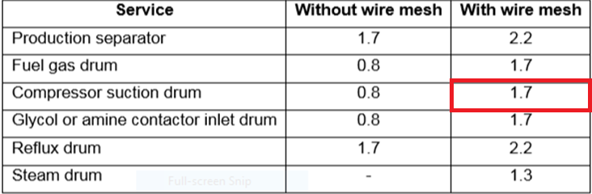

If a vane pack internal is used, the recommended K value is 3.3.

|  |  |  |
| --- | --- | --- |
| **Parameter** | **Value** | **Unit** |
| **ρl** | **989** | **kg/m3** |
| **ρv** | **10.7** | **kg/m3** |
| **Kselected** | **1.7** |  |
| **Vc** | **0.45** | **m/s** |
| **Vmax** | **0.78** |  |
| **Qg** | **7.32** | **m3/s** |
| **ID** | **3450** | **mm** |
| **Required-ID** | **3600** | **mm** |
| **Selected-ID** | **3600** | **mm** |

**4th Step: Height Calculation**

Each and every licensor and company has developed a design basis procedure for sizing

vessels. In this article, a GPSA-based method, Foster-Wheeler-based method and the Licensor

method will be explored.

GPSA

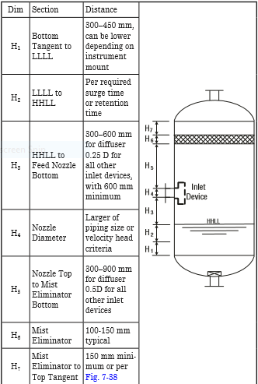

Retention/Surge Time

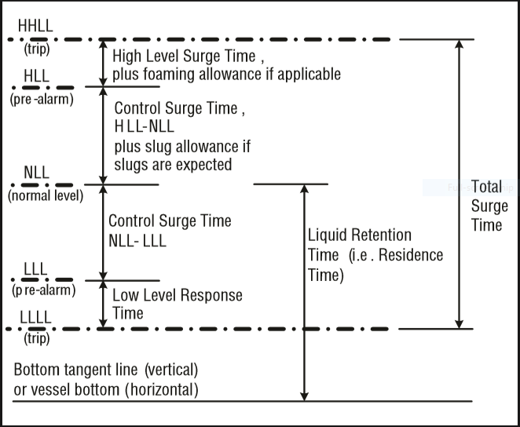

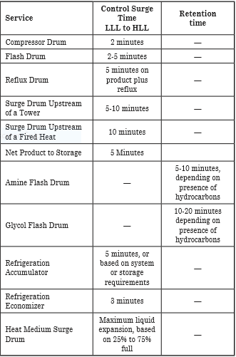

|  |  |  |  |
| --- | --- | --- | --- |
| **Height Elements** | **GPSA** | **LICENSOR** | **Unit** |
| **H1** | **450** | **500** | **mm** |
| **H2** | **575** | **500** | **mm** |
| **H3** | **875** | **600** | **mm** |
| **H4** | **865** | **865** | **mm** |
| **H5** | **1750** | **1700** | **mm** |
| **H6** | **150** | **150** | **mm** |
| **H7** | **150** | **525** | **mm** |
| **HT** | **4815** | **4825** | **mm** |

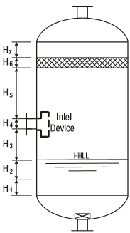

**Calculation, Explanation, and Discussion**

H1 mostly depends on instrument mount position and the number of instrument devices used.

The Licensor for most of his vertical vessel has selected 500 mm in accord with his FCS and

ESD Control System, whereas in GPSA 450 mm is selected as the basis.

H2 is a function of retention time. It seems from the back-calculation that the licensor has

selected 5 minutes for retention time. Likewise, in GPSA a retention time of 2-5 minutes has

been selected for Flash drums. The licensor general retention time table is given in next-page

H3 in GPSA for Half Open pipes is 0.25D and has been the basis for calculation.

H4 is the size of inlet Half Open pipe which is the same size of upstream pipe for both licensor

and GPSA.

H5 in GPSA for Half Open pipes is 0. 5D and has been the basis for calculation.

H6 is the demister pad thickness which is 150 mm for both licensor and GPSA.

H7 in GPSA is minimum 150 mm but in other sketch in GPSA there is a formula for X4 which

connects the upper part of demister pad to outlet nozzle which cannot be used for comparison

here.

Retention Time provided by the licensor

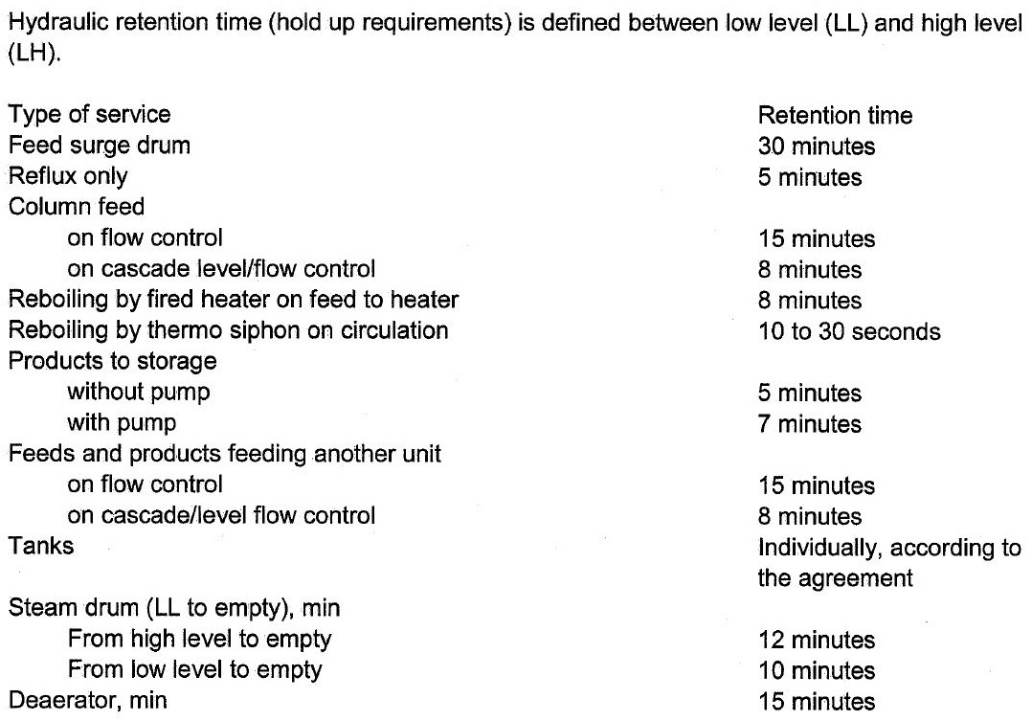

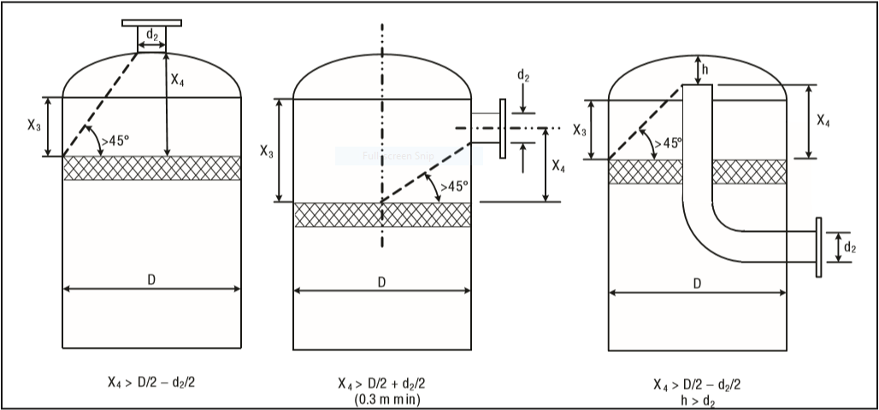

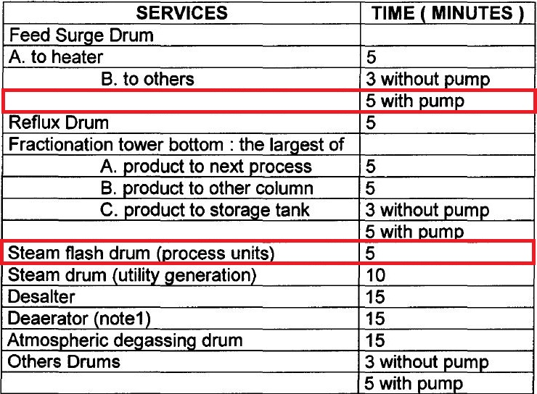Foster-Wheeler

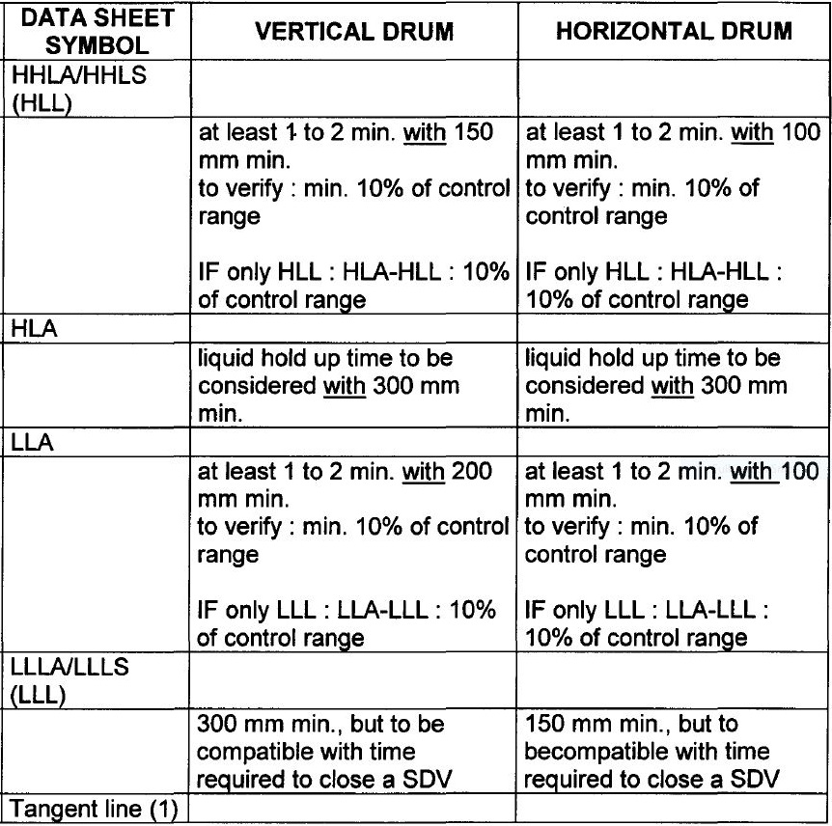

|  |  |  |  |
| --- | --- | --- | --- |
| **Height Elements** | **FW** | **LICENSOR** | **Unit** |
| **H1** | **300** | **500** | **mm** |
| **H2** | **575** | **500** | **mm** |
| **H3** | **-** | **600** | **mm** |
| **H4** | **865** | **865** | **mm** |
| **H5** | **-** | **1700** | **mm** |
| **H6** | **150** | **150** | **mm** |
| **H7** | **-** | **525** | **mm** |
| **HT** | **-** | **4825** | **mm** |



**Manholes, Drain and Vents**

**Foster-Wheeler**

Size of manholes

For vessel diameter < 1000 mm

Flanged vessel shall be considered if equipment contains internals

Otherwise, size of manholes = 18”

For vessel diameter ≥ 1000 mm

Toxic service size of manholes = 24”

Non-toxic service size of manholes = 20”

(Or up to 24” if internals need to be removable through

manhole.)

The drain of the vessel shall always be at the lowest point of a vessel. For vertical vessels they

shall be connected to the bottom outlet line at the low point. For horizontal vessels the drain

point shall be directly on the bottom of the drum at the lowest point ensured through vessel

slope (1:100).

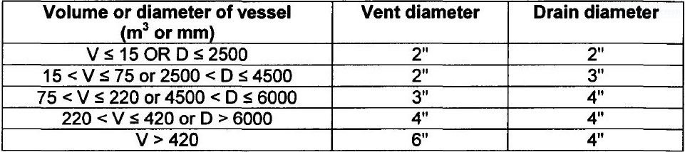

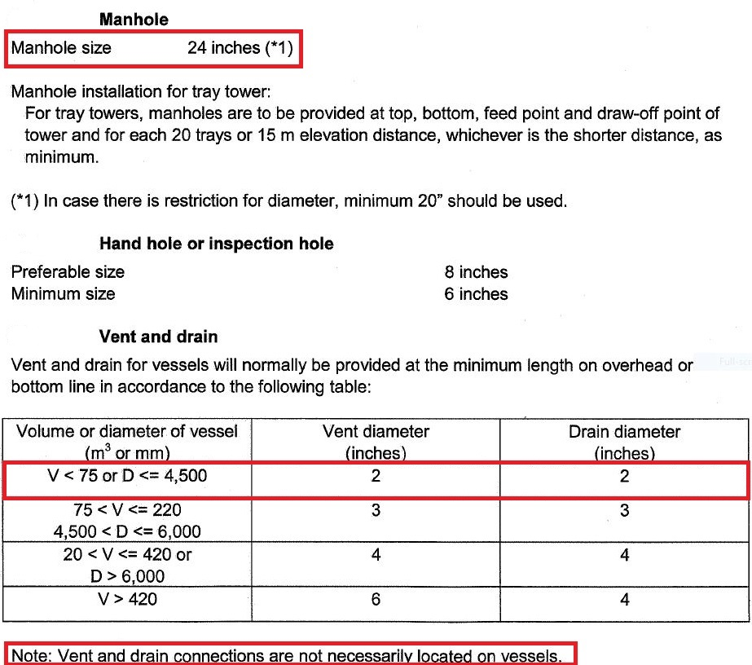Licensor Criteria

**Comparison**

1. The size of manhole for both licensor and FW is 24’.
2. There is no need to have Vent on this drum since there is a control valve to flare system

and if purging is required then by use of these means the task could be performed.

1. The drain valve sized by licensor is 2’ and but by Foster-Wheeler is 3’

|  |  |  |
| --- | --- | --- |
| **Parameter** | **FW** | **Licensor** |
| **Manhole** | **20-24** | **24** |
| **Vent** | **2** | **2** |
| **Drain** | **3** | **2** |
| **Vortex Breaker** | **Yes** | **Yes** |

**6th Step: Select a well-designed Mist Eliminator pad using KG TOWER**

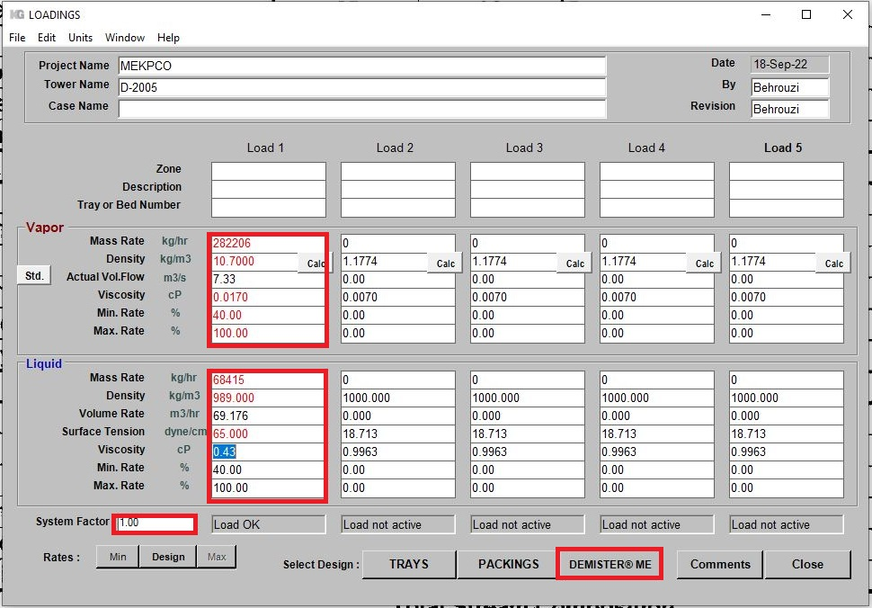Put operating data as input like below

In Koch-Glitsch products there are two types of demister pads:

1. Traditional demister pads
2. High efficiency demister pads

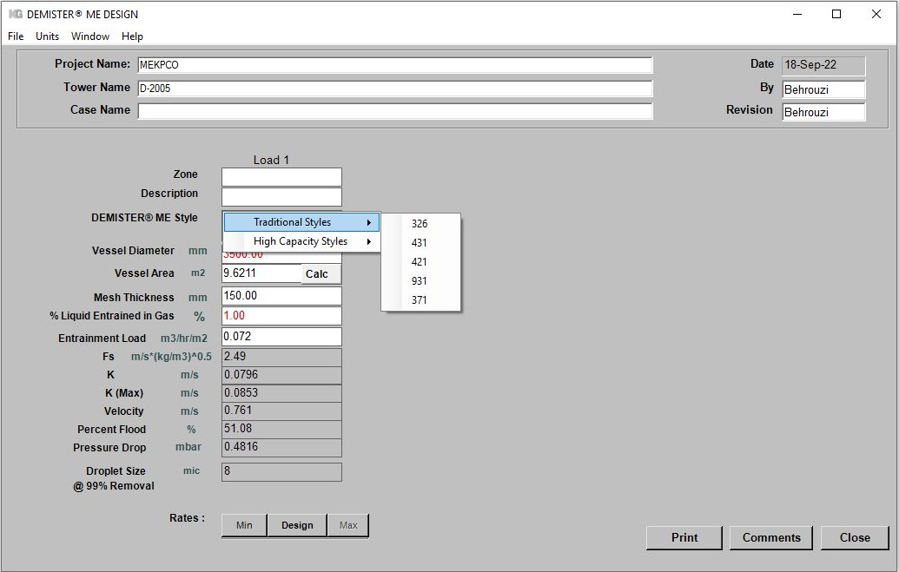

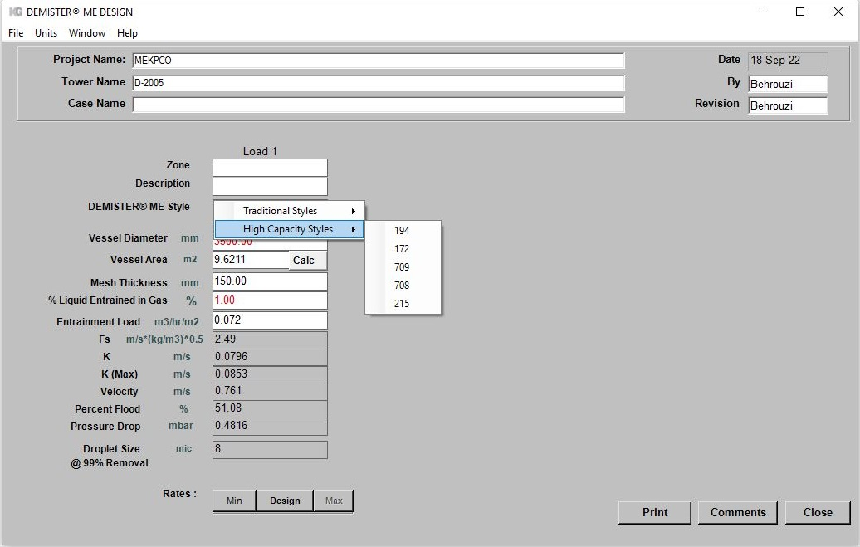

All types will be selected and the results are compared

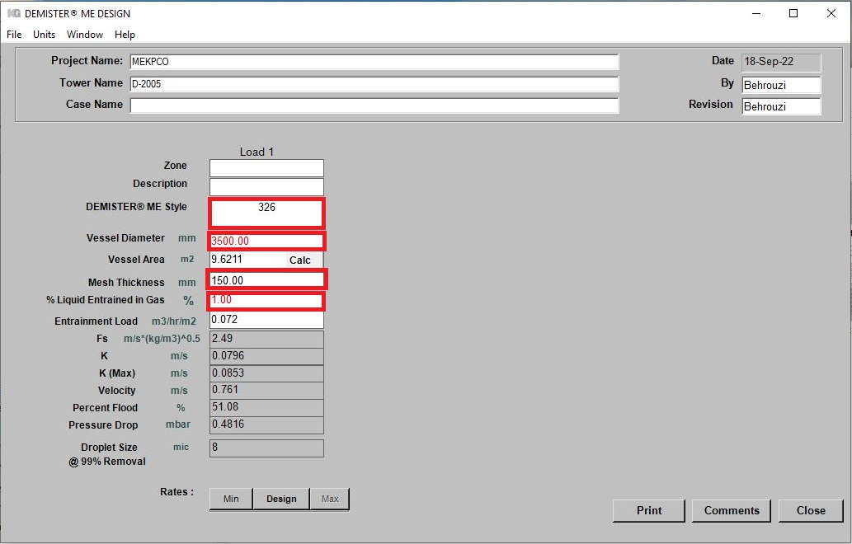

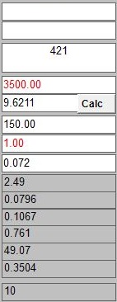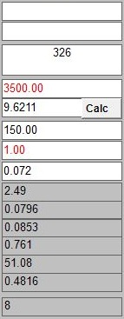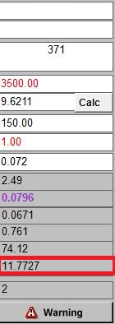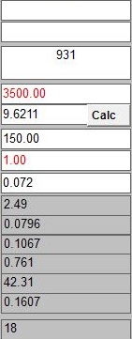

High Efficiency Demister Pad

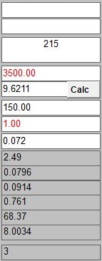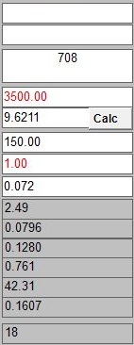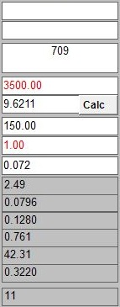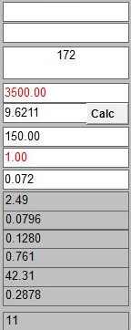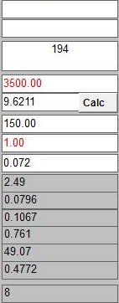

The best options that could be selected seem to be York mesh 172, 709 and 421

