Vertical Vessel

K.O Drum

D-1001

Design and Principles

**Content**

1. **Description**

1. **Design Procedure**
   1. Select proper Orientation
   2. Select and Size proper Inlet Device, Inlet and Outlet ID
   3. Calculate Vessel Diameter
   4. Calculate Vessel Height
   5. Select and Size Manholes, Vent, Drain, Vortex Breaker
   6. Select a well-designed mist eliminator pad

**Description**

The objective of this vessel is to separate liquid particle from the gas. The vessel is

located at plant inlet to prevent condensate from upstream from entering fuel system.

Operating Parameters



Liquid for calculation: 1% of gas total wight with density of 950 kg/m3

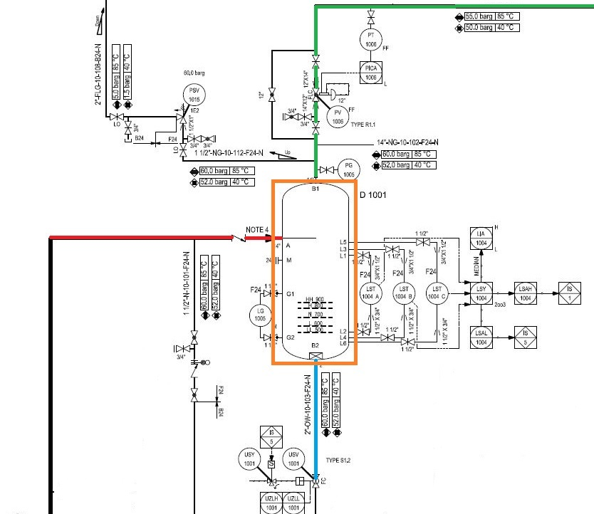

**Design Procedure**

1. Select proper Orientation

2. Select and Size proper Inlet Device, Inlet and Outlet ID

3.Calculate Vessel Diameter

4. Calculate Vessel Height

5.Select and Size Manholes, Vent, Drain, Vortex Breaker

**1st Step: Select proper orientation**

Since the application is gas dominant a vertical vessel is selected.

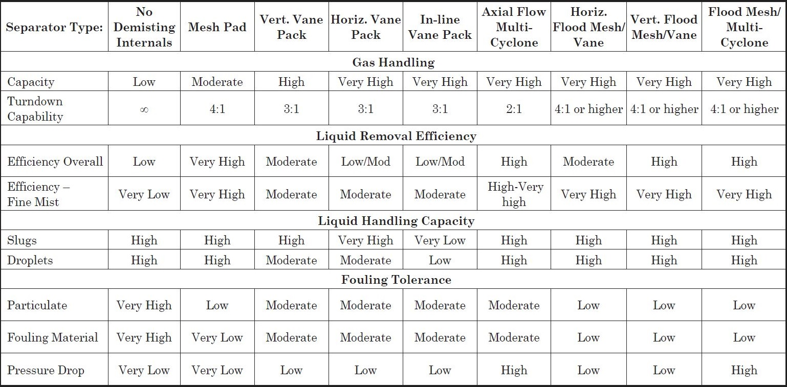Since no downstream requirement is emphasized no de-mister pad is needed.

**2nd Step: Select and Size proper Inlet Device**

Half Pipe has proven itself to be not only effective in large capacities but cost-effective as well

and in many applications is preferred to Diffuser whose performance is superior but too costly.

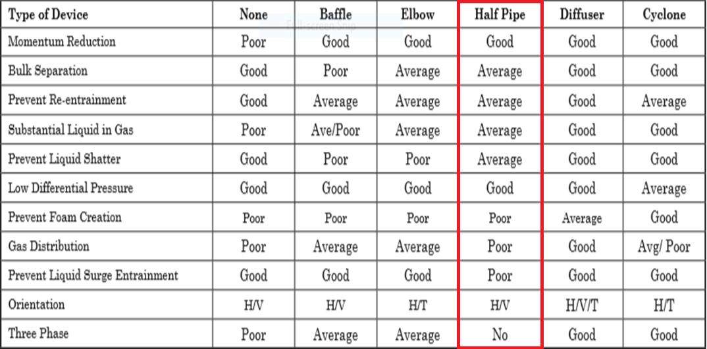

It is also necessary to maintain the inlet velocity head, J, within proper limits for the selected

inlet device to insure good gas distribution and minimum liquid shattering.

Where,

J = (ρV²)

The maximum mixed phase velocity head range used in the industry guidelines varies for the

different inlet devices. Some typical maximums are:

•6000-9000 max. typ, up to 15 000 max kg/m s2 for diffuser distributor

•975-2250 max kg/m. s2 for no inlet distributor

•1500-3750 max kg/m. s2 for inlet half pipe or elbow distributor

•1500-3750 max kg/m. s2 for v-baffle or other simple inlet diverter designs

In addition, some users limit the inlet vapor phase velocity to 9 m/s or 18 m/s. The velocity

should always be below the erosion velocity for the service.

In order to calculate head velocity, at first, we need to perform the followings:

1. Estimation of inlet nozzle ID; Consider inlet pipe ID near the vessel as first and best

estimation.

2. Calculate ρmixture and subsequently Vmixture

3. Calculate J by multiplying ρmixture (Vmixture)^2 and compare it with the last-page criterion.

|  |  |  |  |  |
| --- | --- | --- | --- | --- |
| **Parameter** | **Value** | **Value** | **Value** | **Unit** |
| **Estimated ID** | **12** | **14** | **16** | **inch** |
| **Nozzle Area** | **0.072** | **0.099** | **0.129** | **m2** |
| **ρmixture** | **36.8** | **36.8** | **36.8** | **kg/m3** |
| **Vmixture** | **13.78** | **10.12** | **7.75** | **m/s** |
| **J** | **6988** | **3772** | **2211** | **kg/m. s2** |
| **Criterion** | **3750** | **3750** | **3750** | **kg/m. s2** |

So, both 14 and 16 inch are accepted but it is recommended that inlet piping diameter

match the velocity requirement of the inlet to the separator 10 pipe diameters

upstream of the separator to provide a flow regime which is fully developed before

entering the separator. Thus, 14 inch is accepted.

**Vapor Outlet Section**

The sizing of the vapor outlet nozzle should be such that given the above placement of the

mesh pad, the velocity is not high enough to cause channeling of the gas through the mesh

pad. The nozzle outlet size is typically based on the lesser of that required for piping pressure

drop, or a maximum velocity head criterion. Typical ranges for the maximum velocity head

allowed for the vapor outlet are 4500–5400 kg/m • s2. In addition, some users limit the

absolute velocity to 18 m/s. The pipe size can be decreased to the appropriate size based on

pressure drop considerations, 5-10 pipe diameters downstream of the separator, as required.

14 inch is selected.

|  |  |  |  |  |
| --- | --- | --- | --- | --- |
| **Parameter** | **Value** | **Value** | **Value** | **Unit** |
| **Estimated ID** | **12** | **14** | **16** | **inch** |
| **Nozzle Area** | **0.072** | **0.099** | **0.129** | **m2** |
| **ρmixture** | **36.8** | **36.8** | **36.8** | **kg/m3** |
| **Vmixture** | **13.78** | **10.12** | **7.75** | **m/s** |
| **J** | **6988** | **3772** | **2211** | **kg/m. s2** |
| **Criterion** | **4500** | **4500** | **4500** | **kg/m. s2** |

**3rd Step: Calculate Vessel Diameter**

Each and every licensor and company has developed a design basis procedure for sizing

vessels. In this article, a GPSA-based method, Foster-Wheeler-based method and the

Licensor method will be explored.

**GPSA**

1. Use the following equation and next-page K-values to calculate terminal velocity

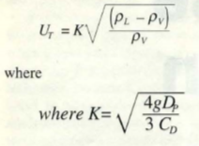

According to GPSA, thanks to the fact that a vertical vessel without demister pad has

been chosen, a K value of 0.046 is selected.

|  |  |  |
| --- | --- | --- |
| **Parameter** | **Value** | **Unit** |
| **ρl** | **960** | **kg/m3** |
| **ρv** | **36.8** | **kg/m3** |
| **Kselected** | **0.046** |  |
| **Ug** | **0.23** | **m/s** |
| **Qg** | **1** | **m3/s** |
| **ID** | **2357** | **mm** |
| **Required-ID** | **2357** | **mm** |
| **Selected-ID** | **2400** | **mm** |

**Notes**

For ID calculation, the following equation has been utilized.

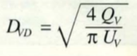

**Foster-Wheeler**

The basis of sizing is the critical velocity Vc (m/s)

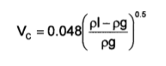

The maximum gas velocity is K $×$ Vc

K is a coefficient depending on the service, and the use or the absence of wire mesh.

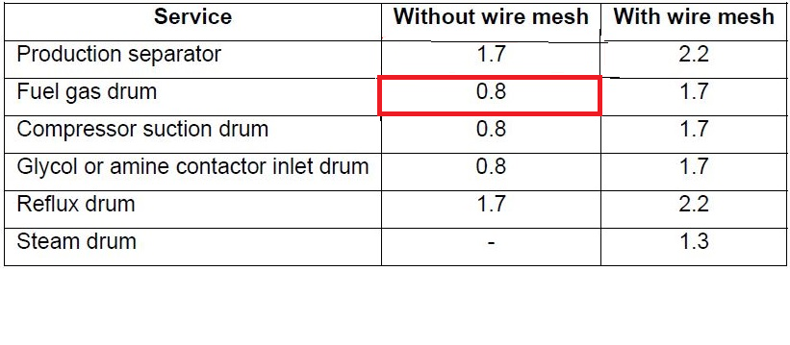Recommended K values are given hereafter for different services.

If a vane pack internal is used, the recommended K value is 3.3.

|  |  |  |
| --- | --- | --- |
| **Parameter** | **Value** | **Unit** |
| **ρl** | **960** | **kg/m3** |
| **ρv** | **36.8** | **kg/m3** |
| **Kselected** | **0.8** |  |
| **Vc** | **0.24** | **m/s** |
| **Vmax** | **0.19** |  |
| **Qg** | **1** | **m3/s** |
| **ID** | **2580** | **mm** |
| **Required-ID** | **2580** | **mm** |
| **Selected-ID** | **2600** | **mm** |

**Svercheck-Method**

1. Use the following equation and next-page K-values to calculate terminal velocity



**Notes**

For ID calculation, the following equation has been utilized.



Uv = 0.75 UT

Svercheck Method-K value

K = 0.35 – 0.01 (764-100/100) = 0.28

For vertical vessel without mist eliminator

Kselected = 0.28/2 = 0.14

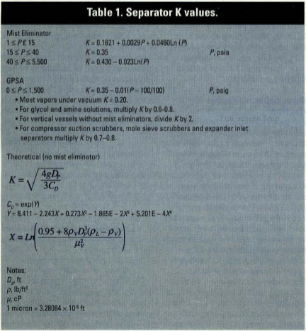

|  |  |  |
| --- | --- | --- |
| **Parameter** | **Value** | **Unit** |
| **ρl** | **960** | **kg/m3** |
| **ρv** | **36.8** | **kg/m3** |
| **Kselected** | **0.14** |  |
| **Ug** | **0.7** | **m/s** |
| **Uv** | **0.52** |  |
| **Qg** | **1** | **m3/s** |
| **ID** | **1560** | **mm** |
| **Required-ID** | **1560** | **mm** |
| **Selected-ID** | **1550 or 1600** | **mm** |

**Explanation, Comparison and Discussion**

Different criteria have been used to size the vary separator and the difference in

diameter results stem from the selected K that each licensor or criterion has set based

on their experience. The following table provides the K value and diameter calculated.

|  |  |  |  |  |
| --- | --- | --- | --- | --- |
| **Method** | **GPSA** | **FW** | **Svercheck** | **Licensor** |
| **K-Value** | **0.046** | **0.038** | **0.14** | **0.14** |
| **Diameter** | **2400** | **2600** | **1550** | **1550** |

**4th Step: Height Calculation**

Each and every licensor and company has developed a design basis procedure for sizing

vessels. In this article, a GPSA-based method, Foster-Wheeler-based method and the Licensor

method will be explored.

GPSA

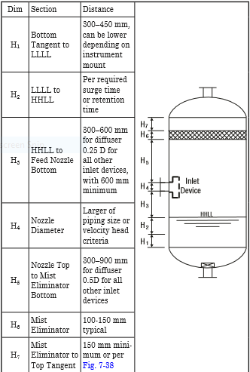

Retention/Surge Time

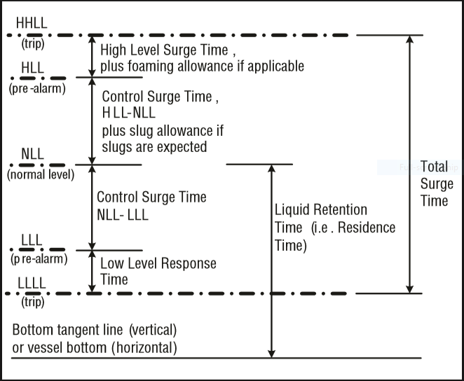

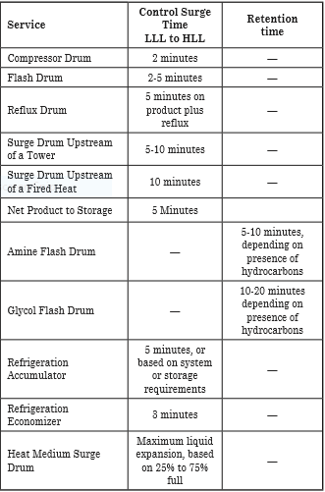

|  |  |  |  |
| --- | --- | --- | --- |
| **Height Elements** | **GPSA** | **LICENSOR** | **Unit** |
| **H1** | **450** | **500** | **mm** |
| **H2** | **50** | **400** | **mm** |
| **H3** | **587.5** | **300** | **mm** |
| **H4** | **355** | **355** | **mm** |
| **H5** | **1200** | **1000** | **mm** |
| **H6** | **-** |  | **mm** |
| **H7** | **150** |  | **mm** |
| **HT** | **2750** | **2550** | **mm** |

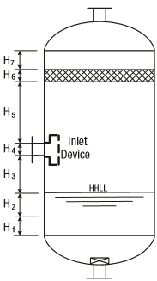

**Calculation, Explanation, and Discussion**

H1 mostly depends on instrument mount position and the number of instrument devices used. The Licensor for most of his vertical vessel has selected 500 mm in accord with his FCS and ESD Control System, whereas in GPSA 450 mm is selected as the basis.

H2 is a function of retention time. Likewise, in GPSA a retention time of 10 minutes has been

selected for Flash drums. The licensor general retention time table is given in next-page

H3 in GPSA for Half Open pipes is 0.25D and has been the basis for calculation.

H4 is the size of inlet Half Open pipe which is the same size of upstream pipe for both licensor and GPSA.

H5 in GPSA for Half Open pipes is 0. 5D and has been the basis for calculation.

Retention Time provided by the licensor

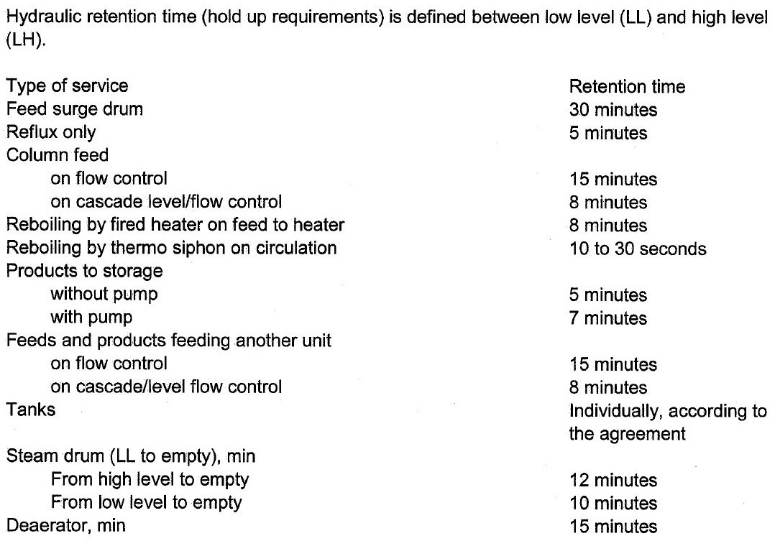

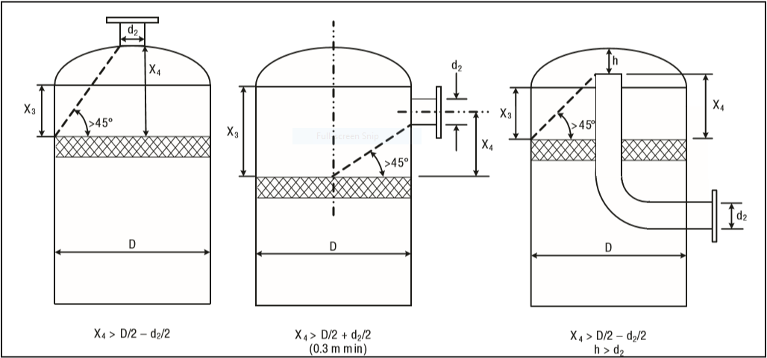

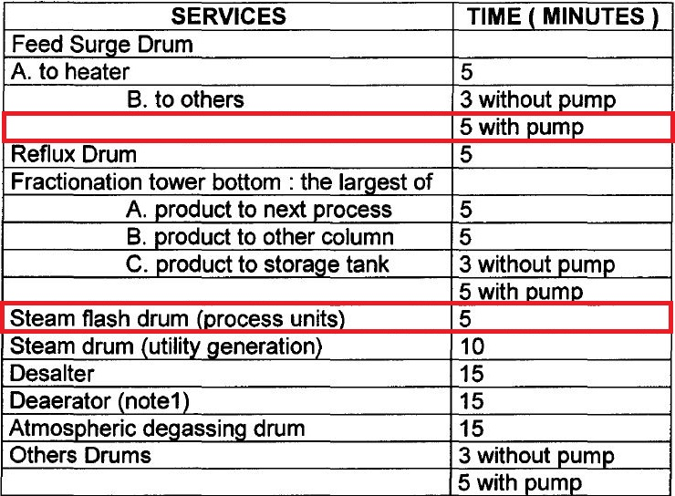Foster-Wheeler

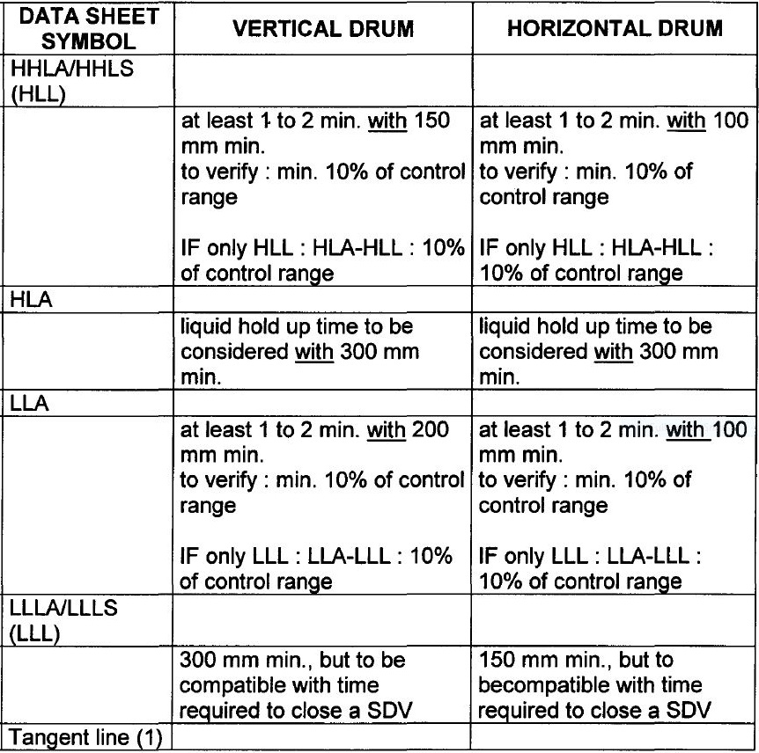

|  |  |  |  |
| --- | --- | --- | --- |
| **Height Elements** | **FW** | **LICENSOR** | **Unit** |
| **H1** | **300** | **500** | **mm** |
| **H2** | **50** | **400** | **mm** |
| **H3** | **-** | **300** | **mm** |
| **H4** | **355** | **355** | **mm** |
| **H5** | **-** | **1000** | **mm** |
| **H6** | **-** |  | **mm** |
| **H7** | **-** |  | **mm** |
| **HT** | **-** | **2550** | **mm** |



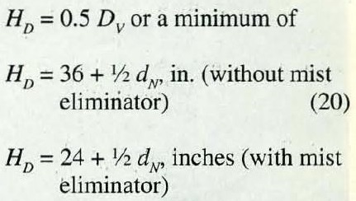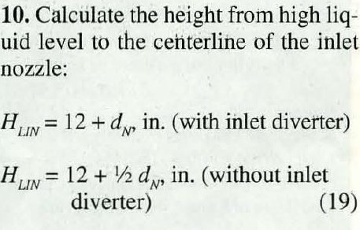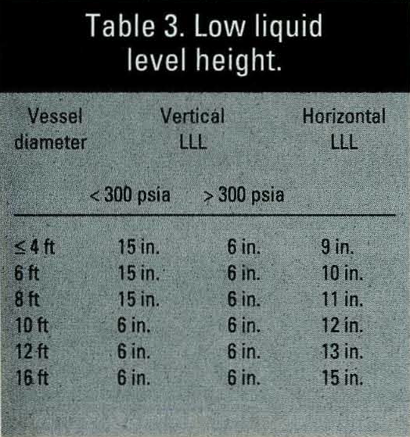**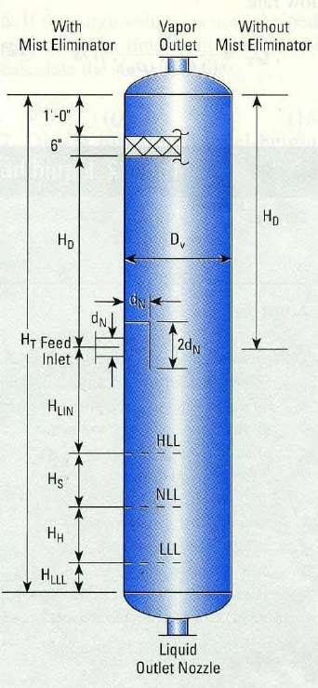Svercek Method**

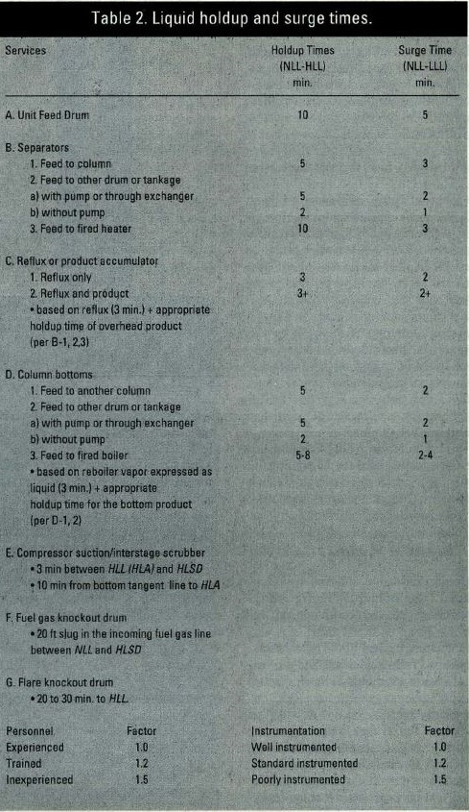

|  |  |  |  |
| --- | --- | --- | --- |
| **Height Elements** | **Svercek** | **LICENSOR** | **Unit** |
| **HLLL** | **150** | **500** | **mm** |
| **HH** | **50** | **400** | **mm** |
| **Hs** | **150** | **300** | **mm** |
| **HLIN** | **700** | **355** | **mm** |
| **HD** | **1100** | **1000** | **mm** |
| **H6** | **-** |  | **mm** |
| **H7** | **25** |  | **mm** |
| **HT** | **2200** | **2550** | **mm** |



|  |  |  |  |  |
| --- | --- | --- | --- | --- |
| **Method** | **GPSA** | **FW** | **Svercek** | **Licensor** |
| **Diameter** | **2400** | **2600** | **1550** | **1550** |
| **Height** | **2650** |  | **2000** | **2550** |

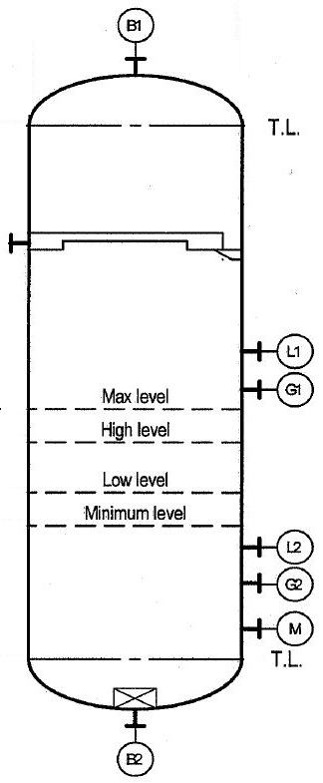

**Manholes, Drain and Vents**

**Foster-Wheeler**

Size of manholes

For vessel diameter < 1000 mm

Flanged vessel shall be considered if equipment contains internals

Otherwise, size of manholes = 18”

For vessel diameter ≥ 1000 mm

Toxic service size of manholes = 24”

Non-toxic service size of manholes = 20”

(Or up to 24” if internals need to be removable through

manhole.)

The drain of the vessel shall always be at the lowest point of a vessel. For vertical vessels they

shall be connected to the bottom outlet line at the low point. For horizontal vessels the drain

point shall be directly on the bottom of the drum at the lowest point ensured through vessel

slope (1:100).

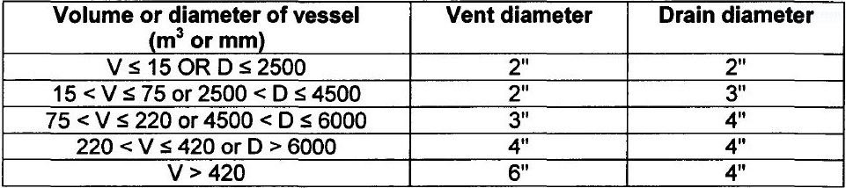

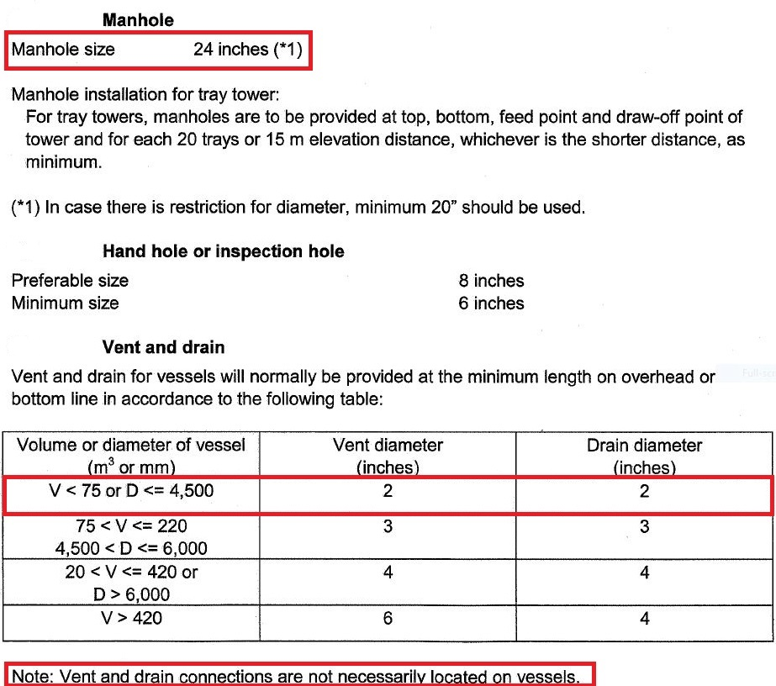Licensor Criteria

**Comparison**

The size of manhole for both licensor and FW is 24’.

Neither Drain nor vent valve has been installed.

|  |  |  |
| --- | --- | --- |
| **Parameter** | **FW** | **Licensor** |
| **Manhole** | **20-24** | **24** |
| **Vent** | **2** | **2** |
| **Drain** | **3** | **2** |
| **Vortex Breaker** | **Yes** | **Yes** |