USV-2125

Sizing and Design Principle

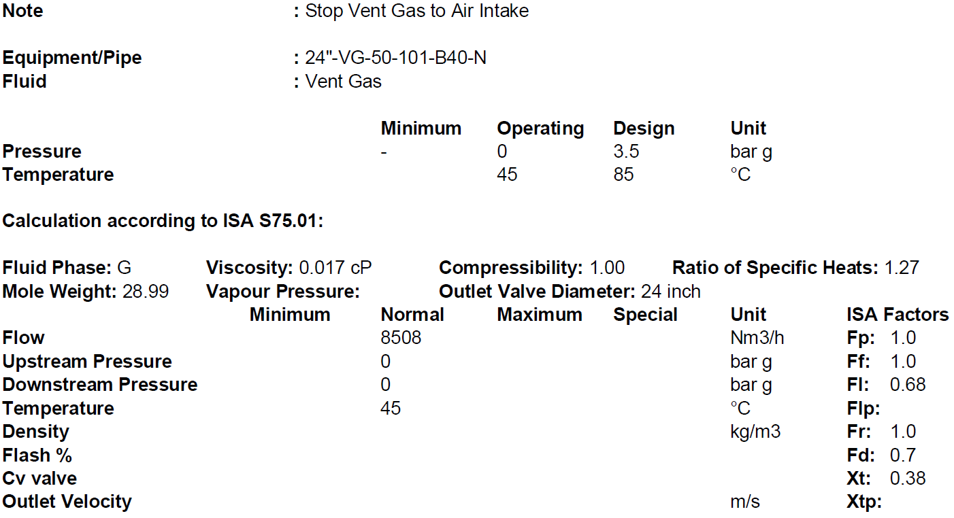**1.Operating Condition**

…………………………………………………………………………………………………………….

**2. Body/Bonnet**

In Body/Bonnet Tab the following information should be determined:

1.Type

2. Size

3.Rating

4.Connection type

5.Body material

6.Pipe inlet and outlet

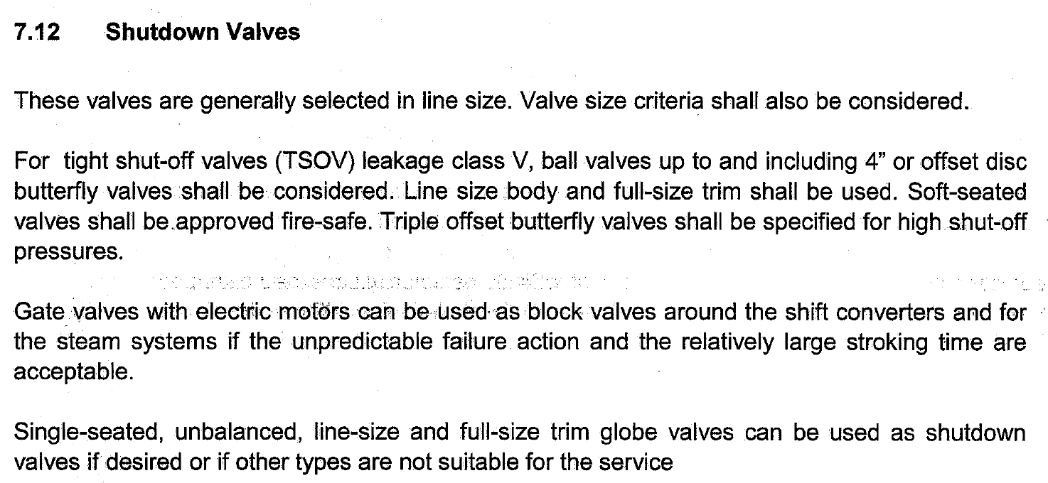**Type:**

Since the valve is used as tight shut-off valve, based on above explanation, butterfly or ball

valve should be used and due to the fact that a line-size body and a full-size trim shall be used,

among these choices butterfly type is selected since the line sizing is 24 in. which is more than

4 in.

**Rating:**

The rating of valves is the same as the rating of connecting pipes. Since the adjacent pipe class

is 150, the valve class would be 150.

**Connection type:**

The three most common methods of installing control valves into pipelines are by means of

screwed pipe threads, bolted gasketed flanges, and welded end connections.

Screwed end connections, popular in small control valves, offer more economy than flanged

ends. The threads usually specified are tapered female NPT (National Pipe Thread) on the

valve body. They form a metal-to-metal seal by wedging over the mating male threads on the

pipeline ends.

This connection style, usually limited to valves NPS 2 (DN 50) or smaller, is not recommended

for elevated temperature service. Valve maintenance might be complicated by screwed end

connections if it is necessary to take the body out of the pipeline because the valve cannot be

removed without breaking a flanged joint or union connection to permit unscrewing the

valve body from the pipeline.

Flanged end valves are easily removed from the piping and are suitable for use through the

range of working pressures for which most control valves are manufactured. Flanged end

connections can be used in a temperature range from near absolute zero to approximately

815°C (1500°F). They are used on all valve sizes. The most common flanged end connections

include flat-face, raised-face, and ring-type joint.

|  |  |  |
| --- | --- | --- |
| Screwed End | Flanged End | Welded End |
| 2” and smaller | Up to class 900 | Suitable for class 1500 and 2500 |

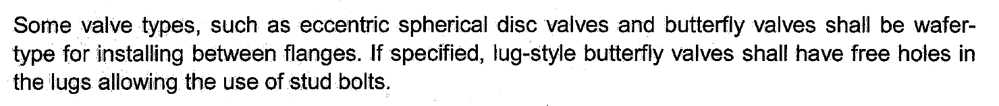

Since the valve type is butterfly, wafer type with RF is used for connection of the valve to

adjacent piping,

**Body material**

1.A216 WCB/WCC or forged carbon steel, A105 is used in non-corrosive services from -28 to

427C.

2. If there are some severe conditions such as flashing, it is typical to use A217 WC9

3. For high temperature services like steam let-down station or HHPS it is a practice to use

A217 WC6.

4. A351 CF8 is used mostly for combined flashing and corrosive services and for temperatures

below -28C.

5. For oxygen services, it is highly recommended to use Monel.

Based on the next-page Table, A 351 CF8 is selected for this application since it contains some

amount of dissolved gas from T-5004

**Body Size**

Body size = Line size = 24 inch

Valve Body Material Selection based on Fluids

|  |  |
| --- | --- |
| Fluid | Material |
| NG | SA216 WCB |
| Purge Gas | SA216 WCB |
| Syngas | SA216 WCB/A351 CF8 |
| Process Condensate | A351 CF8 |
| LPS | SA216 WCB |
| MPS | SA216 WCB |
| HPS | SA216 WCB /SA217 WC6 |
| HHPS | SA217 WC6 |
| LPC | SA217 WC6/WC9 |
| MPC | SA216 WCB |
| HPC | SA217 WC9 |
| BFW | SA216 WCB/ SA217 WC6 |
| WMW | A351 CF8 |
| Nitrogen | SA216 WCB |
| Crude Methanol | SA216 WCB |
| Flashed Methanol | A351 CF8 |
| Refined Methanol | SA216 WCB |
| Process Gas | SA216 WCB/ A351 CF8 |
| Oxygen | Monel |

**3. Trim**

For Trim Tab the following should be specified:

1.Cv required

2.Charachteristic

3.Type

4.Material

5.Leakage Class

**Cv calculation**

Cv required = line sized

**Trim type**

Triple offset is selected when a butterfly valve is selected.

**Trim Charachteristic**

ON/OFF

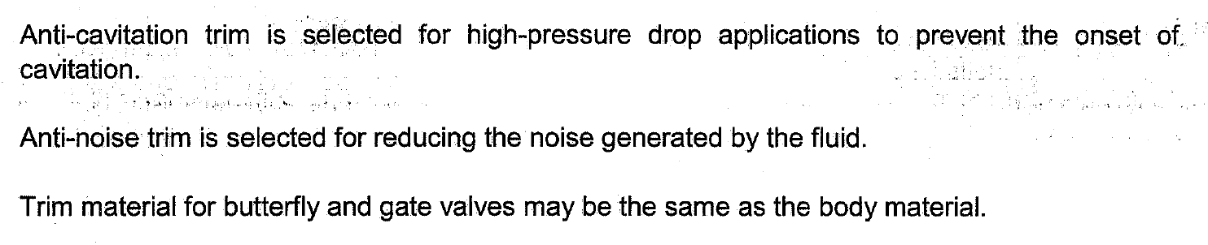**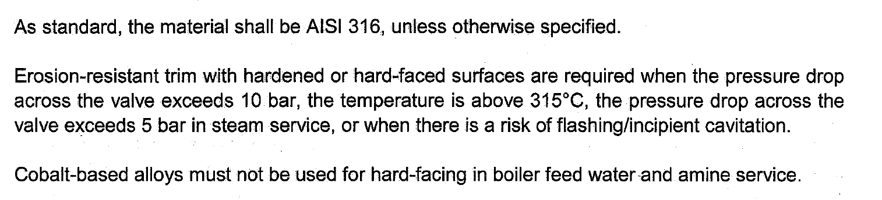Trim material**

Since a butterfly valve is used the trim material is the same as body material which is A 351 CF8

**Leakage Class**

Control valves are designed to throttle, but they are also often expected to provide some type of

shut-off capability.

A control valve's ability to shut off has to do with many factors: Balanced or unbalanced plug,

seat material, actuator thrust, pressure drop, and the type of fluid can all play a part in how wella

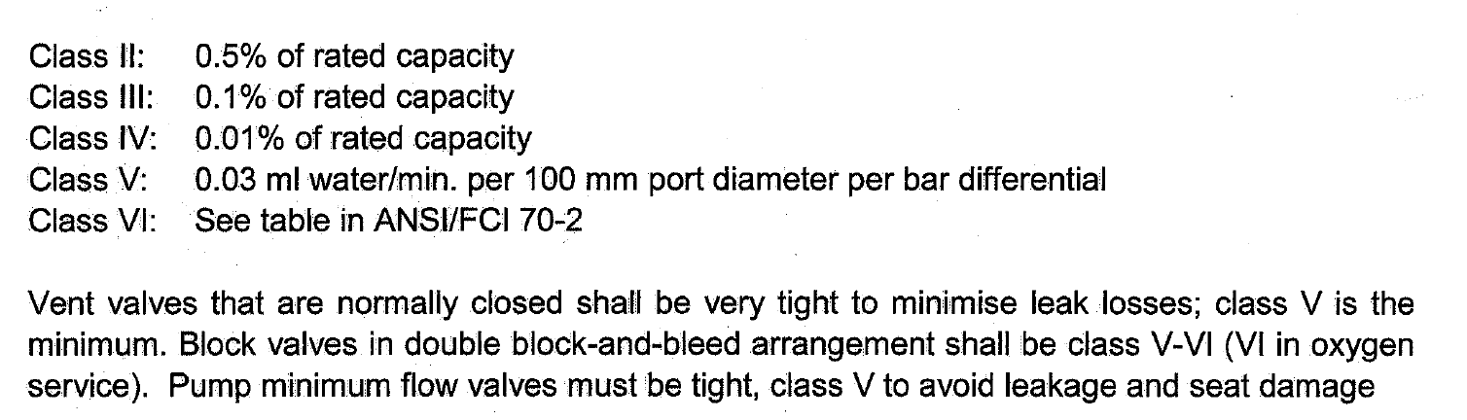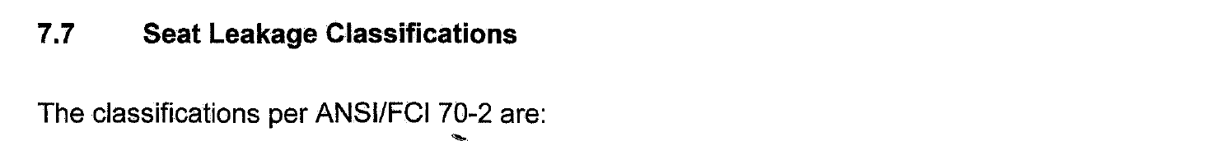particular control valve shuts off.

Class IV is also known as a “Metal-to-Metal” seat classification. It is the kind of leakage rate you

can expect from a valve with a metal plug and metal seat

Class VI is known as a “Soft Seat” classification. Soft Seat Valves are those where either the plug

or seat or both are made from some kind of composition material such as [Nitrile or Polyurethane](https://kimray.com/choose-elastomers-control-valve/).

For tight shut-off valves minimum V shall be selected

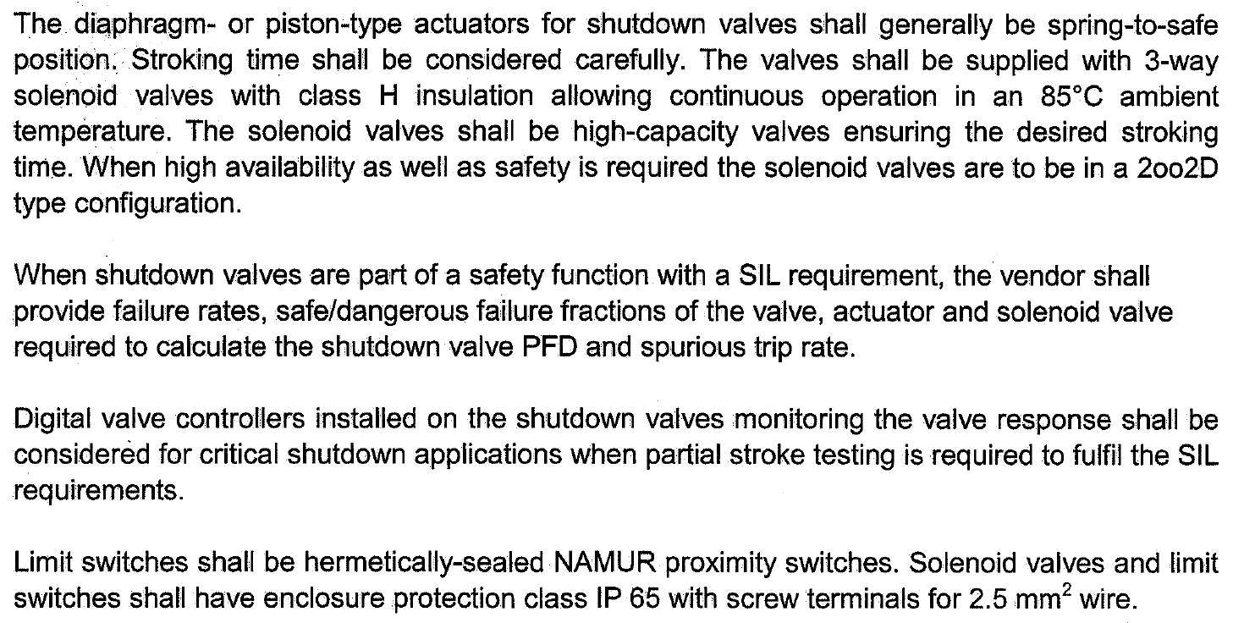**Actuators**

for actuator and positioners Tab the following should be specified:

1.Type

2.Modulating or ON/OFF

3.Failiure position

4.dP for sizing

**Actuator Type:**

Based on above criteria, Piston with spring return shall be selected

ON/OFF type is selected.

**Failure position**

Control valves shall be such that on air failure the valve takes automatically a safe position

either open, or close, or locked in position, depending upon the process requirements.

Based on process requirement FC is selected.

**dp for sizing**

dp equals design pressure which is 3.5 barg

**Solenoid Valve**

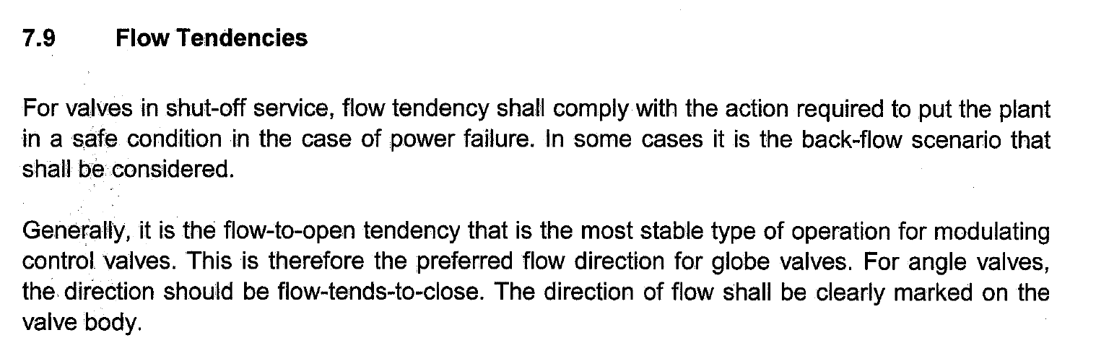Type = 3 way

**Hand Wheel**

No hand wheel is required.