USV-2071
Sizing and Design Principle

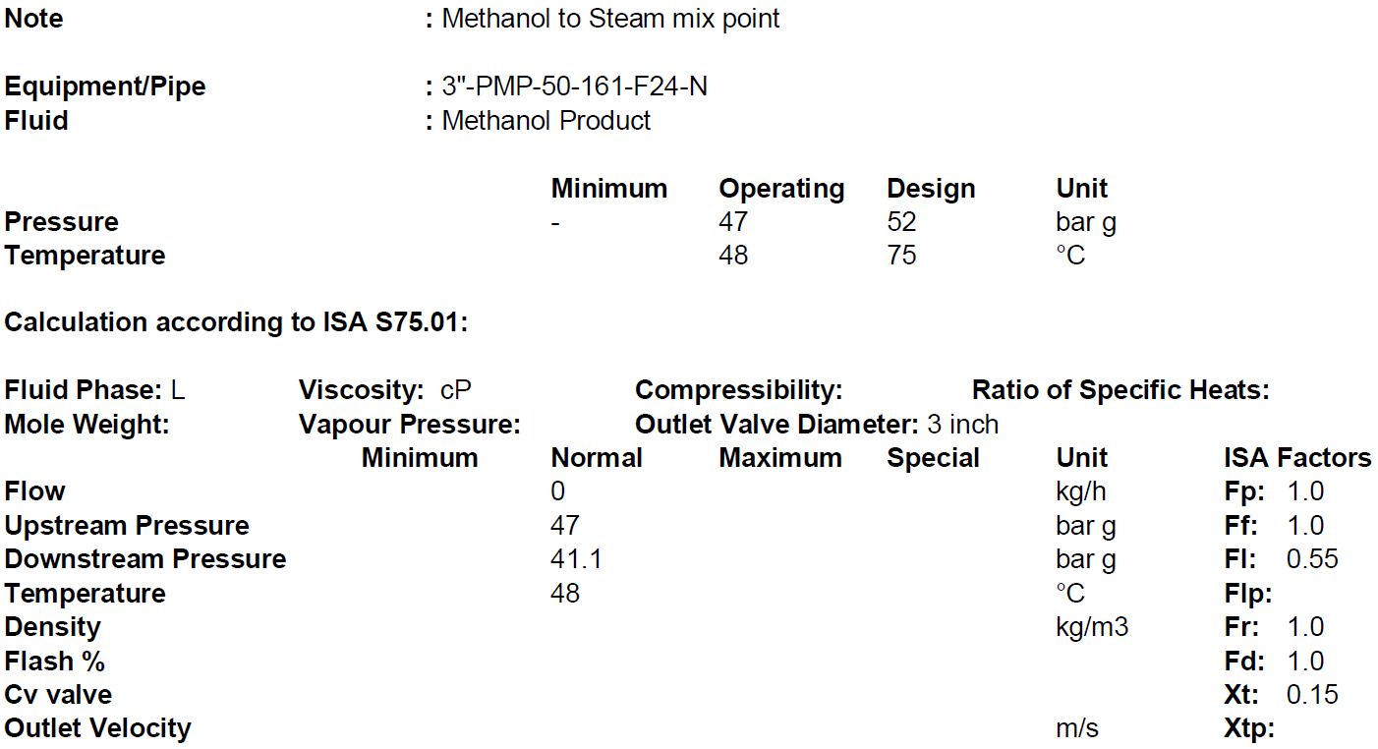
1.Operating Condition

…………………………………………………………………………………………………………….
2. Body/Bonnet
In Body/Bonnet Tab the following information should be determined:
1.Type
2. Size
3.Rating
4.Connection type
5.Body material
6.Pipe inlet and outlet

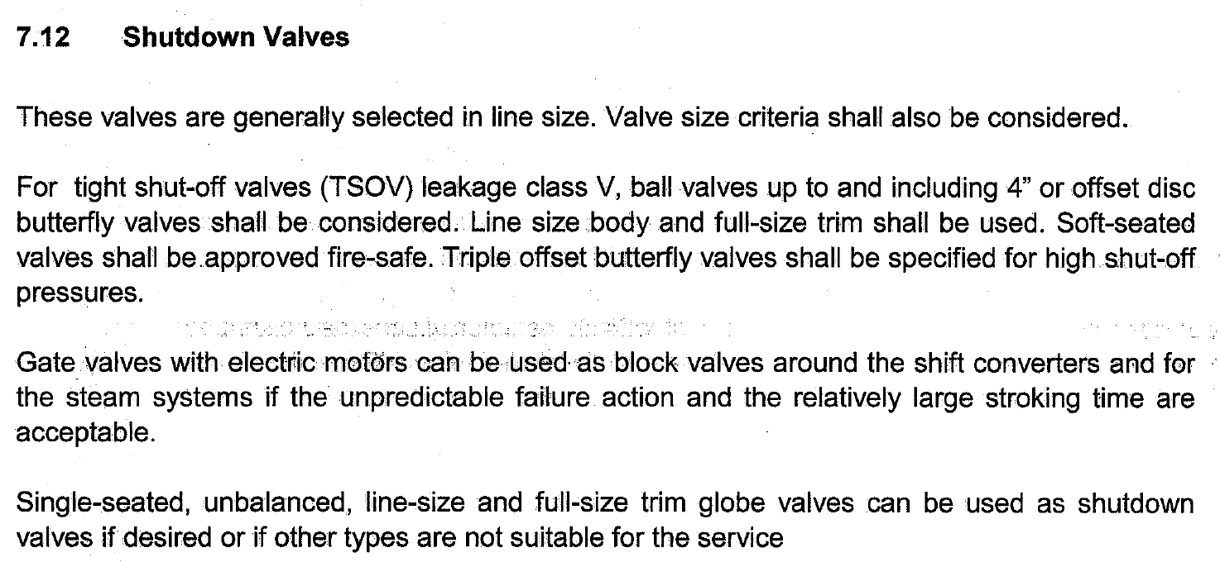
Type:

Since the valve is used as tight shut-off valve, based on above explanation, butterfly or ball
valve should be used and due to the fact that a line-size body and a full-bore trim shall be used,
among these choices ball type is selected since the line sizing is 3 in. which is less than 4
in.

Rating:
The rating of valves is the same as the rating of connecting pipes. Since the adjacent pipe class
is 600, the valve class would be 600.

Connection type:
The three most common methods of installing control valves into pipelines are by means of

screwed pipe threads, bolted gasketed flanges, and welded end connections.

Screwed end connections, popular in small control valves, offer more economy than flanged

ends. The threads usually specified are tapered female NPT (National Pipe Thread) on the

valve body. They form a metal-to-metal seal by wedging over the mating male threads on the

pipeline ends.

This connection style, usually limited to valves NPS 2 (DN 50) or smaller, is not recommended

for elevated temperature service. Valve maintenance might be complicated by screwed end

connections if it is necessary to take the body out of the pipeline because the valve cannot be

removed without breaking a flanged joint or union connection to permit unscrewing the

valve body from the pipeline.

Flanged end valves are easily removed from the piping and are suitable for use through the

range of working pressures for which most control valves are manufactured. Flanged end

connections can be used in a temperature range from near absolute zero to approximately

815°C (1500°F). They are used on all valve sizes. The most common flanged end connections

include flat-face, raised-face, and ring-type joint.

Screwed End | Flanged End | Welded End
2” and smaller | Up to class 900 | Suitable for class 1500 and 2500

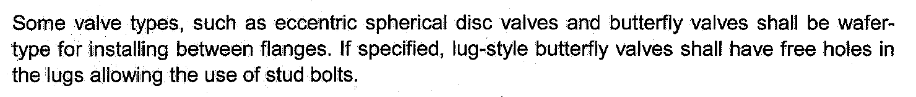

Since the valve type is ball , flange type with RF is used for connection of the valve to
adjacent piping,

Body material
1.A216 WCB/WCC or forged carbon steel, A105 is used in non-corrosive services from -28 to
427C.
2. If there are some severe conditions such as flashing, it is typical to use A217 WC9
3. For high temperature services like steam let-down station or HHPS it is a practice to use
A217 WC6.
4. A351 CF8 is used mostly for combined flashing and corrosive services and for temperatures
below -28C.
5. For oxygen services, it is highly recommended to use Monel.

Based on the next-page Table, A 216 WCB is selected

Body Size
Body size = Line size = 3 inch

Valve Body Material Selection based on Fluids
Fluid | Material
NG | SA216 WCB
Purge Gas | SA216 WCB
Syngas | SA216 WCB/A351 CF8
Process Condensate | A351 CF8
LPS | SA216 WCB
MPS | SA216 WCB
HPS | SA216 WCB /SA217 WC6
HHPS | SA217 WC6
LPC | SA217 WC6/WC9
MPC | SA216 WCB
HPC | SA217 WC9
BFW | SA216 WCB/ SA217 WC6
WMW | A351 CF8
Nitrogen | SA216 WCB
Crude Methanol | SA216 WCB
Flashed Methanol | A351 CF8
Refined Methanol | SA216 WCB
Process Gas | SA216 WCB/ A351 CF8
Oxygen | Monel

3. Trim
For Trim Tab the following should be specified:
1.Cv required
2.Charachteristic
3.Type
4.Material
5.Leakage Class

Cv calculation
Cv required = line sized

Trim type
Full-bore is selected when a ball valve is selected.

Trim Charachteristic
ON/OFF

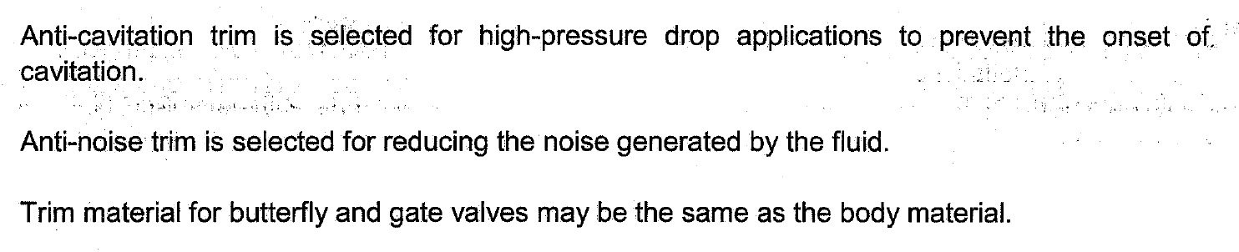
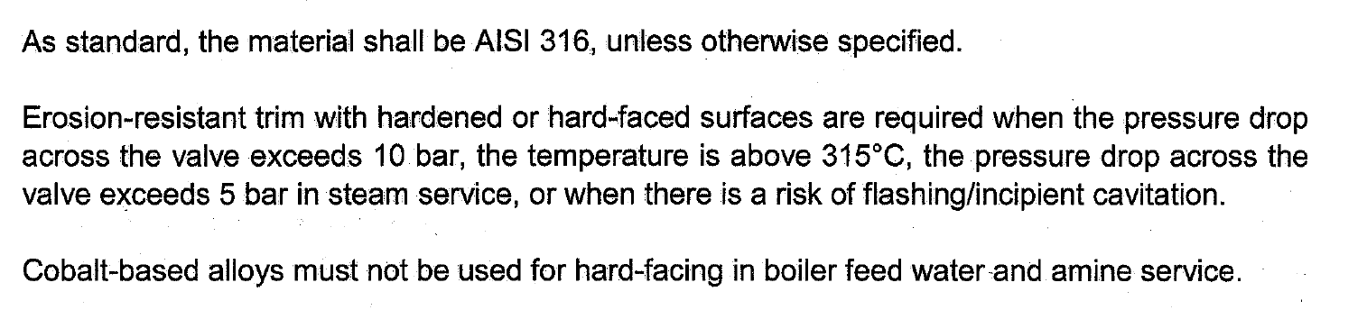
Trim material
Based on above explenation AISI 316 is selected.

Leakage Class
Control valves are designed to throttle, but they are also often expected to provide some type of
shut-off capability.
A control valve's ability to shut off has to do with many factors: Balanced or unbalanced plug,
seat material, actuator thrust, pressure drop, and the type of fluid can all play a part in how wella
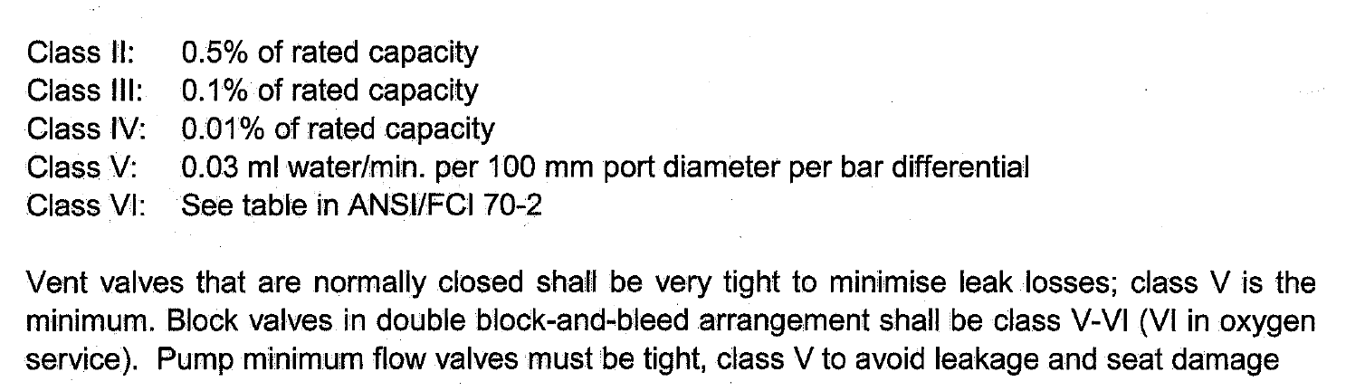
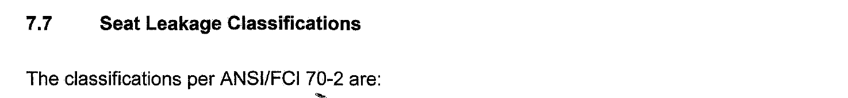
particular control valve shuts off.
Class IV is also known as a “Metal-to-Metal” seat classification. It is the kind of leakage rate you
can expect from a valve with a metal plug and metal seat
Class VI is known as a “Soft Seat” classification. Soft Seat Valves are those where either the plug
or seat or both are made from some kind of composition material such as Nitrile or Polyurethane.
For tight shut-off valves minimum V shall be selected

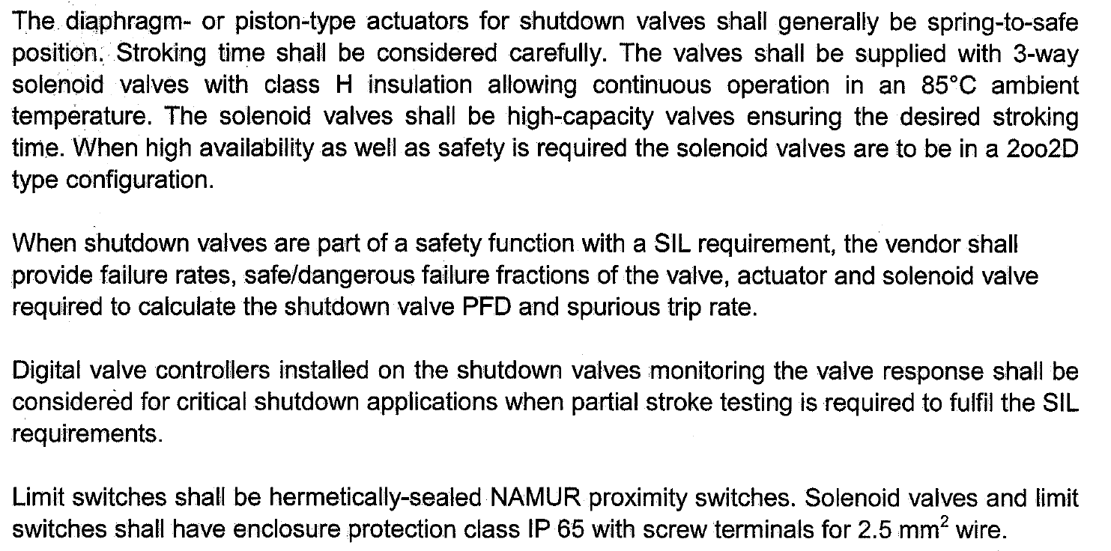
Actuators

for actuator and positioners Tab the following should be specified:
1.Type
2.Modulating or ON/OFF
3.Failiure position
4.dP for sizing

Actuator Type:
Based on above criteria, Piston with spring return is shall be selected
ON/OFF type is selected.

Failure position
Control valves shall be such that on air failure the valve takes automatically a safe position

either open, or close, or locked in position, depending upon the process requirements.

Based on process requirement FC is selected.

dp for sizing
dp equals design pressure which is 52 barg

Solenoid Valve
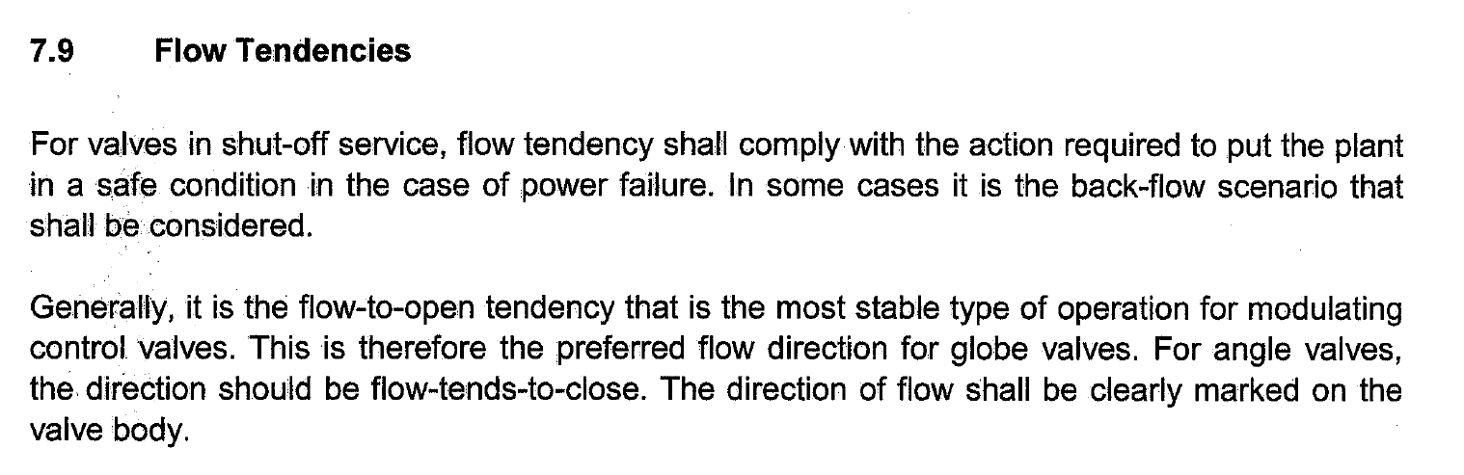
Type = 3 way

Hand wheel
Generally, no hand wheel for TSOV is used.

