PV-1006
Sizing and Design Principle

1.Operating Condition
Fluid: Natural Gas Fluid Phase: G Viscosity: 0.013 cP Compressibility: 0.93

Ratio of Specific Heats: 1.28 Mole Weight: 16.74
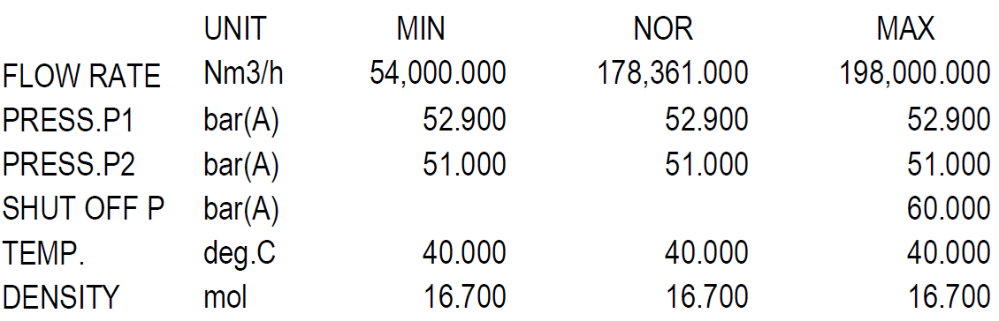

ISA Factors:
Fp : 1.0 Ff : 1.0 Fl : 0.9 Fr : 1.0 Fd : 1.0 Xt : 0.72
…………………………………………………………………………………………………………….
2. Body/Bonnet
In Body/Bonnet Tab the following information should be determined:
1.Type
2. Size
3.Rating
4.Connection type
5.Body material
6.Pipe inlet and outlet

Type:
Since the valve is used for pressure controlling application a Globe valve is used.

Size:

Rating:
The rating of valves is the same as the rating of connecting pipes. Since the adjacent pipe class
is 600, the valve class would be 600.

Connection type:
The three most common methods of installing control valves into pipelines are by means of

screwed pipe threads, bolted gasketed flanges, and welded end connections.

Screwed end connections, popular in small control valves, offer more economy than flanged

ends. The threads usually specified are tapered female NPT (National Pipe Thread) on the

valve body. They form a metal-to-metal seal by wedging over the mating male threads on the

pipeline ends.

This connection style, usually limited to valves NPS 2 (DN 50) or smaller, is not recommended

for elevated temperature service. Valve maintenance might be complicated by screwed end

connections if it is necessary to take the body out of the pipeline because the valve cannot be

removed without breaking a flanged joint or union connection to permit unscrewing the

valve body from the pipeline.

Flanged end valves are easily removed from the piping and are suitable for use through the

range of working pressures for which most control valves are manufactured. Flanged end

connections can be used in a temperature range from near absolute zero to approximately

815°C (1500°F). They are used on all valve sizes. The most common flanged end connections

Screwed End | Flanged End | Welded End
2” and smaller | Up to class 900 | Suitable for class 1500 and 2500

include flat-face, raised-face, and ring-type joint.

Since the valve class is 600, flanged end is used for connection of the valve to adjacent piping,

Body material
1.A216 WCB/WCC or forged carbon steel, A105 is used in non-corrosive services from -28 to
427C.
2. If there are some severe conditions such as flashing, it is typical to use A217 WC9
3. For high temperature services like steam let-down station or HHPS it is a practice to use
A217 WC6.
4. A351 CF8 is used mostly for combined flashing and corrosive services and for temperatures
below -28C.
5. For oxygen services, it is highly recommended to use Monel.
Based on the next-page Table, A 216 WCB is selected for natural gas applications.

Pipe inlet and outlet

Valve Body Material Selection based on Fluids
Fluid | Material
NG | SA216 WCB
Purge Gas | SA216 WCB
Syngas | SA216 WCB/A351 CF8
Process Condensate | A351 CF8
LPS | SA216 WCB
MPS | SA216 WCB
HPS | SA216 WCB /SA217 WC6
HHPS | SA217 WC6
LPC | SA217 WC6/WC9
MPC | SA216 WCB
HPC | SA217 WC9
BFW | SA216 WCB/ SA217 WC6
WMW | A351 CF8
Nitrogen | SA216 WCB
Crude Methanol | SA216 WCB
Flashed Methanol | A351 CF8
Refined Methanol | SA216 WCB
Process Gas | SA216 WCB/ A351 CF8
Oxygen | Monel

3. Trim
For Trim Tab the following should be specified:
1.Cv calculation
2.Charachteristic
3.Type
4.Material
5.Leakage Class

Cv calculation
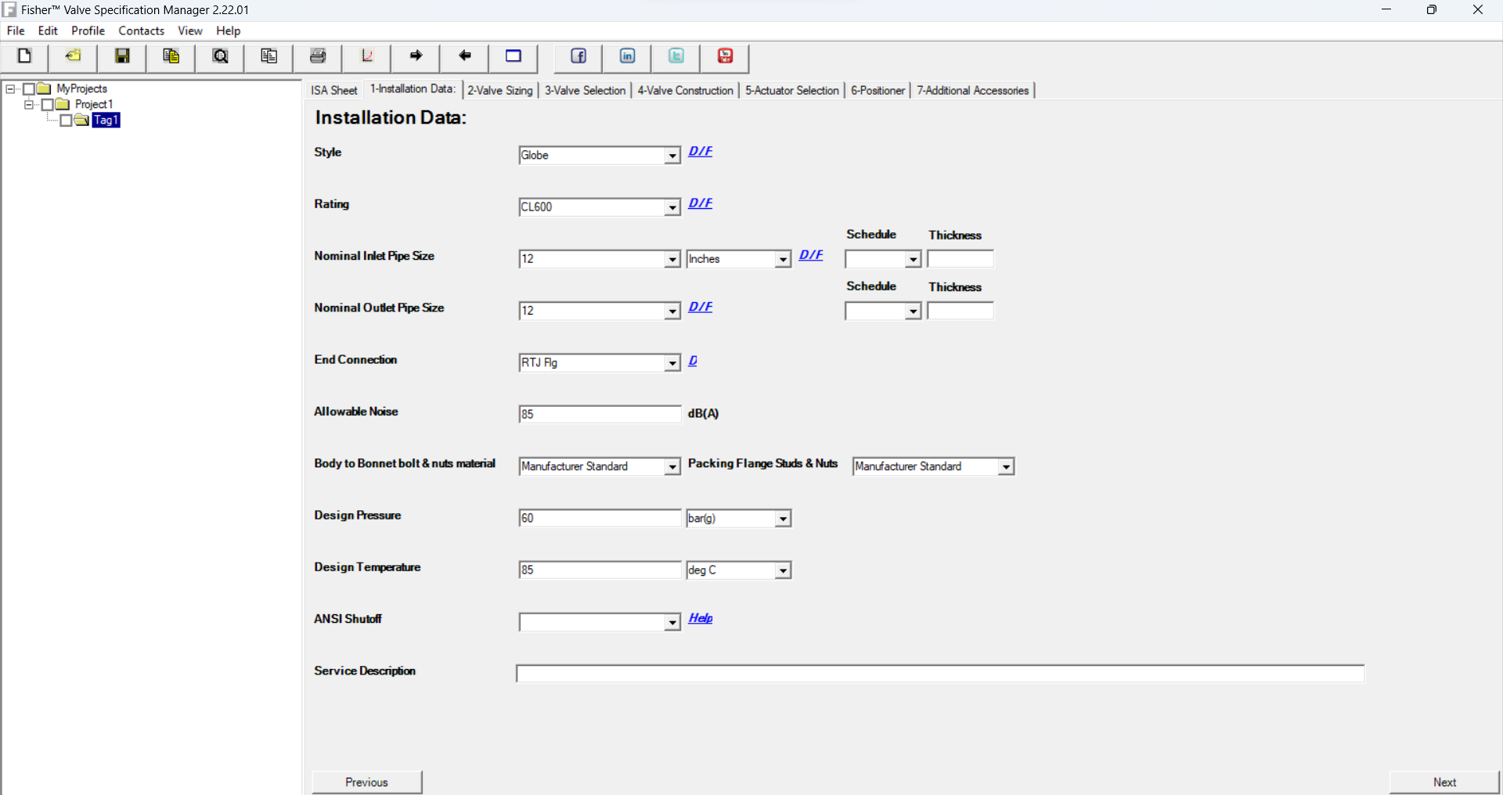
For Cv calculation Fisher FSM software is used.

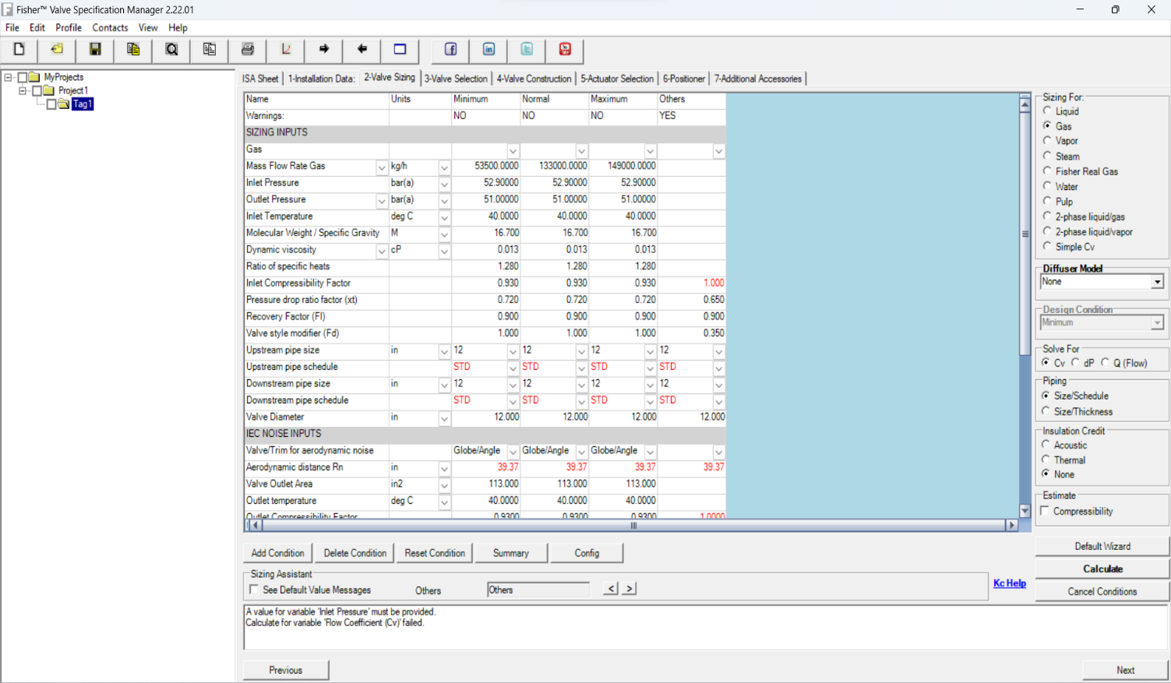

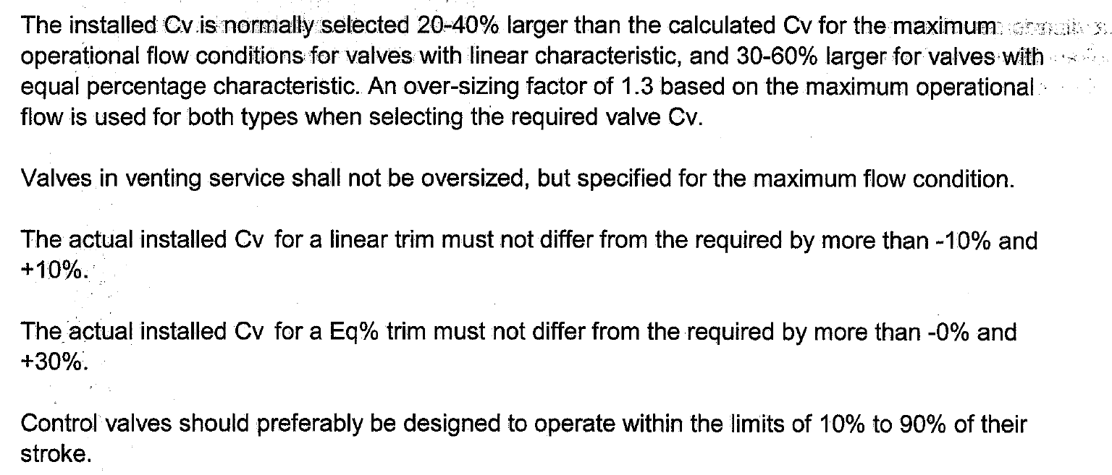
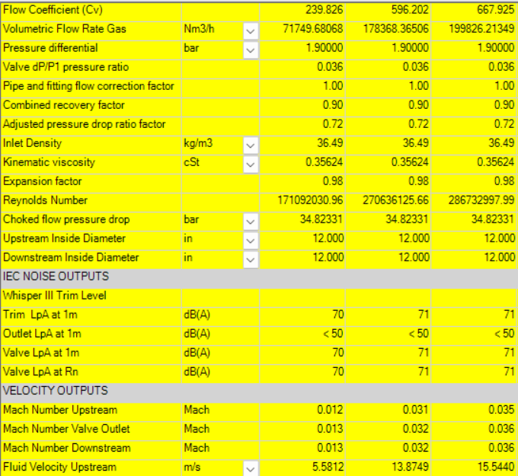
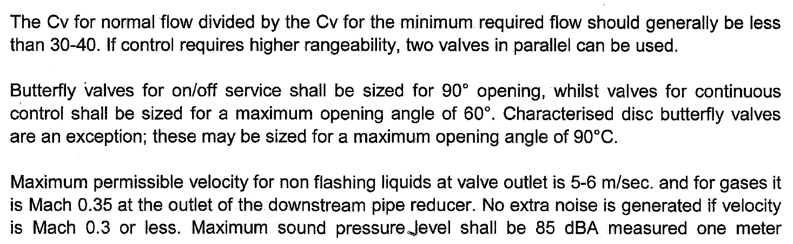
Based on above calculation the Cv for normal operation 596 and for max flow 668 is reported.
Also, the required Cv according to above criteria is 596 * 1.3 = 713
The calculated Noise level is 71 dB at 1 meter which is less than max 85 set by the criteria.
The calculated Mach number is 0.03-0.04 which is much lower than 0.35 set by the criteria.

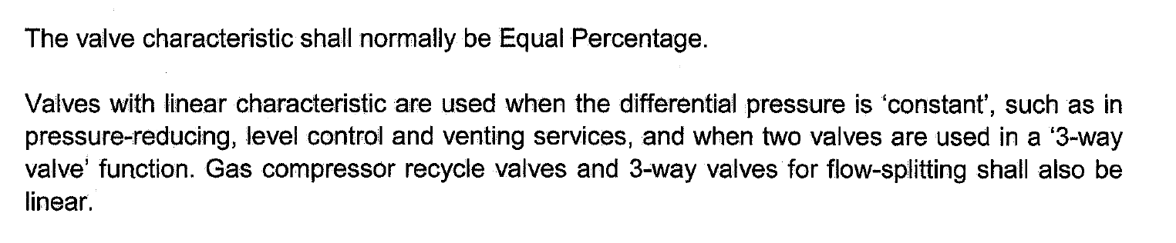
Valve Characteristic
This usually results in using:

a) Equal percentage characteristic on flow and temperature services.

b) Linear characteristic on level services.

c) Linear characteristic usually for pressure control application, however it

requires consideration about energy loss as stated here above.

Linear characteristics shall be applied when specifically so required by the process and/or

control application as follows:

-Compressor anti-surge control,

-Split range control,

-Control valves that are only operated via manual control,

-Minimum flow protection for pumps.

Quick opening characteristic shall only be used when the quick opening
feature is considered to be necessary for process control reasons.

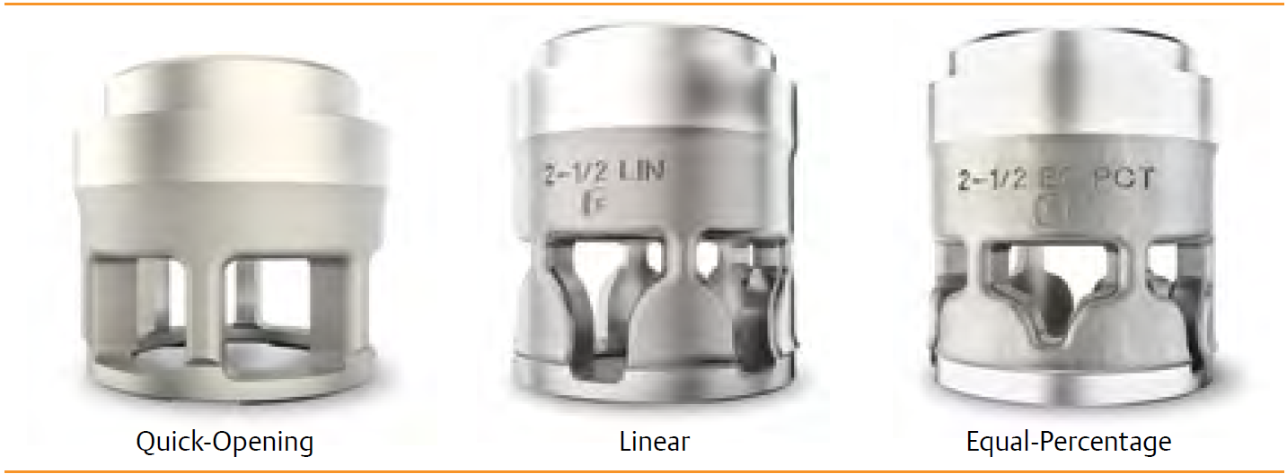

Even though based on above rules a linear characteristic should be selected for pressure
applications, an equal-percentage is selected due to start-up conditions in which at first stages
of start-up low opening of the valve is required while at normal condition high opening is
demanded. Equal percentage characteristic fulfills such demand and therefore is selected.

Trim type
For globe body control valves, the trim construction shall be either single-seated with heavy duty

top guiding for the plug, Double-seated with top and bottom guiding for the plug, or cage type. For

liquid services with a high pressure drop i.e., (boiler feed water), and gas service (pressure let

down), cage trims shall be specified to have the plug supported at the critical area.

Balance type control valve in place of single seat valve in high pressure service shall be
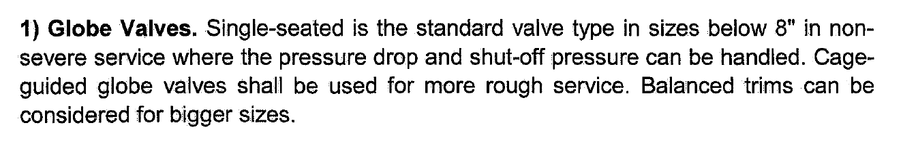
considered.

Based on above explanation since the valve is going to be used in high pressure services and
the size of the valve is more than 8-inch, balanced trim is selected.

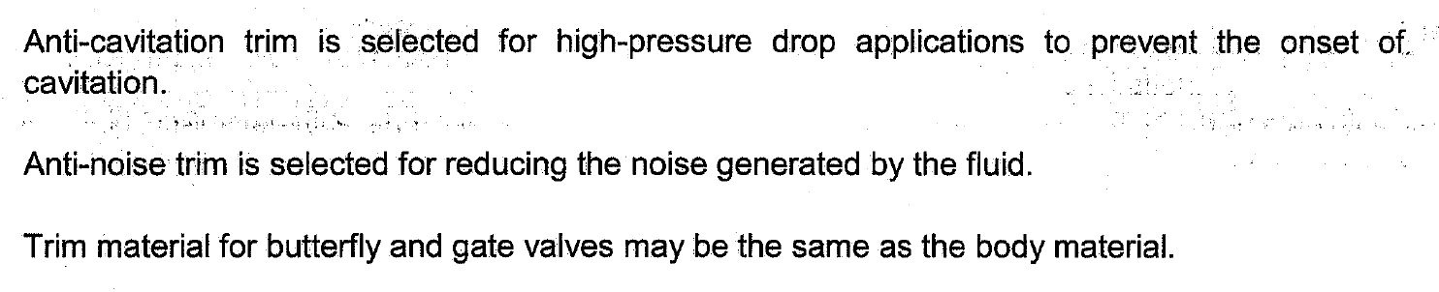
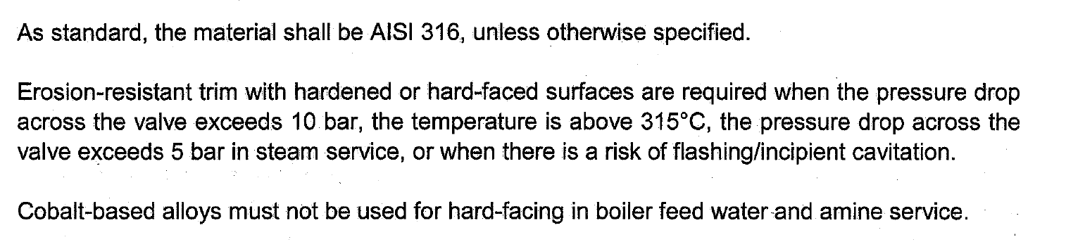
Trim material

Since the pressure drop does not exceed above criteria, the temperature is less than 315 and
there is no risk of flashing or cavitation AISI 316 is selected for this application.

Leakage Class
Control valves are designed to throttle, but they are also often expected to provide some type of
shut-off capability.
A control valve's ability to shut off has to do with many factors: Balanced or unbalanced plug,
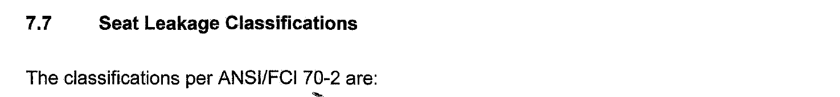
seat material, actuator thrust, pressure drop, and the type of fluid can all play a part in how wella particular control valve shuts off.
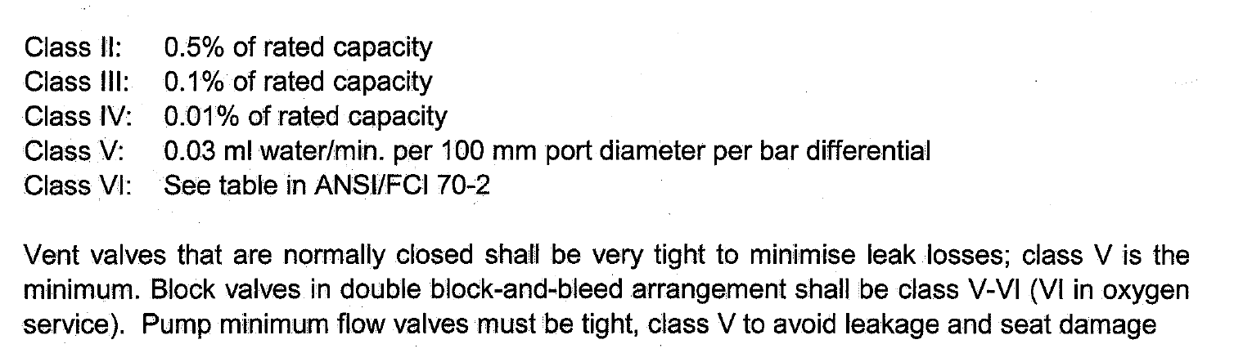
Class IV is also known as a “Metal-to-Metal” seat classification. It is the kind of leakage rate you
can expect from a valve with a metal plug and metal seat
Class VI is known as a “Soft Seat” classification. Soft Seat Valves are those where either the plug
or seat or both are made from some kind of composition material such as Nitrile or Polyurethane.
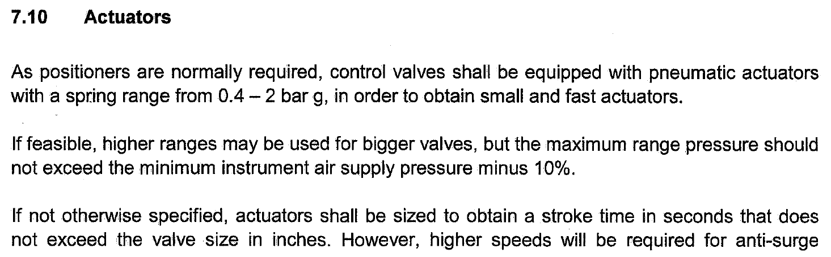
Since it is with metal-to-metal seats Class IV is selected.

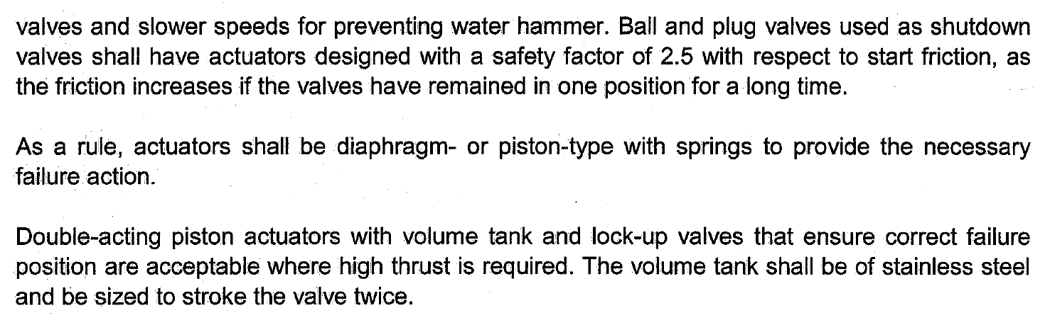
for actuator and positioners Tab the following should be specified:
1.Type
2.Modulating or ON/OFF
3.Failiure position
4.dP for sizing
5.Positioner

Actuator Type:
Based on above criteria, Diaphragm with spring return with spring range of 0.4-2 bar is selected.
Modulating type is selected.
AIR TO CONTROL VALVE OPEN

Failure position
Control valves shall be such that on air failure the valve takes automatically a safe position

either open, or close, or locked in position, depending upon the process requirements.

Based on process requirement air failure holds last position (FLC)

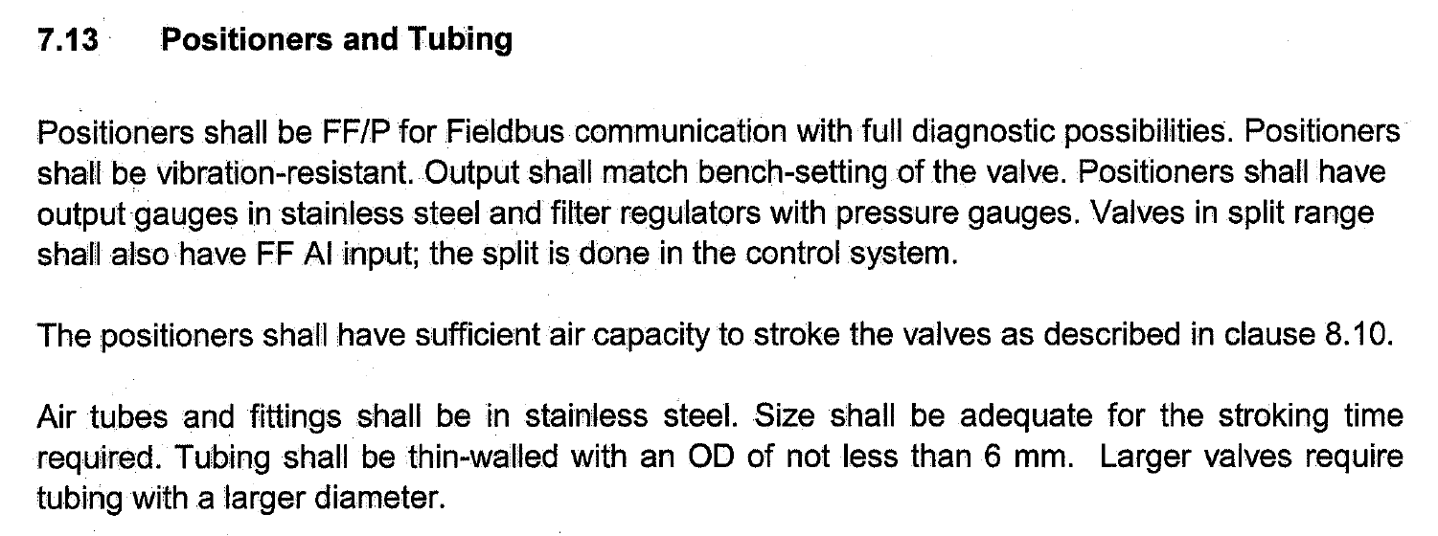

For this valve the type of positioner for this valve is FF/P.
Air Tubes and fitting are in SUS

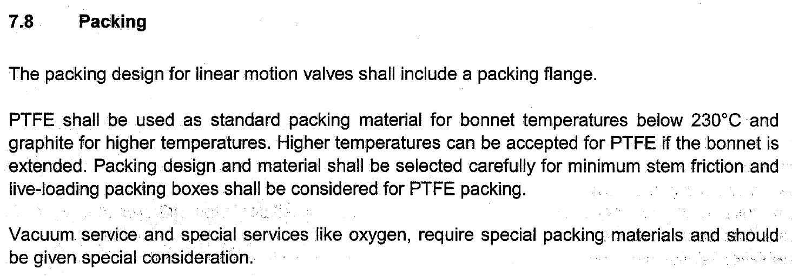
Additional

Since the temperature is less than 230 C then PTFE or equivalent is selected as packing for the
Valve.

Depending upon design of the valve, an extension bonnet may be required to keep the

temperature at the stuffing box to an acceptable value for the applied packing. An extension

bonnet may also be required, when the operating differential pressure across the valve may

cause freezing of the stuffing box/packing and/or ice formation on the trim. This may be the

case, for instance, on compressor recycle (anti-surge) valves. For valves in vacuum service, the

bonnet shall have an extended stuffing box, a lantern ring and a number of packing rings.

Special attention shall be paid to the type of stem packing/sealing facilities as well as stem

surface finish. Packing lubricators with steel isolating control valve shall be provided if

required.
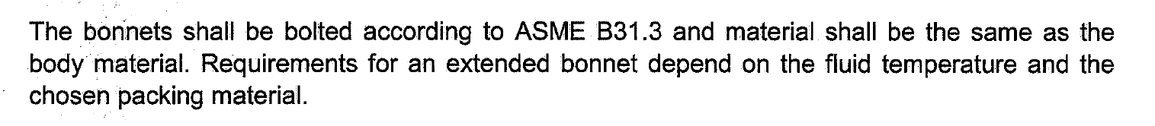

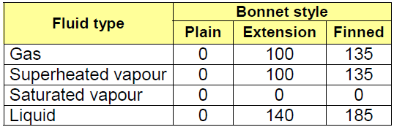

Based on natural gas temperature which is 40C, a standard bonnet is selected.

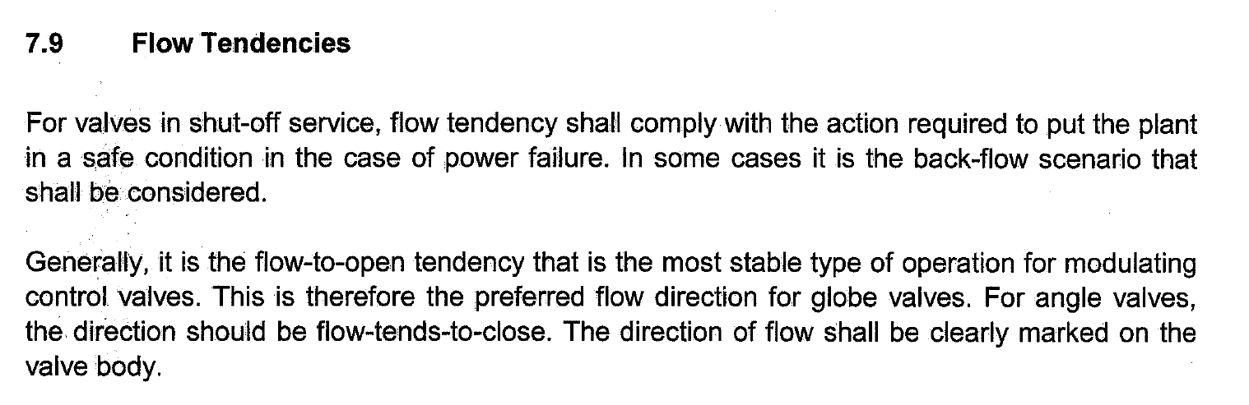
There is a practice by some vendors which as follows:
over-plug flow for liquid services
under-plug flow for gas and vapor services
For the valve with natural gas as fluid a under-plug flow with flow-to-open tendency is selected.

