PV-7028

Sizing and Design Principle

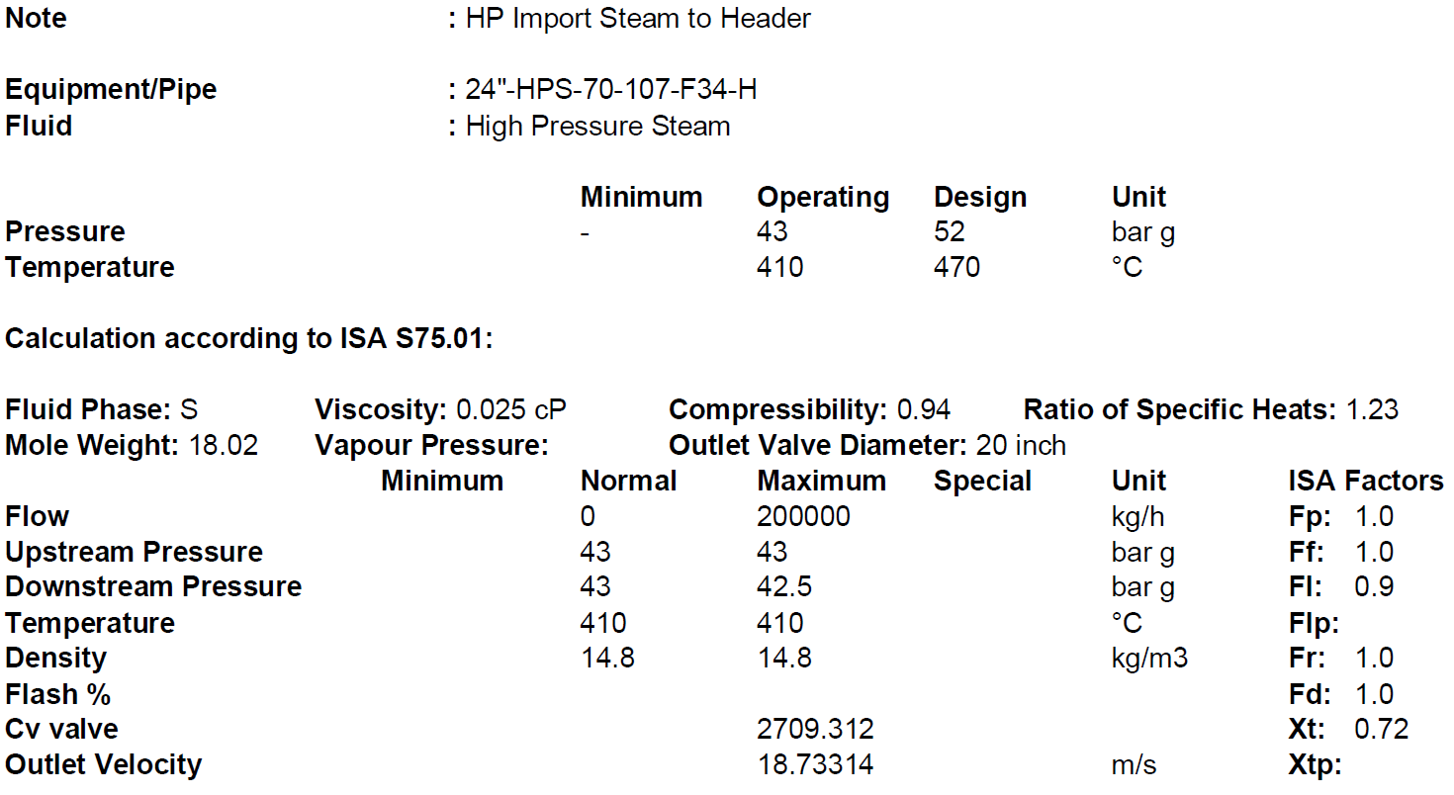1.Operating Condition

…………………………………………………………………………………………………………….

2. Body/Bonnet

In Body/Bonnet Tab the following information should be determined:

1.Type

2. Size

3.Rating

4.Connection type

5.Body material

6.Pipe inlet and outlet

**Type:**

Since the valve is used for flow controlling application a Globe valve is used.

**Size:**

Based on noise calculation when 4 inch is tested the noise is 97 db but when 6 inch is selected

the noise becomes 68 db. Thus 10 inch is selected.

**Rating:**

The rating of valves is the same as the rating of connecting pipes. Since the adjacent pipe class

is 600, the valve class would be 600.

**Connection type:**

The three most common methods of installing control valves into pipelines are by means of

screwed pipe threads, bolted gasketed flanges, and welded end connections.

Screwed end connections, popular in small control valves, offer more economy than flanged

ends. The threads usually specified are tapered female NPT (National Pipe Thread) on the

valve body. They form a metal-to-metal seal by wedging over the mating male threads on the

pipeline ends.

This connection style, usually limited to valves NPS 2 (DN 50) or smaller, is not recommended

for elevated temperature service. Valve maintenance might be complicated by screwed end

connections if it is necessary to take the body out of the pipeline because the valve cannot be

removed without breaking a flanged joint or union connection to permit unscrewing the

valve body from the pipeline.

Flanged end valves are easily removed from the piping and are suitable for use through the

range of working pressures for which most control valves are manufactured. Flanged end

connections can be used in a temperature range from near absolute zero to approximately

815°C (1500°F). They are used on all valve sizes. The most common flanged end connections

include flat-face, raised-face, and ring-type joint.

|  |  |  |
| --- | --- | --- |
| Screwed End | Flanged End | Welded End |
| 2” and smaller | Up to class 900 | Suitable for class 1500 and 2500 |

Since the valve class is 600, flanged end with RF is selected.

**Body material**

1.A216 WCB/WCC or forged carbon steel, A105 is used in non-corrosive services from -28 to

427C.

2. If there are some severe conditions such as flashing, it is typical to use A217 WC9

3. For high temperature services like steam let-down station or HHPS it is a practice to use

A217 WC6.

4. A351 CF8 is used mostly for combined flashing and corrosive services and for temperatures

below -28C.

5. For oxygen services, it is highly recommended to use Monel.

Based on the next-page Table, A217 WC6 could be selected

**Pipe inlet and outlet**

Valve Body Material Selection based on Fluids

|  |  |
| --- | --- |
| Fluid | Material |
| NG | SA216 WCB |
| Purge Gas | SA216 WCB |
| Syngas | SA216 WCB/A351 CF8 |
| Process Condensate | A351 CF8 |
| LPS | SA216 WCB |
| MPS | SA216 WCB |
| HPS | SA216 WCB /SA217 WC6 |
| HHPS | SA217 WC6 |
| LPC | SA217 WC6/WC9 |
| MPC | SA216 WCB |
| HPC | SA217 WC9 |
| BFW | SA216 WCB/ SA217 WC6 |
| WMW | A351 CF8 |
| Nitrogen | SA216 WCB |
| Crude Methanol | SA216 WCB |
| Flashed Methanol | A351 CF8 |
| Refined Methanol | SA216 WCB |
| Process Gas | SA216 WCB/ A351 CF8 |
| Oxygen | Monel |

**3. Trim**

For Trim Tab the following should be specified:

1.Cv calculation

2.Charachteristic

3.Type

4.Material

5.Leakage Class

**Cv calculation**

For Cv calculation Fisher FSM software is used.

Based on above calculation the Cv for max operation 142

The calculated Noise level is 68dB at 1 meter which is less than max 85 set by the criteria.

The calculated Mach number is 0.18 which is much lower than 0.35 set by the criteria.

**Valve Characteristic**

This usually results in using:

a) Equal percentage characteristic on flow and temperature services.

b) Linear characteristic on level services.

c) Linear characteristic usually for pressure control application, however it

requires consideration about energy loss as stated here above.

Linear characteristics shall be applied when specifically so required by the process and/or

control application as follows:

-Compressor anti-surge control,

-Split range control,

-Control valves that are only operated via manual control,

-Minimum flow protection for pumps.

Quick opening characteristic shall only be used when the quick opening

feature is considered to be necessary for process control reasons.

Based on above rules linear is selected./multi flow

**Trim type**

For globe body control valves, the trim construction shall be either single-seated with heavy duty

top guiding for the plug, Double-seated with top and bottom guiding for the plug, or cage type. For

liquid services with a high pressure drop i.e., (boiler feed water), and gas service (pressure let

down), cage trims shall be specified to have the plug supported at the critical area.

Balance type control valve in place of single seat valve in high pressure service shall be

considered.

Based on above explanation since the valve is going to be used in high pressure services

, cage guided balanced trim is selected.

**Trim material**

Based on above criteria AISI316/hard faced should be selected since the temperature is more

than 315C. The vendor has selected AISI316 Gr. 6 Stellite for seat and plug

**Leakage Class**

Control valves are designed to throttle, but they are also often expected to provide some type of

shut-off capability.

A control valve's ability to shut off has to do with many factors: Balanced or unbalanced plug,

seat material, actuator thrust, pressure drop, and the type of fluid can all play a part in how wella particular control valve shuts off.

Class IV is also known as a “Metal-to-Metal” seat classification. It is the kind of leakage rate you

can expect from a valve with a metal plug and metal seat

Class VI is known as a “Soft Seat” classification. Soft Seat Valves are those where either the plug

or seat or both are made from some kind of composition material such as [Nitrile or Polyurethane](https://kimray.com/choose-elastomers-control-valve/).

Since it is with metal-to-metal seats Class IV is selected.

for actuator and positioners Tab the following should be specified:

1.Type

2.Modulating or ON/OFF

3.Failiure position

4.dP for sizing

5.Positioner

**Actuator Type:**

Based on above criteria, because of required high trust double-acting piston actuator is

selected.

Modulating type is selected.

**Failure position**

Control valves shall be such that on air failure the valve takes automatically a safe position

either open, or close, or locked in position, depending upon the process requirements.

Based on process requirement FLO is selected

For this valve the type of positioner for this valve is FF/P.

Air Tubes and fitting are in SUS

**Additional**

Since the temperature is more than 230 C then graphite or equivalent (grafoil) is selected as

packing for the Valve.

Depending upon design of the valve, an extension bonnet may be required to keep the

temperature at the stuffing box to an acceptable value for the applied packing. An extension

bonnet may also be required, when the operating differential pressure across the valve may

cause freezing of the stuffing box/packing and/or ice formation on the trim. This may be the

case, for instance, on compressor recycle (anti-surge) valves. For valves in vacuum service, the

bonnet shall have an extended stuffing box, a lantern ring and a number of packing rings.

Special attention shall be paid to the type of stem packing/sealing facilities as well as stem

surface finish. Packing lubricators with steel isolating control valve shall be provided if

required.

Based on steam temperature which is 345C, a Fin-extended bonnet is selected. But the vendor

has selected normalizing

There is a practice by some vendors which as follows:

over-plug flow for liquid services

under-plug flow for gas and vapor services

For the valve with steam as fluid a under-plug flow with flow-to-open tendency is selected. But

the vendor has selected over plug