Air-cooler Design and Principle

AE-5005

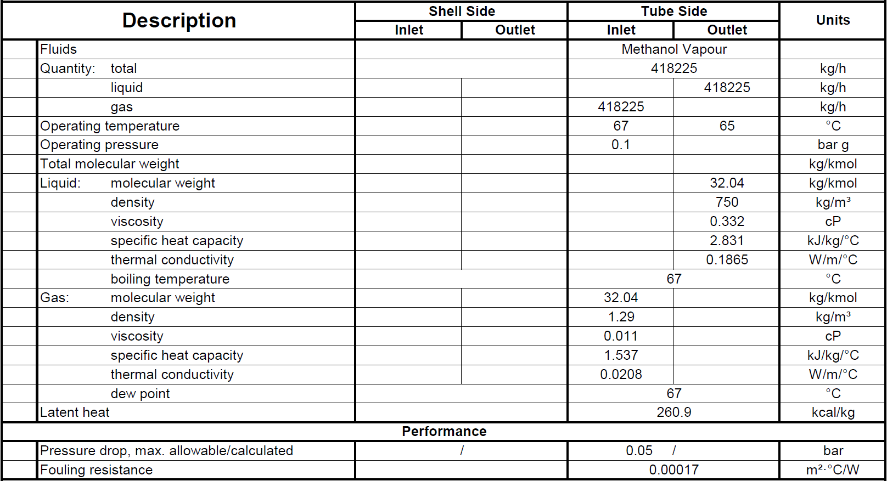1.Process Specification

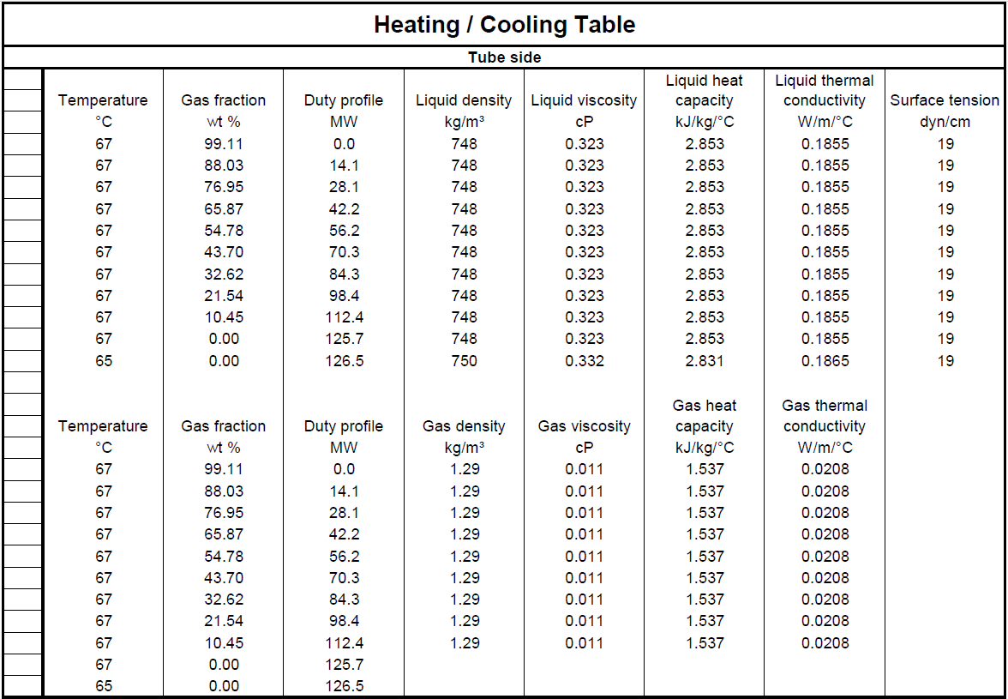

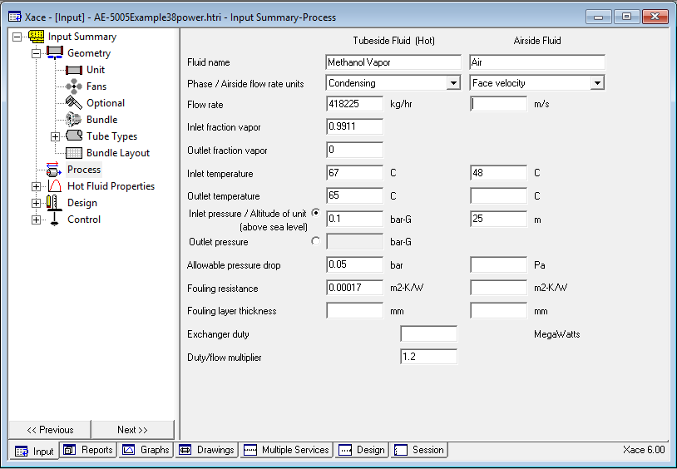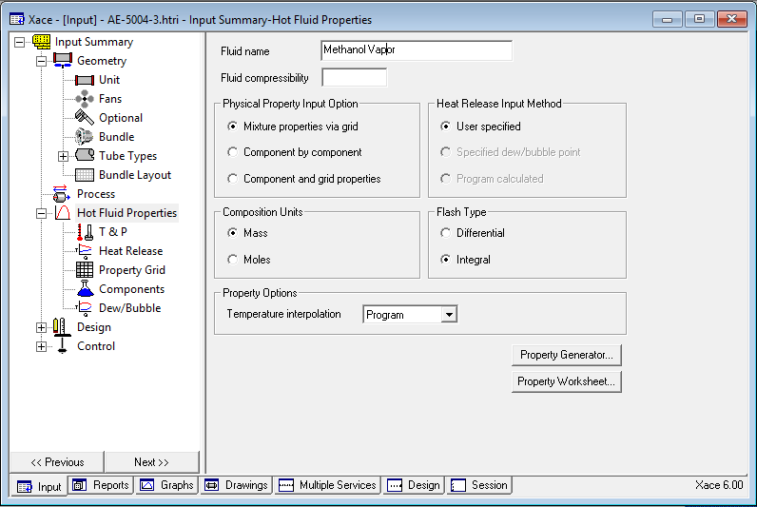2.Process Input to HTRI

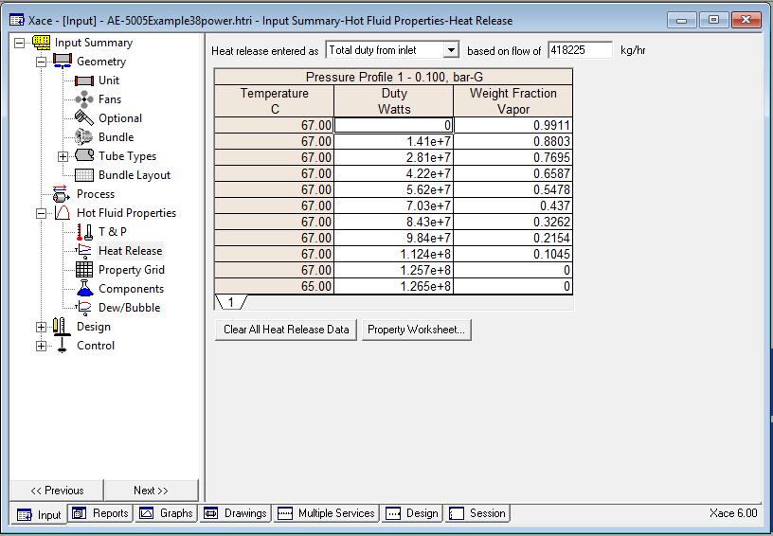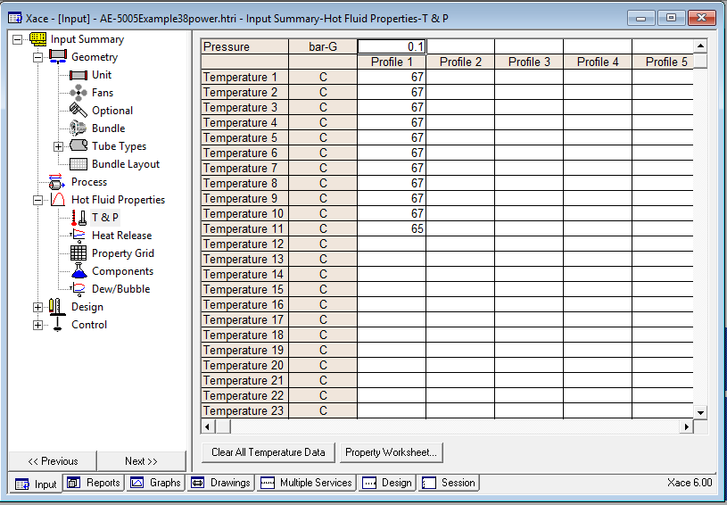

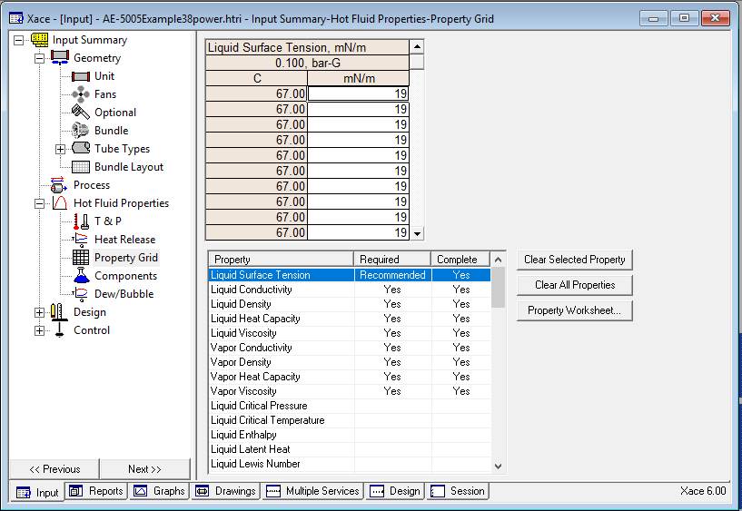

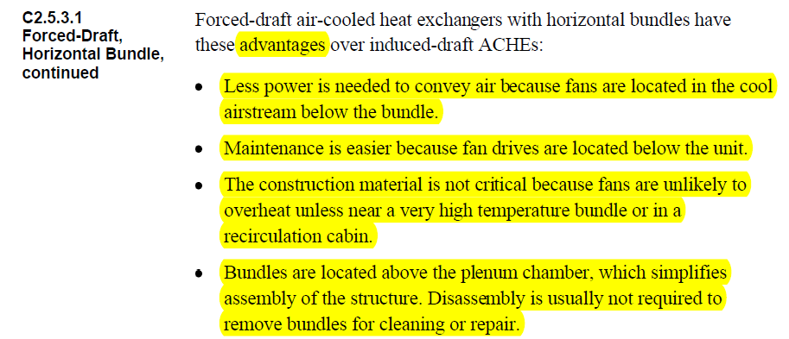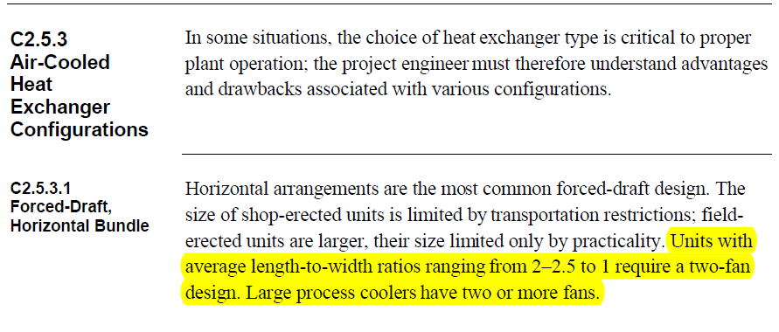3.Unit data to HTRI

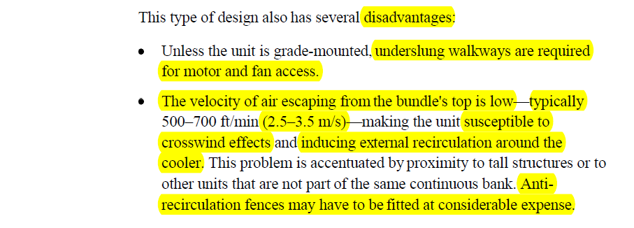

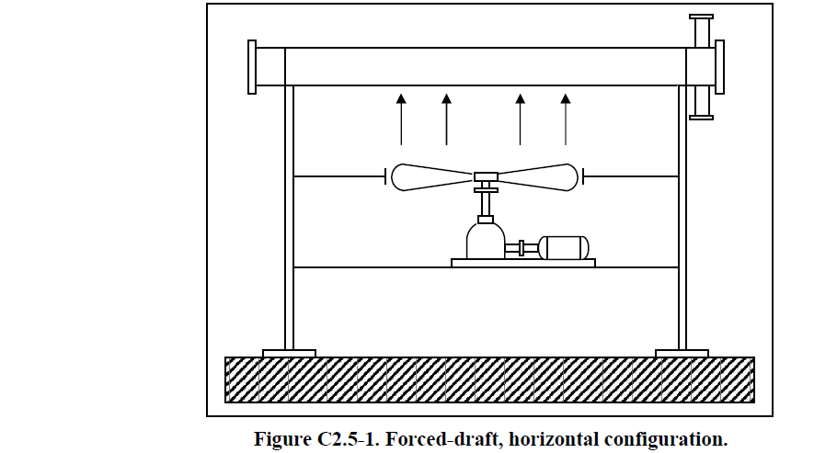

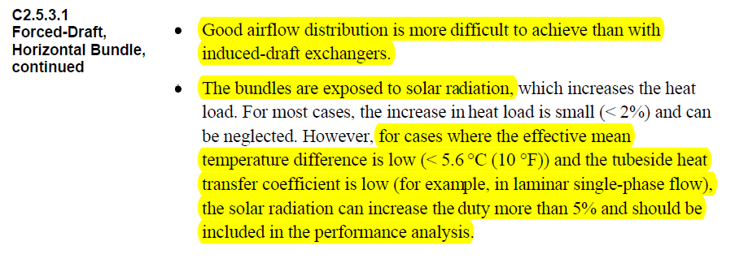

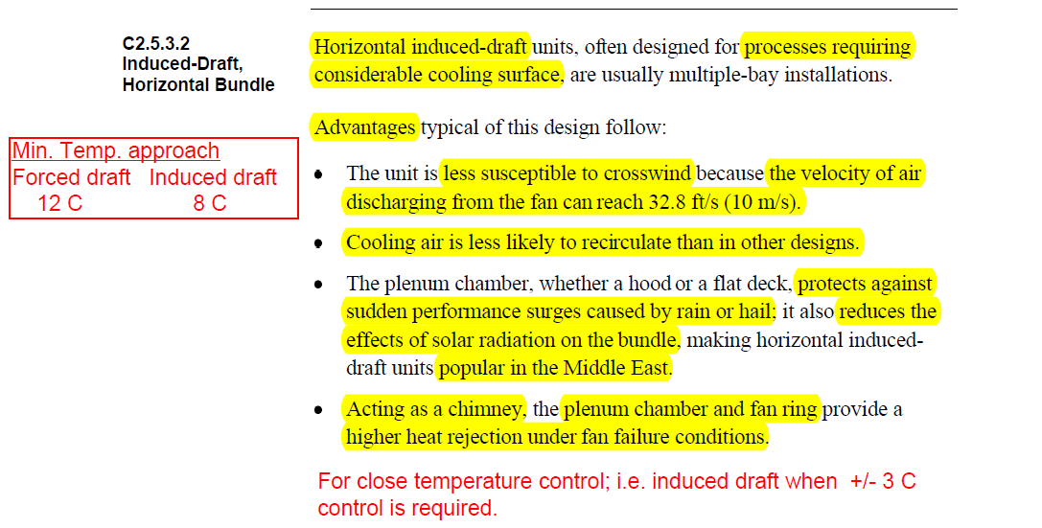

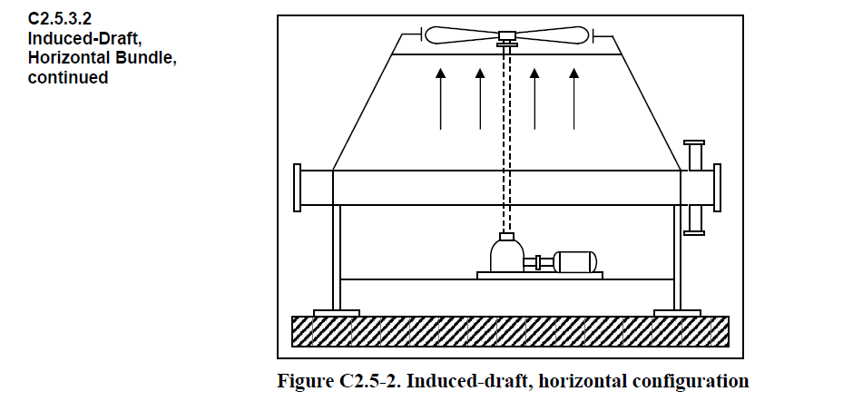

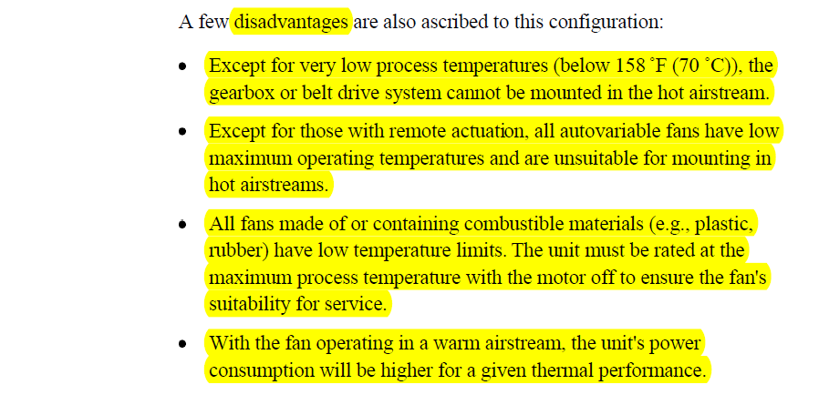

**Bay**

One or more tube bundles, serviced by two or more fans, including the structure, plenum and

other attendant equipment.

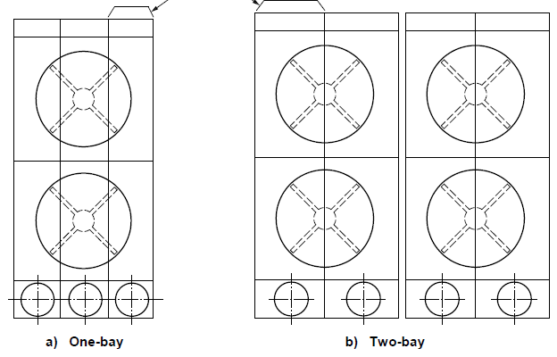

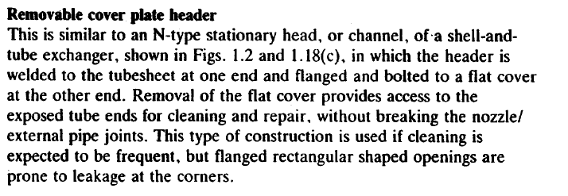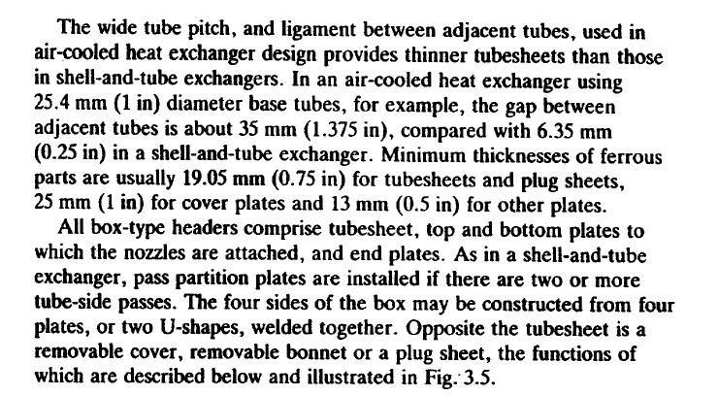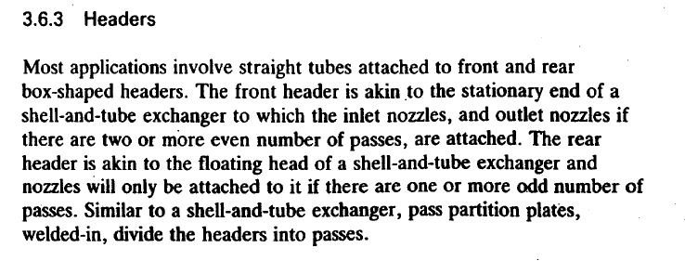

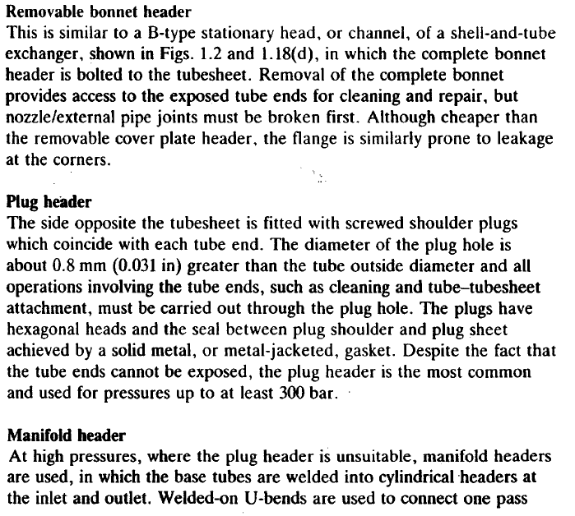

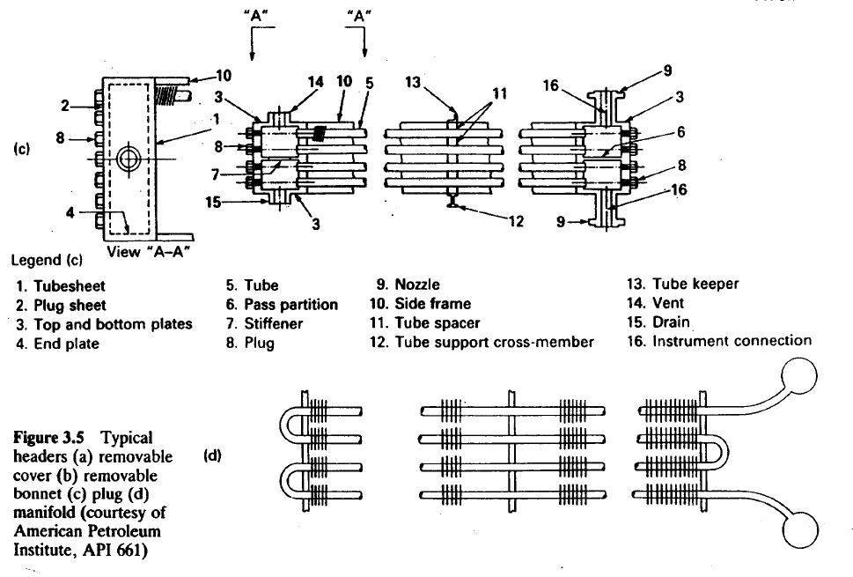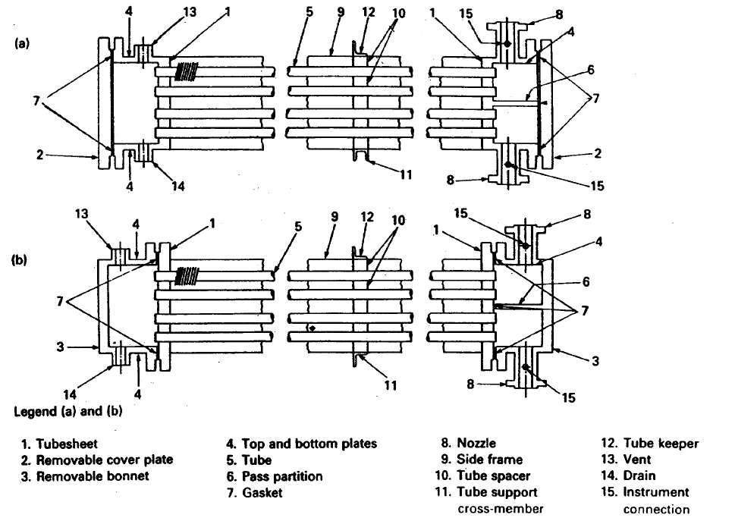

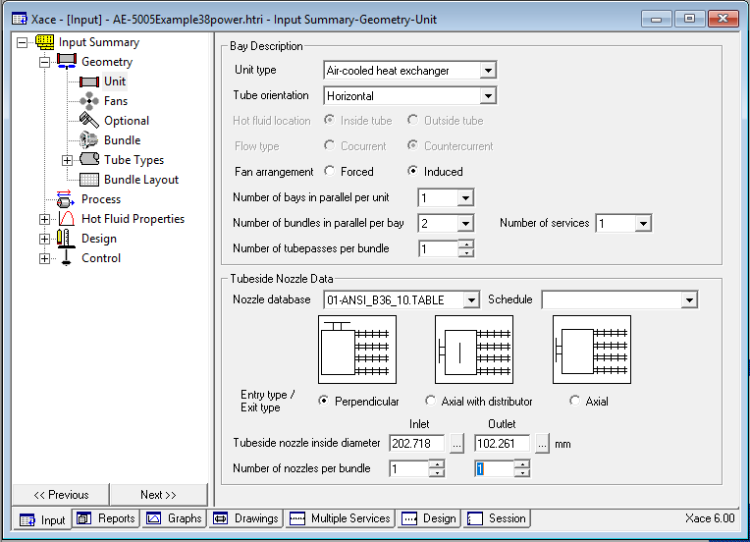

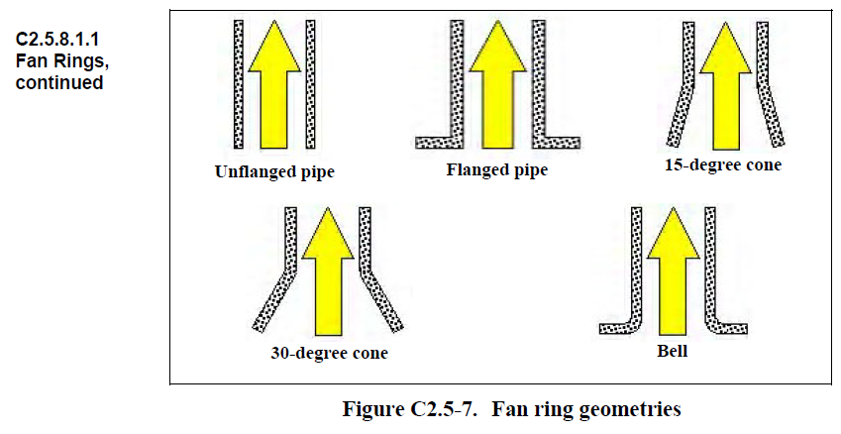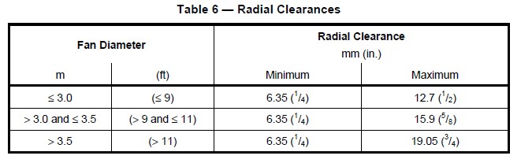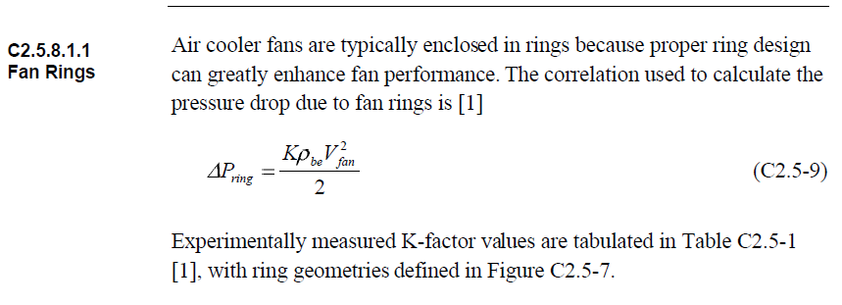4.Fan Data to HTRI

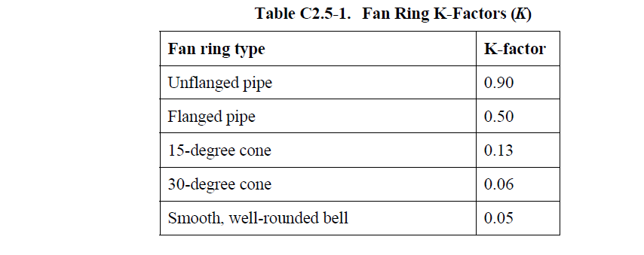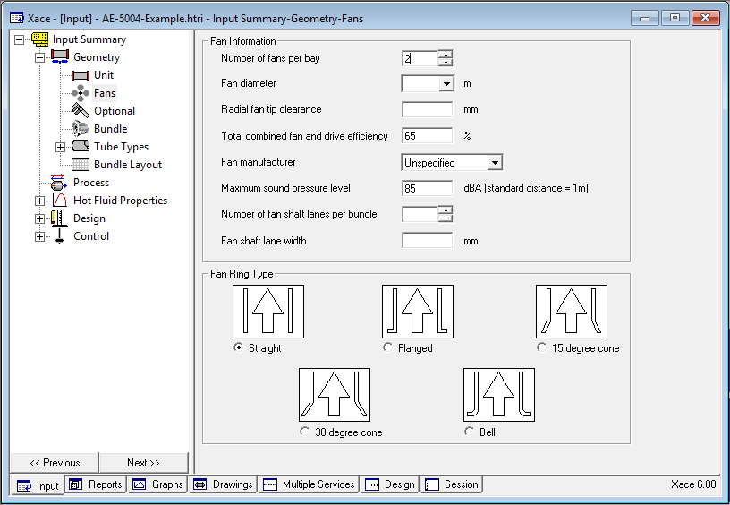

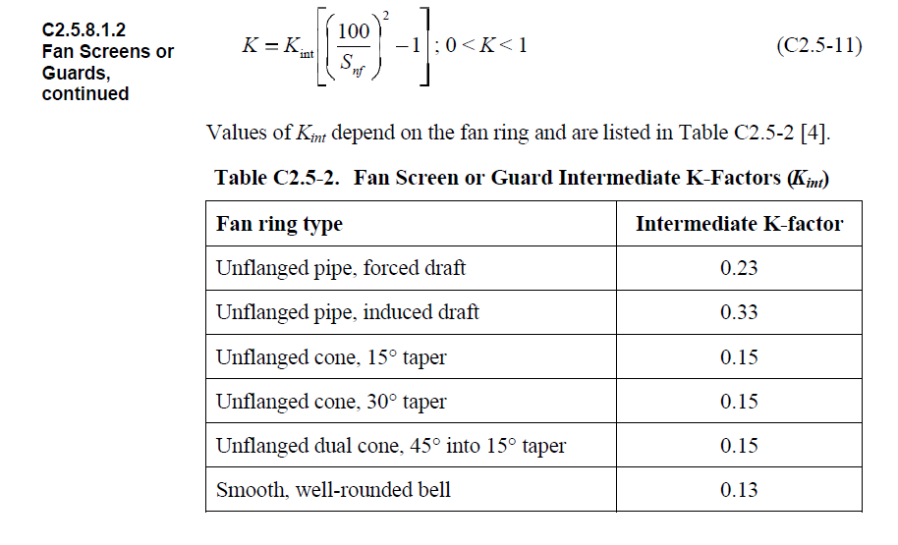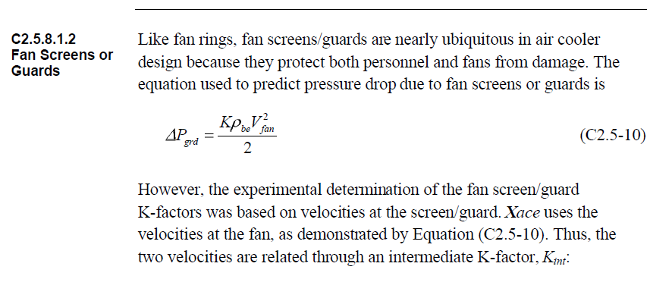5.Optional Data to HTRI

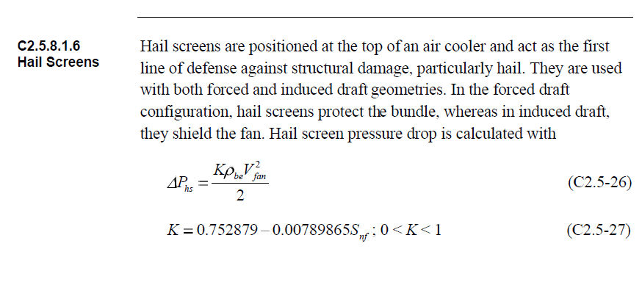

**Drivers**

For electric motor drivers, the minimum required driver rated shaft power (*P*dr) shall be

calculated as follows:

*P*dr ≥ 1.05 (*P*f1/*E*m)

*P*dr ≥ 1.10 (*P*f2)

Where

*P*dr is driver rated shaft power;

*P*f1 is fan shaft power operating at specified minimum design temperature with blade angle set

for design dry-bulb temperature;

*E*m is mechanical efficiency of the power transmissions;

*P*f2 is fan shaft power operating at design dry-bulb temperature.

These requirements apply to fixed-pitch, variable-pitch and variable-speed fans unless

otherwise specified.

Once installed in the bundle, the tubes must be supported to prohibit intermeshing of the fins, and “bunching” of the tubes, which allows for openings in the tube that allow channeling of the airflow. Several means of tube support are utilized dependent on manufacture.

The most common tube support is provided by a “wiggle strip” that is place between each row, and runs between each tube. This method allow for support of the tube from the fin tip and is susceptible to movement in the bundle during transportation.

Another common method, utilized by some manufacturers, is to wrap aluminum strips around the perimeter of the tube at designated spots along the length. These strips are stapled to prohibit them from loosening. Again, this provides support from the tip of the fin.

A third method is the scalloped channel. This method provides a strip, normally fabricated from aluminum that cradles each tube and runs the entire width of the bundle.

The scalloped channel is formed to provide both supports from the fin tip, and to the tube

wall. Based on the configuration, it is not able to move after inserted, and also provides a means of keeping the tubes spaced properly.

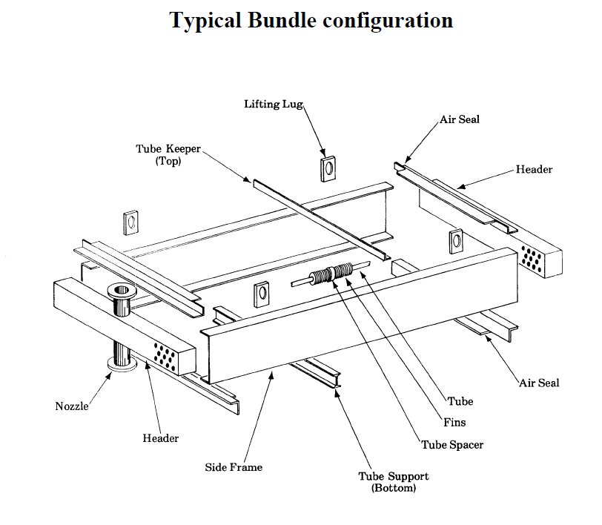Tube support can also be provided by cast zinc collars. This method requires a zinc collar to be poured at each support spot on the tube. This method, while providing excellent support, is normally cost prohibitive.

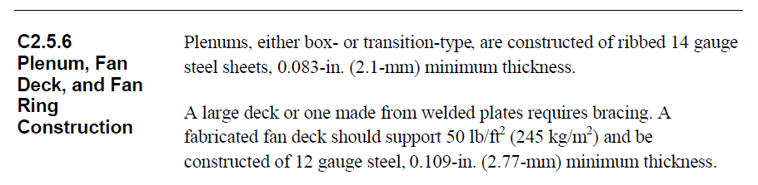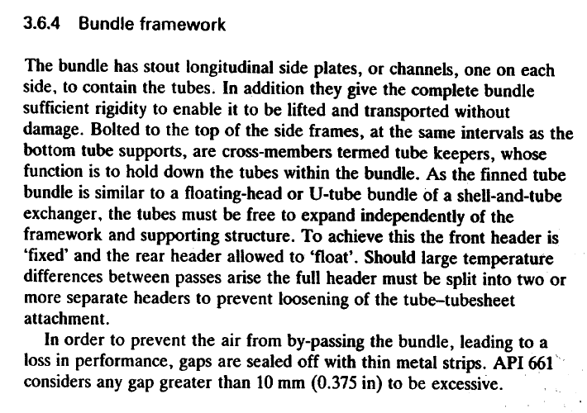



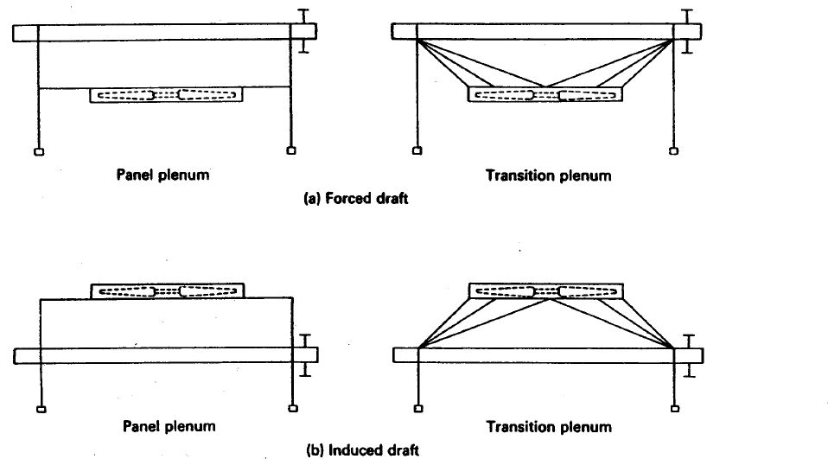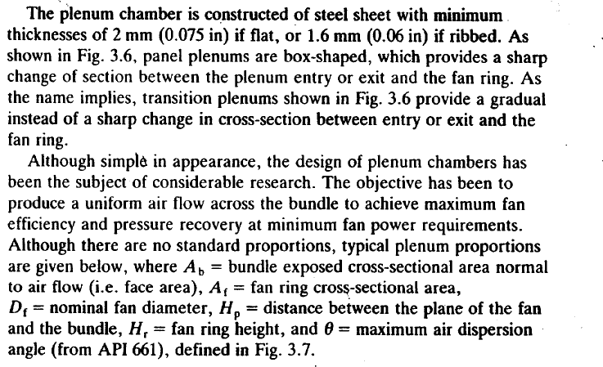

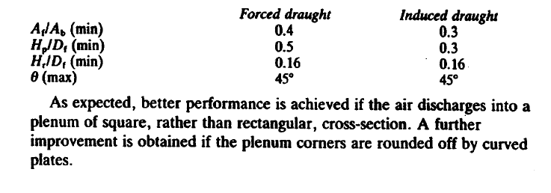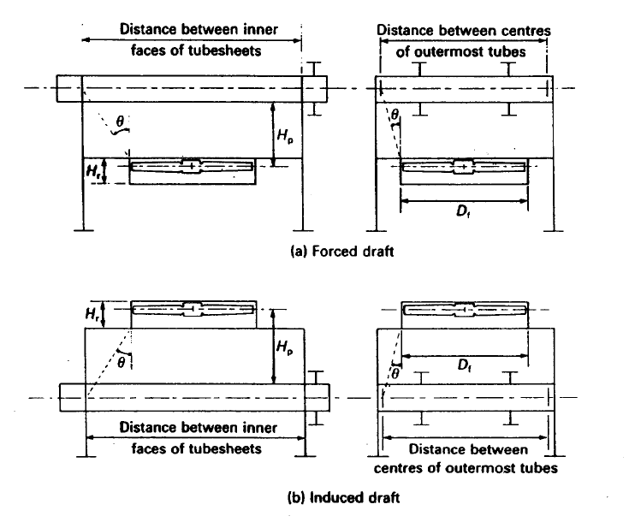

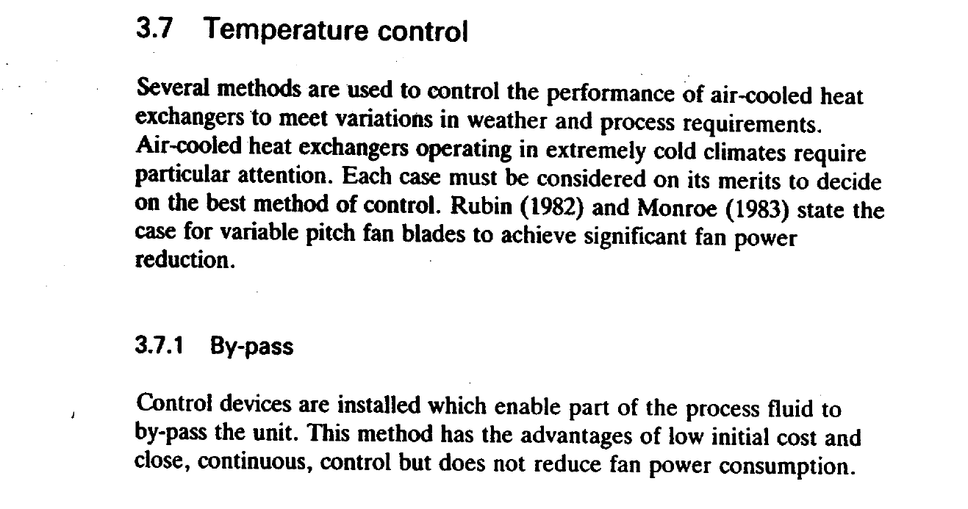



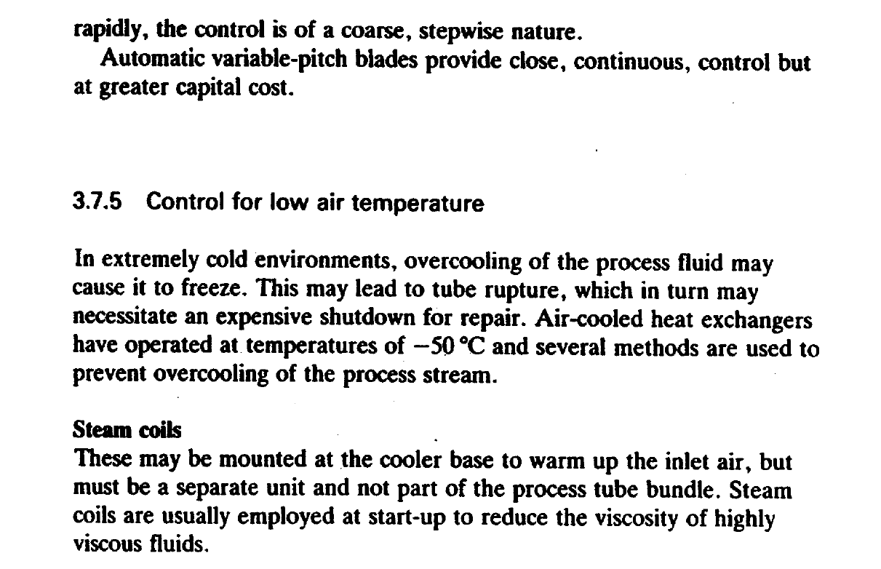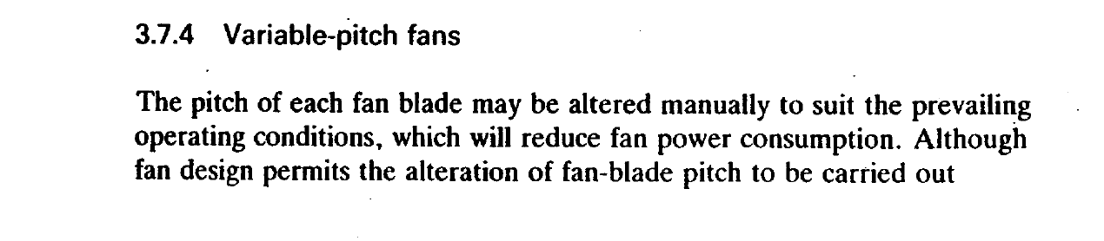

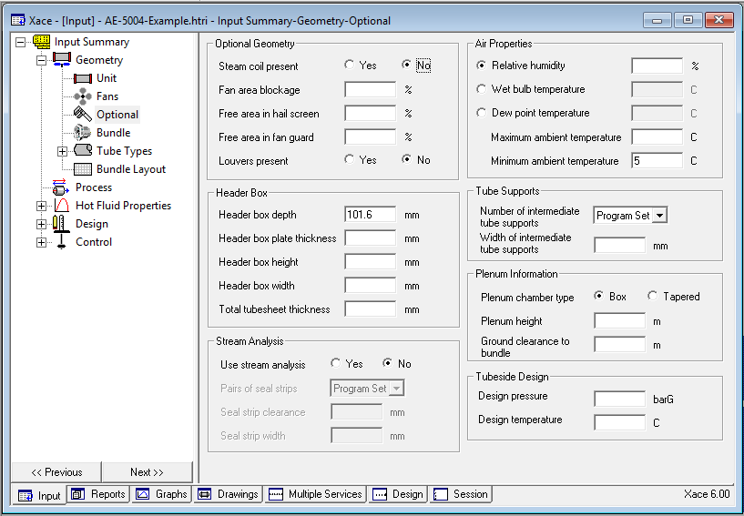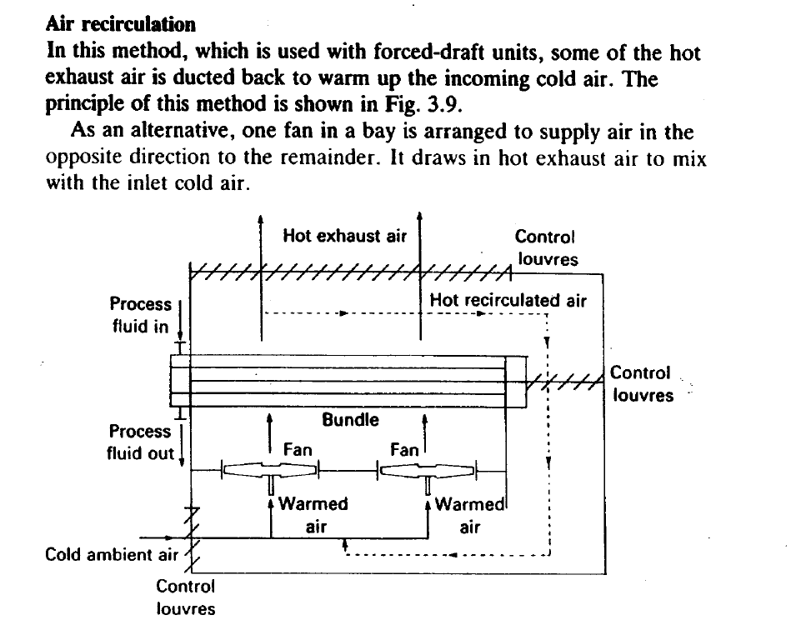

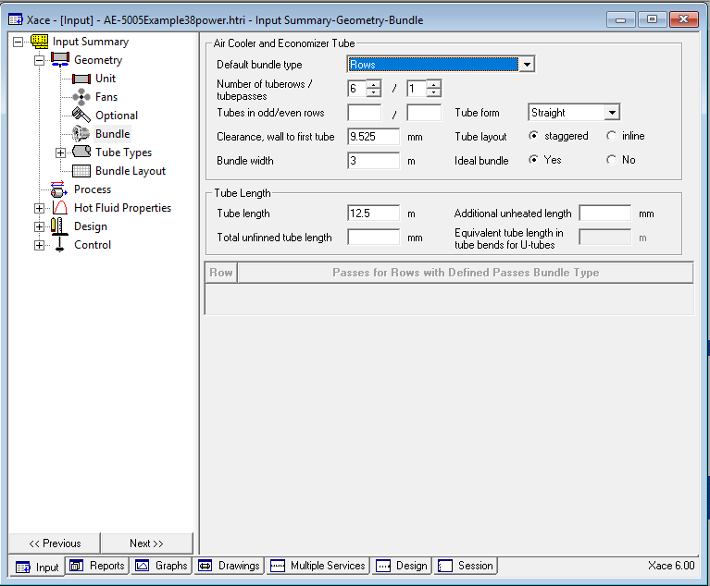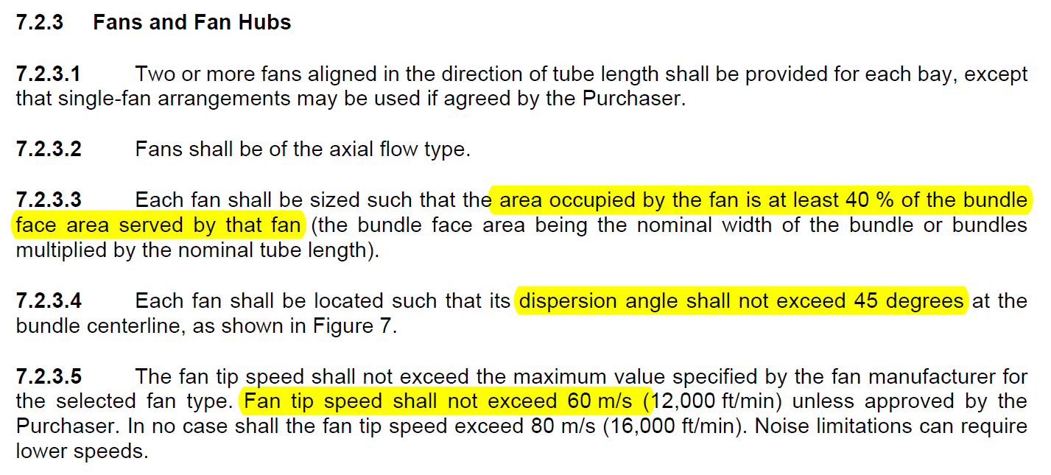6.Bundle Data to HTRI

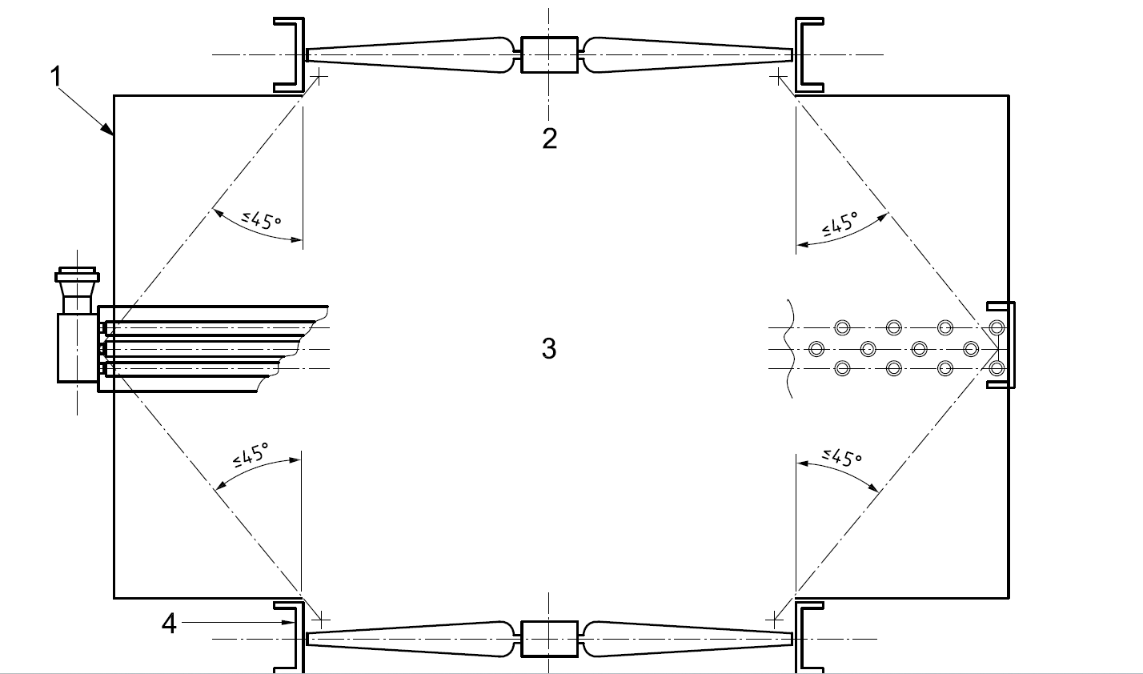

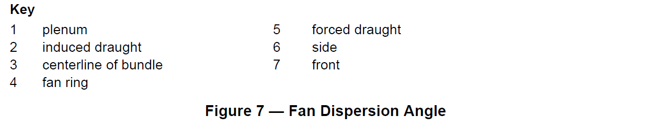

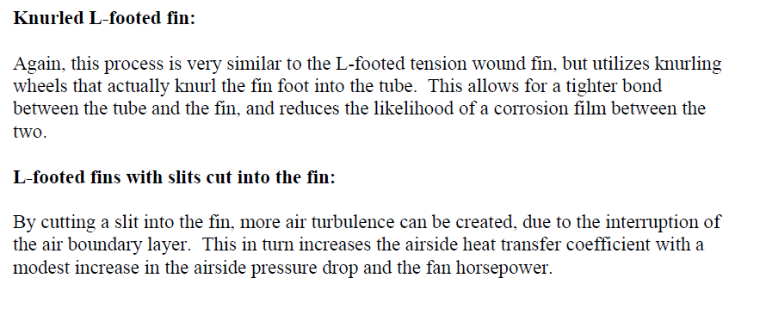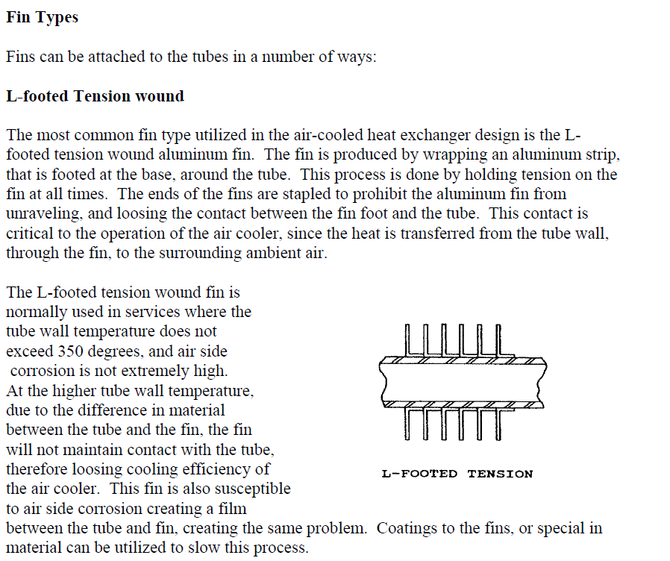7.Tube type Input to HTRI

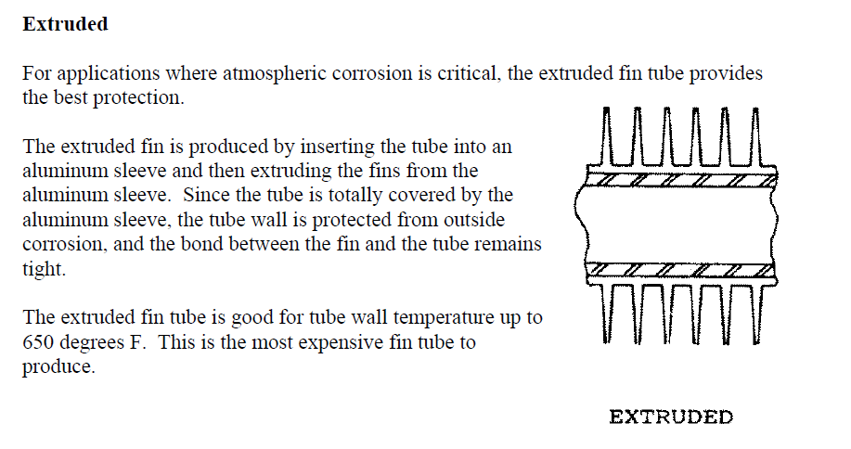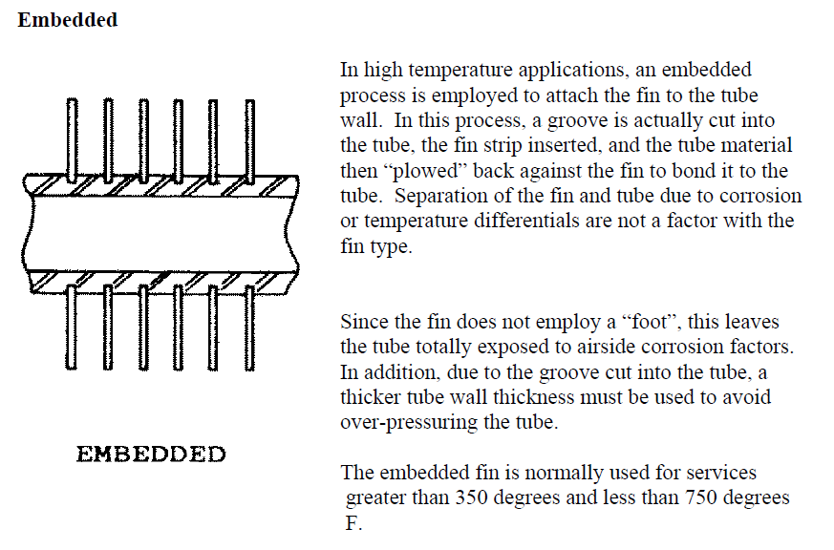

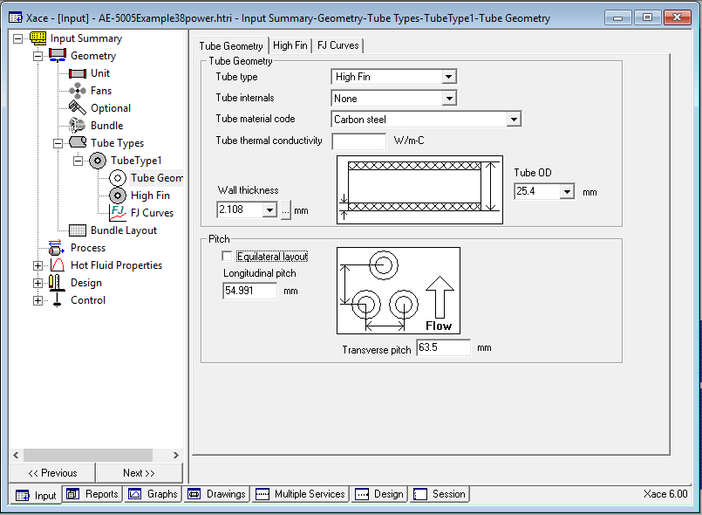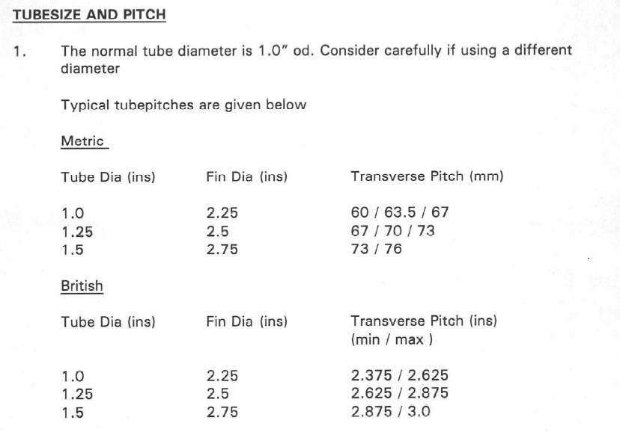

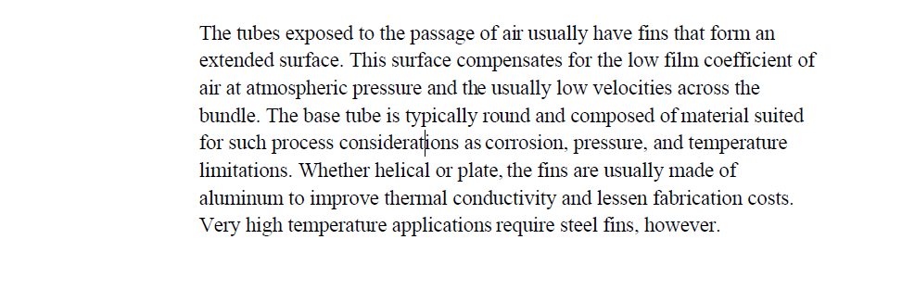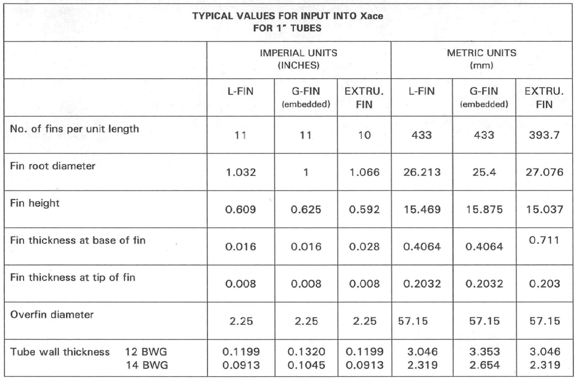

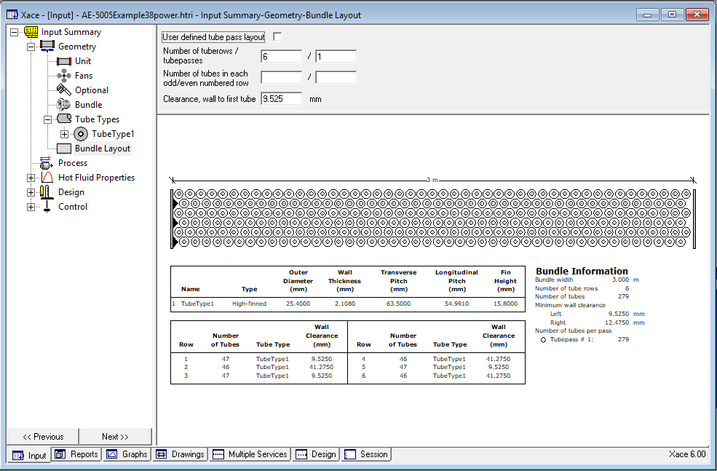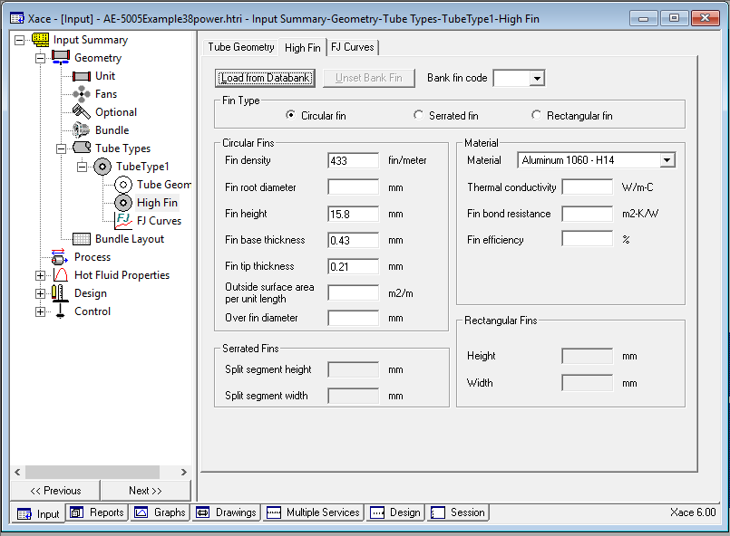

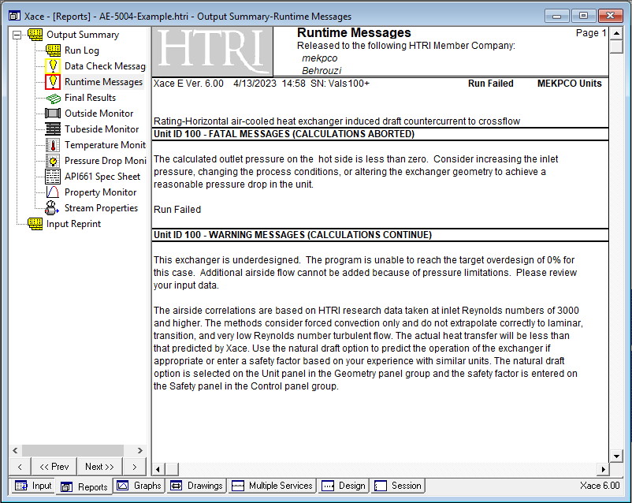Results

Since 1 bay was selected, which is very low for such high flow, the software failed to run. Thus, the number of bays is increased to 2 and the program is run again. The summery of the actions are provided below.

|  |  |  |
| --- | --- | --- |
| Number of bays | Pressure drop | Driver Power |
| 1-5 | Failed | Failed |
| 6-10 | Underdesigned | Underdesigned |
| 12 | 533855 | 69821215 |
| 15 | 10797 | 28983 |
| 18 | 3163 | 4138 |
| 21 | 1661.5 | 1508 |
| 24 | 939 | 616 |
| 27 | 590 | 296 |
| 30 | 430 | 180 |
| 33 | 318 | 111 |
| 36 | 259 | 80 |
| 39 | 205 | 55 |
| 40 | 192 | 49 |
| 41 | 179 | 44.46 |
| 42 | 165 | 38 (44) |

Now we stop here and try to change some parameters to optimise the required driver power.

|  |  |  |
| --- | --- | --- |
| Actions | Pressure drops | Driver Power |
| Increasing fan efficiency to  75% | 164.9 | 33.6 (38.78) |
| Changing fan ring type to  cone 30 | 133.9 | 28.43 (32.83) |

Now one of the parameters that should be taken into account is the flow regime. To find out how it looks like graph tab is clicked and then Flow regime map is selected.

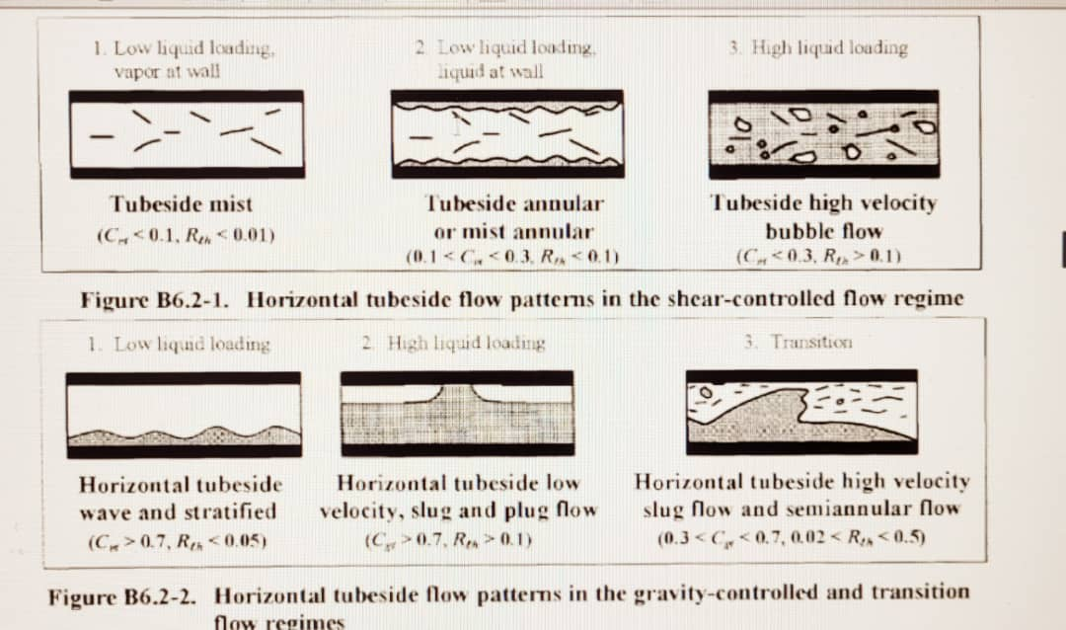How it is interpreted

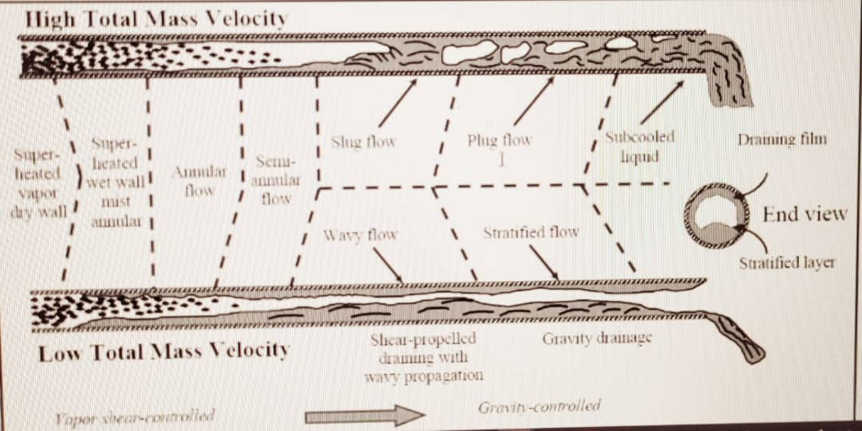

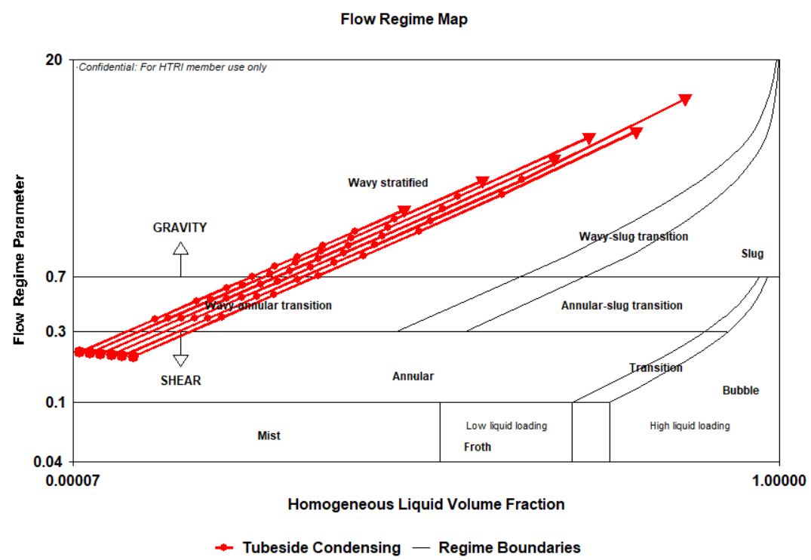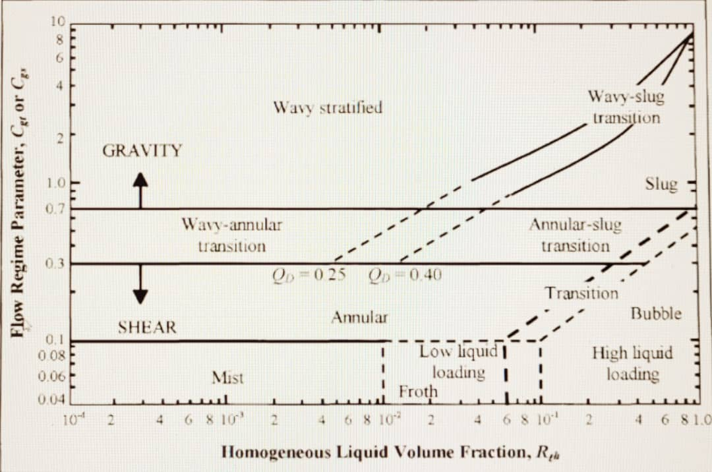

Notes:

Only the last tube-pass in a multipass condenser should be in gravity-controlled flow. Remember that in gravity-controlled flow, the vapor-phase heat transfer coefficient can become very low especially when non-condensible are present.

The effect of tube inclination contributes to an approximate avarage increase of only 20 percent in the tube-side heat transfer coefficient on the avarage tube side heat transfer. HTRI therefore recommends inclining tubeside condensers in gravity-flow about 3 degrees towards the draining condensate end to prevent condensate back flow.

So, in order to adjust the flow regime, map we perform the following actions:

|  |  |  |
| --- | --- | --- |
| Actions | Pressure drop | Driver Power |
| Changing from one pass to two passes | 114.3 | 21.81(25.18) |
| Changing from two pass to  3 passes (4-1-1) | 112 | 21.14(24.41) |
| Changing 3 passes orientation from (4-1-1) to (3-2-1) | 112 | 21.15(24.41) |
| Force seperation | 129 | 26.9(31.05) |
| Get back to (4-1-1) | 113 | 21.5 (25) |

Now let’s see the impacts of the steps on flow regime:

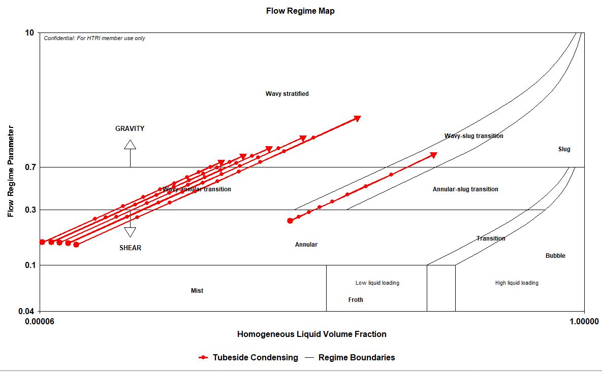

Two-passes with the orientation of 5-1

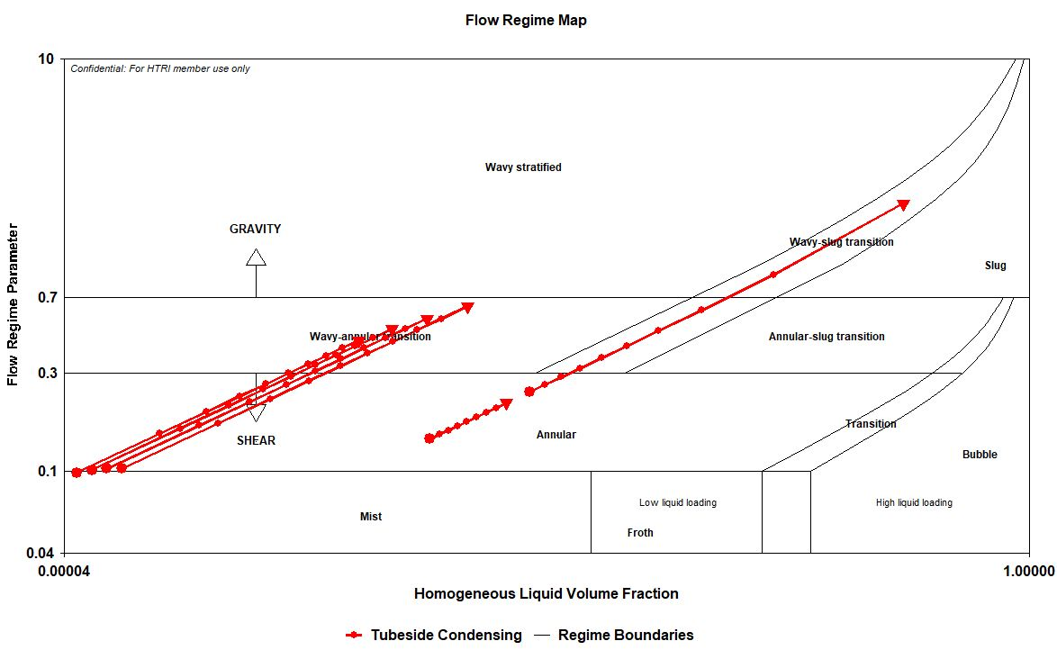

Three passes with the orientation of 4-1-1

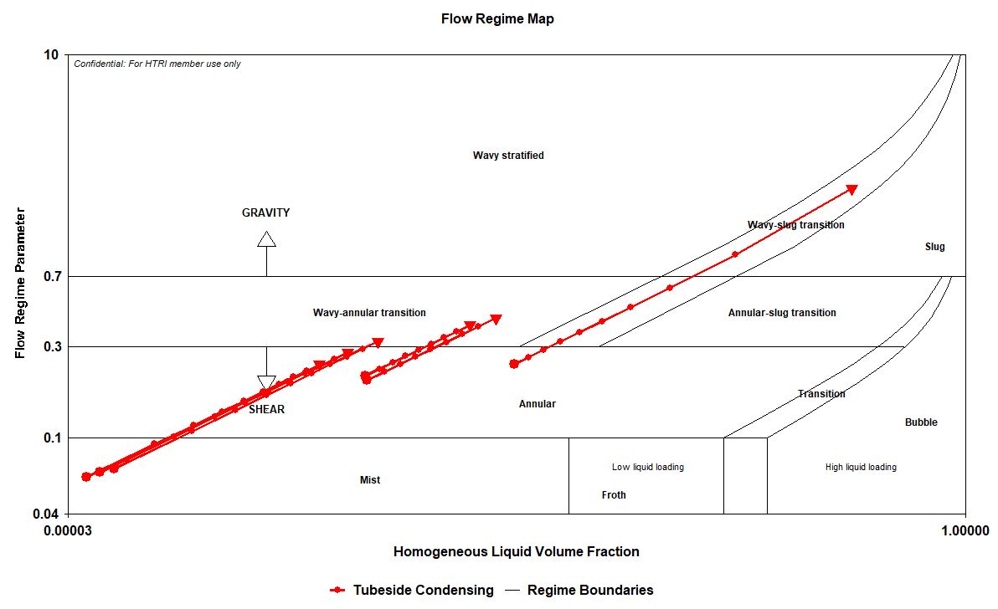

Three passes with the orientation of 3-2-1

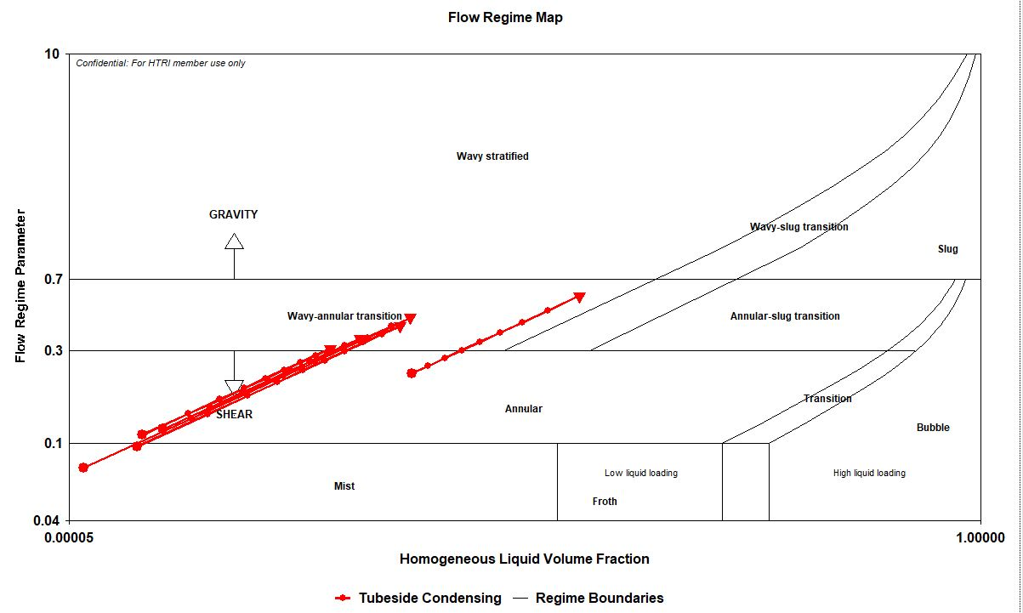

Three passes with the orientation of 3-2-1 in Force

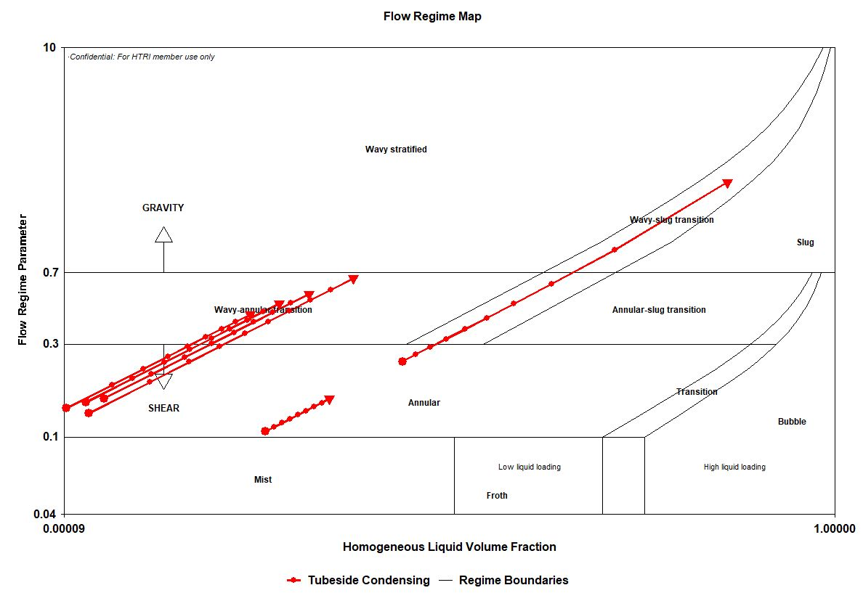

Three passes with the orientation of 4-1-1 in Force

Now Let’s choose another path and start with 39 bays, aiming to design air-cooler with maximum driver fan of 45 kw.

The following actions are taken which is summarized below:

|  |  |  |
| --- | --- | --- |
| Actions | Pressure drops | Driver Power |
| Choosing 39 bays | 205 |  |
| Changing fan ring type to  cone 30 | 165 | 46.51 |
| Changing fan efficiency from 65% to 75% | 165 | 40.31(46.54) |
| Increasing the number of passes to 2 passes | 136.8 | 29.4(34) |
| Increasing the number of passes to 3 passes with  4-1-1 oriantation | 133.8 | 28.33 (32.7) |
| Force | 132 | 27.95 (32.27) |

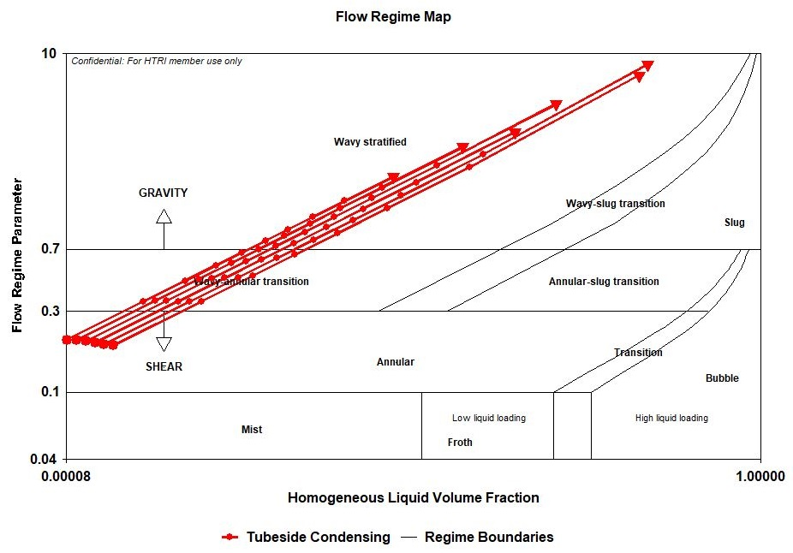 Flow regime map for one pass

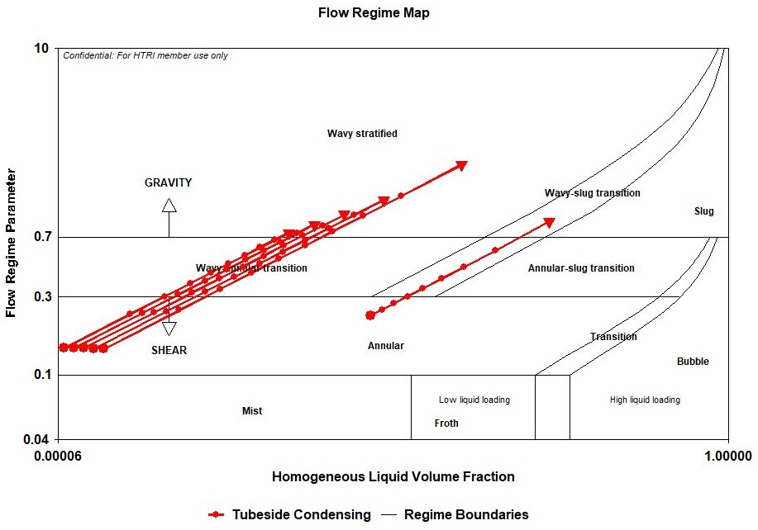

Flow regime for two passes

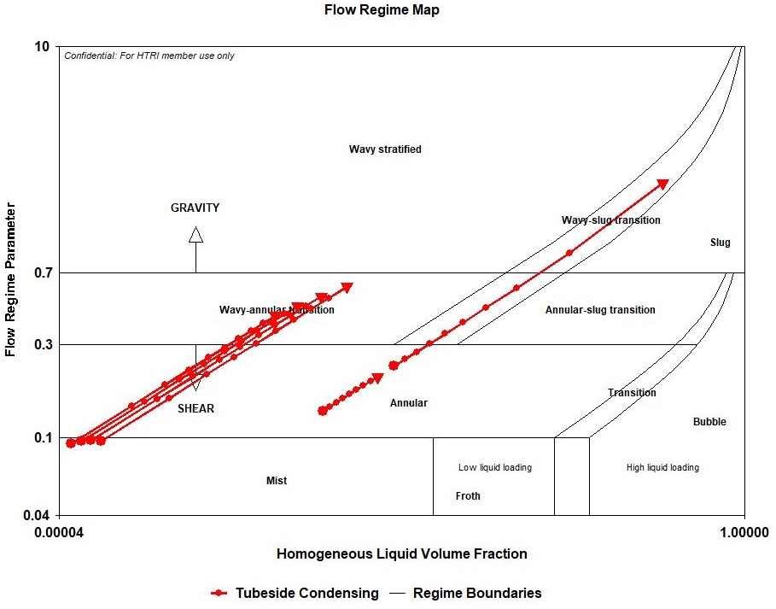

Flow regime for three passes

 Flow regime for three passes in Force

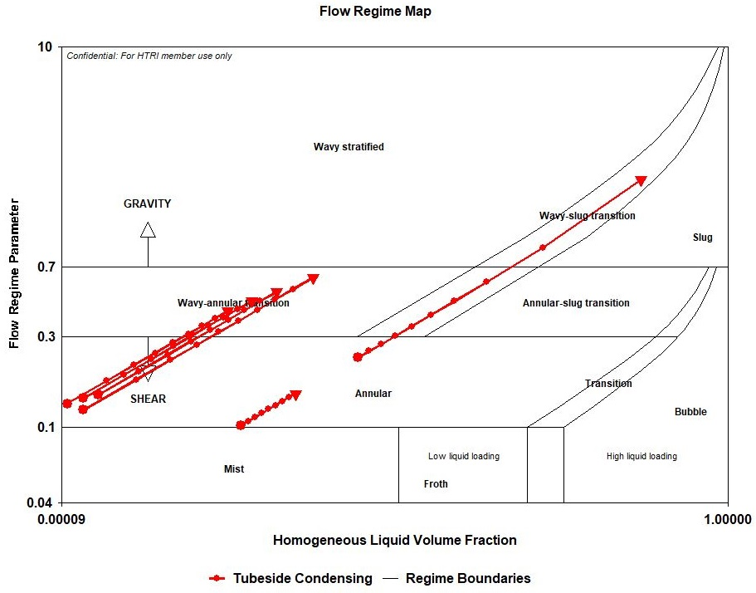

Vendor Thermal Calculation

Differences in assumptions:

|  |  |  |
| --- | --- | --- |
| Parameter | Me | Vendor |
| Temprature | 48 | 50 |
| Inlet Nozzle |  | 193.67 |
| Outlet Nozzle |  | 87.32 |
| Tube passes | 4-1-1 | 5-1 |
| Tubes in odd/even rows | 46 | 44 |
| Total unfinned tube length | 0 | 78 |
|  |  |  |

|  |  |  |  |
| --- | --- | --- | --- |
| Parameter | Vendor | PEA | PEB |
| Bay | 48 | 38 | 37 |
| Power | 27 | 36.84 | 40.34 |
| Total Power | 96 * 27 | 76 * 37 | 74 * 41 |
| Pressure Drop | 119 | 141 | 149 |
| Flow regime | No | Yes | Yes |
| Bundle Weight | 1534349 | 1257180 | 1224096 |
| Reliability | First |  |  |

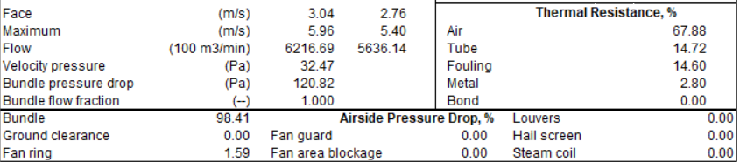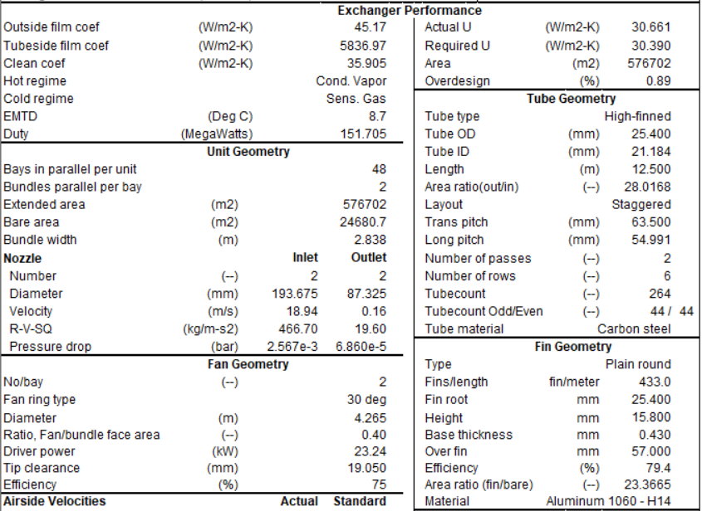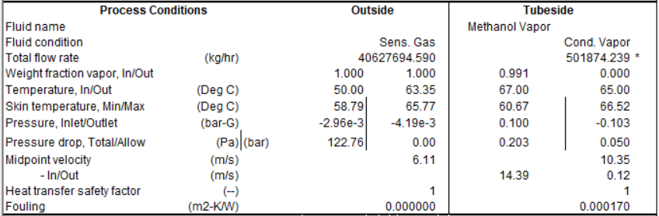Results:

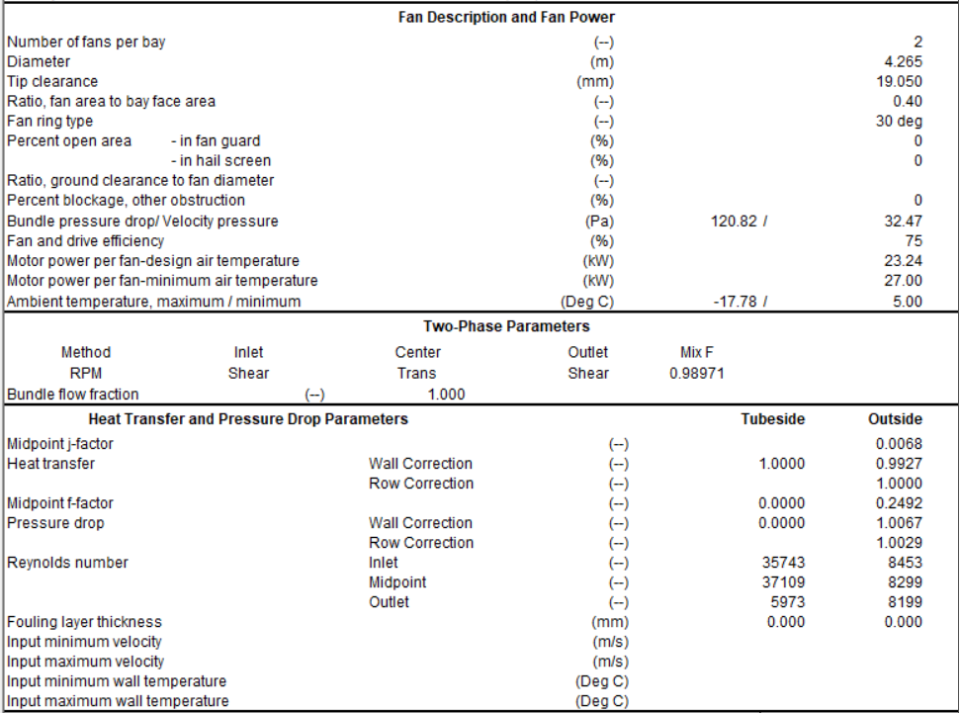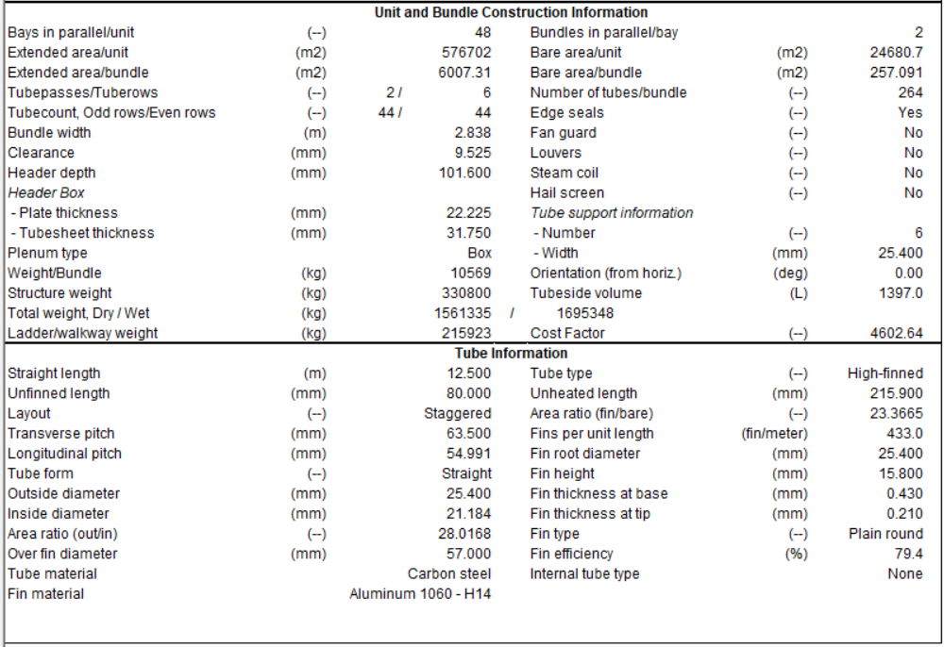

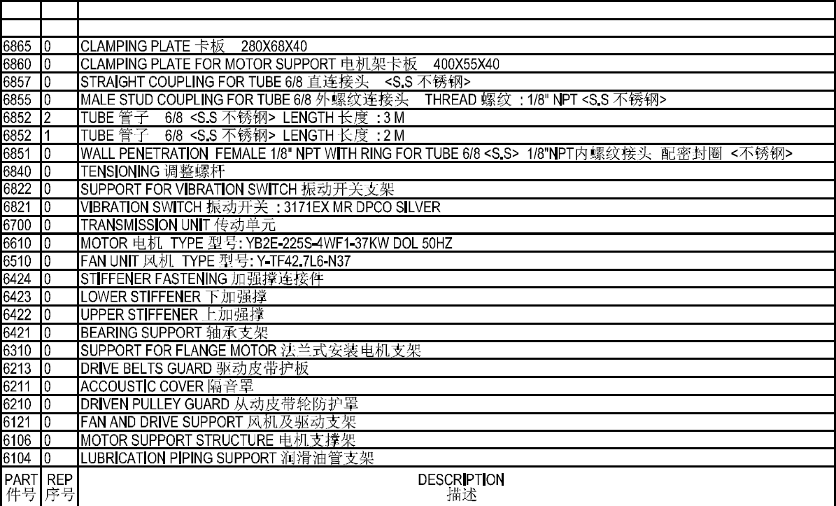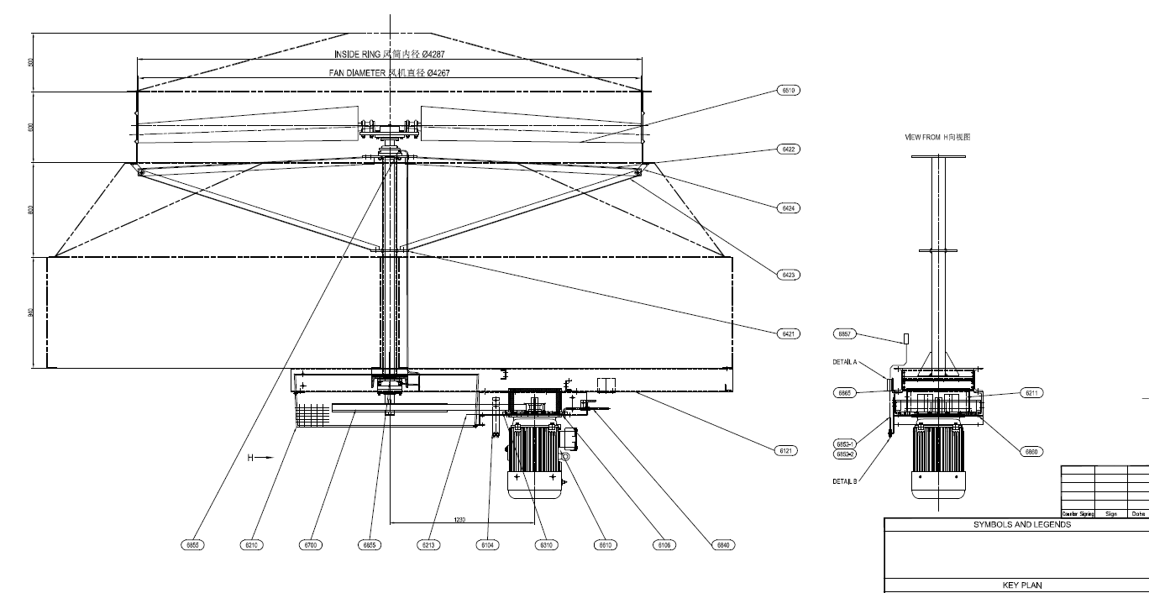Drawings

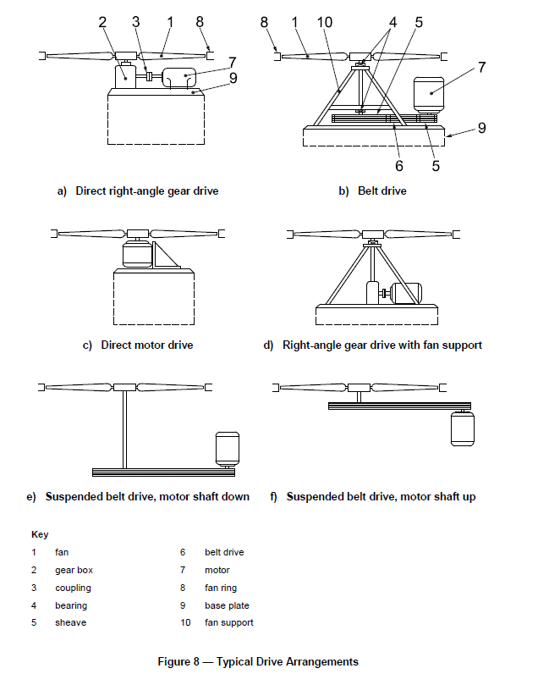

Note from API-661:

1. V-belt drive assemblies suspended from the structure may be used with motor drivers rated

not higher than 30 kW (40 hp).

2. High-torque type positive-drive-belt drive assemblies suspended from the structure may be

used with motor drivers rated not higher than 45 kW (60 hp).

3. Electric motors rated higher than 45 kW (60 hp) shall use gear drives; smaller motors may use gear drives.

