Air-cooler Design and Principle

AE-5004

1.Process Specification

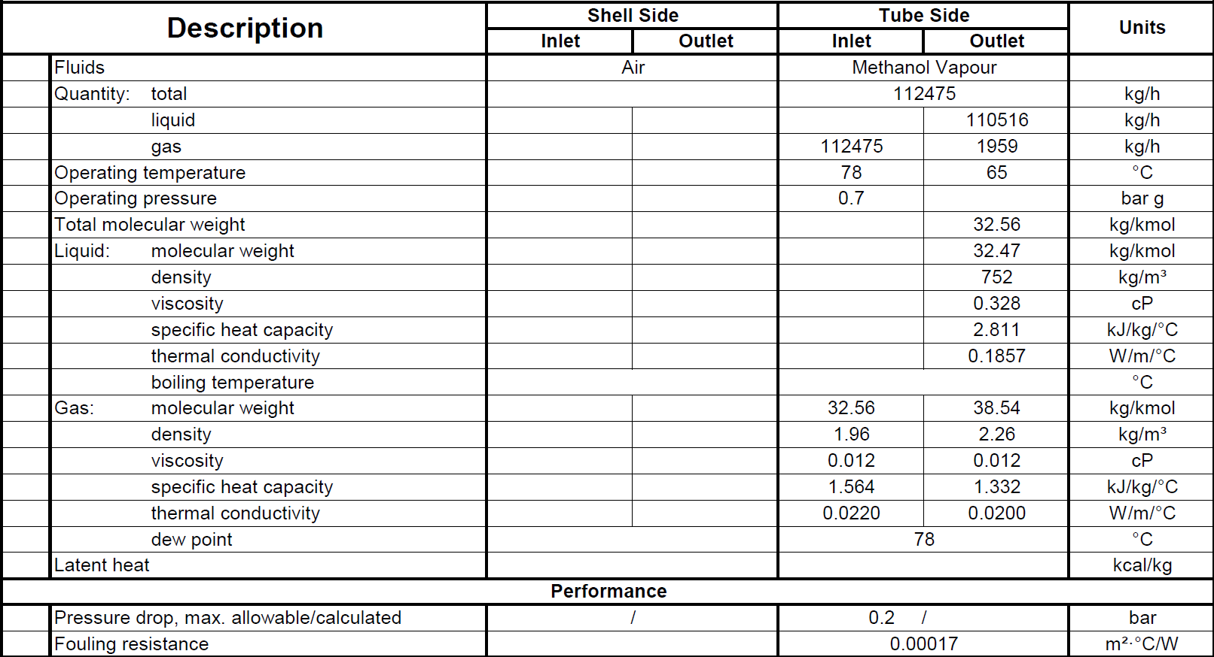

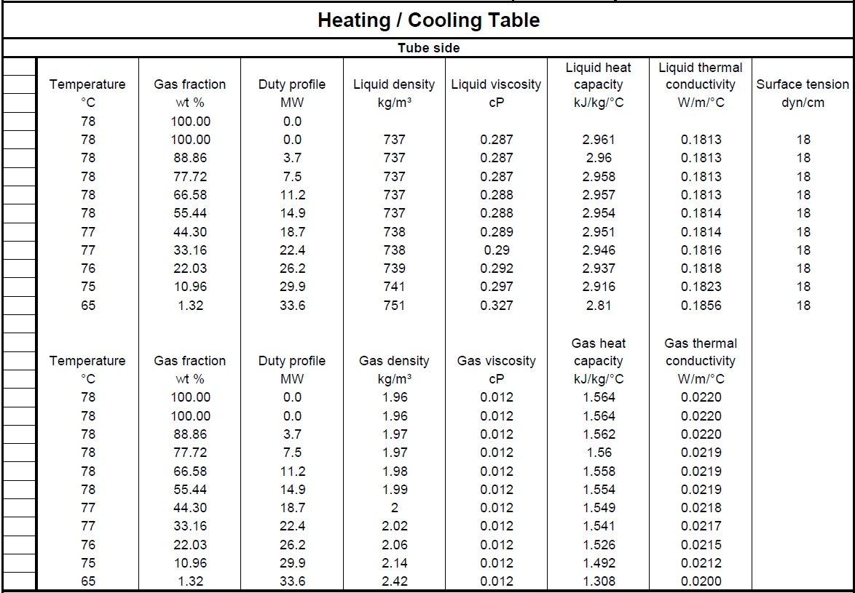

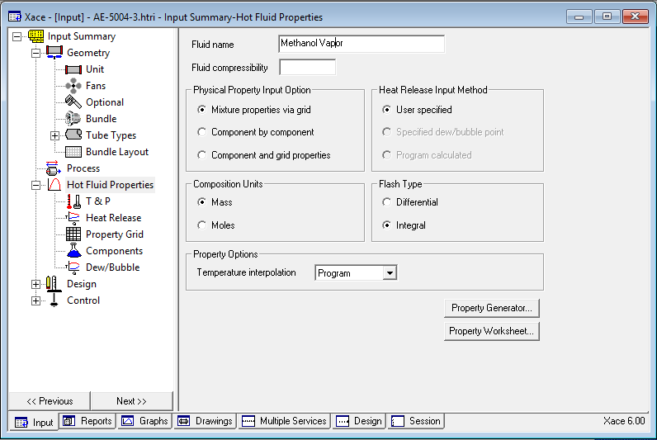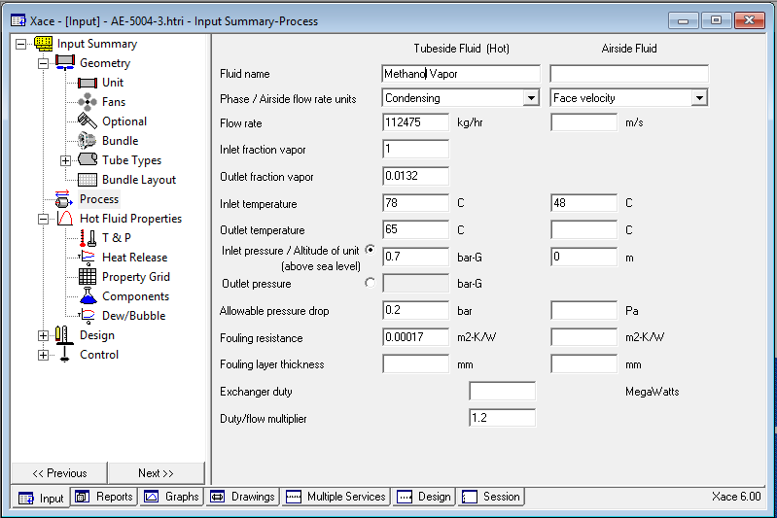2.Process Input to HTRI

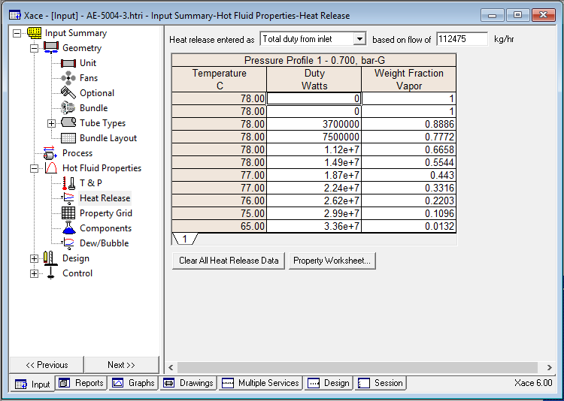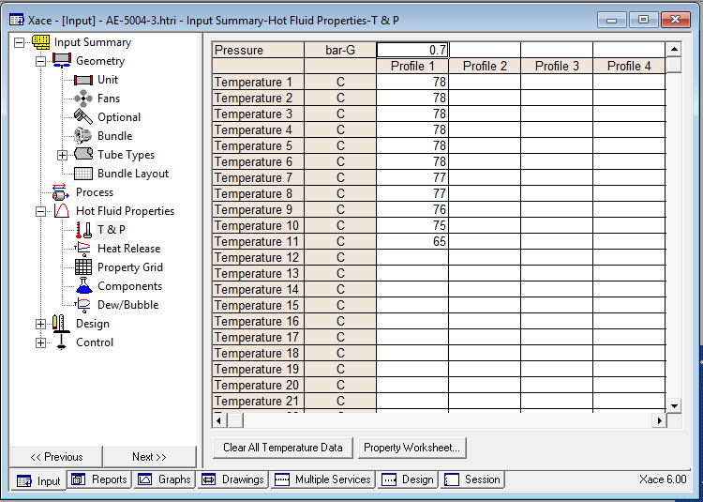

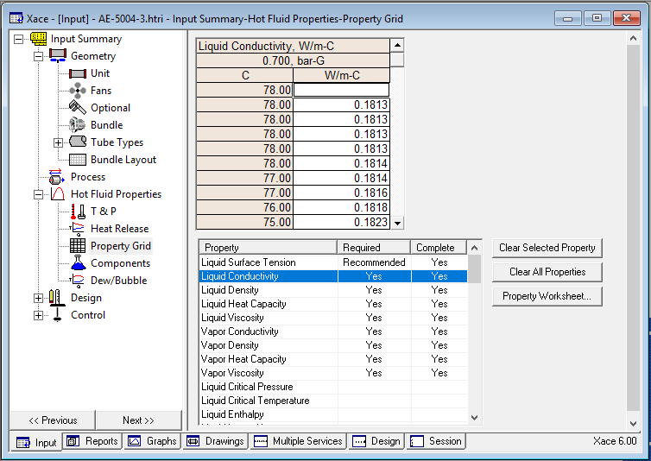

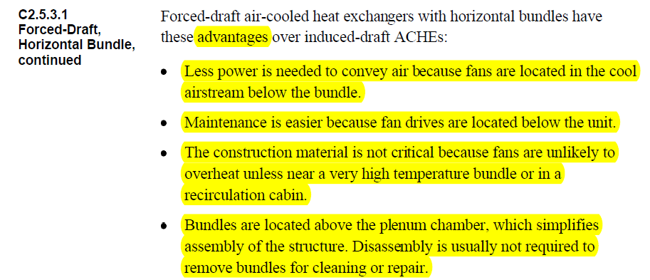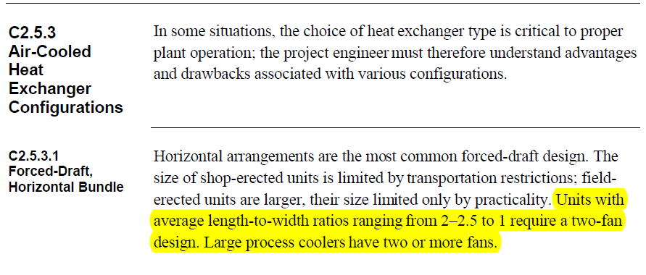3.Unit data to HTRI

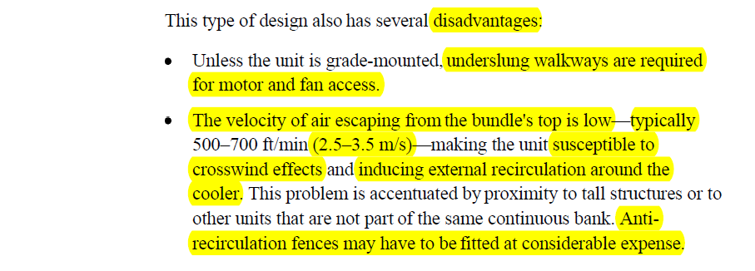

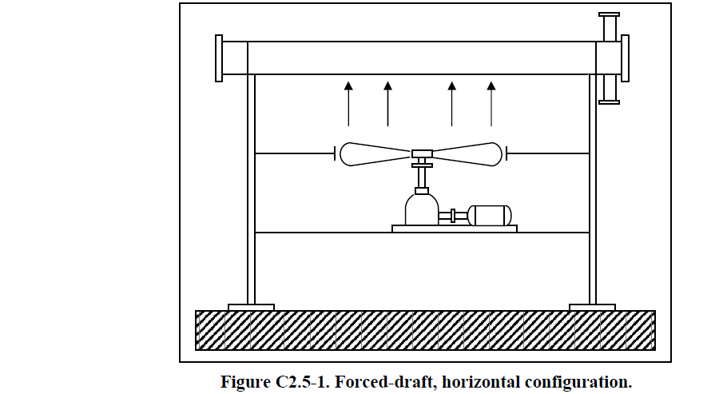

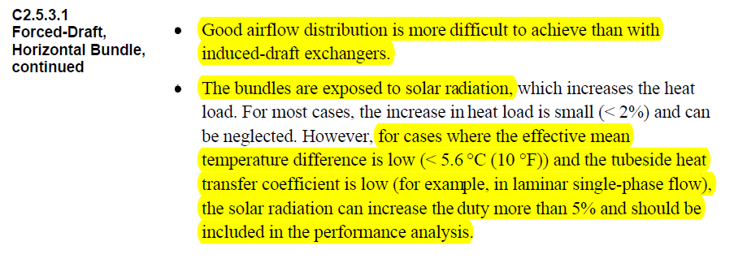

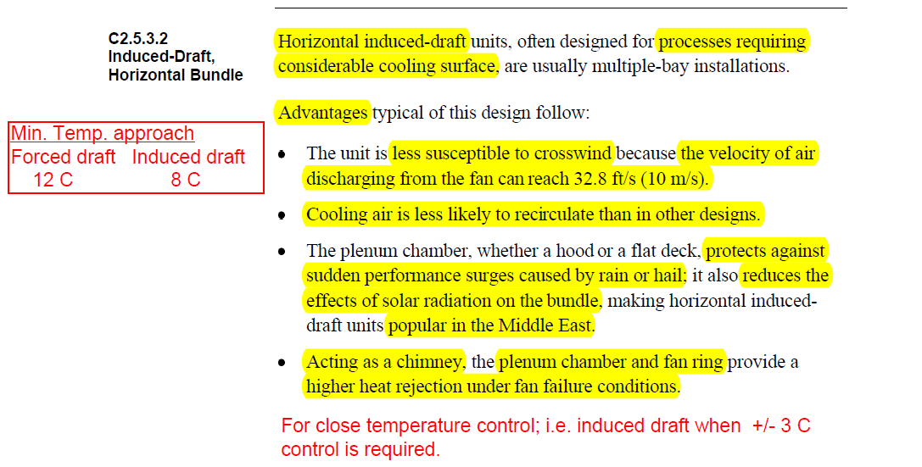

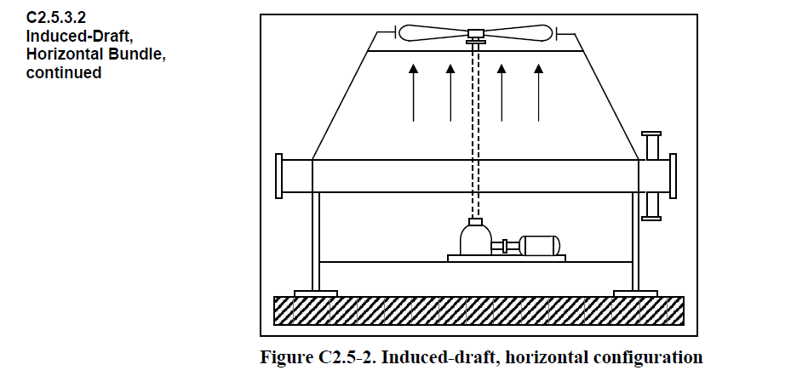

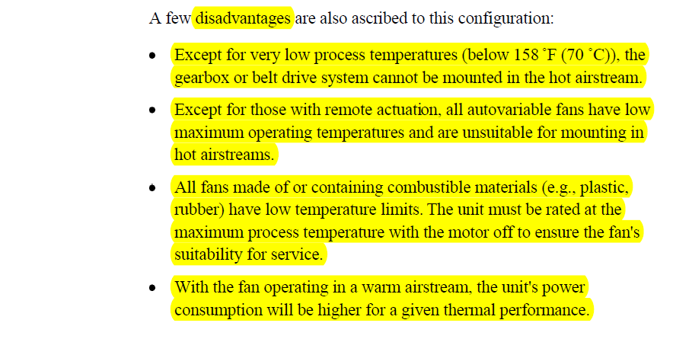

**Bay**

One or more tube bundles, serviced by two or more fans, including the structure, plenum and

other attendant equipment.

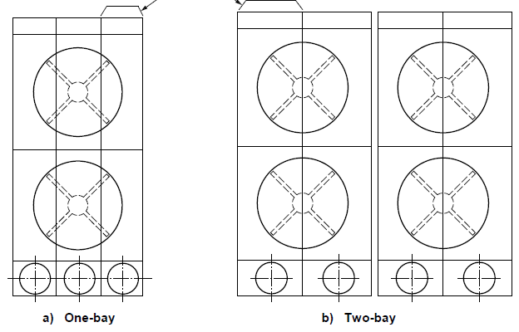

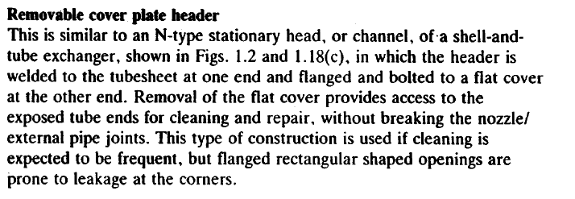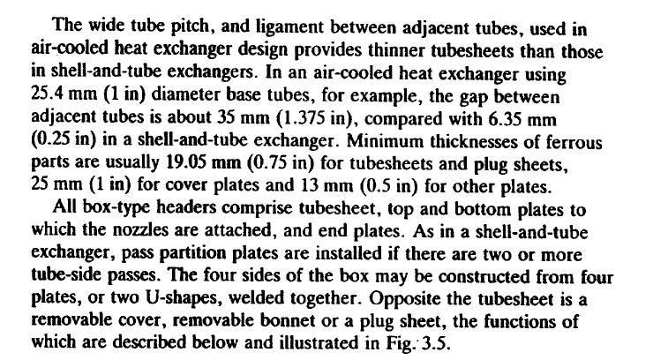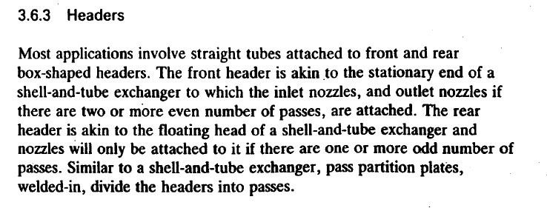

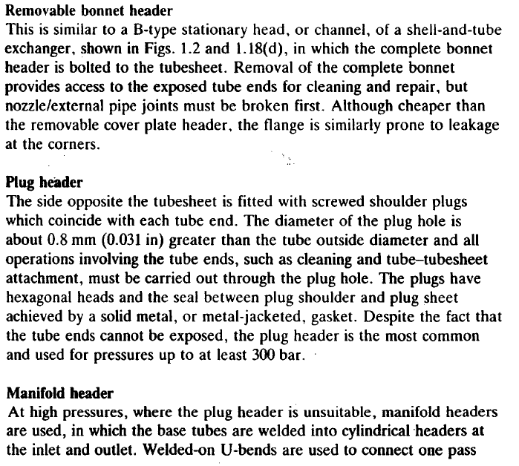

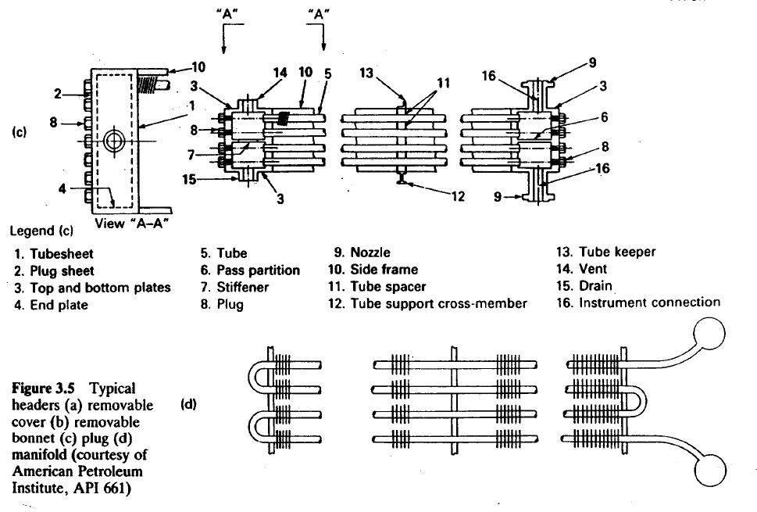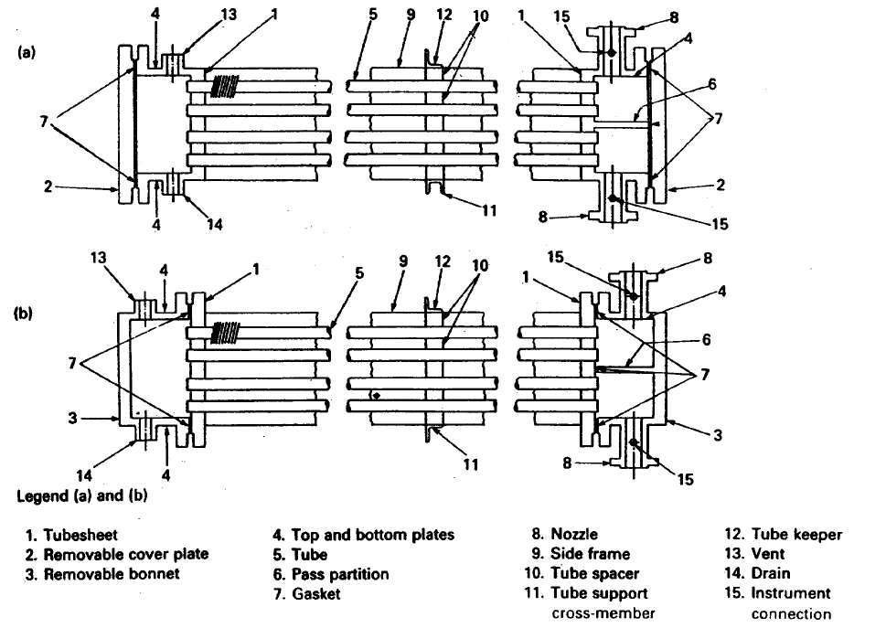



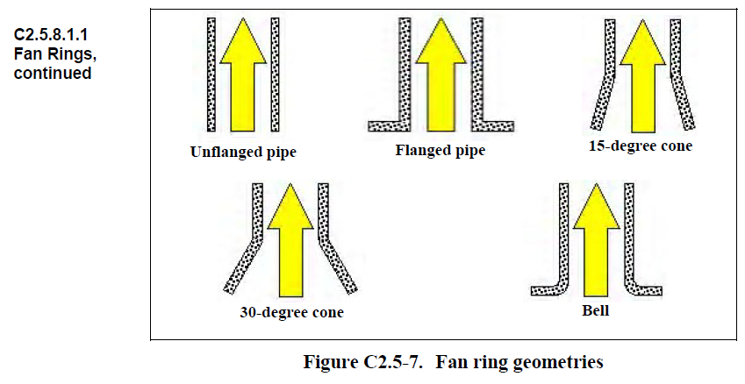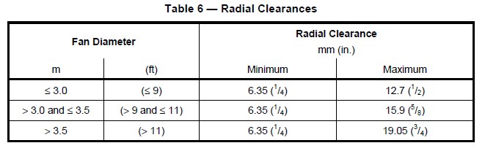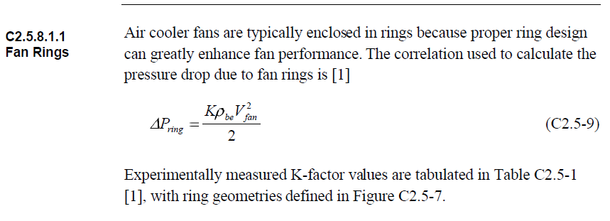4.Fan Data to HTRI

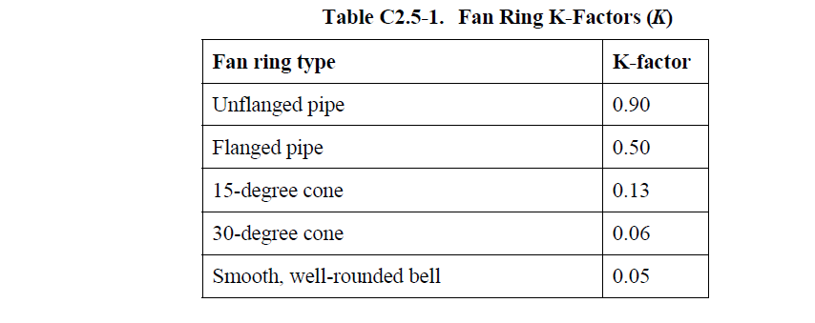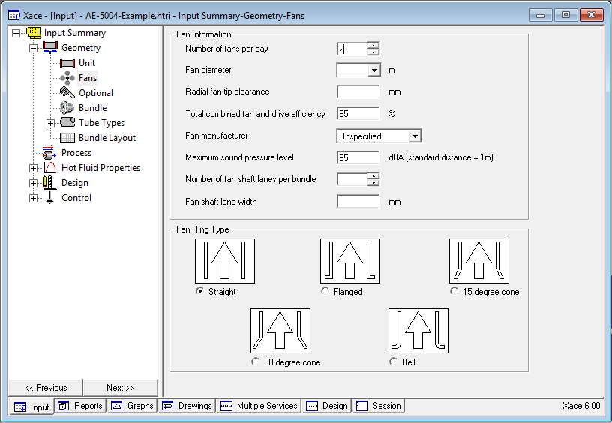

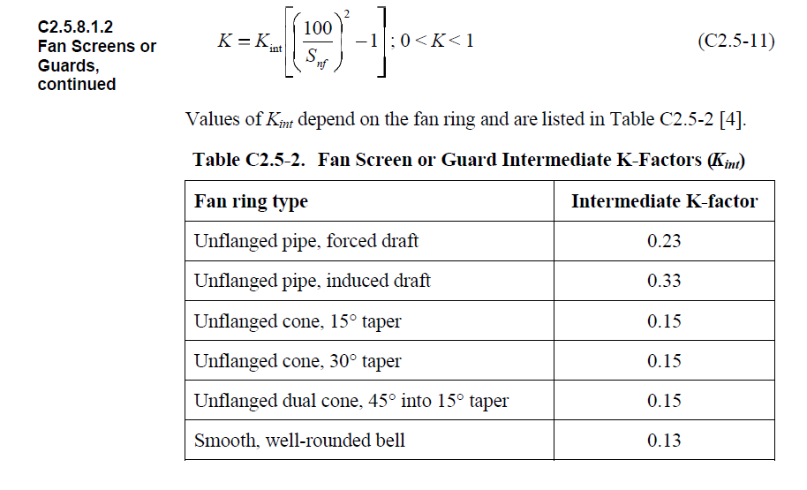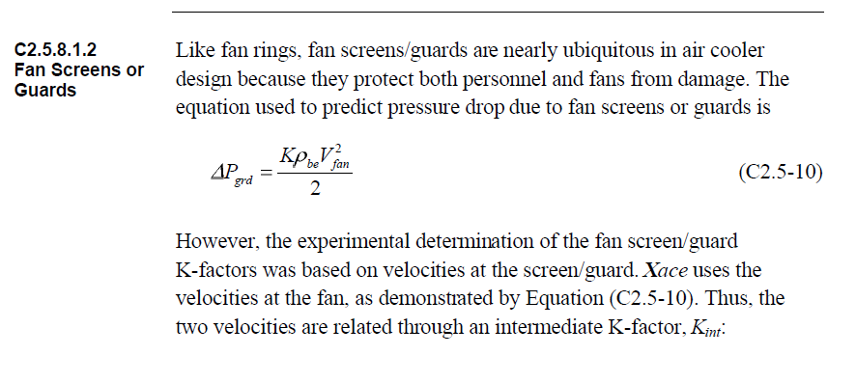5.Optional Data to HTRI

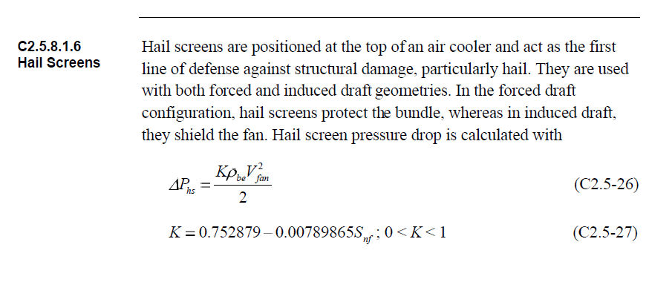

**Drivers**

For electric motor drivers, the minimum required driver rated shaft power (*P*dr) shall be

calculated as follows:

*P*dr ≥ 1.05 (*P*f1/*E*m)

*P*dr ≥ 1.10 (*P*f2)

Where

*P*dr is driver rated shaft power;

*P*f1 is fan shaft power operating at specified minimum design temperature with blade angle set

for design dry-bulb temperature;

*E*m is mechanical efficiency of the power transmissions;

*P*f2 is fan shaft power operating at design dry-bulb temperature.

These requirements apply to fixed-pitch, variable-pitch and variable-speed fans unless

otherwise specified.

Once installed in the bundle, the tubes must be supported to prohibit intermeshing of the fins, and “bunching” of the tubes, which allows for openings in the tube that allow channeling of the airflow. Several means of tube support are utilized dependent on manufacture.

The most common tube support is provided by a “wiggle strip” that is place between each row, and runs between each tube. This method allow for support of the tube from the fin tip and is susceptible to movement in the bundle during transportation.

Another common method, utilized by some manufacturers, is to wrap aluminum strips around the perimeter of the tube at designated spots along the length. These strips are stapled to prohibit them from loosening. Again, this provides support from the tip of the fin.

A third method is the scalloped channel. This method provides a strip, normally fabricated from aluminum that cradles each tube and runs the entire width of the bundle.

The scalloped channel is formed to provide both supports from the fin tip, and to the tube

wall. Based on the configuration, it is not able to move after inserted, and also provides a means of keeping the tubes spaced properly.

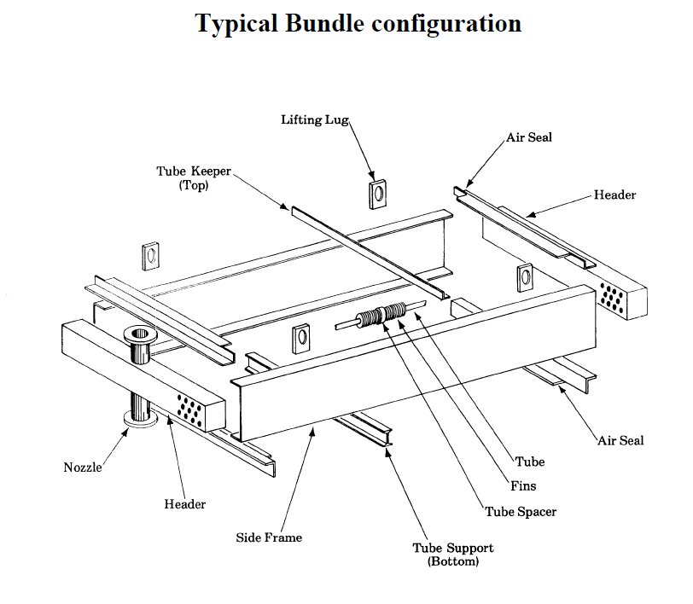Tube support can also be provided by cast zinc collars. This method requires a zinc collar to be poured at each support spot on the tube. This method, while providing excellent support, is normally cost prohibitive.

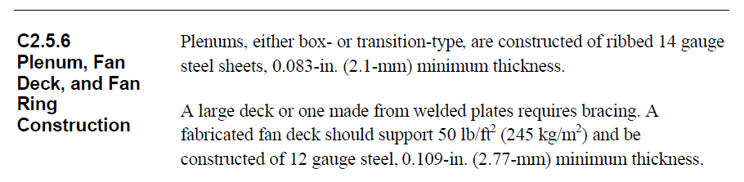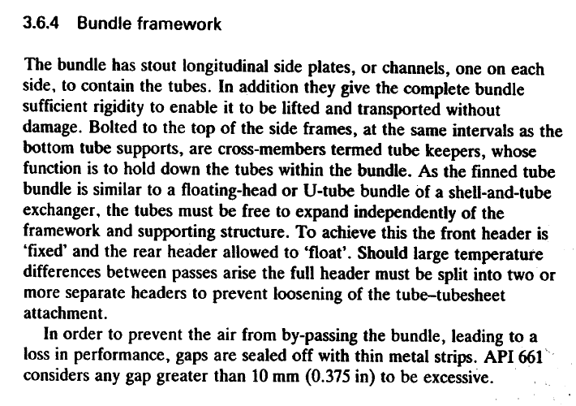



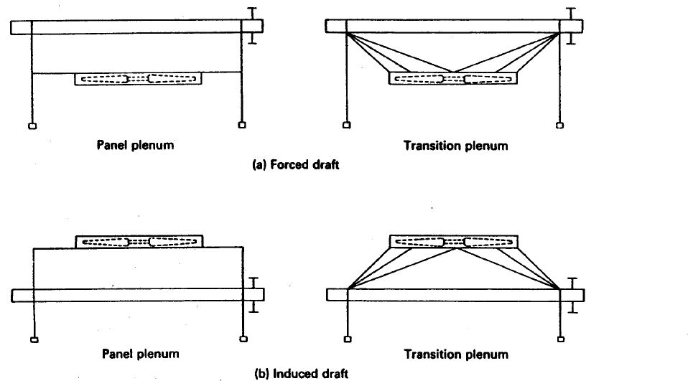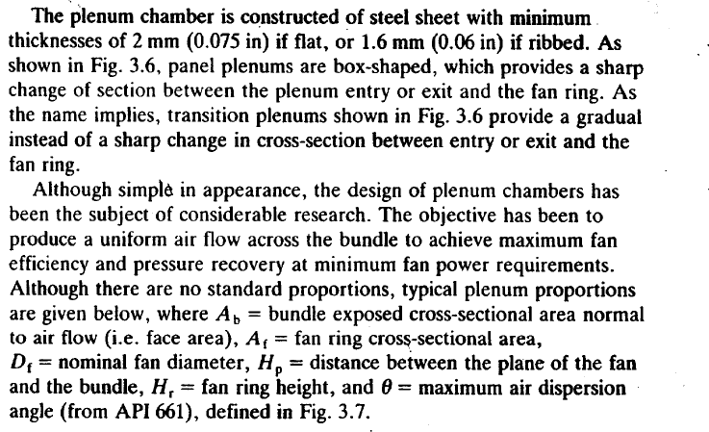

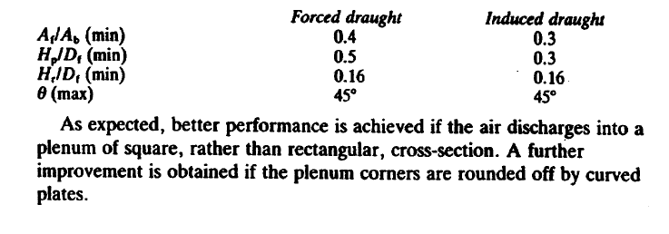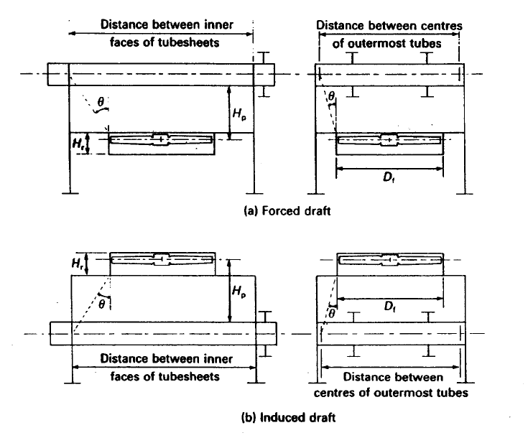

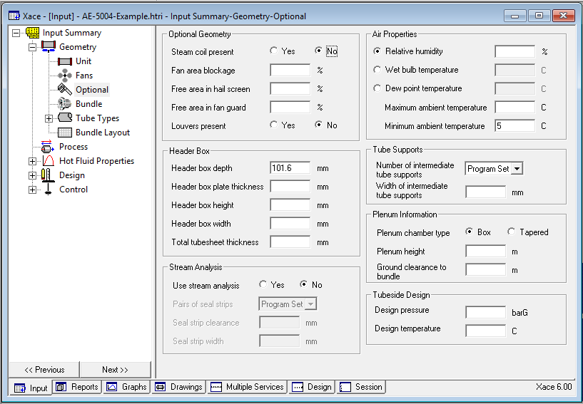

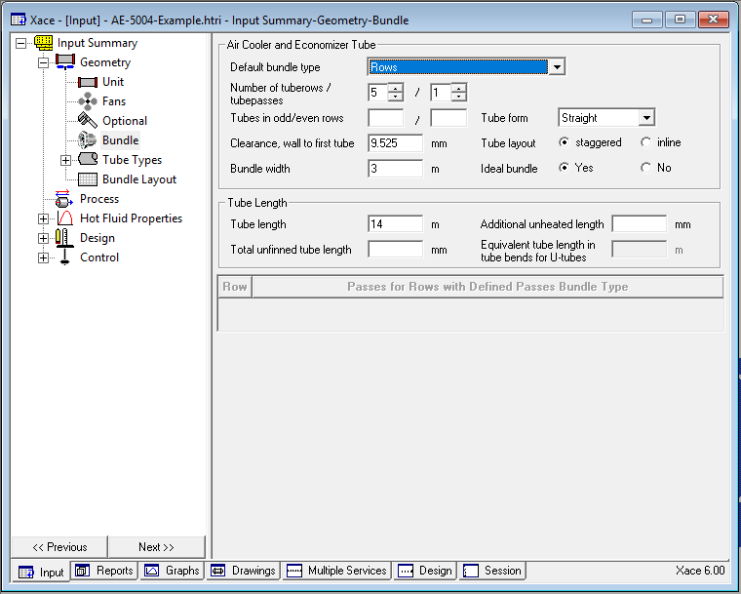6.Bundle Data to HTRI

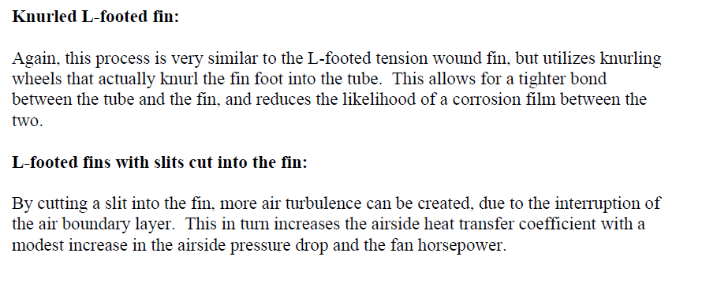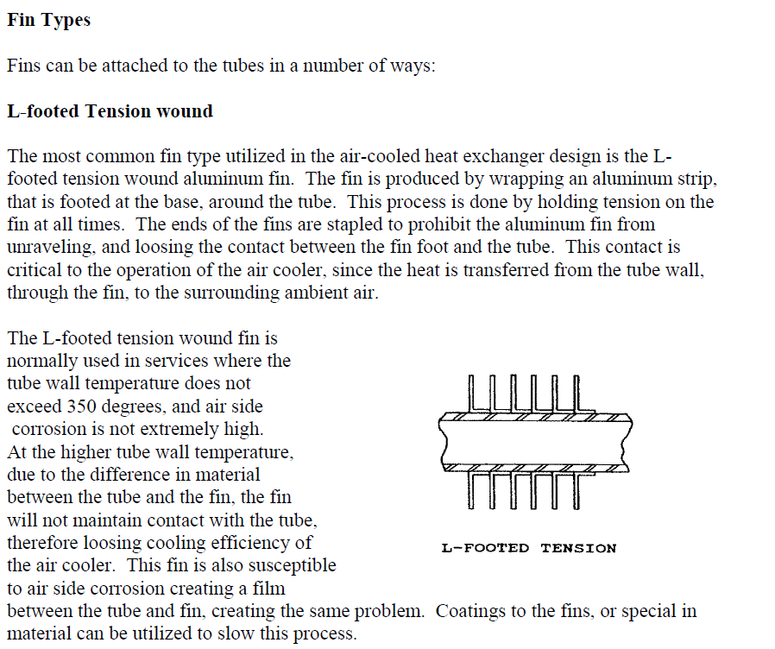7.Tube type Input to HTRI

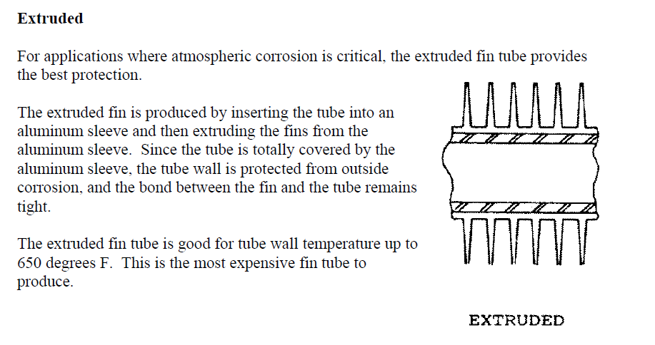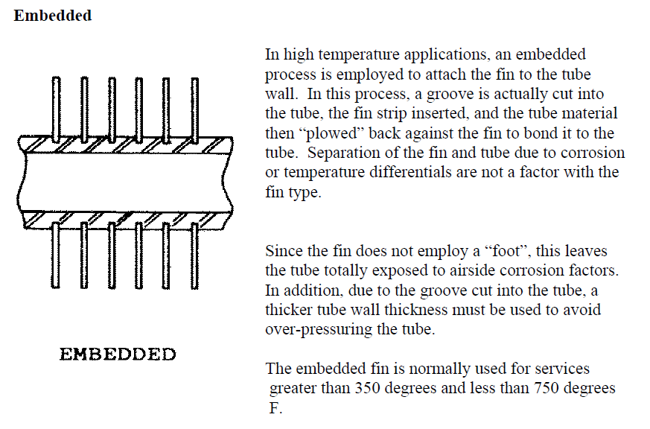

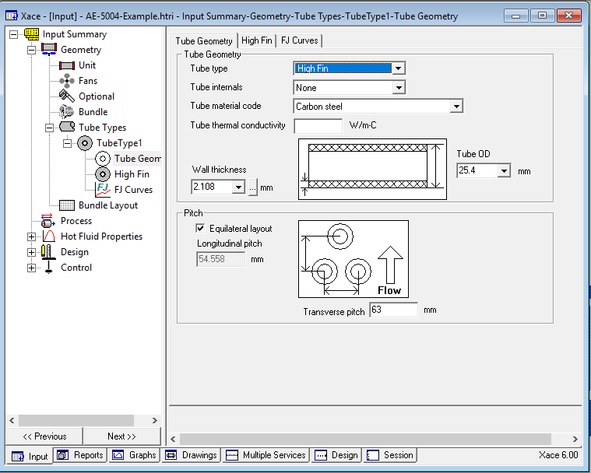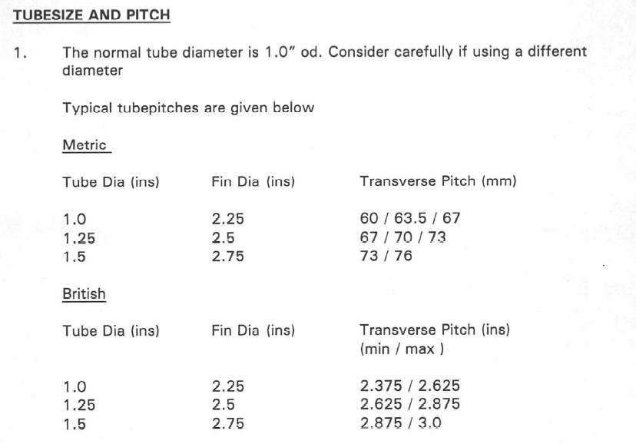

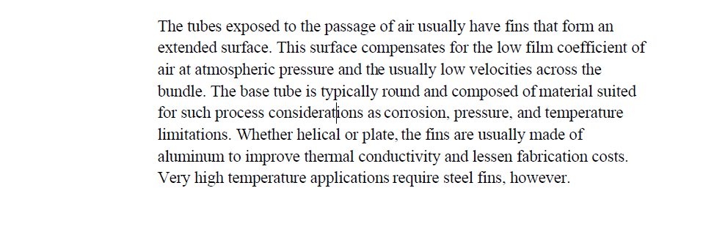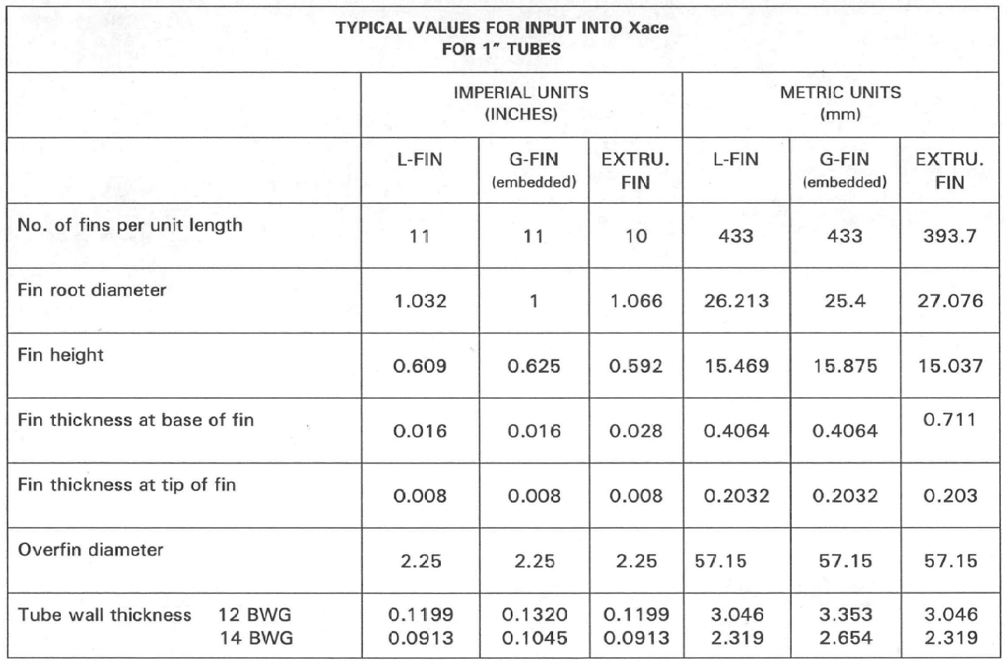

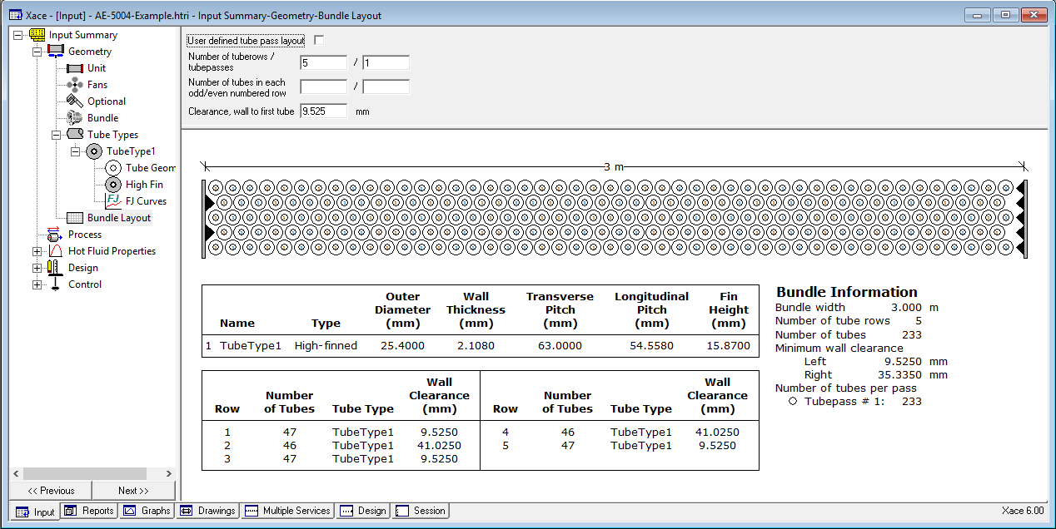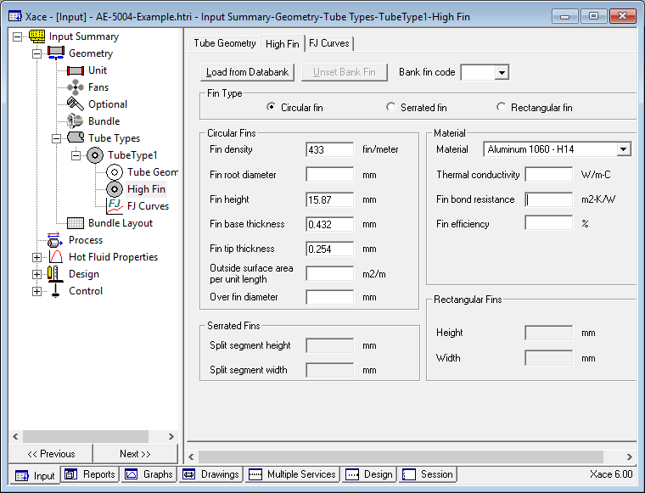

Results

Since 1 bay was selected, which is very low for such high flow, the software failed to run. Thus, the number of bays is increased to 2 and the program is run again.

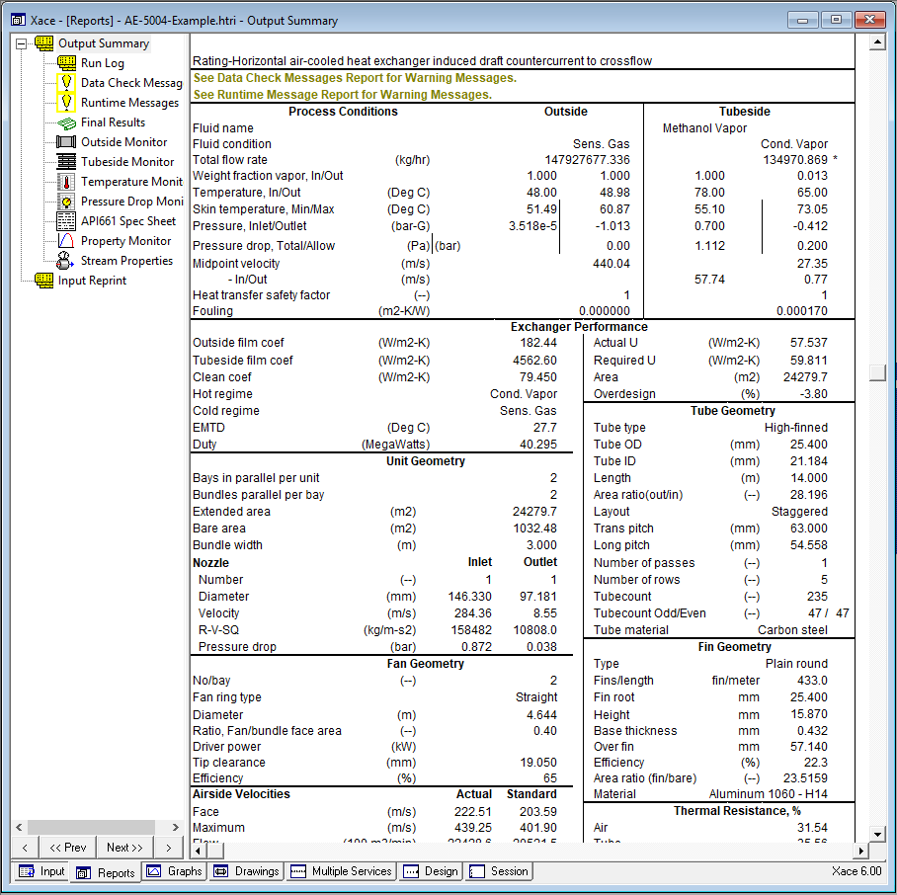

It is not acceptable since the amount of air flow is extremely high. In addition, the driver power and pressure drop is not clear, which means that the number of bays should be increased.

|  |  |  |
| --- | --- | --- |
| Number of Bays | Driver Power | Pressure Drop |
| 3 | 25857 | 9044 |
| 4 | 1411 | 1422 |
| 5 | 348 | 583 |
| 6 | 122 | 301 |
| 7 | 59 | 190 |
| 8 |  |  |

Now the fan efficiency is changed to 75% and the required driver power becomes 51 kw. Then the fan ring type is changed from straight to 30 C cone. As a result, the power required reduces to 42 kw and the pressure drop reached 149pascal. But the criterion here is the power at minimum air temperature which 48 kw.

Also, by looking at the flow regime map, the regime is not well-distributed. In order to enhance the condition, the number of passes is increased to 2 passes (4-1) and the regime is enhanced. At the same time power is reduced to 25.5 kw.

Then the orientation changed to 3-2 with and without force condition. In force condition the required power and pressure drop is more than other scenario.

Now the number of bays is increased to 8 bays due to the fact that the required power at minimum air temperature is 58 kw. In doing so not only the required power reduces to 24 kw but also the pressure drop decreases to 97 pascal.

As the last step the number of passes was increased to 3 passes to improve flow regime in flow map. As a result pressure drop became 73 pascal, the driver power became 15 kw .

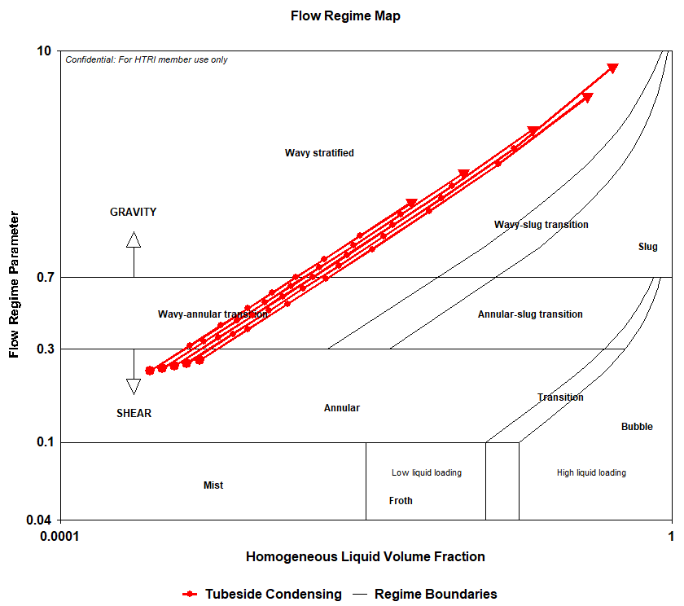

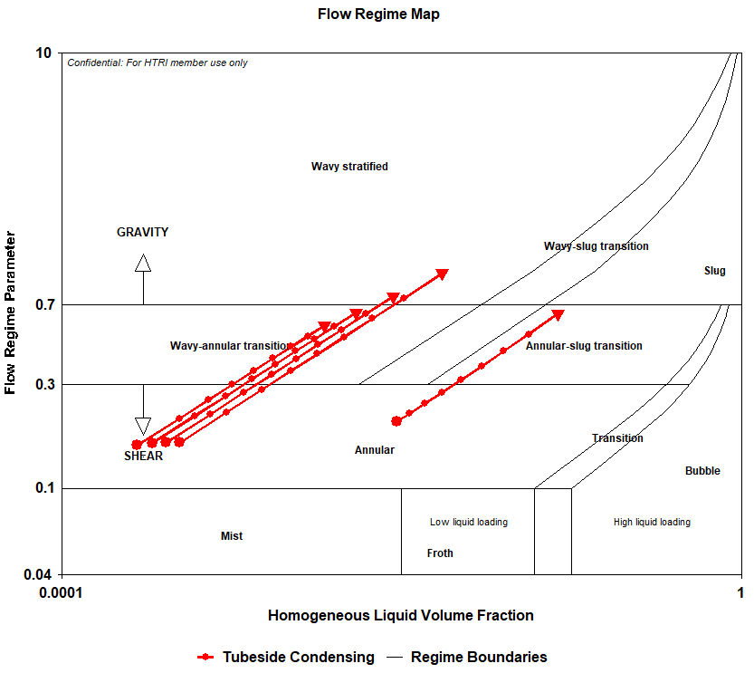

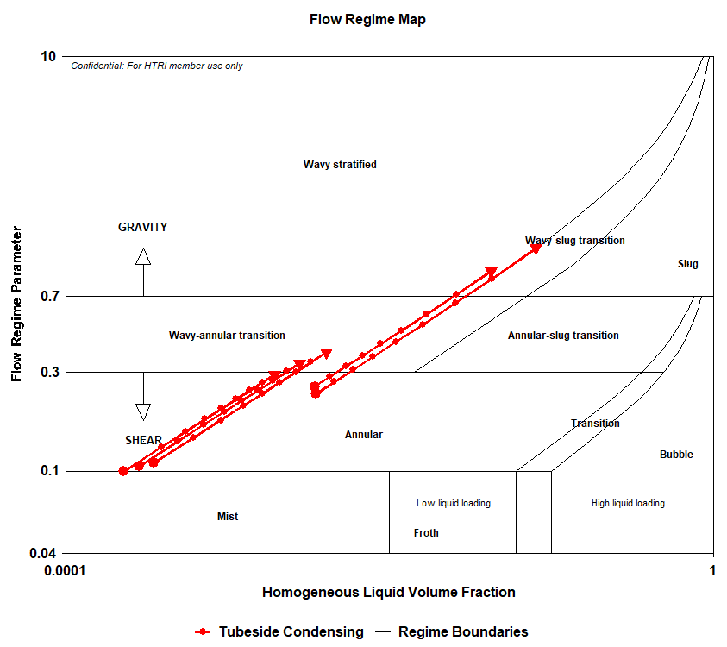

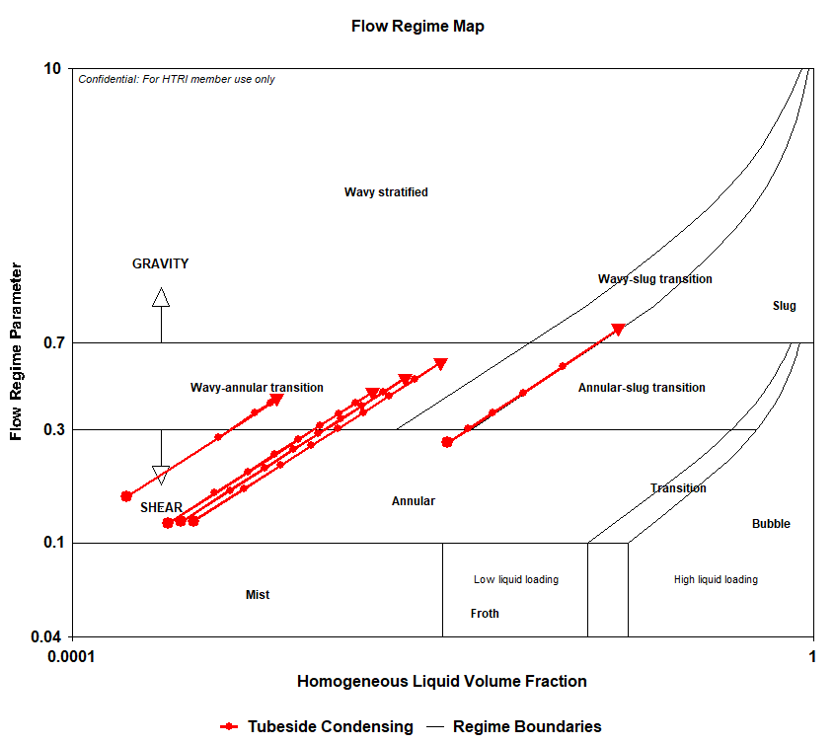

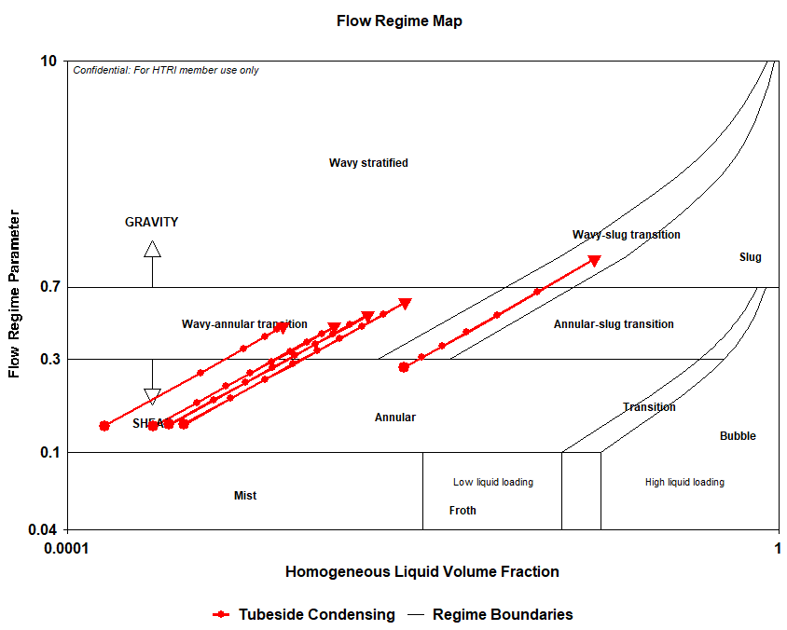

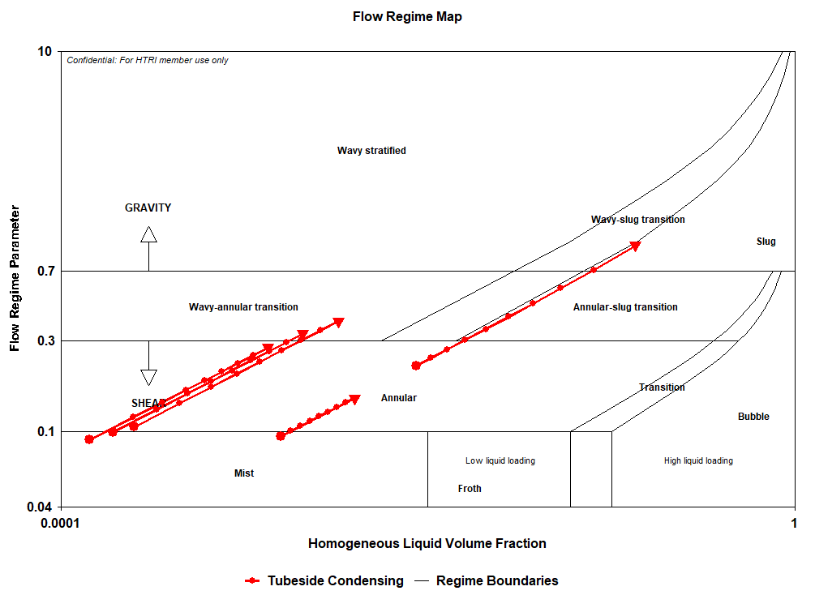

|  |  |
| --- | --- |
| Number of Bays | 8 |
| Number of Passes | 2 (4-1) |
| Fan Efficiency | 75% |
| Transverse Pitch | 69.5 |
| Number of Tubes | 210 |
| Pressure Drop | 71 |
| Driver Power | 18 |
|  |  |

