T-6001

Design and Principles

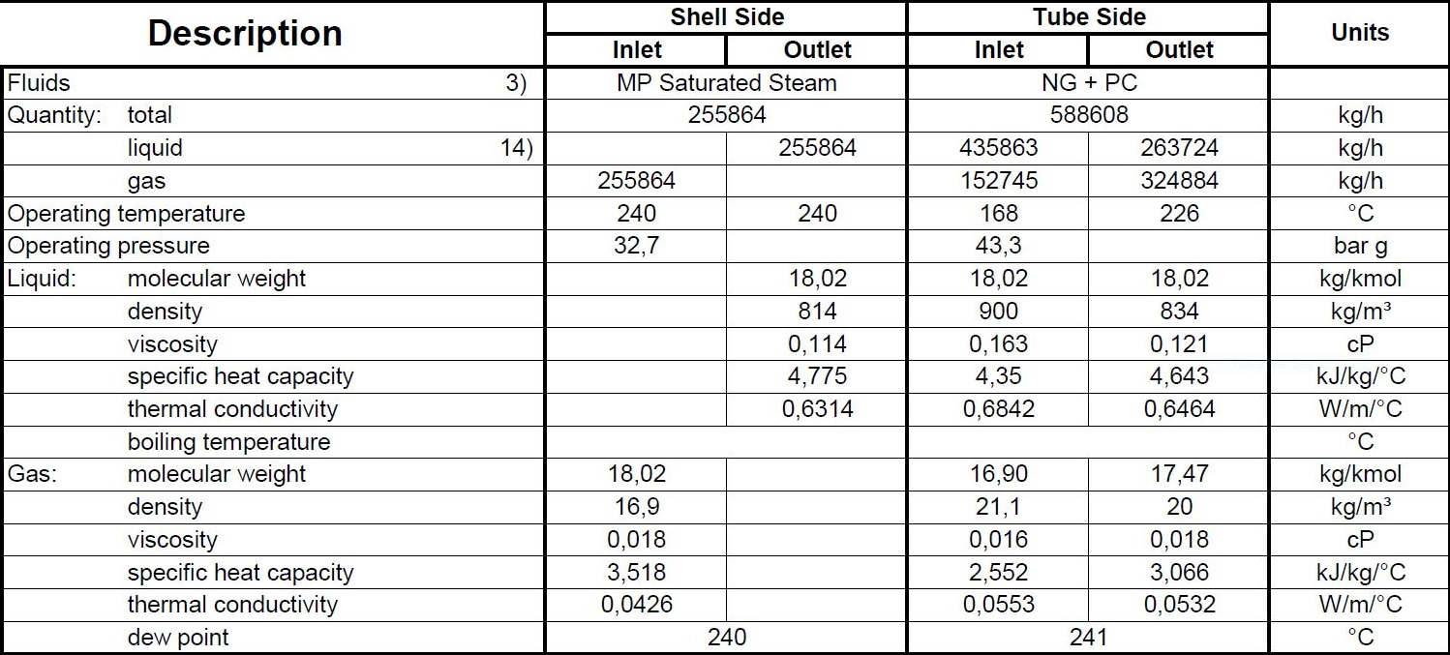**Process data**

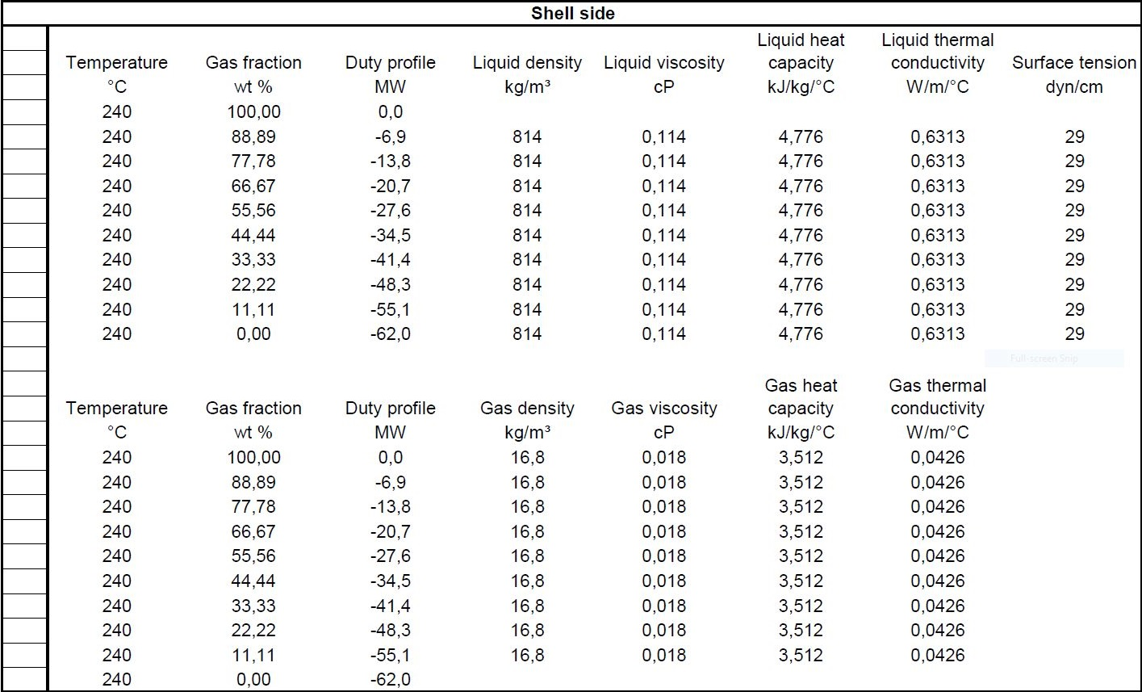**Heating and Cooling Table**

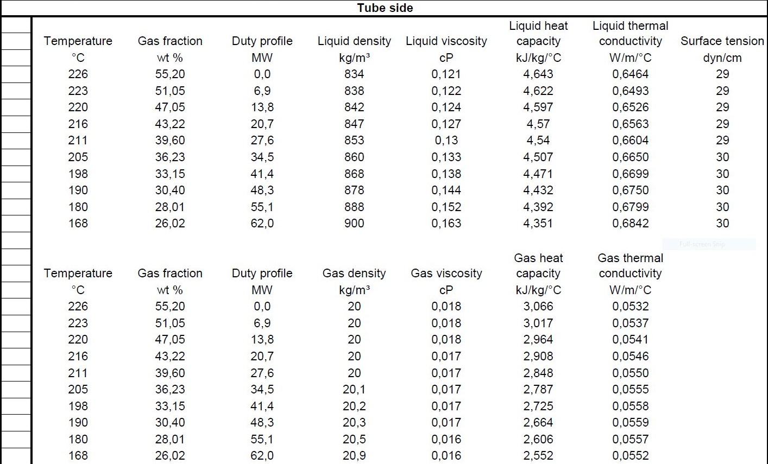

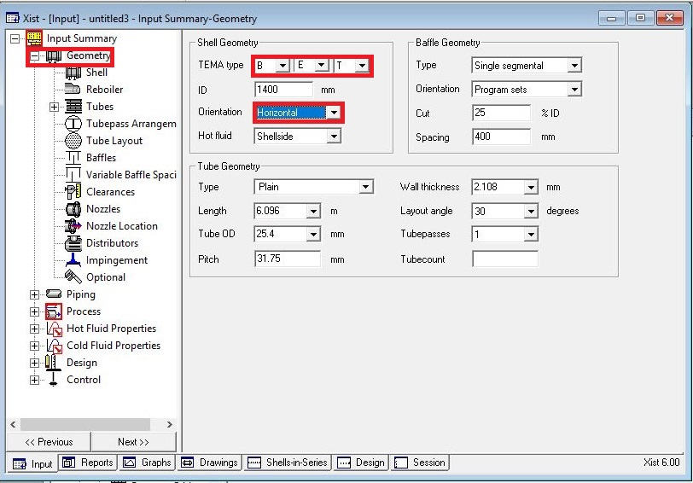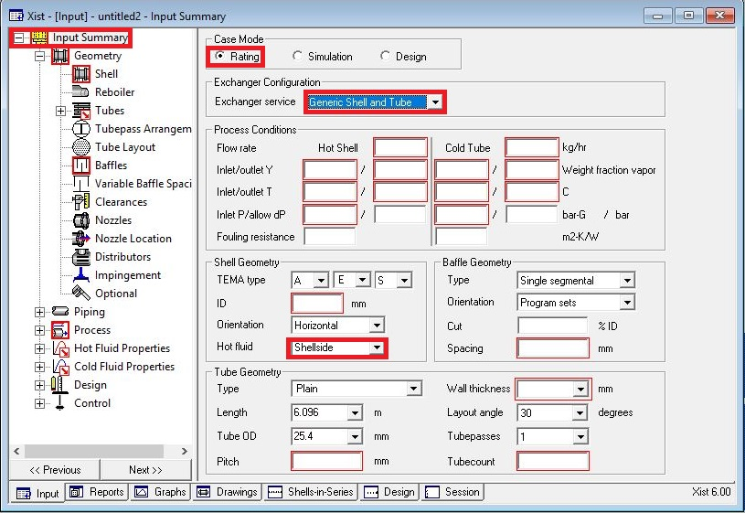**Open HTRI and Input Summery sheet and enter data in red areas**

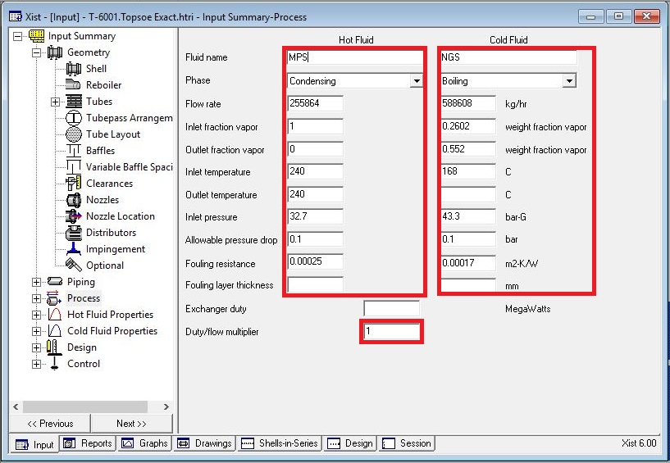**Enter operating data in process sheet in red areas**

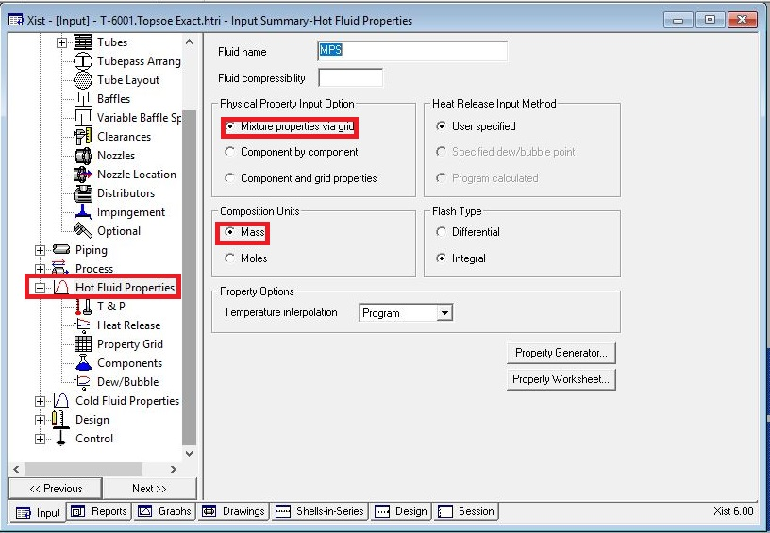**Enter heating and cooling table data in hot and cold fluid properties in red areas**

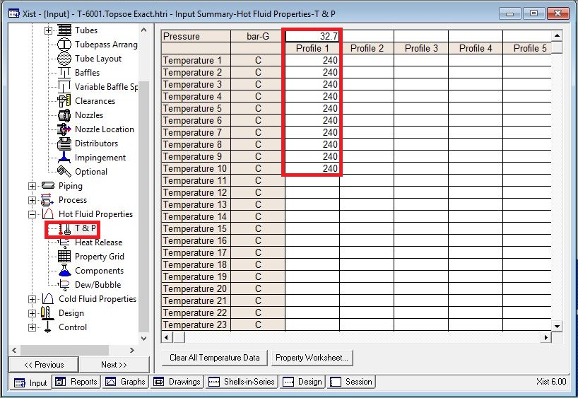

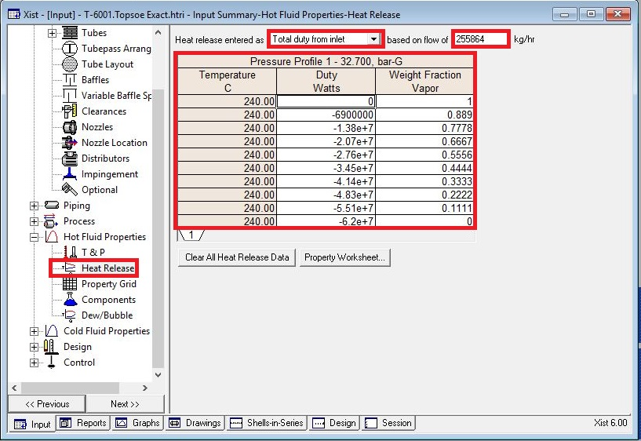

Put shell info in shell sheet in red areas

Note:

* 1. Initially estimate shell ID between 1.5-3 times tube-side pipeline ID, here it is 18 inch

so first estimation would be 55 inch.

* 2. Because of its capacity two heat exchangers in parallel are selected.
* 3. Cocurrent direction is considered as flow direction since the orientation is vertical it is

solely viable for MPS to enter from top to be condensed at bottom and the same

happens to water in tube to be flowed because of gravity.

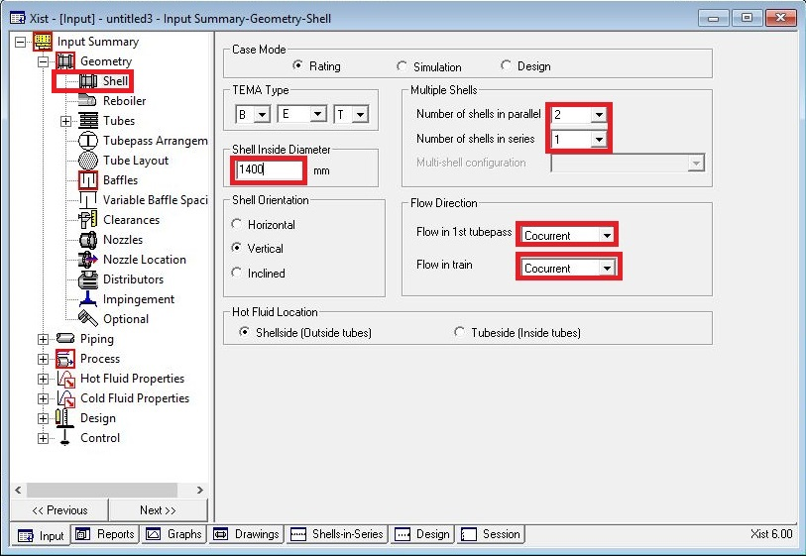

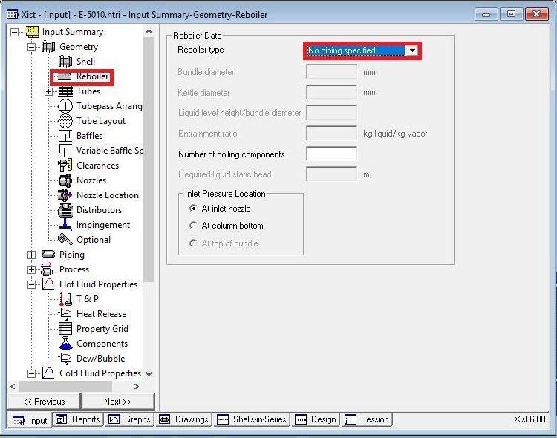In Reboiler Sheet do not enter an input

Put Tube mechanical data

* Note that since mixing between water and natural gas is going to happen, tube with 25.4

OD is selected

* Since Tube material is SS due to presence of CO2, Tube thickness 2.11 is selected

according to table below

* Select Pitch 31.7 to pass TEMA R.2.5

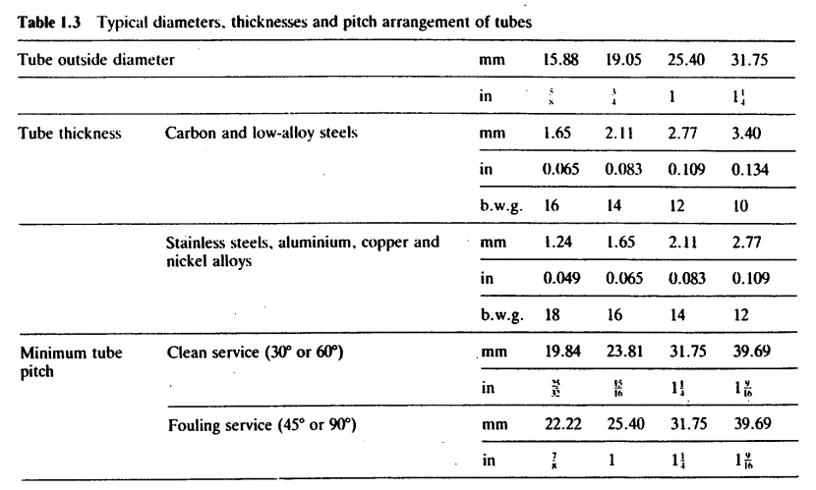

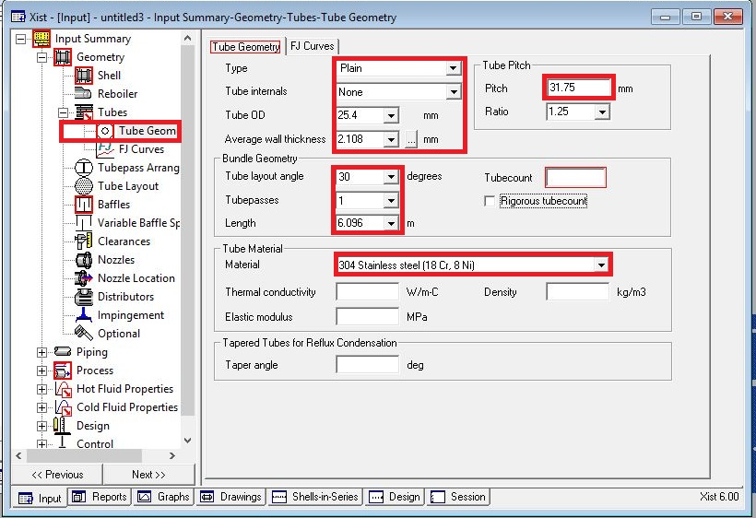

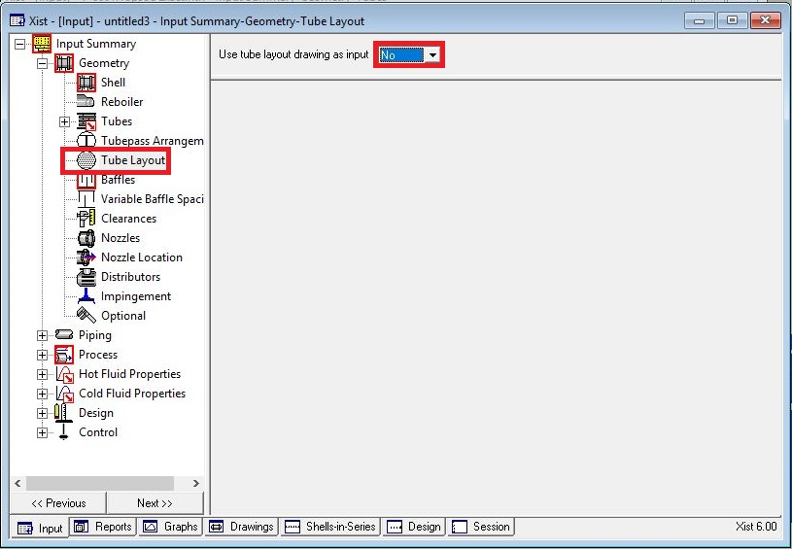Act like below

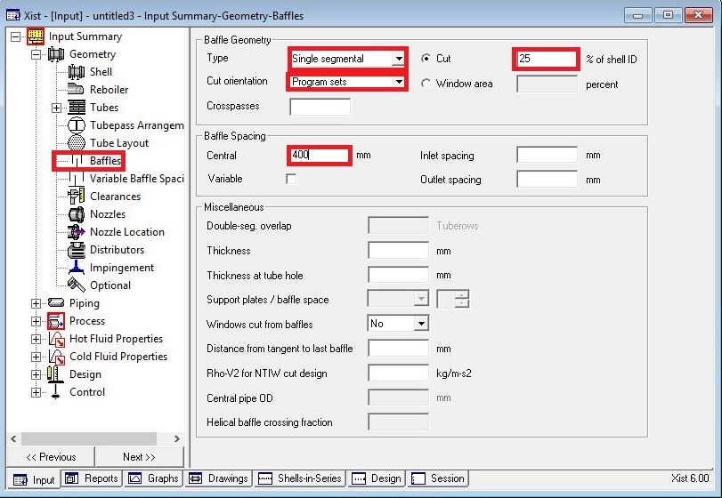Put baffle info in baffle sheet in red areas like below

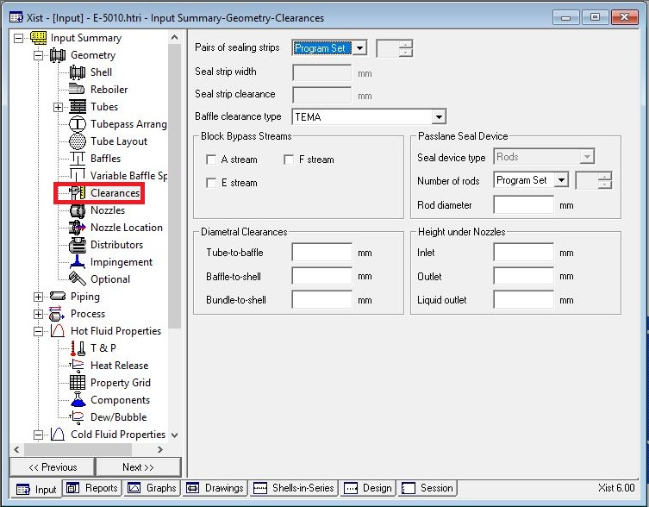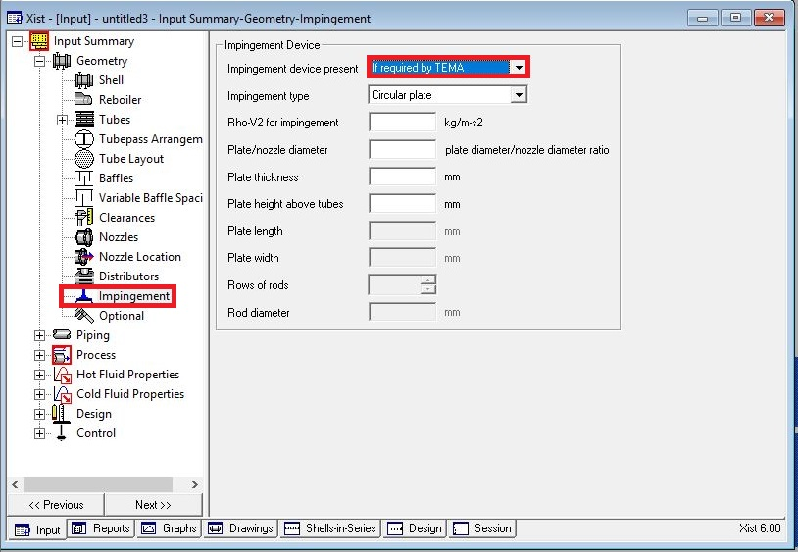Act exactly like below for impingement sheet and Clearance

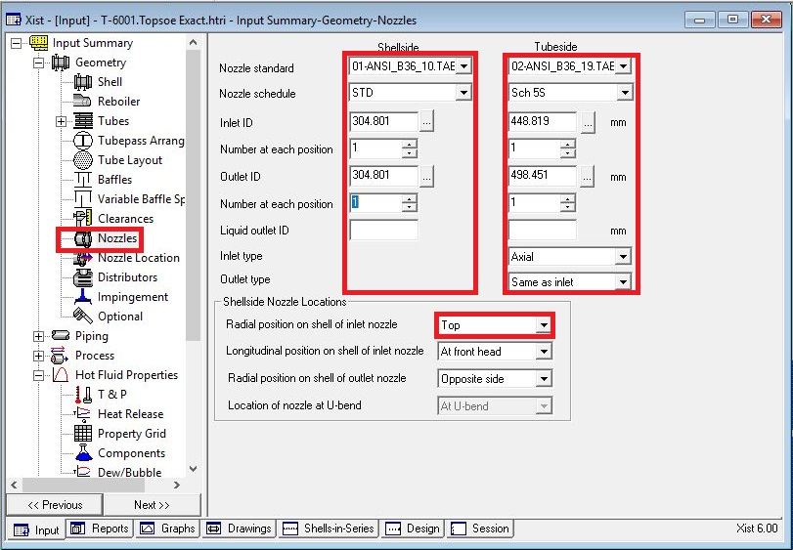Enter nozzle info from piping info

Set nozzle location

* Remember that first sketch is horizontal one but due to some warnings vertical one is

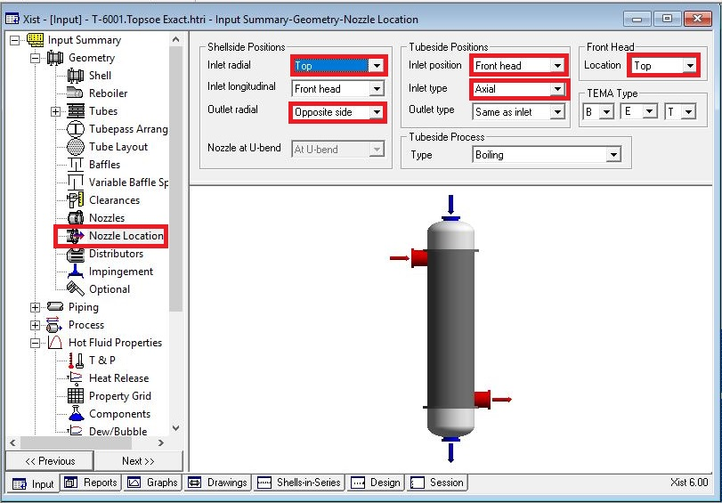selected and therefor the last sketch is put below.

Results:

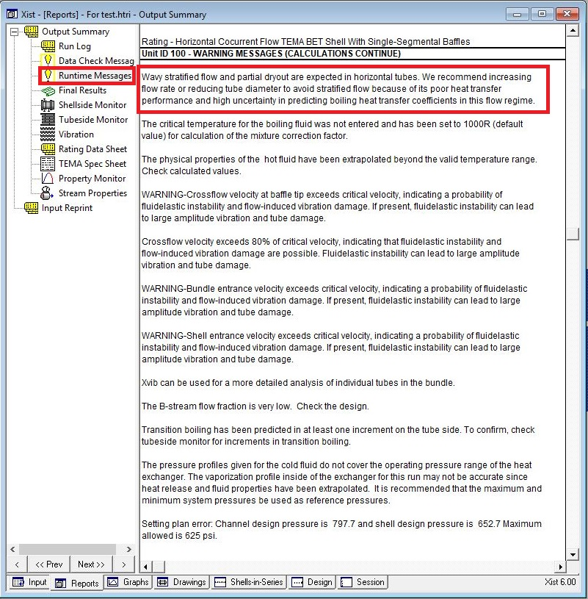Now run and it results with following run messages

* Due to flow regime vertical orientation is selected and the warning disappears.
* By looking at overdesign factor and dp around shell side it appears that shell ID should

be increased.

* At first it is increased to 1700 mm and then to 2000. The resultant is that dp decreases

to a good point but not satisfactory but overdesign factor reaches to -30 %. For now, it

seems better to increase tube length 9.75m which results in an increase in oversize

factor by 32.5 % but dp increases to 0.25. As for next step the segmental baffle is

changed to double segmental baffle to decrease dp to 0.07. Cross-pass is decreased

from 25 to 20 to not only pass minimum TEMA baffle spacing limit but also increase B-

stream.

Now it is time to increase overdesign factor. For doing so at first shell ID is increased to

2150 and as a result, overdesign factor increases to 4.5%. So, tube length is increased

to 12.1 m to increase its overdesign factor and this results in 17% overdesign factor.

In order to eliminate two warnings in next pages about 800 tubes were eliminated and

during elimination since the surface area is reduced the overdesign factor is also

reduced therefore tube length is increased to 13m to counteract that.

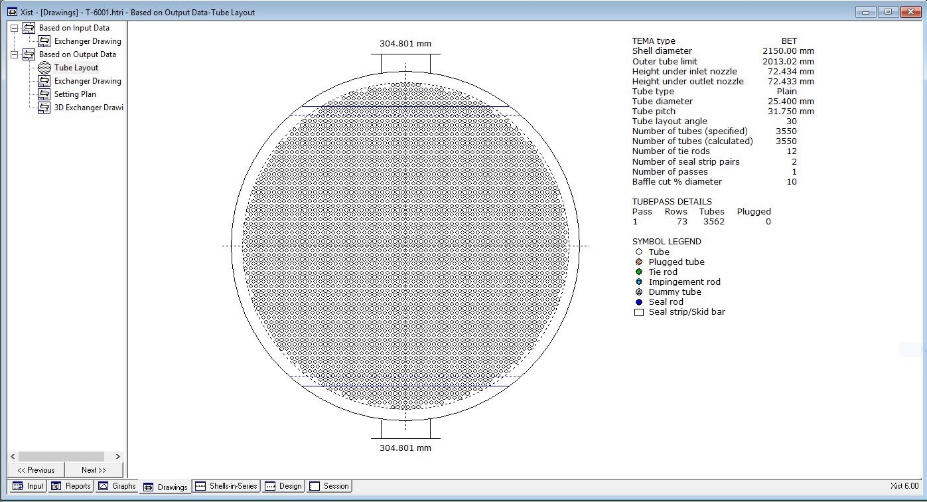

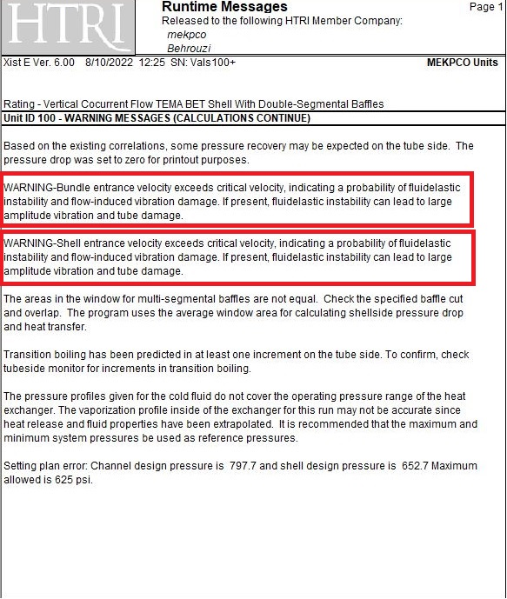

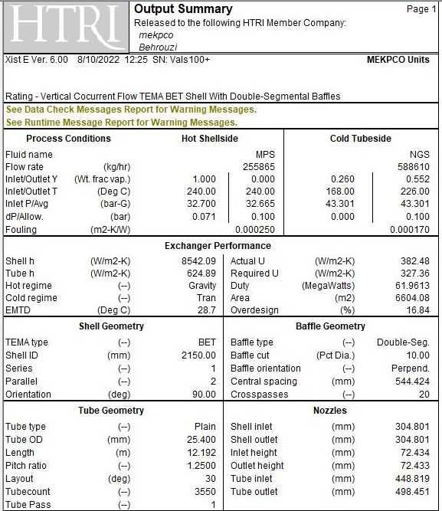

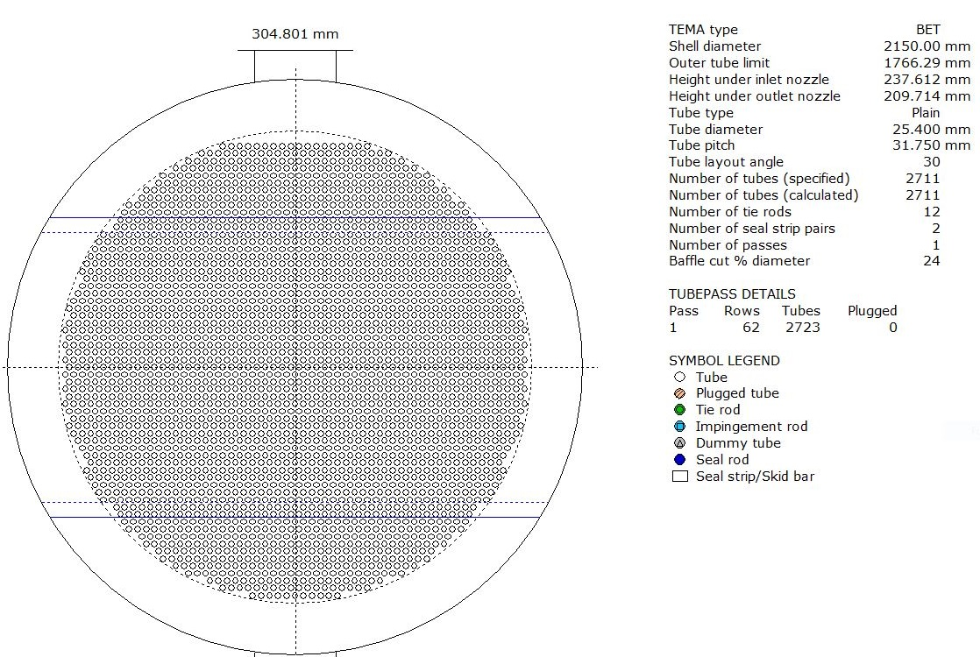After eliminations of tubes, it results like below:

