E-6003

Design and Principles

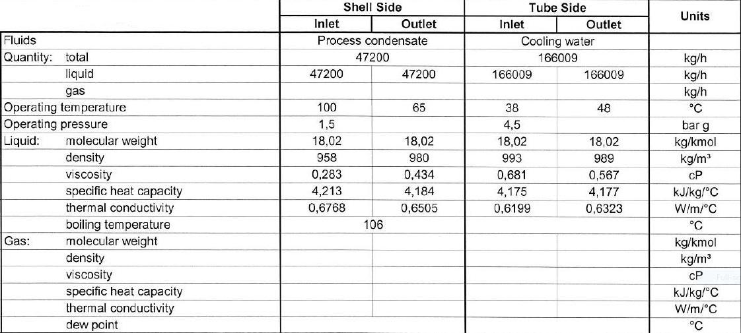**Process data**

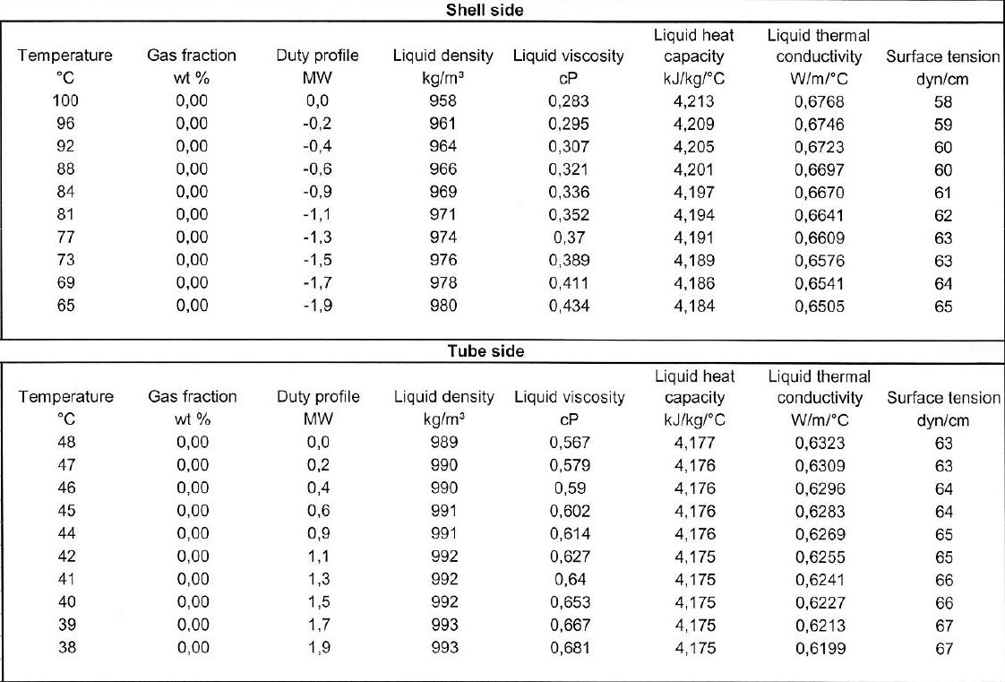**Heating and Cooling Table**

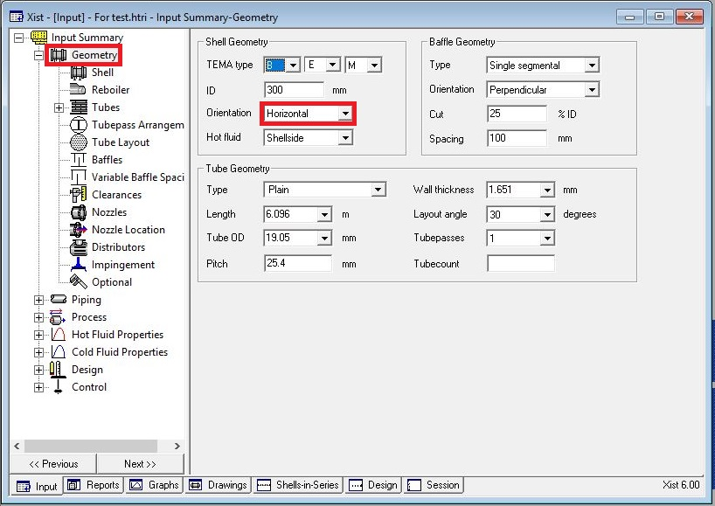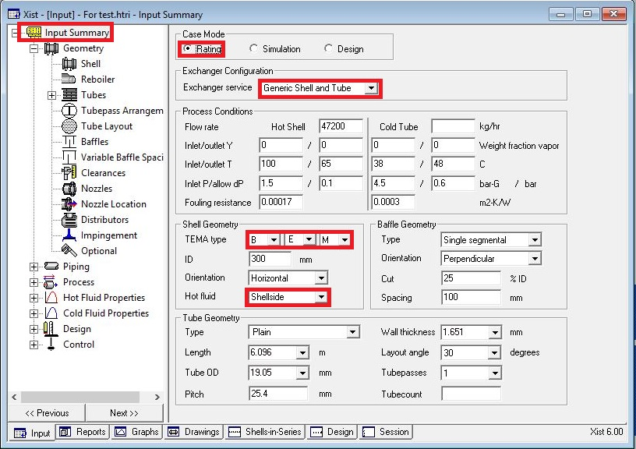**Open HTRI and Input Summery sheet and enter data in red areas**

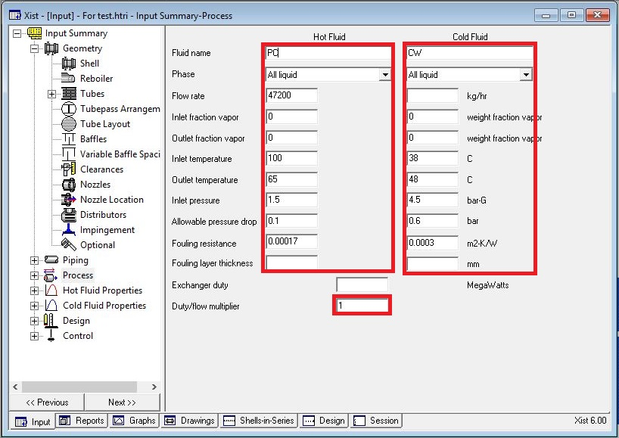**Enter operating data in process sheet in red areas**

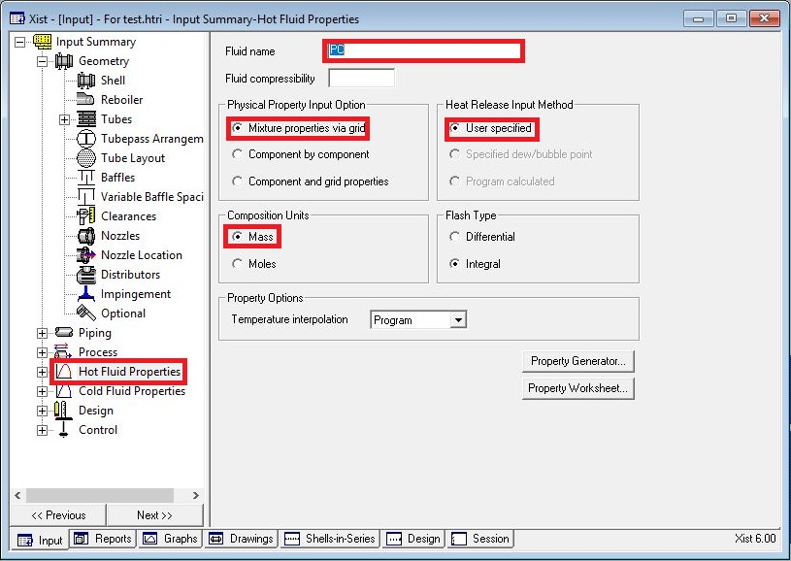**Enter heating and cooling table data in hot and cold fluid properties in red areas**

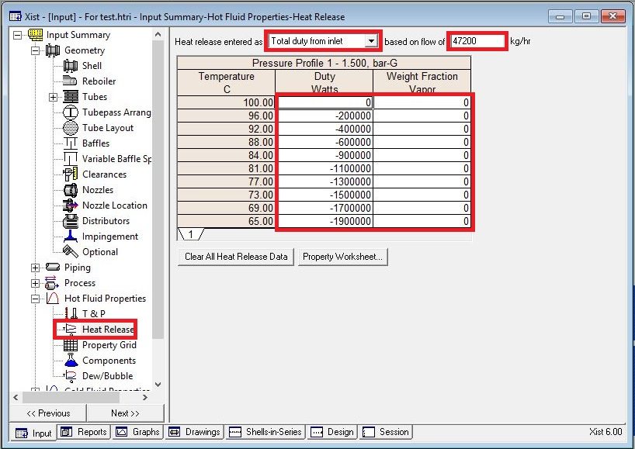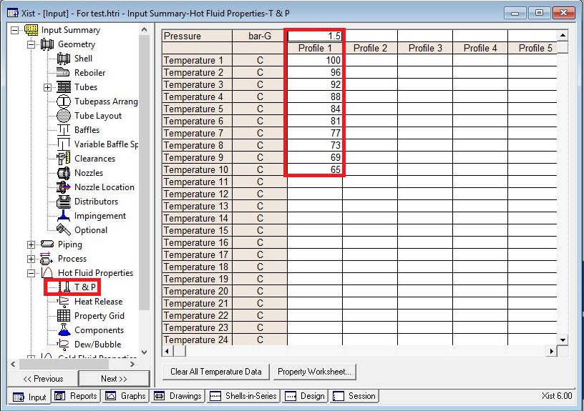

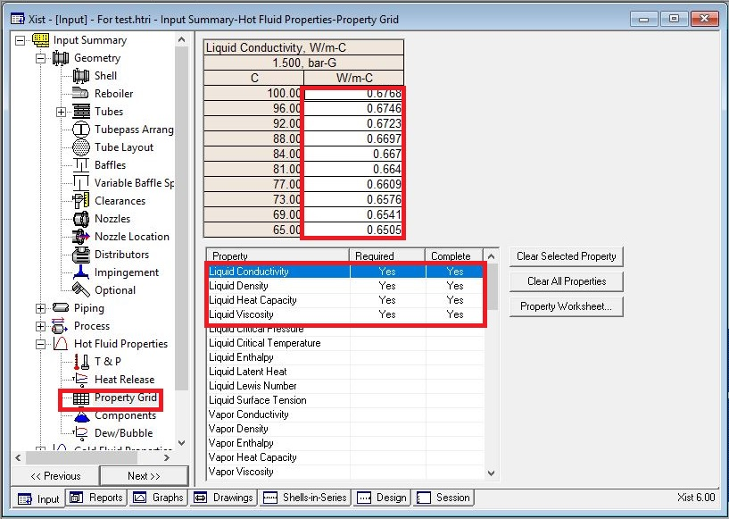

**Put shell info in shell sheet in red areas**

Note:

1. Initially estimate shell ID between 1.5-3 times tube-side pipeline ID, here it is 6 inch so

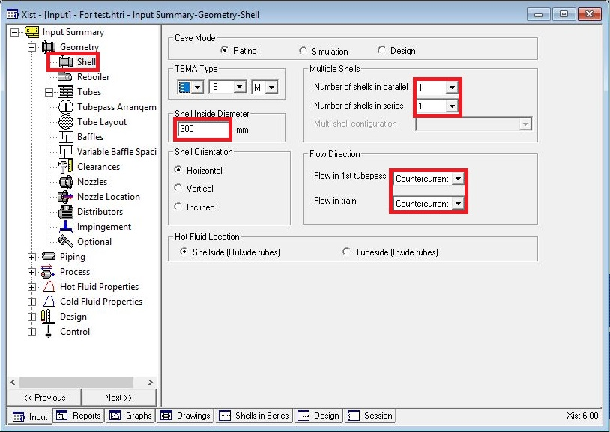first estimation would be 12 inch.

**In Reboiler Sheet do not enter an input**

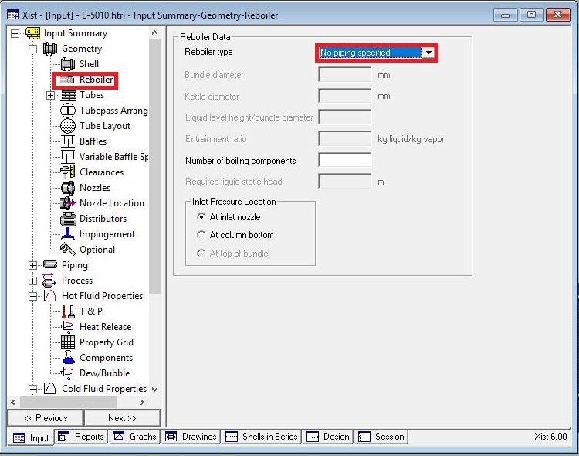

**Put Tube mechanical data**

Since it is cooling water, 19.05 is selected and thanks to presence of CO2 and Ammonia

in the water Duplex SS is selected.

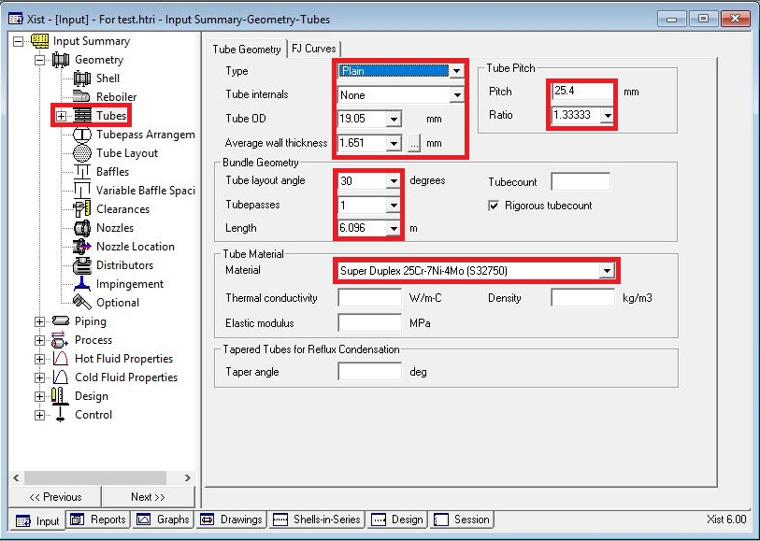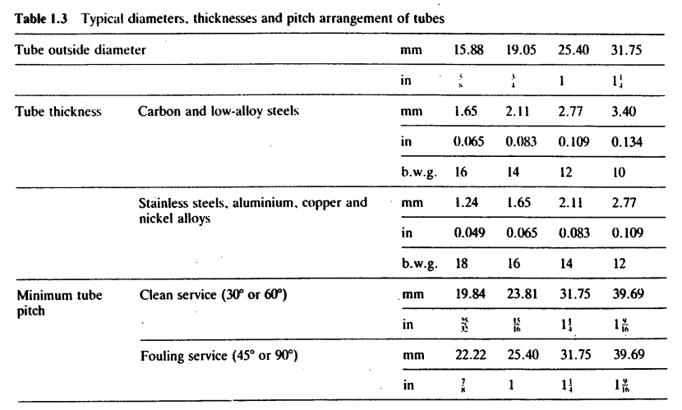According to table below tube thickness of 1.65 is chosen.

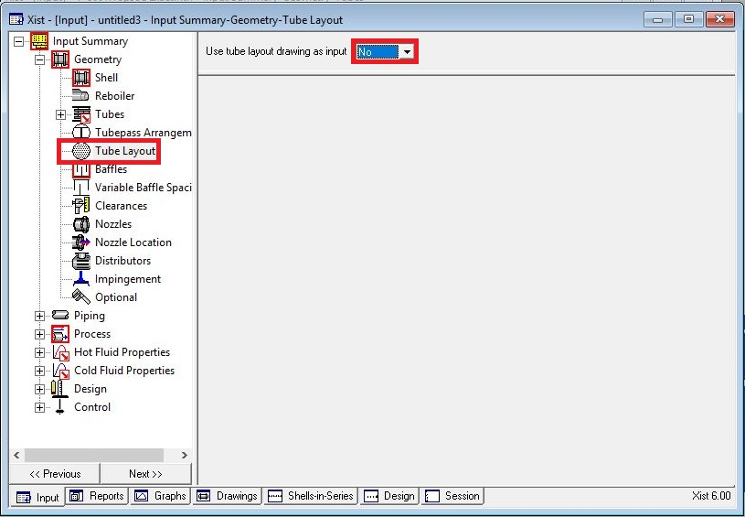Act like below

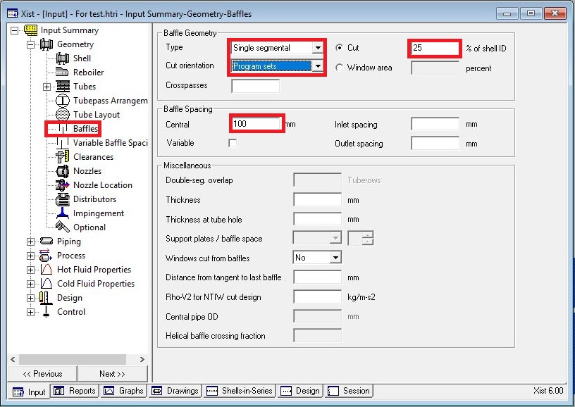**Put baffle info in baffle sheet in red areas like below**

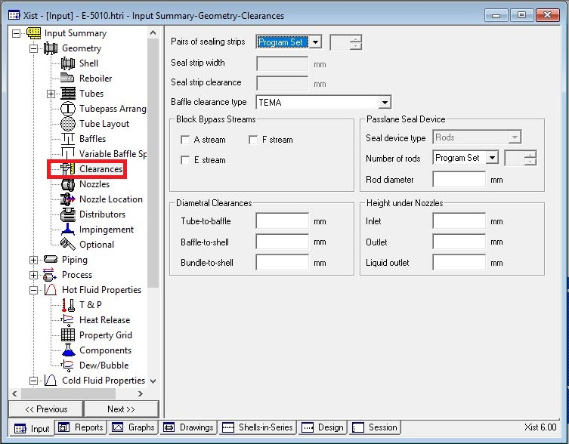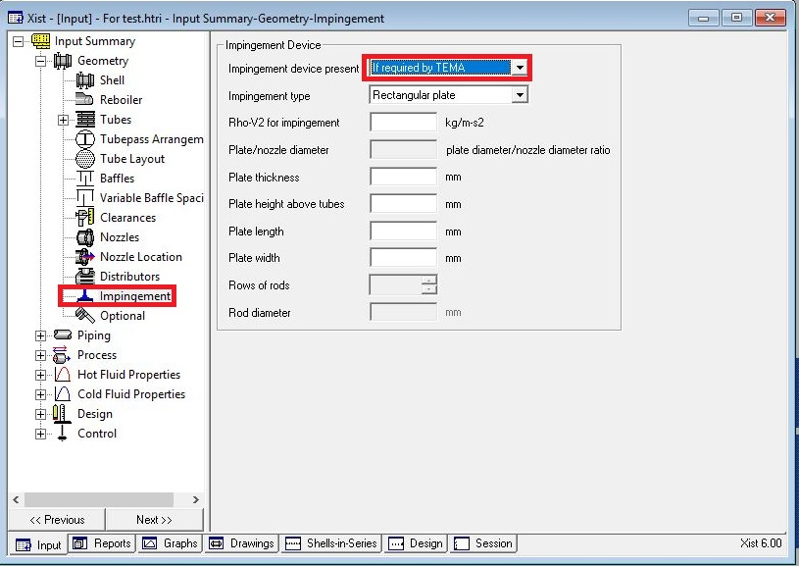Act exactly like below for impingement sheet and Clearance

**Enter nozzle info from piping info**

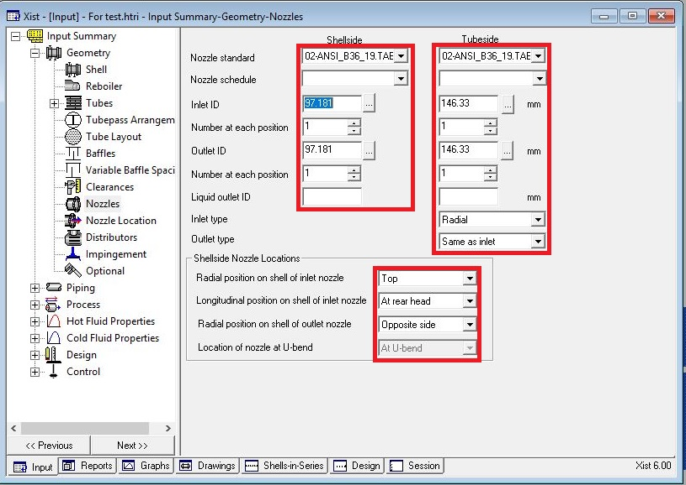

**Set nozzle location**

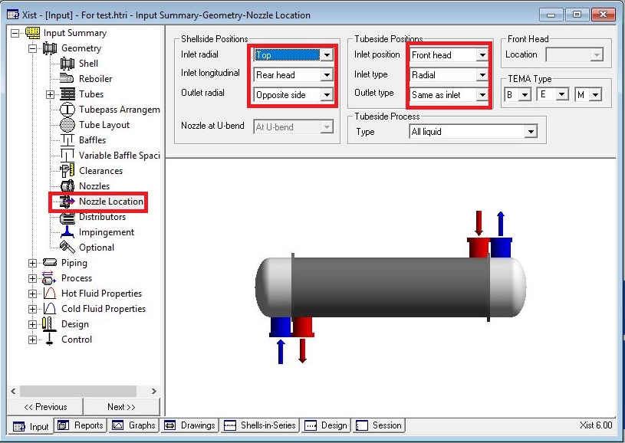

**Results:**

1. Now run and the dp in hot shell side becomes 1.62 bar and overdesign factor becomes -22%

2. Now increase the shell ID and overdesign factor becomes 35% and dp reduces to 0.89 bar

3. Now increase baffle spacing to 250 mm and run it again. Dp reduces to 0.215 and overdesign

Factor to 33%.

|  |  |
| --- | --- |
| **Spacing** | **Oversizing** |
| **100** | **35** |
| **250** | **33** |
| **300** | **31** |
| **350** | **31** |
| **400** | **30.5** |

4. Now decrease tube length to 4.87 to reduce oversize factor and run it and oversizing factor

becomes 5.54%. As a result, dp also reduces to 10.17

5. Now increase Shell ID to 450mm and reduce Tube length to 4.27m simultaneously and the

result is that dp becomes 0.138 bar and overdesign factor 14%

6. Now increase Shell ID to 500 mm and activate tube layout and run it and the overdesign

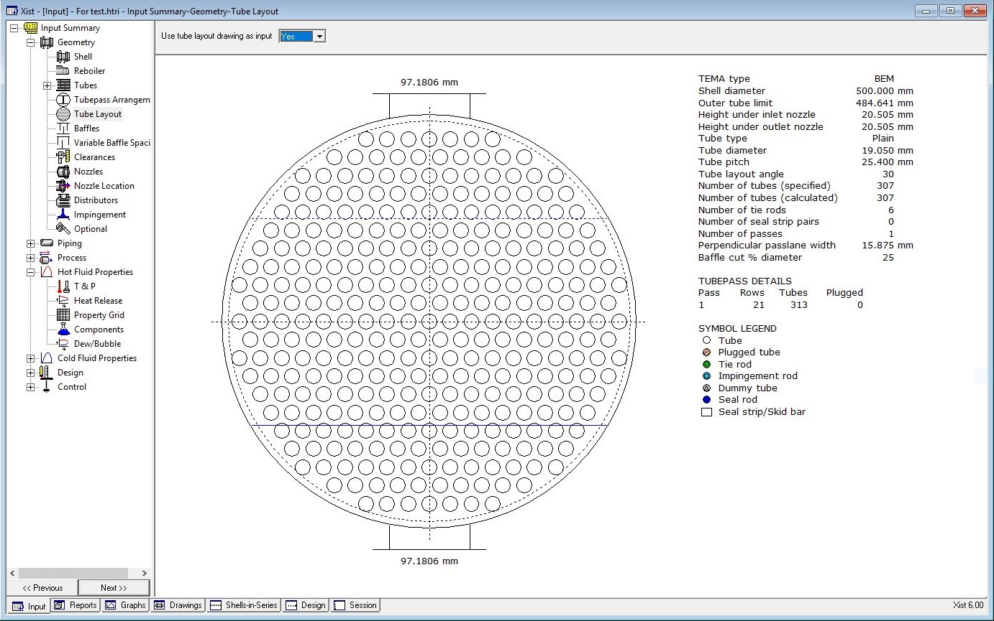 factor becomes 40%

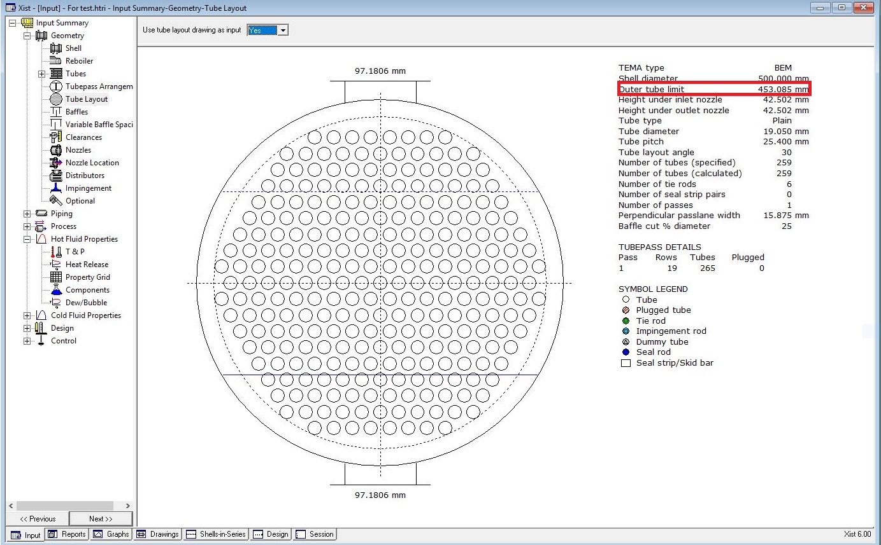7. Now omit some tube like below and run it and the overdesign becomes 21%

But after doing so, the water velocity in tube side reaches less than 1 m/s so we try to

use double pass and by doing so, dp in tube side goes from 0.11 to 0.39 bar and tube

side h goes from 5426 to 9898 and the velocity goes from 0.98 to 2.11.

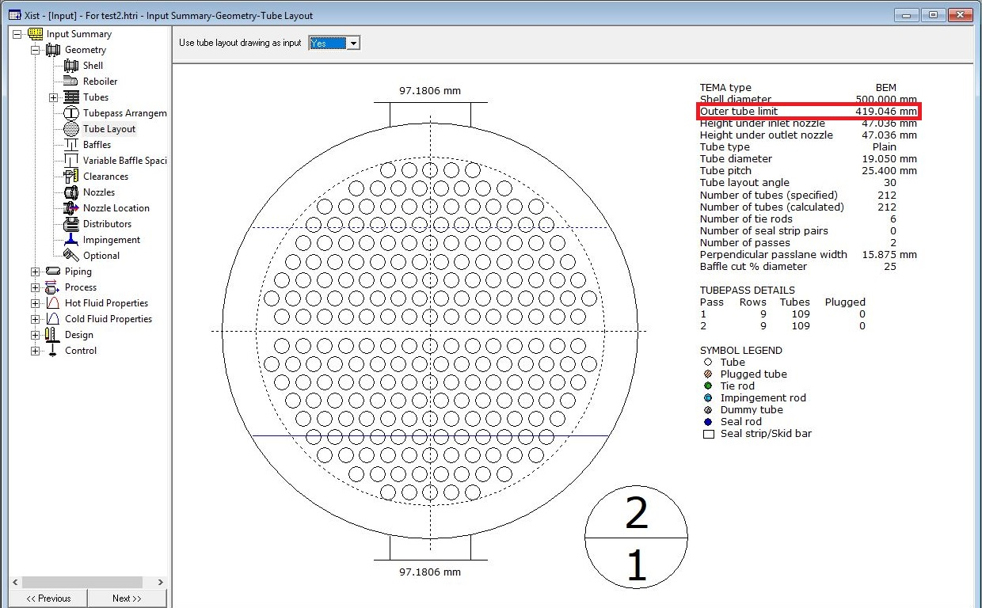8. Now omit some tubes like below and run it and overdesign factor becomes 7%

Now the only fly in the ointment is that B stream is low so different cut and spacing for baffle is

tested and baffle cut of 35% is tested and the overdesign factor becomes 1.73% and B-stream

increase to 50%.

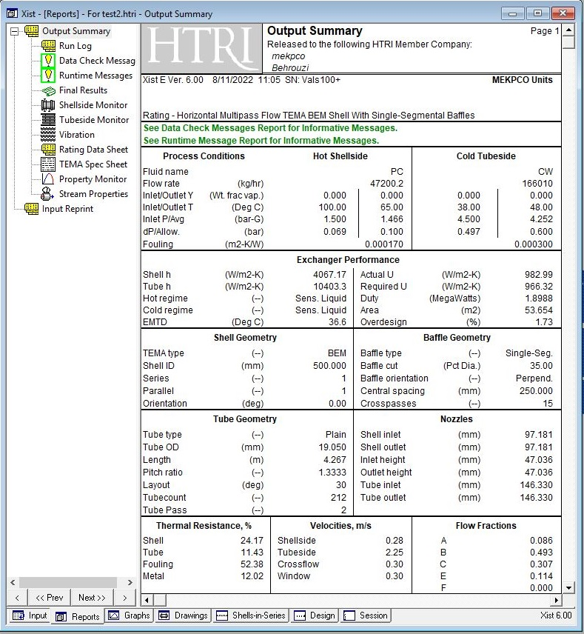

If baffle cut of 25% is selected then B-stream be as low as 41% but overdesign factor is

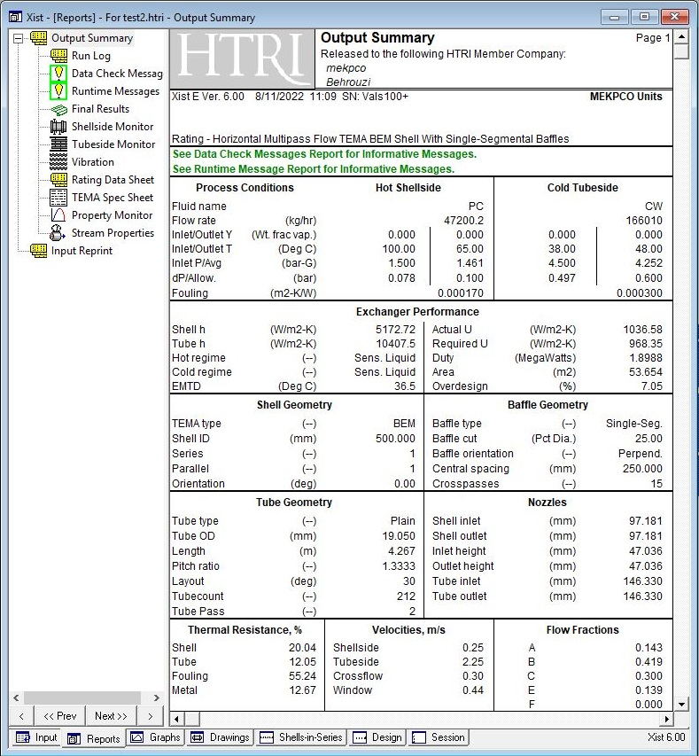about 7%

Now if the baffle cut 35% and increase tube length to 4.87 and run it. This results in overdesign

factor of 16% and so reduce the number of tubes till the overdesign factor becomes 10%. Then

activate impingement plate and omit some tubes and run it.

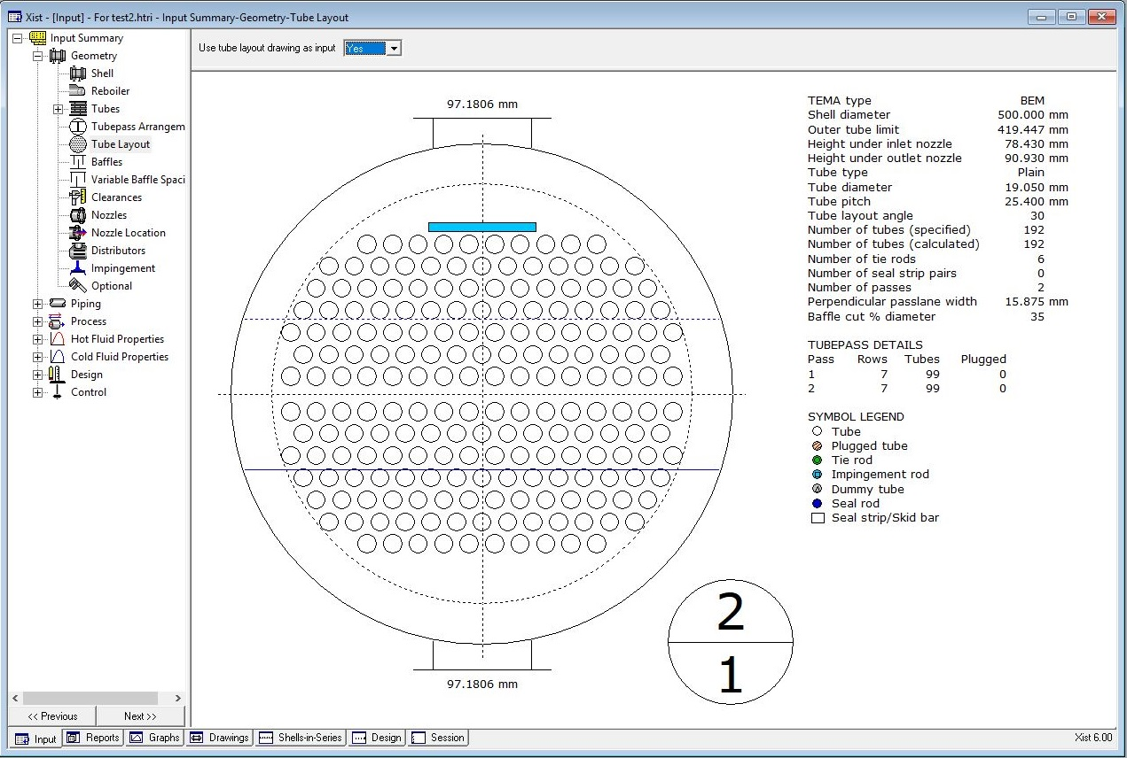

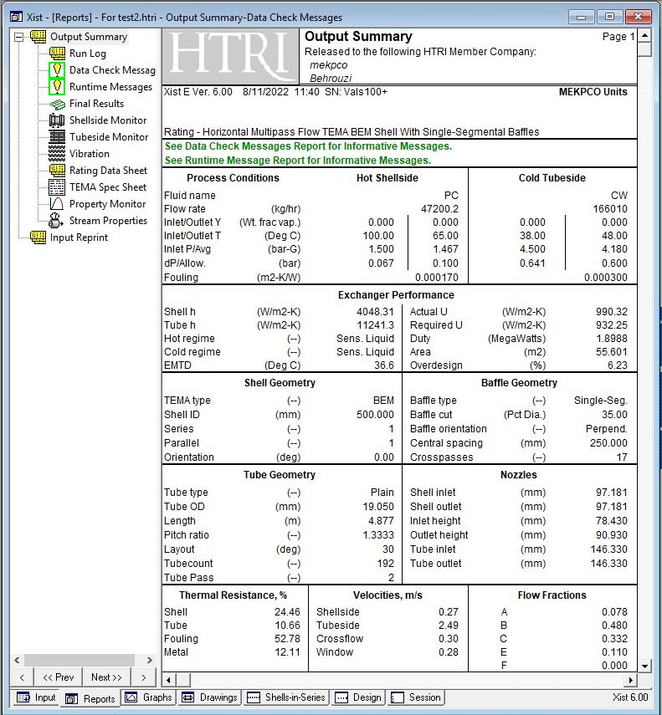

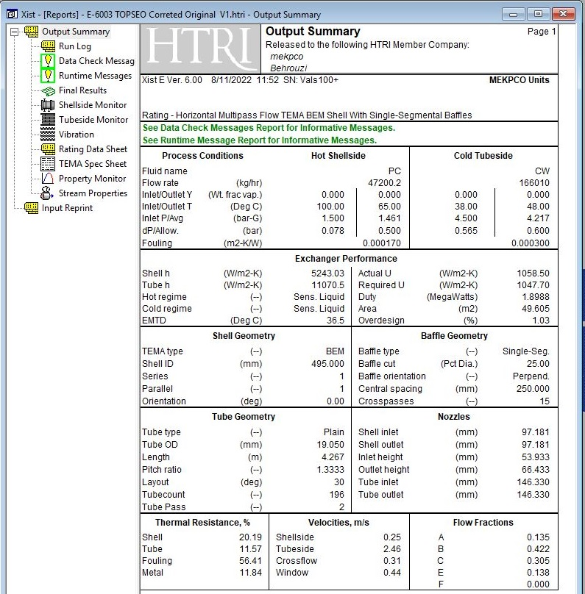Licensor Design

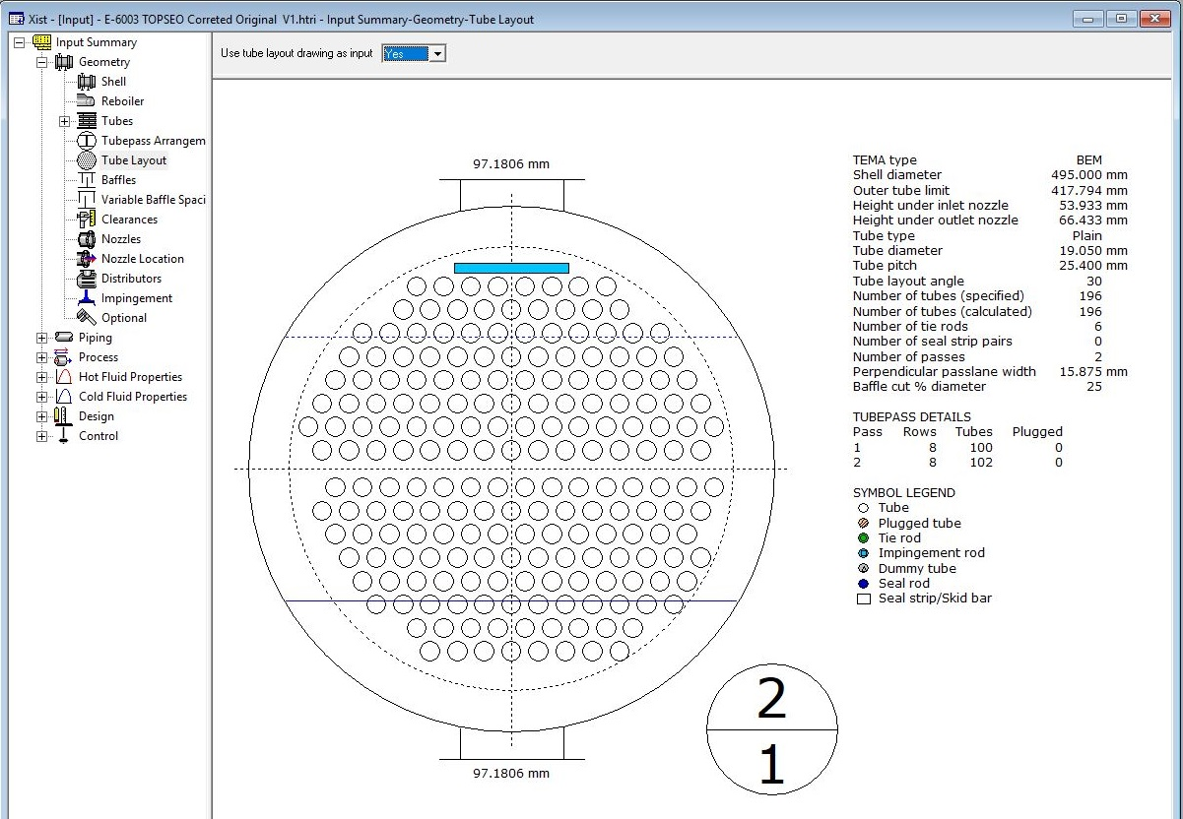

Which one should be selected?

While Topsoe design offers a heat exchanger with lower weight, that of mine offers a heat

exchanger with higher overdesign factor.

By the way Topsoe configuration was also tested on my design and my configuration was

slightly higher than that of Topsoe design

Drawings

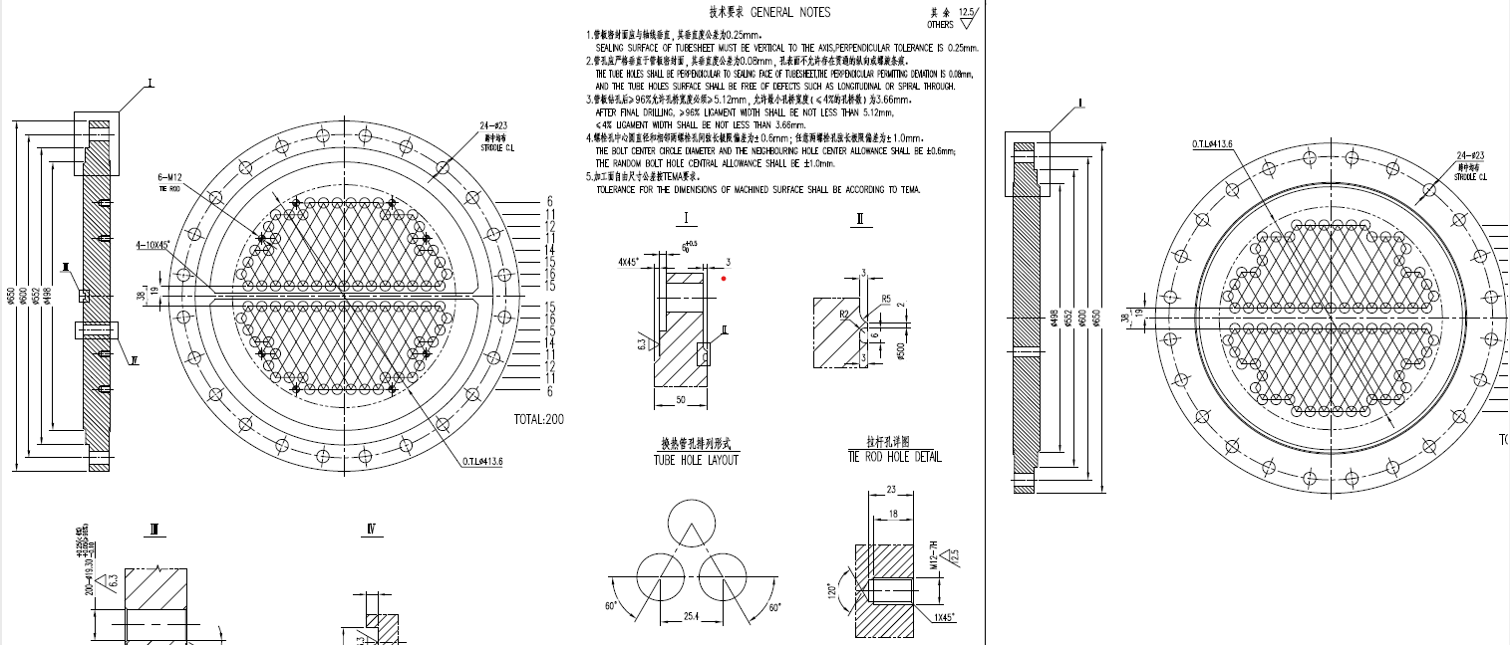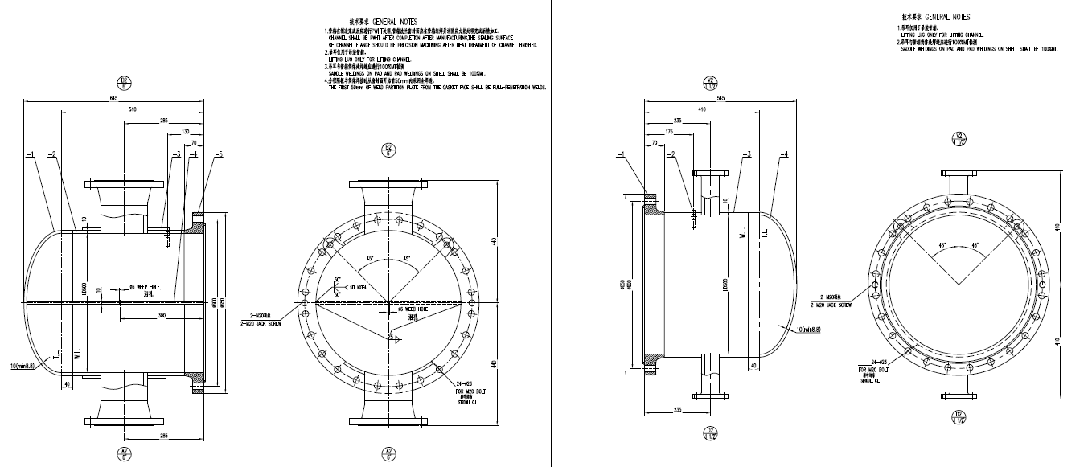

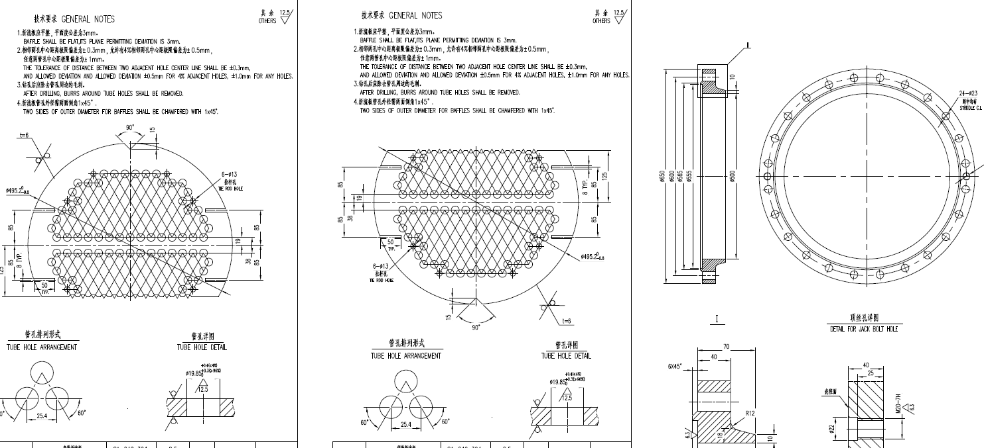

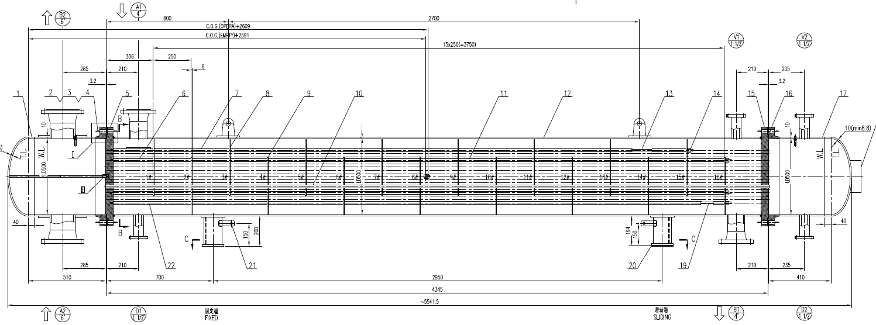

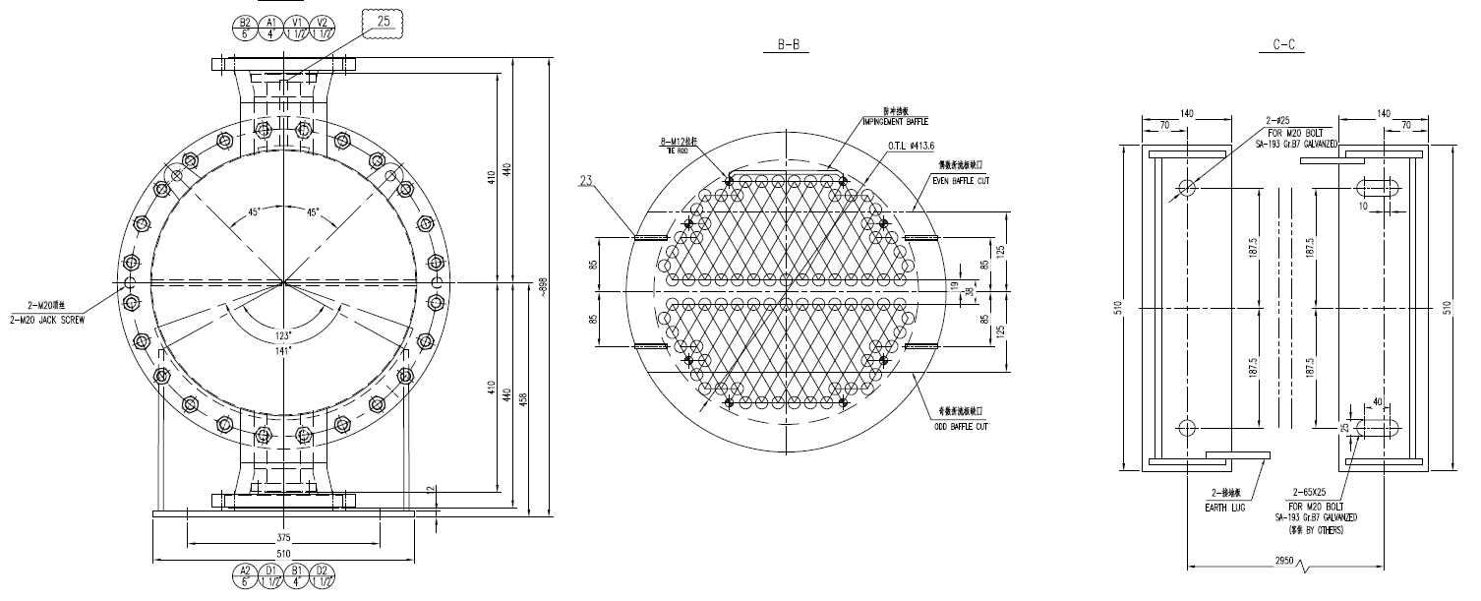

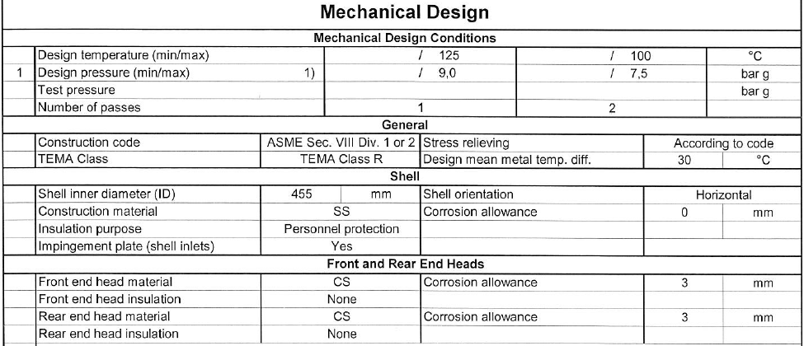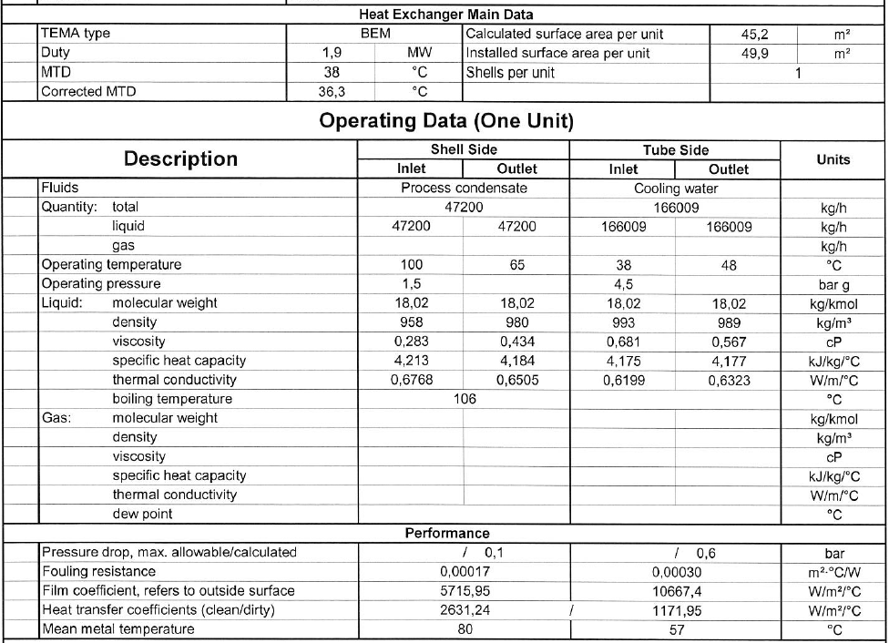Datasheet

