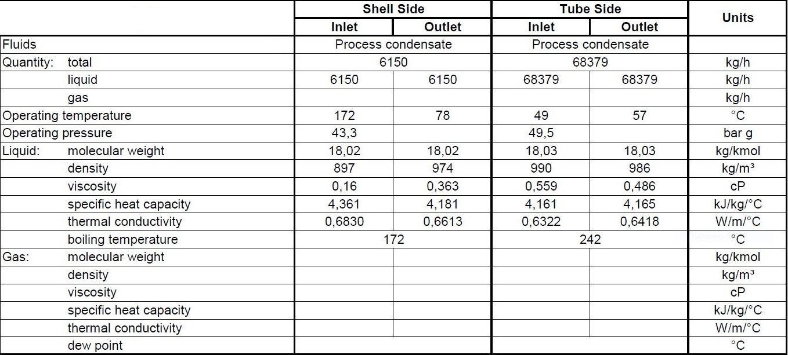**Process data**

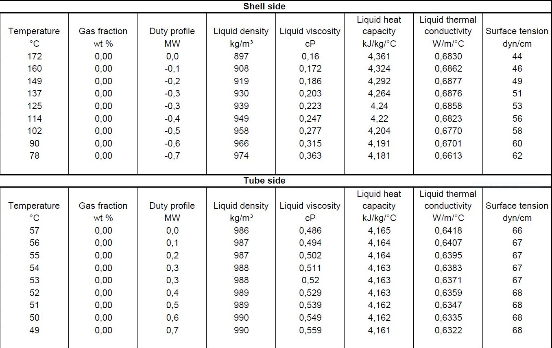**Heating and Cooling Table**

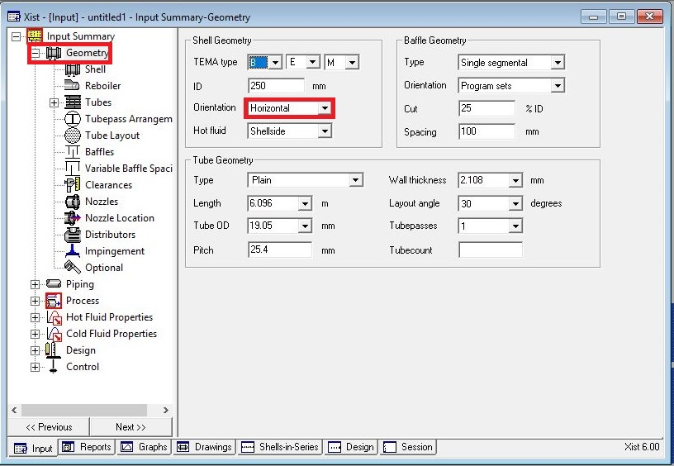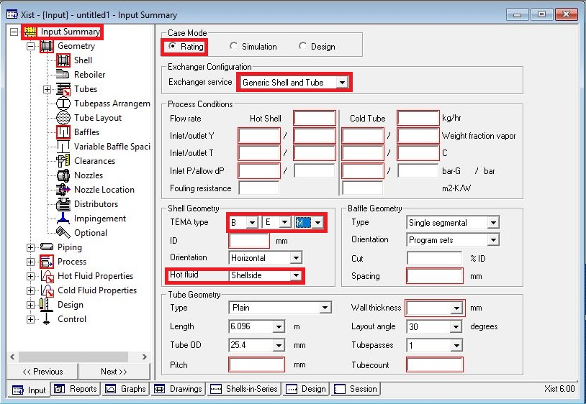**Open HTRI and Input Summery sheet and enter data in red areas**

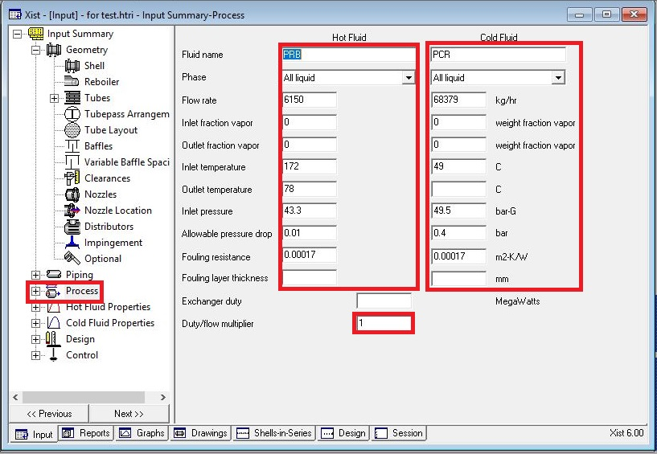**Enter operating data in process sheet in red areas**

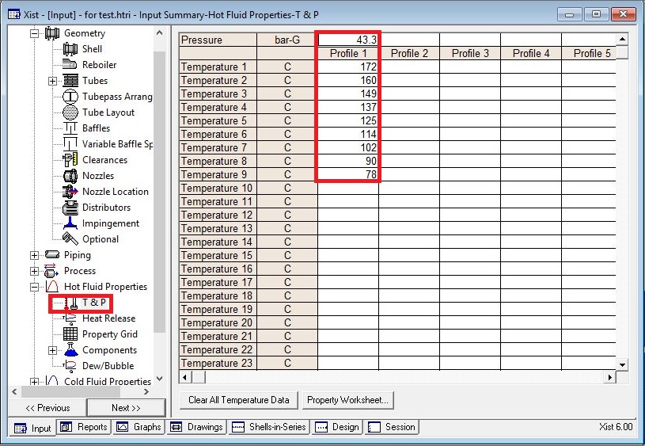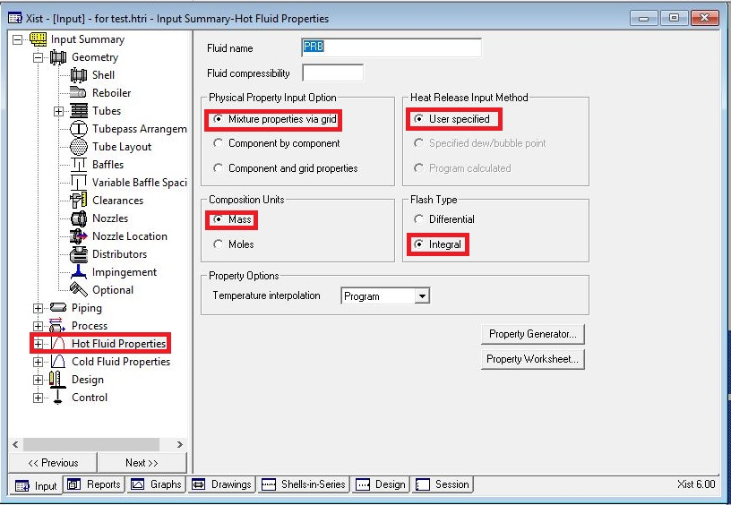**Enter heating and cooling table data in hot and cold fluid properties in red areas**

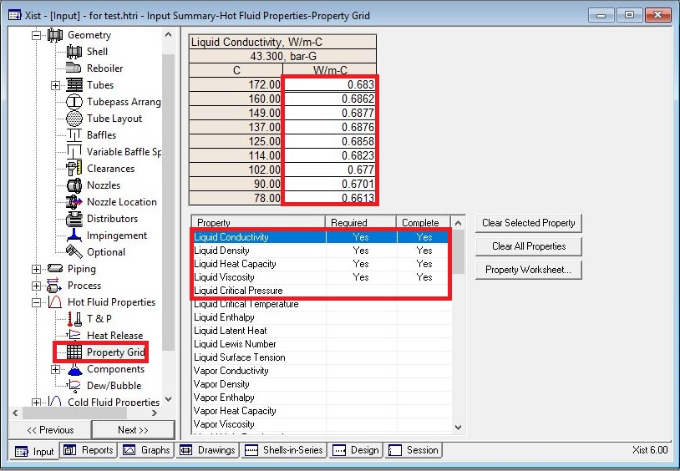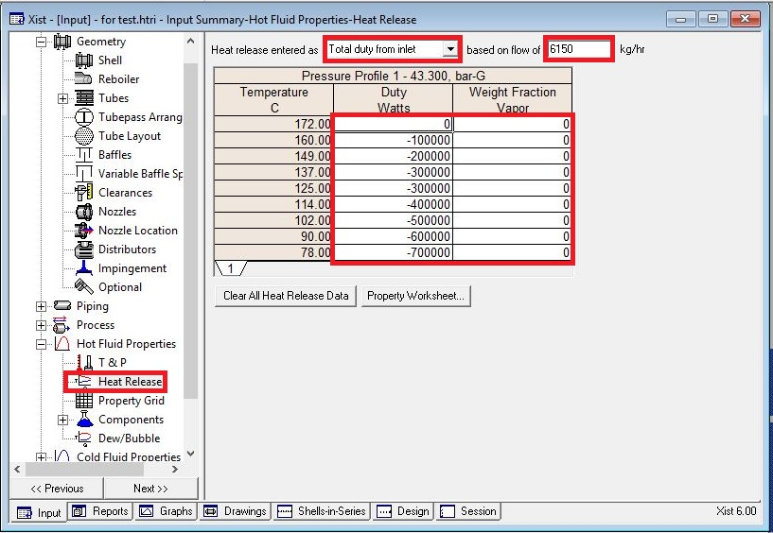

Put shell info in shell sheet in red areas

Note:

1.Initially estimate shell ID between 1.5-3 times tube-side pipeline ID, here it is 4 inch so first

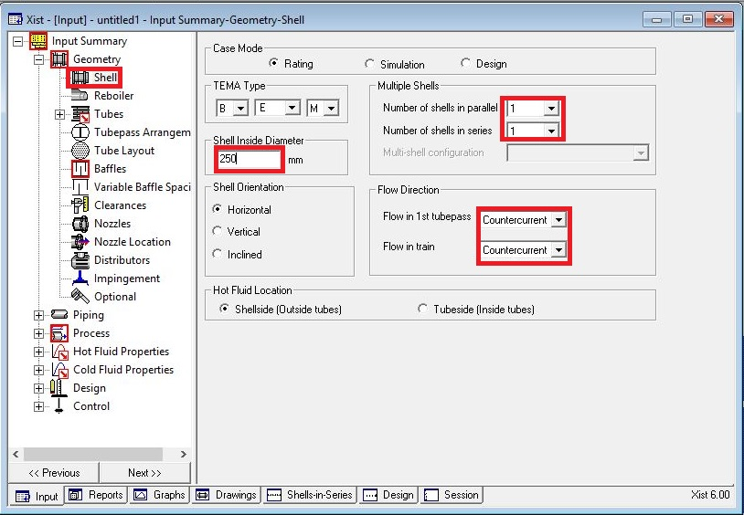 estimation would be 250mm

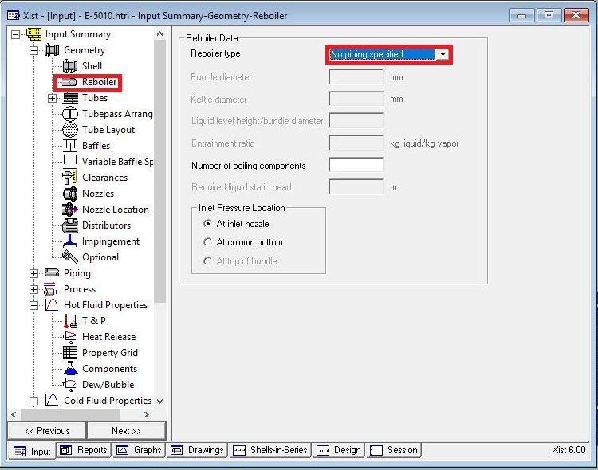In Reboiler Sheet do not enter an input

Put Tube mechanical data

Since it is water, due to velocity criteria, 19.05 is selected and thanks to presence of CO2 and

Ammonia in the water SS is selected.

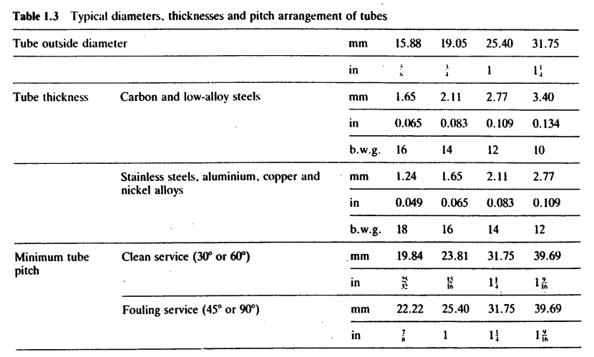According to table below tube thickness of 1.65 is chosen.

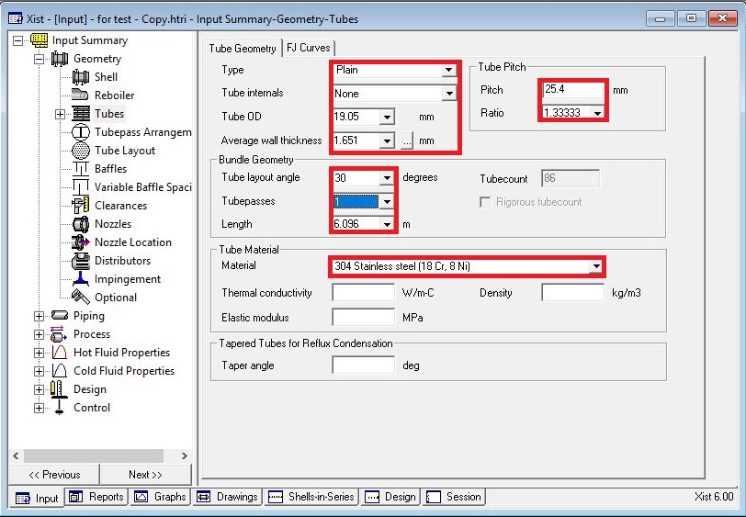

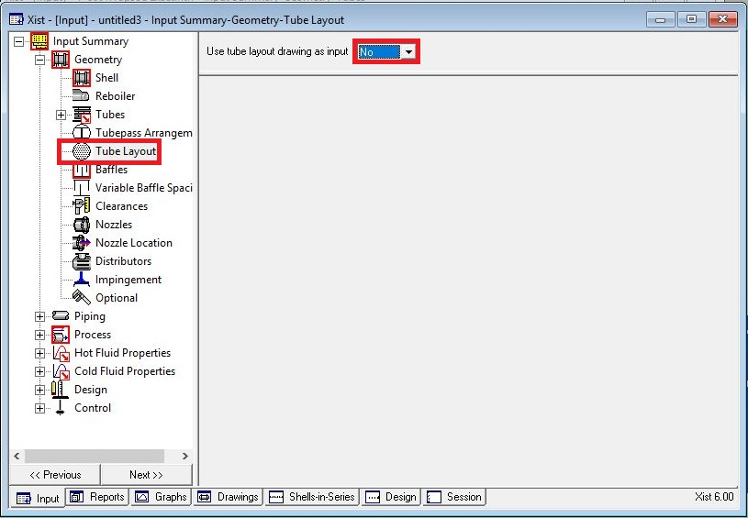Act like below

Put baffle info in baffle sheet in red areas like below

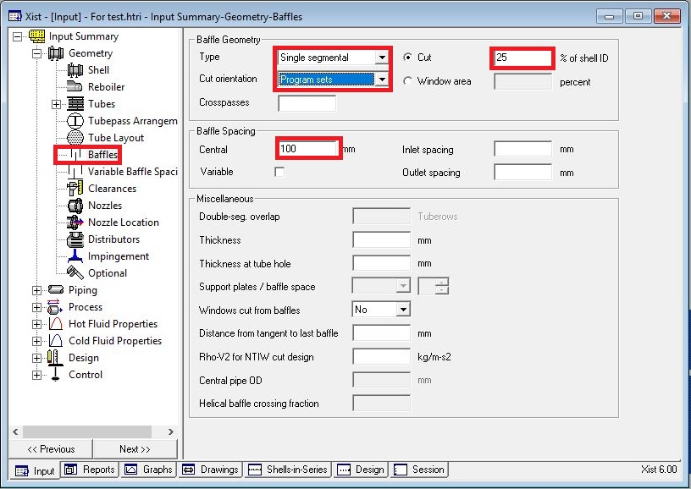

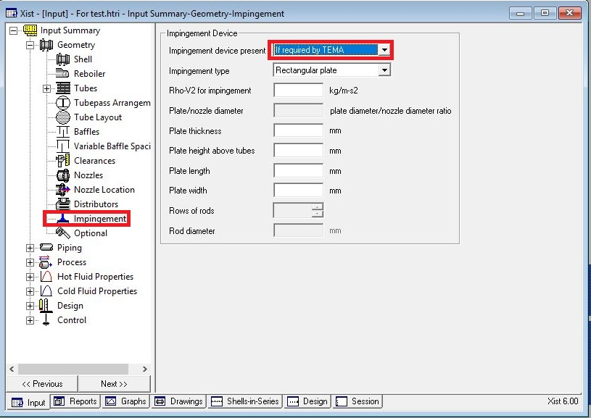Act exactly like below for impingement sheet and Clearance

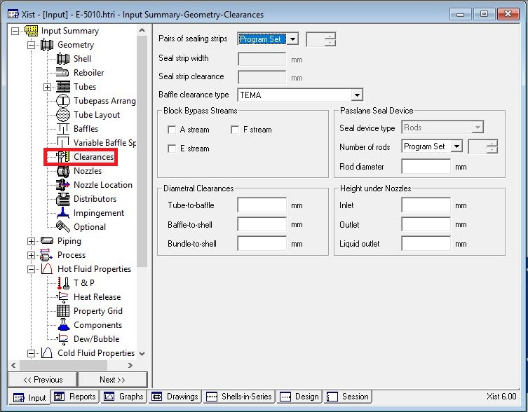

Enter nozzle info from piping info

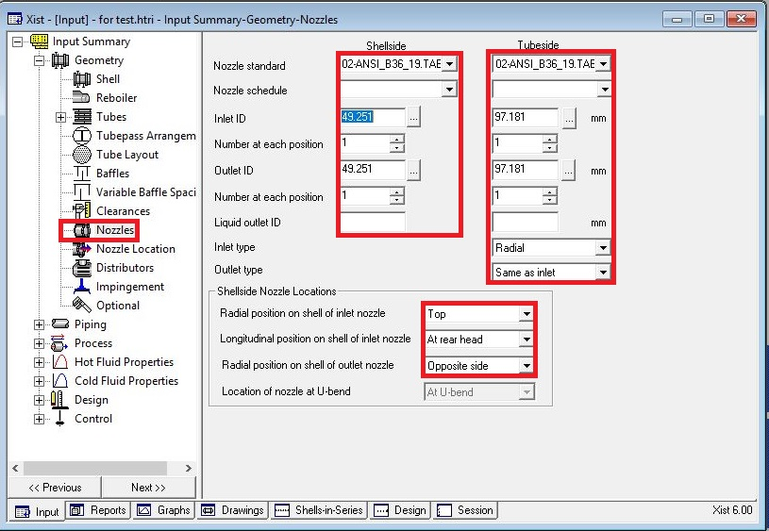

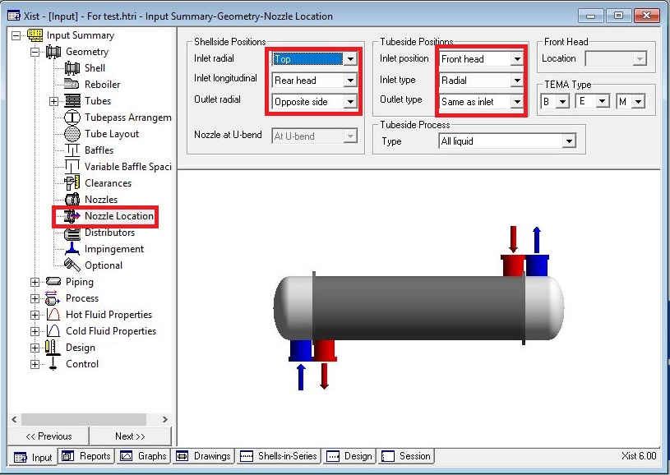Set nozzle location

Results:

1. Now run and this results in 129% overdesign factor and shell dp of 0.06 bar. Just

remember there is no need to take any action for below warning sometimes, because

later you see that after activation of tube layout option this will disappear. So from this

result we realize that the diameter due to dp I shell side should be increased and in

order to decrease the overdesign factor tube length is decreased in stepwise manner to

4.27m and after run, the result is that alongside with decrease in overdesign factor to

59%, dp reduces to 0.04 bar. Repeat it and reduce the tube length to 3m and run it and

as a result the overdesign factor reduces to 11% and dp becomes 0.03 bar.

1. Now before increase shell ID please play with baffle spacing to reduce dp in shell side.

|  |  |  |  |
| --- | --- | --- | --- |
| **Spacing** | **Dp** | **Overdesign** | **B-stream** |
| **100** | **0.034** | **11.7** |  |
| **150** | **0.023** | **9.58** | **57** |
| **200** | **0.019** | **7.41** | **62** |
| **250** | **0.017** | **6.25** | **65** |
| **300** | **0.016** | **4.86** | **67** |

3. Increase the baffle spacing to 250

4. Activate tube layout option and increase the shell ID to 300 mm and run it. Dp reduces to 0.015

and overdesign factor to 43%.

5. Since water velocity is at minimum, we double pass the tube side and run it. Notice that

controlling side is the shell side and by doing so , tube side h increases from 6224 to 11792 ,

overdesign factor decreases from 34 to 26 due to decrease in surface area , dp in shell side

increases from 0.098 to 0.42 bar and velocity from 1 to 2.4 m/s

6. by checking Vibration page for pv2 in bundle entrance we perceive that there is no need to

have impingement plate.

7. for dp reasons we increase the shell side ID and to keep overdesign factor constant then omit

some tubes . Dp reduces to 0.011 and overdesign factor to 40%. Then some tubes were omitted

but dp criteria not met. So Shell ID was increased to 350 and tube length reduced to 2.8 m. and

after some tube omission final sketch is reached with overdesign factor of 7.25%.

Please notice that changing direction of concurrent or countercurrent in this case study does not

have any substantial impact on overdesign factor. However, Topsoe proposed concurrent

direction is preferred.

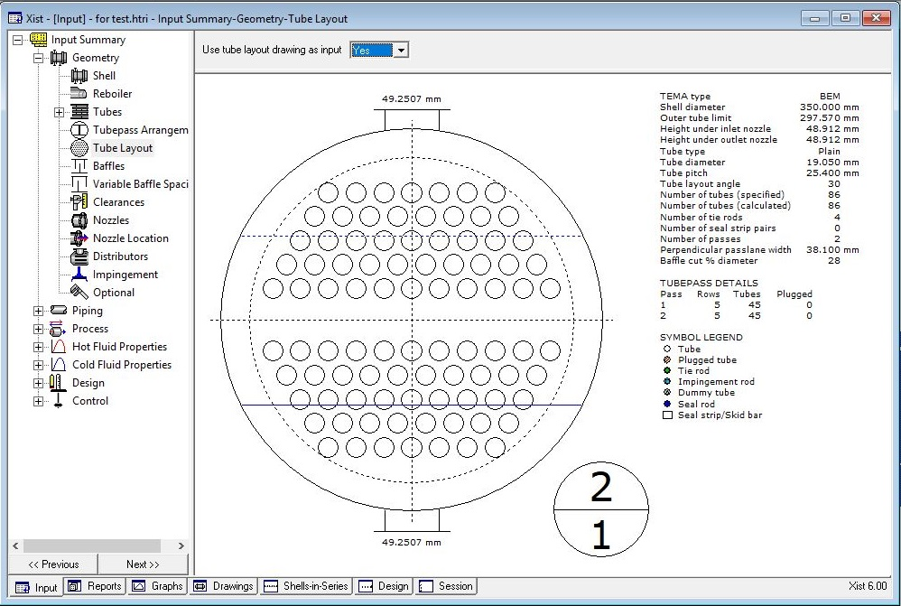My Design

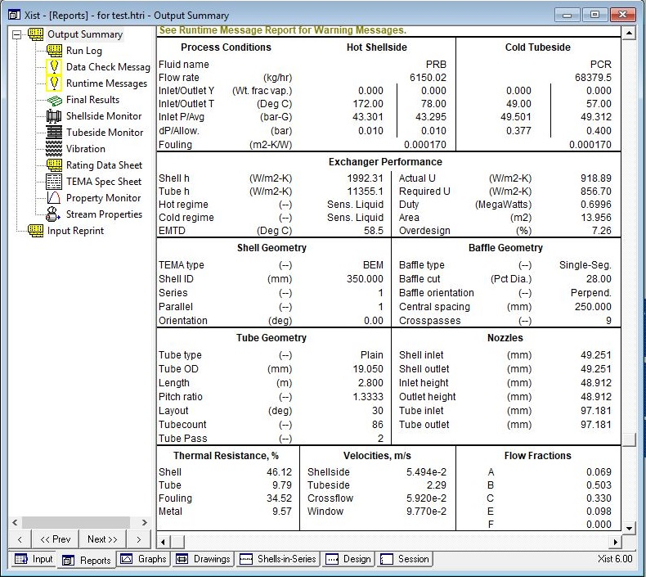

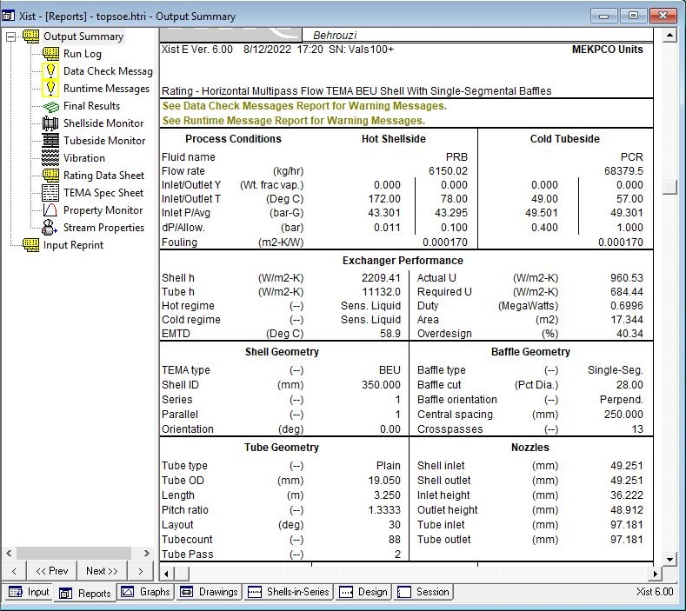Licensor Design

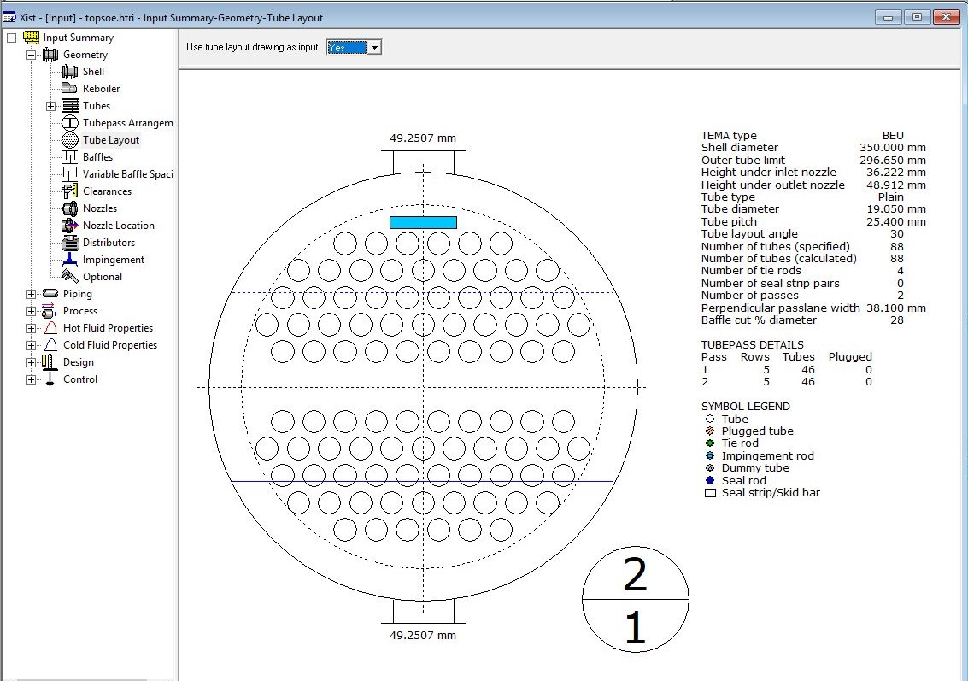

From process perspective it is not needed to have such heat exchanger with such low dp

design. therefore, in my perspective following design with following result could be used.

|  |  |
| --- | --- |
| **Parameters** | **Value** |
| **Shell ID** | **270** |
| **Tube length** | **3.65** |
| **Baffle Spacing** | **200** |
| **Baffle cut** | **35** |

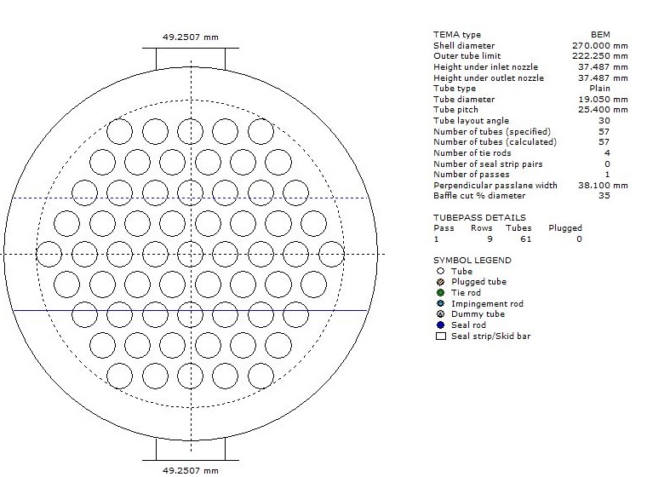

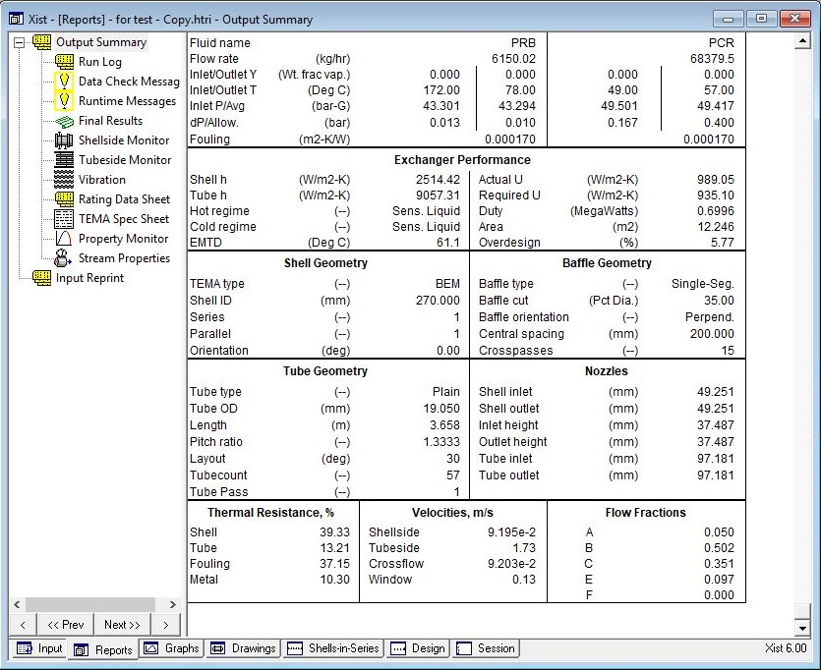

Comparison between different Design:

While Topsoe design offers a heat exchanger with 40% overdesign and 844 kg weight and my

design gives 7% overdesign and 823 kg weight , process design gives an overdesign of 5% and

620 kg weight.