**Process data**

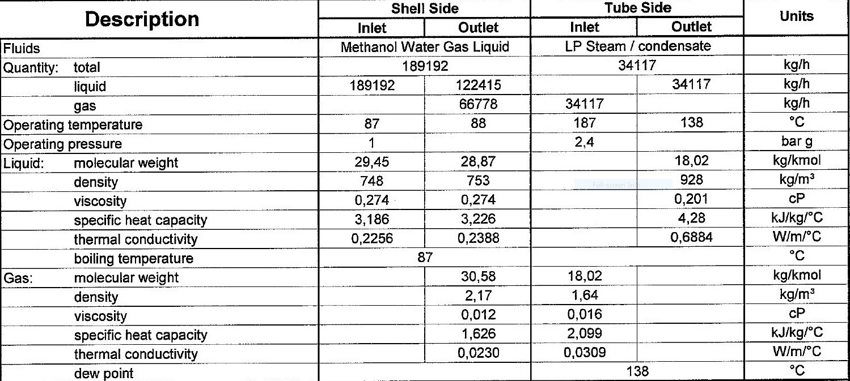

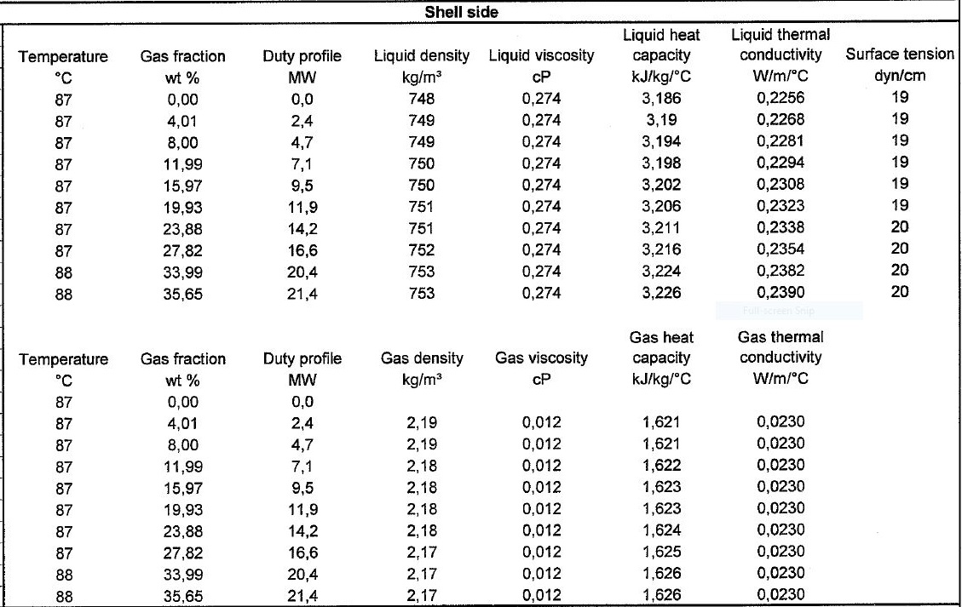**Heating and Cooling Table**

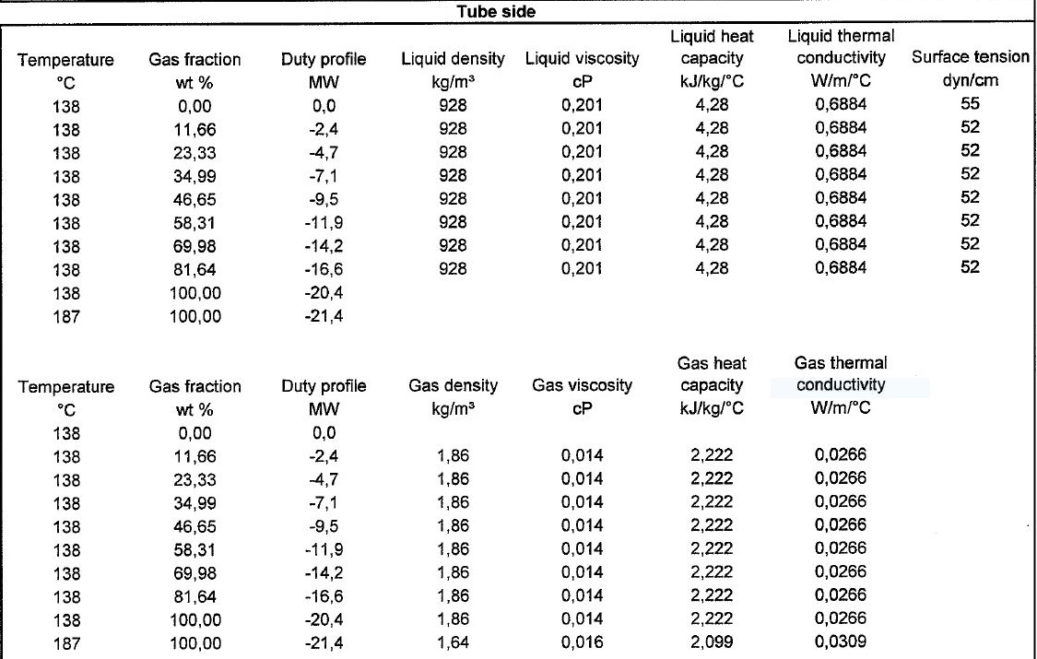

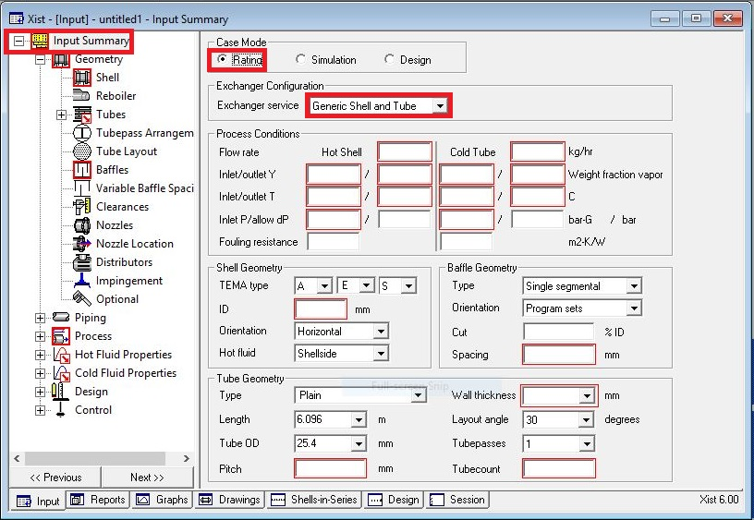**Open HTRI and Input Summery sheet and enter data in red areas**

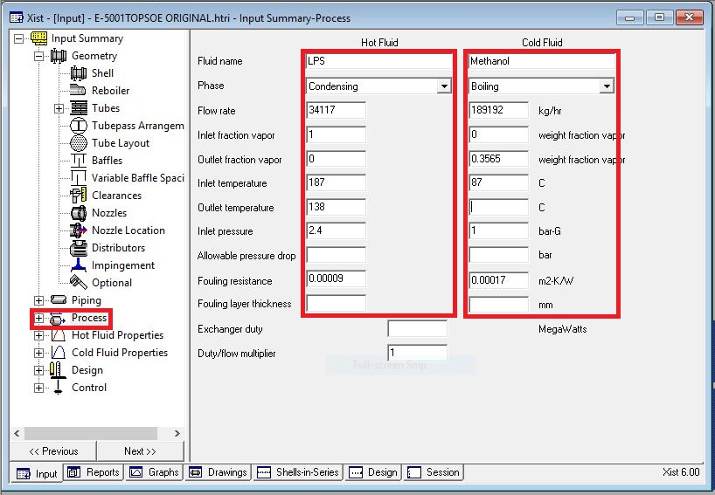**Enter operating data in process sheet in red areas**

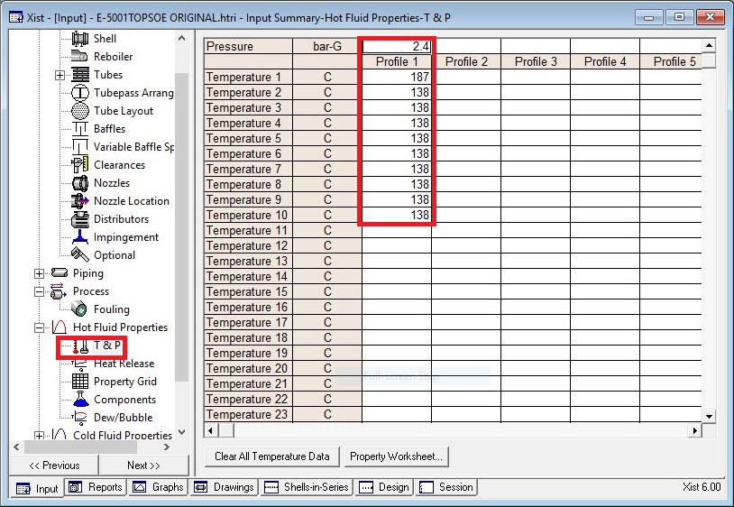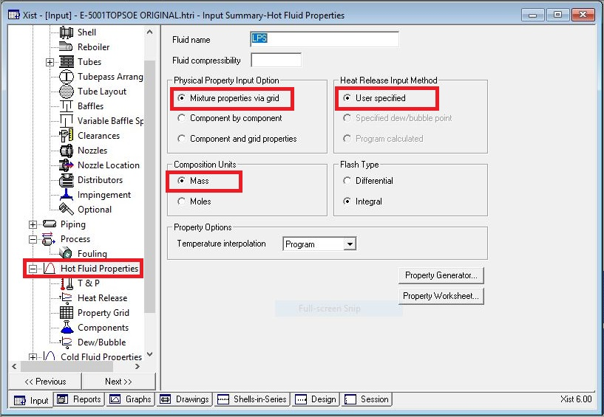**Enter heating and cooling table data in hot and cold fluid properties in red areas**

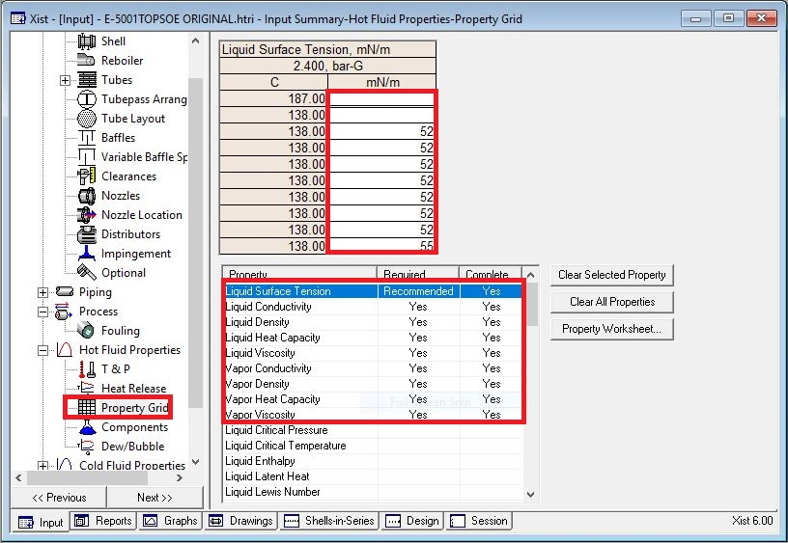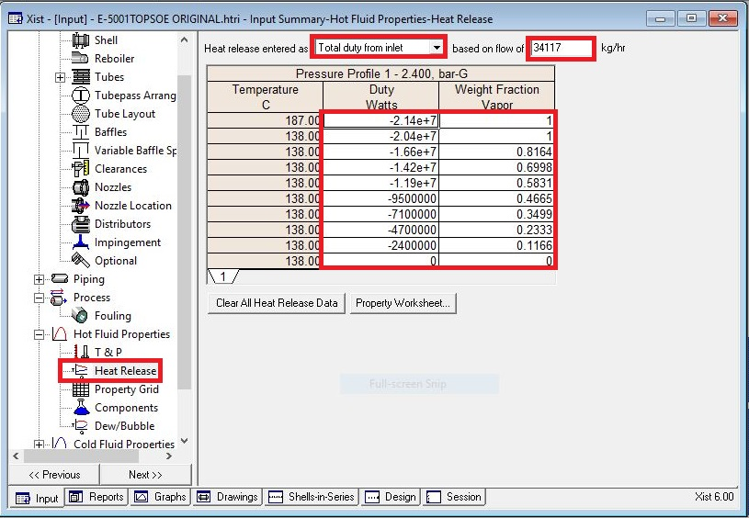

Put shell info in shell sheet in red areas

Note:

* 1. Initially estimate shell ID between 1.5-3 times tube-side pipeline ID, here it is 14 inch

so first estimation would be 42 inch (1000 mm )

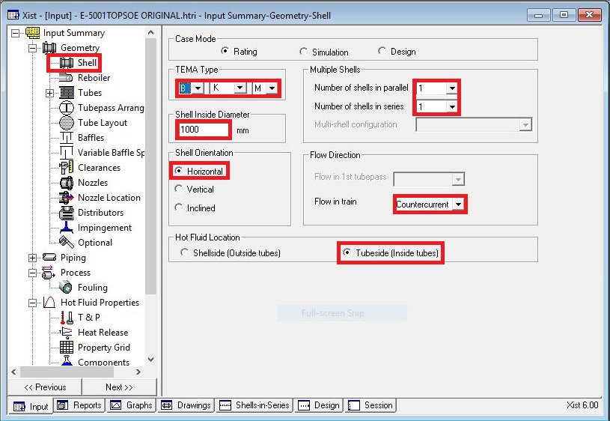

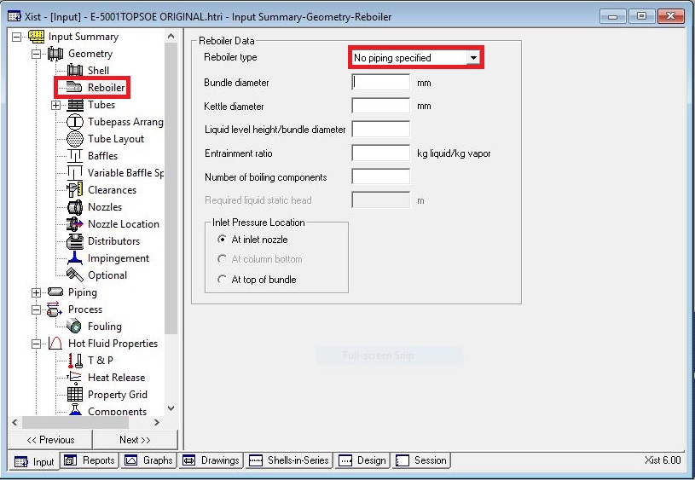In Reboiler Sheet do not enter an input

Put Tube mechanical data

* Tube with 25.4 OD is selected
* Since Tube material is CS , Tube thickness 2.11 is selected but not according to table

below

* Select Pitch 31.75 to pass TEMA R.2.5

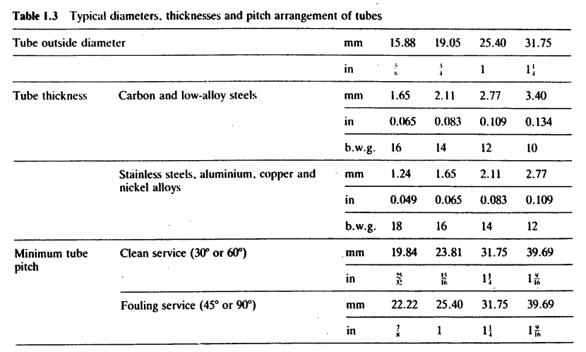

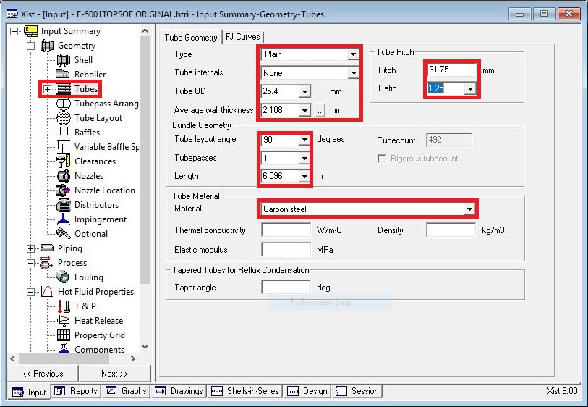

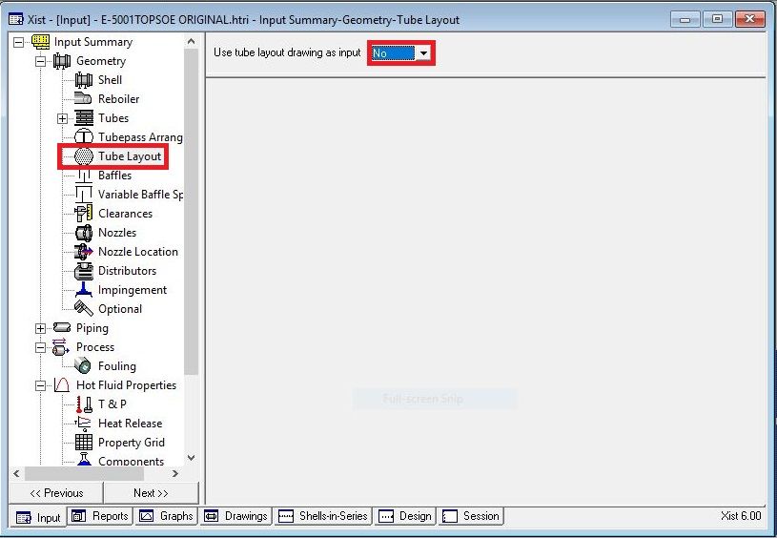Act like below

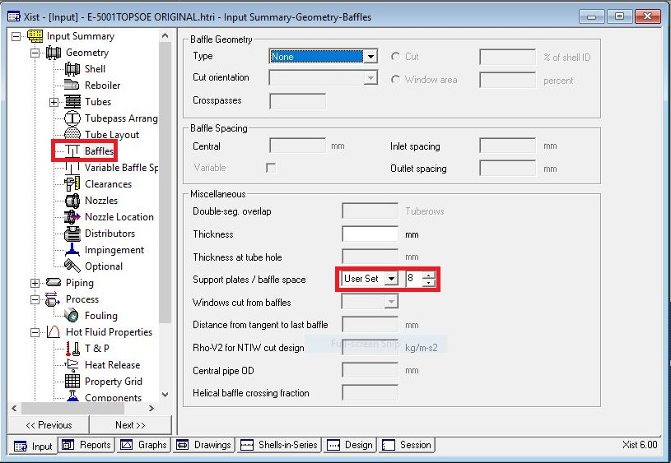Put baffle info in baffle sheet in red areas like below

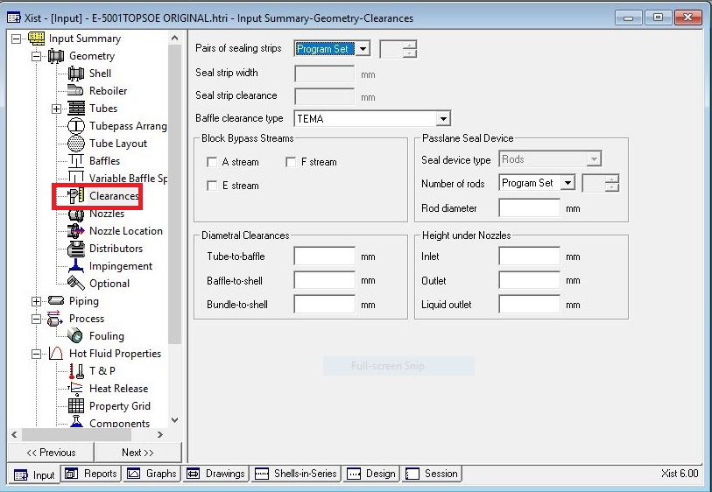Act exactly like below for impingement sheet and Clearance

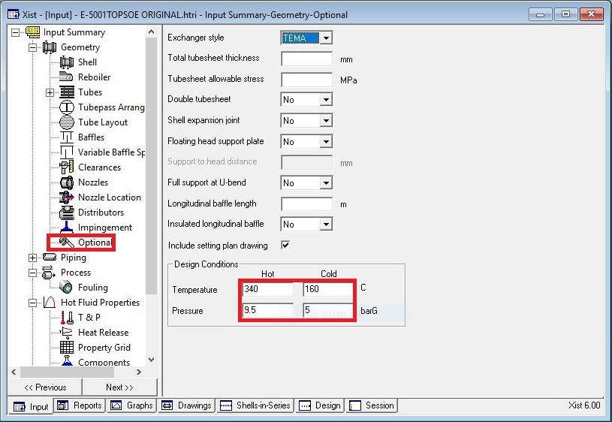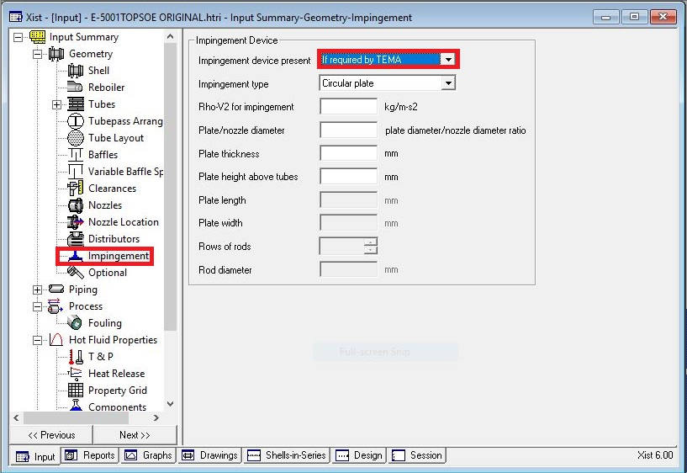

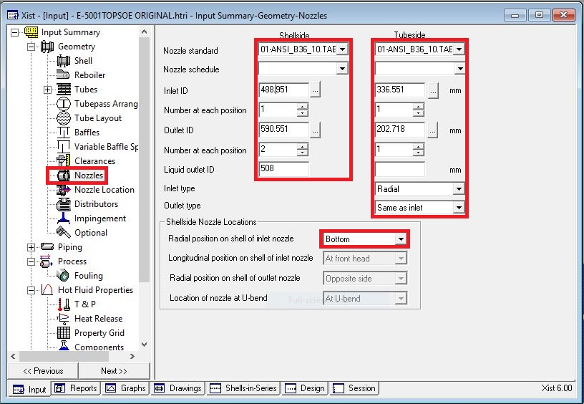Enter nozzle info from piping info

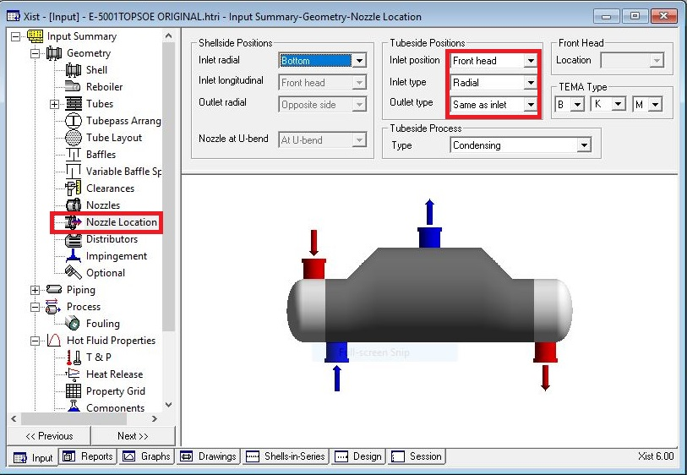Set nozzle location

Results:

Now run and it results with following run messages

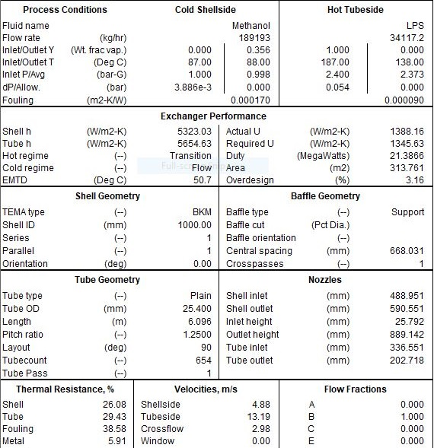

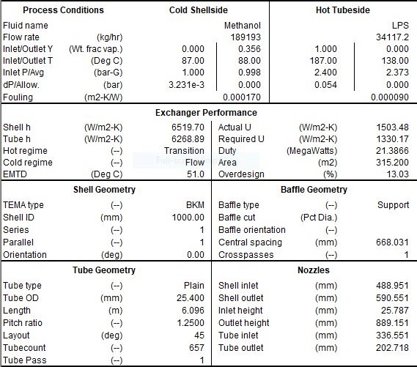Now change tube angle to 45 and run it again:

This design is good and satisfactory and do not know the reason why Topsoe changed it to U-type

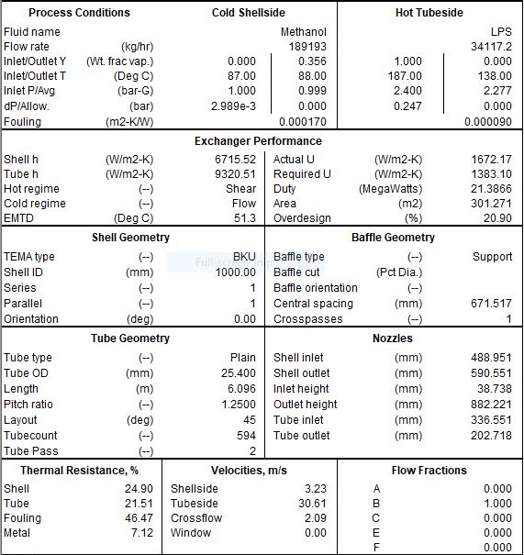It is practical to have U-type in reboilers. In addition, tube side is the controlling side.

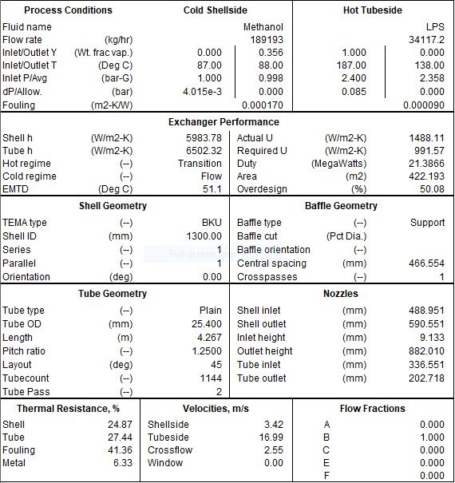In order to lower the pressure drop and velocity in tube side, shell ID is increased to 1300 mm and alongside that tube length was decreased to 4.2 to counteract the dramatic increase in overdesign factor.

In next move Topsoe has changed tube OD to 31.75 and tube pitch to 45 . The reason is not

clear but probably wanted to decrease the number of tubes from approximately 1100 to 550

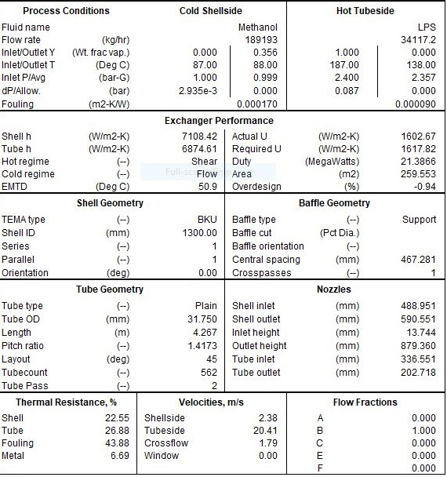tubes but the velocity increased again.

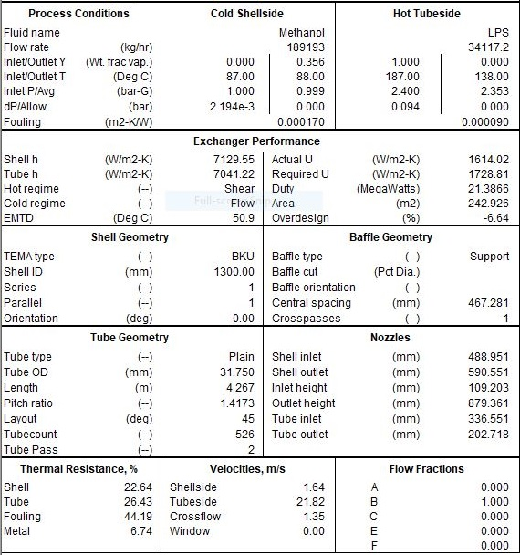After inactivation of tube layout

