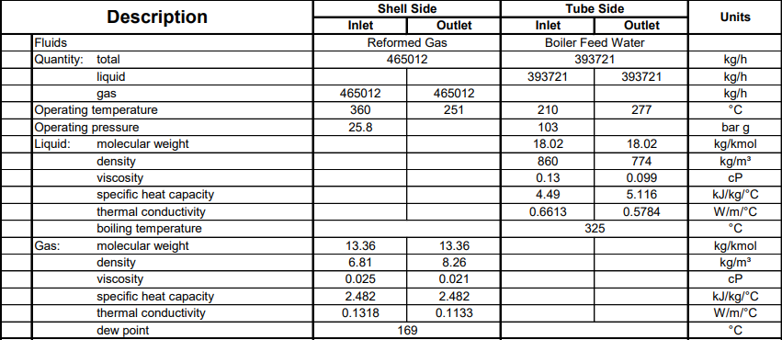**Process data**

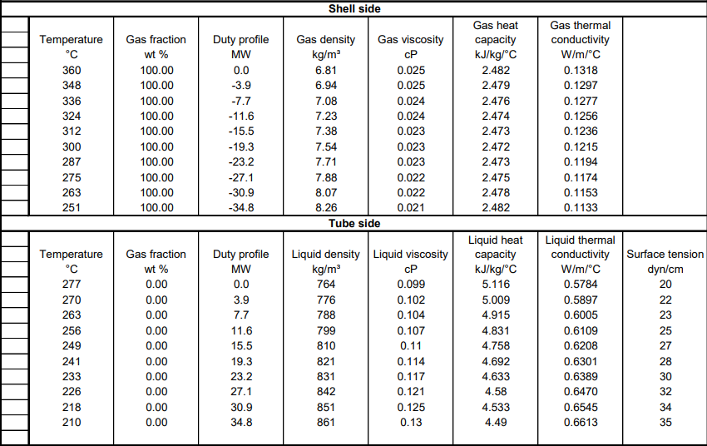**Heating and Cooling Table**

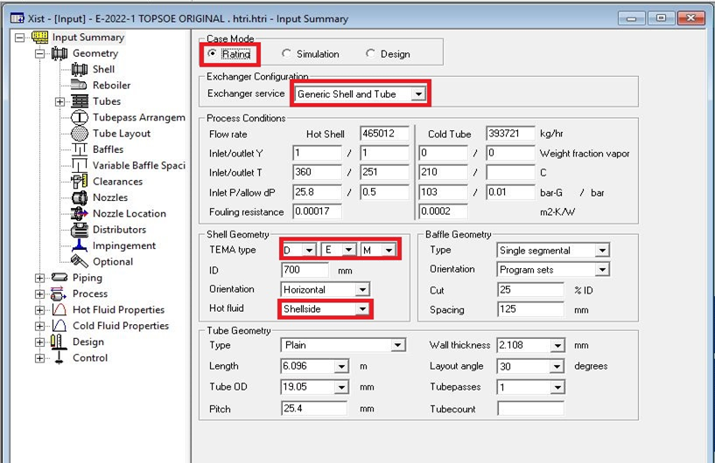**Open HTRI and Input Summery sheet and enter data in red areas**

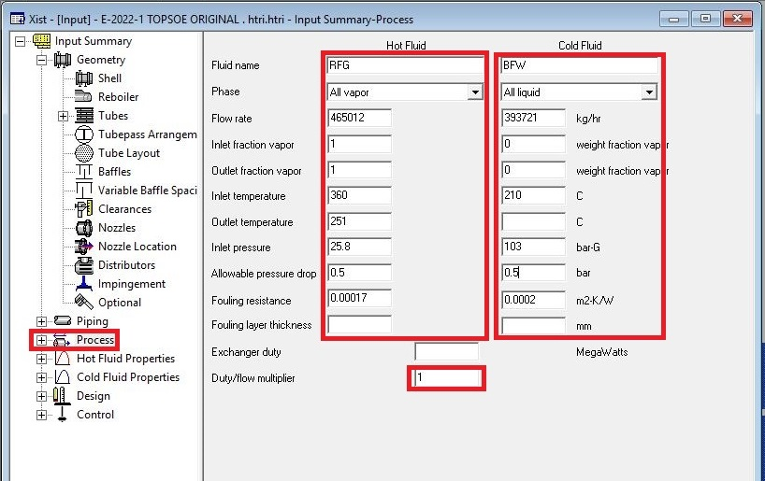**Enter operating data in process sheet in red areas**

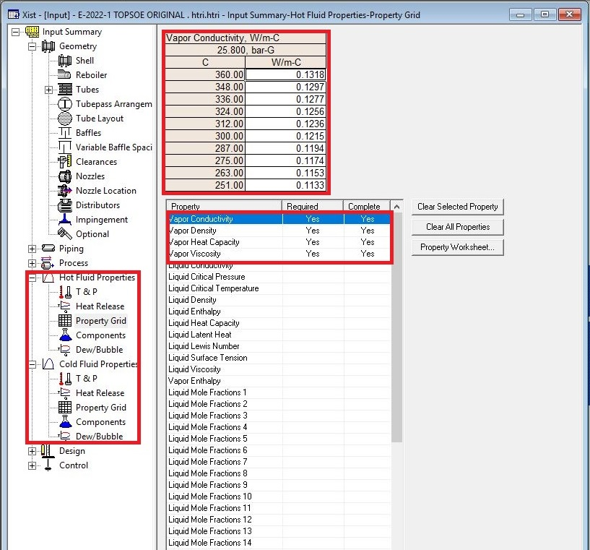**Enter heating and cooling table data in hot and cold fluid properties in red areas**

Put shell info in shell sheet in red areas

* Note:
* 1. Initially estimate shell ID between 2-3 times tube-side pipeline ID, here it is 10 inch so

\first estimation would be 30 inch or 760 mm.

* 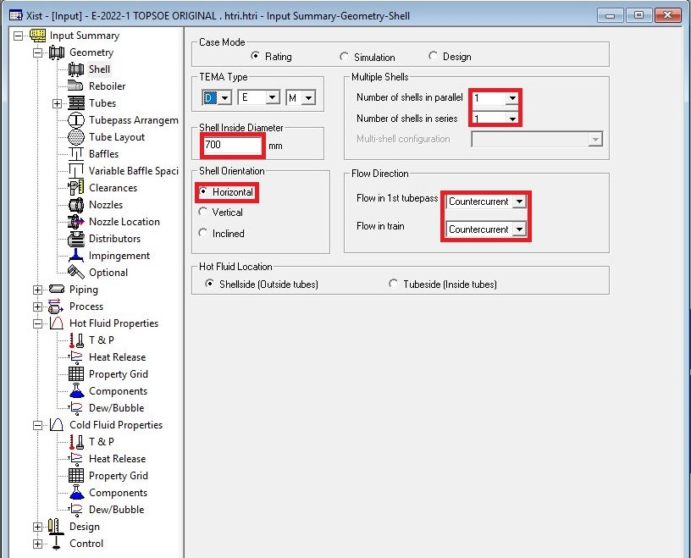 2. If there is one heat exchanger act like the rest.

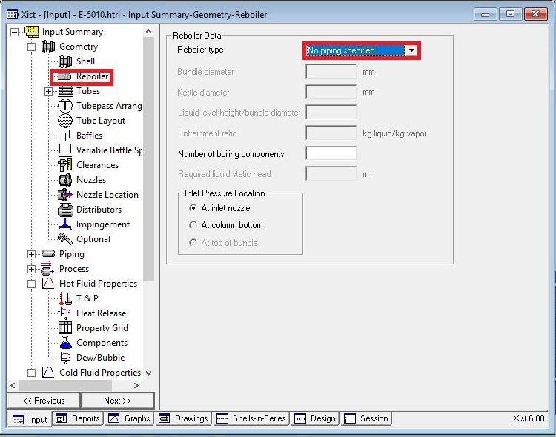In Reboiler Sheet do not enter an input

Put Tube mechanical data

* Note that since it is treated BFW, tube OD 19.05 is selected
* According to table below Tube thickness 2.11 is selected.
* Select Pitch 25.4 to pass TEMA R.2.5

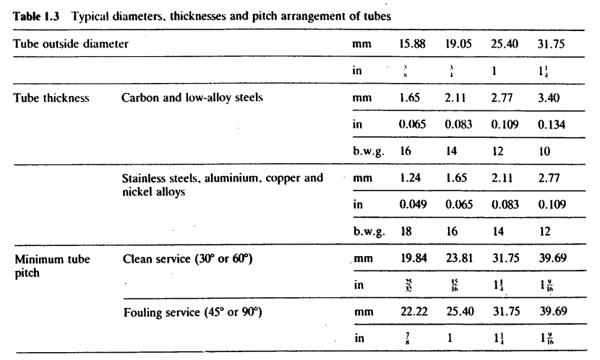

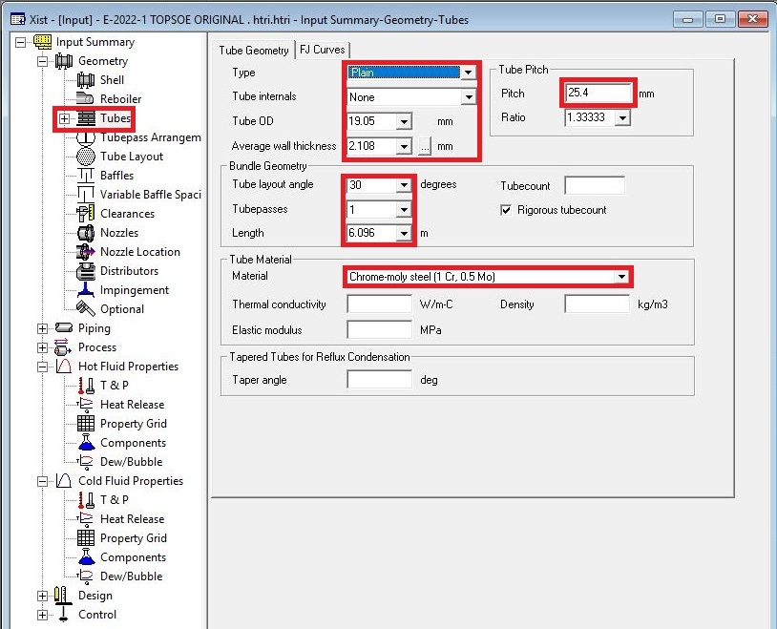

Put baffle info in baffle sheet in red areas like below

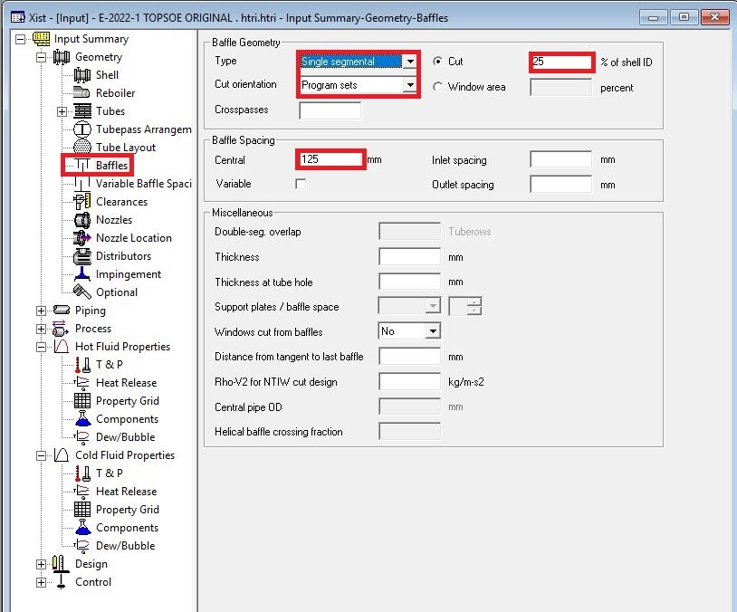Note that according to TEMA, minimum baffle spacing of shell ID/5 should be selected

Enter nozzle info from piping info

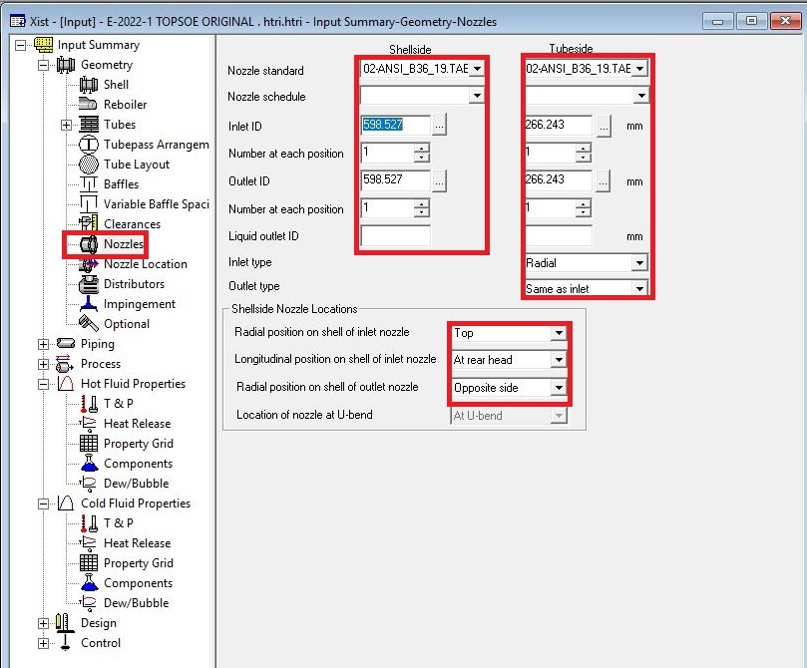

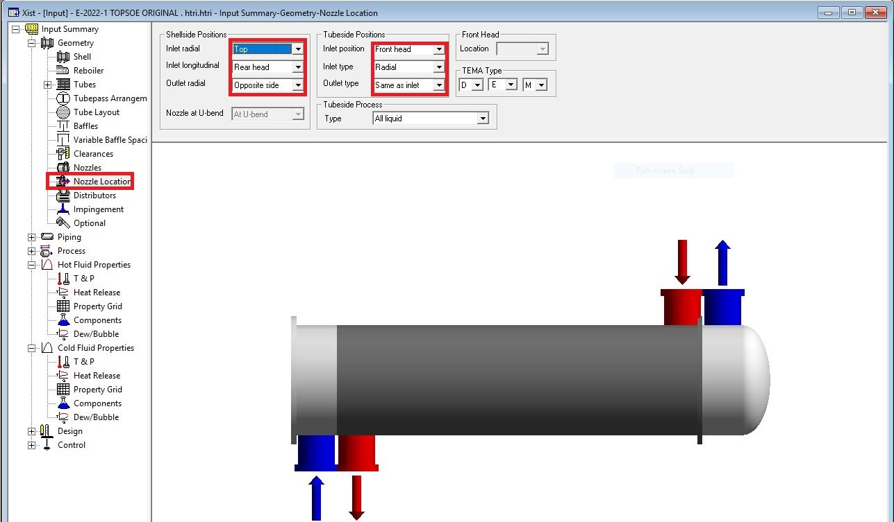Set nozzle location

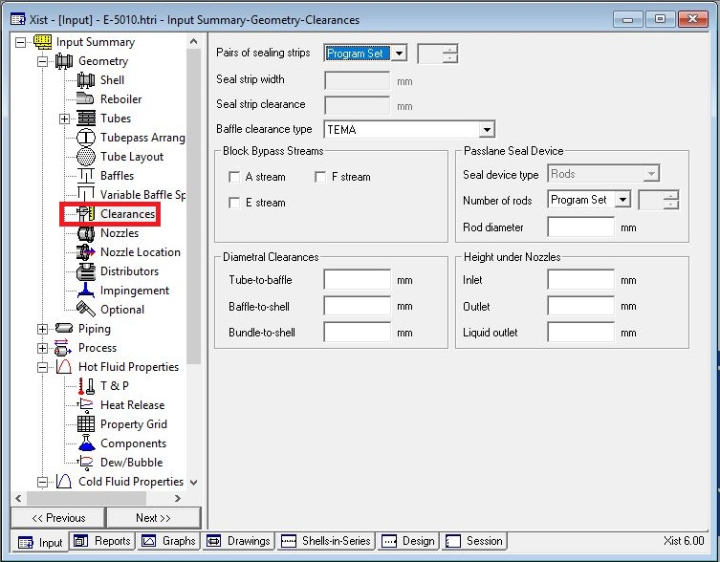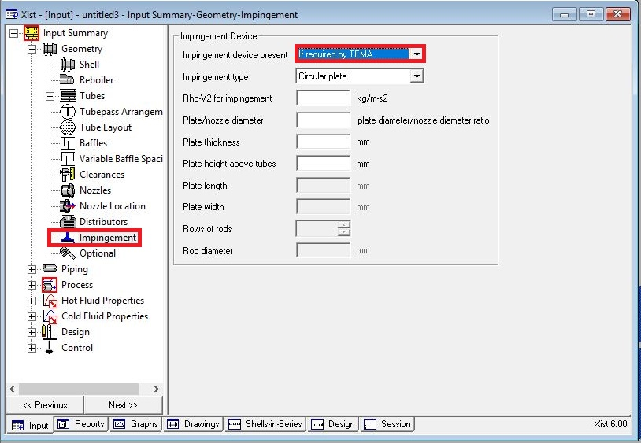Act exactly like below for impingement sheet and Clearance

Results:

1. Now run and it says: increase shell ID and when you increase it till ID is 1500 mm, it

still fails and at the same time there is the warning about baffle type, so changing baffle

type to NTIW, still it says it fails with the warning that baffle spacing should be

increased and when it is increased to 300 mm, it runs but the results are not satisfactory

because it does not pass shell dp which is 0.5 bar.

2. Now change baffle type to double segmental to reduce the pressure. They are known

for low dp usages but still it is not satisfactory since it does not meet shell dp which is 0.5

bar.

3. Note that alongside with dp criteria when Runtime messages sheet is opened the

warnings on next page is shown. Therefor we can conclude that the geometry should be

changed to X type and when you do so all but three warnings are eliminated and that is

good!!

4. Next step is to optimize process conditions. First and foremost, check dp criteria for

both tube-side and shell-side. For this both of them are met but we have some

abnormalities such as maldistribution in shell-side. In order to solve the problem,

increase nozzle numbers to 4 and the warning gets away!!

5. By the way do not pay attention to set plan error and physical properties error. They

are useless.

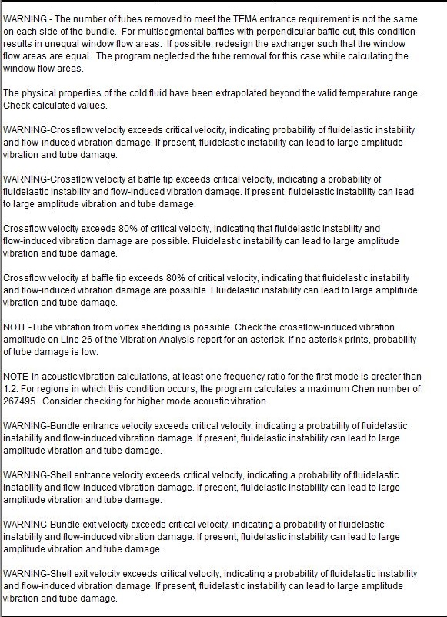

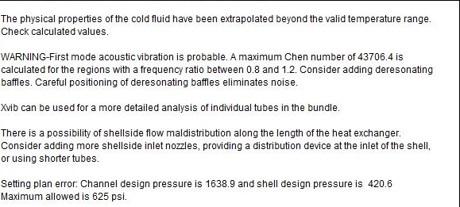

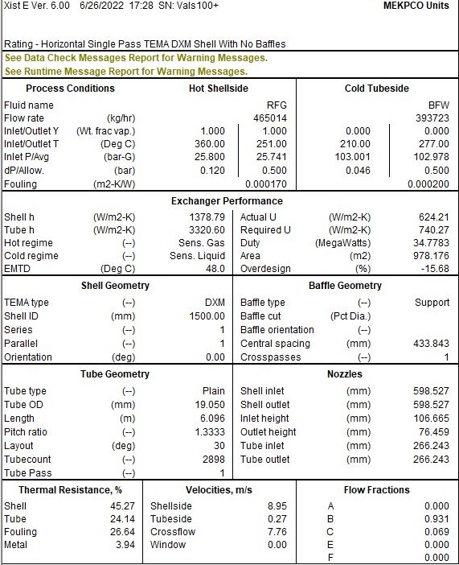Now look at the process result:

Note three important things:

1. Dp criteria is met.

2. But water velocity is lower than 1 m/s set by TEMA

3. Over design factor is less than 0 which is normally 10 % and sometimes it varies by 15%

according to different practices.

So it sounds as if the tube passes is increased the problem is about to solves because adding

tube passes not only increases the water velocity but also increases Heat transfer. Not until the

passes is augmented to 4 , the velocity reaches 1.05 m/s . Note that Overdesign factor when

tube pass is 1 is about -10% and when tube passes are 4 overdesign factor is 15%. Another

point that at the same time dp in tube side increased since v2 has a direct impact on dp and

lastly, tube H increased consequently. Don’t forget to change the type from DXM to DXU.

In order to solve the acoustic vibration, change the tube length, most times it helps! But before

increasing tube length in order to let overdesign factor stay constant tube number should be

reduced. Now active tube layout and run the program again. It is common to eliminate tubes in

inlet and outlet. Eliminate some rows in inlet and outlet and run it again and as a result

overdesign factor reduces. In order to counteract that increase the tube length. It is not until

tube length is about 8,7 m the acoustic vibration omits and for now the number of U-tubes is

1110.

In order to compensate the loss in duty due to Tube number decrease tube length is increased

to 10 m and run it again and the oversize factor is about 10%

Lastly note that the distance between distribution plate and inlet nozzle is about id/5, here 300

mm.

Remember that the only warning is about maldistribution in shell inlet. By adding a distribution

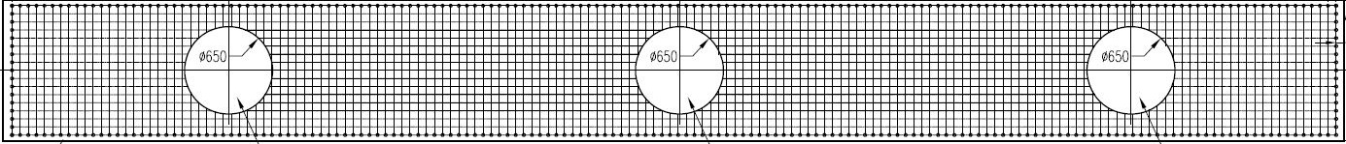plate the problem is usually solved.

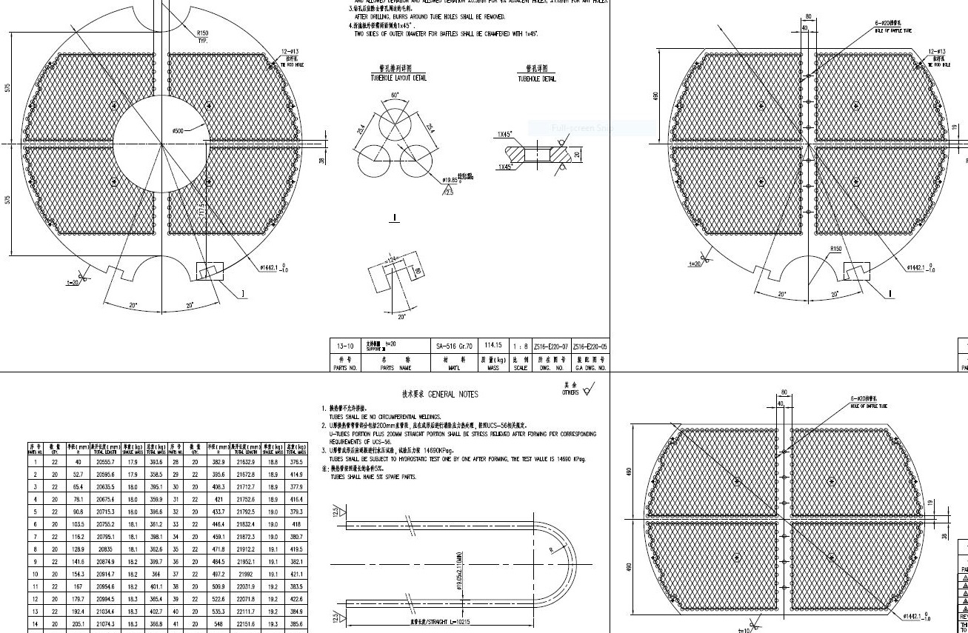

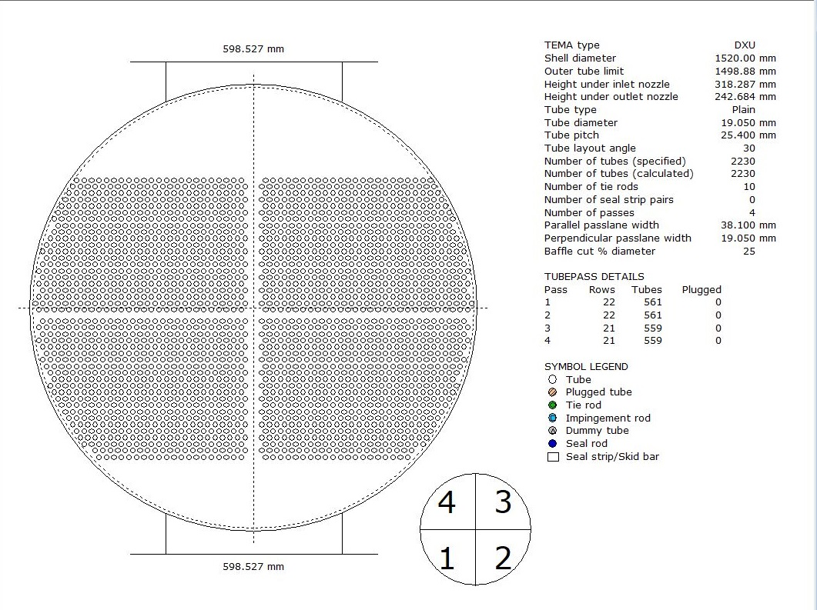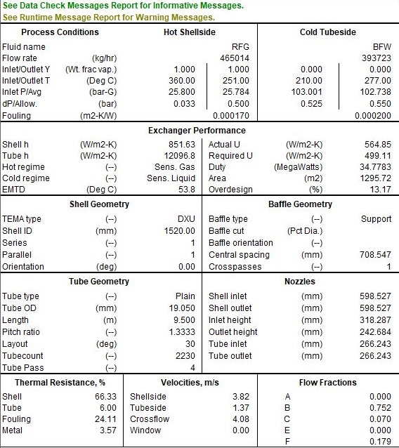Final Results