Methanol-Hydrogen-Ammonia
Fired Heater Construction

A fired heater has various components which are thoroughly explained in the following paragraphs.
1.Catalyst tubes
2.Hairpins
3.Radiant section
4.Convection section

1.Catalyst tubes
Typically, 312 tubes in the reformers are used which are divided between two chambers; it means that each chamber has 156 tubes. Now each chamber has 6 subsections which means that each subsection has 26 tubes. The tubes are butt-welded to cold collector. It should be stated that the life time of each catalyst tube is 100000 hr.
Each catalyst tube itself has the following components:
- Loose blind flange
- Two-part ring
- Inlet nozzle-pig tale
- Main tube
- Grid
- Reducer
1.1. Loose blind flange
As its name suggests, it consists of loose and blind flange as shown in next page. The blind flange is connected to a hanger and under the blind flange there is cover bolt which holds a fiber insulating block which prevents the flow of the heat to the surrounding atmosphere. The fiber insulating block is of class of 1260C and is vacuum formed. It should be noted that a ceramic paper is installed before the block. The internal diameter of the flange is the same as tube diameter. The material used for blind and loose flange is typically ASTM A 182 F22.Since the flanges are not exposed that much to heat then there is no need to insulate them. In order to enhance the flange welding it is typical to carry out post weld heat treatment. The post weld heat treatment is done with temperature increase of 220C/hr. and the holding time is between 705-725C with the cooling rate of 280C/hr.

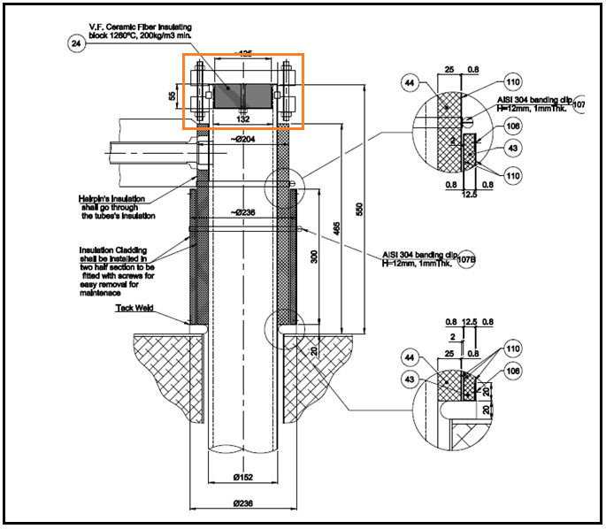
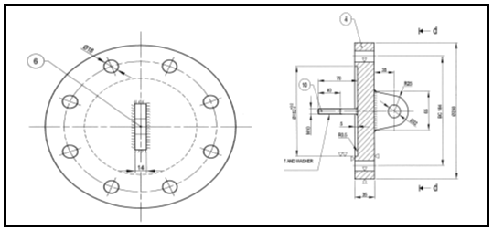

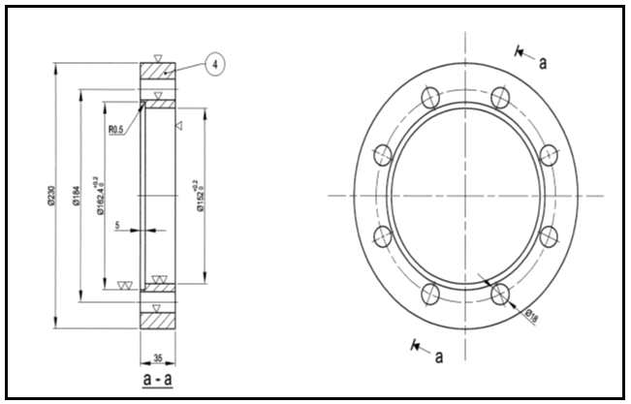

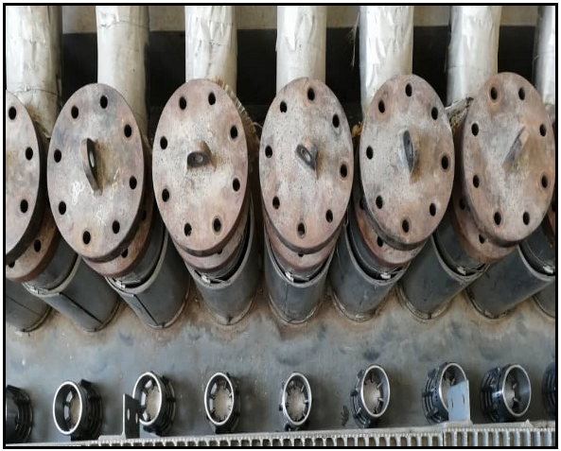

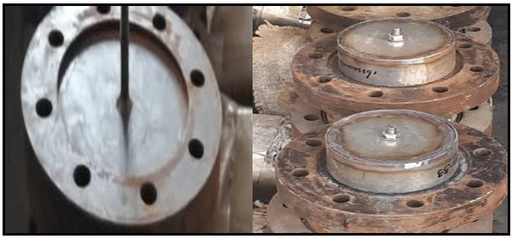

1.2. Inlet nozzle
The purpose of inlet nozzle is to connect the hairpins to catalyst tubes with the inner diameter of 40mm and outer diameter of 70mm. The typical material used is ASTM A182 F321 H. The inlet nozzle is located typically 120mm below the flanges.
1.3. Main tubes
Typical length of the tube for methanol, ammonia and hydrogen plant is approximately 13m and the material used is Cr25Ni35NbTi. Based on tube stress analysis of different vendors the minimum sound wall temperature for such reformer is 9.2mm. Typical ID for the tubes is approximately 13cm and OD is 15cm. The main tube has three cast part, the minimum length of which is 2.5m. The parts are butt-welded to each other. Based on the next page picture the end of the main tube is reduced from 80mm to 45mm. As it is shown, at the of the main tube we have an internal tube and external tube; the internal tube is welded to the reducer. The upper end of the main tube is exposed to the atmosphere but there is a guide ring between the catalyst tubes and fiber modules of furnace arc. The length and thickness of the ring is 300mm and 3m respectively.

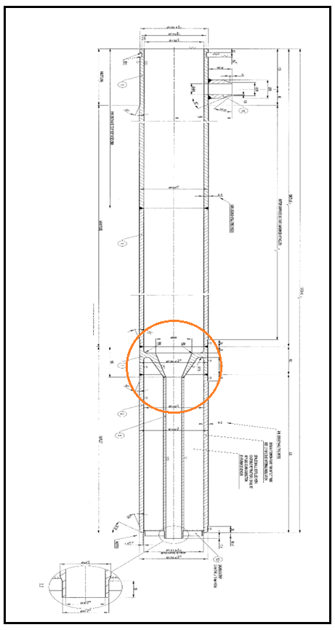

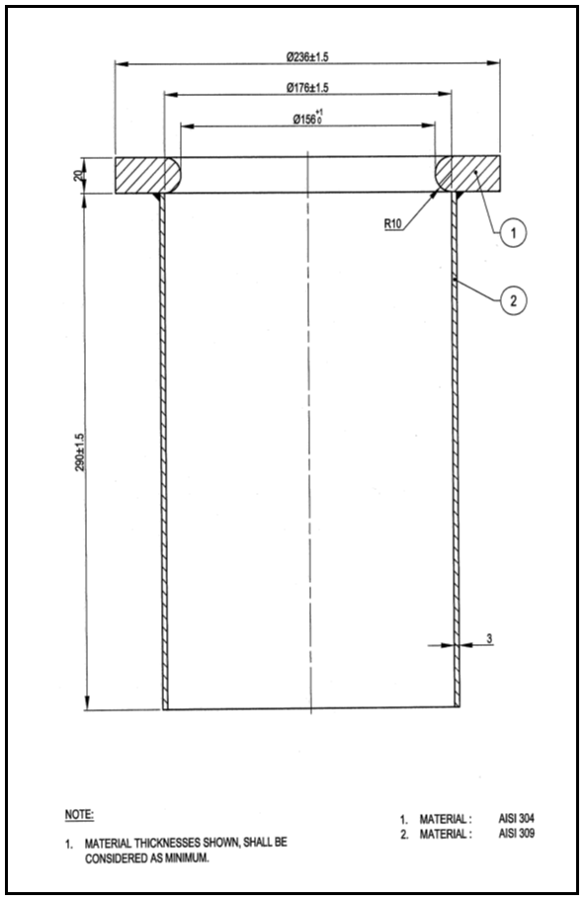

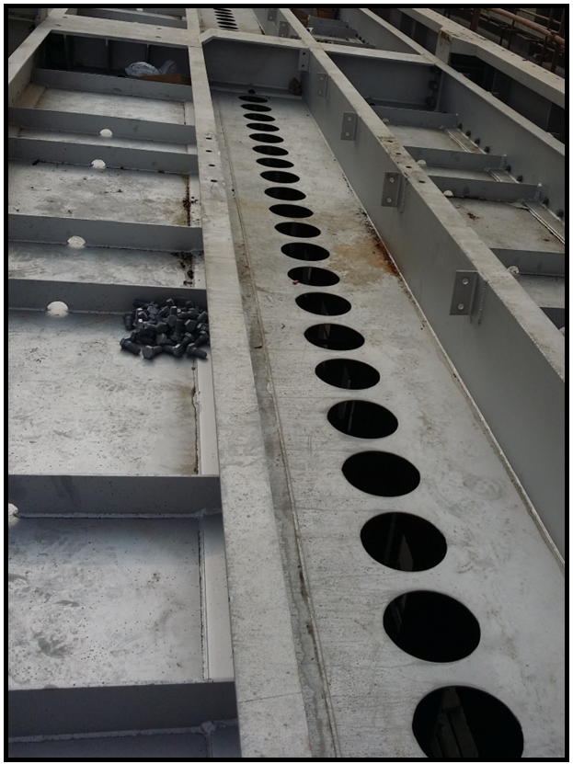

1.4. Grids
Grids, which serve the function of holding the catalysts inside the tube are installed at the end of catalyst tubes or at the inlet of reducer to internal tube. Gas stream can simply go through the circular holes.
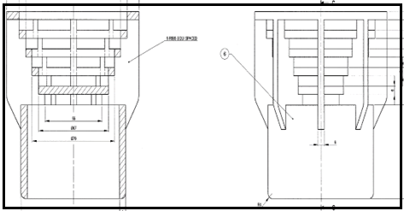

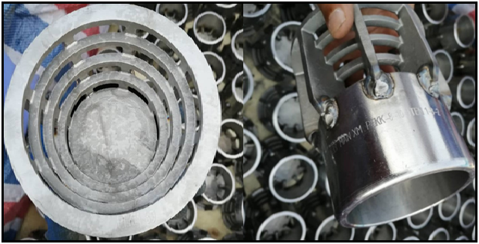

1.5. Reducer
The function of the reducer at the end of the catalyst tubes is to connect catalyst tubes to cold collector. The way they are connected is shown below. The internal tube is reduced and is welded to internal tube of cold collector.
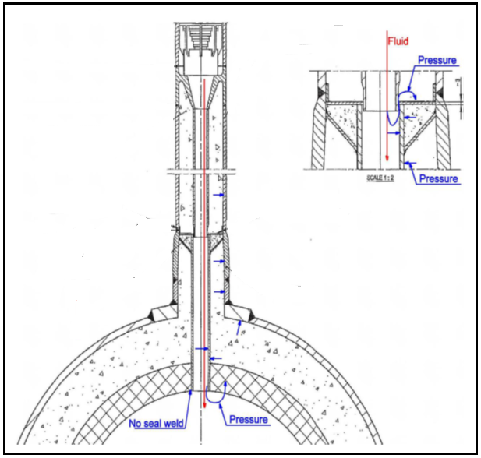

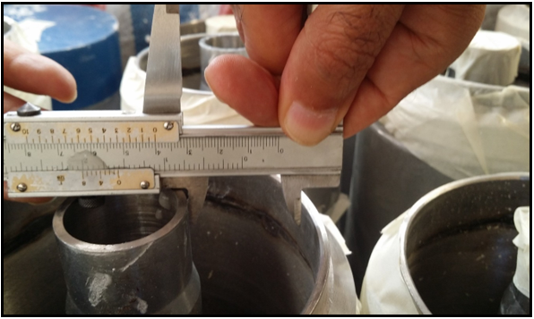

Before welding the catalyst tubes to cold collector, the volume between internal and external tubes is filled with insulating castable firelite 2300VL, then we have ceramic fiber paper compressed and finally we have castable refractory in the triangle section.
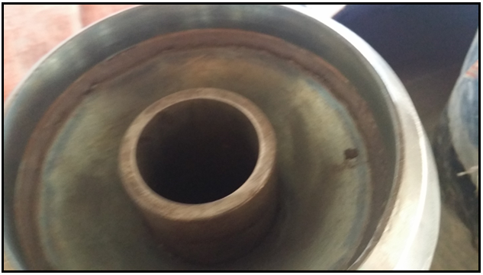

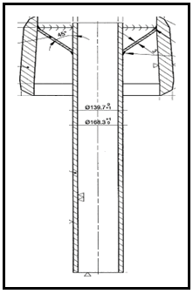

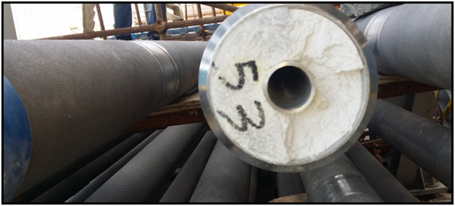

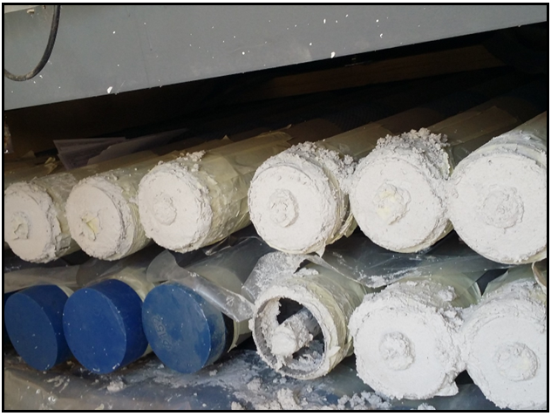

Before installation of catalyst tubes, they should be washed with acetone free of sulfur or chlor. Also, in order to remove moisture in castable dry-out procedure should be performed. 600 mm of catalyst tube end plus the reducer should be covered by electrical coil. During the dry-out the temperature should be increased 60C/hr. and the holding temperature is around 120C with holding time of 1-4hr. The criteria to finish dry-out is when there is no amount of steam coming out. The cooling rate is 60C/hr.

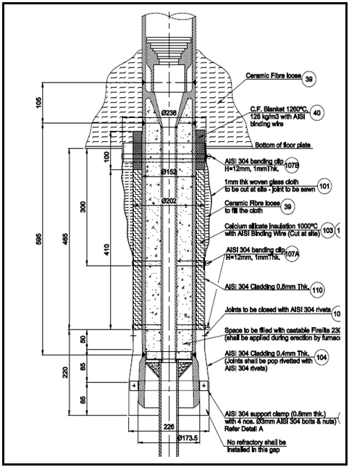

2.Hairpins
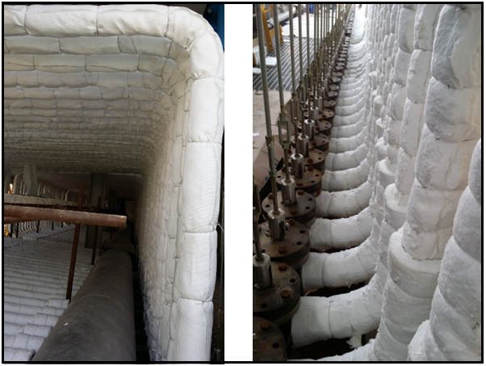
Hairpins serve to connect the inlet distributer and catalyst tubes and the material used for hairpins is ASTM A312 TP 321H. In order to maintain the load they are bended to 4 parts. In order to prevent heat loss, hairpins are covered by 2 layers of Ceramic Fiber Blanket AES160 Kg/m2, one layer of Wrapping Glass Fiber Cloth and one layer of foil. To be able to maintain such structure together, binding wire is used.
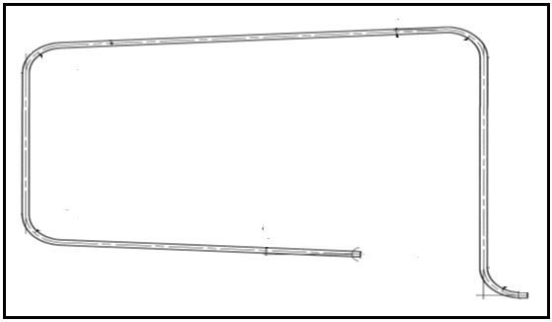

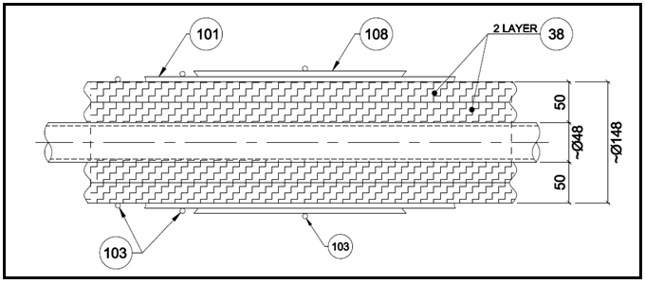

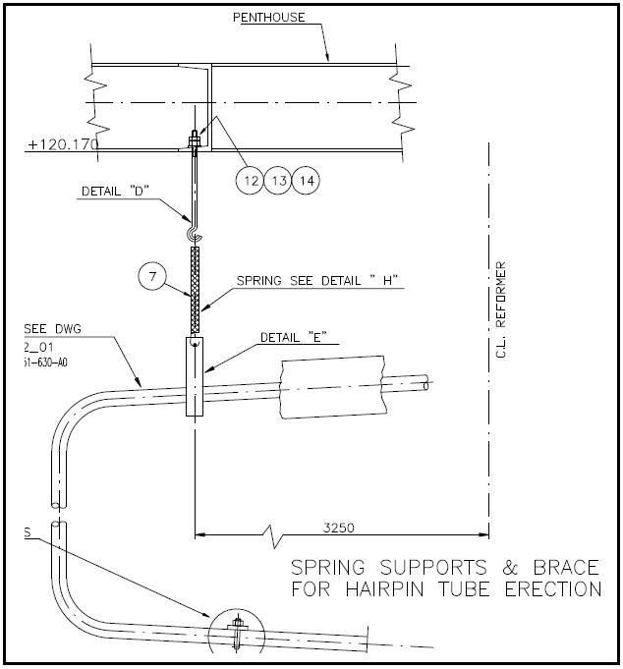
In order to balance all forces, a spring support with the following design is used. It is noteworthy that the length of spring during fabrication, installation, and operation is 276,506, and 542 mm respectively.
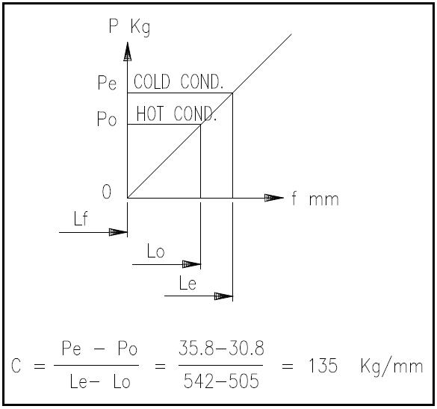

In order to fabricate such hairpins, the following steps are taken:
2.1. Re-inspection of Pipes
2.2. Marking for cold bending
2.3. Cold bending
2.4. Marking for cold bending
2.5. Adjustment
2.6. Cutting
2.7. Beveling
2.8. NDT
2.9. Pickling and Passivation
2.10. Cleaning
2.11. Air Blow
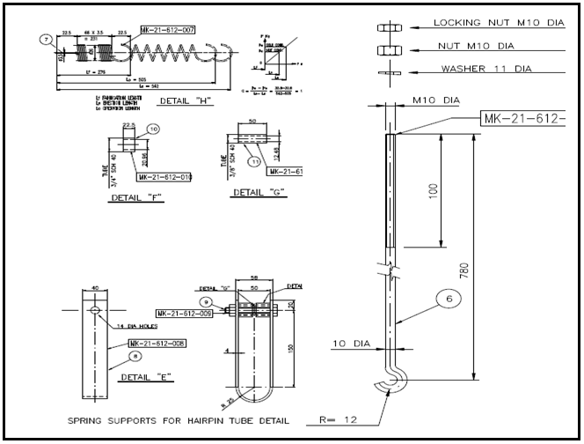
2.12. Final Inspection

3.Radiant section
Radiant section itself has the following sections:
3.1. Side wall burners
3.2. Side wall peep holes
3.3. End wall peep holes
3.4. Side wall burners in-between
3.5. Floor
3.6. Radiant Arch
The mentioned sections do not have special design consideration; the thing that makes each section special and unique is the refractory used in each section. Generally, a layer of block insulation and a layer of insulating firebricks are used for side-wall burners and floor section. Also, ceramic fiber modules are used for side wall, end wall, arch, and flue gas duct.

3.1. Side wall burners
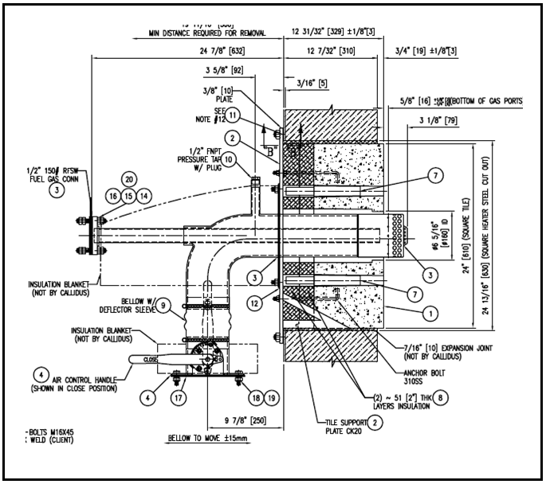
The side wall burners arrangement consists of 3 layers which starts with insulation block, then firebrick Gr.23 and firebrick Gr.26 from viewing direction. From lower part it starts with ceramic fiber module, ceramic fiber blanket, firebricks, dry expansion joint and burner plate.
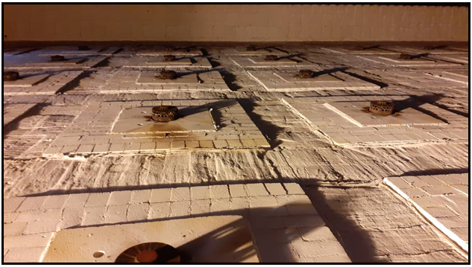

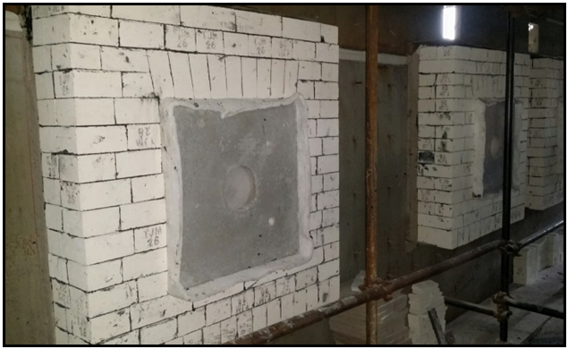

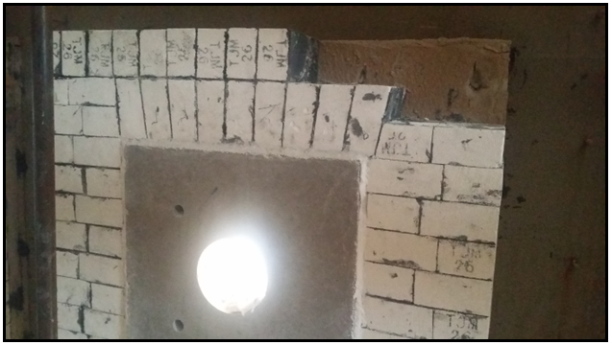

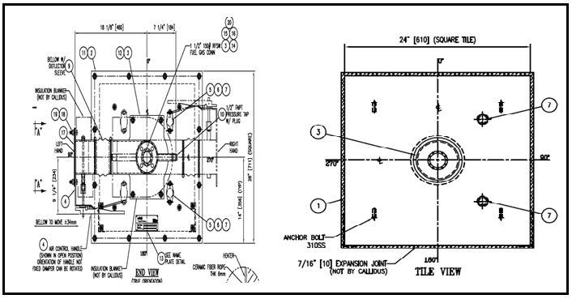

Notes:
- Insulation blocks, which are fabricated under vacuum have a maximum operating temperature of 1100 C with the density and thermal conductivity of 300-360 kg/m³ and 0.06-0.08 w/m.k respectively. The typical thickness used are 25 and 50 mm.
- Firebrick Gr.23 has the following characteristics:

- Firebrick Gr.26 has the following characteristics:

- There are two grades of ceramic fiber modules including 1260C and 1425C. For this project 1425C grade was used. Here are other characteristics:

Standard Length | 230×114
Composition | TiO₂+Al₂O₃: 55-65%  SiO₂:35-40%  Fe₂O₃: max 0.8%
Maximum Operating Temperature | 1425C
Density | 650-800 kg/m³
Thermal Conductivity | 0.27-0.35 w/m.k @ 600-1200C
Permanent Linear Change | -0.5%
Density | 128 kg/m³ before compression  160-170 kg/m³ after compression
Composition | Al₂O₃: 35%  ZrO₂:15%
Maximum Operating Temperature | 1425C
Thermal Conductivity | 0.15-0.18 w/m.k @ 600-1200C

Standard Length | 230×114
Composition | TiO₂+Al₂O₃: 35-45%  SiO₂:40-55%  Fe₂O₃: max 1%
Maximum Operating Temperature | 1260C
Density | 480-530 kg/m³
Thermal Conductivity | 0.15-0.26 w/m.k @ 600-800C
Permanent Linear Change | -1%

- There are two grades of ceramic fiber blankets including 1260C and 1425C. For this project 1260C grade was used. Here are other characteristics:

Density | 128 kg/m³ before compression
Composition | Al₂O₃ + ZrO₂:45%
Maximum Operating Temperature | 1260C
Thermal Conductivity | 0.15 w/m.k @ 600C
Thickness | 25 mm

- There are two grades of ceramic fiber blankets including 1260C and 1425C. For this project 1425C grade was used as expansion joint around burners. Here are other characteristics:

Density | 128 kg/m³ before compression
Composition | Al₂O₃: 35%  ZrO₂:15%
Maximum Operating Temperature | 1260C
Thermal Conductivity | 0.15 w/m.k @ 600C
Thickness | 10 mm

- The arrangement around burner tips is like this : At first we have two layers of insulating blocks (Vacuum formed fiber module + Calcium silicate 1000C), then one layer of Tile LE-Carw-6 Perforated with the composition of 60 % alumina.

3.2. Side wall peep holes
At first, we have precast refractory peep hole block and castable firebrick surrounded by dry joint and fire bricks. Mortar joint are used in firebricks in-between. In order to keep refractories in position M16 bolts are used. On next page there is a drawing which illustrates the above explanation.

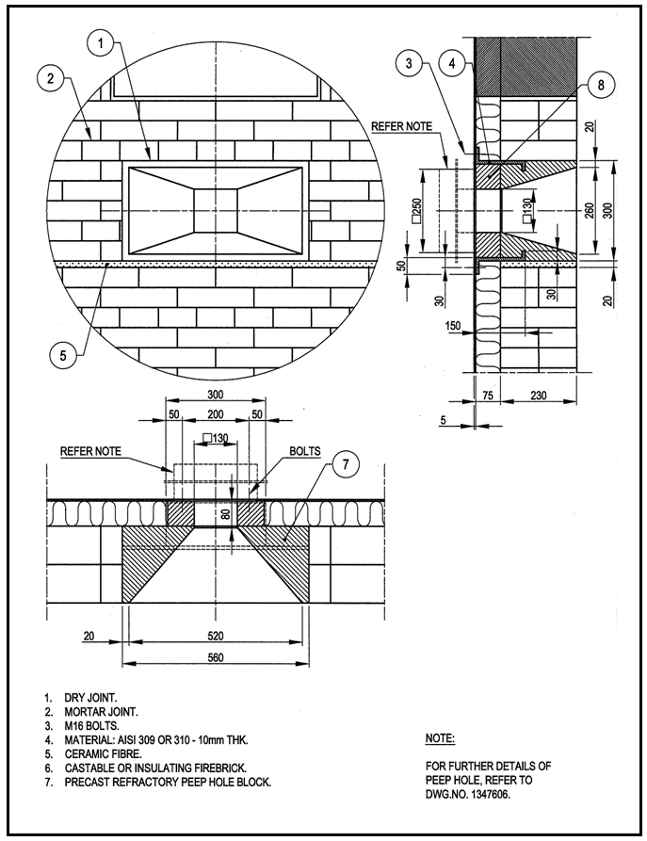

3.3. End wall peep holes
Since the temperature in end-wall and side-wall is different different material is used for side-wall peep holes. In this purpose vacuum formed peep hole block surrounded by ceramic fiber module is used.
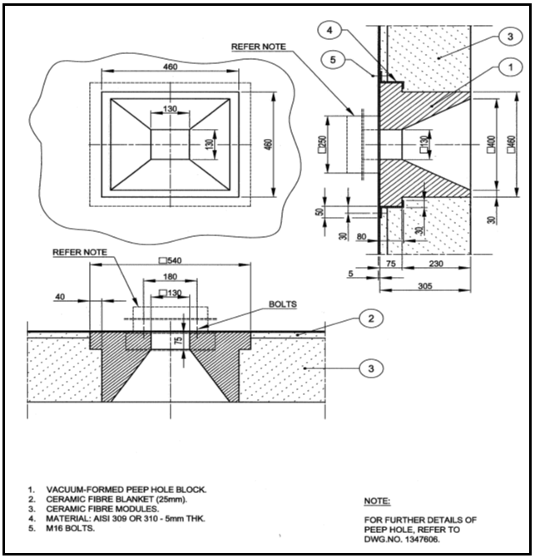

3.4. Side wall burners in-between
The typical arrangement consists of ceramic fiber blanket 1260 C and ceramic fiber module.
3.5. Floor
The floor arrangement is made up of 6 layers from upper part to lowest part starting with one layer of high duty firebricks, three layers of firebricks Gr. 23 and two layers of insulation block 1100 C with the thickness of 25 and 50 mm.
- High duty firebricks
As its name suggests the firebricks are high duty and are used just in first row. It is noteworthy that the firebricks are installed in a loose manner so that there is space for thermal expansion. Based on API it is recommended installing dry expansion joint with the material of ceramic fiber blanket (grade 1425 and Thk. Of 15 mm) after each seven firebricks. Here are some characteristics of high duty firebricks.

Density | 1900-2100 kg/m³
Composition | Al₂O₃ + TiO₂ : 38-42%
Thermal Conductivity | 1.33 w/m.k

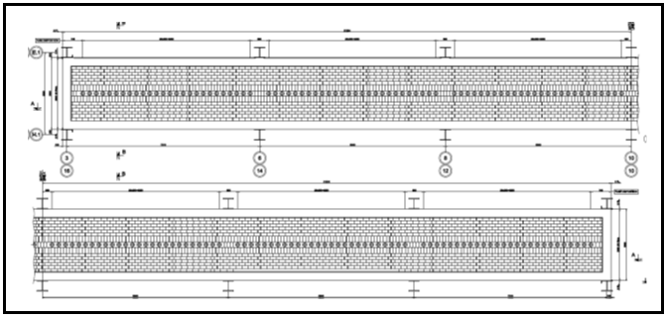

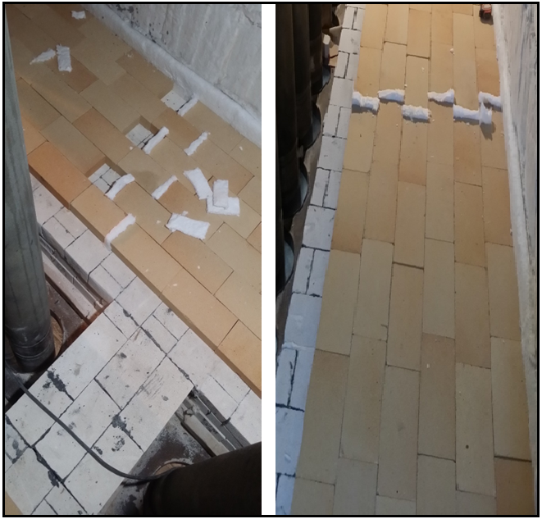
- Firebricks Gr.23 are used for rows 2-3-4 and air setting mortar are installed vertically between those firebricks. Remember mortars should not be used horizontally so that there is enough space for firebricks to expand. Here is a summary of mortar characteristics.
Density | 1700 kg/m³
Composition | Al₂O₃: 34%  SiO₂:60%  Alkalis:3%
Operating temperature | 1425

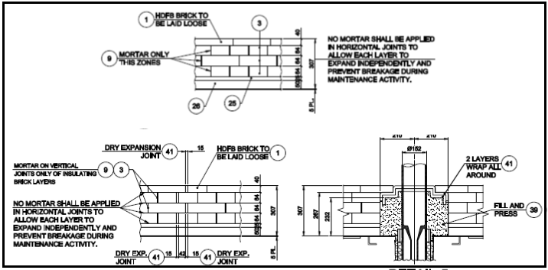

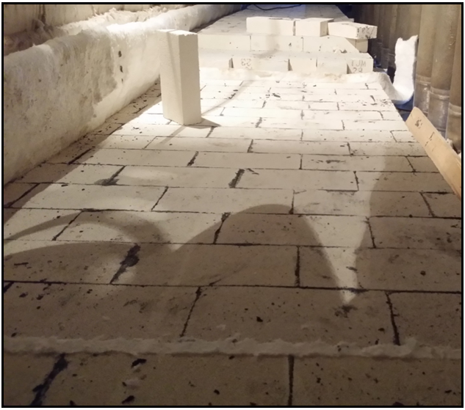

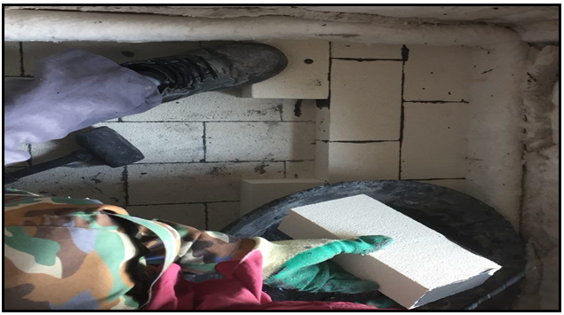
- In rows 5-6 insulation blocks with 25 and 50 mm thicknesses are used.

- It should be noted that the arrangement of firebricks around the catalyst tubes is different and it is in such a way that from the bottom of the floor we fill around the catalyst tubes with loose fiber with the vertical length of 230 mm and dr of 100 mm. Loose fibers are alumina silica with 45% Al₂O₃ , density of 100 kg/m³, operating temperature of 1260C and thermal conductivity of 0.1. In addition, 2 layers of ceramic fiber blanket 1425C with thickness of 25 mm are used.
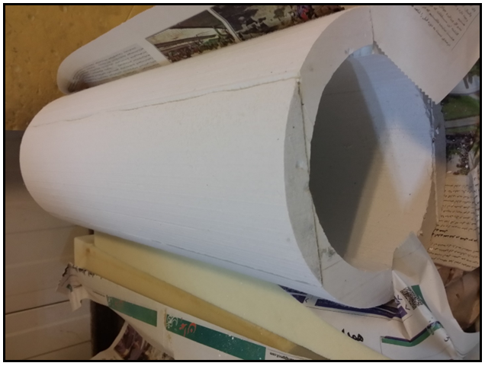

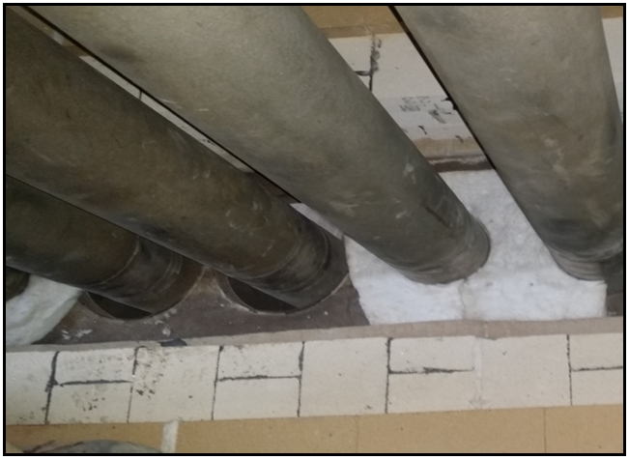

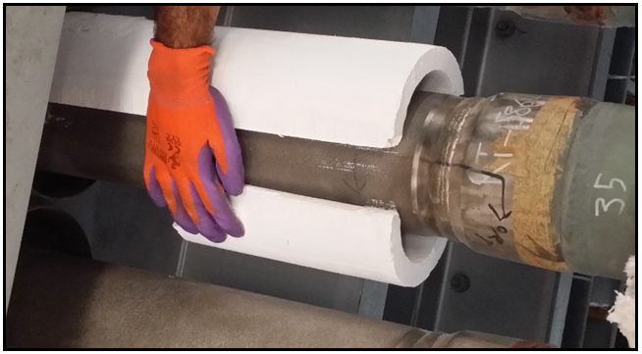

3.6. Radiant Arch
For the radiant arch of reformer, it is normal to use fire blanket 1260 and fiber module.
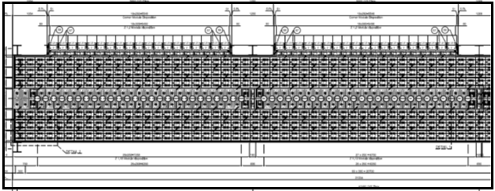

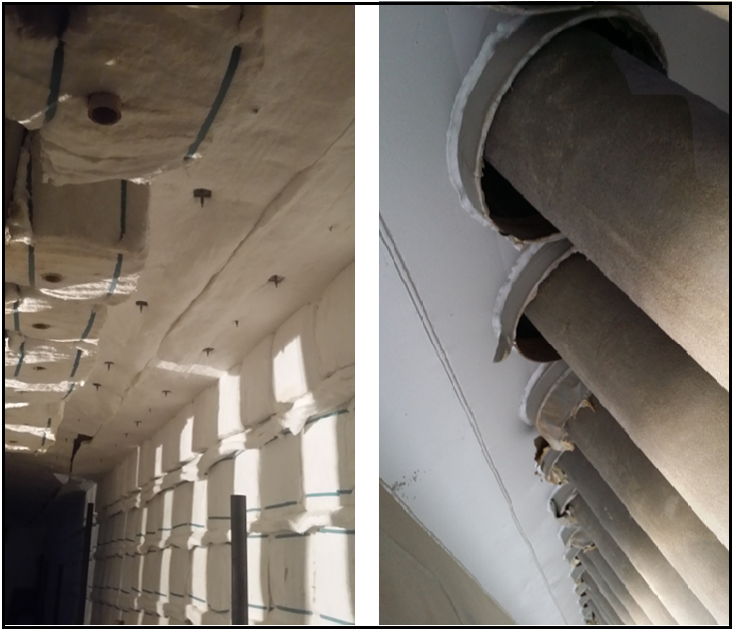

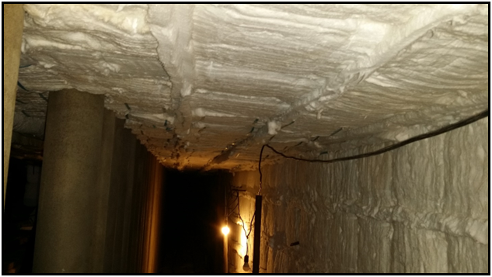

4.Convection section
High flow of flue gas passes the flue gas duct which has a mild slope and then it exchanges heat with different heat exchangers.
4.1. Flue gas duct
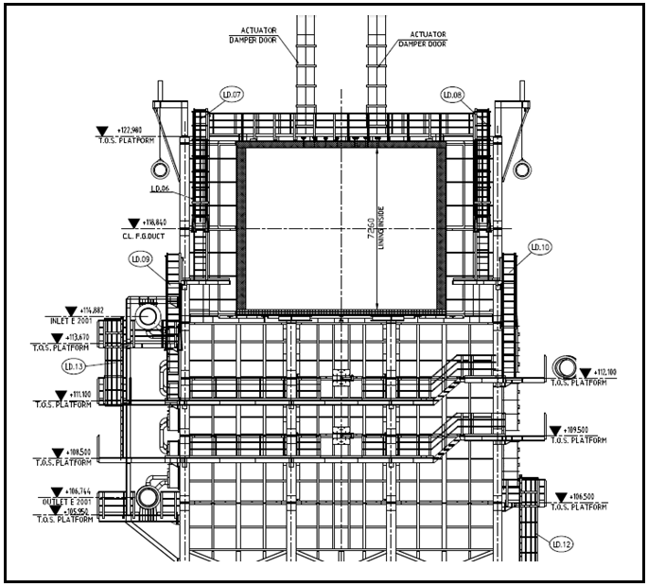
The flue gas with the temperature of 1092C goes through flue gas duct, which has a length of 42 m and height increase of 8 m. Its floor arrangement consists of 76 mm of insulating firebricks with thermal conductivity of 0.18-0.24 w/k.m and density of 530 kg/m³ and 2 layers of insulating blocks (25 mm and 50 mm). On its wall at first, we have ceramic fiber blanket 1260 and then ceramic fiber module 1260.

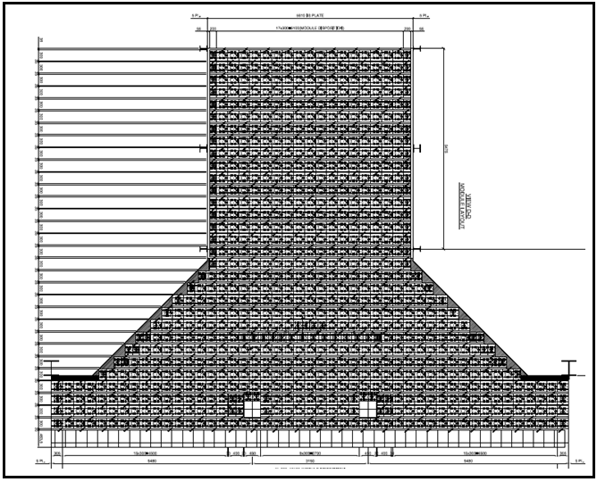

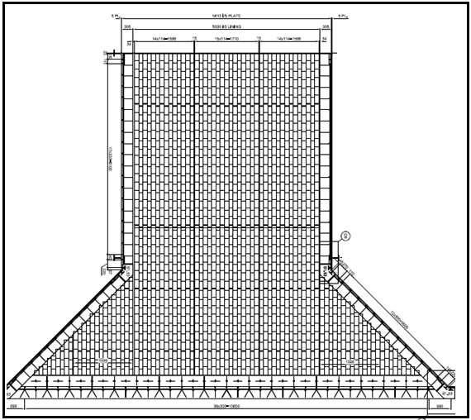

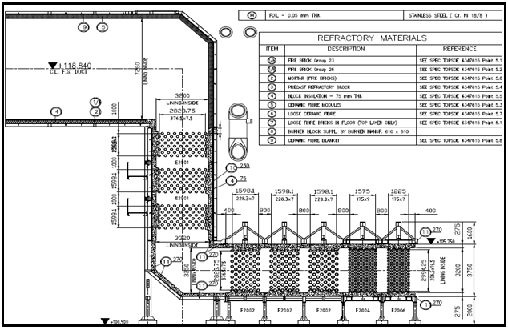
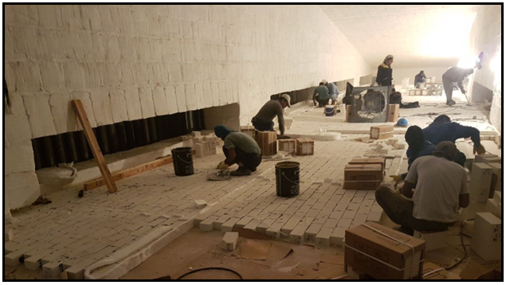

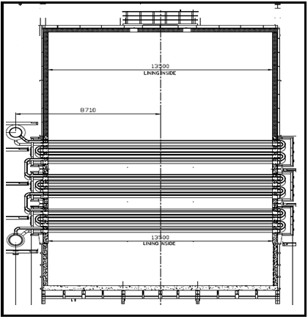

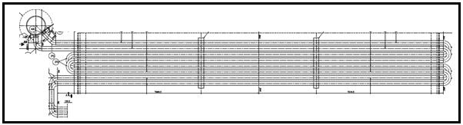

5.Cold collector
The cold collector is located horizontally at the gas outlet of the reforming furnace. Its fuction is to collect the process gases from the catalysts tubes and to transfer them to the next process unit. The collector is lined internally with refractory materials and the temperature on the steel shell is thus appreciable lower than the temperature of the contained gases.
The operating and design conditions for the cold collector are as follows :
- Design pressure: 35 barg
- Operating pressure: 32 barg
- Operating temperature (process gas): 740C
- Design temperature(shell): 300C
- Main shell temperature: max 150C
- Max design gas velocity: 20 m/s
- Ambient design temperature: 40C
- Gas composition: H₂, N₂, CO, CO₂, CH₄, H₂O
5.1. Materials for cold collector refractory lining
5.1.1. Inner castable lining
High alumina castable refractory. The castable material shall conform to the following:

Type | Firecrete 95
Composition | Al₂O₃ : 94%  SiO₂ <0.1%  Fe₂O₃ <0.1
Thermal conductivity @1100C | 1.25 kcal/m.h.c
Bulk density | 2.3-2.9 kg/dm³
Cold crushing strength  ASTM C-133 | 450 kg/cm² .min

5.1.2. Impervious layer
An impervious layer shall be installed between the inner castable lining and the insulating castable refractory in order to prevent propagation of cracks from one component of the lining to another.
The layer can be achieved by means of a heavy coat of non-soluble paint or oil. Great care must be taken to choose a material which will have no adverse effects on the process or the lining materials under operating condition.
5.1.3. Insulating castable refractory
The main insulating component of the lining is installed between the inner castable lining and the shell. The material shall be characterized by low thermal conductivity (especially with regard to the hydrogen content of the process gas), reasonably low silica content, low linear shrinkage and high thermal stability.
There is a possibility of condensation within this layer and the material shall therefore be completely insoluble in water. In cases where this component is relatively thick, it is advisable to divide into two layers of equal thickness, thus preventing cracking due to excessive differential temperature between the inner and outer surfaces. In such cases the two layers shall be separated by an impervious layer. The material shall conform to the following:

Classification | ASTM C-401 Class P/Q
Temperature limit | 1260
Material | Firelite 2300 VLI
Principal analysis | Al₂O₃ : 45%  Fe₂O₃ < 0.6%  SiO₂ < 35%
Cold crushing strength-ASTM C-133 | 35 kg/cm²
Thermal Conductivity at 500C | 0.2 kcal/m.h.c
Density | 0.83-1.03 kg/dm³

5.1.4. Bonding cement
To ensure good adhesion between the insulating castable and the inner surface of the shell, a coating of bonding cement shall be applied to the shell before the castable is installed. The cement shall have good adhesive properties and shall be non-soluble in water. It must not contain any ingredient which can be harmful to the steel shell under design condition.

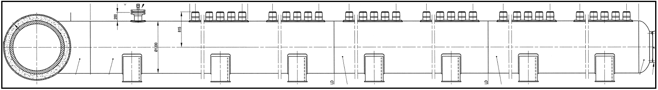
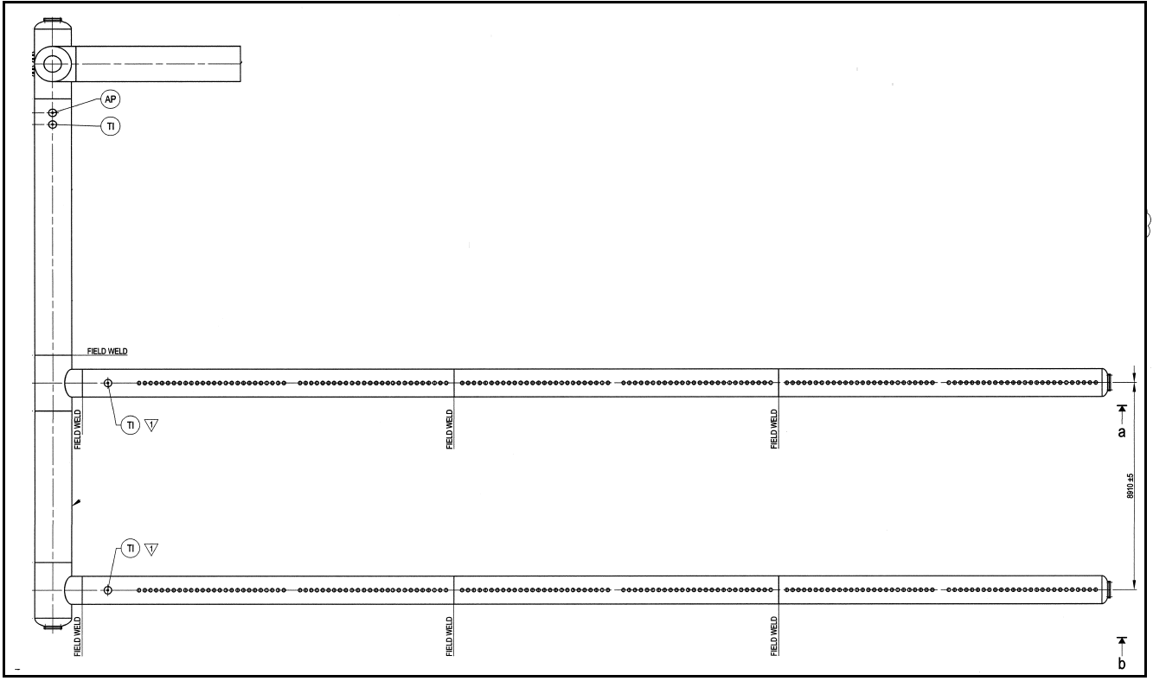
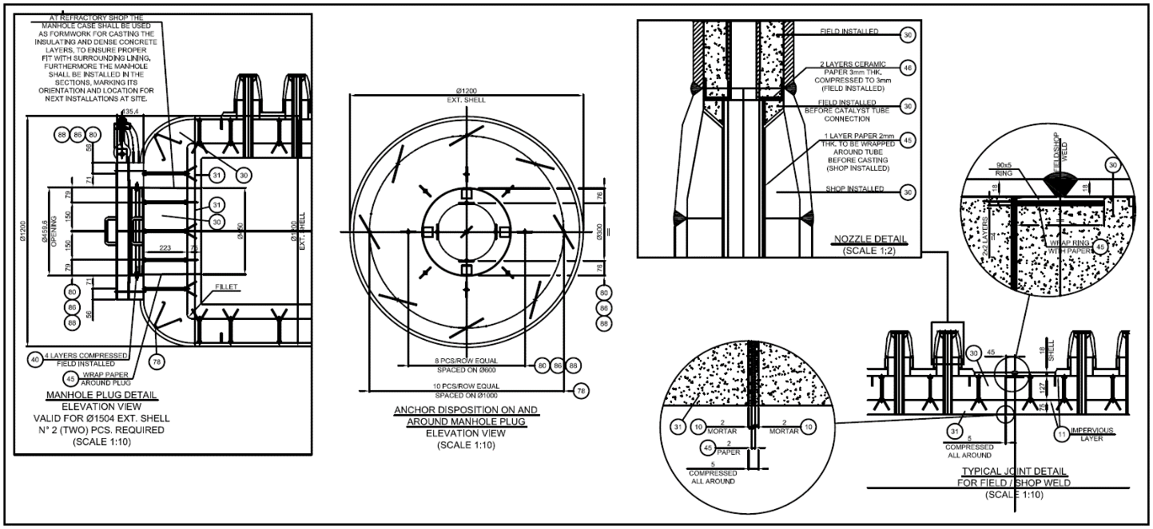

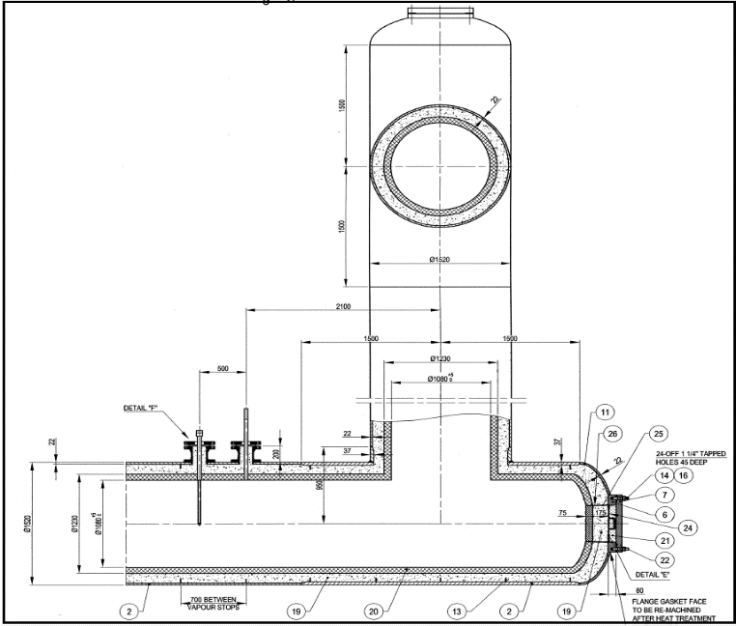
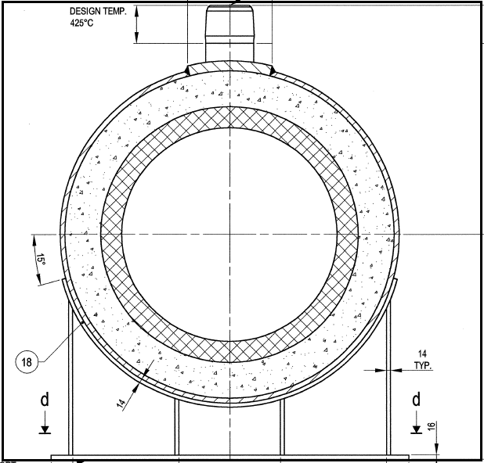
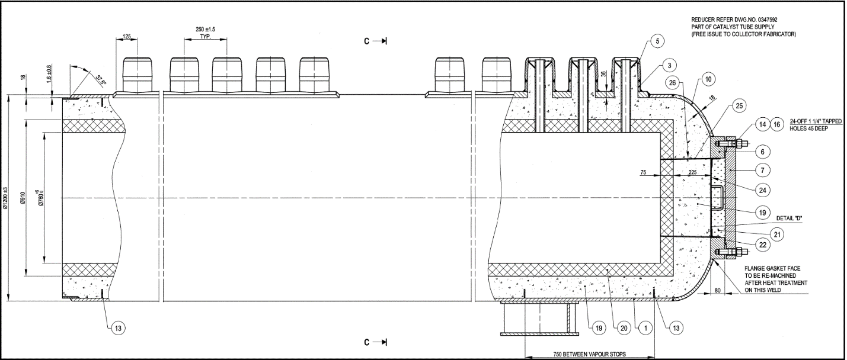

6.Stack
Calculation of stack diameter
$$V=\frac{m'}{ρg(\frac{πD^{2}}{4})} >9 m/s$$
Temperature: 161 $℃$
Pressure: 0 mm WG
Flow: 469314 kg/h = 130 kg/s
Gas Density: $\frac{342}{161+273.15}=0.78=0.75$
V = $\frac{130}{0.75×(0.78 D^{2}}>9 m/s$
D = 4300 mm
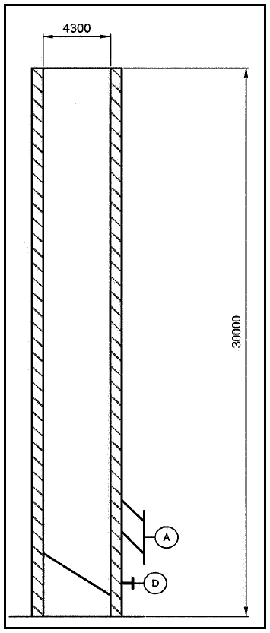
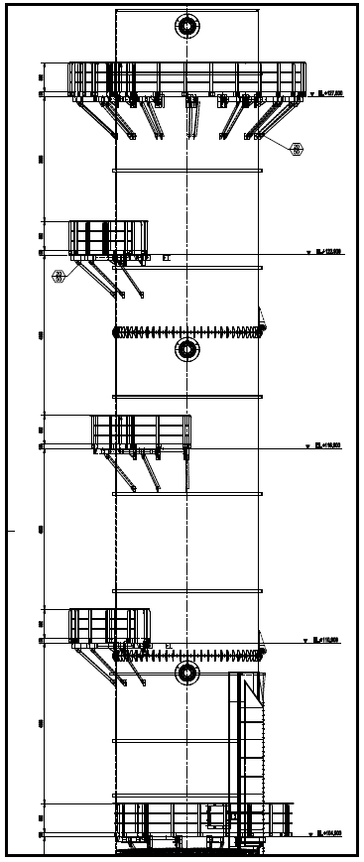

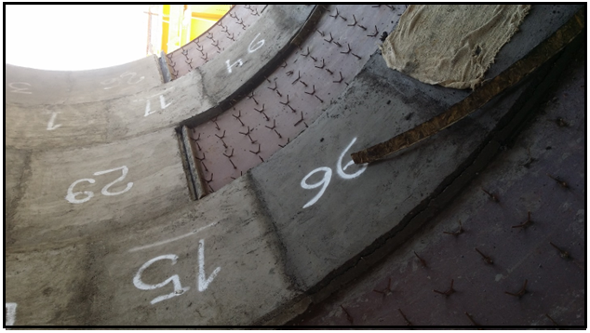

7.Burners
The burners must be of the forced draught radiant wall type provided with a single fuel nozzle. It is essential that no forward flame propagation occurs.
The burners are mounted in the side-walls of the refractory-lined furnace chambers. The furnace consists of two chambers.
The fuel for the burners is a mixture of natural gas fuel and purge gas. Also, the combustion air is preheated.
Natural gas and purge gas LHV are 34.5-37 KJ/Nm³ and 9.85-10.45 KJ/Nm³. Combustion air is preheated by means of plate heat exchanger to reach a temperature of 175C. Also its pressure is increased via FD fan to 200 mmWG. The excess air should be 10% so that excess O₂ at stack outlet is 1.6-2%.
The burners should be operated in a way that the heat released based on purge gas should be maximum 75% of the whole heat release.
The combustion gas temperature at burner tips is approximately 1200 C. Based on environmental standard, the dry mole ppm for NO_{x} and CO at 3% of O₂ should be between 20-100 ppm.
Burner plate consists of one layer of insulation block [ vacuum formed ceramic fiber 1260 and calcium silicate 1000 ] with the thickness of 50 mm and a layer of 60% Al₂O₃ in pre-fired form. The quality of insulating material between burner block and mounting plate should be in such a way that the burner plate temperature during normal operation should be maximum 70 C more than ambient temperature.
Before the combustion, the fuel gas is premixed with combustion air as shown in next page. An orifice restriction is used to control the pressure. Based on operating and design condition, the material used is CS with the rating of 150. Combustion air connection includes air control handle and Bellows deflector sleeve. Maximum leakage should be less than 10%.

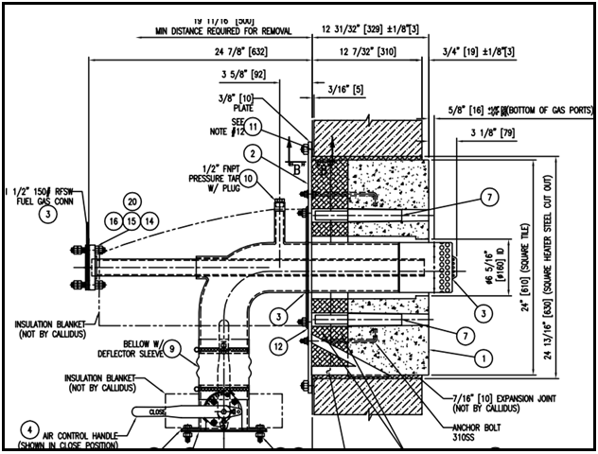

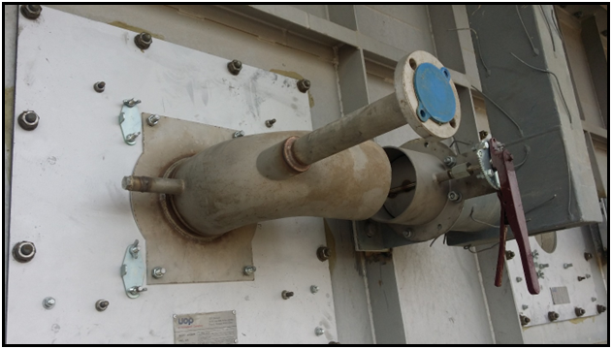

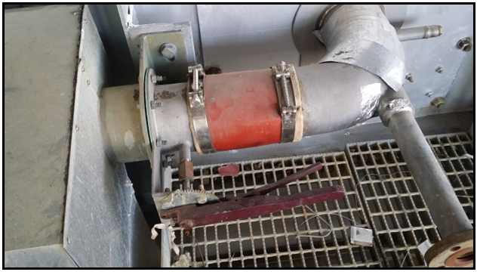

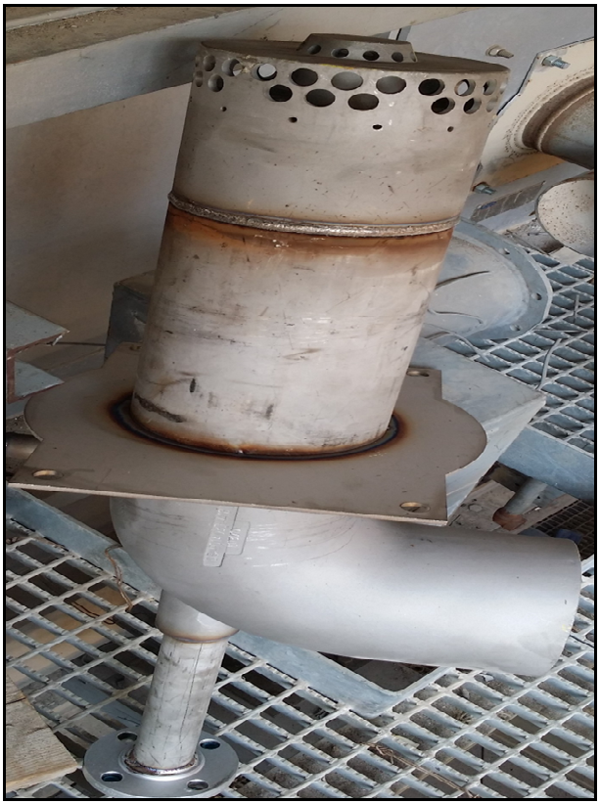

When we use NG as the source of the fuel, the pressure changes between 0-0.3 barg. Flame pattern is round. The minimum pre-firing temperature is 260C and the maximum service temperature is 1650 C.-
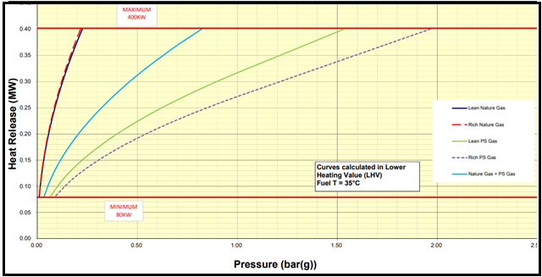

Based on the drawing, we expect the maximum duty when the pressure is around 0.8-0.9 barg and normal duty when the pressure is 0.6-0.7 barg.
