Safety Integrated Level ( SIL ) Verification

General Definition

What is risk?

A Risk is the amount of harm that can be expected to occur during a given time period

due to specific harm event.

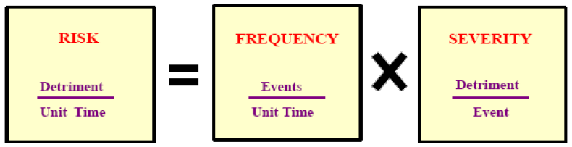

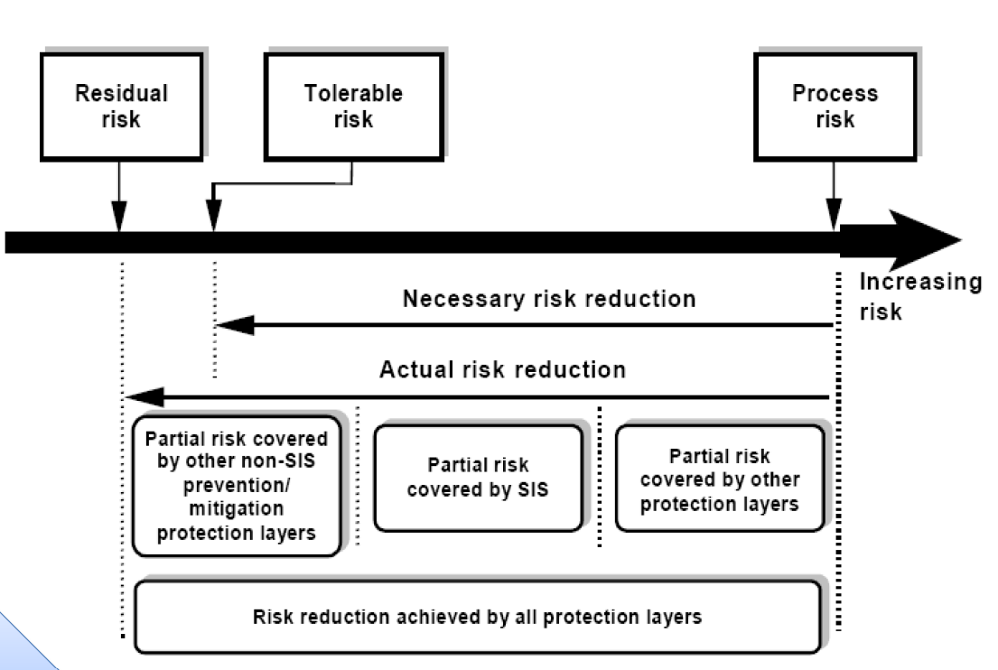

Safety related system consists of:

* Mechanical protection system
* Passive protection system
* Basic process control system
* Alarms
* Safety instrumented system (SIS)

What is SIS?

A relative level of risk-reduction provided by a safety function, or to specify atarget level of risk reduction. In simple terms, SIL is a measurement of performance required for a Safety Instrumented Function (SIF).

Notes

1. The function of SIS is called SIF. More than one SIF could be allocated to a SIS.
2. A SIS consists of a sensor, logic solver and final element.

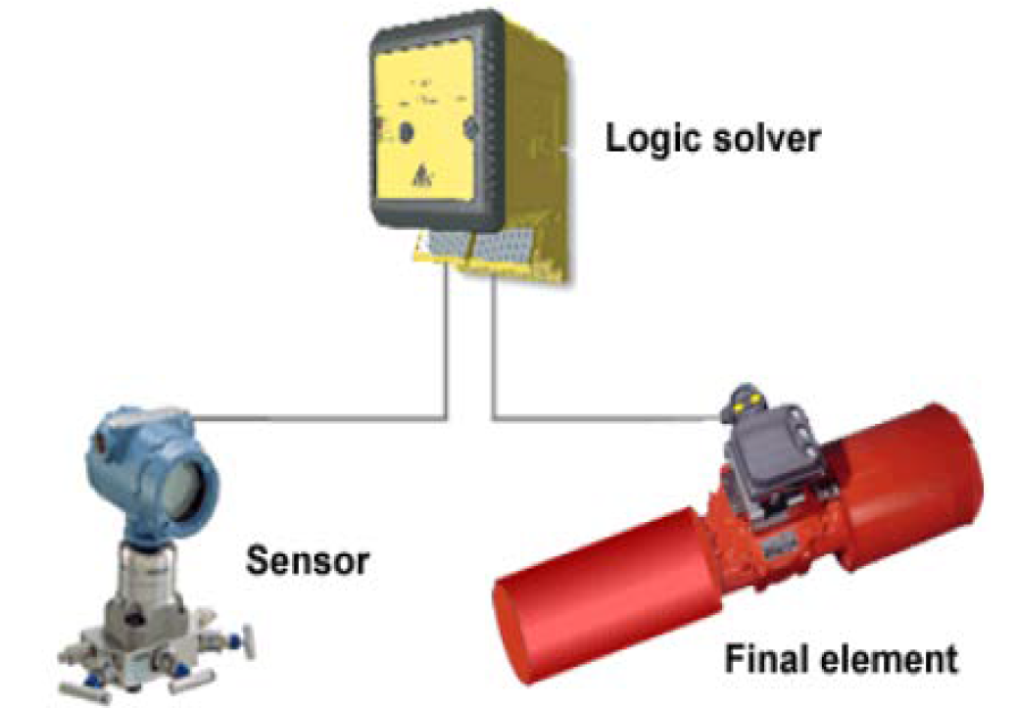

1. The ability of a SIS is to carry out the actions necessary to achieve a safe state in process.
2. Standards: IEC-60508 for general industry and IEC-60511 for oil and gas industry.

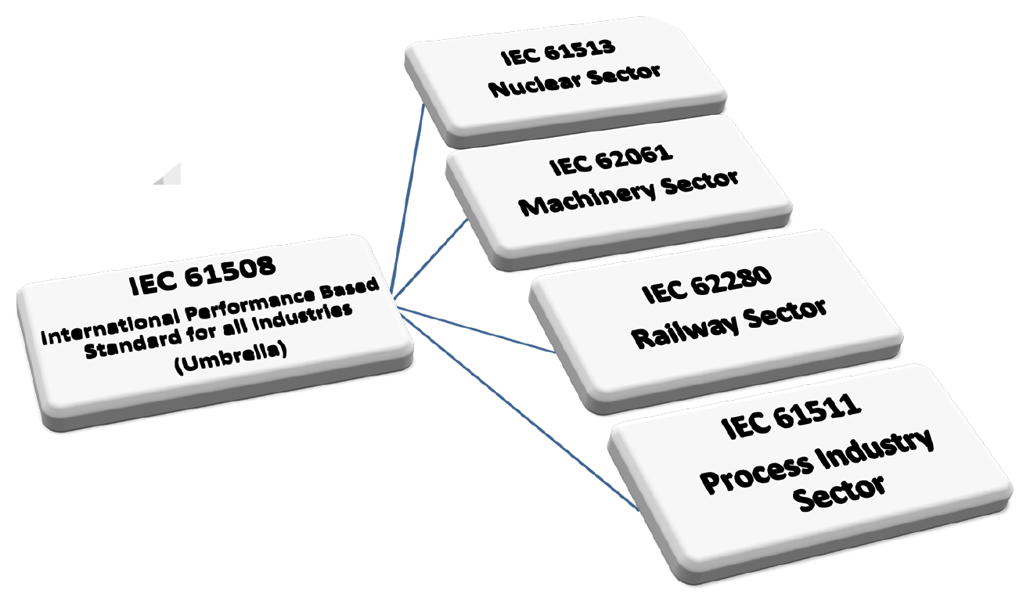

IEC-61508:

Functional Safety of Electrical/Electronic/Programmable Electronic Safety Related Systems

IEC-61511:

Functional safety –safety instrumented systems for the process industry sector

ANSI ISA-84.00.01:

Application of Safety Instrumented Systems for the Process Industries

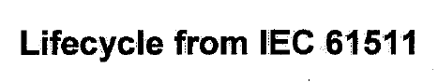

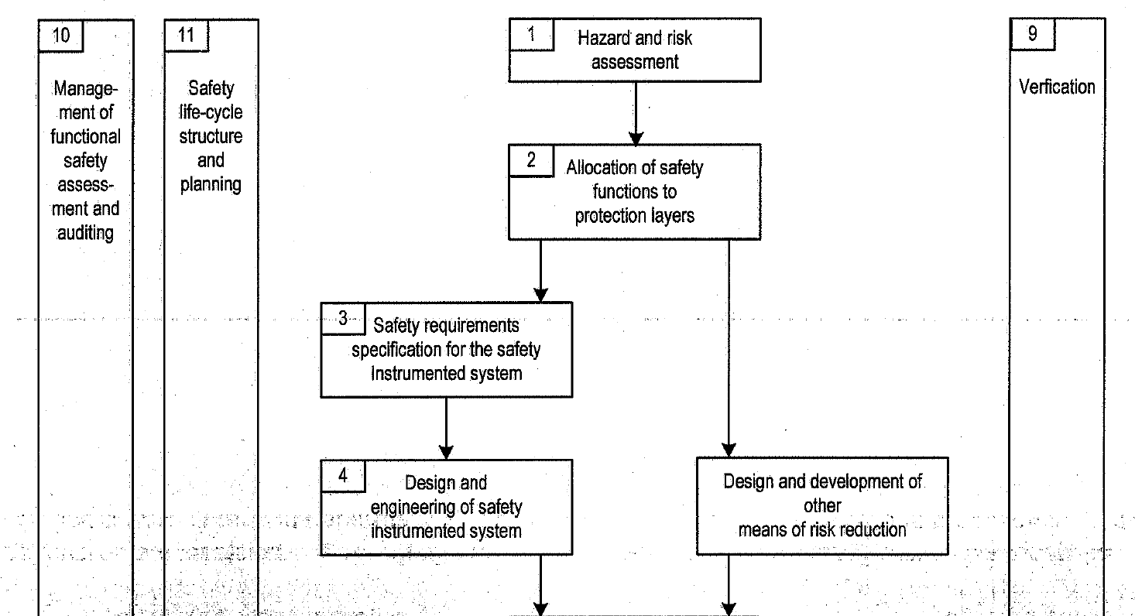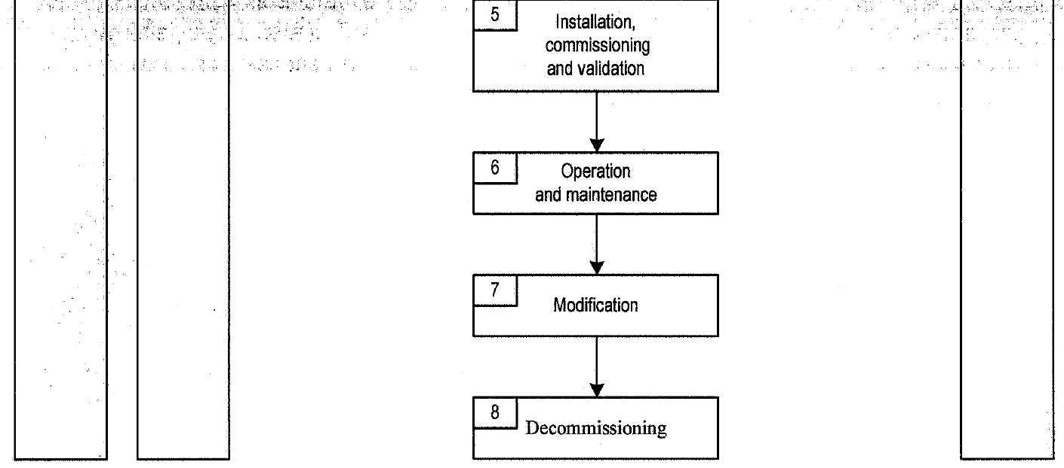

Stages of SIL Study

1.Target SIL Evaluation

What SIL should be allocated for the SIF?

2.SIL Verification

Does SIS fulfill Target SIL requirements?

SIL Verification Procedure

In order to verify the selected SIL in a loop, 3 components should be taken into account.

A. SIL capability stated in the certificate

B. Calculate PFD for each and then sum them and find the corresponding SIL

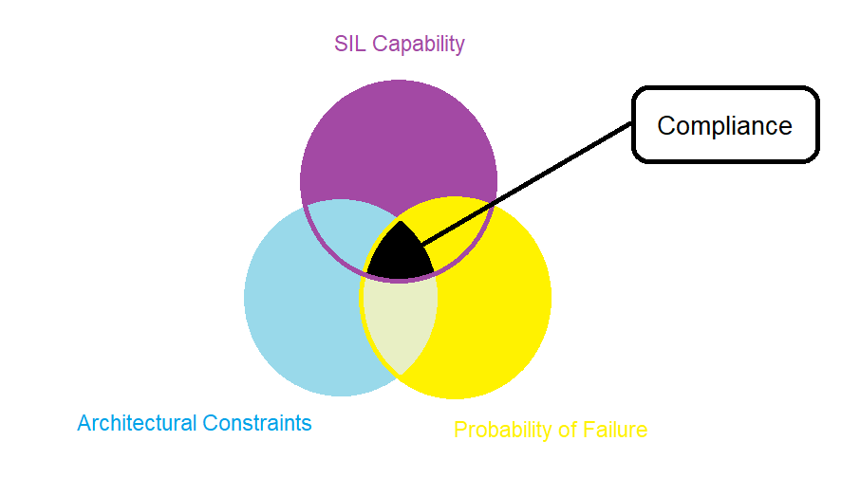C. Check architectural constrains by checking first rout.

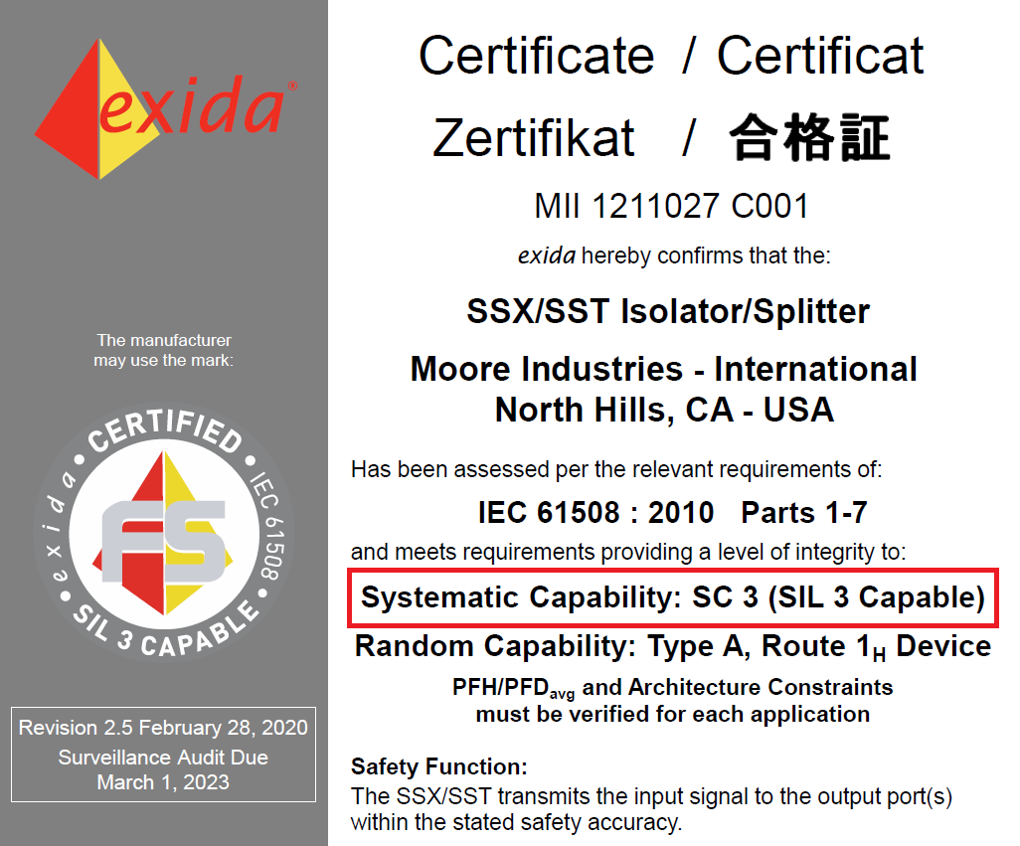SIL capability stated in the certificate

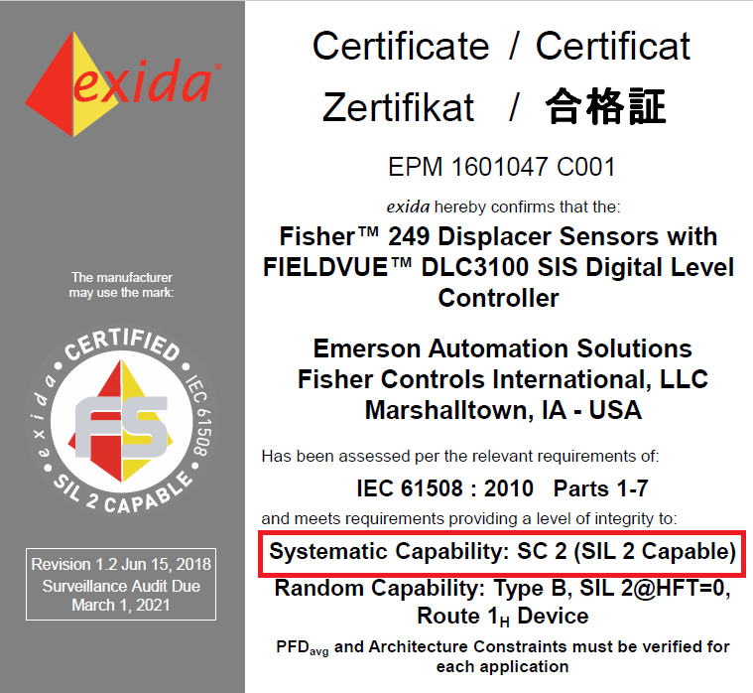

Calculate PFD for each and then sum them and find the corresponding SIL

Primary Definitions:

Failure Frequency:

The probability that a system fails during a specified period of time.

Mean Time To Fail (MTTF)

Probability of Failure upon Demand (PFD) : equals to λ times TI divided by 2 if λ.TI<<1. It is assumed that after each time interval the equipment is as new as first day. Time interval is really important when regarding sil target.

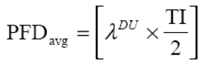

Test intervals (TI) (directly affects PFD)

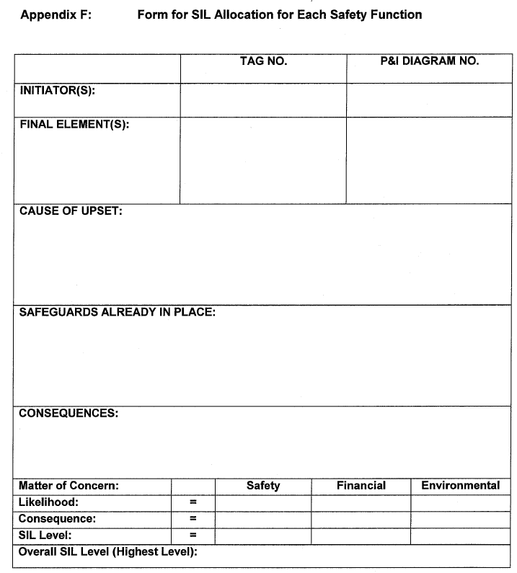

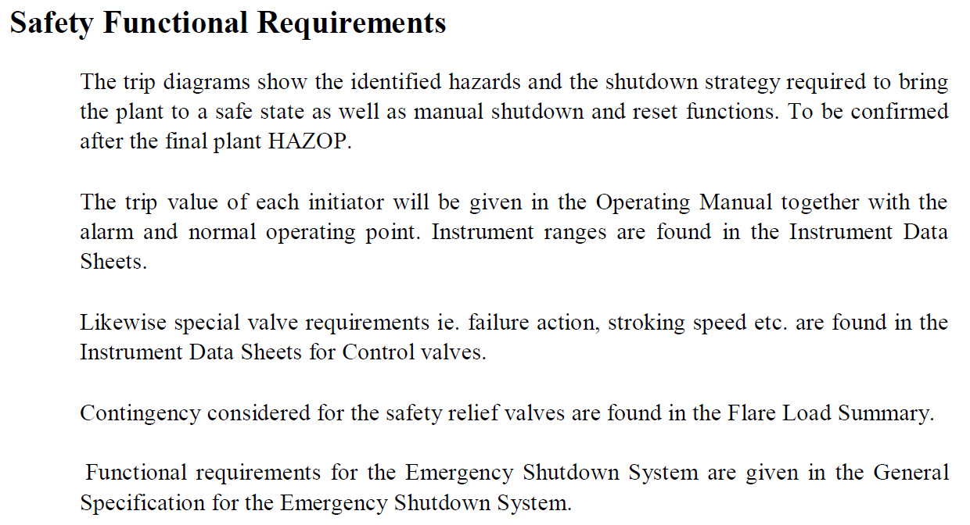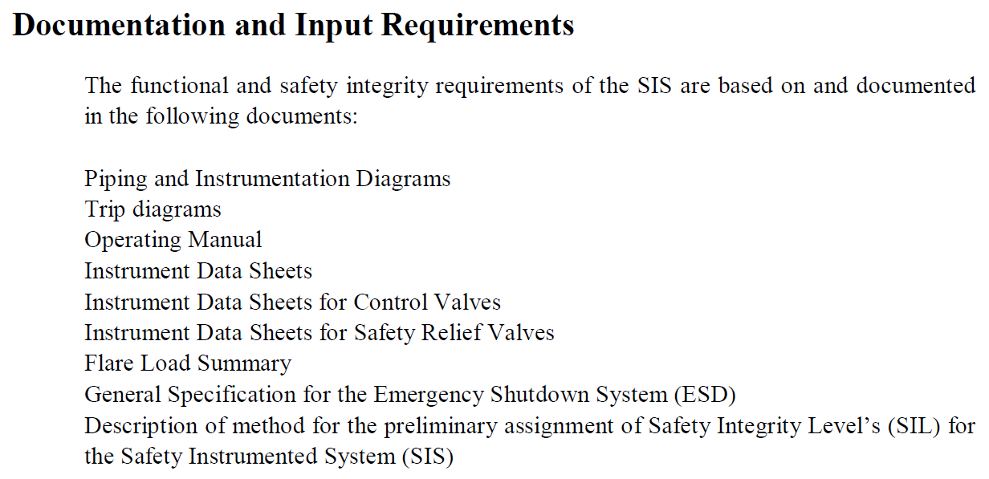

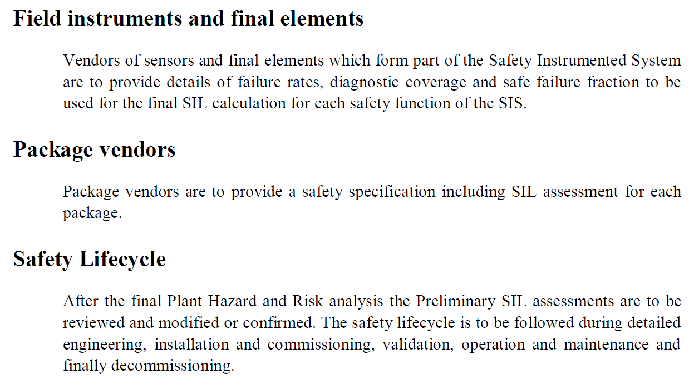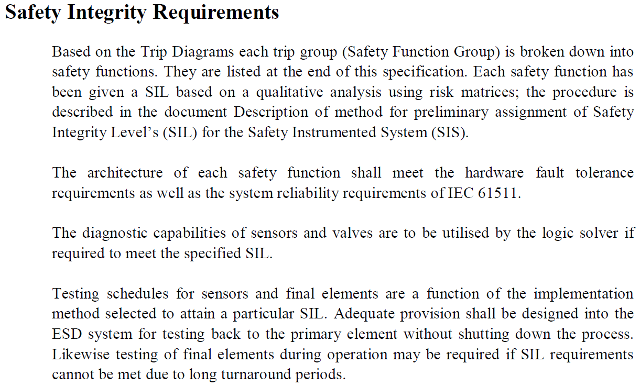

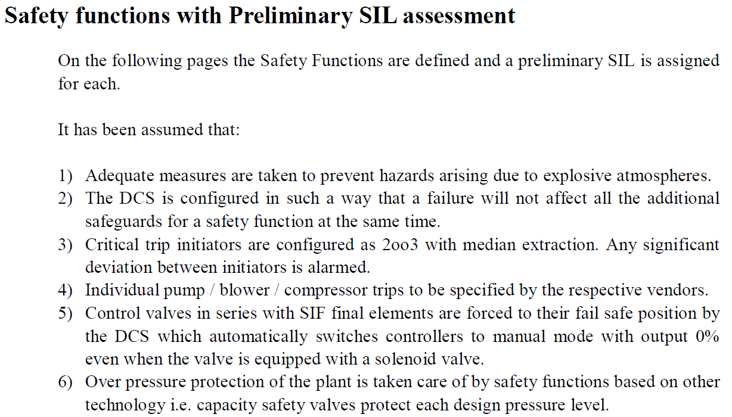

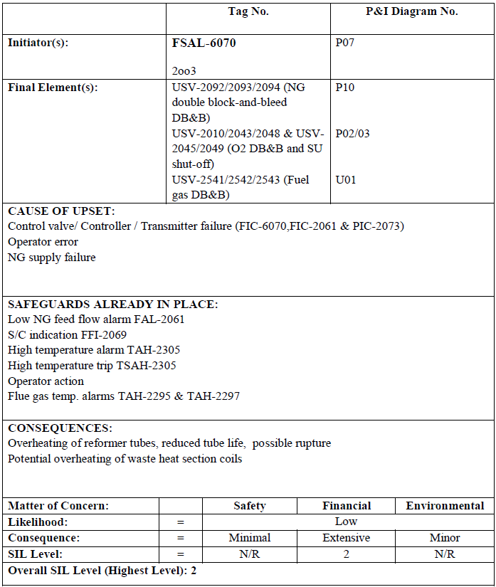Examples

