Design Criteria

CONTENTS
- DOCUMENT SCOPE....................................................................................................... 5

- INTRODUCTION.............................................................................................................. 5

3. PROJECT OVERVIEW .......................................................................................................... 5

3.1 Plant Description.............................................................................................................. 6

4. CODES AND STANDARDS...................................................................... 7

5. REFERENCE DOCUMENTS.................................................................... 7

6. ABBREVIATIONS ..................................................................................... 7

7. DEFINITIONS ......................................................................................... 10

8. MECHANICAL DESIGN CONDITIONS................................................... 12

8.1 Design Pressures................................................................................ 12

8.2 Design Temperatures ......................................................................... 18

8.3 Material Selection ............................................................................... 21

8.4 Lethal service classification for pressure vessels................................ 24

9. EQUIPMENT DESIGN CRITERIA .......................................................... 25

9.1 Pumps................................................................................................. 25

9.2 Compressors, Fans & Blowers............................................................ 30

9.3 Heater and Boiler ................................................................................ 33

9.4 Vessel ................................................................................................. 33

9.5 Heat Exchangers and Air Coolers....................................................... 42

9.6 Columns and Trays............................................................................. 47

10. PIPING.................................................................................................... 47

10.1 General Design and Hydraulic ............................................................ 47

10.2 Insulation and Heat Tracing ................................................................ 49
10.3 Line Sizing Criteria.............................................................................. 50
10.4 Absolute Roughness........................................................................... 56
11. FLARE AND COLD VENT SYSTEMS .................................................... 56
11.1 Type of Flare Tip................................................................................. 56
11.2 Flaring Flowrates ................................................................................ 57
11.3 Radiation Levels Criteria..................................................................... 57
11.4 Emissivity Coefficient .......................................................................... 57
11.5 Flare and cold vent lines sizing criteria ............................................... 57
11.6 Flare Drum Sizing ............................................................................... 59
11.7 Purge Gas........................................................................................... 59
12. SOFTWARE............................................................................................ 60
13. APPENDIX.............................................................................................. 62

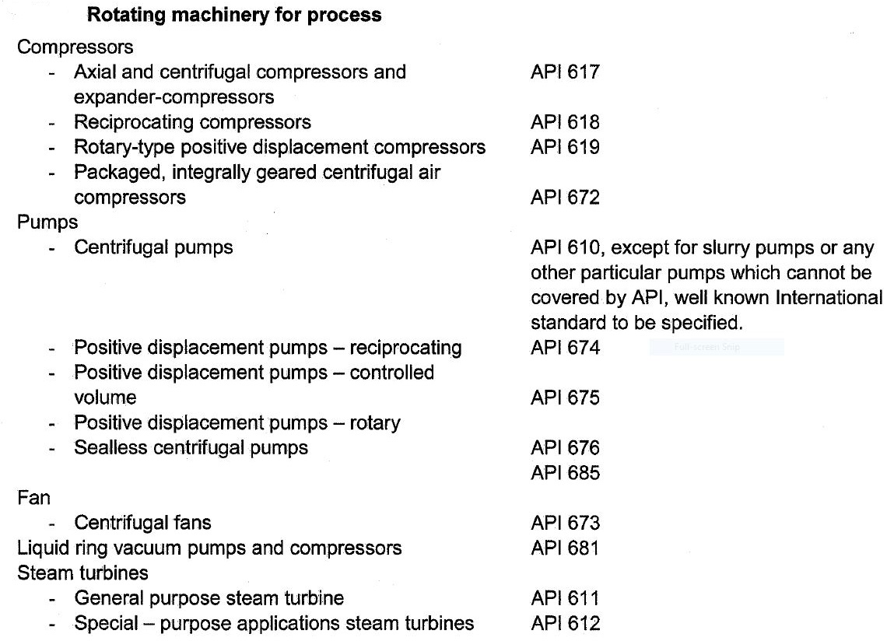
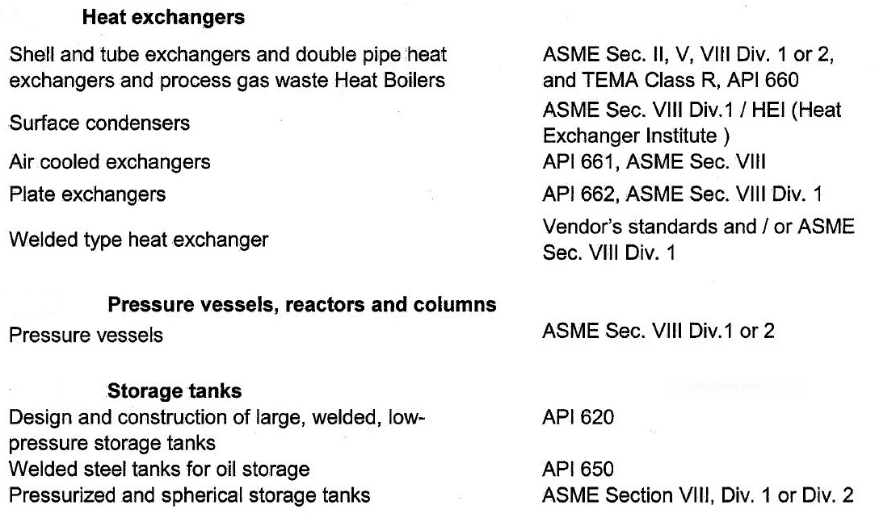
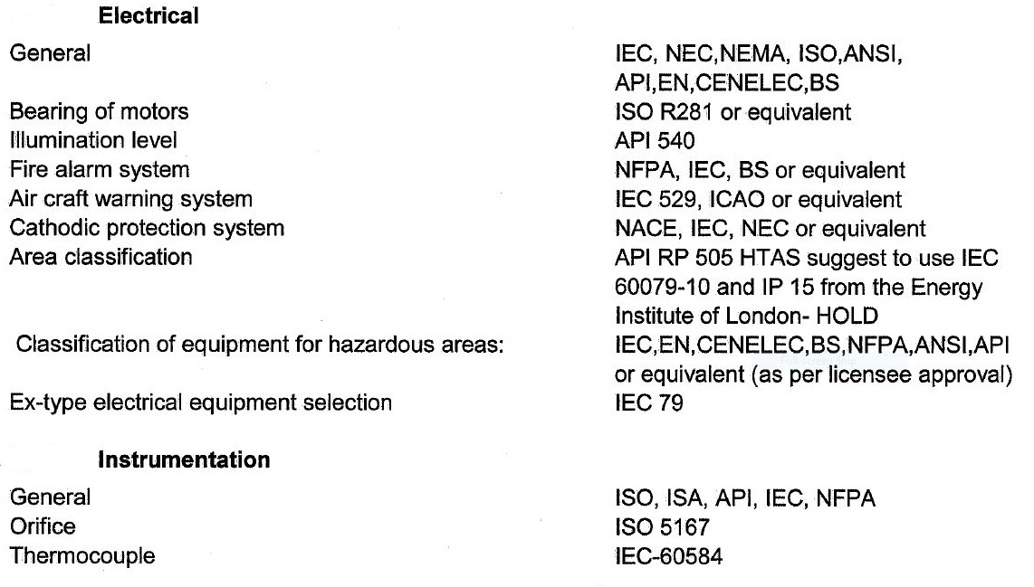
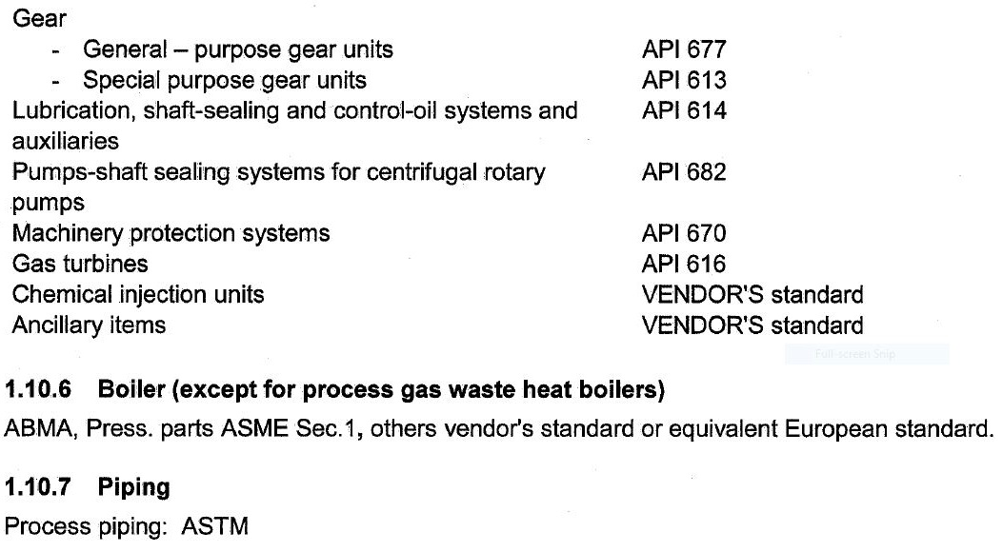
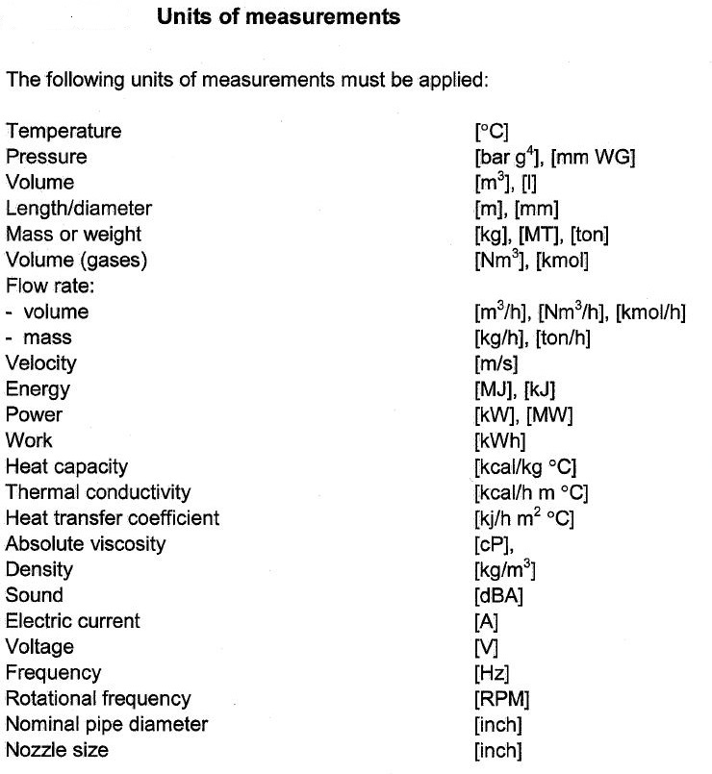

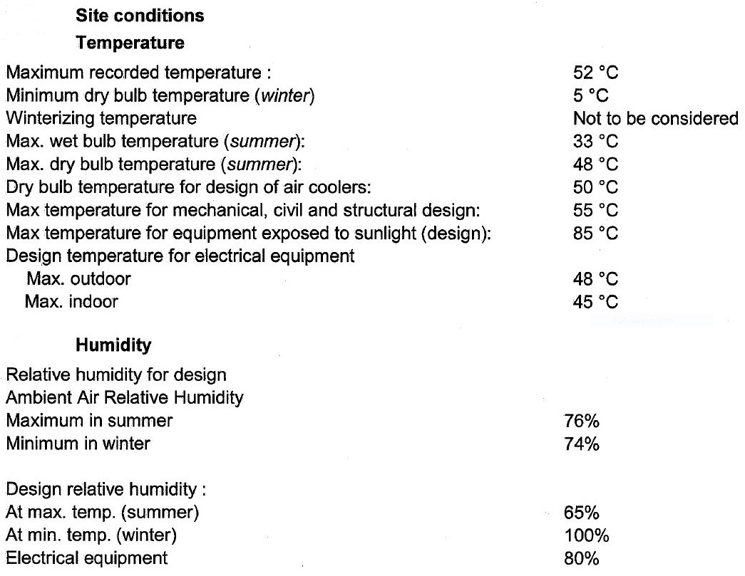
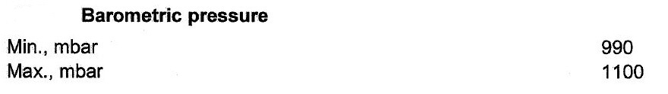

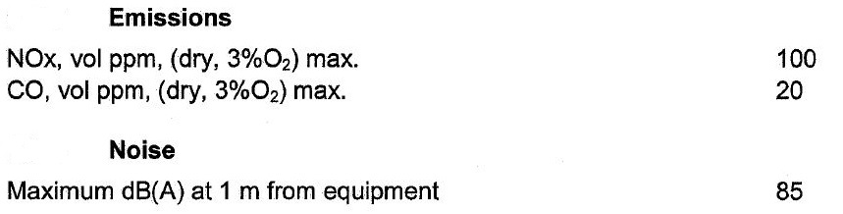
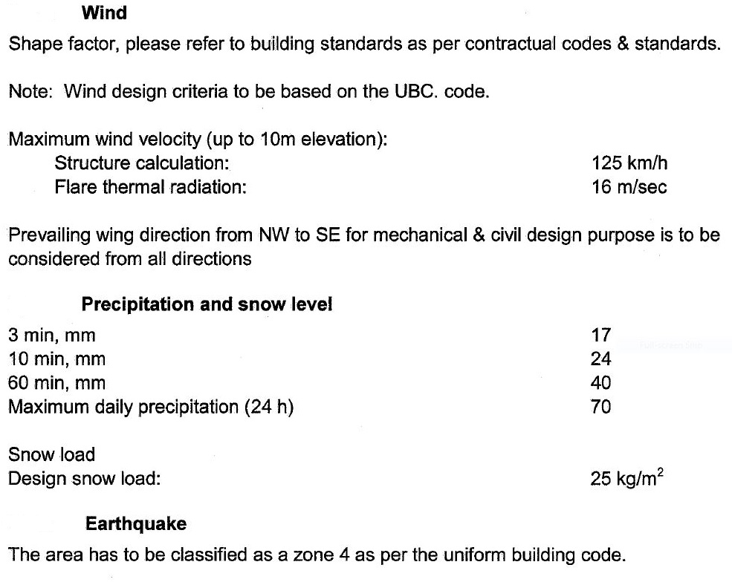

Utility Characteristics
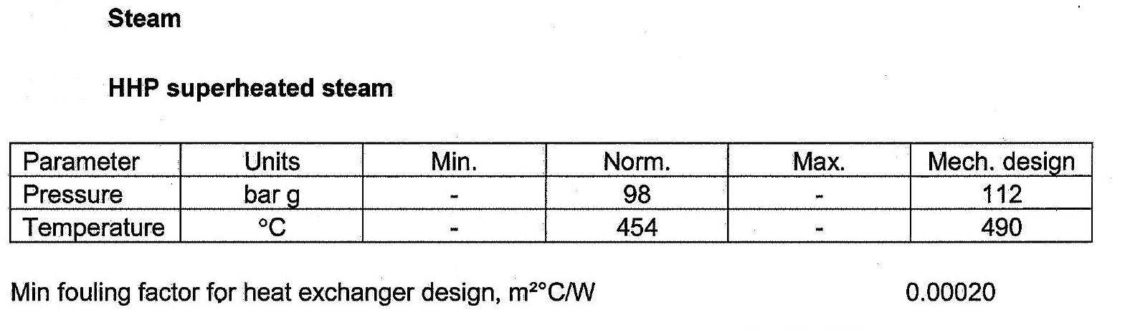
Existing utility characteristics are shown below.
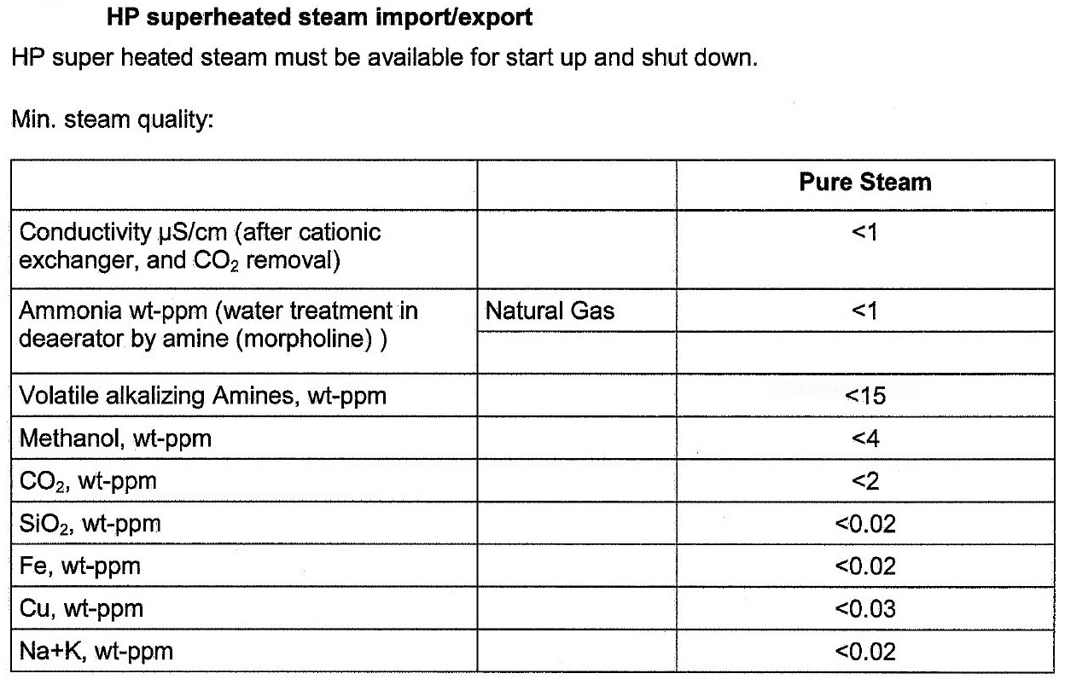

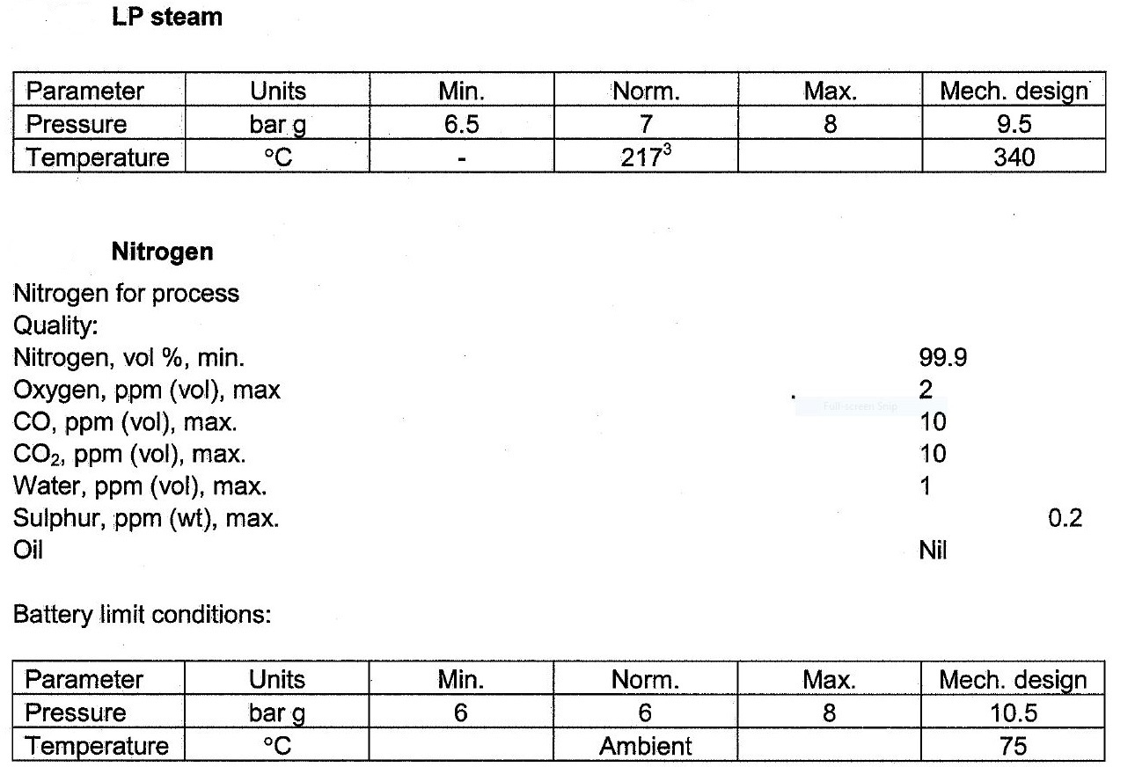
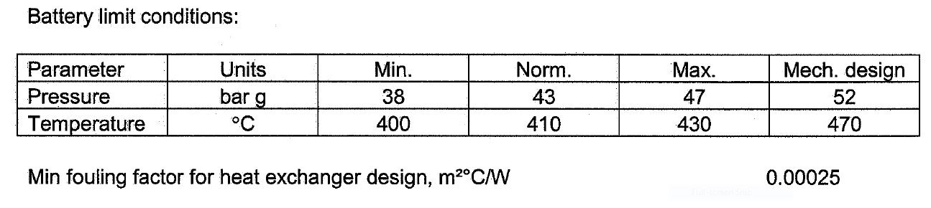

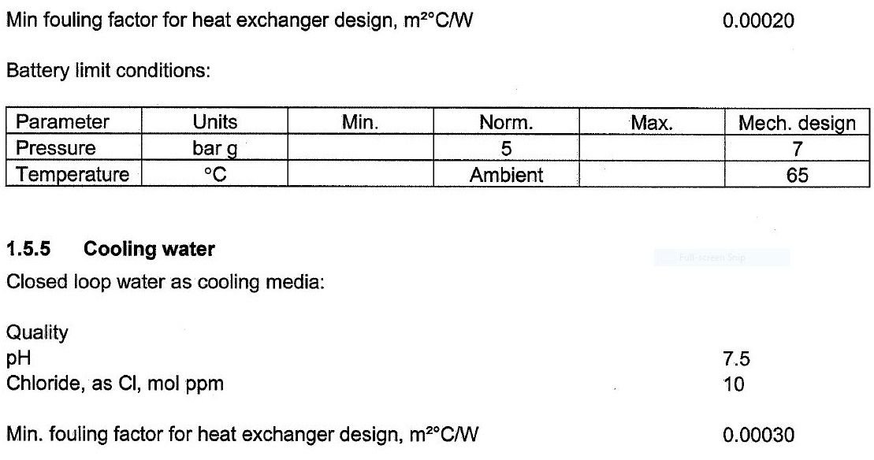
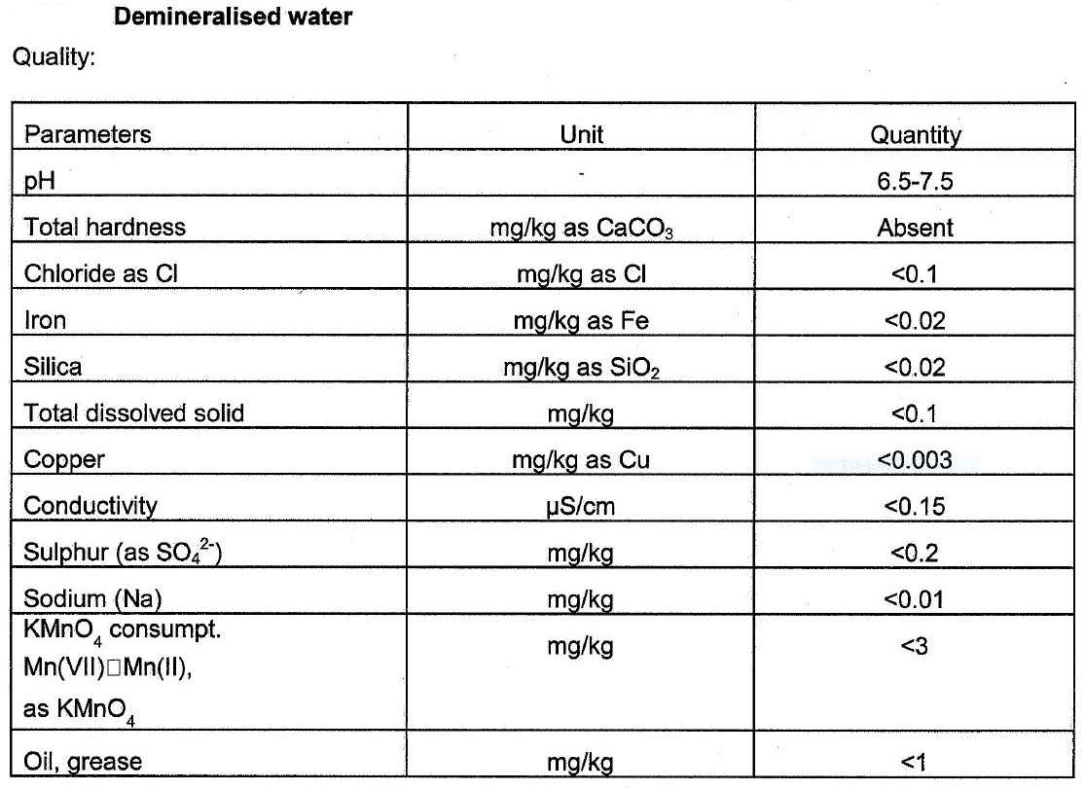
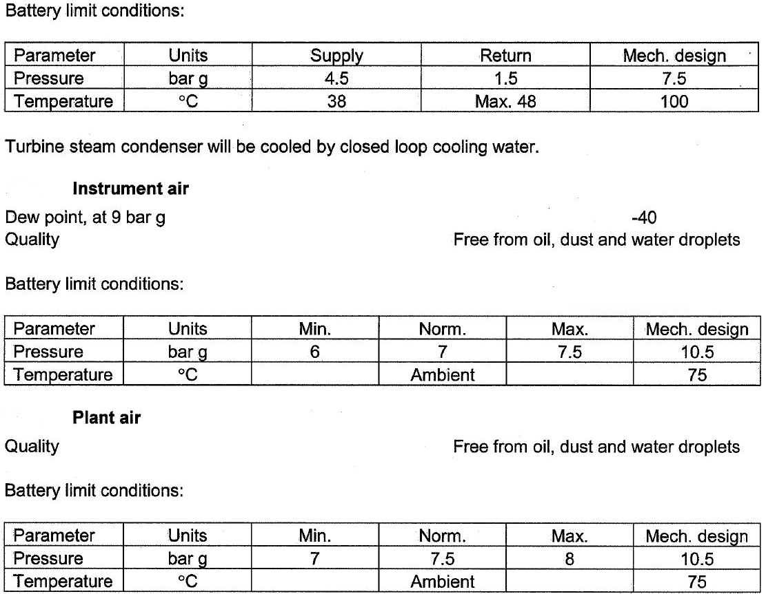

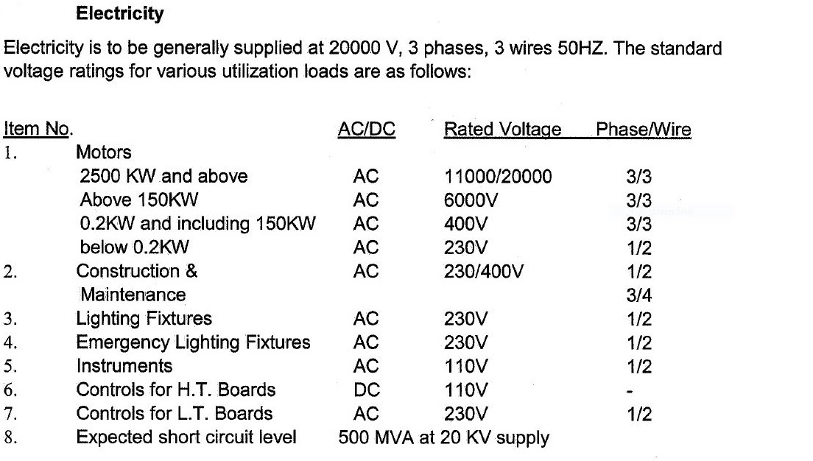

Design Pressures

The design pressure is the maximum and/or minimum pressure for which the mechanical

calculation shall be performed. The set pressure of the relief valve must be lower than or equal

to the design pressure of equipment. For vacuum rating designation, pressure shall be shown

as external. The maximum operating pressure is defined as the maximum pressure which

occurs during normal modes of operation, including start-up and shutdown, and should take full

account of any hydrostatic head, and other pressure drop across the item.

Maximum operating pressure (barg) | Minimum design pressure (barg)
< 1 | 2 or 3.5 (*) minimum
1 -10 | MOP + 1 bar (**)
> 10 | MOP + 10%

(*) 2.0 barg for PSV discharging to atmosphere, 3.5 barg for PSV discharging to flare network.
(**) 2 or 3.5 barg as minimum design pressure considering the criteria in Part (*).

Notes:
1. Vapor pressure at design temperature should be considered as design pressure except

when safety relief valves are provided.

2. Equipment that operates at pressure below atmospheric pressure shall also be designed

for full vacuum.

Equipment that could face vacuum under abnormal conditions such as:

- Vacuum conditions during start-up, shut down and/or regeneration purges

- Normally operated full of liquid but can be blocked in and cooled down

- Containing condensable vapor but can be blocked in and cooled down (especially

Equipment which is subjected to steam out).

- Could undergo a vacuum condition through the loss of heat input

- Loss of artificial gas blanketing on vessels containing liquids in a vessel containing

liquids with a vapor pressure less than atmospheric at the minimum storage temperature

- Product storage tanks and vessels where net output is possible (e.g., Unloading).

They shall be treated on a case-by-case basis and be designed for full vacuum unless fully

reliable protection devices are provided (vacuum breaker, pressurization gas, low pressure

switch etc.)

3. In Atmospheric storage tanks:

- Without gas blanketing, the design pressure shall be the hydrostatic pressure

considering the tank full of liquid.

- gas blanketed and with a seal pressure lower than 100 mm of H2O, the design pressure

shall be the hydrostatic pressure considering the tank full of liquid plus 150 mm H2O.

- gas blanketed and with a seal pressure not higher than 400 mm of H2O, design

pressure shall be the hydrostatic pressure considering the tank full of liquid plus 500 mm

of H2O.

4. For Welded Steel Tanks for Oil Storage, unless otherwise specified by the purchaser, the

internal design pressure shall not exceed the weight of the roof. In no case shall the

maximum design pressure exceed 9 inches water column. When the design pressure for a

tank with an aluminum dome roof is being calculated, the weight of the roof, including structure,

shall be added to the weight of the shell. Vents shall be sized so that the venting requirements

can be handled without exceeding the internal design pressure.

5. For Large, Welded, Low-Pressure Storage Tanks, design pressure, in pounds per square

inch gauge, shall be at least equal to the total pressure on the wall of the tank at the level where

the cover plate is located or shall be 15 pounds per square inch gauge, whichever is greater.

The design pressure for the gas vapor space of the tank shall not exceed 2 pounds per square

inch gauge.

6. As with jacketed vessels, some tanks such as double wall tanks will be subject to an external

design pressure, because the external pressure in the annulus between the walls may exceed

the internal pressure, even when the internal pressure is at or above gauge pressure. Open

vents or other means of relieving the annulus pressure is often employed to limit this external

pressure.

7. If a control or block valve is installed downstream the heat exchanger, the design pressure

shall be the same of the upstream equipment or the actual shut-off pressure of the upstream

purchased pump. If a control or block valve is installed upstream the heat exchanger, the

design pressure shall be calculated as the design pressure of the downstream equipment at the

inlet point plus 1.20 times the pressure drop of the circuit between the heat exchanger inlet and

the inlet points of the downstream equipment plus static head (if any).

8. For S&T heat exchangers, design pressure of one side shall not be less

than operating pressure of the other side.

9. For lines and equipment located on discharge side of rotating machineries (pumps,

compressors, …) and are not protected by pressure relief valve, design pressure shall be:

- Maximum shut-off

- Blocked-in pressure plus static head (if any)

- Above mentioned pressure whichever is greater.

10. OVHD condenser and reflux drum: design pressure will be calculated based on the column

top operating pressure.

Bottom reboiler: design pressure will be calculated based on the maximum column bottom

operating pressure plus static head.

11. For equipment in equilibrium with (‘riding on the’) flare, the design pressure of the equipment

is at least the maximum flare back pressure at any point of the flare system or the flare design

pressure, whichever is higher.

12. Hydraulic pressure due to the relative elevation between equipment and also the PSV’s

location shall be considered.

13.Special equipment – it should be noted that some items of equipment, e.g. glass lined

vessels, carbon block exchangers etc., may have design difference between the two sides of

the unit, rather than maximum system design pressure.

14.Particular Cases: The Design Pressure (DP) of the Equipment is as follows:

Compressors

At the reciprocating compressor discharge:

DP = MOP + 2 bar for MOP ≤ 20 bar g,

DP = MOP + 10% for MOP > 20 bar g.

PSVs are required.

At the discharge of the centrifugal compressor:

DP = MOP + 1 bar for MOP ≤ 10 bar g,

DP = MOP + 10% for MOP > 10 bar g.

Generally, surge pressure is above design pressure and PSVs are required.

Consideration shall be given to compressor arrangement to determine the settle-out pressure of

the isolated system. The settle-out pressure is the equilibrium pressure reached between the

suction and discharge isolating valves of the compressor system when the compressor is

stopped or shut down.

Generally, the design pressure of the equipment and piping at compressor suction shall be

above this settle-out pressure in order to avoid unnecessary lifting of PSVs. For variable speed

compressors, the maximum discharge pressure shall be calculated from the performance curve

at the maximum trip speed setting prior to arriving at design pressure considerations.

Pumps

a- Centrifugal pumps

• Generally, no PSVs are provided at the discharge of centrifugal pumps and the design

pressure shall be the discharge pressure of the pumps at no flow with the maximum suction

pressure and the maximum specific gravity

• When the discharge pressure of the pumps at no flow is not available, this pressure can be

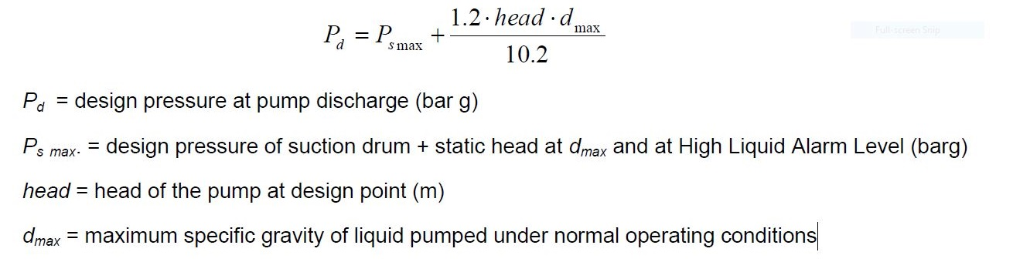
estimated:

b- Positive displacement pumps

At discharge of positive displacement pumps:

DP = MOP + 1 bar for MOP ≤ 10 bar g,

DP = MOP + 10% for MOP > 10 bar g.
PSVs are required.

In case of two pumps in series, the maximum differential head shall be the sum of the maximum

differential head of each pump if there is no pressure relief valve between the pumps.

Heat exchangers design pressure

Maximum Operating Pressure (barg) | Minimum Design Pressure (barg)
0 < MOP ≤ 1 | 3.5
1 < MOP ≤ 3.5 | 5
3.5 < MOP ≤ 17 | MOP + 2
17 < MOP ≤ 70 | MOP x 1.1
70 < MOP ≤ 140 | MOP + 7
140 < MOP | MOP x 1.05

Loss of containment of the low-pressure side to atmosphere, is unlikely to result from a tube

rupture where the pressure in the low-pressure side (including upstream and downstream

systems) during the tube rupture does not exceed the corrected hydrotest pressure.”

It should also be noted that:

“Pressure relief for tube rupture is not required where the low-pressure exchanger side

(Including upstream and downstream systems) does not exceed the criteria noted above.”

The corrected hydrotest pressure is defined as:

“Hydrostatic test pressure multiplied by the ratio of stress value at design temperature to stress

value at test temperature.”

The recommended practice consists of oversetting, if necessary, the design pressure of the low-

pressure side of heat exchanger:

• In all cases up to limit of 150#

• After analysis, case by case, for higher pressure

This practice applies only to the heat exchanger itself and does not concern relevant piping and

valving. Since double pipe type heat exchangers are considered a piping item, they are

excluded.

As an alternative to relief valve installation the design should consider the capacity of the shell

side piping and downstream unit to accept the tube rupture case.

Full vacuum conditions shall be added to design conditions since vacuum can happen during

cooling of such equipment (when not connected to atmosphere) unless fully reliable protective

devices are provided (vacuum breaker, pressurization gas, low pressure switch).

Columns

For columns, the same design pressure shall be selected for the top of a fractionation tower and

associated condenser, reflux drum and inter connecting piping. The design pressure at the

bottom of a column (vapor phase) is determined by adding the column pressure drop to the

column overhead design pressure.

Liquid density and maximum liquid height in the bottom shall be specified on the process data

sheet to allow the vessel designer to calculate the bottom thickness. Special attention shall be

paid to the case when the hydrostatic test is to be done in the vertical position, e.g. a field test,

as the tower will be filled with water. A water column equal to column height shall be considered

when calculating vessel thickness.

Design Temperatures

The design temperature is the value used for the mechanical design of equipment.

In all cases, design temperatures of all equipment shall be quoted as Maximum design

temperature /Minimum design temperature.

Equipment operating above 0°C

Max. design temperature = max. operating temperature + 15°C or maximum exceptional

operating temperature, whichever is the greater.

Note: exceptional operating temperature shall be considered for operations exceeding a total of

100 hours per year.

Maximum design temperature for equipment exposed to solar radiation shall be at least 85°C.

This value should be examined case by case for equipment on which dilatation problems can

occur (such as double wall tank, fixed tube sheet, plate heat exchanger) and for insulated high

pressure vessels (not to increase wall thickness).

For those equipment items not exposed to solar radiation the maximum design temperature for

all equipment shall be at least 55°C. This is the maximum estimated temperature that can be

achieved in insulated equipment and equipment shaded from the sun after prolonged shutdown.

Equipment operating below 0°C

As a general rule the minimum design temperature shall be:

TD = TSM - 5°C, or minimum ambient temperature, whichever is lower.

Where:

TD: Minimum Design temperature (°C)

TSM : Minimum continuous operating temperature (°C), however see Note (1) below.

• Notes:

- When applicable, the exceptional temperature generated by depressurization of

equipment or interconnected items system shall be indicated as well as the related

residual pressure. Depending upon the depressurization philosophy of the plant,

dynamic simulations of equipment have to be performed using commercial or in-house

software so as to determine the relevant pressure and temperature of depressuring

conditions (see Section 12, Software).

- Temperature associated with a gas blow by from one equipment item shall be

considered for the buried drum (belonging to the drainage system) design temperature.

- When applicable an exceptional ‘hot’ design conditions set (e.g., temperature and

related design pressure) may be added to the ‘cold’ design conditions set for equipment

operating at low temperature. (An exceptional condition may be steam out etc.).

Emergency Depressurising

The minimum design temperature must take into account any depressurization and

repressurisation(depending on material selection) of the equipment / piping that may occur

either during an emergency or shutdown situation or gas blow-by from one equipment item to

another equipment item and to the possible consequence of a change of material.

The emergency depressurizing shall impact the material selection as follows:

Piping material

Piping material shall be selected taking into account the minimum temperature encountered

during depressurization. Piping repressurisation shall be considered as to be performed with

the minimum depressurization temperature.

Vessel material

The minimum temperature due to the blowdown conditions shall be associated with design

pressure. Although depressurization of any section of the plant cannot be performed unless

the section is isolated and permission is obtained, repressurisation may take place by

operator’s error or a valve failure, therefore the minimum temperature shall be associated

with design pressure. Credit for special devices to ensure that the plant shall remain isolated

and depressurised shall not be considered.

In addition, the above criteria shall ensure safe operation in case of residual piping stress

being present (in particular for small diameter nozzle/piping).

Heat exchanger and air cooler

The following conditions mentioned hereafter shall be applied generally up to the next piece of

process equipment:

- Consideration for design temperature definition shall be given to cooling medium failure

when coolers are used. Downstream of an air cooler, the design temperature is

determined considering that 20% of the duty is provided by natural draft. Where possible

detailed thermal analysis of natural convection cooling under the worst design ambient

conditions shall be performed to arrive at the maximum cooler outlet temperature.

- For the bypassed air cooler, the design temperature of the downstream equipment, if

any, shall be the maximum upstream operating temperature of the bypassed exchanger.

- Downstream of other coolers, the design temperature shall be the upstream maximum

operating temperature.

- Fixed tubesheet exchangers shall not be used and other designs shall be considered if

the difference between the average shell metal temperature and the average tube metal

temperature in any tube pass exceeds 28°C.

Cleaning and steam out

The steam-out conditions for vessels are 150°C @ atmospheric pressure. For equipment

subjected to steam-out operations, full vacuum condition shall be specified at 150°C.

The accidental temperature which may occur in emergency situations, such as loss of utilities,

valve closure, air cooler failure or any abnormal operation lasting for a short duration, is not to

be taken into account as long as the temperature increase does not exceed the code’s limits

(investigation has to be undertaken with specialists on a case-by-case basis)
However, equipment containing parts which can be damaged by an abnormally high

temperature shall be designed for this temperature. This mainly concerns equipment internals.

Material Selection

The following section is provided as a general guideline. Final material selection shall be

determined by the materials department.

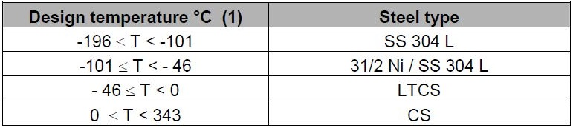
Material selection used for vessel

(1) Design temperature corresponding to operating conditions. For temperature due to

depressurization, LTCS might be suitable to use at lower temperature (<-45°C) provided

that the vessel shall naturally reheat before repressurisation. This limit should be determined by

the Mechanical Department, depending on vessel wall thickness.

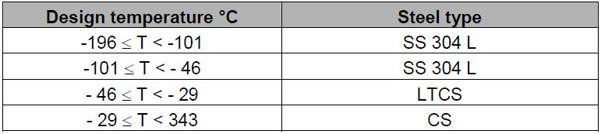
Material selection used for piping

General considerations

H2S and CO2 corrosion results in metal loss and in metal embrittlement (cracking). Sulphide

Stress Corrosion Cracking (SSCC) can be limited by using materials listed in the NACE

MR0175 / ISO15156. Hydrogen Induced Cracking (HIC) corrosion is directly linked to the

material quality, specifically the presence of elongated inclusions and microsegregations.

Therefore, HIC control is a matter of material specification.

Post-weld heat treatment

For caustic soda and amine service of any concentration, a post weld treatment for stress relief

shall be specified to avoid corrosion cracking.

No post weld heat treatment shall be performed on Austenitic Stainless-Steel materials.

Corrosion allowance
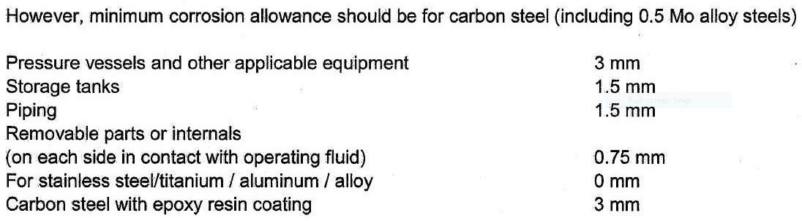
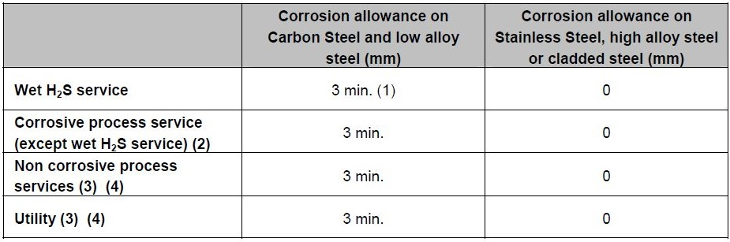

Notes:

1) Minimum corrosion allowance depending on corrosion control philosophy

2) e.g. amine systems, sulphur recovery units

3) The corrosion allowance applies for pressure vessels, shell and tube type and air fin type

Heat exchangers

4) For piping, refer to piping classes

5) For storage tanks, corrosion allowance shall be:

- For fixed roof tank: 1.5 mm for shell and roof except tank bottom where wall thickness is

generally imposed by other constraints

- For floating roof type tank: 0 mm

Protective painting shall be applied on roof and shell (above overflow) where condensation may

occur and bottom part of shell where water may accumulate.

EQUIPMENT DESIGN CRITERIA

The minimum margin between the normal and rated flow for a pump shall be as below:

• Reflux pump = +20% of normal flow

• Other process pump = +10% of normal flow

• Utility pump = +10% of normal flow

• Export pump from storage to pipeline (continuous operation) = +15% of normal flow

• Loading Pump (to road and rail tankers or marine vessels) = +0% of nominated loading rate.

• Boiler feed water pump = See applicable codes but not less than +10% of normal flow

To be noted that:

• When a non-automatically controlled minimum flow protection has been installed, the

permanent recirculation flow (if required) must be added to the net process flow.

• Normal and rated flow shall be identical in such instances as:

1) Intermittent service pumps: e.g. sump pump.

2) When the pump has been overrated to allow for a centrifugal type and if overrating is ≥ 10%.

3) Re-circulation flow such as for product loading lines or through amine filtration system.

• Pump automatic start shall generally be done through the Flow Switch Low Low (FSLL) (if flow

transmitter already exists) but shall need to be examined on a case by case basis. The

determination of automatic start shall be based on consideration of the following guidelines and

applicability:

1) Personnel safety: for example flare knockout drum pump shall be started in order to avoid

liquid in flare tips. In that case, considering the discontinuous operation of flare drum pumps,

the start of the spared pump can be performed by Level Switch High (LSH) or by Distributed

Control System (DCS) logic.

2) Equipment safety: for example Boiler Feed Water (BFW) pump shall be started in order to

protect the steam drum and the steam coil.

3) Severe process upset: pumps that can generate a process unit trip or that can generate an

off-spec product shall have spares that can be started automatically.

4) Flaring: automatic start shall not be considered to minimise the flaring, for example reflux

pumps, unless a severe process upset is faced.

9.1.1 Physical Properties

Physical characteristics of the fluid being pumped are based on the heat material balance

verified during the FEED study.

9.1.2 Capacity

Design margins as set out in Section 9.1 shall be applied when setting pump design capacities.

For flows less than about 3.4 m3/h, a larger pump is usually purchased and a fixed recycle is

added to provide for recirculation of excess pumped fluid to the suction supply. An orifice plate

is frequently included in the bypass line and this can be supplied by the pump vendor, who shall

size the orifice for a minimum flow requirement. The pump requisition sheet shall specify a

capacity equal to the desired flow (including extra capacity) plus the amount bypassed.

9.1.3 Suction Calculation

This calculation yields the system pressure available at the pump centreline of horizontal pumps

or at the centreline of the suction inlet nozzle for vertical shaft pumps. It involves the summation

of the feed vessel’s normal operating pressure, the static head loss, the pressure drop in the

suction piping resulting from friction, inlet-exit, and other losses.

The static head for vertical vessels is calculated from the bottom tangent line while for horizontal

vessels, the bottom invert line is used. Usually, no credit is taken for the head contributed by

liquid operating levels in a vessel. This should be reviewed on a case by case basis.

a) Suction line equivalent length (Le)

Equivalent length may be calculated in two ways for the suction lines, either the user inputs

straight line length and fitting factor and the Le is calculated by multiplying the two, or the Le is

estimated from the pipe diameter d (inches) as follows:

Pumping temperature < 150° C Le = (8d+30) m

Pumping temperature >= 150° C Le = (12d+30) m

NB: the estimation excludes an allowance for suction strainer. This shall be included as an

additional loss

b) Centerline elevations of horizontal pumps

The pump centerline elevation is selected from the table below. If the flow exceeds 4540 m3/h

the Mechanical group shall be consulted.

The suction pipe for fluids at or near their bubble point shall be adequately sized if the pressure

drop is inthe range of 0.01 to 0.06 bar/100m.

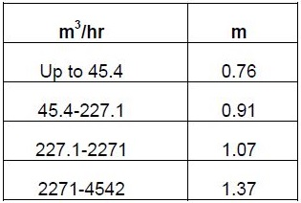

Net Positive Suction Head Available (NPSHA)

NPSHA is calculated by deducting the vapor pressure of the fluid at pumping conditions from

the Suction Pressure and converting it to pressure head in terms of liquid column.

Process engineers shall include a Safety Margin of 1.0 m in the NPSH calculated for: -

a) All boiling point fluids either single or multi-component.

b) Fluids that contain dissolved gas.

c) Foaming fluids.

In the case of boiler feedwater pumps, a margin of 2.0 m shall be used.

The static head used in calculating the NPSH shall be taken from either the tangent line or

bottom invert line in the suction vessel to one of the following:

The centre line of a horizontal or rotary pump.

The suction impeller on a vertical centrifugal pump.

The design of suction lines from storage tanks shall be based on the NPSH taken from the

Lowest specified level in the tank at which rated pump capacity is required.

Suction line sizing for reciprocating pumps shall take into account acceleration head.

9.1.5 Discharge Calculations

For pump discharge lines when fittings and valve count are not available, a reasonable estimate

of the total equivalent length can be made by multiplying the approximate run of actual pipe by

the multiplying factor. Details of applicable factors are given in section 10.3.6.

9.1.6 Shutoff Pressure

The shutoff pressure of a typical centrifugal pump is approximately equal to the sum of the

maximum suction pressure and 120% of the net differential pressure generated by the pump,

based on the maximum anticipated fluid density. Other pumps with steep Head-Flow curves

such as turbine, multistage and mixed flow pumps, however, shall have higher shutoff

pressures. The process engineer specifying these types of pumps shall consult with the

Rotating Equipment Group to determine this value since it may influence the design pressure of

downstream equipment.

The maximum discharge pressure sets the design pressure of a pump casing. This is the sum

of the maximum suction pressure and maximum differential pressure, which usually occurs at

zero flow. In cases where the feed vessel is protected by a safety relief valve, the maximum

suction pressure shall be equal to the sum of the safety valve set pressure and the maximum

static head.

9.1.7 Equipment Pressure Drops

The following typical pressure drops shall be used in line size calculation when the actual

pressure drop data are not available:
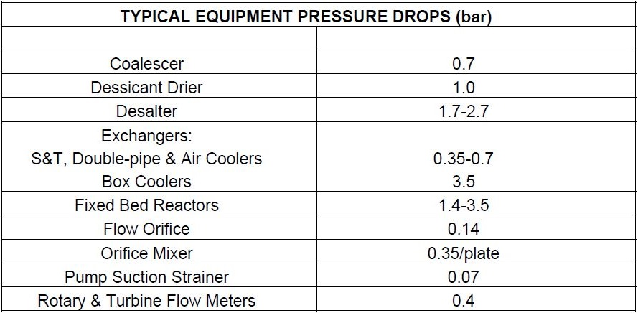

For systems involving multiple heat exchangers in series, consult with the Heat Exchanger

Group for pressure drop estimation.

9.1.8 Control Valve Pressure Drop

The control valve normal pressure drop is calculated in three ways:

• 33% of frictional pressure drop or,

• 10% of operating pressure or

• The value corresponding to a control valve pressure drop of 0.7 bar at maximum flow.

The maximum of these three values is inputted into the calculation for the net design discharge

pressure.

For systems operating above 69 barg, the control valve may take less than 10% of the operating

pressure, depending on process and control considerations.

The pressure drop of a control valve on the discharge of a pump should be a minimum of 20%

of the system dynamic pressure loss at normal flowrate, or 0.7 bar, whichever is greater. (This

criteria do not apply to loading pumps).

Pump Cooling Water Requirement

Cooling water, preferably fresh, is used to cool bearings, stuffing boxes, pedestals and glands to

safe temperature levels.

The coolant rate varies with temperature and to some extent with pump size. For design

purposes, the following rates shall be used:

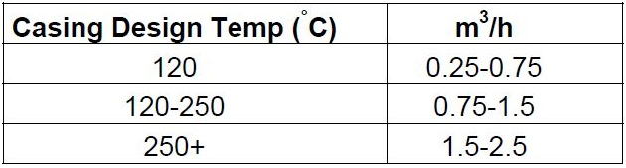

Pump Efficiency

The efficiency of centrifugal pumps varies from about 20% for low-capacity pumps (less than 6.3

m3/h) to a high of almost 90% for certain large capacity pumps. Low head pumps using open

type impellers are less efficient than closed impellers.
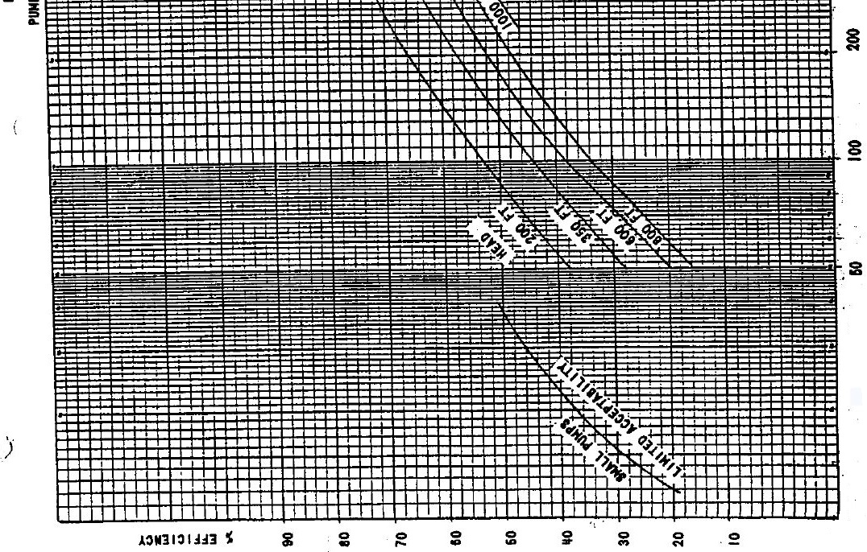
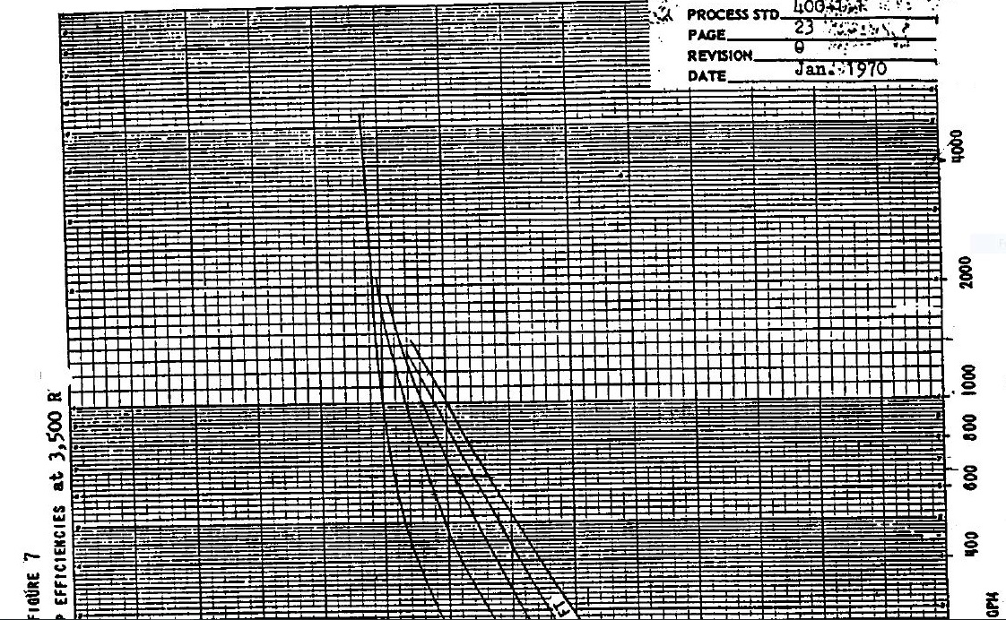
Compressors, Fans & Blowers

International Standards are utilised to identify tolerances for rotating equipment, such as the API

600series. In addition the following criteria shall be applied.

• Normally no margin is taken if the flow is constant, a 10% margin can be used if the flow is

directly coming from a production separator to take into account slugging regime.

• The variations of gas compositions, molecular weight, specific heat ratio etc., and the

operating conditions (mainly suction pressure and temperature) shall be taken into account to

determine the sizing case, and shall be listed on the Process Data Sheet

Compressor Process Specifications

9.2.1.1 Operating Case

If more than one case exists, all these alternative cases shall be included in the specification so

that the compressor vendor is able to evaluate the most stringent case for design.

9.2.1.2 Capacity

The volumetric flowrate capacity shall be determined by the compressor manufacturer from the

data sheet provided. The process engineer shall determine the mass flowrate based on

minimum, normal and maximum flow conditions. Design margins are as set out in Section 9.2.

9.2.1.3 Suction Temperature

Suction temperature is to be accurately specified since it is directly related to the volume of gas

at suction conditions, the discharge temperature, and the horsepower requirements. It is

important for the vendor to know the minimum and maximum temperatures for proper

compressor design and selection of correct driver rating.

9.2.1.4 Suction Pressure

Suction pressure is the pressure at the suction flange of the compressor and not before filters,

pulsation dampers, etc. The suction pressure shall be accurately specified.

9.2.1.5 Molecular Weight

Molecular weight is an important consideration in the design of a centrifugal compressor. When

this or any type of compressor is to be used in multiple services, the vendor is to be supplied

with data on the molecular weight of the gases in each of these services.

9.2.1.6 Specific Heat Ratio

The specific heat ratio is also an important consideration in the design of centrifugal and

reciprocating compressor as it affects both power and efficiency of the machines. It shall be

clearly documented what the basis for the stated specific heat ratio e.g. ideal or polytropic etc.

9.2.1.7 Compressor Power Estimation

Compressor power estimates shall include gear losses. When a compressor is to be used in

vacuum or refrigeration service, peak driver load may be required during start-up and a footnote

to this effect is to be added to the specification form. The final determination of compressor

power requirements and discharge gas temperatures is part of the vendor’s responsibility.

9.2.1.8 Gas Composition

This is to be supplied by the process engineer and is to be expressed on a wet basis if the gas

contains moisture.

9.2.1.9 Discharge Temperature (maximum allowable)

This is to be supplied by the process engineer when a known process limitation exists.

Discharge temperatures are limited by gas reactions, eg. polymerisation or in the case of air

compressors with the lube oil, safe lubrication temperatures. Some compressors are limited by

mechanical considerations and these shall be defined by the Mechanical Equipment Group and

the compressor vendor.

9.2.1.10 Corrosive Compounds

Corrosive compounds in the gas (such as sulphur oxides, hydrogen sulphides, acidic

compounds, chlorides, etc.), shall be specified by the process engineer as these may determine

the selection of materials by materials group or the compressor manufacturer.

9.2.1.11 Start-up considerations

Start-up methods shall be considered by the process engineer since items such as anti-surge

control systems, bypass lines, valve lifters and pockets on reciprocators, etc., are involved. In

addition, compressors generally require a running-in period during which time an alternative

feed gas may be used.If air is to be used for running-in, then suitable vents, etc. may be an

additional requirement.

9.2.1.12 Compressor Selection and Comparison

Centrifugal compressors are the preferred type for the majority of applications.

Reciprocating compressors shall be considered for conditions of low flow, high differential

pressures, intermittent loads, varying gas densities, and varying discharge pressures, combined

with moderate temperatures.

Screw compressors shall be employed for applications involving relatively low flows and

differential pressures. Their selection shall be referred to the rotating equipment specialists.

9.2.1.13 Safety Considerations

The following potential hazards shall be considered for compressor installations.

a) At high pressures, many reactions proceed at higher rates, e.g. the reaction between a

hydrocarbon lube oil and oxygen or air. The discharge temperature of air from reciprocating

compressors is generally limited to about 149-166°C. Compressor circuits frequently have

automatic shutdown instrumentation, which operates on high gas discharge temperature.

b) Excessive discharge pressures from positive displacement machines can be attained if a

discharge valve is inadvertently closed. Therefore, safety valves are mandatory for this class of

compressors.

c) Adequate ventilation of the compressor house shall be provided when compressing toxic or

flammable gases. This is frequently accomplished by omitting the siding from a portion of the

compressor house.

d) Adequate inlet KO drums shall be provided where necessary to prevent liquid slugs from

damaging compressors. Providing demisters in the KO drum can reduce entrainment.

e) Rotating compressors and their drivers have speed limitations. Trip-outs are indicated and

these are usually supplied by the vendor and specified by the Mechanical Equipment Section.

9.2.1.14 Bearing and Seal Losses

The polytropic horsepower absorbed by the gas compression phase does not include additional

power,which is required for bearing and seal losses.

The combined losses shall be estimated from the table below and shall be added to the

polytropic power requirement.

Polytropic Power, kW Power Loss, kW

Up to 4500 19

Above 4500 38

Gear Losses

The mechanical efficiency of gears used to transmit power from a driver to a compressor varies

as follows:

Type of Gear Mech. Efficiency % Gear Loss

Single Reduction 98-98.5 2 – 1.5 %

Double Reduction 97-97.5 3 – 2.5 %

Triple Reduction 96-96.5 4 – 3.5 %

9.3 Heater and Boiler

The design margins to be applied are as follows:

• Fired heaters and furnaces: 10% on design duty

• Boilers: 10% on design flow rate

Vessel

9.4.1 Overdesign Factor

• First separation equipment (plant inlet) : 10% on inlet gas flow rate

• Other drums : 0% unless specific requirements

• Fractionation column : 0% unless specific requirements

9.4.2 Vapour Area Sizing

The following excludes the flare/vent drums, desalters and electrostatic dehydrators.

• If internals are installed, the common vapour internal shall be a wire mesh but for some

services a vane pack can be used with COMPANY approval.

• The use of other vapour internals such as cyclones, etc. Requires COMPANY approval.

• The basis of sizing is the critical velocity Vc (m/s)

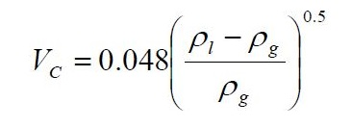

ρl = liquid density in kg/m3

ρg = vapour density in kg/m3

Vc = critical velocity in m/sec

The maximum gas velocity is K*Vc

K is a coefficient depending on the service, and the use or the absence of wire mesh.
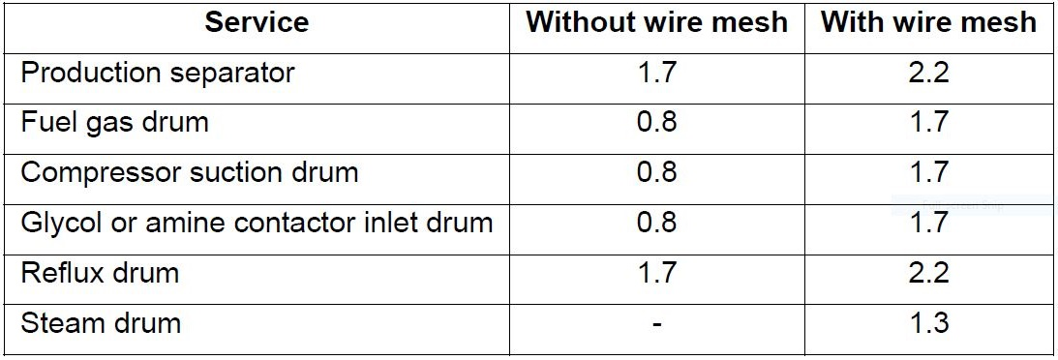
Recommended K values are given hereafter for different services.

• If a vane pack internal is used, the recommended K value is 3.3. This shall be confirmed with

the vendor.

• For horizontal vessels without vapor internal (wire mesh, vane pack,), the minimum

distance between the top of the vessel and the LSHH (level switch high high alarm) set point is

the largest of 300 mm or 0.2 internal diameter.

• Vessels handling paraffinic oil shall not be equipped with gas internals

• The above separation criteria do not apply to slug-catchers which are not vessels and are

indeed, a coarse Vapour-Liquid Separator.

A high efficiency inlet distributor can be considered to improve gas/liquid separation provided

that EPCC Contractor verify pressure drop through distributor and dimensions between inlet

distributor/mesh and inlet distributor/High Liquid (HLA-high liquid alarm point).

Hold-up and Residence Time of Liquids

• If the vessel is sized to receive a slug, that slug volume shall be taken between Normal Liquid

Level and High Liquid Level.

• The residence time corresponds to half of the holdup time, the Normal Liquid Level (NLL)

being set at 50% of the High and Low Liquid Level range. Exceptions shall be specified on data

sheet.

• The minimum liquid hold up time between Low Level Alarm and High Level Alarm are as

follows:
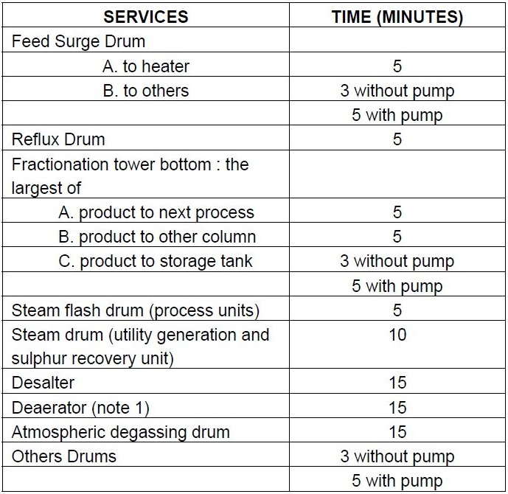

Note 1: Liquid hold up time is based on one deaerator shutdown associated with the normal

liquid flowrate.

Note 2: The above criteria apply generally to all vessels (horizontal or vertical) where the liquid

volume is one of the controlling cases for sizing.

• Two phase separators
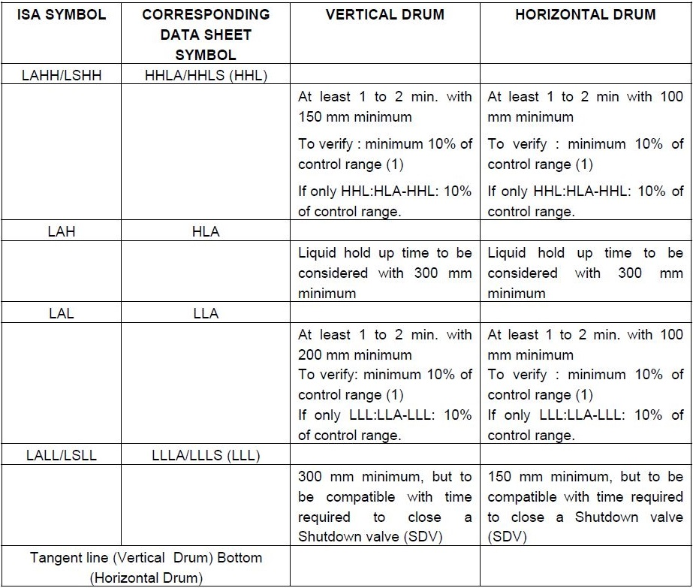

Control range is the vertical distance between the high level alarm (HLA) and the low level

alarm (LLA) with the normal control liquid level set point (NLL) set usually at 50% of the HHL-

LLL distance

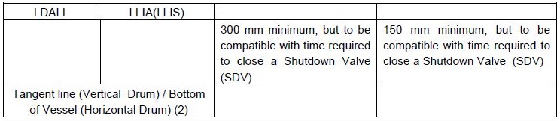
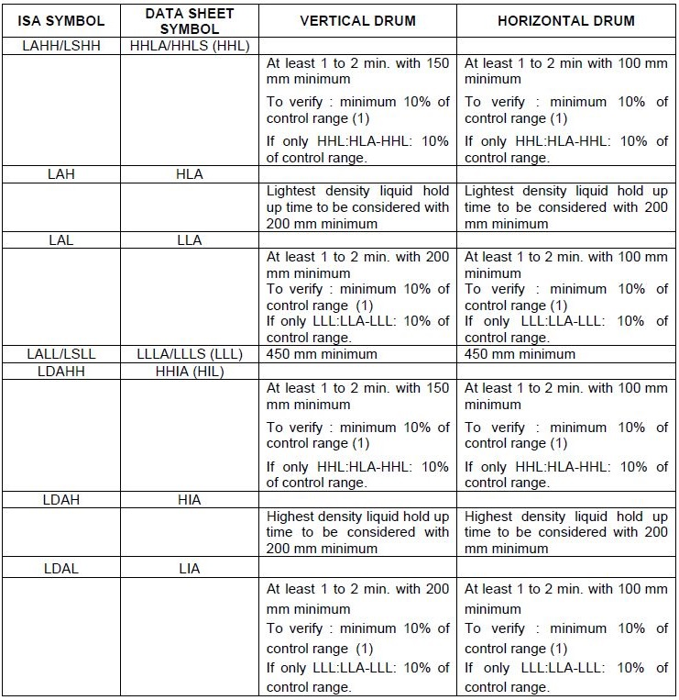
• Three phase separators
1) Control range is the vertical distance between the high level alarm (HLA) and the low level

alarm (LLA) with the normal control liquid level set point (NLL) set usually at 50% of the

HHL-LLL distance. This definition also applies to each discrete and separated liquid phase

for three phase separators.

2) Exception is made for vertical vessel with negligible liquid on clean service with manual or

on/off liquid outlet valve; in that case volume of the hemi-spherical head can be used : Low

Low Liquid Level (LLL) (or LLLA/LLLS) location to be still compatible with Shutdown Valve

(SDV) or control valve closing time.

3) When applicable, the hold up time below the low low liquid level (LLLA or ILLLA) has to be

compatible with the time required to close a Shutdown Valve (SDV) or to trip the pump(s)

taking suction from the vessel.

4) Stand pipe shall be installed on clean service when at least 3 level instruments are required

to be installed (independently from level instrument required for safety actions) e.g.: one level

transmitter with two level gauges.

5) Minimum size for stand pipe: 3”

6) Particular case: slug catcher: stand pipe shall be installed.

7) Gauge glasses and level controller shall cover the full range of level transmitters and alarm

switches.

8) Connections for level instruments generating a trip function shall be independent from control

function.

General notes for Three Phase Separator:

For three-phase separators, the retention time for the two liquid phases shall be considered.

1. The effective retention volume in a vessel is that portion of the vessel in which the two liquid
phases remain in contact with one another. As far as the two liquid phases’ separation is

concerned, once either substance leaves the primary liquid section, although it may remain
in the vessel in a separate compartment, it cannot be considered as a part of the retention

volume.

2. The highest density liquid retention volume is taken between the bottom for horizontal

vessels and bottom tangent line (for vertical vessels) and the normal interface liquid level

(INLL).

3. The lightest density liquid retention volume is taken between the INLL and the normal liquid

level (NLL)

9.4.4 Diameter

• As a general rule, inside diameter shall be specified on process data sheets (in mm)

• If the required inside diameter for a vessel is lower than 800 mm, a note shall be added

specifying that a piping element is acceptable.

• For vessels less than 1000 mm ID, flanged heads may be specified.

• Recommended L/D ratio for horizontal vessel:
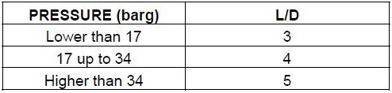

Manholes

Size of manholes

• For vessel diameter < 1000 mm

• Flanged vessel shall be considered if equipment contains internals

• Otherwise, size of manholes = 18”

• For vessel diameter ≥ 1000 mm

• Toxic service size of manholes = 24”

• Non-toxic service size of manholes = 20” (or up to 24” if internals need to be removable

through manhole.)

Location of manholes

• At the opposite side of the utility connection for horizontal vessel

Number of manholes

• Vessel

• For vessel length/height less than 6 m a single manhole shall be provided. For other vessel

(length/height > 6m), two manholes to be provided at least ; one manhole each 6 m for longer /

higher vessel. If vessel is equipped with internals (baffles etc.) , one manhole to be provided on

each compartment.

• Trayed column

• Manhole shall be provided at the top, below the bottom tray, at the feed tray, at any other tray

at which removable internals are located, and at intermediate points so that the maximum

spacing of manholes does not exceed 15 trays. Tray spacing with manholes in the internal shall

be at least 900 mm.

Handhole

Handhole size = 8”. Handhole to be installed on vessel with diameter less than 800 mm or on

vessel where severe fouling of internals is expected.

9.4.7 Vortex Breaker

Vortex breaker to be installed for the following services:

• Pump suction

• Outlet to thermosiphon or kettle reboilers

• Letdown to a low-pressure system

A vortex breaker in fouled/dirty service shall have a standoff of 150 mm from vessel wall

/bottom.

9.4.8 Drains, Vents and Overflow Connections

• Location

The drain of the vessel shall always be at the lowest point of a vessel. For vertical vessels they

shall be connected to the bottom outlet line at the low point. For horizontal vessels the drain

point shall be directly on the bottom of the drum at the lowest point ensured through vessel

slope (1:100).

• Vent and drain diameter shall be defined as follows:
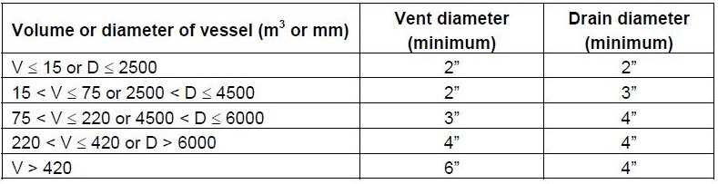

Drain number:

For horizontal drums having a length greater than 6 m TL to TL, additional drain connections

shall be considered. An additional drain is also required on each compartment of a vessel. On

toxic service, an open drain connection (washing out) is to be provided with a blind flange. Size

of open drain connection shall be of the same diameter as drain connection.

• Overflow:

For vessels equipped with overflow connections, the overflow nozzle line size shall be at least

one size greater than the inlet/outlet nozzle, whichever is greater.

Utilities Connections (steam out, purging)

Utility connections (2” minimum) shall be sized as follows:

• Drums and heat exchangers (when applicable): 2”

• For large vertical drums, two 2” connections shall be provided for diameter >= 4.5m

• For horizontal vessel with a length >= 6m and operating in toxic service, two 2” connections

shall be provided.

• If vessel is equipped with internals (baffle), one 2” connection shall be provided on each

compartment

• Columns: as follows with regard to column diameter, D (m)

1. D ≤ 4 : 2”

2. 4 < D ≤ 5.5 : 3”

3. D > 5.5 : 4”

Utility connections, when specifically required, are not necessarily located on vessels

(advantage may be taken to use connection on drain to steam out / nitrogen purge the vessel)

but should remain operational even when the vessel is isolated.

No hard piping connection for steam out / nitrogen purge shall be provided.

9.4.10 Elevation of Equipment

As a general rule for a vessel containing a liquid at its boiling point, a minimum elevation of

5000 mm shall be specified when supplying a centrifugal pump. The elevation shall be updated

when NPSH requirements are defined with rotating equipment specialist.

If there is no process requirement regarding the elevation, a note on PID shall be indicated

“Minimum for piping”.

9.4.11 Nozzle Sizing

The following criteria for vessel and column nozzles design shall be used:

Inlet line:

• ρ∗v2 max = 1500 if no inlet device is foreseen

• ρ*v2 max = 3000 if half pipe or baffle inlet device is foreseen

• ρ*v2 max = 6000 if Schoepentoeter or other vane pack inlet device is foreseen

Outlet line:

The same criteria which are used for line sizing (see below paragraph 10.3) shall be used.

Size of Inlet, Gas Outlet and Liquid Outlet Nozzles

- Inlet

a) Size based on normal volumetric flow + 10% ( liquid + vapor flow )
b) Limit inlet velocity to 7-13 m/s
c) Round nozzle diameter up or down to nearest standard size

- Gas outlet
a) Size on normal flow
b) Velocity limit 15-30 m/s

- Liquid outlet
a) Normal flow + 10%
b) Velocity limit 1-3 m/s HC
2-4 m/s water
c) Min. diameter = 2″ (avoid plugging

Towers Recommended Minimum Tray Spacing and Oversizing

Factor in Tray Towers

3-8-1) Minimum Tray Spacing

TRAY DIAMETER TRAY SPACING

1300 mm ID or less 450 mm
1300 to 3000 mm ID 550 mm
3000 mm ID and larger 600 mm

* ABOVE FIGURES SHALL BE USED JUST AS A FIRST ESTIMATION. FOR PRECISE

FIGURES CONFIRMATION OF VENDOR IS NEEDED.

Tray spacing shall be greater than the minimum where required for access to

column internals, man way location, vapor disengaging, nozzle interference or

other reasons.

Minimum distance from top tray to top tangent line shall be 750mm or as

required to accommodate man way, internals or nozzles. Minimum hole diameter for perforated

trays shall be 1/2 inch. Minimum trayed column size shall be 750mm internal diameter.

3-8-2) Design Oversizing Factor:

- Flooding factor for fractionating trays: 78% maximum

- Flooding factor for pumparound trays: 83% maximum

- Flooding factor for steam stripping trays and side cuts strippers regardless of Stripping

medium: 75% maximum
- Down comer back-up: 50% maximum of the tray spacing.

- Type of internals: structured packing may be applied, provided that they are compatible with

coke formation tendency of the service. Random packing can be used in columns less than 750

mm in diameter

Heat Exchangers and Air Coolers

9.5.1 Oversizing

• Shell and tube heat exchangers and air coolers: 10% on surface based on design duty.

9.5.2 Fouling Factors

The following gives some indicative fouling factors for process and utility fluids which can be

reviewed case by case. They can be applied to items such as electric motor cooling and used to

check vendor’s data.

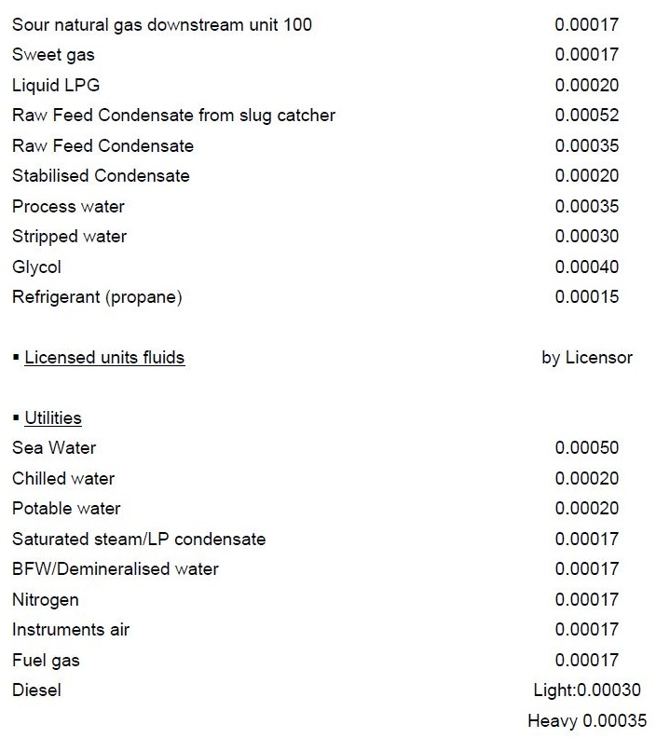
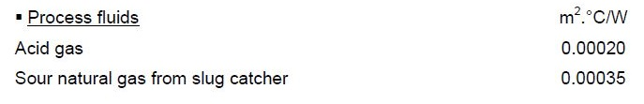
Fouling Factors for Plate Exchangers

For Plate Frame Heat Exchangers, a general fouling factor of 0.00005 m2 °C/W shall be taken

for all fluids (or Process Licensor recommendation).

For Plate Fin Heat Exchangers, no fouling factor shall be applied but an extra surface of 15% to

be added on calculated area.

Temperature Approach for Heat Exchangers

The temperature approach shall be optimised for heat exchangers but it shall not be smaller

than:

• 5°C for TEMA type heat exchangers (shell and tube)

• 10°C for air coolers

• For plate type heat exchangers (PHE) and printed circuit heat exchangers (PCHE) the vendor

shall confirm and specify the requirement on a case by case basis.

• 3°C for kettle type

9.5.5 Specific Requirements for Heat Exchangers

TEMA R shall be generally used for all shell and tubes and air fin type heat exchangers. Fixed

tube sheet exchangers are acceptable for non fouling service on the shell side. In this case

Licensor or EPCC Contractor shall define all exceptional operating conditions (start-up,

shutdown) to check the necessity to provide an expansion bellow on the shell.

9.5.6 Air Cooler Type

The air cooler shall be of an induced type when the air cooler is installed on pipe rack. Forced

draft type shall be considered:

• If air cooler is installed at grade

• If inlet process temperature is above 175°C or calculated air outlet temperature is over 93°C

• Several sections stacked (in the case of multiple service exchangers).

When control of process side temperature is required then the control method shall be defined

on a case-by-case basis.

In all cases design margins for air cooler fans shall be specified.

9.5.7 Allowable Pressure Drop- Shell and Tubes

Typical allowable pressure drops are given below:

9.5.7.1 Liquids

Total Pressure Drop (bar)
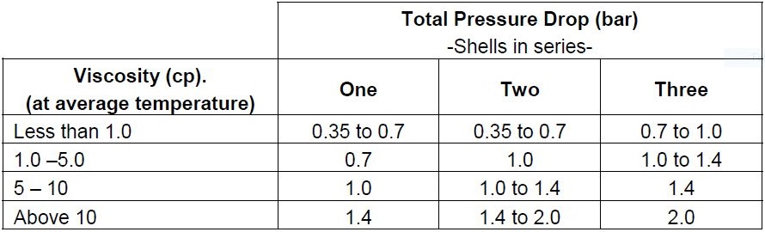
-Shells in series

Notes:
1) Under the following circumstances, ΔP’s approaching the higher recommended values shall

be employed: when the ΔT is small (28°C or less) or when the temperature range is large,

(above111°C).

2) Calculated tube side pressure drop values are subject to greater variation than shell side

values, because of the nature of tube bundle construction.

3) It must be realised that little can be gained by specifying increased pressure drop for one fluid

in an exchanger when the other fluid has a significantly lower film coefficient.

4) For gravity flow, the pressure drop is usually limited from 0.07 to 0.14 bar.

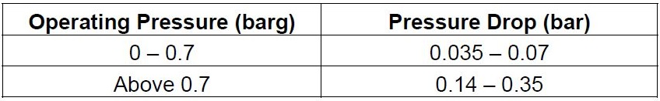
Gases

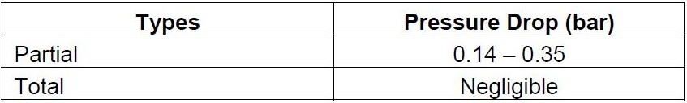
Condensers

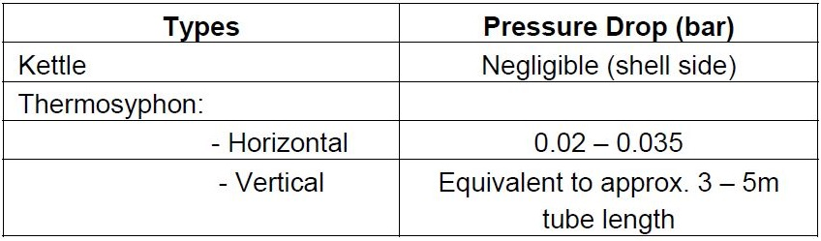
Reboilers

Allowable Pressure Drop- Air Fin Exchangers

Suggested pressure drop for various services are given below. However, care should be taken

to ensure that the selected pressure drop results in the most economic overall installation.

The allowable pressure drop for product cooling and non-critical services shall not control the

size of the exchanger, as this may result in an uneconomic design which could be avoided by

reconsidering the hydraulics of the process circuit. Special consideration is required for wide

temperature range cooling of viscous liquids, low pressure gases or condensation of vapours at

very low pressures. In these services, pressure drop is a critical requirement, which greatly

influences the size of the heat transfer surface.
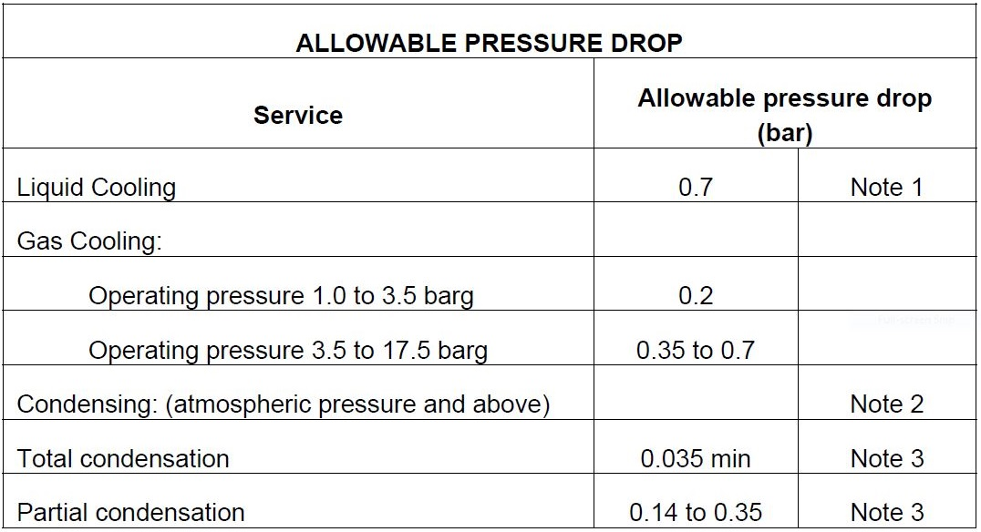

Notes:

1) Not valid for viscous fluids.

2) For vacuum service the selection of an allowable pressure drop should be from the results of

an economic study. Pressure drops are usually in the range of 3-5 mmHg.

3) For multi-pass air coolers high pressure drops assure proper flow distribution. The higher

pressure drop shall also assure proper distribution at lower than design throughput.

Columns and Trays

Towers shall be sized based on flows that are 110% of the respective material balance figures

to allow for any vagaries in the equations of state, operational control around the material

balance duty point and effects of fouling etc. Tray loadings used for sizing should be the vapour

to the respective tray and the liquid leaving it.

PIPING

10.1 General Design and Hydraulic

The guidelines and process sizing criteria detailed below shall be implemented in conjunction

with the latest COMPANY approved Piping Specification, e.g. use of nonstandard pipe sizes.

10.1.1 Line velocity and friction loss for liquid line and gas line

Line size of each line shall be firstly selected based on the mass flow rate and in accordance

with the velocity range criteria and then be checked in accordance with the friction loss range

criteria as given in paragraph 10.3 Line Sizing Criteria.

10.1.2 Minimum piping sizes

Except for instrument piping, connections to equipment or piping in which minimum flow velocity

requirements govern the minimum size shall be:

• 3/4” for pipe when located above ground

• 2” for process line on pipe rack

• 2” for utility lines on pipe rack

• 2” for pipe-on-pipe sleeper

• 2” for underground steel pipe

• 2” for underground nonmetallic piping

Pump suction calculations and NPSHA

For the NPSHA calculation method refer to Section 9.1.4. For the value of NPSHA specified on

the process data sheet, the referenced elevation shall be indicated (e.g. grade, pump,

centerline, etc.) With pumps in parallel and/or spare pumps, consideration shall be given to

ensure that the common suction line leading to the individual pump suctions are sized

adequately to cater for the additional flow imposed whether it is for a short or extended duration.

When sizing suction lines for reciprocating pumps, acceleration head shall be considered.

Pump suction line shall not be smaller than suction nozzle and shall be at least the same

diameter as the line. If ball valves are appropriate for the service, then ‘full bore’ (FB) ball valves

shall be used for all valves on the suction and marked on the P&ID.

Pump suction valve shall be in the same diameter as the line.

Control valve
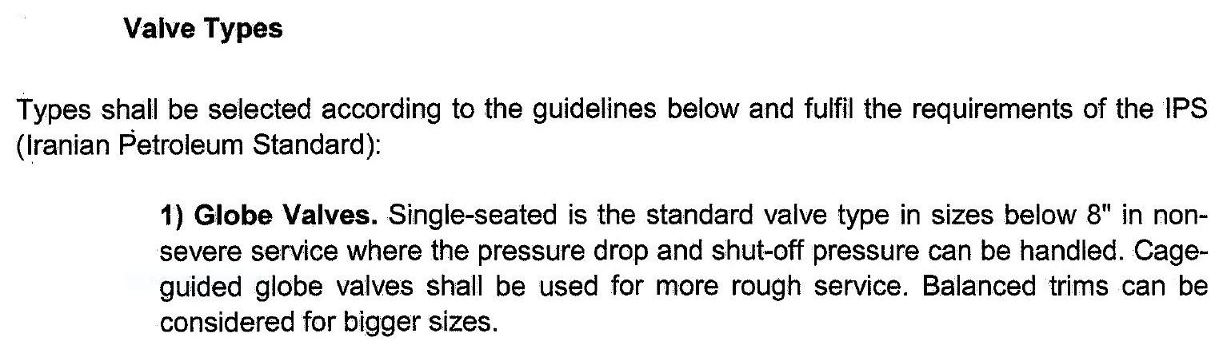

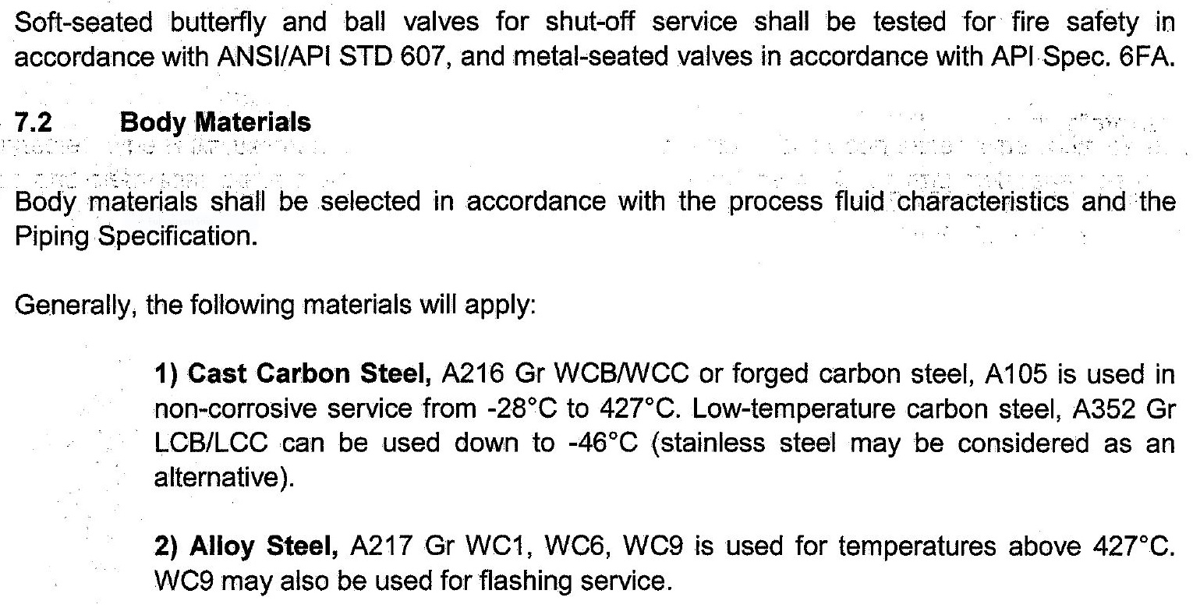
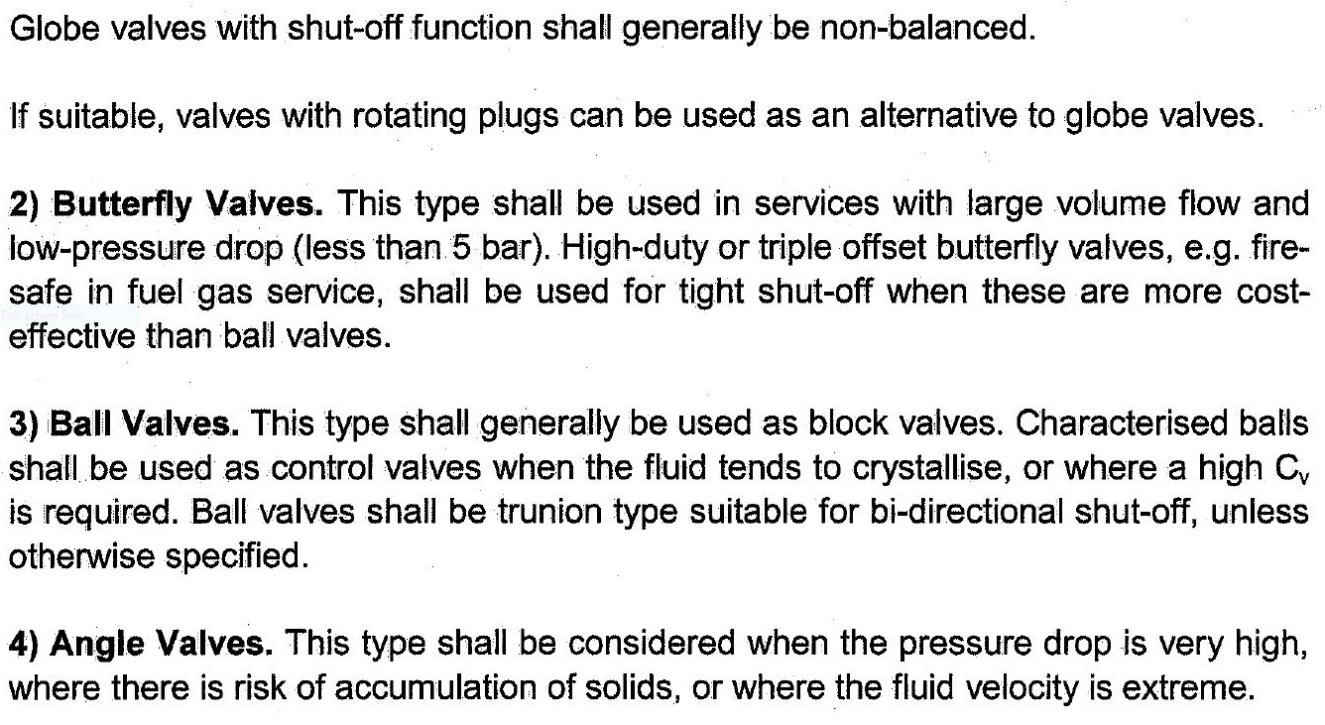
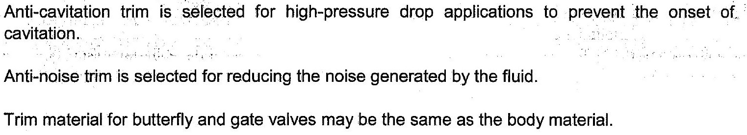
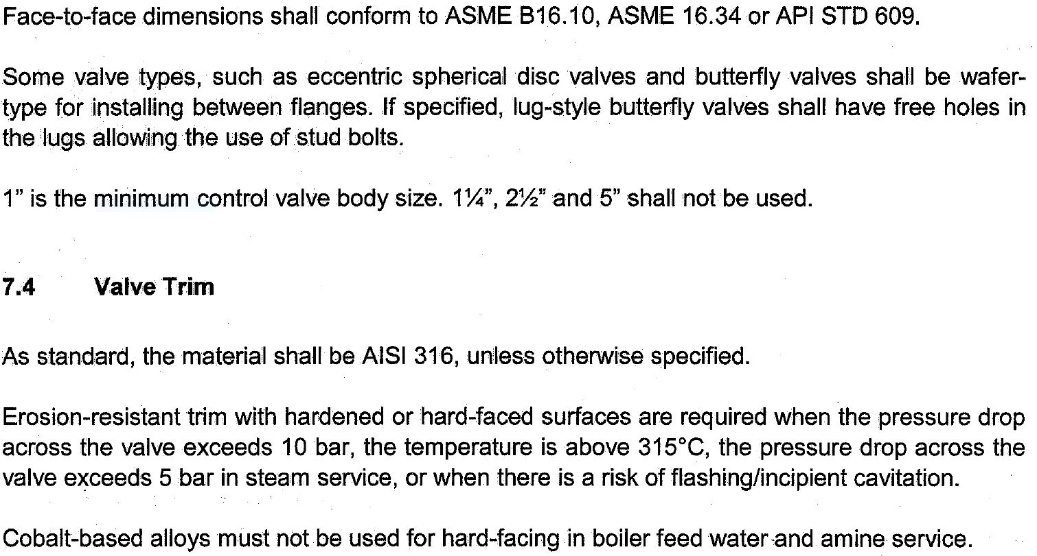
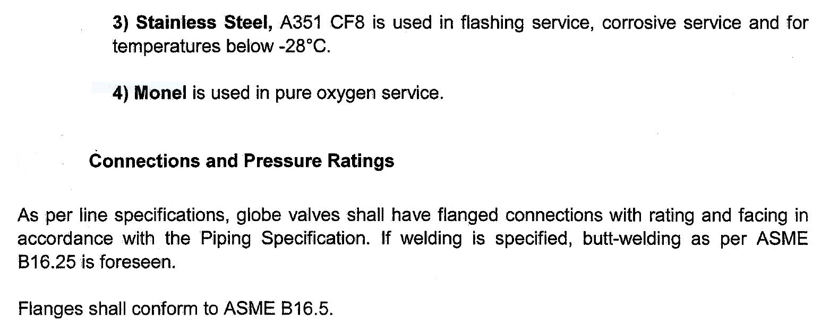
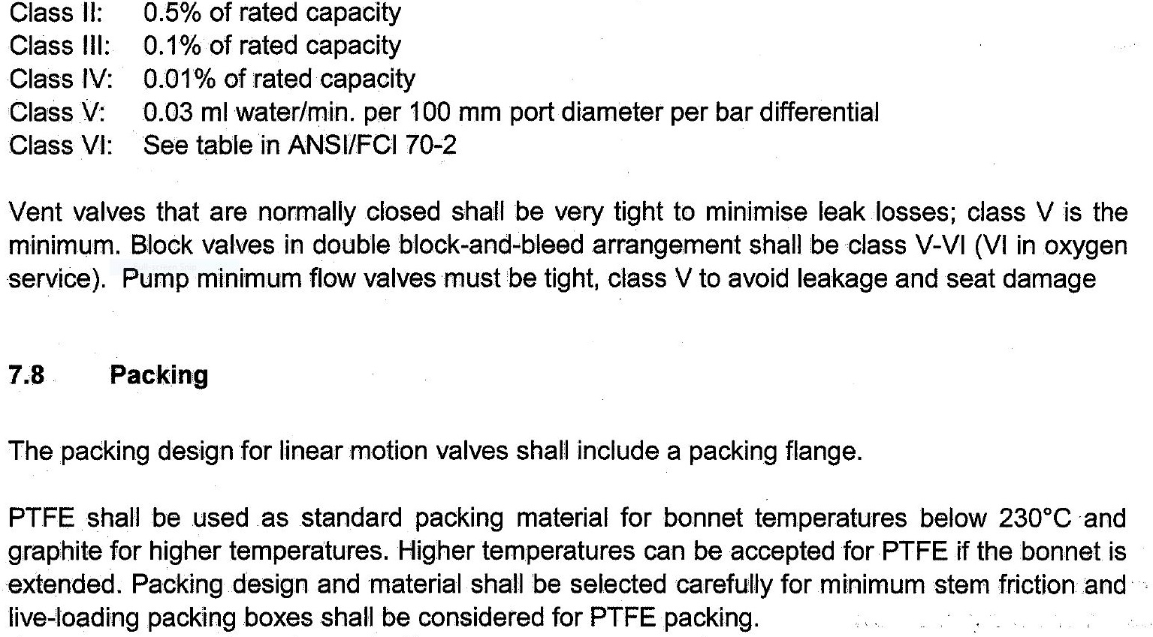
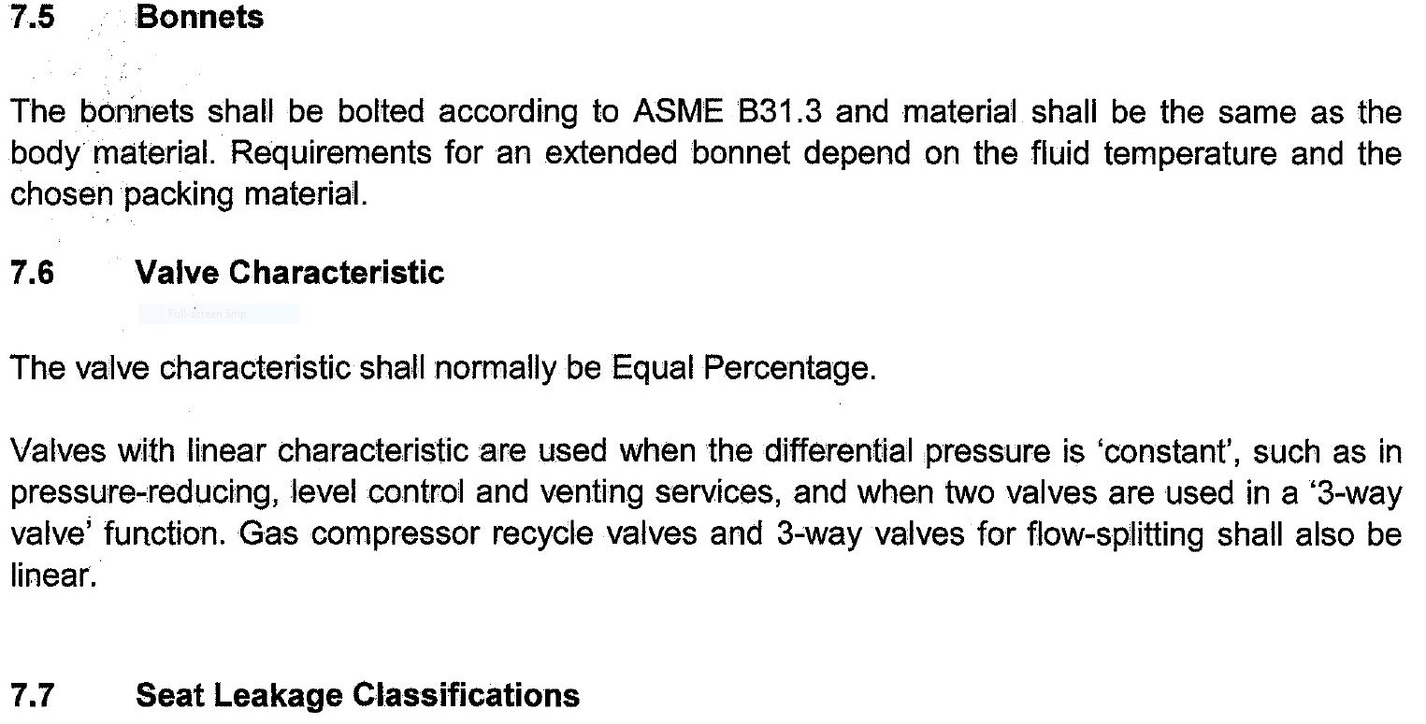
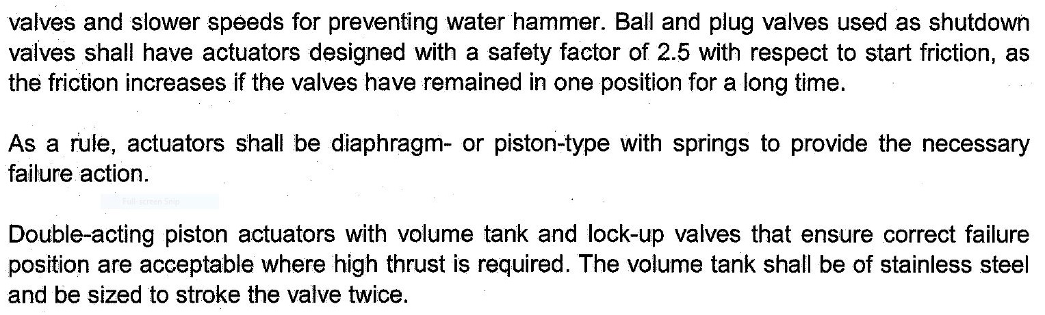
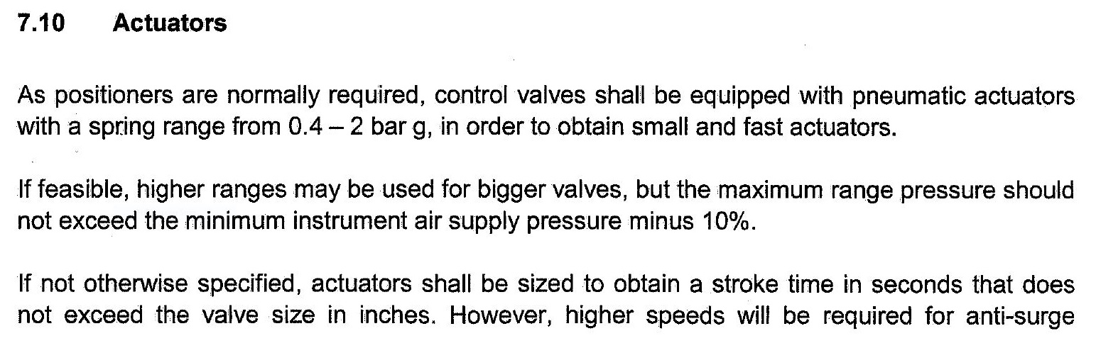
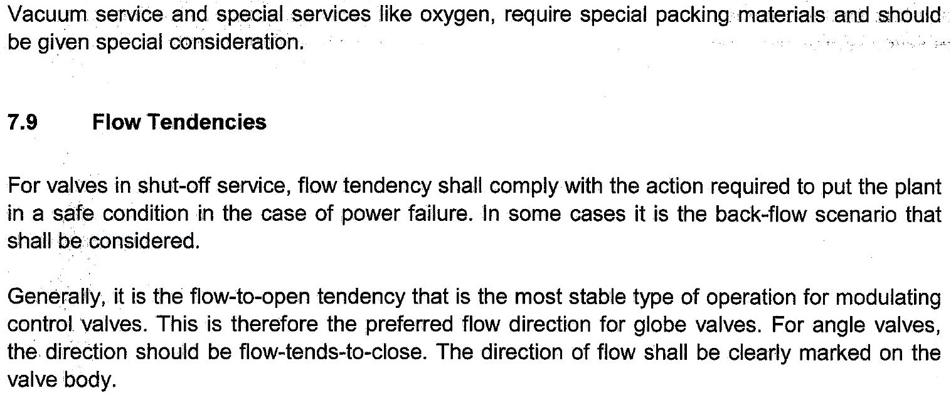

• Control Valve pressure drops are defined in section 9.1.8.

• In case of mal-operation, the gas blow-by calculation shall consider the flow rate through the

control valve when fully open and also through its by-pass when fully open, where installed. If

the calculated flowrate oversizes the flare, the manual by-pass could be removed or a

mechanical interlock between the associated manual block valves could be installed.

Piping, Vents and Drains

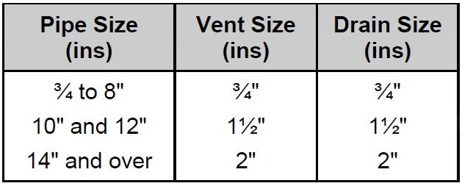

Generally, the range of control valve opening should be between 10% for minimum flow rate

and 80% for maximum (design) flow rate. At the normal flow rate valve opening percent should

be 60%-70%.

- Control valve pressure Drop (ΔPcv) which is utilized to size the control valve should be

calculated / specified for routes without and/or with compressor/pump separately as follows:

i) For the routes without comp. /pump, ΔPcv should be calculated according to the following

relation: ΔPcv = (Ps – Pe) – ΔPsh – F

Where Ps and Pe are operating pressure of equipment in the start and end of the route, ΔPsh is

the static head difference between start and end of the route and F is the total frictional press.

Drop of the route excluding the control valve which to be calculated at design flow rate through

control valve.

ii) For the routes with compressor/pump, ΔPcv should be considered 16 psi or 10-15% of the

total pressure drop of the route including pressure drop of control valve, whichever is greater, at

the maximum design flow rate. In both cases ΔPcv should be calculated using the mentioned

equation at the normal and minimum flow rates through control valve and control valve opening

to be checked to make sure that it is not below the lower opening limit.

- Pressure drop at maximum design flow rate (minimum pressure drop of control valve) shall be

calculated at the condition of the minimum suction liquid level and maximum discharge liquid

level. Minimum liquid level shall be based on low liquid level (LLL).

- Pressure drop at minimum flow rate (maximum pressure drop of control valve) shall be

calculated at the maximum suction liquid level.
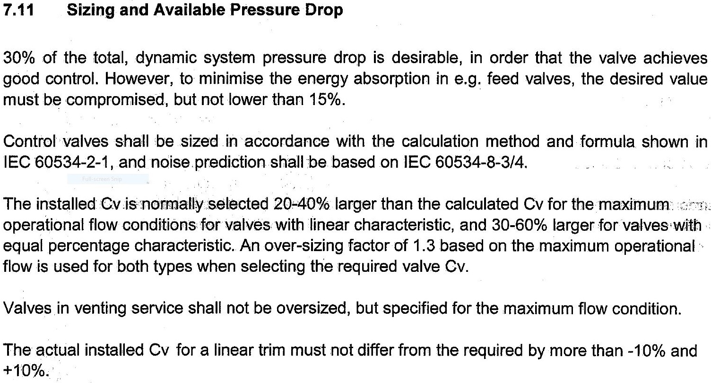

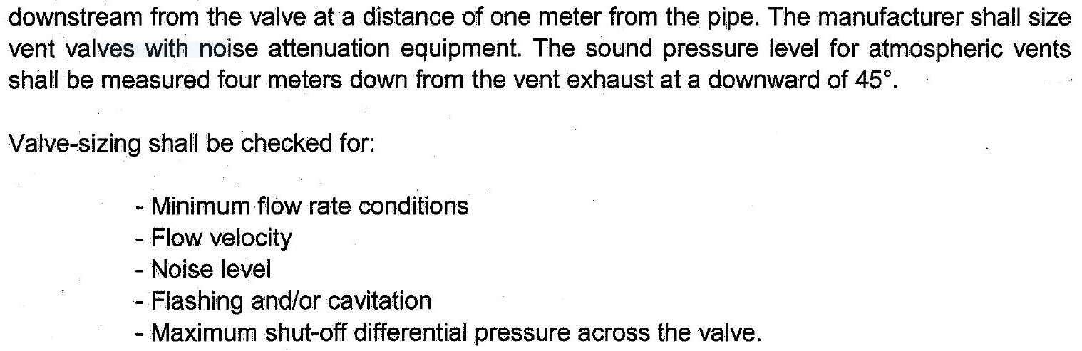
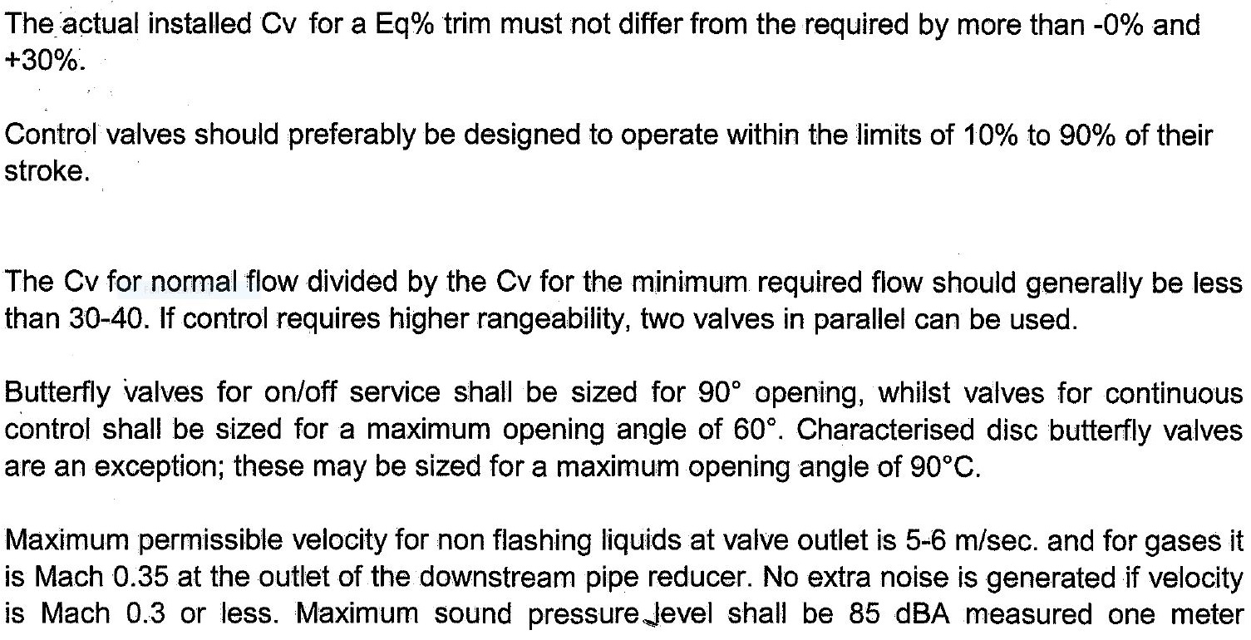

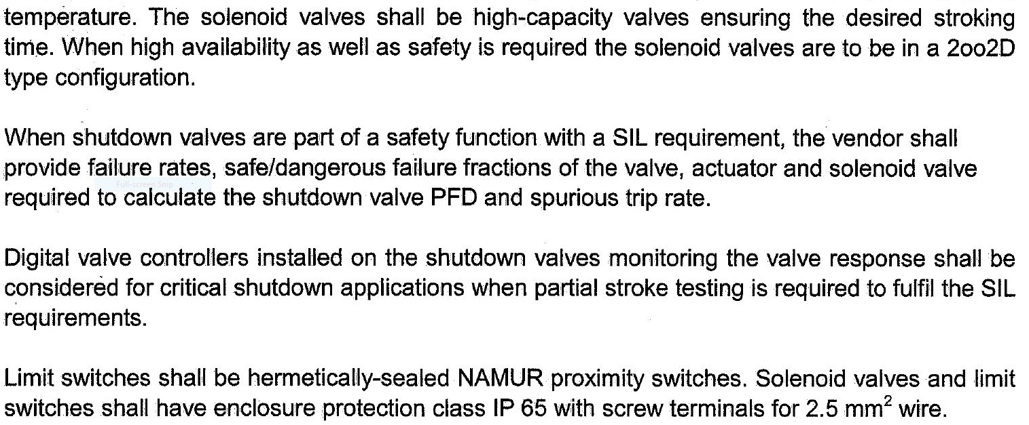
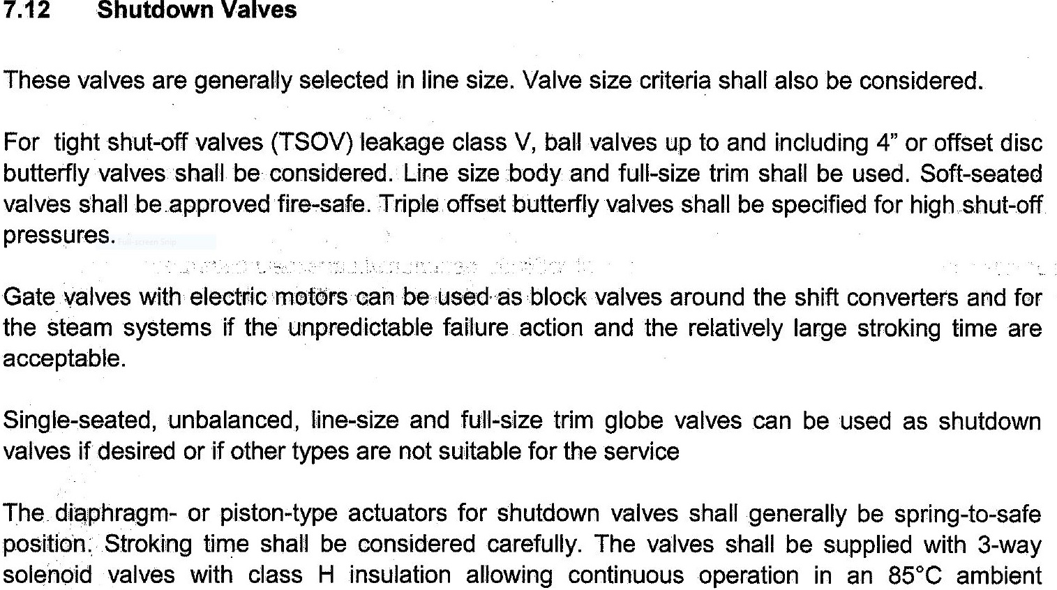

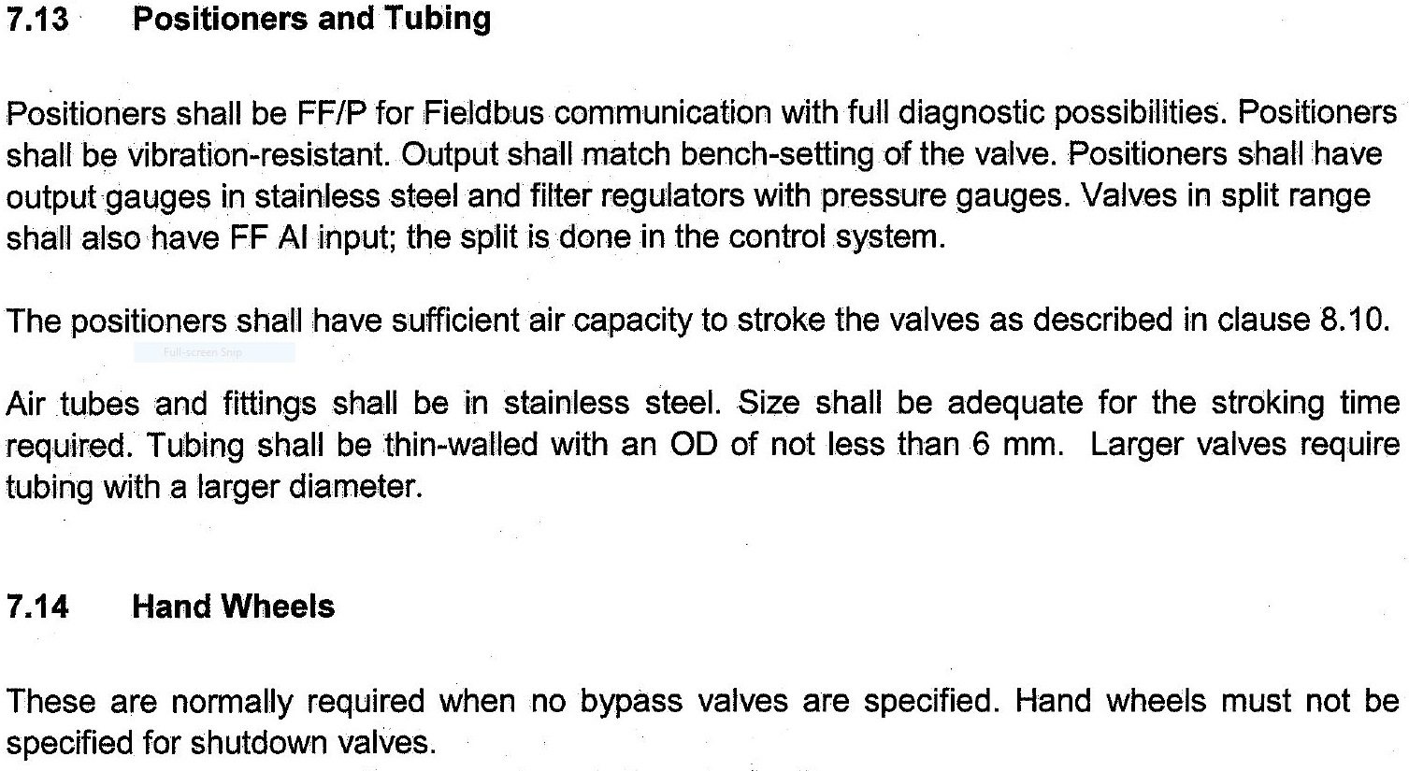

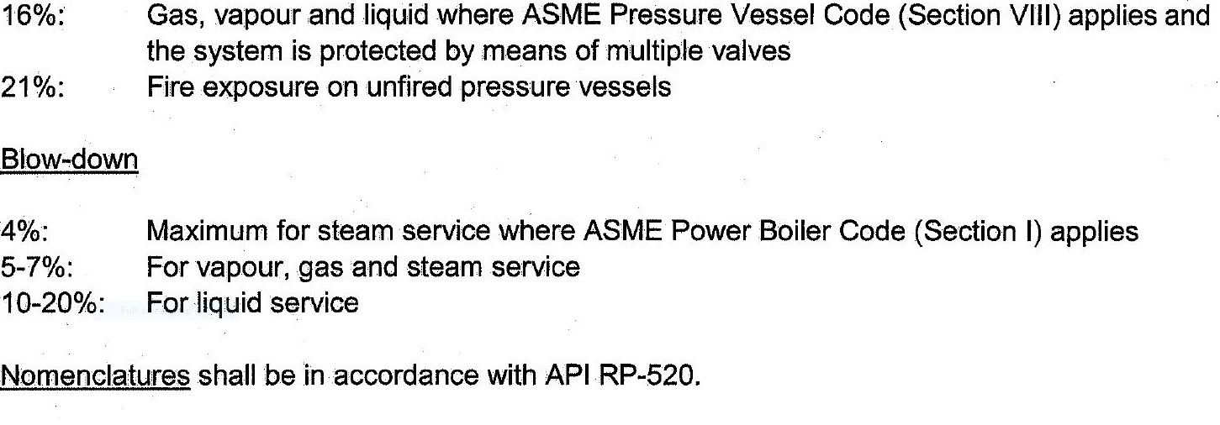
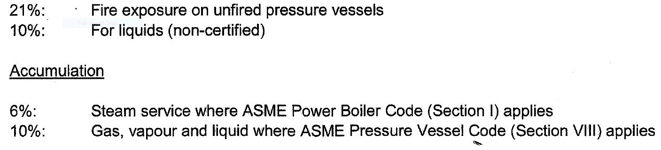
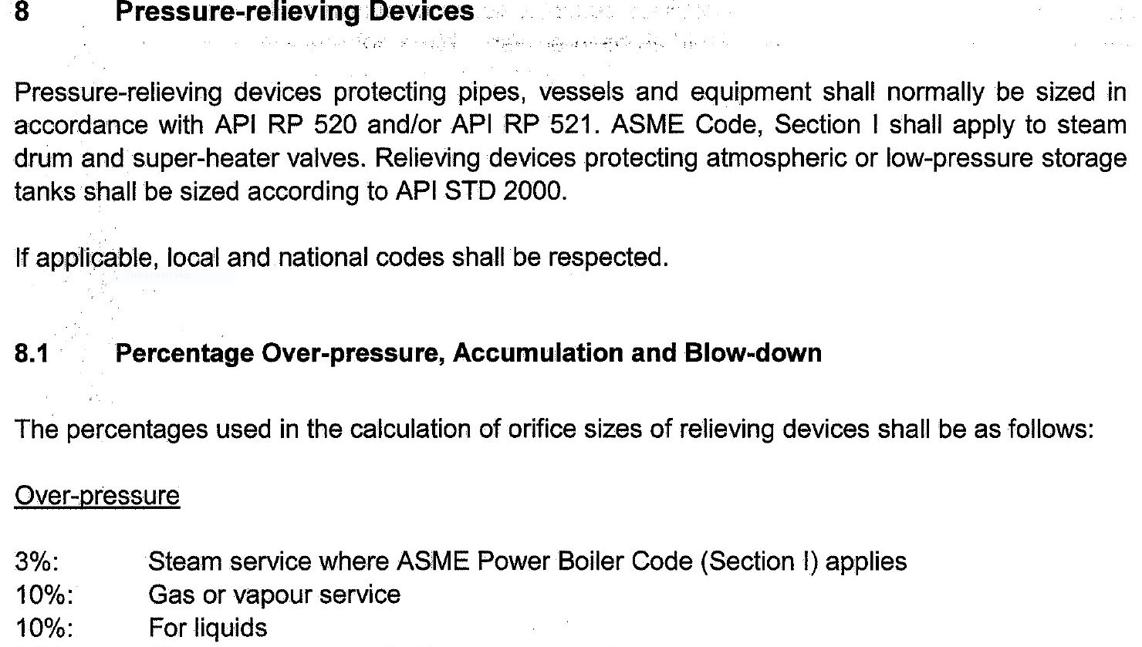
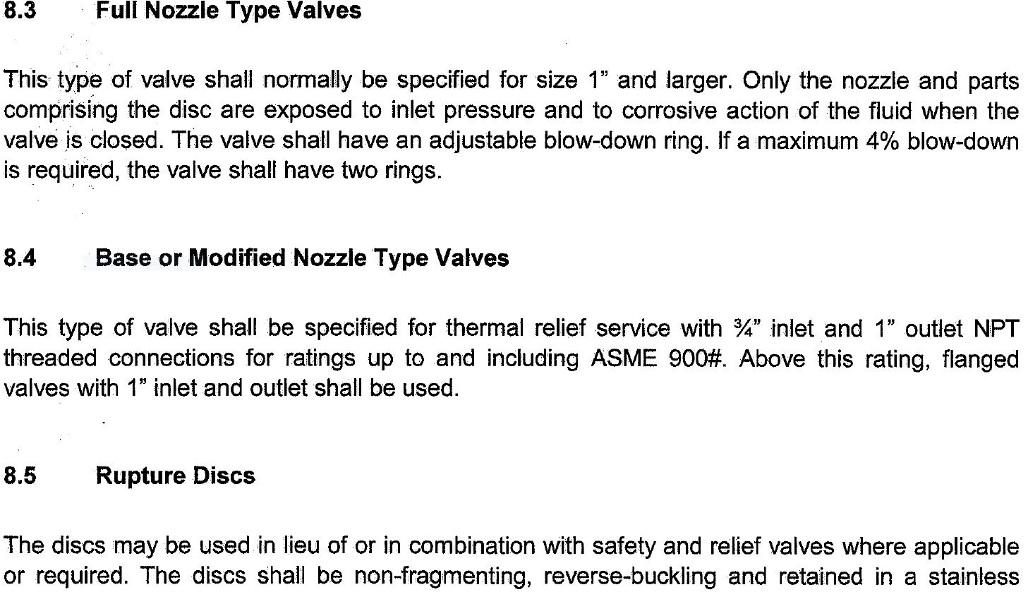
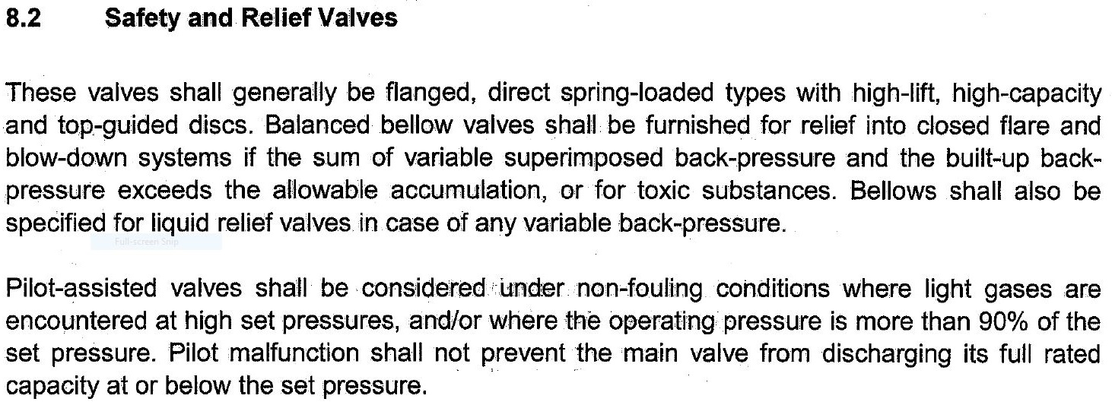
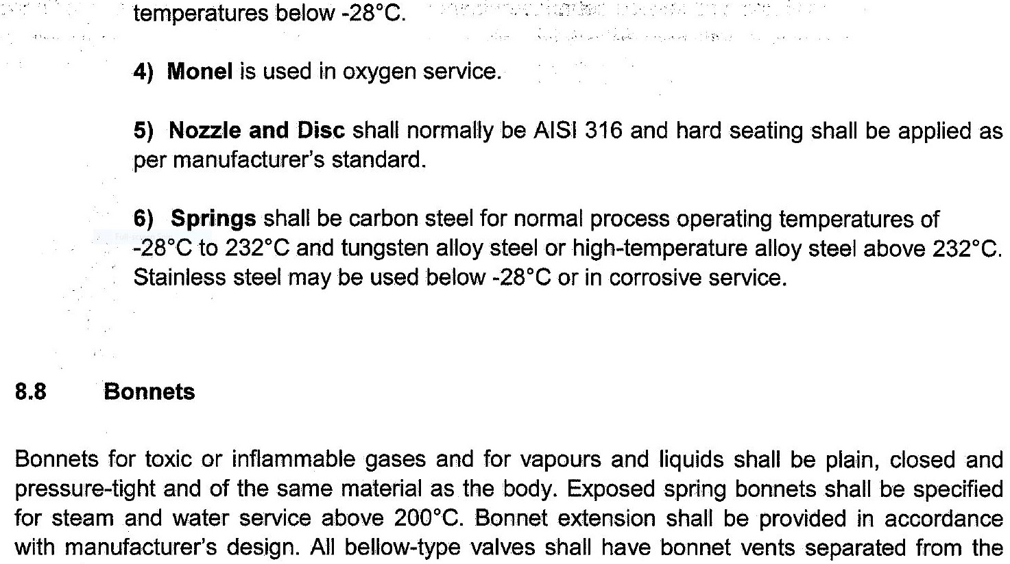
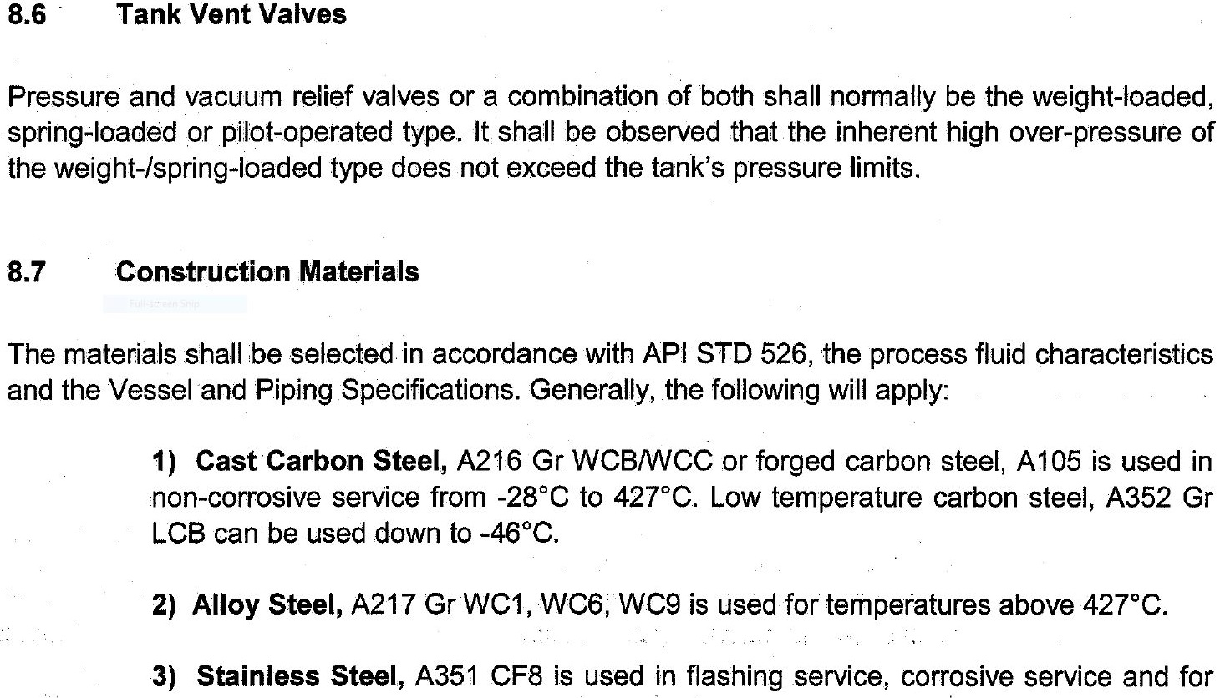
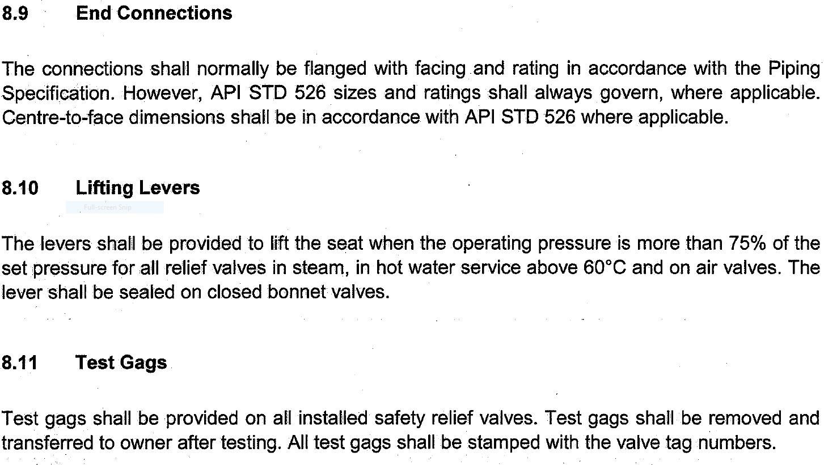

Air Coolers

On air coolers one 2" vent shall be located at the highest point in the inlet header and one 2"

drain at the lowest point in the outlet header. The exact location of these vents and drains is

dependent on the actual cooler design. Connections shall be valved and blanked off.

Pump Casings

For non-operating vents and drains, provide ¾" valved and blanked off vents and drain (not

shown on P&ID). EPCC Contractor shall provide drain connections for pump casings, with the

drain piped to the edge of the baseplate by the pump vendor.

For non-volatile services, casing vents and pump drains shall be valved and piped to pump

baseplate or into a sewer

For volatile services, casing vents and drains shall be piped to relief header and sewers via a

sample cooler.

Additional Notes

• Valved / blanked off vent and drain connection shall be furnished on all equipment that is not

self-venting or self-draining. Connection shall be located on equipment, if practical, but may be

located on connected piping when there are no valves or blocks between the vent or drain

connections and the equipment.

• Hydrostatic vents and drains shall be provided by EPCC Contractor, and shall not be shown

on P&ID.

• For total condensing service in shell and tube exchangers, EPCC Contractor to provide a

flanged 2" vent nozzle on shell at opposite end to shell inlet.

• At relief valves, a ¾" valved blanked off bleed shall be shown between safety valve and any

block valve on inlet and discharge side.

• Vents from vessels that may chill and freeze during depressuring shall have double block

valves separated by at least 900mm.

10.2 Insulation and Heat Tracing

Thermal insulation for hot or cold services may be required for:

• Heat or cold conservation of equipment and piping,

• Personnel protection of equipment for operating temperatures above 70°C. A physical barrier

with warning signs attached to hot surface is preferred to thermal insulation if it is not required

for process reasons,

• To avoid external water condensation or ice,

• Steam or electrical heat tracing.
In all cases, insulation shall be minimised in order to limit CUI (Corrosion Under Insulation).

10.3 Line Sizing Criteria

This paragraph shall not be applied to the flare lines. The pressure drop and velocity guidelines

provided may be used for the preliminary sizing of lines. However, the final sizing shall also take

into account other factors, such as pump NPSH requirements, pressure drops available, and

specific process requirements.
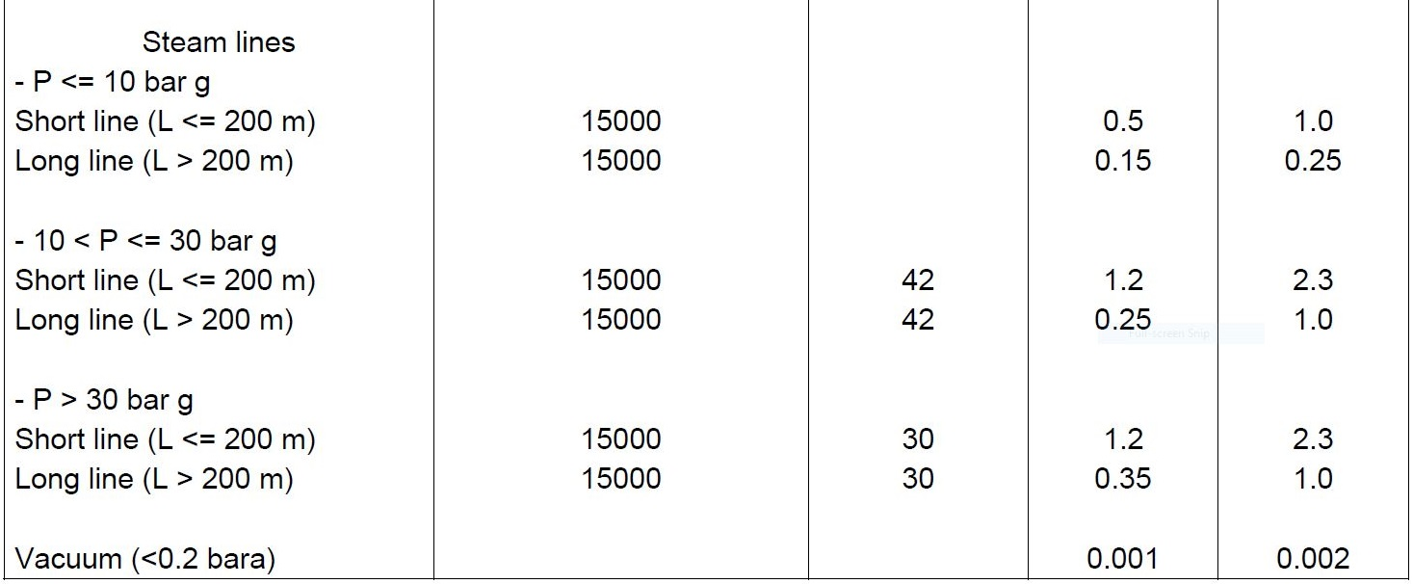
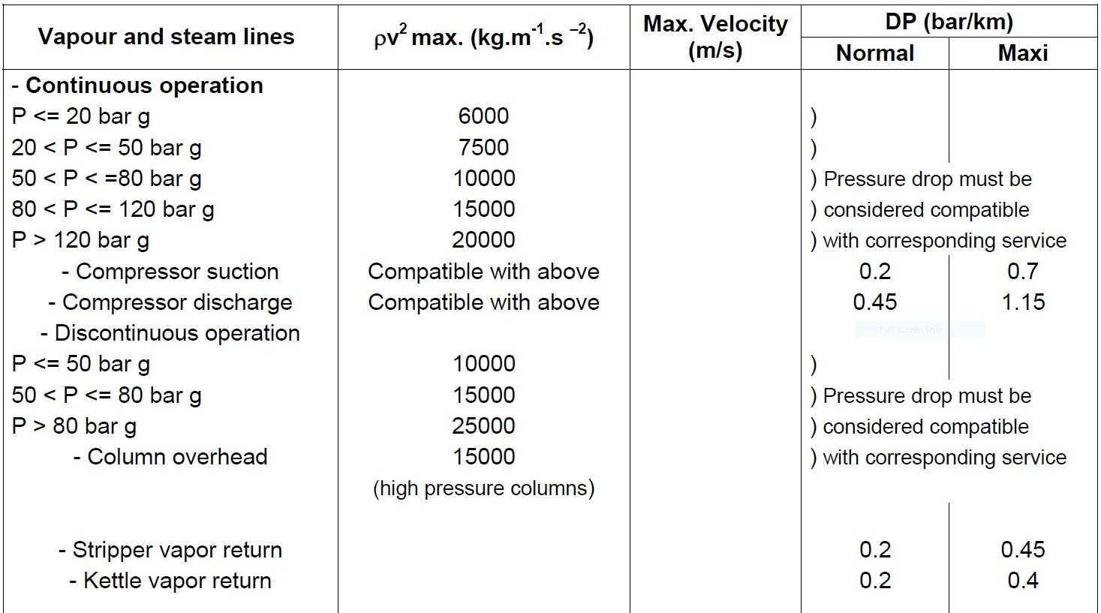
Where specific maximum velocity limits are given these shall not be exceeded.

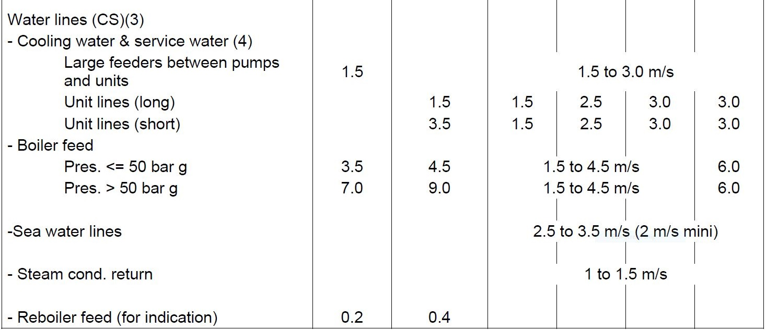
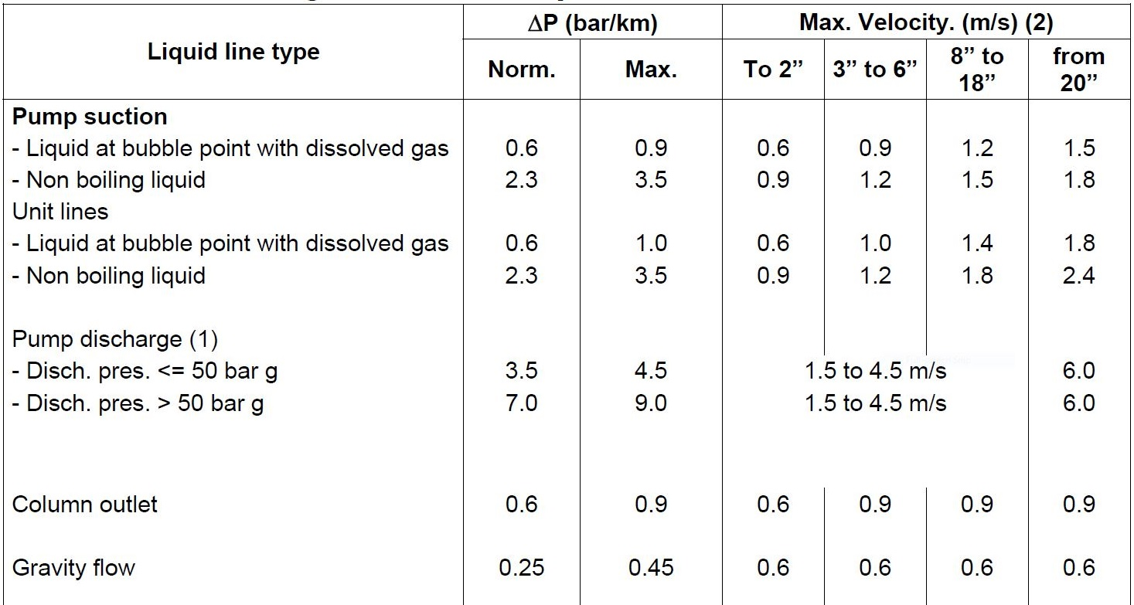

Notes:

1) 3.0 m/s maximum (2 m/s average) at storage tank inlet or in loading.

2) Vendor and/or Licensor requirements could supersede maximum velocity values upon

COMPANY approval.

3) Special considerations can be applied for copper-nickel or glass reinforced plastic piping

uponCOMPANY approval.

4) Velocities below 1 m/s shall not be used for cooling water service to avoid solids deposition.

5) For amine service velocity should not exceed 1 m/s to avoid corrosion/erosion.

6) For lines containing mixtures of hydrocarbon and water, velocity should be limited to 1 m/s to

avoid generation of static.

7) 60 to 98% sulphuric acid lines velocity should not exceed 1.2 m/s to avoid corrosion.
Line sizing criteria for two phase flow

For preliminary mixed phase fluid line size calculations, the average density method shall be

used while considering the following criteria:
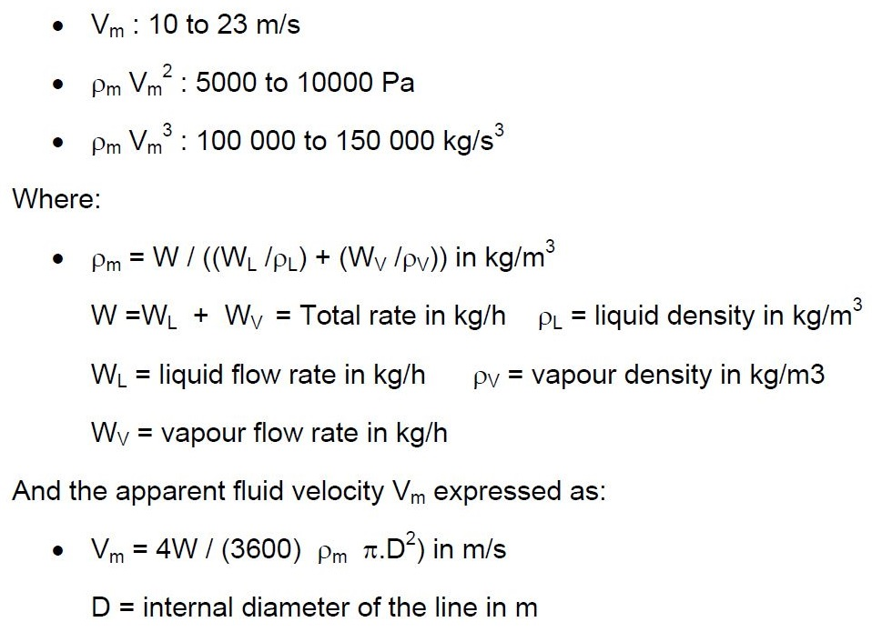

In general, continuous flow patterns should be ensured such as:

• Stratified, annular, bubble, wavy flow patterns, etc. For horizontal lines or slightly sloped.

• Annular or bubble flow, etc. For the vertical lines

• For horizontal lines in slug and plug flow regimes and for vertical line in slug flow regimes

reinforced anchoring shall be specified.

Line sizing criteria for offsite line

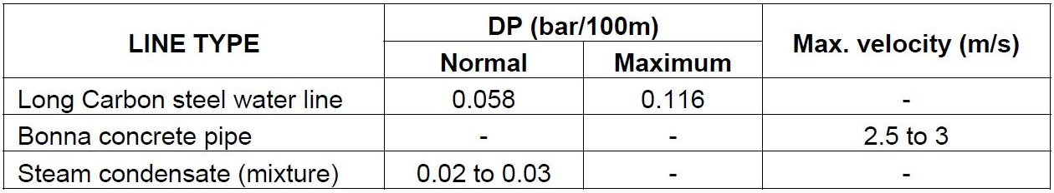
The following criteria are typical and shall have to be supported by economic appraisal

Corrosion/Erosion Criteria

Corrosion

For corrosion resistant material (SS, Special alloys…), no limitation of flowing velocity up to 100

m/s and no requirement for corrosion allowance.

For non corrosion resistant material, in corrosive fluid service, a corrosion allowance for the design service life and corrosion inhibitor injection are required. The flowing velocity is limited by the inhibitor film integrity. The process designer shall consult the project material and corrosion specialist who shall be responsible for implementing COMPANY approved guidelines.

Erosion

For Duplex, SS or alloy material, the flowing velocity shall be limited to :

• 100 m/s in single phase vapour lines and multiphase lines in stratified flow regimes (65 m/s for

13 % Cr material),
• 20 m/s in single phase liquid lines and multiphase lines in annular, bubble or hydrodynamic
slug flow regime,

• 70 m/s in multiphase lines in mist flow regimes

For Carbon Steel material:

• In case of continuous injection of corrosion inhibitor, the inhibitor film ensures a lubricating

effect which drifts the erosion velocity limit. The corrosion inhibitor erosion velocity limit shall be

calculated taking into account the inhibitor film wall shear stress.

• In case of uninhibited fluid, the API RP 14 E recommendation shall apply : the flowing velocity

must be maintained below the erosional limit:

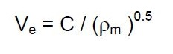

With: Ve erosional velocity in m/s

ρm gas / liquid mixture density at flowing conditions in kg/m3

The empirical constant ‘C’ is equal to 183 to 207. C values of up to 245 can be considered on

peak flow rates only in case of absence of abrasive (solid) particles such as sand. When solid

and/or corrosive contaminants are present C values shall not be higher than 122 in SI units.

Two phase (liquid / gas) Lines
Each mixed phase flow line shall be handled as special cases, taking the
following considerations into account:
a) Erosional velocity
Two phase flow should be sized primarily on the basis of flow velocity.
Flow velocity should be kept at least below fluid erosional velocity. The
velocity above which erosion may occur can be determined by the
following empirical equation:

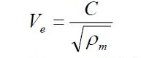

V = fluid erosional velocity, ft/s
C = empirical constant
= 125 for non-continuous services
= 100 for continuous services
m ρ = gas / liquid mixture density at operating pressure and
temperature, lb/ft3

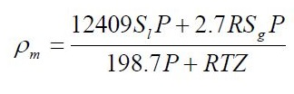

P = Operating pressure, psia
l S = Liquid specific gravity (water=1, use average gravity for hydrocarbon
water mixture) at standard condition
R = Gas/liquid ratio, ft3/barrel at standard condition
T = Operating temperature, R
S = gas specific gravity (air=1) at standard conditions
Z = gas compressibility factor

The minimum cross sectional area required to avoid fluid erosion may be
determined from the following equation

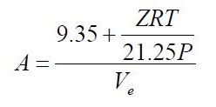

b) Minimum Velocity

Stable flow Pattern shall be established for two phase flow lines. This method is to be used to

determine the maximum line size permissible, before unstable flow occurs. If possible, the

minimum velocity at minimum flow (turn-down) should be about 10 ft/s to minimize slugging

of separation equipment.

Pipeline Hydraulics

Pipeline hydraulics is to be calculated based on the relevant NCE work

instructions with the following general guidelines:

- The Mukherjee & Brill pressure drop correlation is to be used, unless the client asks for

another correlation.

- The Mukherjee & Brill Hold-up correlation is to be used, unless the client asks for

another correlation.

- Minimum temperature of 60oF(15.6oC) and maximum temperature of 90oF(32.2oC)

should be considered for soil temperature at one meter depth in the Iranian southern

area.

- Soil conductivity is to be calculated from detail soil reports. If such data is not

available, Soil conductivity of 0.5 Btu/hr.ft2 in maximum soil temperature case and soil

conductivity of 0.4 Btu/hr.ft2 in minimum soil temperature case should be taken for

Iranian south oil fields area.

- A 10oC (18oF) margin shall generally been considered between operating temperature

and hydrate formation temperature.

Equivalent Line Length Calculation

The total equivalent length (Le) can be calculated using a factor multiplied by the straight length

of pipe or by adding up the equivalent length of pipe fittings and the straight length of pipe. This

method shall be used when pipe routing has not been finalised / defined.

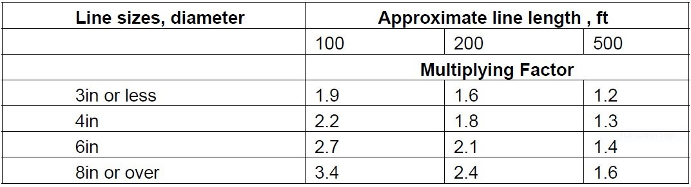
TABLE OF FITTING FACTORS

Absolute Roughness

Values for absolute roughness for commonly used materials, which are used in liquid and

vapour line sizing calculations, are as follows:
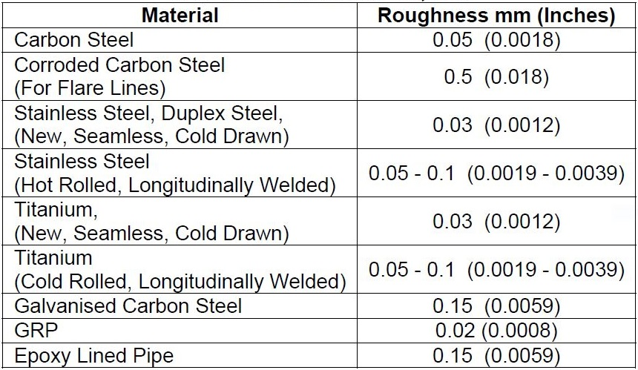

FLARE AND COLD VENT SYSTEMS

11.1 Type of Flare Tip

For flare and cold vents, the tip can be conventional or sonic depending on the required back

pressure and noise limitation.

When possible a sonic tip shall be preferred. Sonic tip with Coanda effect and/or with variables

slots are prohibited.

The flares shall be smokeless. Suitable media (Steam, Air, Fuel Gas) shall be considered for

smokeless operation of Flares.

The analysis of the causes of relief is required and an occurrence flaring loads balance

including each individual relieving rate for each possible cause shall be performed.

Radiation Levels Criteria

The radiation levels criteria shall follow the Basic Engineering Design Data. The minimum

relative humidity stated on the basis of design shall be applied.

Emissivity Coefficient

When the radiation calculations are performed by a flare vendor it is necessary to check

carefully the emissivity coefficient used. The emissivity coefficient used by vendors does not

take into account the liquid carry over, they consider an ideal gas/liquid separation. The droplets

size for the flare drum sizing and the expected liquid carry over shall be clearly indicated in the

flare tip process data sheet.

RECOMMENDED EMISSIVITY COEFFICIENT

For pipe flare:

• Natural gas molecular weight of 18 : 0.21

• Natural gas molecular weight of 21 : 0.23

• Ethane : 0.25

• Propane : 0.30

• See also API RP 521

For sonic flare:

The minimum emissivity coefficient = 0.13 for all gases without liquid carry over, and 0.15 with

liquid carryover not exceeding 5% weight.

11.5 Flare and cold vent lines sizing criteria

11.5.1 Lines upstream relieving devices

PSV’s:

For the line sizing, the maximum capacity of the PSV (recalculated with the selected orifice),

shall be considered even if this figure exceeds the actual maximum flow rate due to process

limitations. ΔP between the protected equipment and the PSV < 3% of PSV set pressure (API

RP 520 Part II)

Inlet line diameter ≥ PSV inlet diameter

• ρV2 ≤ 25 000 kg/m/s2 for ∅ of line ≤ 2”

• ρV2 ≤ 30 000 kg/m/s2 for P ≤ 50 bar g

• ρV2 ≤ 50 000 kg/m/s2 for P > 50 bar g

DEPRESSURISATION DEVICE

• Minimum line size 2”

• ρV2 criteria are the same as for PSV’s

11.5.2 Line downstream relieving devices

Flare and cold vent headers and sub-headers:

• Minimum line size 2”

• Back pressure to be compatible with the protected equipment

• Velocity and ρV2 :

SINGLE PHASE (GAS AT THE RELIEF DEVICE INLET) :

• Intermittent flow:

• Lines downstream relieving devices and sub-headers : 0.7 Mach maximum and

ρV2 < 150000 kg/m/s2 considering the maximum capacity of the relieving devices even if this

figure exceeds the actual maximum flow rate due to process limitation and the relevant

occurrence.

• Headers : 0.7 Mach maximum and ρV2 < 150 000 kg/m/s2 considering the maximum flow rate

due to process limitations and for the relevant occurrence, however a velocity of 0.8 Mach could

be accepted for a long straight line without elbows and connections (e.g stack, lines on bridge)

• For a ρV2 > 100 000 kg/m/s2 vibration and line support studies are required.

• Continuous flow:

• Velocity < 0.35 Mach and ρV2 ≤ 50 000 kg/m/s2

• MULTIPHASES (2 phase flow at the inlet of relieving device) :

• Velocity ≤ 0.25 Mach and ρmvm

2 ≤ 50 000 kg/m/s2

The sizing shall be done for the line downstream each device with the built-up back pressure for

the corresponding occurrence and not with the maximum built-up pressure for the maximum

flow rate to the flare or cold vent. The same shall be applied for the header and sub-headers.

11.6 Flare Drum Sizing

For flare drum and cold vent drum, the sizing shall follow API RP 521 method with the following

droplets size in microns:

• Remote flare or cold vent offshore: 600 μm

• Vertical flare or cold vent onshore: 600 μm

11.7 Purge Gas

The purge gas is provided to avoid:

• An explosive mixture in the stack or header due to air intake into the flare or cold vent stack.

• The risk of burn back which induces the quickest deterioration of the flare tip.

The purge gas flowrate shall not be lower than the value given by the following equation:

Without gas seal : Purge gas flow = 24 000 x D3 x MW-0.565

• With gas seal : Purge gas flow = 12 000 x D3 x MW-0.565

Where : Purge gas flow in Sm3/h

D is the tip internal diameter (1) in m

MW is the purge gas molecular weight in kg/kmol

(1) For sonic flare, the tip internal diameter is taken as the equivalent diameter corresponding to

exit gas area

The above formulae shall be applied only to the flare tip, assuming COMPANY/Project

procedures do not allow the application of flare tip vendor’s guaranteed purge rates.

For purging of sub headers and headers, the purge velocity shall be a minimum of 0.03m/sec as

per API RP521 (Section 4.4.3.4.2).

For flare, if fuel gas is used for purge gas, the source of purge gas shall be common to the fuel

source to the pilots in order to avoid a loss of purging while pilots remain in service.

The heaviest available gas should preferably be used as the normal source of purge gas in

order to minimise the vacuum pressure in the flare header for an elevated flare or cold vent.

In some cases, nitrogen could be used as purge gas. In these situations, pilots able to run in a

predominantly inert gas environment shall be installed after detailed case by case evaluations

with the flare tip vendor.

Since the allowable radiation level is a function of the length of exposure, factors involving

reaction time and human mobility should be considered. In emergency releases, a reaction time

of 3 - 5 seconds may be assumed. Perhaps 5 seconds more would elapse before the average

individual could seek cover or depart from the area, which would result in a total exposure

period ranging from 8 to 10 seconds. The above table is maximum allowable radiation

intensities inclusive of solar radiation. The solar radiation in southern parts of Iran shall be taken

as 300 Btu/hr.ft2 . Flare stack diameter is generally sized on a velocity basis, although pressure

drop should be checked. One may want to permit a velocity of up to 0.5 Mach for a peak, short-

term, infrequent flow, with 0.2Mach maintained for the more normal and possibly more frequent

conditions for low-pressure flares. However, sonic velocity operation may be appropriate

for high-pressure flares. The tip pressure drop is taken from vendor’s information. For sonic type

tip the backpressure will be assumed 2 to 5 Barg depending on load, when there is not any

information.

3-10-2) Header Sizing

The major criteria governing the sizing of the header are the backpressure

and gas velocity. Flare headers must be large enough to prevent excessive

back pressure on the plant safety valves and to limit gas velocity and noise

to acceptable levels.

The sonic velocity of the relief gas is calculated as below.

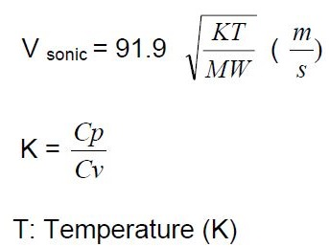

MW: Molecular Weight

Maximum velocity in a line is 0.7 Mach for short duration relieves only.Maximum flowing velocity

in the lines between of the PSV’s to the first subheader shall in general be less than 0.7 Mach.

For the PSV’s where the outlet velocity is higher, a reducer shall be installed as close as

possible to the PSV to increase line size and hence limit the velocity to max 0.7 Mach

downstream at the reducer.

Instrumentation

Selection of Instrument Housing

Field mounted instrument shall be suitable for operation in industrial, humid, sulfurous

and corrosive surrounding atmosphere and be adequately designed to prevent

generation of an explosion.

Instrument enclosure’s “degree of protection“shall be in accordance with IEC 529.

The minimum degree of protection for junction boxes (containing terminals only) shall

be IP 54. For enclosures containing electronic components or coils (solenoid valves)

the minimum degree of protection shall be IP 65.

Instruments/JB’s located in areas subject to deluge shall be IP 66.

For instruments below grand level/underground, it shall be IP 68.

The minimum degree of protection for indoor instrument shall be IP 42.

Instruments, boxes and panels located in a hazardous area shall be certified to meet

the electrical area classification; any certified equipment shall be stamped according

to the protection and the relating code and shall be delivered with a conformity

certificate issued by a recognized laboratory.

Gas Group classification is done according to CENELEC/IEC standards. The

correspondence chart hereafter is used for CENELEC/IEC classification (only to use

for conversion from API to CENELEC/IEC):

CENELEC/IEC API REMARKS

Group IIC Class I, Group A Acetylene

Group IIC Class I, Group B Hydrogen

Group IIB Class I, Group C Ethylene, ethyl-ether,

Group IIA Class I, Group D Methane, butane,
propane, naphtha, …

Zone 0 Division 1 Explosive mixture is continuously present

Zone 1 Division 1 Explosive mixture is likely to occur in normal operation

Zone 2 Division 2 Explosive mixture is not likely to occur in normal
Operation

The temperature class is indicted by the following symbols:

• T1 Maximum external temperature 450 oC (842 oF)

• T2 Maximum external temperature 300 oC (572 oF)

• T3 Maximum external temperature 200 oC (392 oF)

• T4 Maximum external temperature 135 oC (275 oF)

• T5 Maximum external temperature 100 oC (212 oF)

• T6 Maximum external temperature 85 oC (185 oF)

The method of protection is defined by the CENELEC/IEC rules and identified by a

small letter as follow:

- d Flameproof enclosure (explosion-proof) CENELEC EN 50-018/IEC 79-1, 79-1A

- e Increased safety CENELEC EN 50-019/IEC 79-7

- ia Intrinsic safety for Zone 0 CENELEC EN 50-020/IEC 79-3, 79-11

- ib Intrinsic safety for Zone 1 or 2 CENELEC EN 50-020/IEC 79-3, 79-11

- p Pressurized enclosures CENELEC EN 50-016/IEC 79-2

- n Electrical apparatus for potentially explosive atmospheres CEI EN 50-021

For standardization purpose, installation of certified type instrument in non-hazardous

area is acceptable.

As far as possible, explosion proof protection type shall be used instead of intrinsically

safe.

The minimum requirement of protection method shall be done according to the

following chart:

Equipment Zone 1 Zone 2

Instrument EEx-d/EEx-ia/ib EEx-d/n

Solenoid valve EEx-d EEx-d

Junction box EEx-e EEx-e

Local enclosure (with relays, electronic, …) EEx-d/EExp EEx-n

Lamp indicator (LED) EEx-ia/ib EEx-d/n

Thermocouple EEx-ia/ib EEx-d/n

Push button EEx-ia/ib EEx-d/n

Lighting EEx-e EEx-e
Level gauge illuminator EEx-d EEx-d

Horn EEx-d/e EEx-d/e

Electrical Power Supply

All control and safety systems located in CCR’s and ITR’s shall be powered from 110V

AC UPS system located in electrical substation. Necessary autonomy requires battery

back up for 30 min. This UPS is limited to feed the FCS, F&G, ESD systems, PLC’s,

equipment, analyzers, and other instruments. This power supply shall not be used for

lighting or tracing.

No voltage other than 24V DC, 110V DC or 110V AC will be used except if clearly

specified by LORC. Other voltages may be used internal to the systems so long as

these voltages do not exceed 110V AC or 110V DC and they are generated by system

Supplier/ Vendor.

Equipment such as FCS, ESD, F&G system cabinets shall be powered by a set of

redundant UPS feeders (i.e. 2 feeders) for each equipment. Equipment such as printers,

stations, solenoid valves, etc. shall be powered by a single UPS feeder from related

systems. FCS, ESD and F&G systems shall be equipped with reliable DC generation

systems provided by Supplier. These internal power supplies and distribution systems

shall be redundant.

Package control cabinets will receive 110V AC 50 Hz supplied by a single or dual

feeder system (to be defined for each package).

Installation and Process Connections
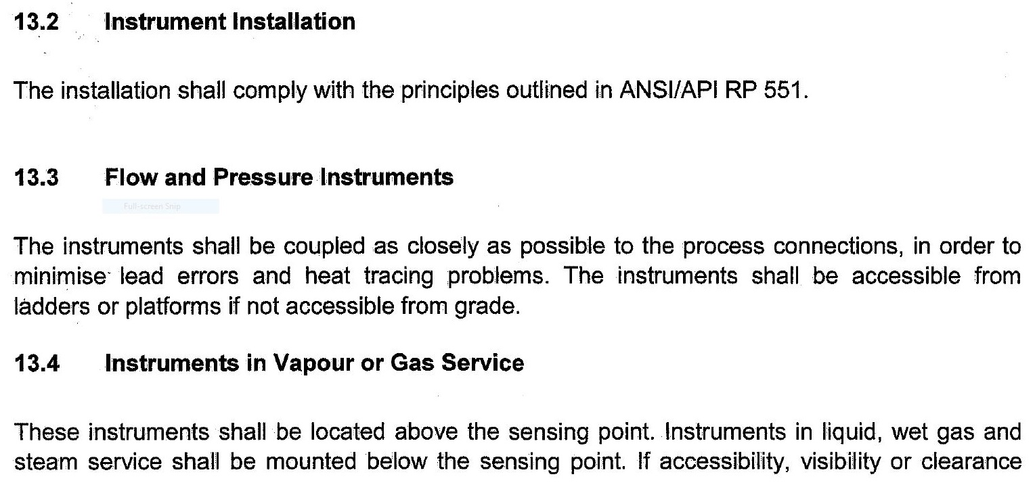
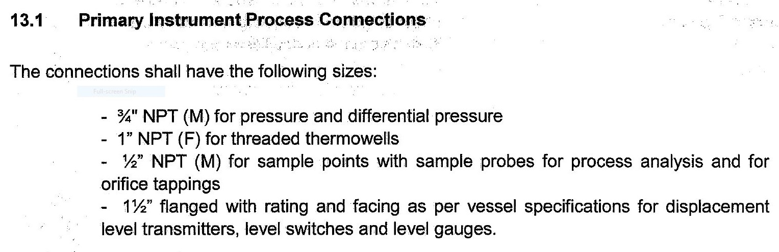
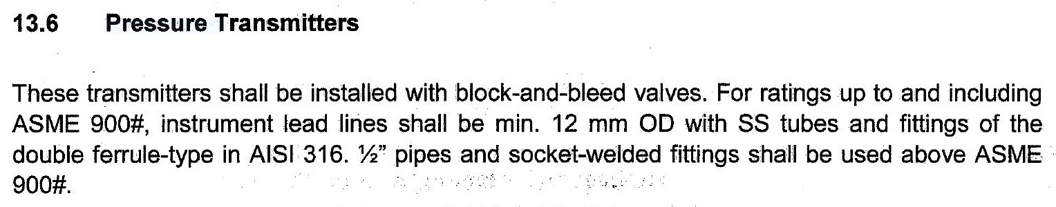
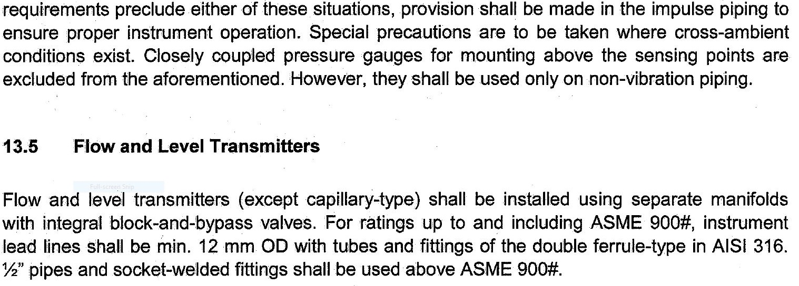

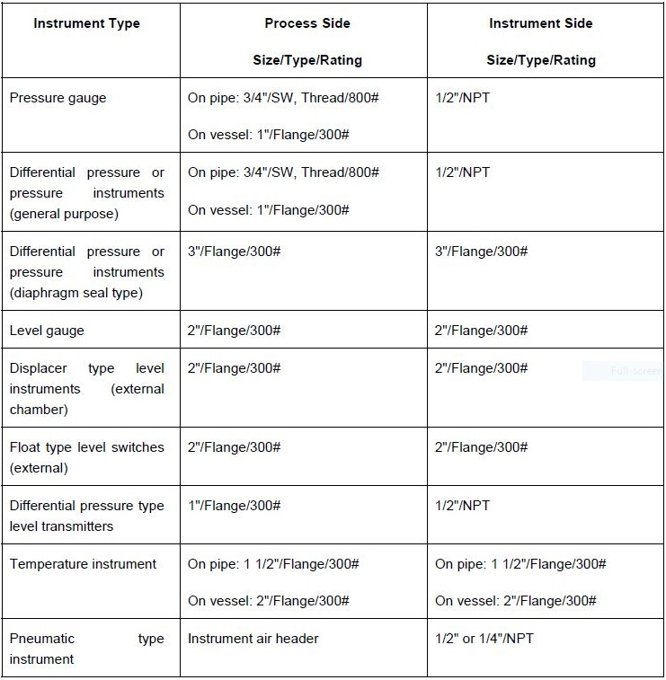

Pneumatic Supply

The operating range for pneumatic signal transmission shall be 0.2 to 1 barg.

All pneumatic components of instrument system shall be designed for the following

supply conditions:

• Pressure:

- 5 Barg Minimum operation

- 7 Barg Maximum operation

• Temperature:

- Ambient Temperature (normal)

- 49 oC Temperature (maximum)

- -10 oC at 7 barg Dew point

• Oil content: Oil free

An air set with filter, output gauge and regulator shall be provided with each instrument
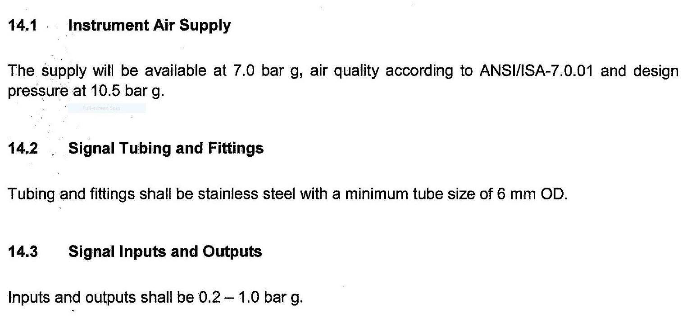
consuming instrument air.

Field Sensors General Requirements

Field Sensor

The same type of instruments shall be used for control of utilities and for process control. Safety

components shall be completely independent from process control component. Trip contact

shall not be derived from the same instrument. Single component failure shall have a minimum

effect on overall availability.

The following requirements with respect to the field instrumentation shall be implemented:

- Materials exposed to the process fluid shall be in accordance with the fluid conditions

(pressure, temperature, corrosion) and with the relevant piping class.

- Carbon steel body construction (except transmitters, see here after) shall be a minimum

specification for parts exposed to process fluid when not specified otherwise.

- For pressure and differential pressure transmitter, both body and element material shall be

AISI 316 as a minimum standard, or the manufacturer’s standard material, whichever provides

the best corrosion resistance. Where the nature of fluid requires a higher alloy or other

material, the material shall be consistent with the piping or equipment

specification.

- Movements for instruments shall be stainless steel or better when

specified.

- All inserted instruments (e.g. thermo-wells, sampling probes, etc.) shall be specified as per the

process data sheet including all service conditions (pressure, velocity, temperature, density,

fluid composition) which shall be provided by Contractor.

- NACE requirement shall be applied in case of sour service.

- The design of pressure parts shall be based on the allowable stresses of

the ANSI.

- All components, particularly if containing electric contacts, shall be

vibration resistant.

- On line instrument shall have flanged connections.

- All instruments shall have an over-range protection up to the maximum design static pressure

indicated on the instrument data sheet.

- Instrument exposed to vacuum shall have under-range protection to full vacuum.

- All electronic field instruments shall have cable gland entries of ISO M20x1.5.

4.2.2.2 Local Switch

Process variables used for initiating the shutdown systems shall be derived, as a

general rule, from the electronic switches.

When switches are used as sensing devices they shall have normally closed contact

to open on trip condition.

When they are provided for safety purpose in non fail-safe configuration they shall

include a resistor for line monitoring.

Switch devices shall have a minimum rating of 120V AC, 2A, inductive, unless specified

otherwise on the relevant data sheets.

4.2.2.3 Transmitters

Electronic transmitters, strain gauge or capacity type shall be used as general rule.

Transmitters generally will be digital from FF certified bus-powered.

Those connected to the ESD system will be preferably of smart transmitter type and

compatible with HART. If smart type transmitters are selected for ESD application

they shall be configured as “read only”.

Smart transmitters (2 wires) with digital calibration superimposed on 4-20 mA signals

shall be the rule to allow remote calibration from a “pocket” interface at marshalling

level.

Electronic transmitters will be provided with an integral digital indictor for maintenance

purpose. A digital display indicator can be provided, using digital mode communication

when associated to “smart” transmitter.

4.2.2.4 Diaphragm Seal and Capillary

For measurement of viscous fluids, solids containing fluids, highly corrosive fluids or

where temperature changes may influence the fluid conditions, the use of diaphragm

seal and capillary may be considered as an alternative to instrumentation with flushing

on the measuring impulse line. Diaphragm seal shall normally be integral with the

instrument. Special coating materials may be considered where these will improve the

corrosion resistance of the diaphragm.

For remote seal applications, capillaries shall be kept as possible (at least 1meter)

and shall not exceed 6m. For differential pressure application the capillary shall be of

the same length. The capillary tubing material shall be of AISI type 316 type

stainless steel and be shielded by flexible stainless steel tubing with PVC cover,

according manufacturer’s standard.

4.2.3 Signal Requirements

4.2.3.1 Inputs

- IS digital from FF certified bus-powered transmitters,

- Non-IS digital from FF certified bus-powered transmitters,

- IS analogue 4-20 mA, 24 VDC from smart type two-wire transmitters with

HART protocol,

- Non-IS analogue 4-20 mA, 24 VDC from smart type two-wire transmitters

with HART protocol,

- IS analogue 4-20 mA DC from smart type four-wire transmitters with HART

protocol,

- Non-IS analogue 4-20 mA DC from smart type four-wire transmitters with

HART protocol,

- On-Off hardwired signals for non-safety related interlock performance from

volt-free contacts,

- IS inductive high frequency pulses from proximity sensors, pulse or BCD,

- Communication with ESD and other systems,

- On-Off signals from ESD, substation, other systems, via volt-free contacts.

4.2.3.2 Outputs

- IS digital to FF certified positioners via bus segment,

- Non-IS digital to FF certified positioners, via bus segment,

- IS analogue 4-20 mA, 24 VDC to smart type positioners with HART protocol,

- Non-IS analogue 4-20 mA, 24 VDC to smart type positioners with HART

protocol,

- On-off signals to external hardwired annunciator, substation, etc. volt-free

SPDT contact rated minimum 2 Amps at 24 VDC,

- Communication signals (Modbus, TCP/IP, etc).

Flow Instruments

As a general rule flow shall be measured from orifice plate differential pressure, unless

special considerations make necessary to use other types of instruments such as:

- Variable-area flow meters for local indication,

- Electromagnetic flow meters,

- Ultrasonic flow meters,

- Vortex flow meters,

- Coriolis flow meter,

- Turbine flow meters or positive displacement meter,

- Thermal flow meter.
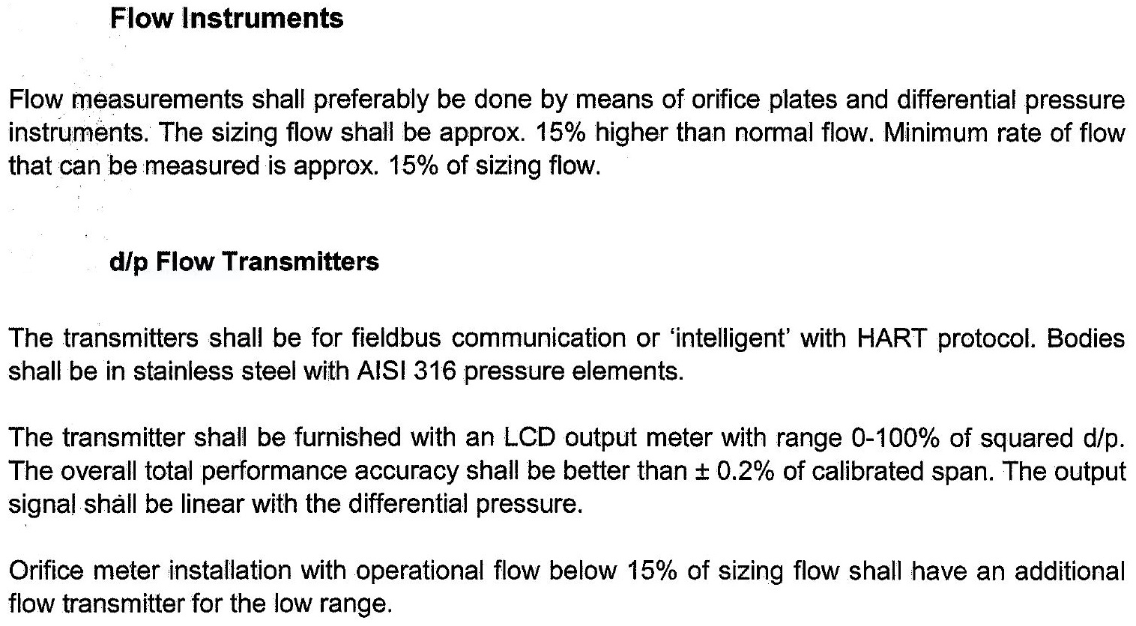
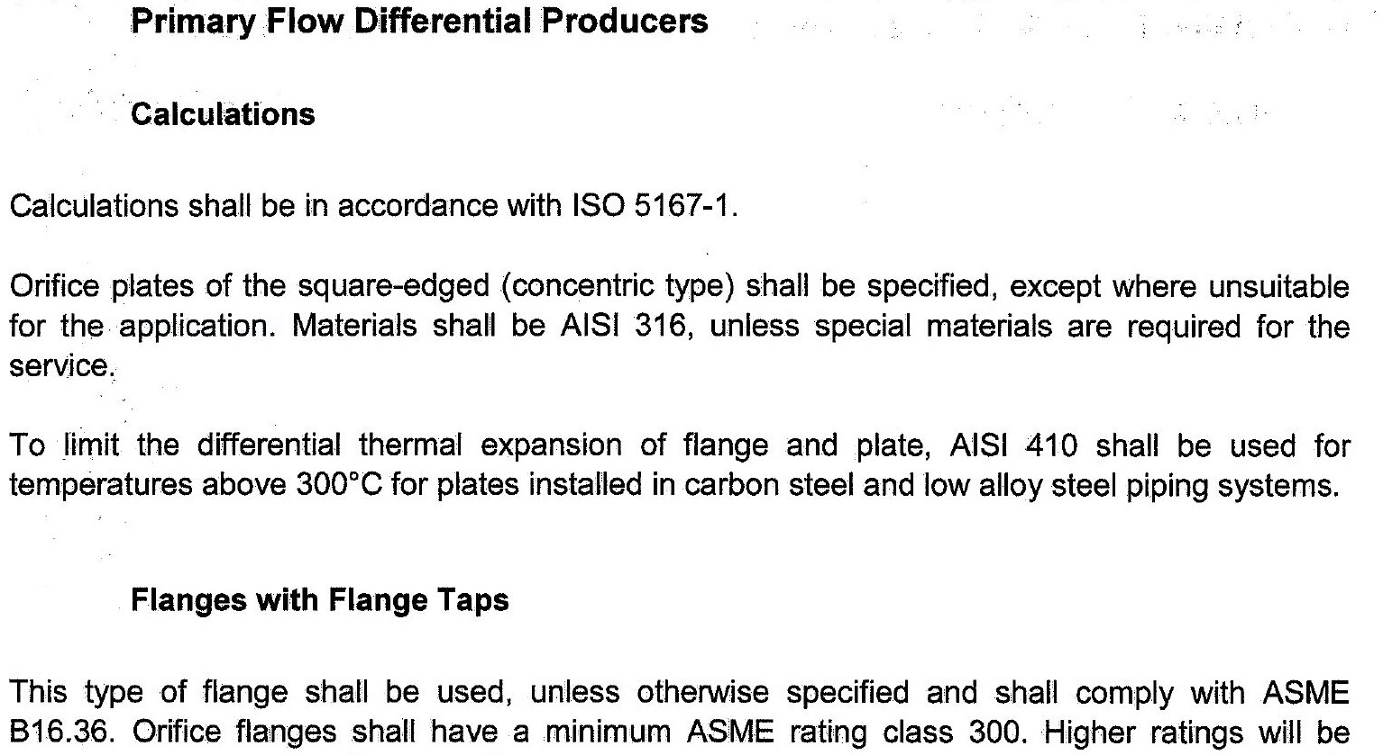
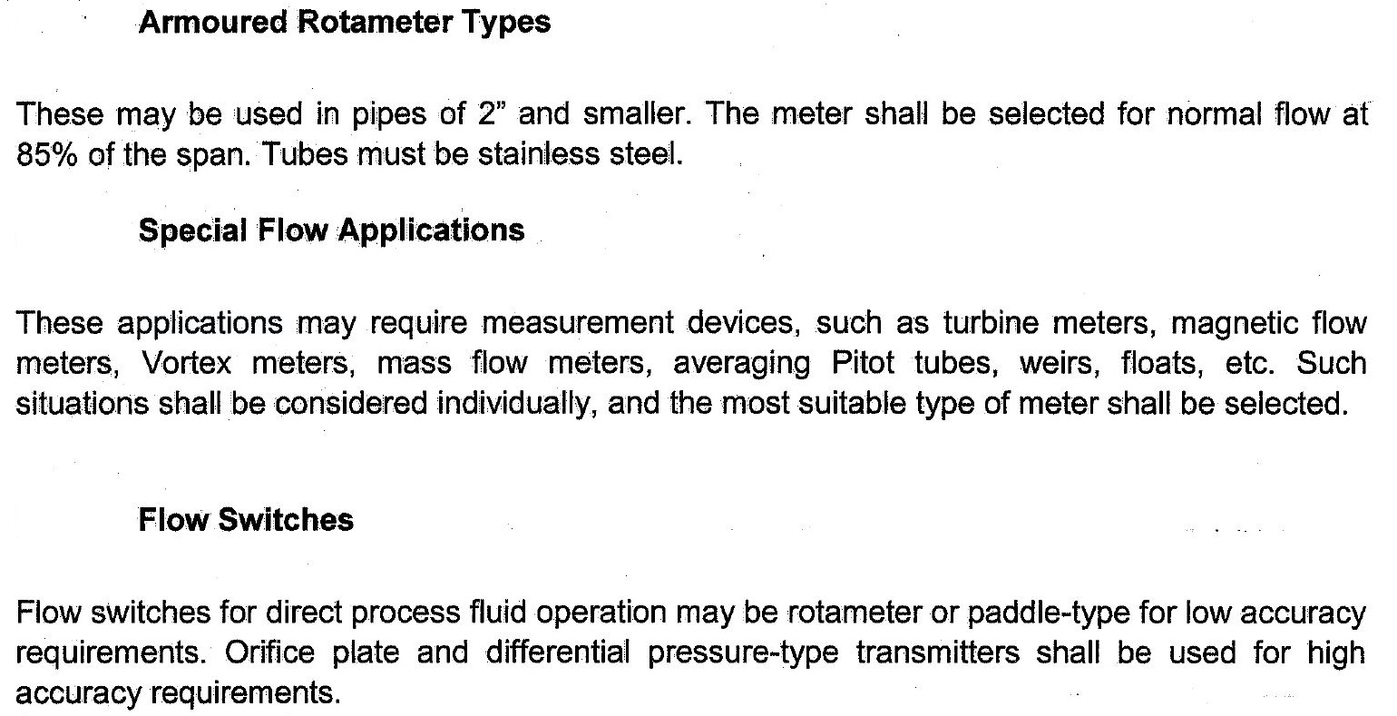
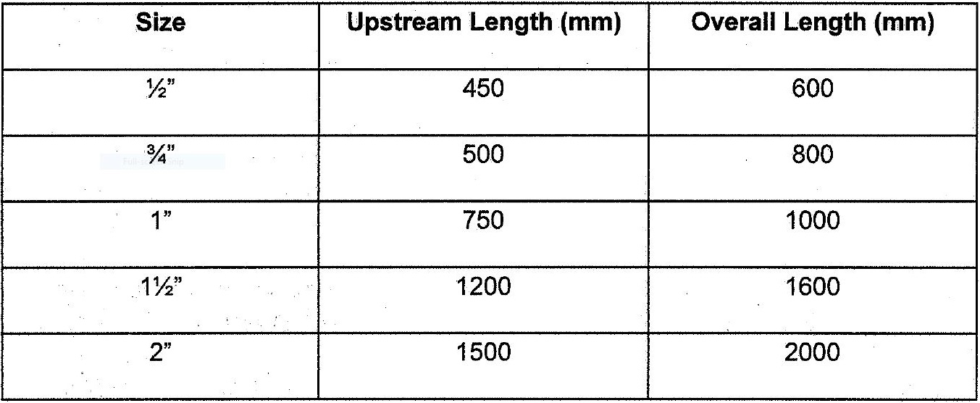
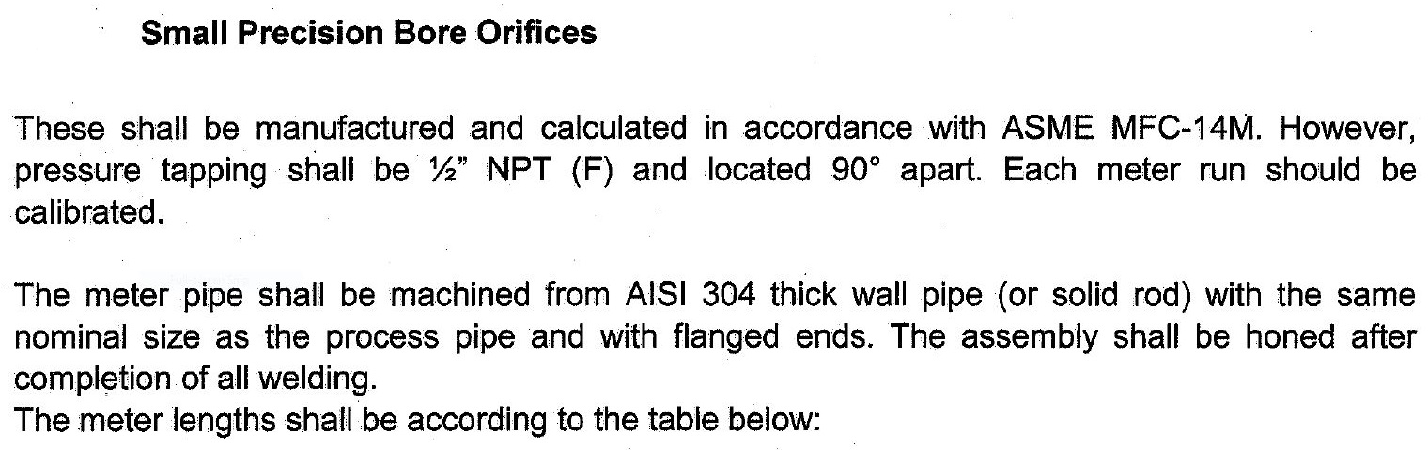
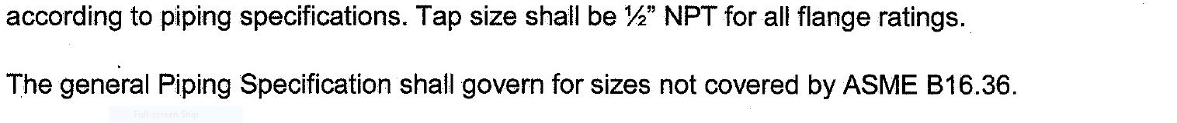

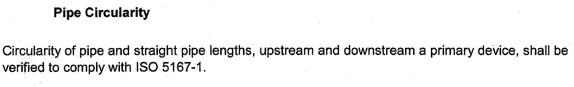
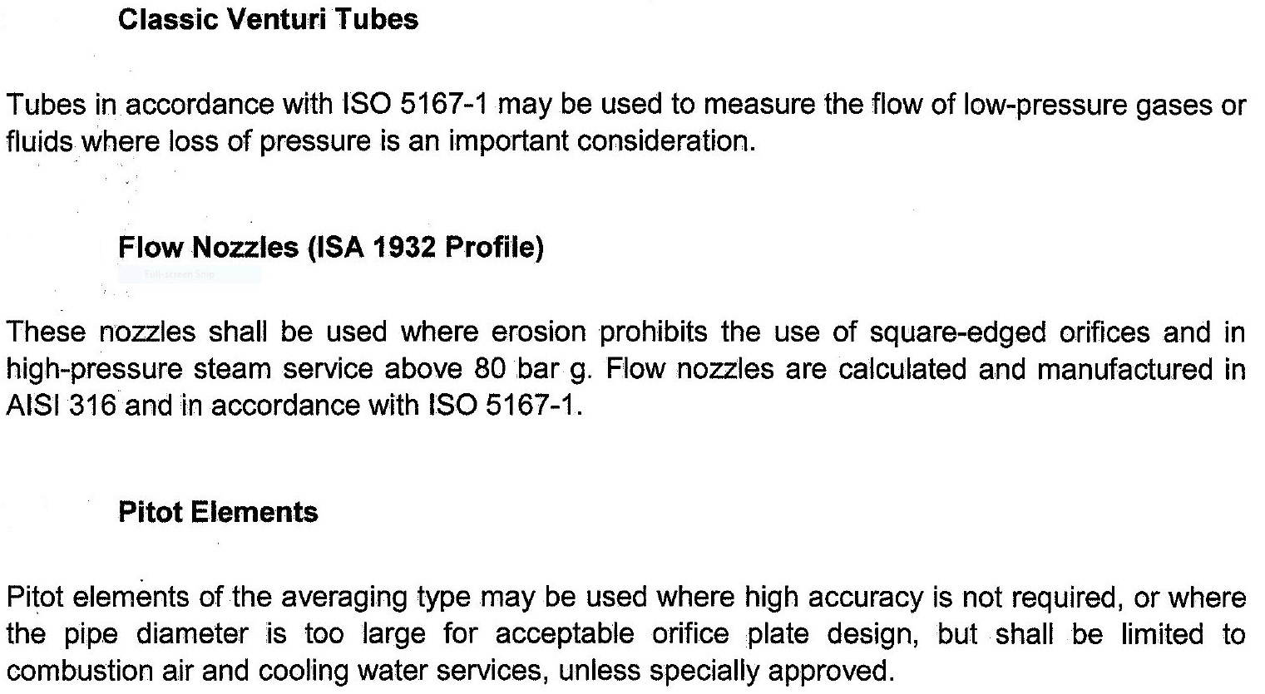

Level Instruments

As a general rule level for remote transmission or local control shall be from differential

pressure transmitter or from displacement type level instrument.

Displacement-type transmitter shall be selected for interface measurements.

For special applications, other principles of measurement may be considered, such as

ultrasonic instrument or instruments based on capacity, conductivity, radar/laser or

bubble type.
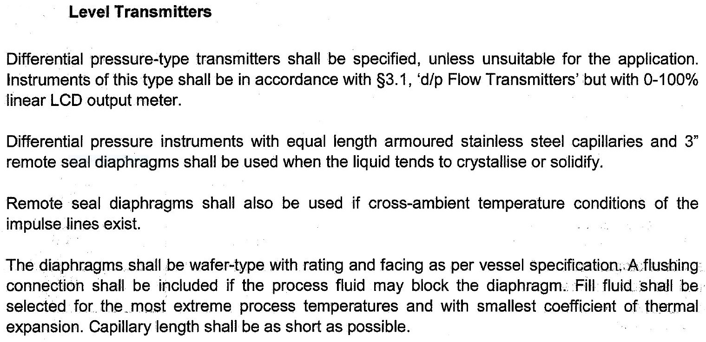

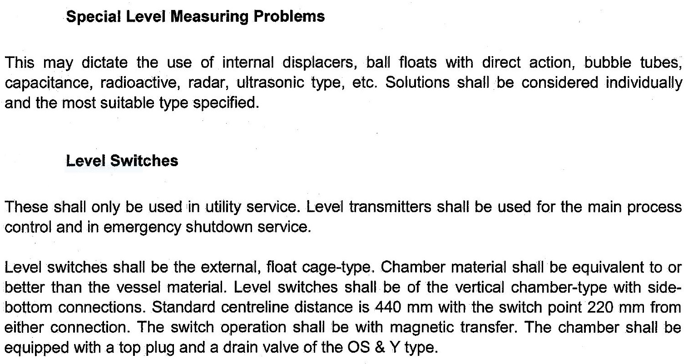
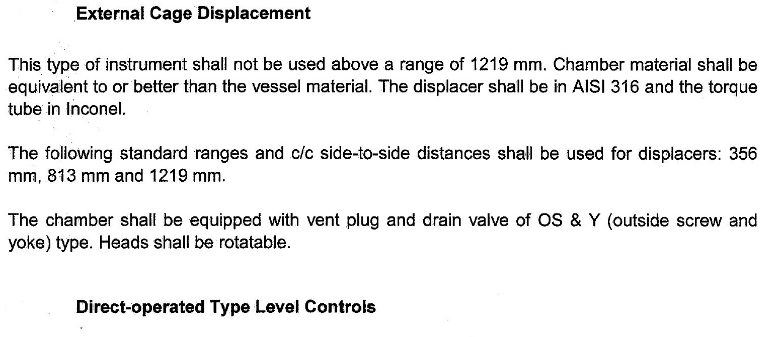

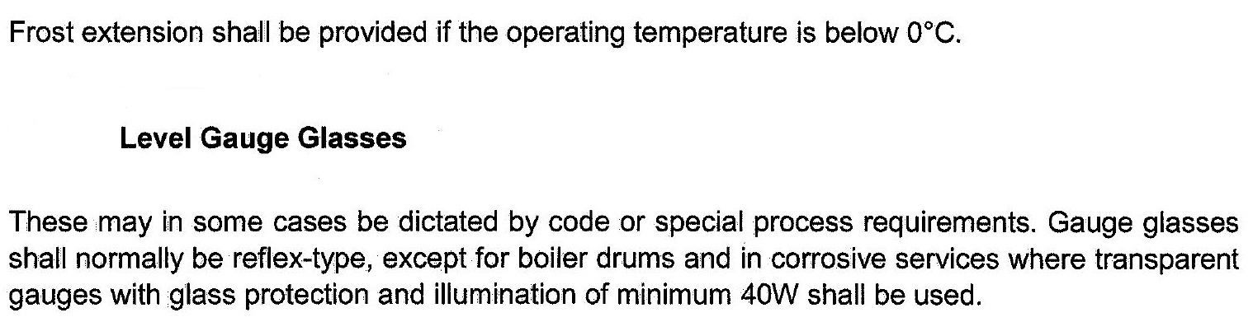
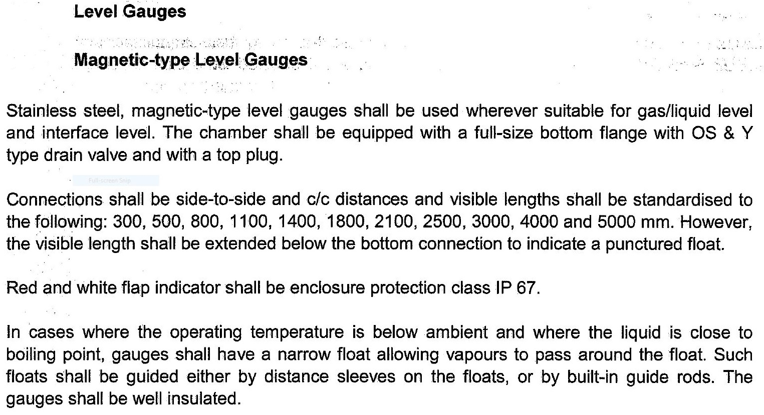

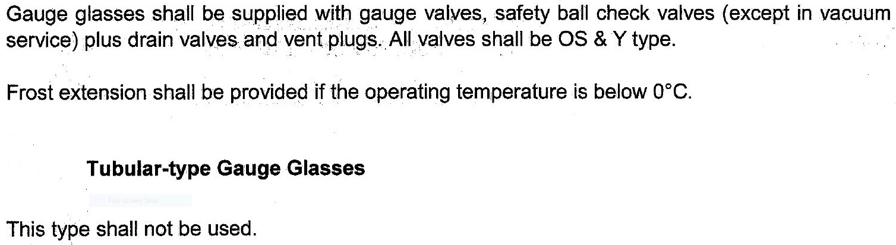
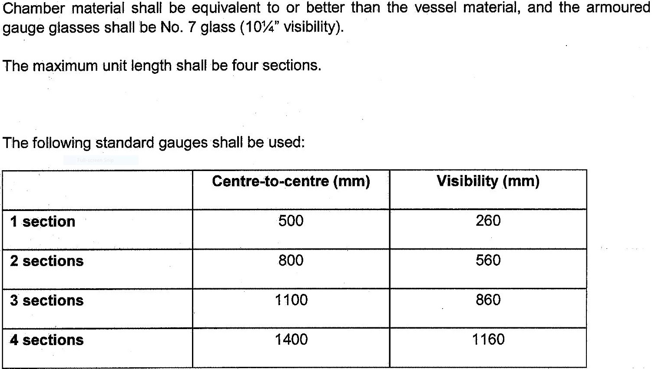

4.5 Pressure Instruments

Generally the range upper limit will be 1.5 times the normal operating pressure.

Over-range pressure protection shall be provided, up to design pressure indicted on

data sheets. For differential pressure transmitters over-range pressure protection shall

be able to protect the sensing element from the maximum design pressure applied to

each side with the opposite side vented to atmosphere.

Pressure gauges shall normally be bourdon tube-type with external part filled with

glycerin or silicone oil. Process connection shall be 1/2" NPT male, bottom position

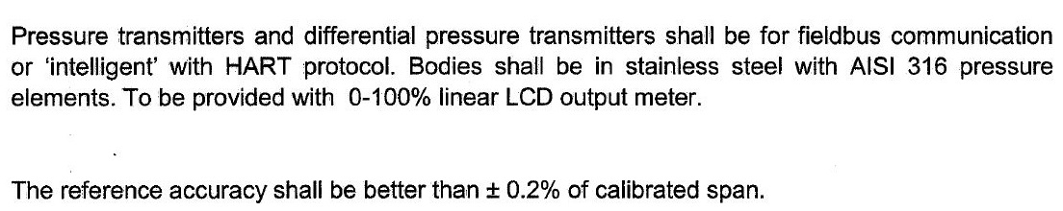
suitable for direct mounting.
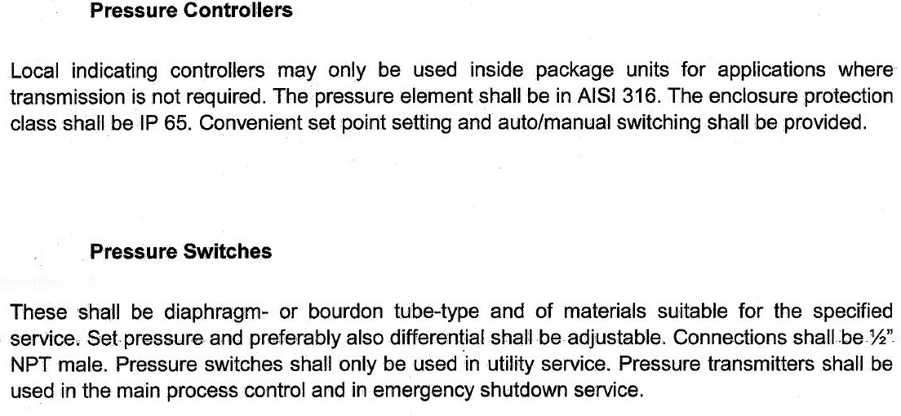

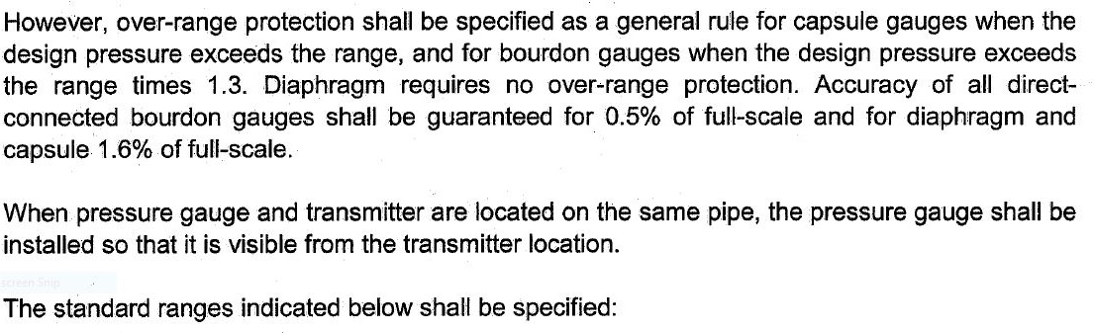
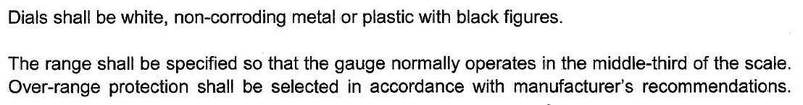
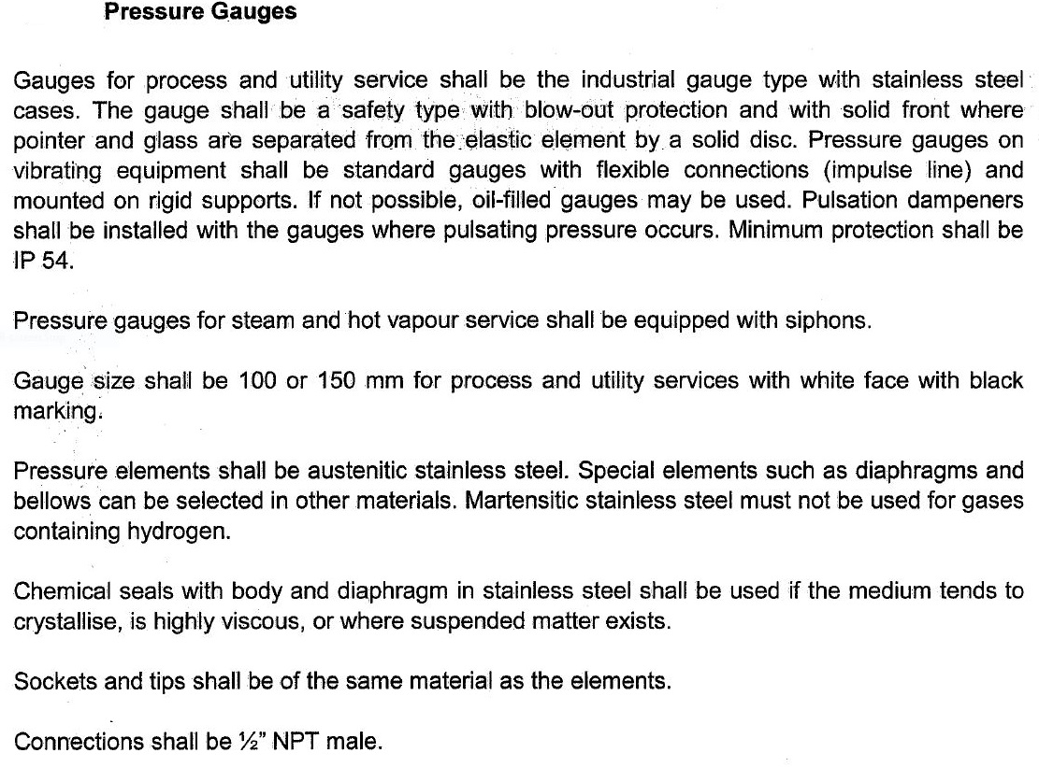
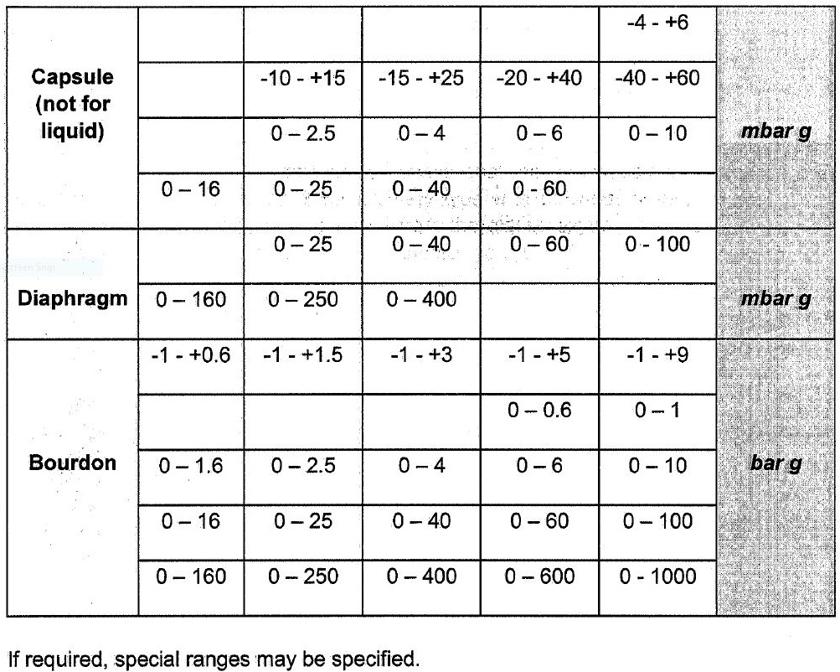

4.6 Temperature Instruments

For process temperature up to 500 oC, as a general rule, temperature transmission

shall be achieved by resistance element associated with a transmitter.

Use of RTD separate amplifier and use of thermocouples shall be restricted to

machines and heaters.

RTDs and thermocouples shall be ground insulated type.

Head mounted ohm/I (RTD) or mV/I (T/C) converters shall generally be applied.

The temperature detectors shall be installed in thermowells. Standard length

thermowells shall be used. Process connection for thermowells shall be 1 1/2" on pipe

work up to 2500# and 2" on lines over 2500# and on vessels.

For the measurement of fluid temperature below 0 oC, the length of the head extension

shall suit the insulating thickness but the head shall extend at least 200 mm outside

the insulation.

Thermowells shall be solid machined and drilled in a tapered configuration. They shall

be stainless steel as a minimum, flanged type. Where the nature of fluid requires a

higher alloy or other material, the thermowell material shall be consistent with the

piping or equipment specification.

Thermowells for test points shall be provided with plug.

Where high velocity gases are present, it will be necessary to check thermowells for

the “vortex shedding effect”.

Where the application of thermowells would be impractical, thermocouples and

resistance thermometers may be located on the surface of pipes or vessel, etc.

Spring-loaded sensor shall be used.

The minimum length for 4" pipe and larger shall be approximately midway between the

center of the pipe and the opposite wall, unless otherwise specified by calculated fluid

velocity.

Wake frequency calculation to ASME PTC 19.3 shall be produced in high velocity

lines; the wake frequency shall not exceed 80% of the natural frequency of the

thermowell. Calculations shall be provided for all non-standard lengths
