Our Mistakes

Part 1

Gas Station-Filters

Problem

High pollution in natural gas or other similar abnormalities

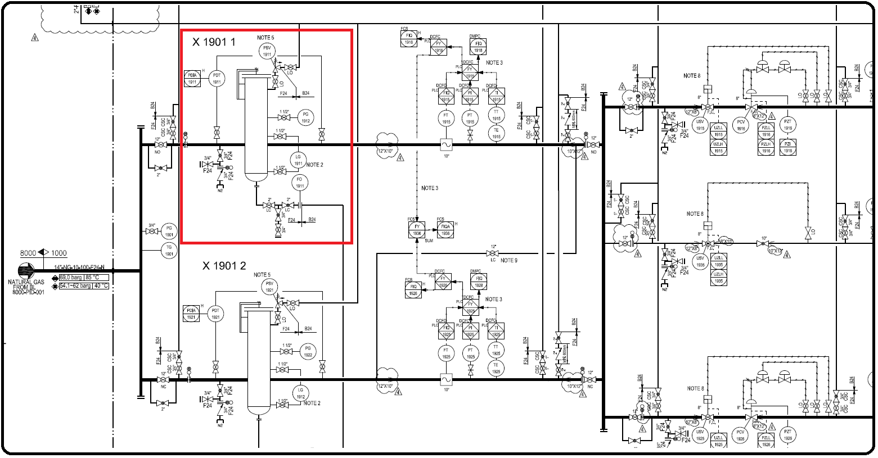P&ID

Effect

Downstream equipment

Possible solutions:

Changing the design of filter internal

