Our Mistakes

Utility

PV-7002

Problem

The opening of the valve abruptly changes.

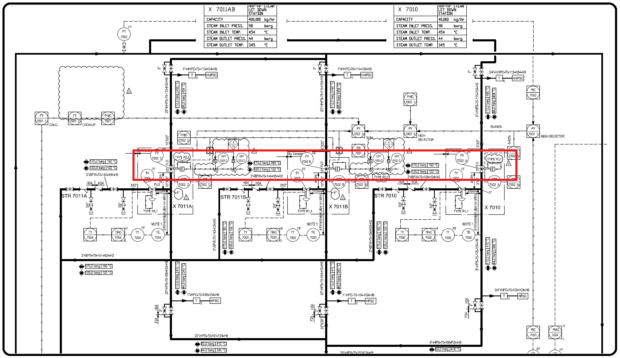P&ID

Cause

Mechanical failure or instrumentation failure.

Effect

It impacts different steam system pressure.

Solution

Disassemble it to be checked in shop-for instance checking the stem or any object which might have caused the problem.

If not so, then improve the positioner brand as we did and the problem solved.