Our Mistakes

Utility

Chemicals

Problem

Sometimes the line between dosage pumps and steam drum becomes chocked.

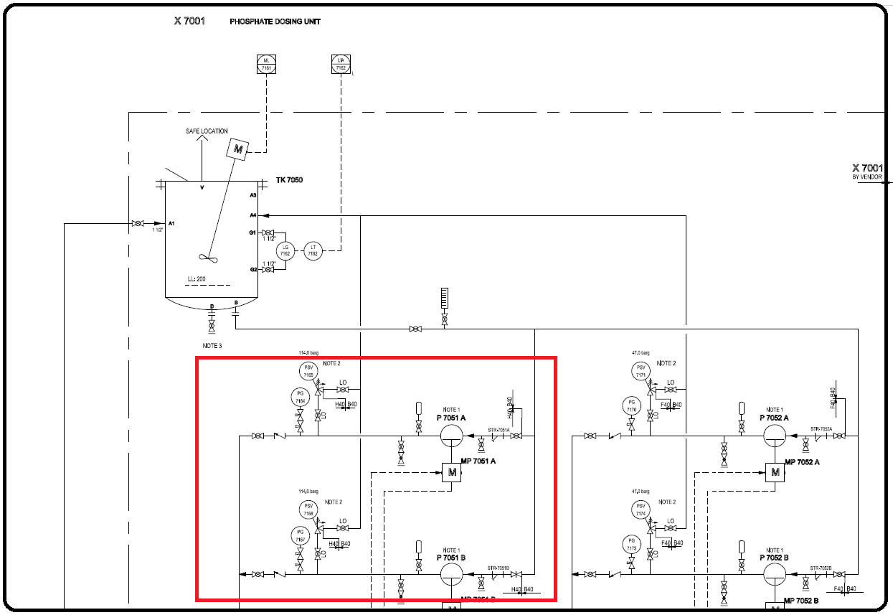P&ID

Cause

High concentration of chemicals.

Effect

Water chemistry

Solution

Lowering the concentration of water in the storage tank.