Our Mistakes

Steam Drum

Blow-down

Problem

Due to carryover of silica by steam, process engineering department tried to lower the level of steam drum to 70%. As a result, the blow-down flow stopped.

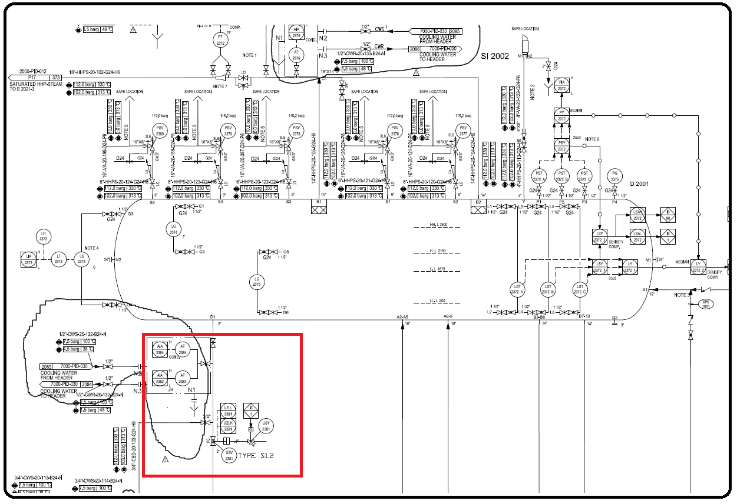P&ID

Cause

Lack of experience

Effect

In long term it might impact water chemistry

Solution

Don’t decrease the level below continuous blow-down line. Check the drawing before taking any actions.

