Our Mistakes

Saturation Unit

LV-6021 B

Problem

The valve has been corroded.

P&ID

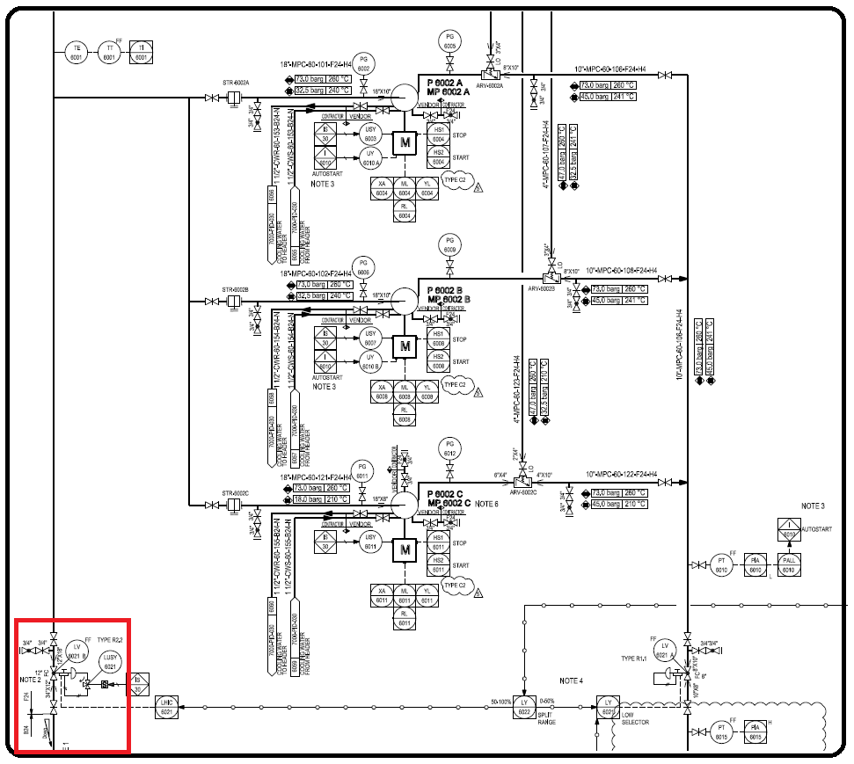

Cause

The valve is designed in a way that it should be normally close, but since the plant was working at about 60% capacity instead of 100%, the was a surplus amount of condensate water. Operators did not have a choice other than this line and as a result the flashing condition caused such damage.