Our Mistakes

Reforming Unit

NG-Fuel

Problem

Playing fast with control valves which controls fuel flowrate to the furnace leads to dramatic changes in the draught pressure, which ultimately trips the reformer.

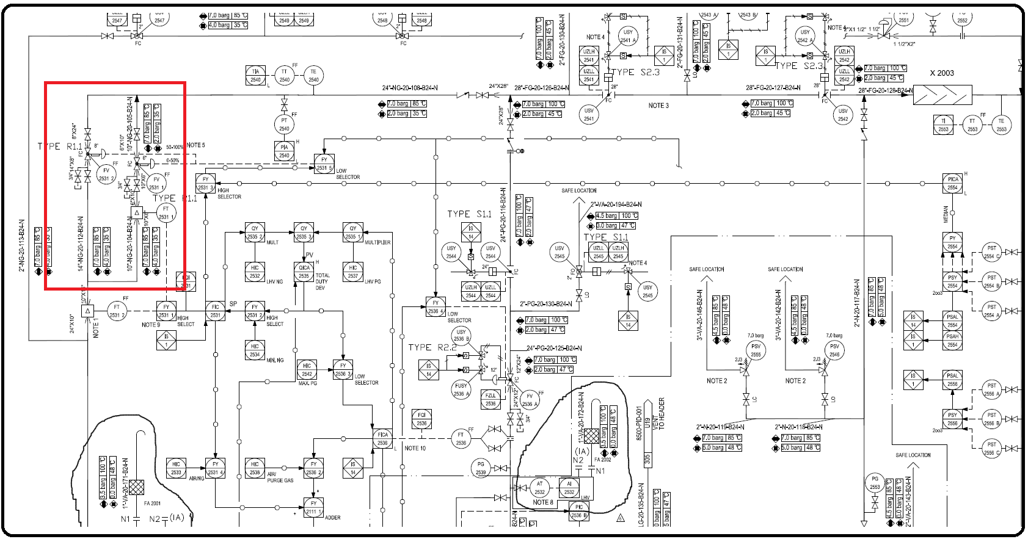P&ID

Cause

Mal-operation or low amount of experience

Effect

Adding fuel abruptly changes the temperature suddenly which finally changes the density of flue gas and unfortunately in most cases the automatic controller can’t cope with the new situation; consequently, the draught pressure gets out of range.

Solution

Take smooth actions.