Our Mistakes

Reforming Unit

Figure8

Problem

Over pressurization of downstream lines or equipment

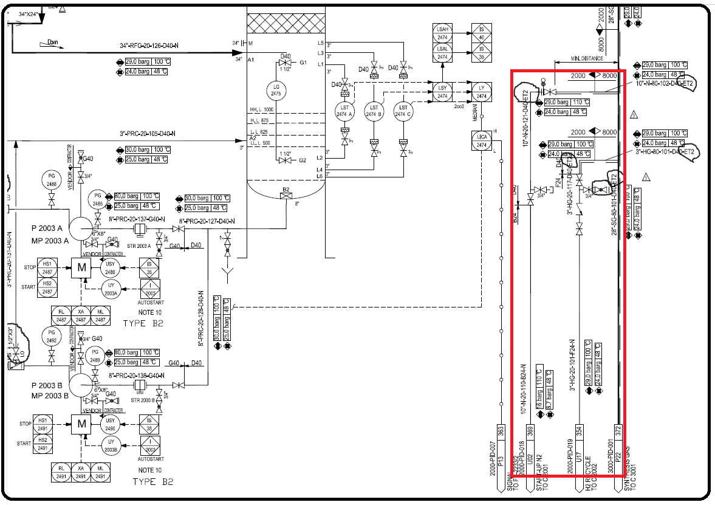P&ID

Cause

Operation personnel did not go according to operation manual.

Effect

Damage to downstream equipment

Solution

Stick to operation manual written by process engineering department.