Our Mistakes

Reforming Unit

Air Bypass

Problem

Due to mal-operation of bypass valve of combustion air, the draught pressure of reforming got out of range and as a result, the plant went in a state of total shut-down.

P&ID

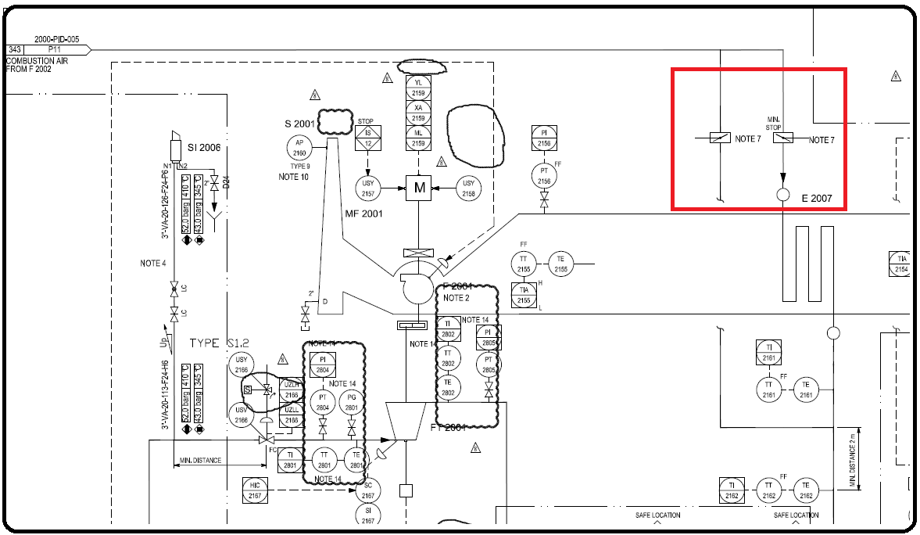

Cause

Fast action in opening or closing the bypass valve causes the rapid change in air flowrate which is simultaneously exchanging heat with flue gas in APH-2007. Thus the temperature of flue gas changes rapidly, which has a substantial impact on flue gas density and velocity. Since automatic control system is not able to respond accordingly, the draught pressure changes dramatically and gets out of operating range.

Effect

Total shut-down of the plant.

Solution

The operator should open or close in a extremely slow manner.