Our Mistakes

Reforming Unit

P-2001

Problem

ARV or say modernized check valves are not working properly

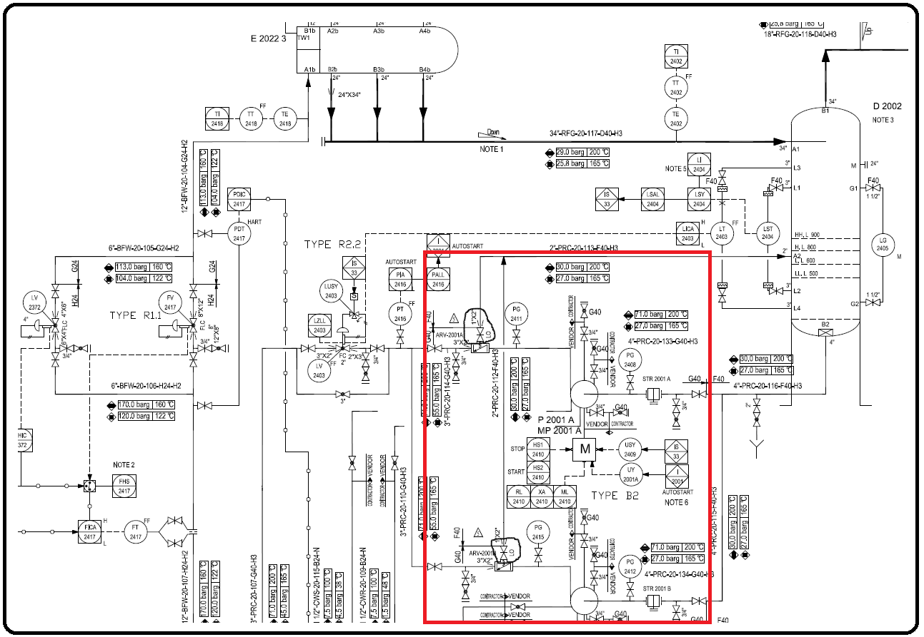P&ID

Cause

Mechanical failure or particle obstructions.

Effect

Backflow or in worst case scenario, explosion

Solution

If already installed add conventional check valve or in design stage, use conventional check valve. If you and your department can’t reach a consensus, then consult a manufacturer who has years of experience.