Our Mistakes

Hydrodesulfurization

PV-1006

Problem

The stem of the valve becomes sticky. It can’t move freely.

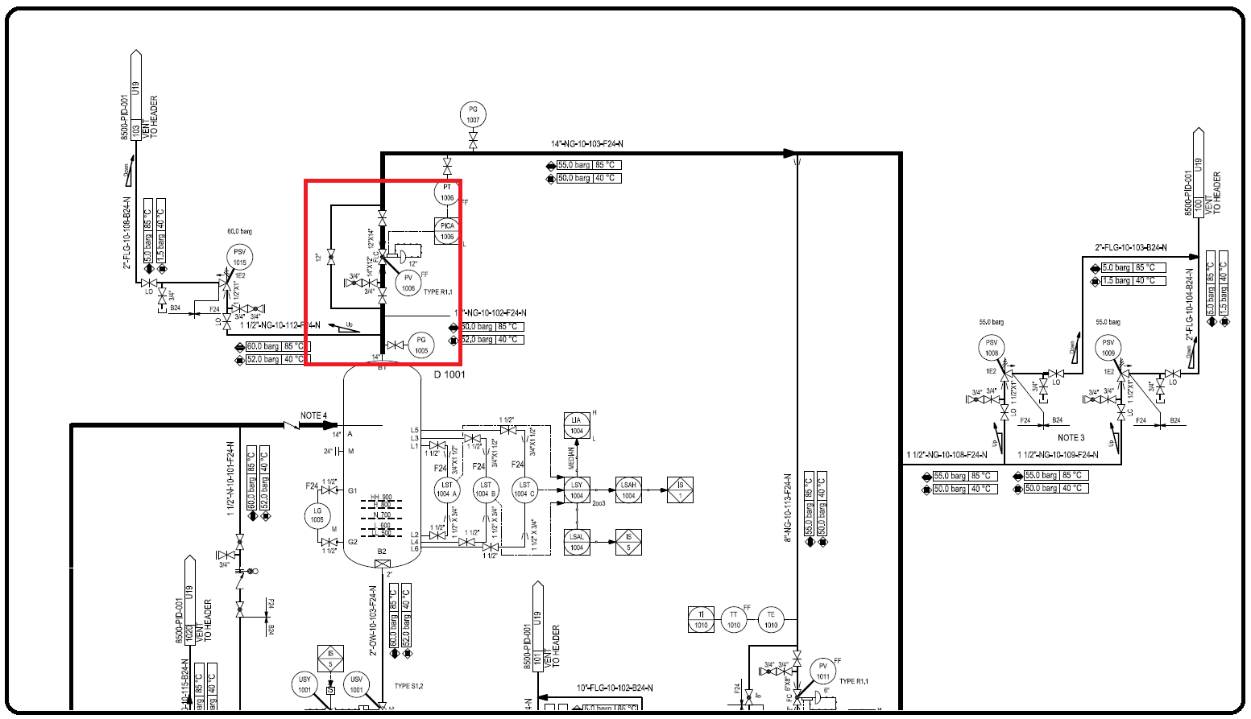P&ID

Cause

The objects in natural gas stream passing through the valve.

Effect

It affects the downstream equipment and process operation. It is not atypical if it trips the whole plant.

Solution

Checking natural gas status or pressure drop over dry gas filters; if high then change the filter

Action by maintenance and operation personnel

Change the direction of flow to bypass valve and then isolate the control valve. Purge the line with nitrogen and disassemble the valve to be maintained!