Our Mistakes

Utility

D-7001

Problem

There is the possibility that the deaerator might become full of water.

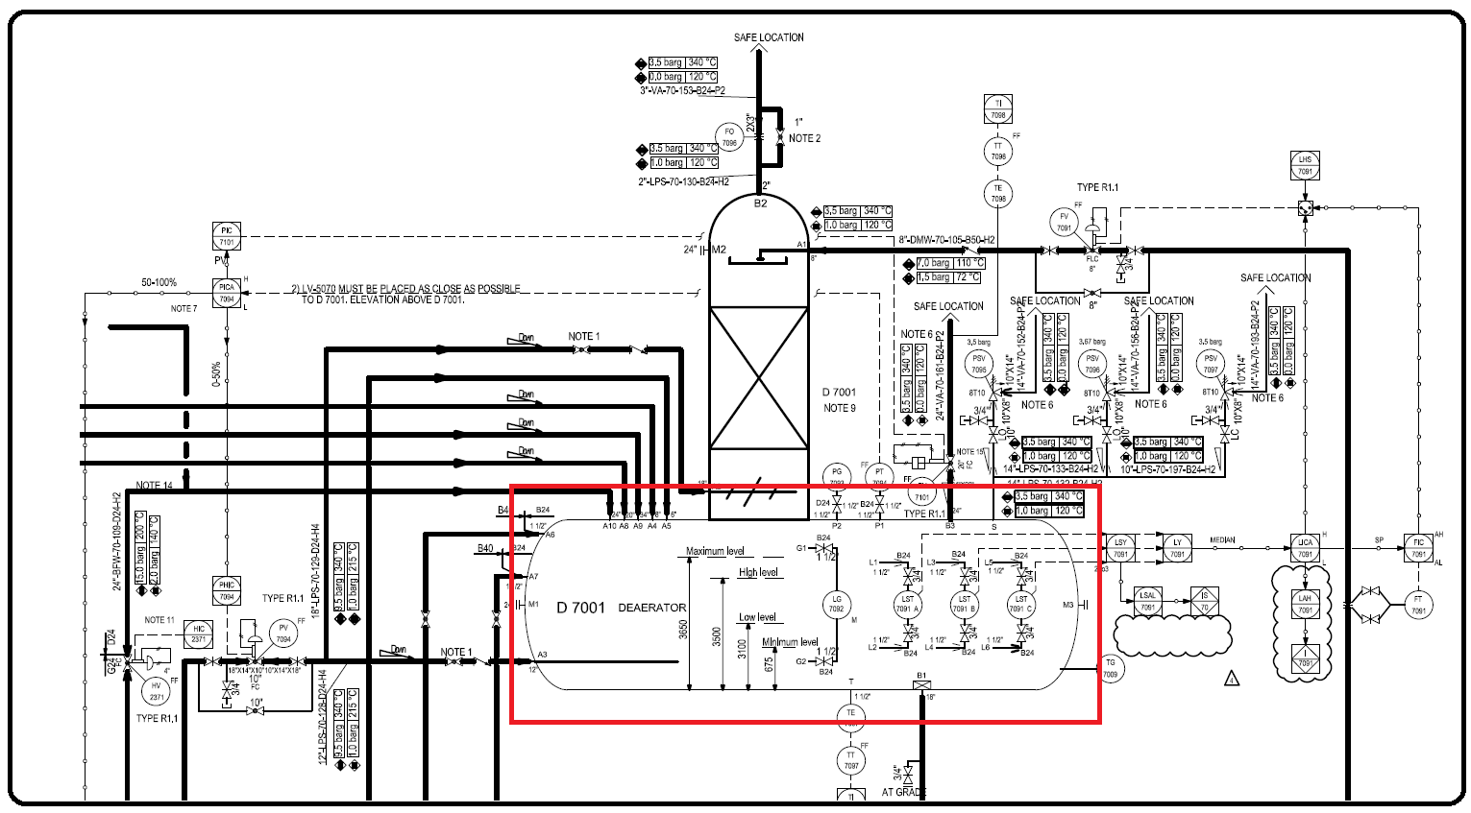P&ID

Cause

Any reasons such as control valve failure or pump failure.

Effect

Deaerator Damage

Solution

Adding an internal line which does not allow the water to reach more than 90% of level.