Our Mistakes

Saturation Unit

PV-6025

Problem

The operation personnel complain that it is difficult to play with PV-6025 which controls the steam flowrate to the saturator and is a butterfly valve. They think that if we change it to globe valve it would be better.

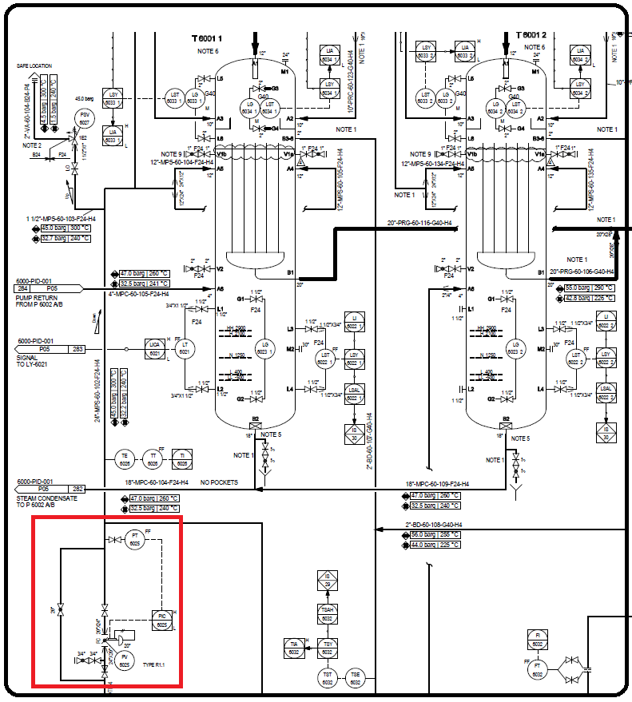P&ID

Cause

When the plant is operating at 100 % capacity, everything is in good shape. The problem starts when the control room operators use the valve during start-up; even a little change in the MV of the valve increases the flowrate more than expected. Simply butterfly valves have high impacts when their opening changes from 0-35% but from 40% to above it has literally no impacts in most cases.

Effect

It impacts the final value of steam to carbon ration for fired heaters.

Solution

Both types are good and have seen both types in steam applications. Just remember that butterfly valves are mostly used when we are dealing with high flow rate in the order of 400-500 ton/hr. and at the same time the pressure drop should be lower than 5 bar.

If you are in design stage for such application with flowrate of 100-300 ton/hr. globe valve seem to be better but if you are in operation don’t need to change anything!