Our Mistakes

Saturation

P-6002

Problem

The machinery team reports that they can’t properly warm-up the pumps P-6002

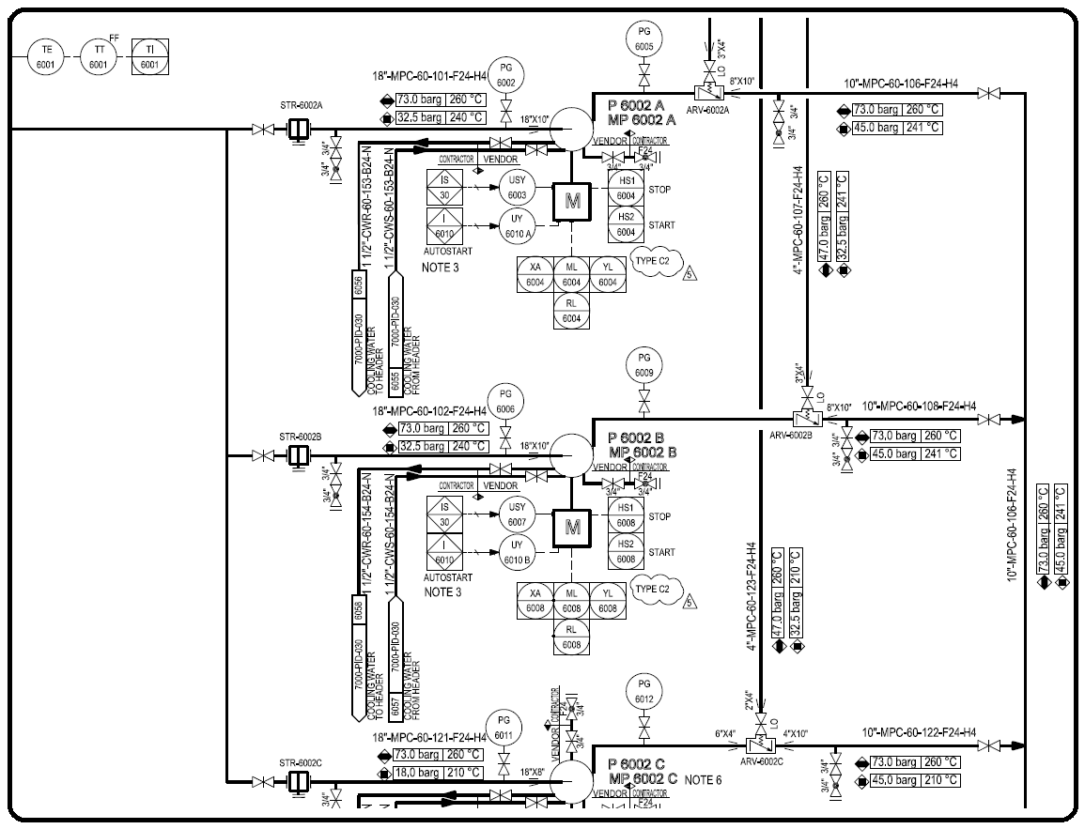P&ID

Cause

There is no proper means to warm-up the system.

Effect

Damage to the pumps due to experiencing abrupt changes in temperature

Solution

Adding a bypass like below

