Our Mistakes

Saturation Unit

D-6002

Problem

The Ammonia stripper is not able to separate ammonia from water based on spec.

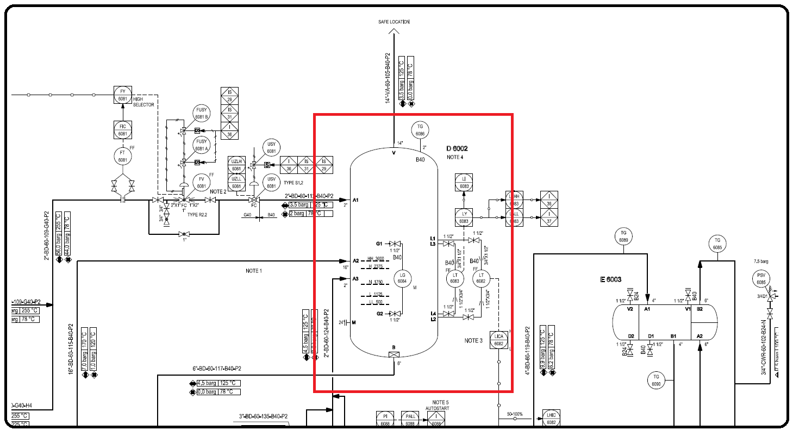P&ID

Cause

The drum is not sized properly.

Effect

The ammonia in the outlet water is more than specification and causes some trouble for downstream treatment facility.

Solution

The sizing of drum should be changed or steam injection should be added.