Our Mistakes

Reforming Unit

P-2001

Problem

The strainer should be changed from time to time more than expected.

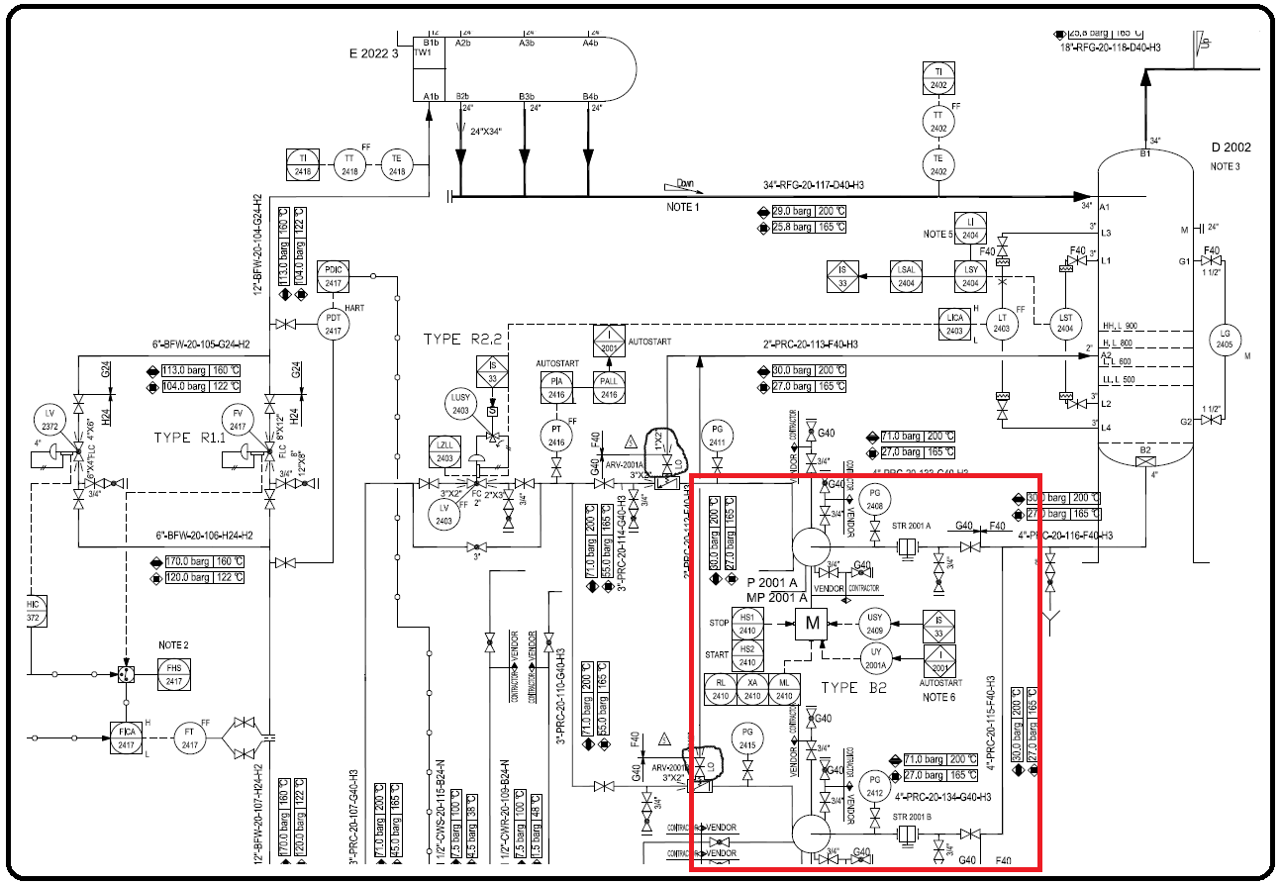P&ID

Cause

Catalyst particle which are carried by the inlet stream.

Effect

The pumps can’t pressurize the liquid.

Solution

Select a mesh with optimized number of holes.