Our Mistakes

Reforming Unit

LV-2016

Problem

Even though the material was suitable for the application we observed severe corrosion in the control valve.

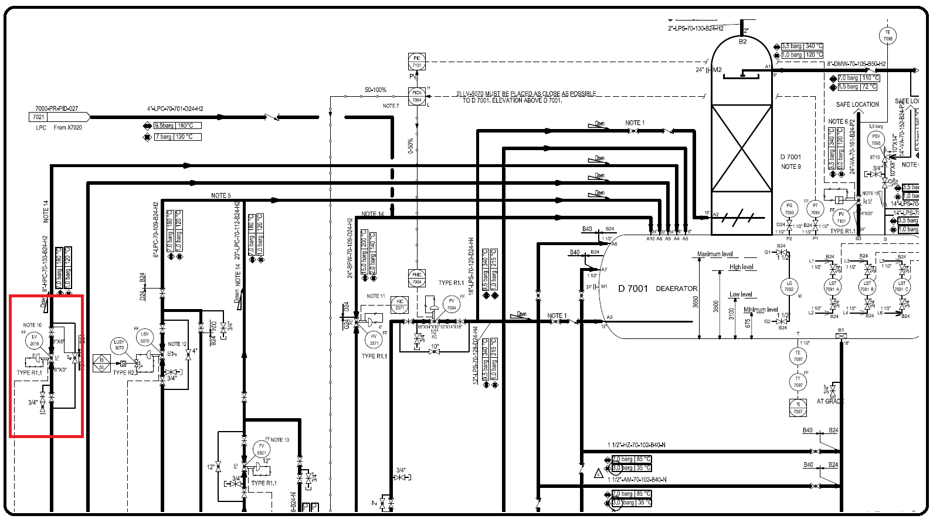P&ID

Cause

Lack of experience which led to wrong installation of control valve.

Effect

Creation of jetting steam which corrodes the body of the valve.

Solution

There is no need to change the material if already suitable based on convention. You just need to change the direction.

