Our Mistakes

Reforming Unit

BFW-Injection

Problem

There is the possibility that the gas might go in reverse direction and pollute the BFW system.

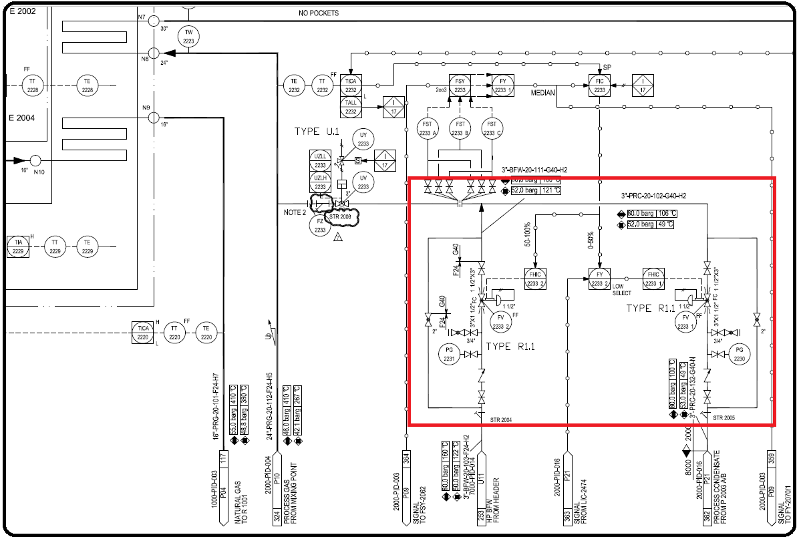P&ID

Cause

Lack of experience or abundance of work

Effect

Pollution in BFW system

Solution

Instead of adding check valve in such location, put the check valve after the branch.