Our Mistakes

Polishing Unit

Mixing Point

Problem

Regardless of the production pf a plant, whether it is methanol, ammonia or ethylene and so on, you always need a polishing unit to treat condensate. The most important part of a polishing unit is resin reactors. The resin absorbs cations and anions till it reaches its maximum capacity which is indicated by an increase in conductivity or PH or SiO2 content. Therefore, it needs regeneration from time to time.

In order to regenerate the resins, acid and caustic with usual concentration of 1-4 % are used but the acid and caustic are purchased from other companies with higher concentration- caustic48% and sulfuric acid 98%- and then they are diluted with DM water to reach 1-4% concentration. When acid and DM water are mixed due to exothermic reaction and mixing process of these two components, after a while, transferring pipeline becomes corroded in different parts and creates operational hazard and halt the process. Note that according to sulfuric acid curve the highest corrosion rate occurs around 87-89% of sulfuric acid, not in 98%!!

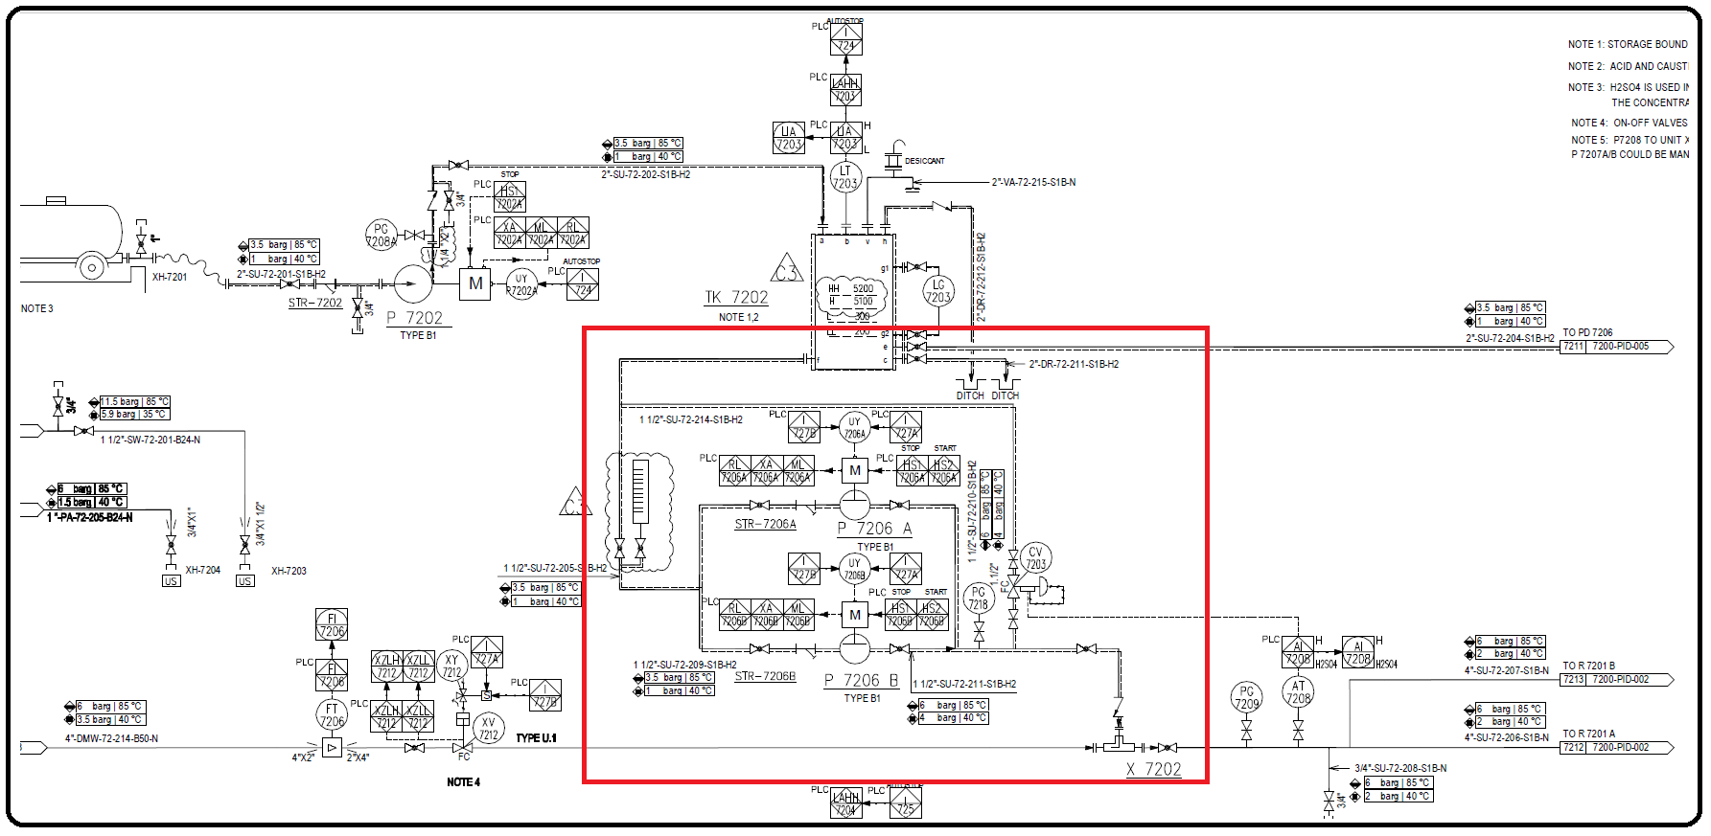P&ID

Causes and Solution

We have checked up to five polishing unit vendor documents and most of them had this problem but one of them less than others. Herein are the tips:  
1. Augment process protection: it means that add more isolation valve before mixing point to prevent DM water from backflowing to acid line. Secondly, add more drain in different parts so that accumulated acid in pipeline after regeneration is drained properly. Lastly, use double check valve but different types according to API.  
2.  Utilize lining for part of the pipeline: the most common materials are PVDF, EPDM, Glass and PTFE.  
  
Note that if you purchase 98% sulfuric acid, PVDF is not suitable for this application since according to compatibility chart it is not compatible with sulfuric acid with concertation higher than 93%.  
  
[Glass](https://www.linkedin.com/feed/hashtag/?keywords=glass&highlightedUpdateUrns=urn%3Ali%3Aactivity%3A6949588806220066816) is resistant against sulfuric acid but according to their handbook they are brittle and does not possess sufficient mechanical strength. One company used it and after 5 months they had to replace it.  
  
[EPDM](https://www.linkedin.com/feed/hashtag/?keywords=epdm&highlightedUpdateUrns=urn%3Ali%3Aactivity%3A6949588806220066816) is suitable for application with acid concentration lower than 50%. Nonetheless, in one company it was used for lining of their check valves with higher concentration and it had worked well.  
  
[PTFE](https://www.linkedin.com/feed/hashtag/?keywords=ptfe&highlightedUpdateUrns=urn%3Ali%3Aactivity%3A6949588806220066816) is suitable for all temperature and concentration rating of sulfuric acid.