Our Mistakes

Part 2

Gas Station-Flowmeter

Problem

Not according to international or domestic standards

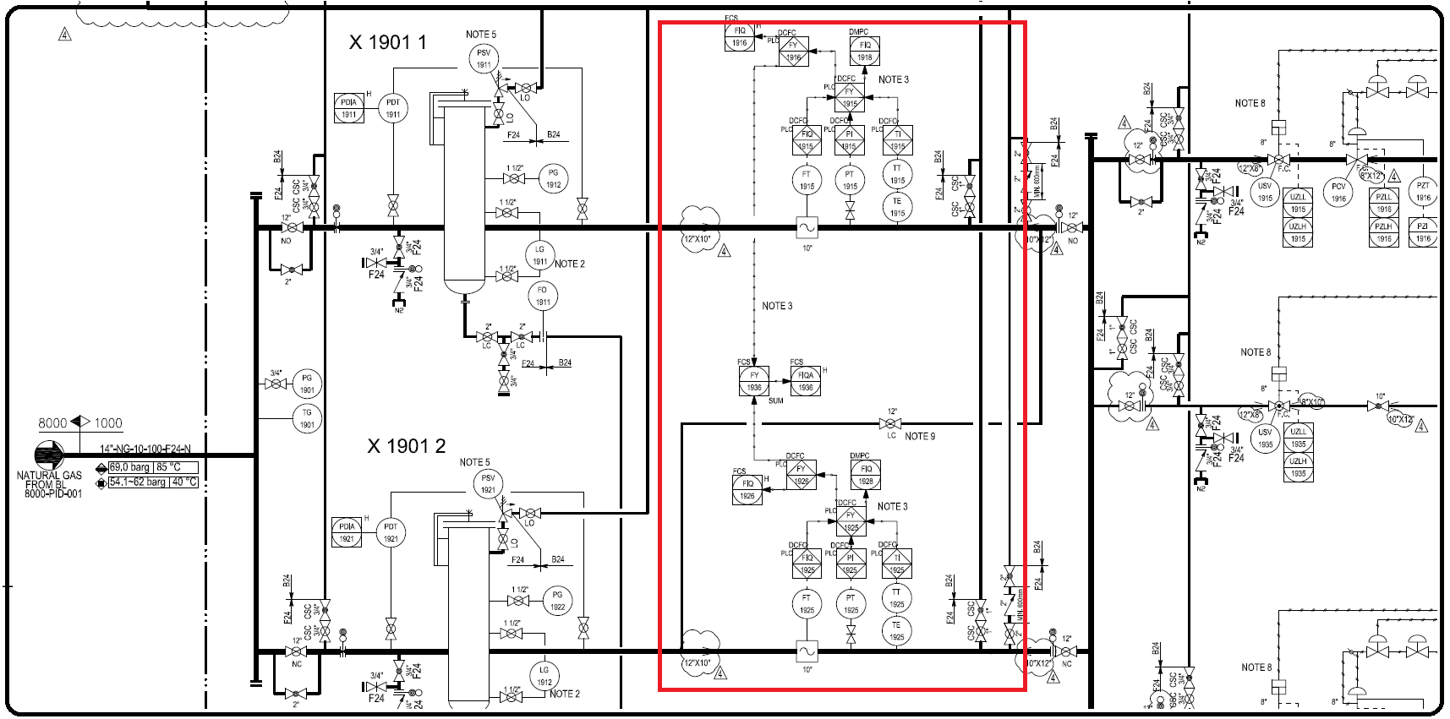P&ID

Effect

Theoretically the proving flowmeter should not be in service and when needed it should be put in service. By such configuration when we have some problems with first flowmeter, we have to put the first flowmeter out of service and as a result it could be checked by maintenance personnel. Because we don’t have another flowmeter, we have to use the proving flowmeter. Such action might impact the calibration status of the proving flowmeter.

Solution

Based on the standard, we should have three lines with three flowmeters to avoid such problems.