Our Mistakes

Oxygen Unit

USV-2045

Problem

The valve does not open during start-up.

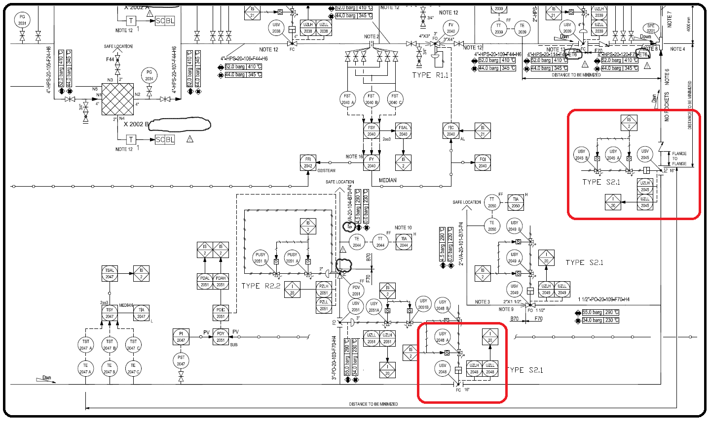P&ID

Cause

High pressure drops over the valve.

Effect

Explosion or delay in start-up

Solution

Increase in SIL of the loop- Use of valve manufactured by proven vendors- Pay attention to actuator design