Our Mistakes

Utility

Flowmeter type

Problem

We always have some arguments with the nearby company which provides us with utility. They say they have Coriolis flowmeter; thus, they are right.

P&ID

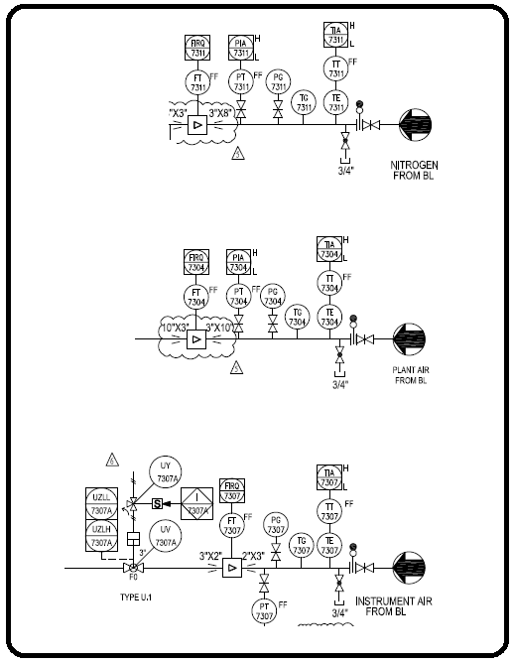

Solution

|  |  |
| --- | --- |
| Application | Flowmeter Type |
| Gas station | Ultrasonic |
| Fuel system | Ultrasonic-Turbine-Vortex |
| Fluid with high amount of conductivity | Magnetic |
| Fluids with conductivity less than 5 us/m | Vortex |
| Low pressure gases | Venturi |
| High pressure steam services | Flow nozzle |
| High erosion present | Flow nozzle |
| Battery limit-Product | Coriolis |
| Process unit where controlling parameters is a high priority | Orifice |