Our Mistakes

Logic

IS-6

Problem

During the shut-down of reformer in ammonia and methanol plants, the catalyst should be cooled down and protected against oxidation by a mixture of methanol and steam.

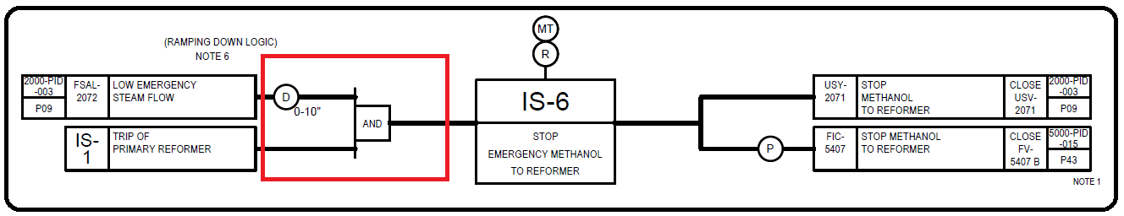Interlock Drawing

Cause

Wrong incorporation of delay function in logic and interlock diagram

Effect

Catalyst damage or oxidation

Solution