Our Mistakes

Hydrodesulfurization

Temperature Transmitter

Problem

Cooling medium temperature can’t be monitored during change of catalyst.

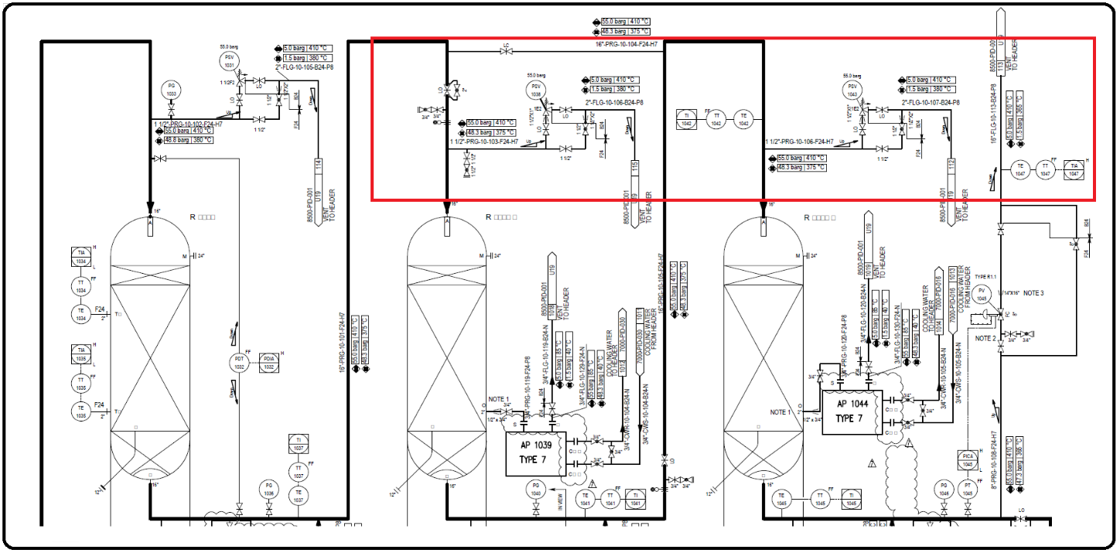P&ID

Effect

There is the possibility that wrong estimation of the cooling medium could lead to disaster since the catalysts are

Solution

Adding a temperature transmitter solves the problem.