Our Mistakes

Reforming Unit-Logic

IS-1

Problem

Due to mal-operation or wrong design of interlock of the furnace in reforming unit, the reformer went out of service.

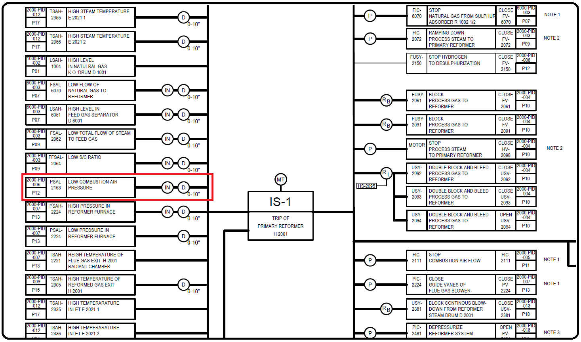Interlock Drawing

Solution

After a mini-HAZOP we decided the time delay to be 120 seconds.