Storage Tank Material Selection

Storage tanks built in accordance with API 650 commonly are made of mild steel. API 653 contains requirements for tank inspection, repair, alteration and reconstruction. As discussed in Chapter 1, as a minimum 1.5 mm (1/16 in.) corrosion allowance normally is specified for storage tanks. Where experience indicates a 1.5 mm (1/16 in.) corrosion allowance is not adequate, internal linings usually are specified. Where tanks are lined internally and painted externally, a zero-corrosion allowance often is specified. Notch tough steel is required when the design metal temperature is 10°C (50°F) or below (lowest one-day mean temperature of 2°C [35"F] or below). High-strength steels sometimes are used in large diameter tanks to minimize cost by reducing the required thickness. Care should be exercised when selecting high-strength steels for fluids containing hydrogen sulfide because of the potential for SSC. As a minimum, the hardness of the welds should meet NACE RP0472.

Corrosion in Petroleum Storage Tanks

Corrosion in atmospheric storage tanks can be divided into three zones: (1) the tank roof, (2) the walls, and (3) the bottom. Corrosion on the underside of the tank roof is controlled by the relative amount of air and hydrogen sulfide, as well as the temperature. As can be seen in Figure 5.26,18 the worst condition is 0.5% hydrogen sulfide. Inorganic zinc coatings are used most commonly for corrosion protection of the roof area. Inert gas blankets also can be used to prevent corrosion in cone roof tanks. The corrosion rate as a function of tank wall height is shown in Figure 5.27.18 Corrosion in light (API density 50 degrees or lighter) is higher than in heavier products because oxygen solubility is higher. Corrosion is high in the 80% to 90% level of the side wall due to the mechanism shown in Figure 5.28.18 In floating roof tanks, corrosion is found in the area where the major travel of the floating roof occurs (often this is halfway up the tank).I8,l9This corrosion is a result of the oxygen that enters the tank around the roof seals, concentrating in the water layers on the gasoline just beneath the floating roofs. The scale formed in this area is then scraped away by the moving roof, exposing fresh metal to attack. Coatings usually are used to solve this corrosion problem. Tank bottom corrosion is a function of the water layer that exists on the bottom of most tanks. The presence of sulfate-reducing bacteria, characterized by shiny pits, is more of a problem in heavy stocks because oxygen cannot get to the bottom. Tank bottom corrosion is controlled by coatings and by draining the water from the tank bottom periodically. API RP 652 contains recommendations on lining above-ground petroleum storage tank bottoms. Both epoxy and polyester coatings reinforced with chopped glass fiber have been used successfully in places where severe corrosion has occurred. For new tanks in which corrosion is expected, coal tar epoxy usually is specified for the bottom. When the tank is on soil or other conductive media and water cannot be prevented from contacting the underside of the tank bottom, cathodic protection in accordance with NACE RP0193 normally is applied. In some locations double bottoms have been used in tanks to minimize leaks into the ground and to facilitate leak detection. The space between the two bottoms often is filled with sand. If the double bottom is a retrofit, accelerated corrosion of the new steel can occur because of the difference in corrosion potential of the new bare material and the old corroded material. Since it is almost impossible to seal the space between the two bottoms, a cathodic protection system usually is used to prevent corrosion. Impressed current cathodic protection is preferred over a sacrificial system because the current requirements often are higher than that which can be obtained from sacrificial anodes. Further information on double bottom tanks is contained in Meyers20and McJones.\*' More details on design and corrosion of tanks are contained in Menick22 and Meyers.

Low-Pressure, Low-Temperature Tanks

Liquid ammonia, liquefied propane gas (LPG), and liquefied natural gas (LNG) would not be expected to cause corrosion problems since they are stored at low temperatures (-33"C, -42"C, and -162OC [-28"F,-40"F,a nd -260"FI respectively). However, there have been reports of SCC in fully refrigerated (-33°C [-F]) liquid ammonia storage tanks. Cantwell has reported SCC of LPG spheres as a result of trace amounts of hydrogen sulfide in the LPG.23 The primary concern in storing these fluids has been resistance to brittle fracture. Appendix A lists common materials suitable for the low temperatures at which these fluids are stored. More detailed requirements for liquid ammonia and LPG tanks are contained in Appendix R of API 620 and in BS 7777. More detailed requirements for LNG tanks are contained in Appendix Q of API 620 and in BS 7777. Ultrafine grain materials for LPG tanks must be used with caution because failure can result from excessive weld repair, which causes strain damage in the base metal. There have been a few steel wire-wrapped concrete tanks used for LNG; however, the majority are of double-wall construction. The three basic types of double wall tanks in order of increasing cost are: 1) single containment, 2) double containment, and 3) full containment. The most commonly used type is the single containment shown in Figure 5.29. The single containment tank has a carbon steel outer wall (designed for atmosphere temperature), which is separated from the inner tank by foamed fiberglass (to absorb expansion and contraction) and perlite insulation. An example of a double containment type would be one with a prestressed concrete outer wall either separated from the carbon steel outer wall or lined with carbon steel.

An example of a full containment type is one that has a reinforced concrete roof and a prestressed concrete outer wall. The inner tank on all three types is made of either 9% nickel steel (usually economical for large tanks), 304 *SS* (UNS S30400), or aluminum (usually economical for small tanks).

Nine percent nickel steel usually is used in the quenched and tempered condition. Modem steelmaking practices have made it possible to obtain high fracture toughness in 9% nickel steel. A Charpy V-notch impact strength of 100 J (74 ft-lbs) at -196°C (-320°F) now commonly is specified. Tempering should be done at 580"C+ 6°C (1,075"F f. 10°F). Below 565°C (1 ,050"F), temper embrittlement can result; above 595°C (1,100"F), austenite will form and upon cooling transform to martensite, thereby lowering the toughness. For 9% nickel steel with thicknesses greater than 25.4 mm (1 in.), fracture mechanics testing should be considered to determine the maximum allowable flaw size. The maximum thickness where good properties can be obtained is 51 mm (2 in.). The minimum thickness should be 9.5 mm (3/8 in.) because of the potential for warpage from the severe blasting required for descaling 9% nickel steel.

Using fracture mechanics testing or BS 7777, design stresses can exceed those allowed by API 620, Appendix Q (218.6 MPa [31.7 ksi]). In these cases, the allowable stress is limited to two-thirds of the yield strength. Although the allowable stresses in BS 7777 are higher than in API 620, Appendix Q, the wall thickness of a tank designed to BS 7777 is thicker than that required by API 620, Appendix Q. This is because BS 7777 requires a full height hydrostatic test while API 620, Appendix Q requires only a partial height hydrostatic test to 1.25 times the LNG load. Because of long successful service of tanks designed to API 620, Appendix Q, there is a trend in the industry away from the full height hydrostatic test. Since the 65Ni-15Cr-Fe weld metal normally used to join 9% nickel is weaker than the base metal, the yield strength of the weld metal limits the allowable design stress. The maximum yield strength currently attainable with 65Ni-15Cr-Fe filler metal is 414 MPa (60 ksi). The 414 MPa *(60* ksi) minimum yield strength of 65Ni-15Cr-Fe 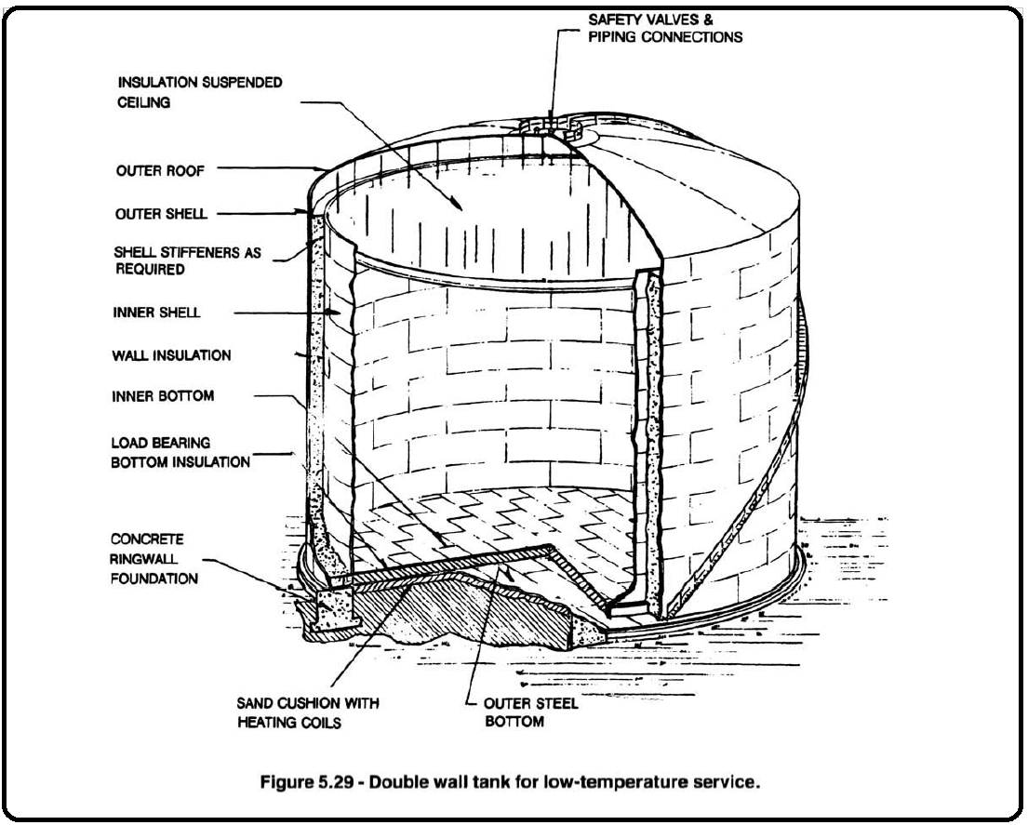filler metal minimizes the thickness required in the tank wall and, consequently, the cost.