Material of Construction

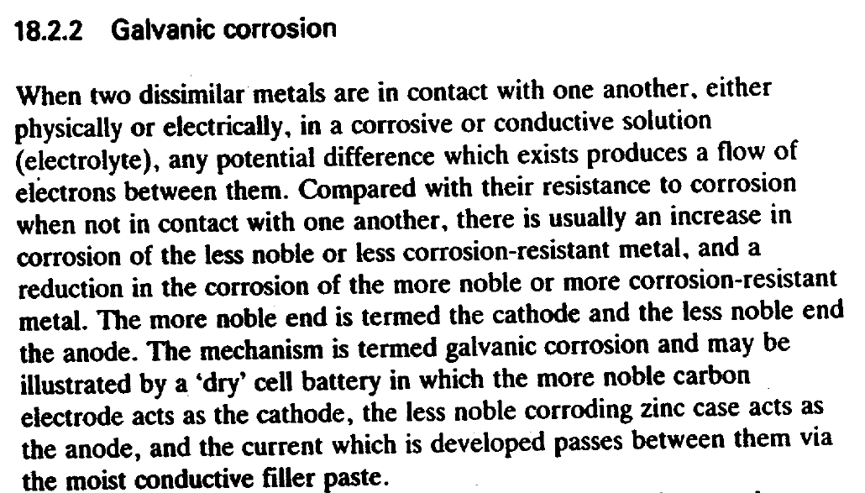
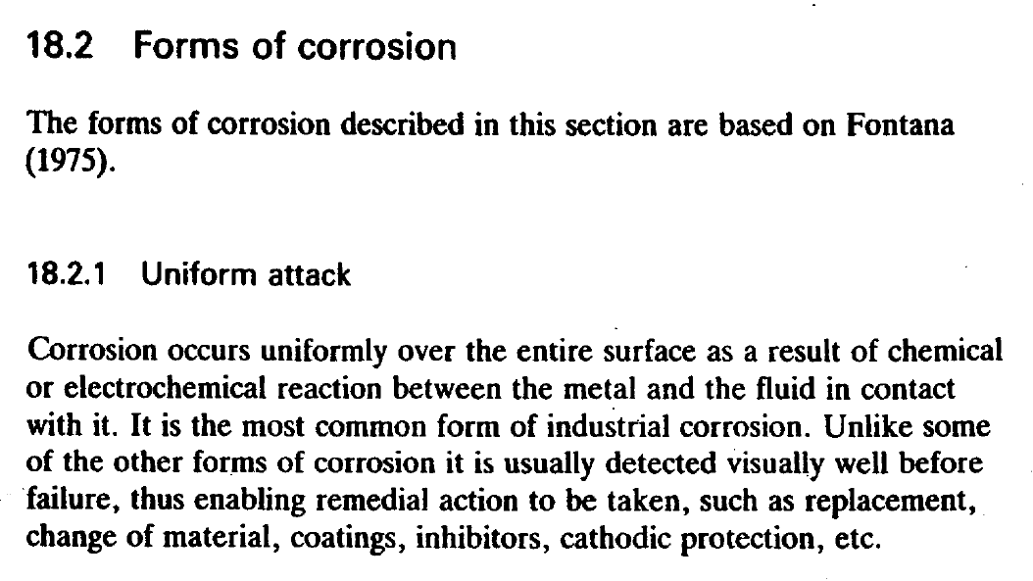
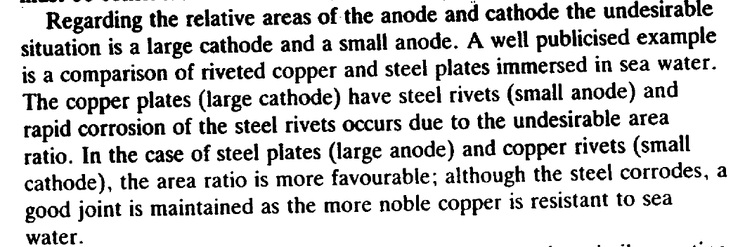
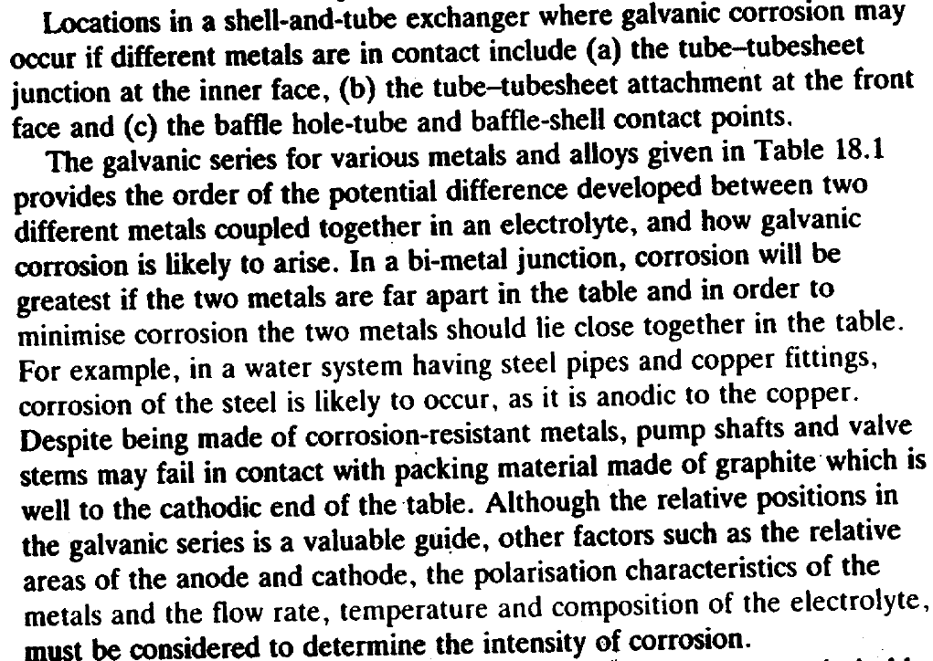

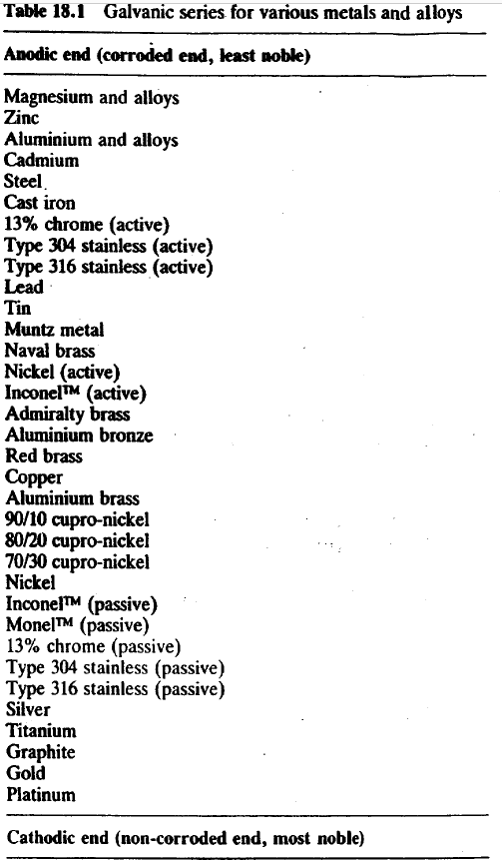
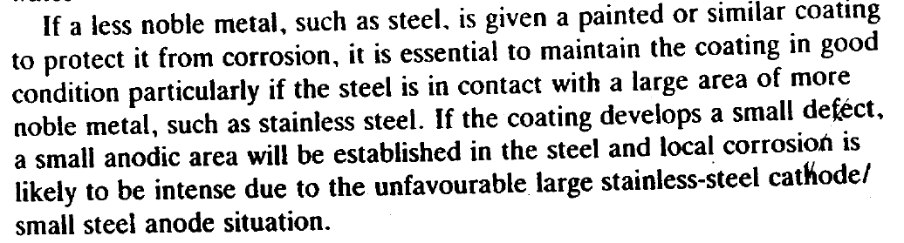

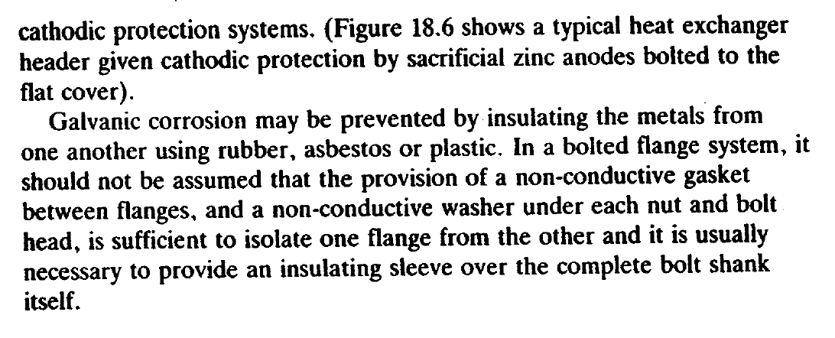
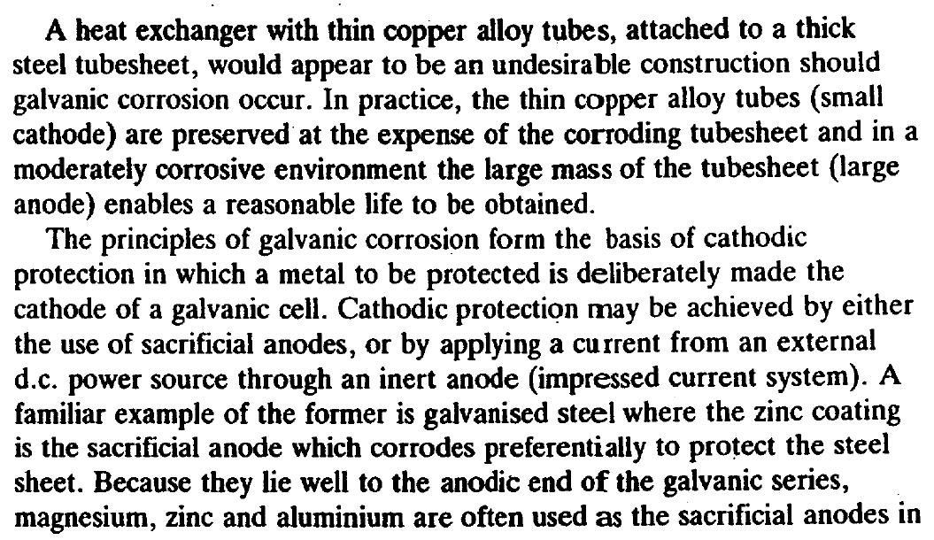

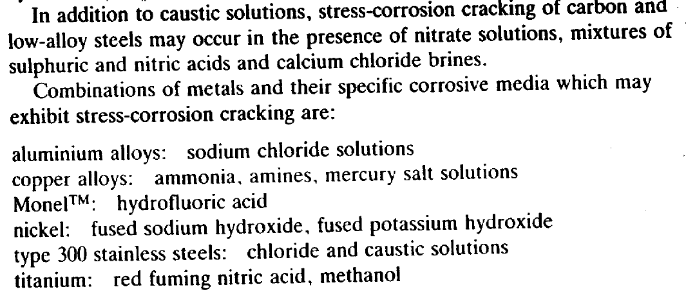
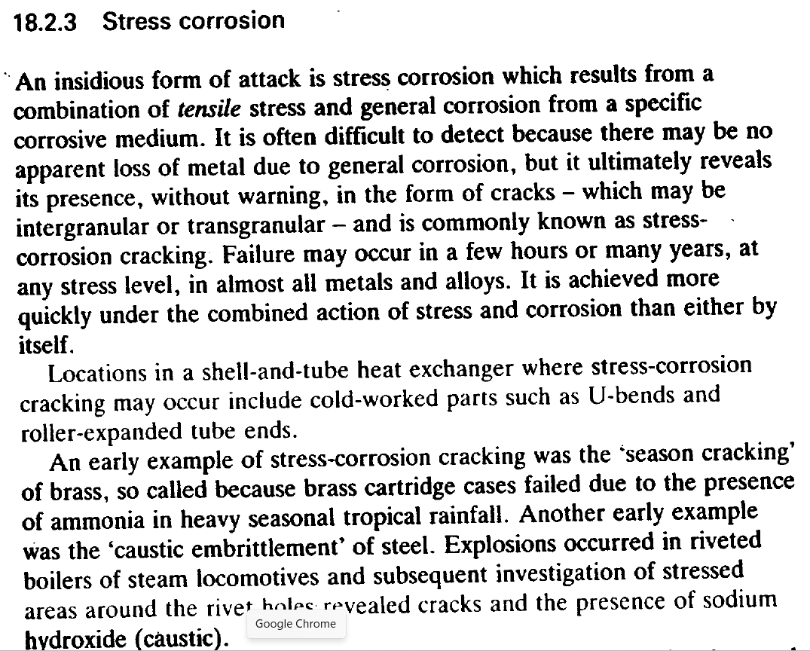
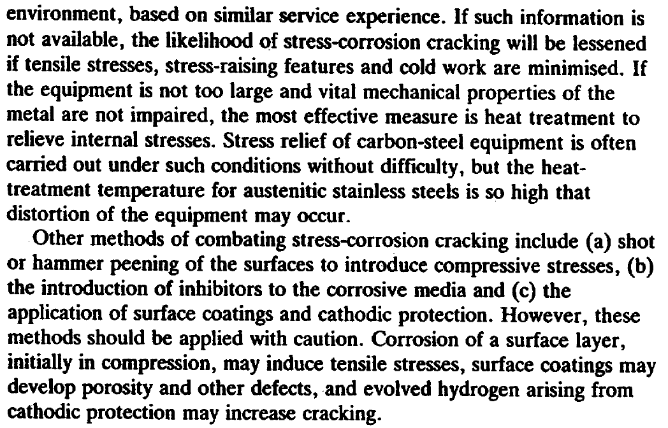
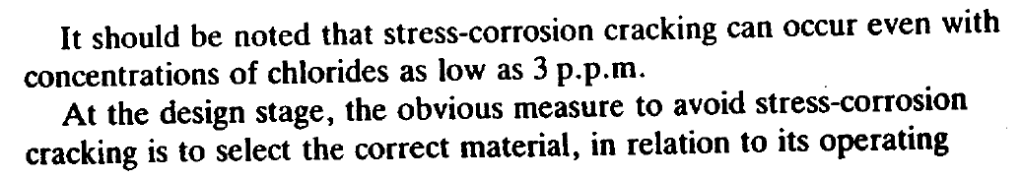

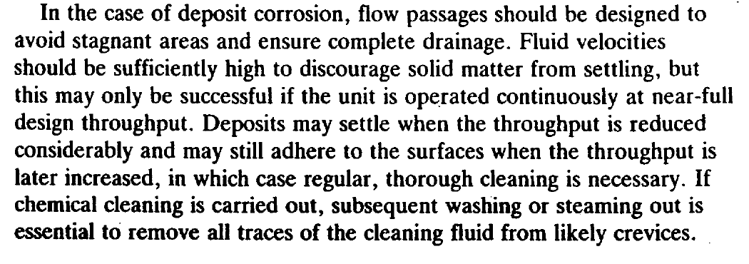
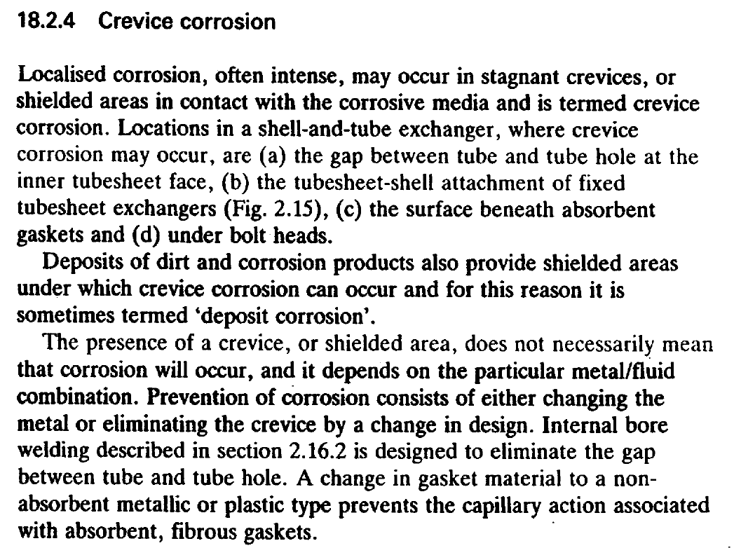
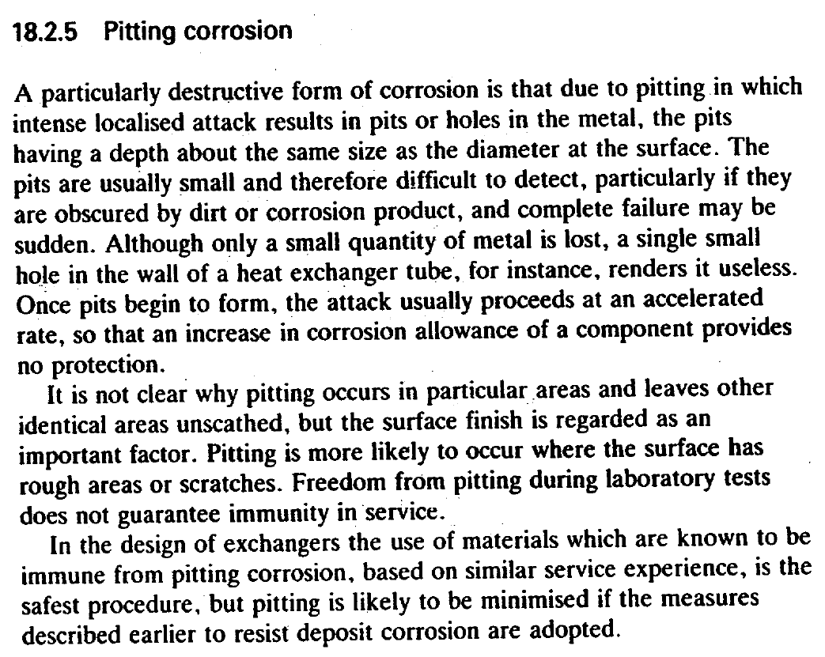

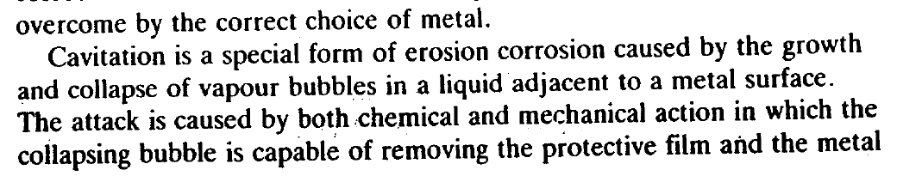
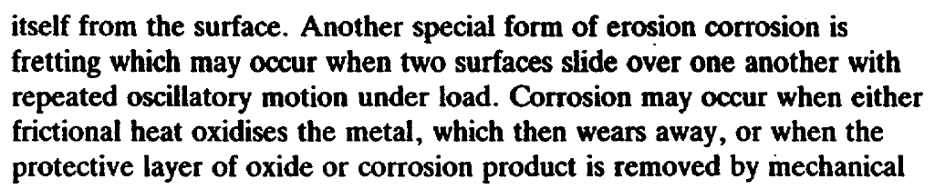
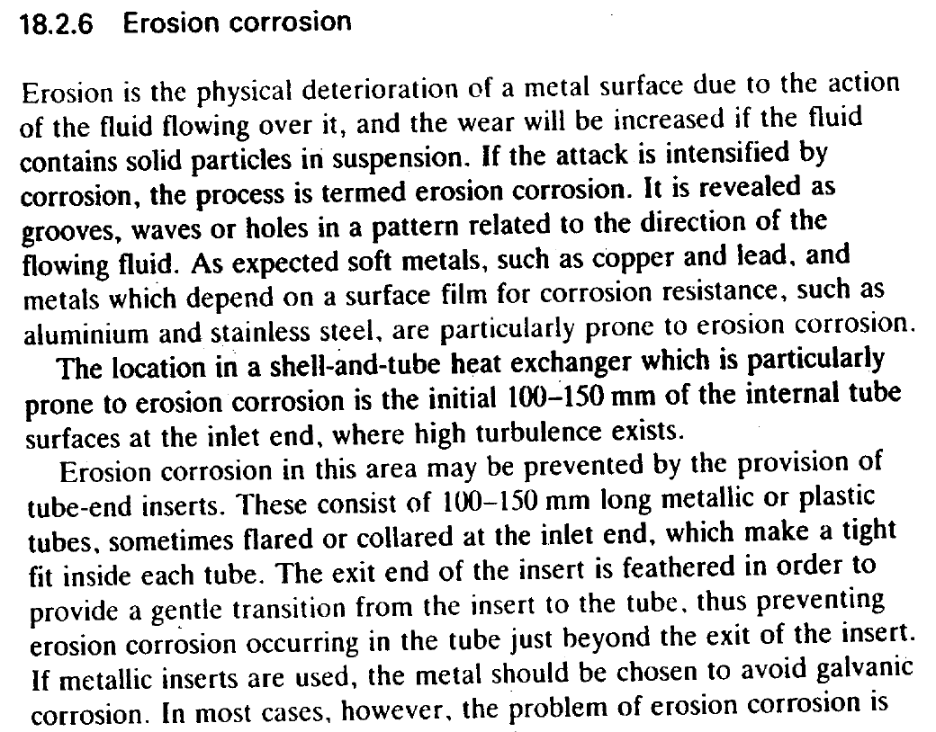
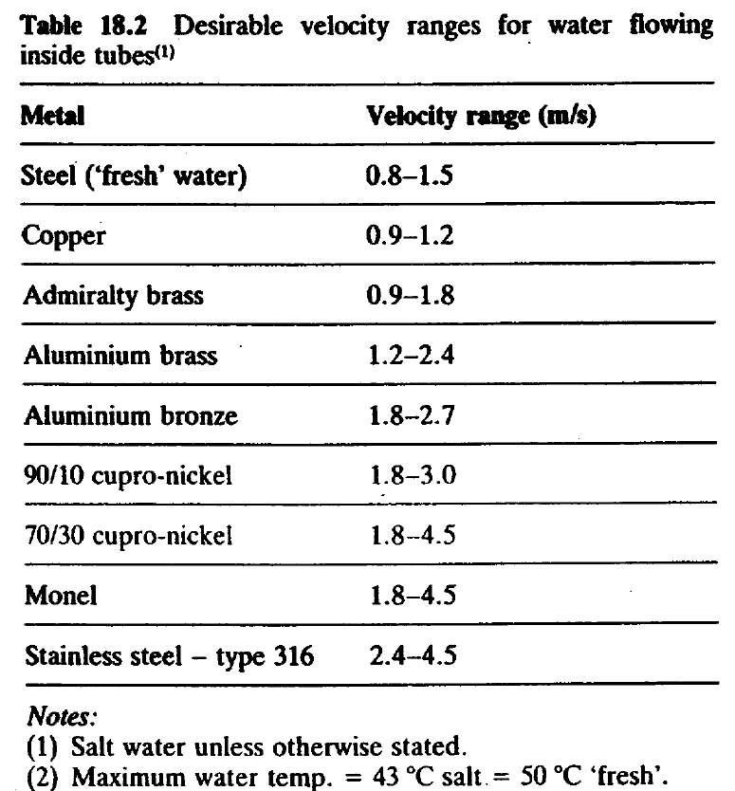
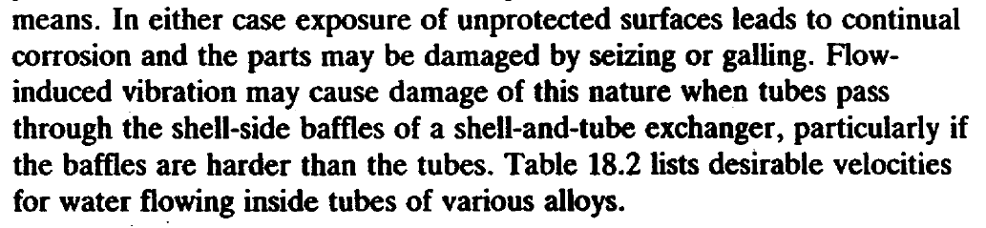
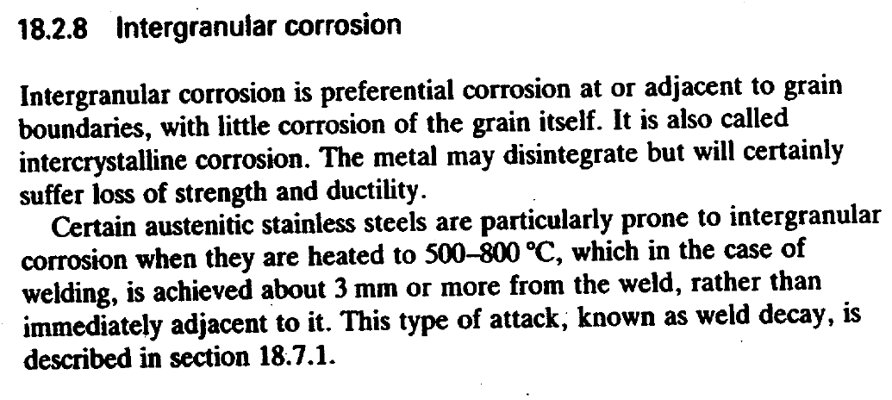
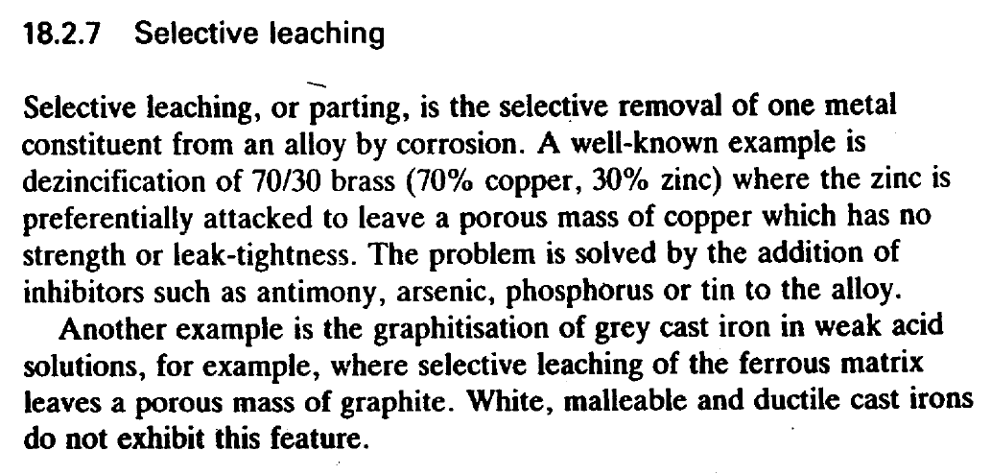

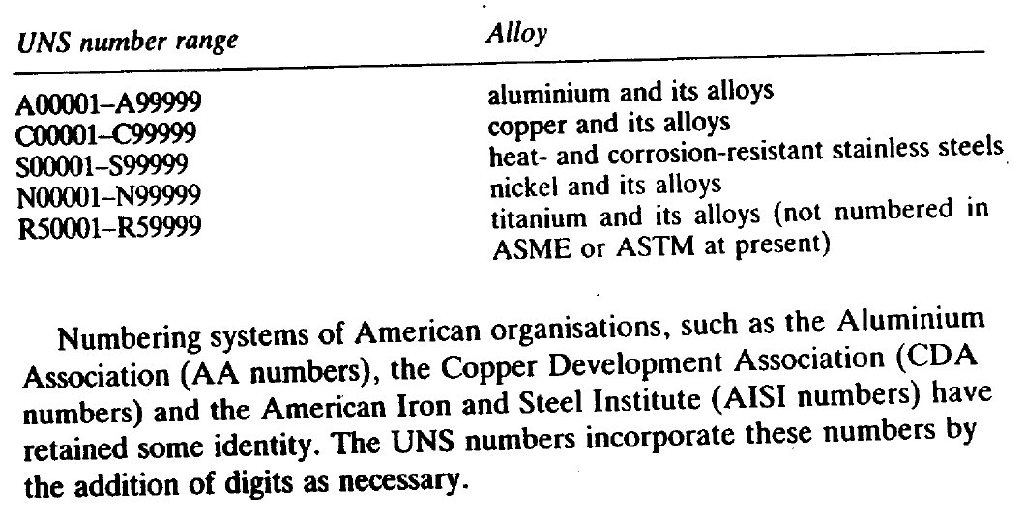
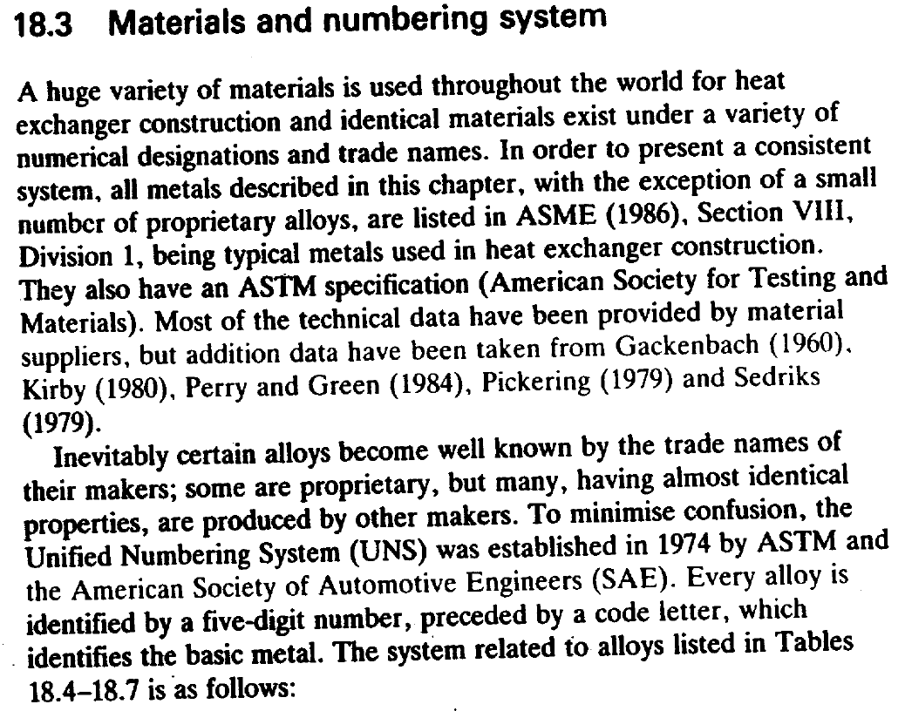
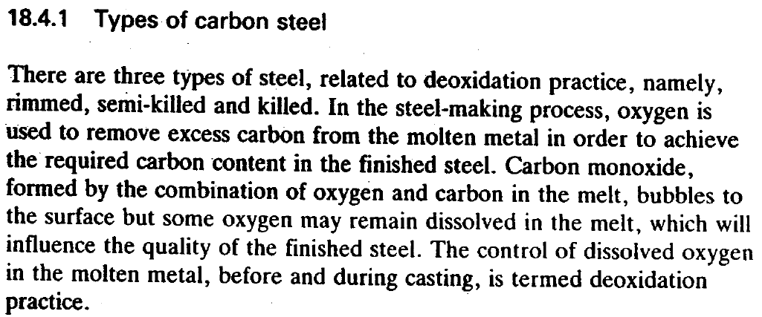
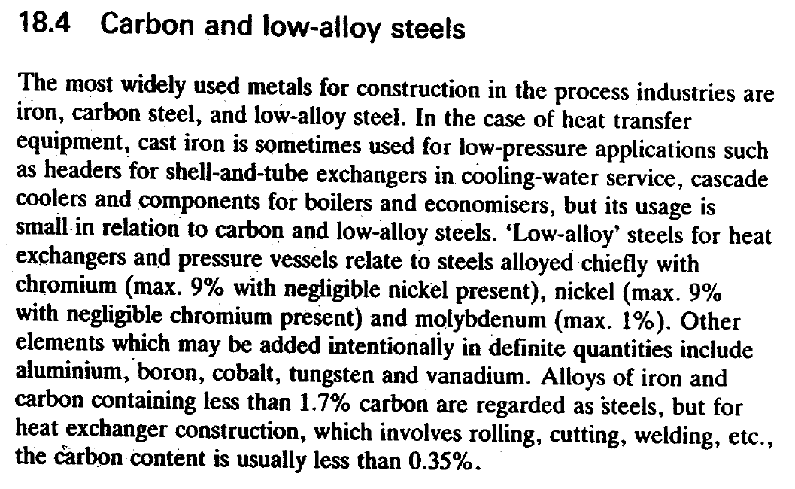

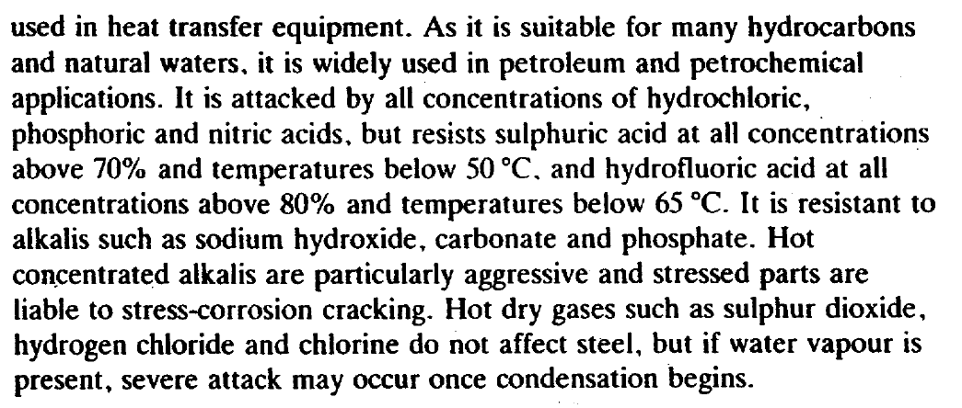
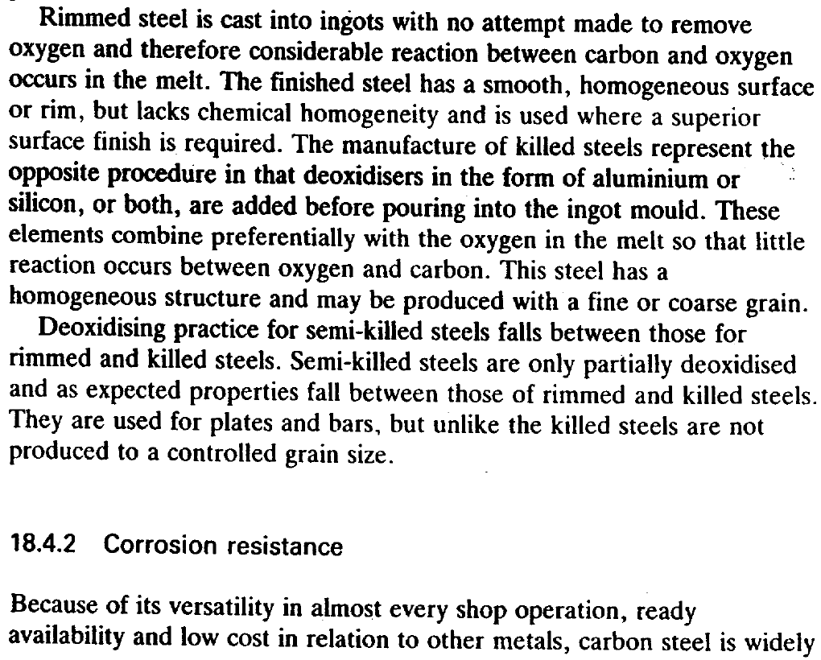
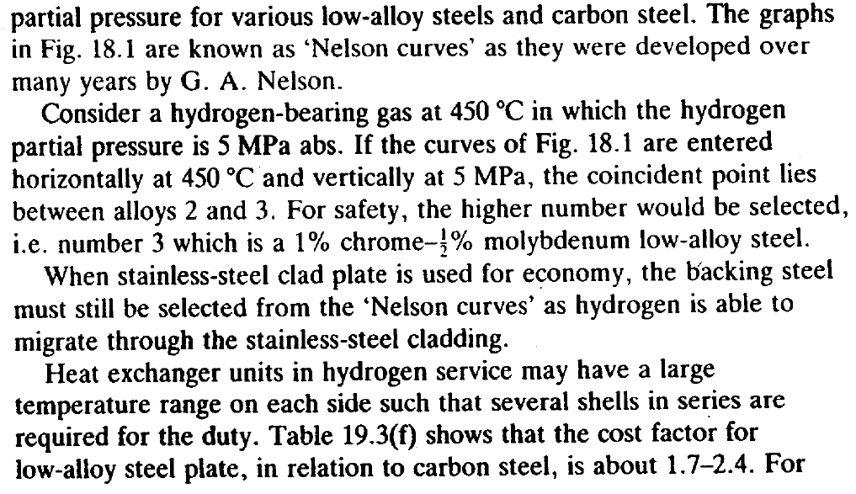
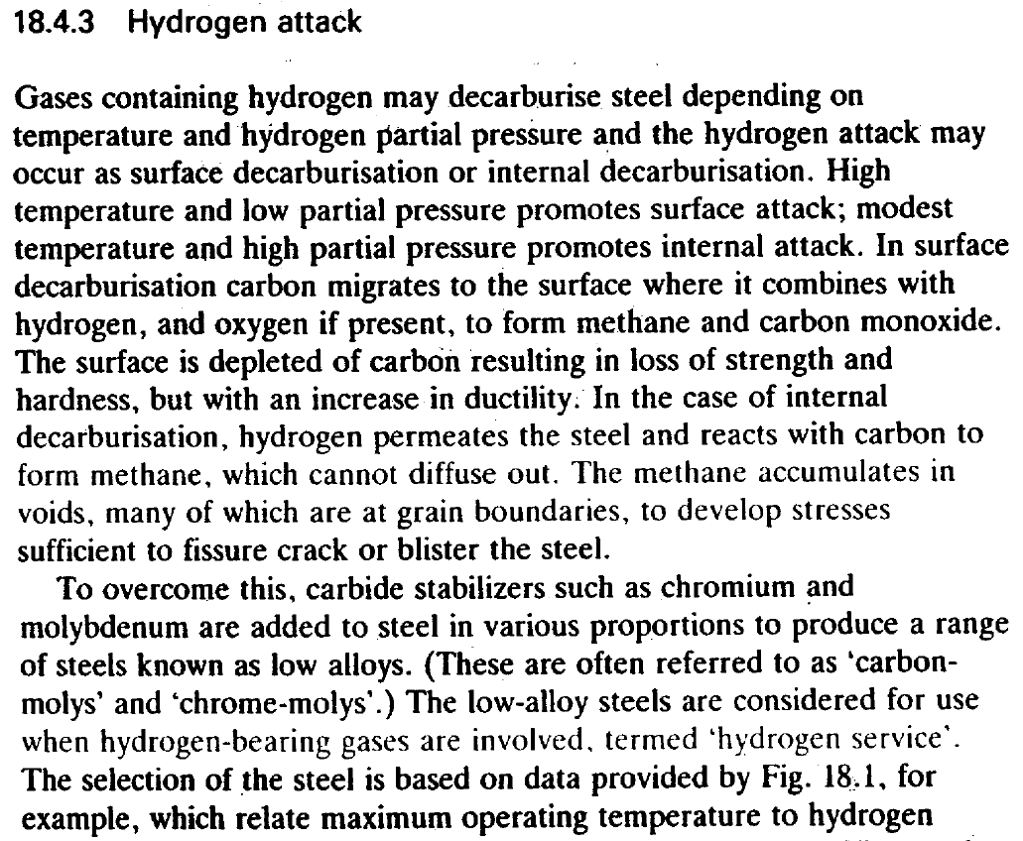
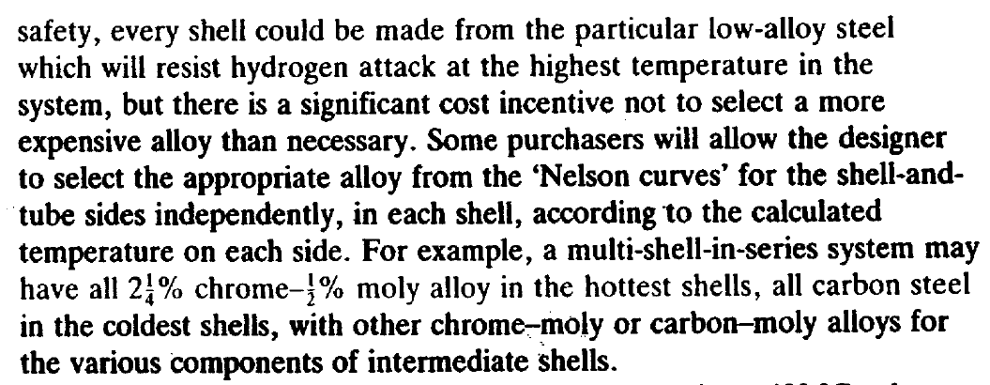
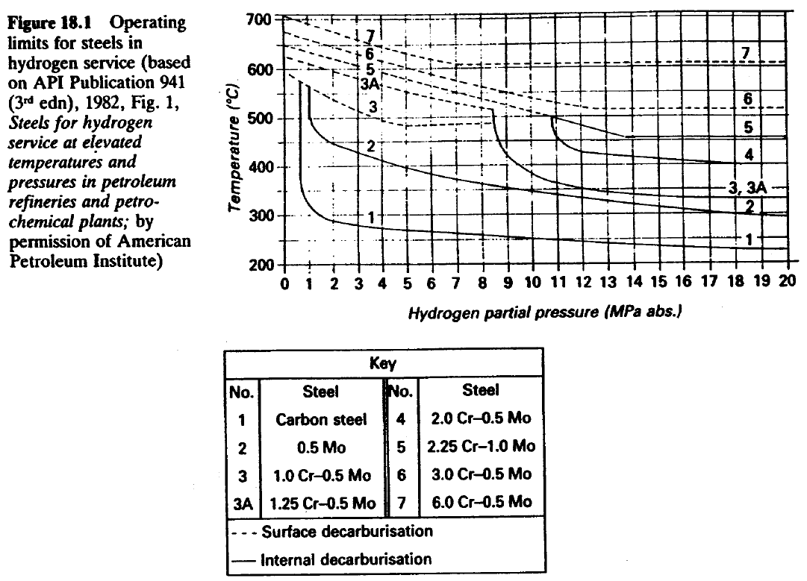
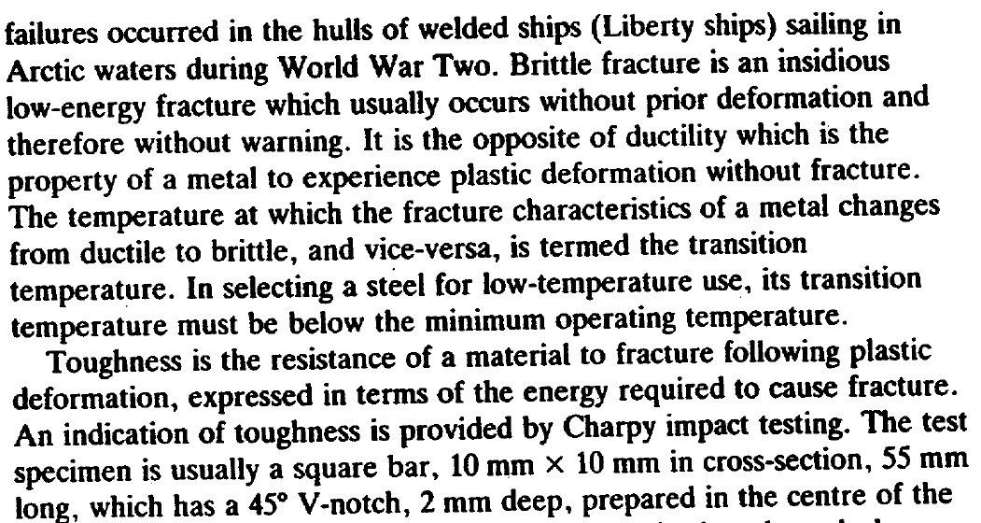
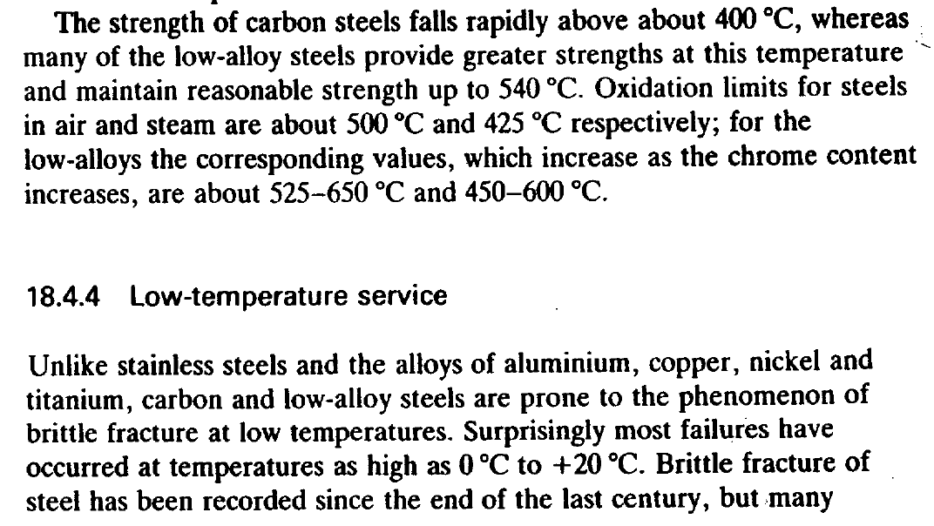

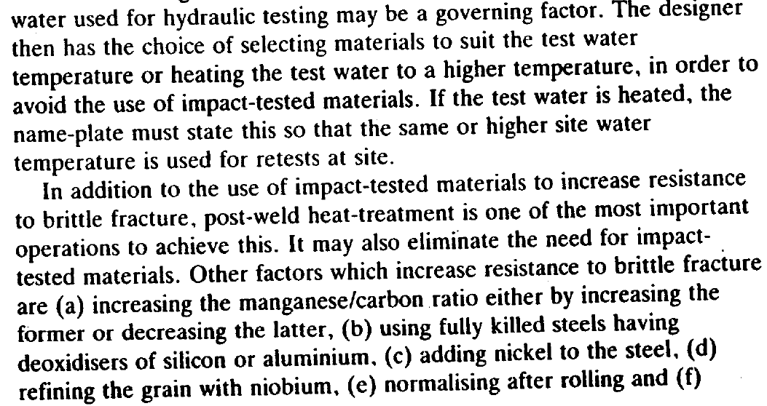
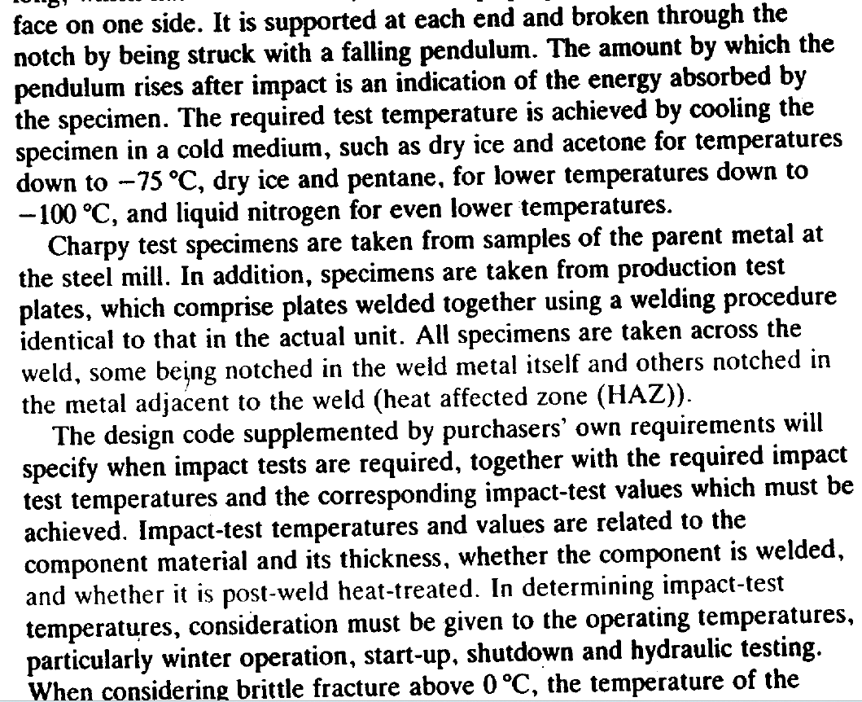
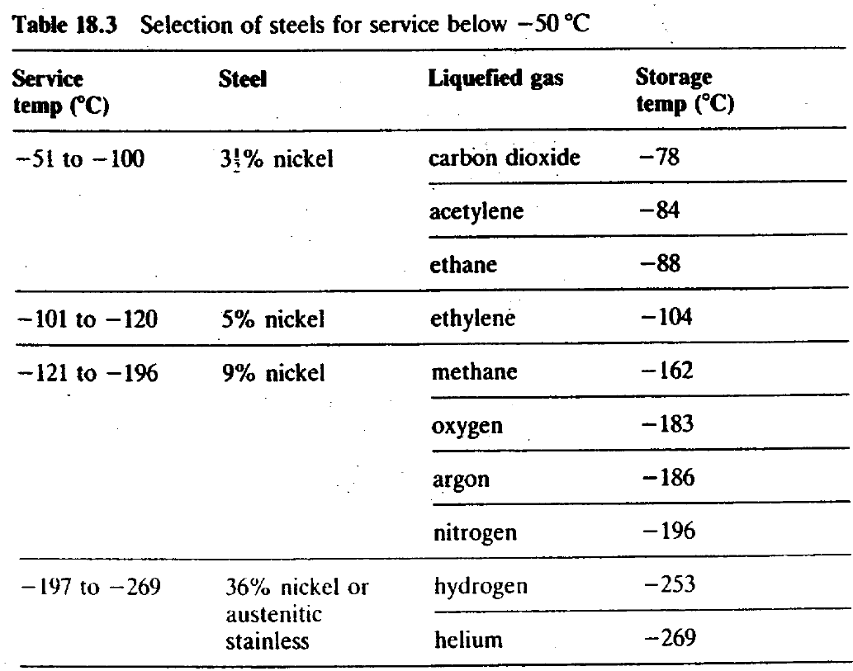
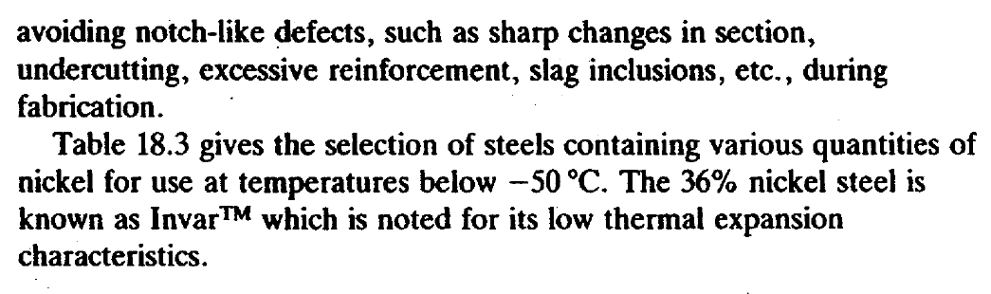

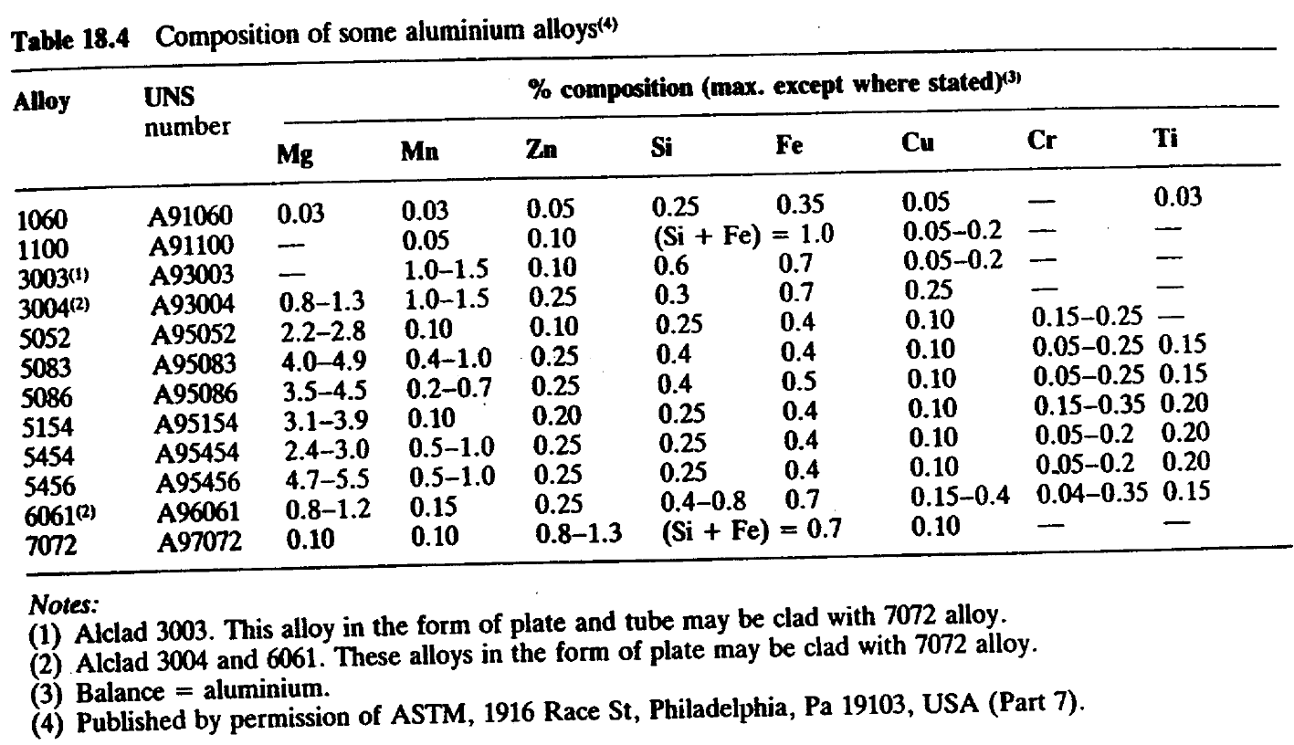
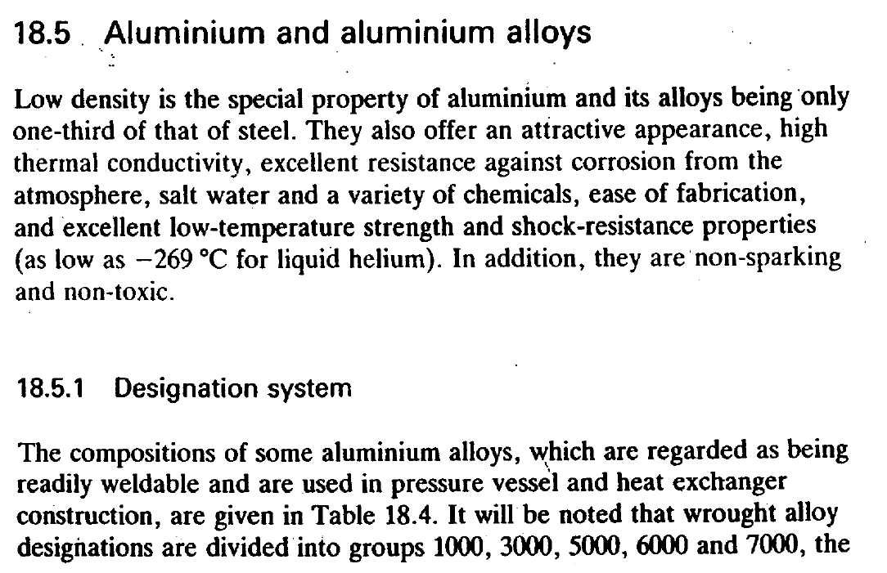
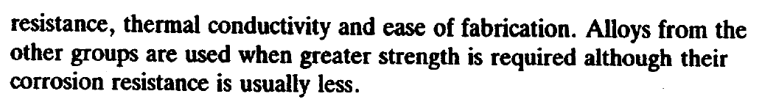
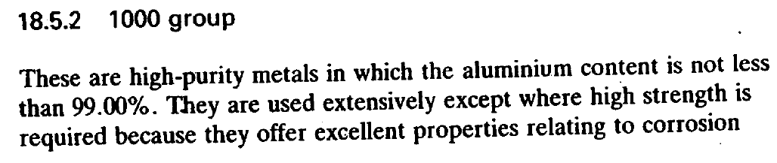
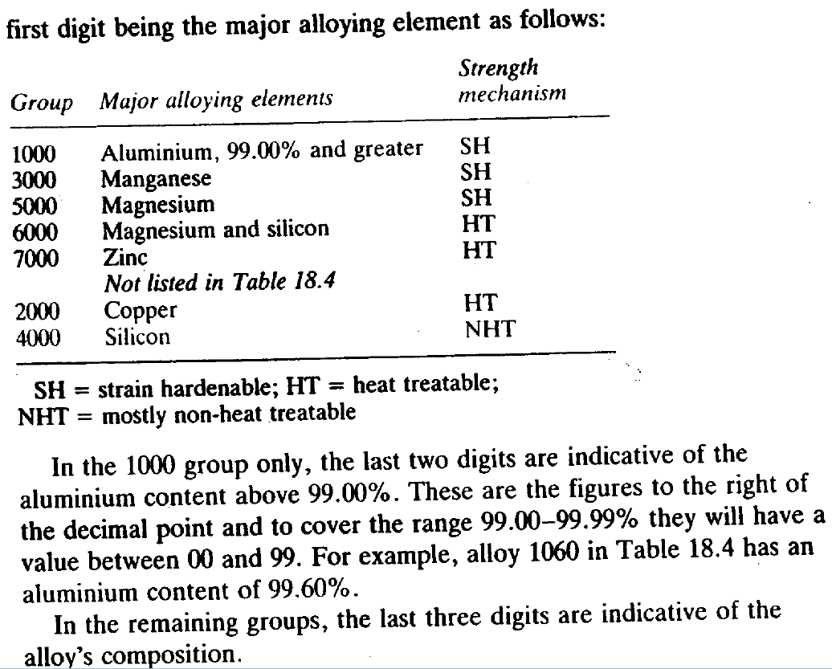
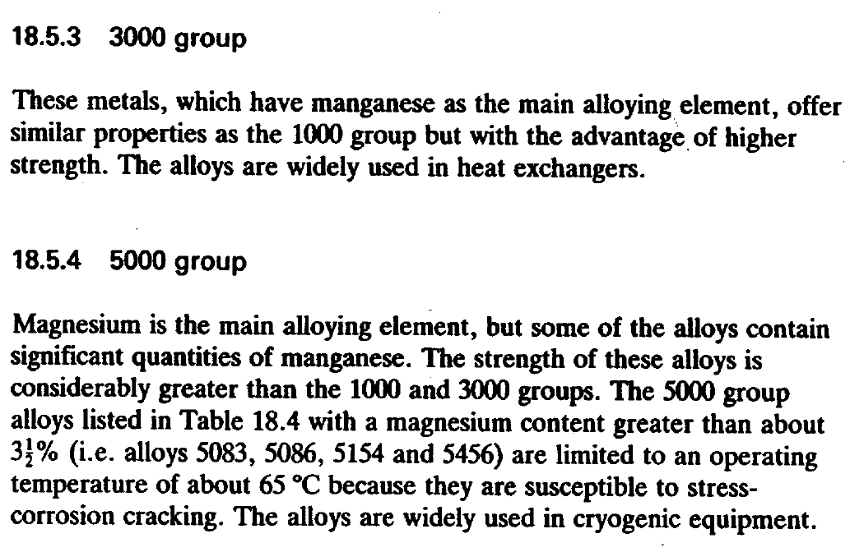
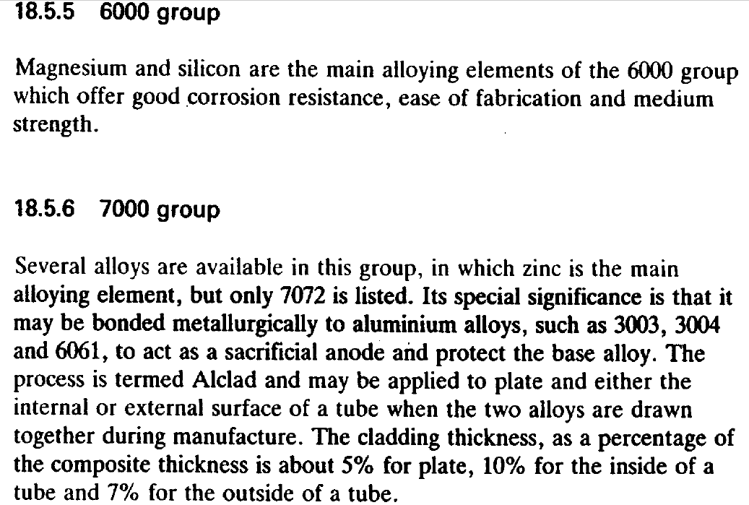
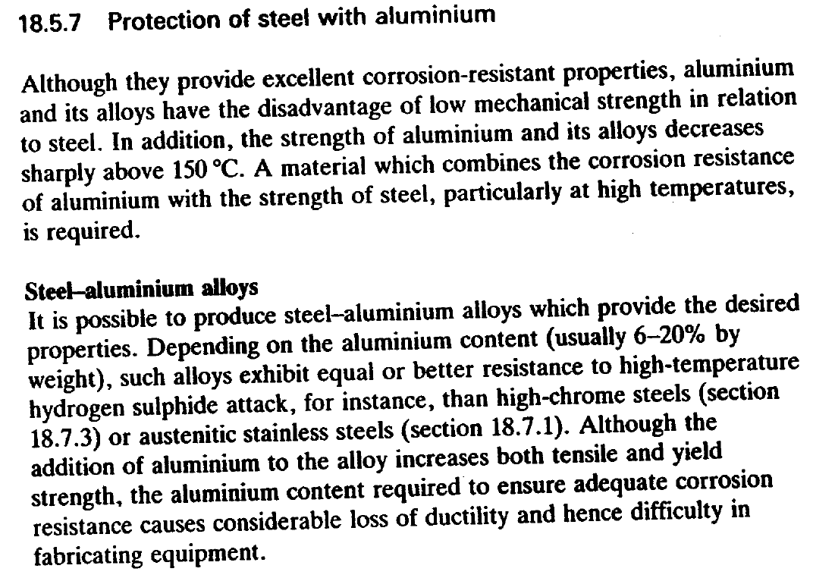
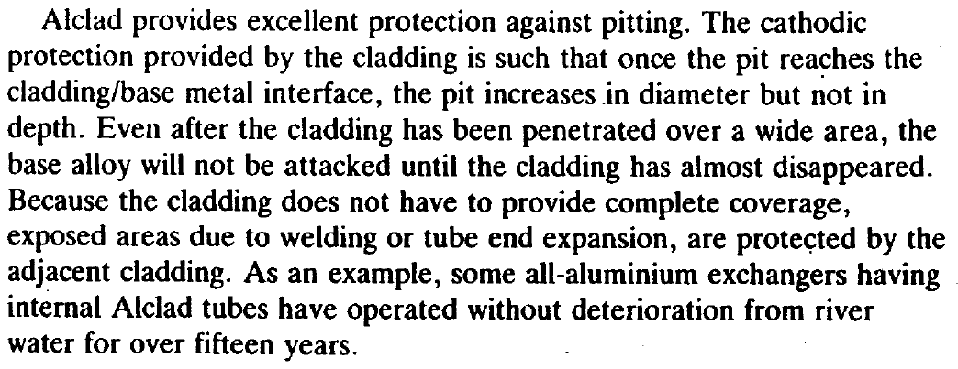

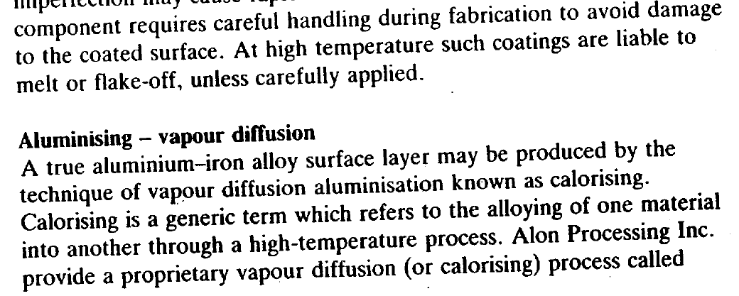
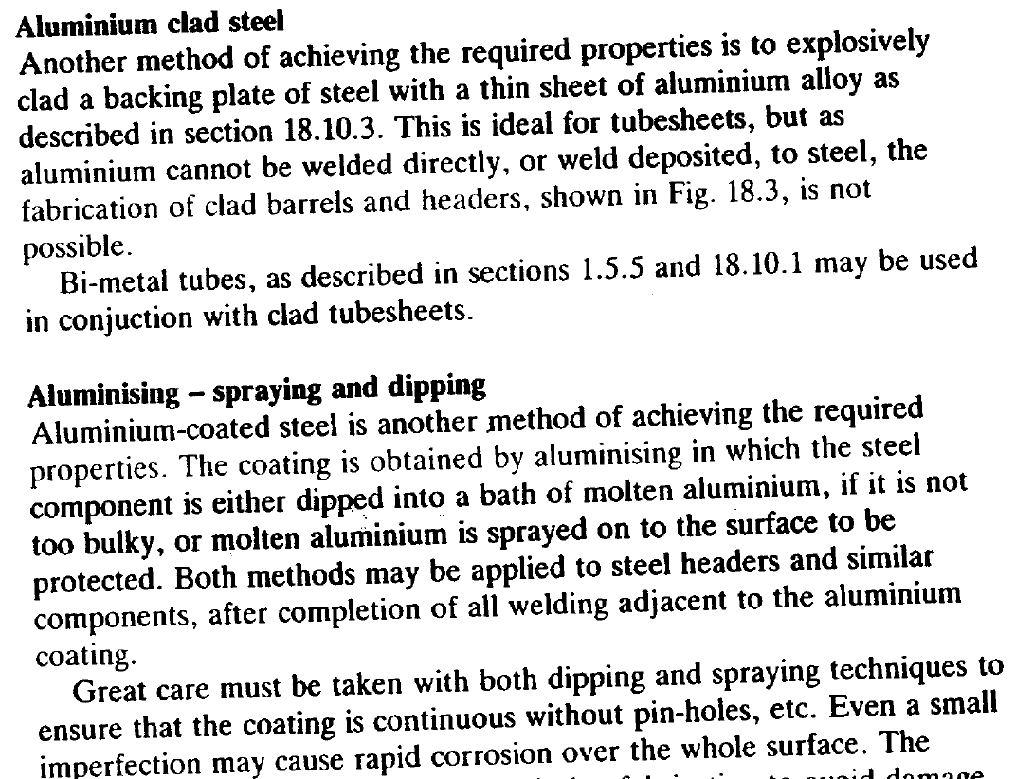
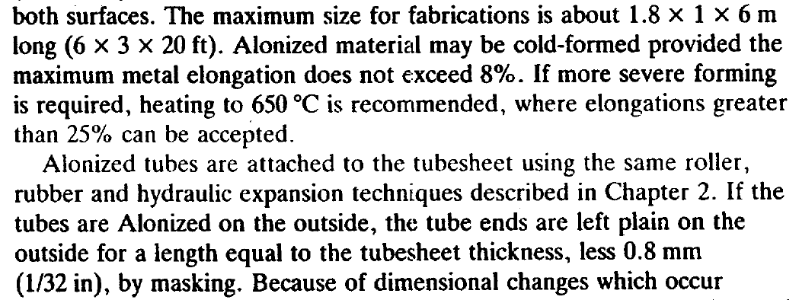
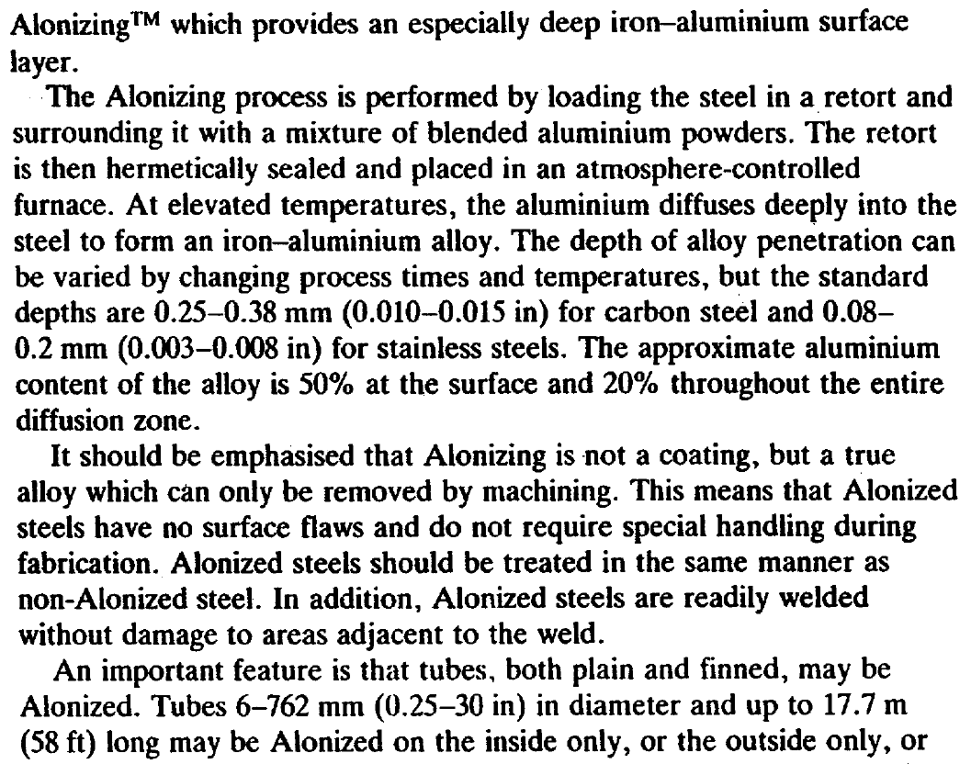
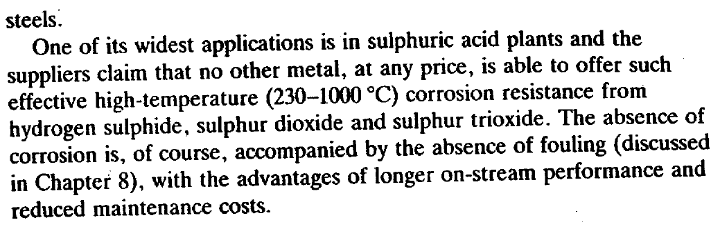
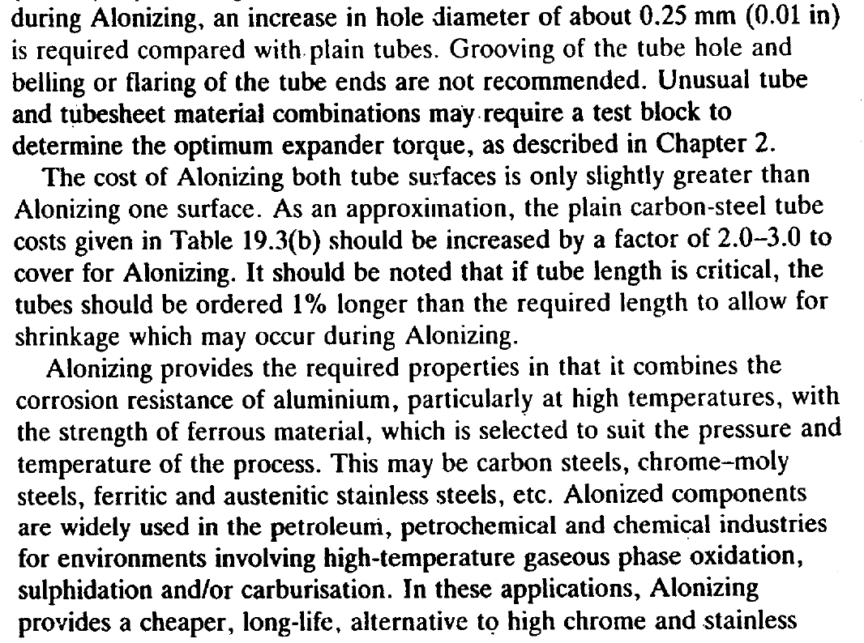

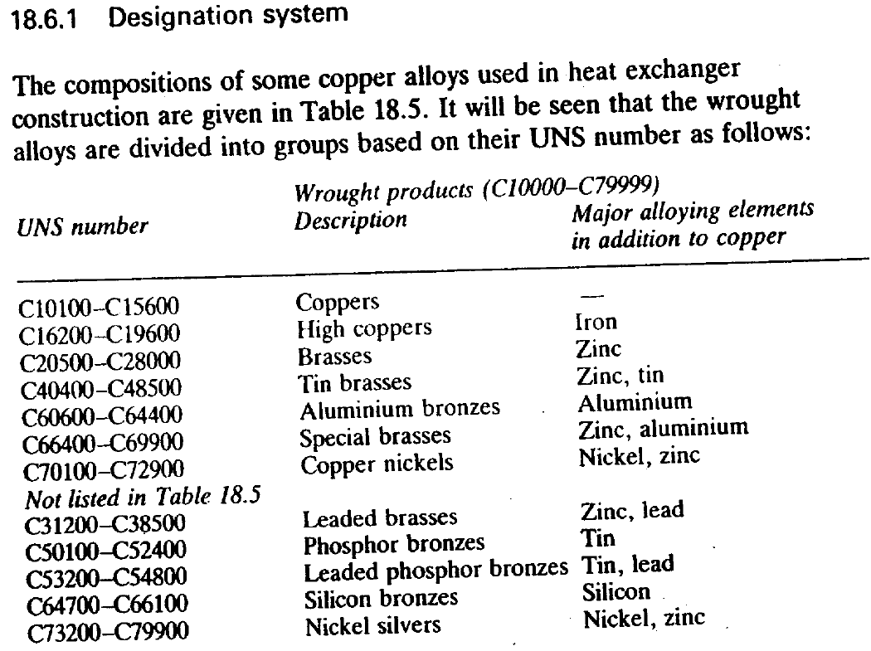
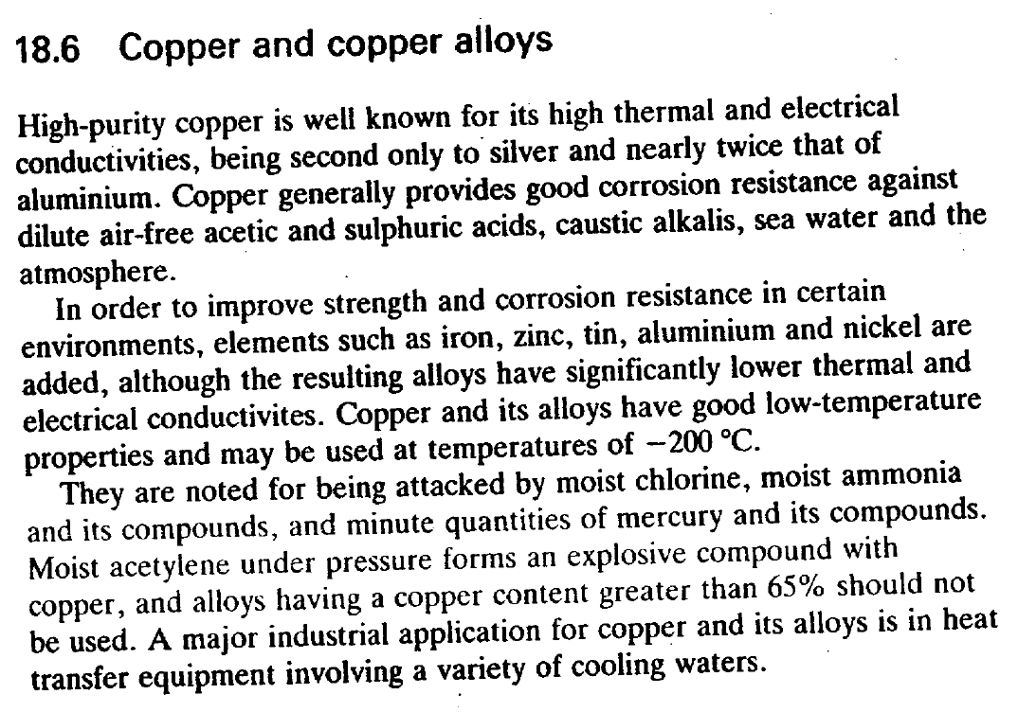
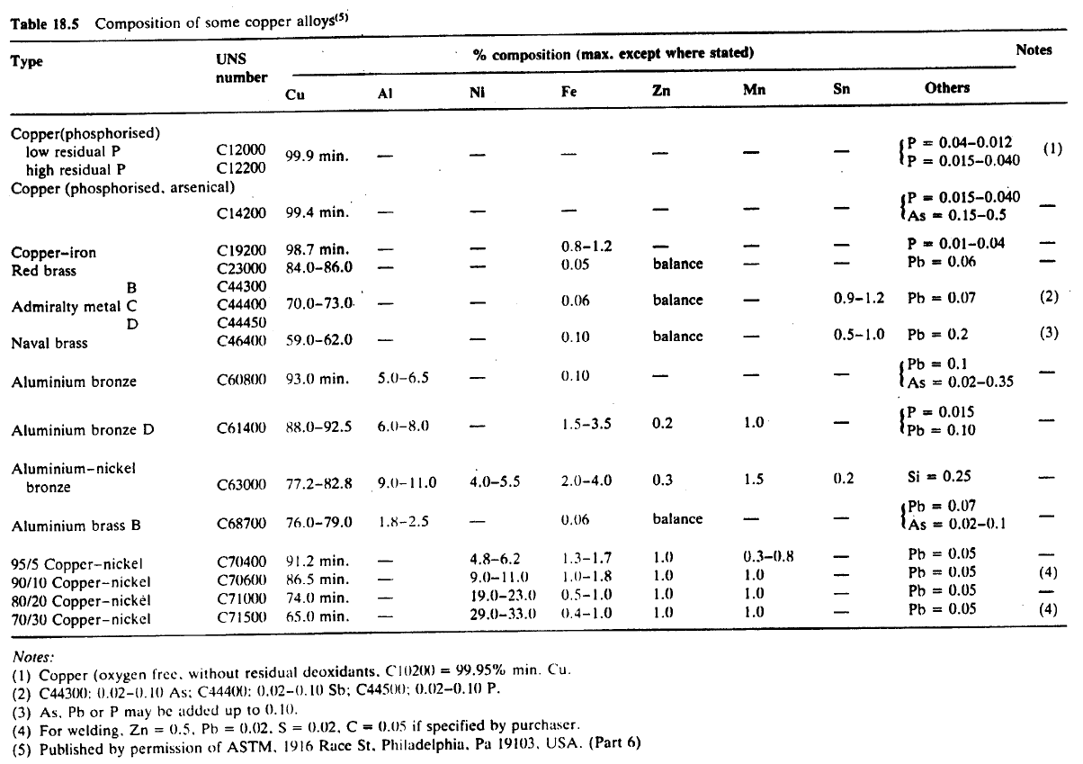

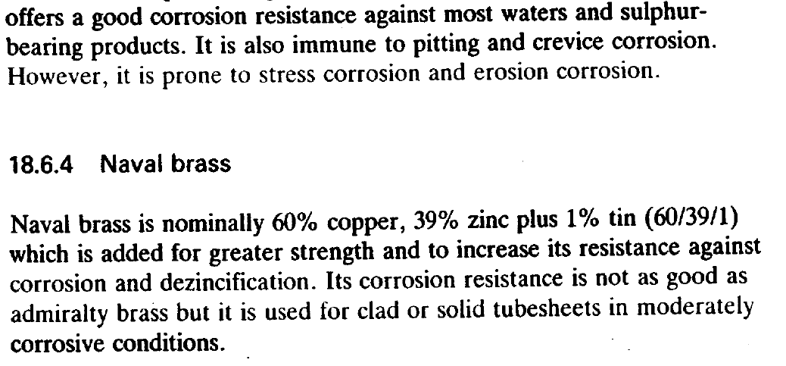
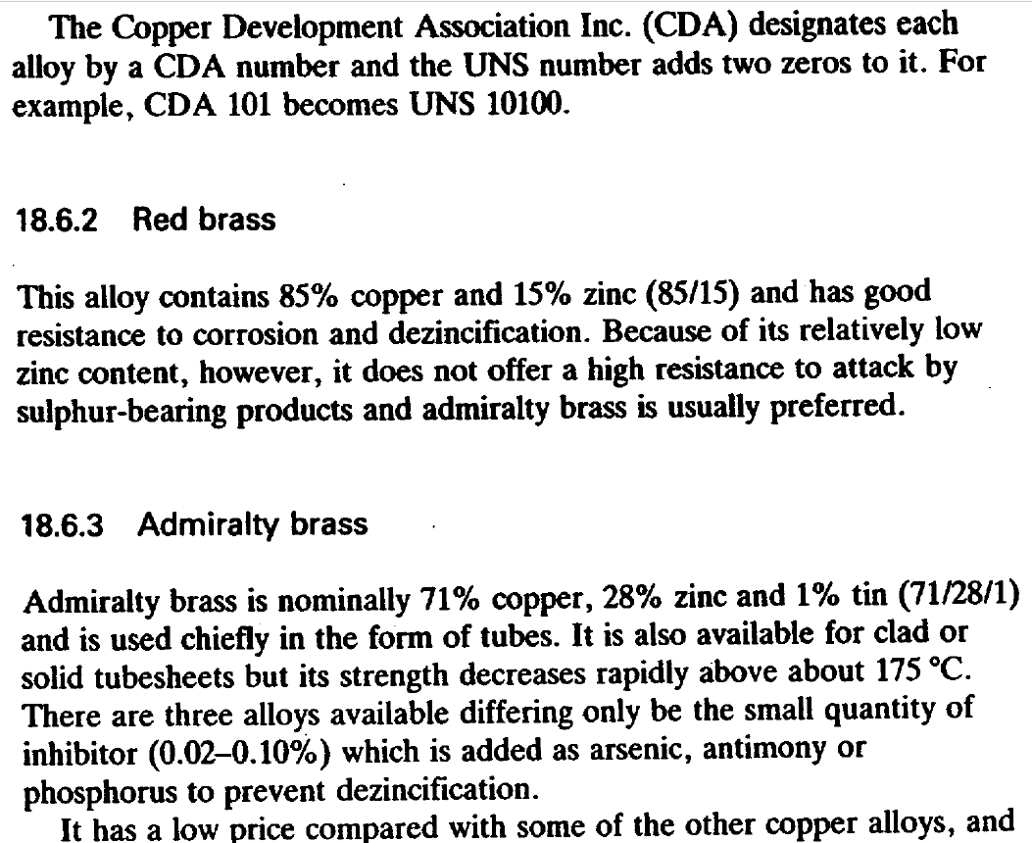
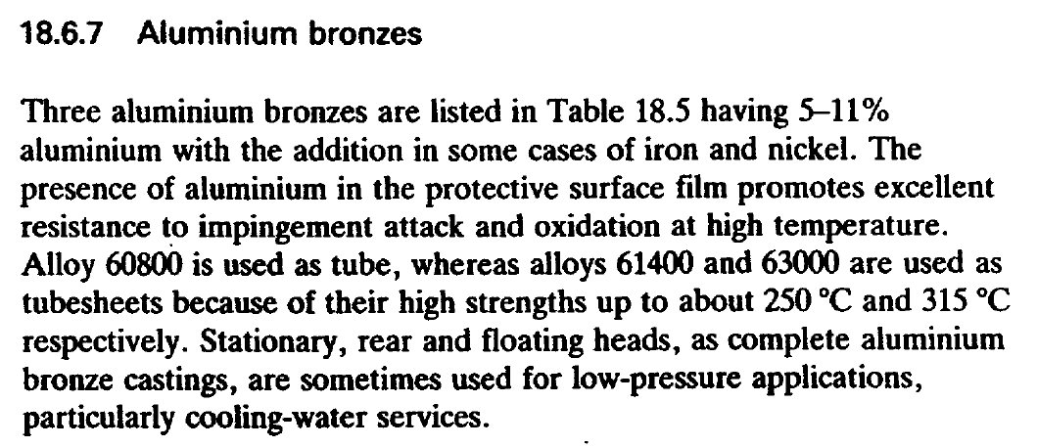
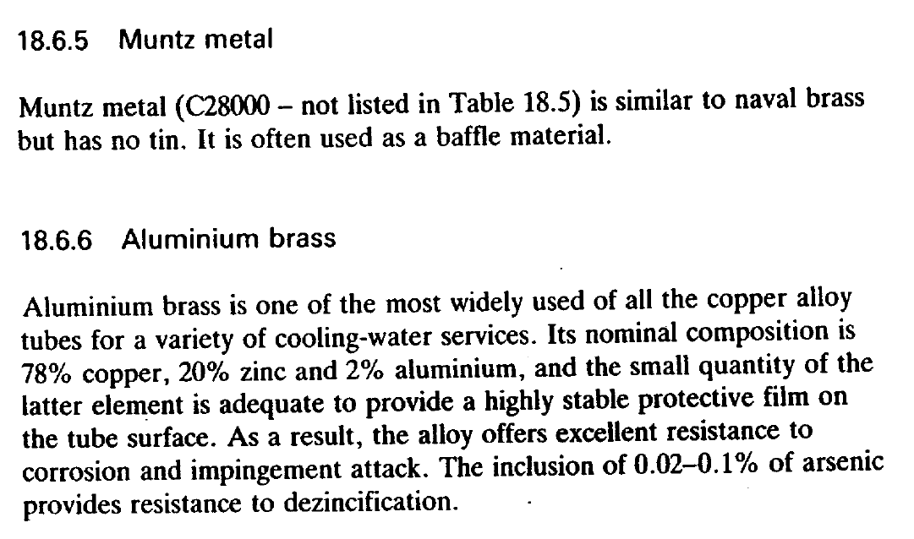

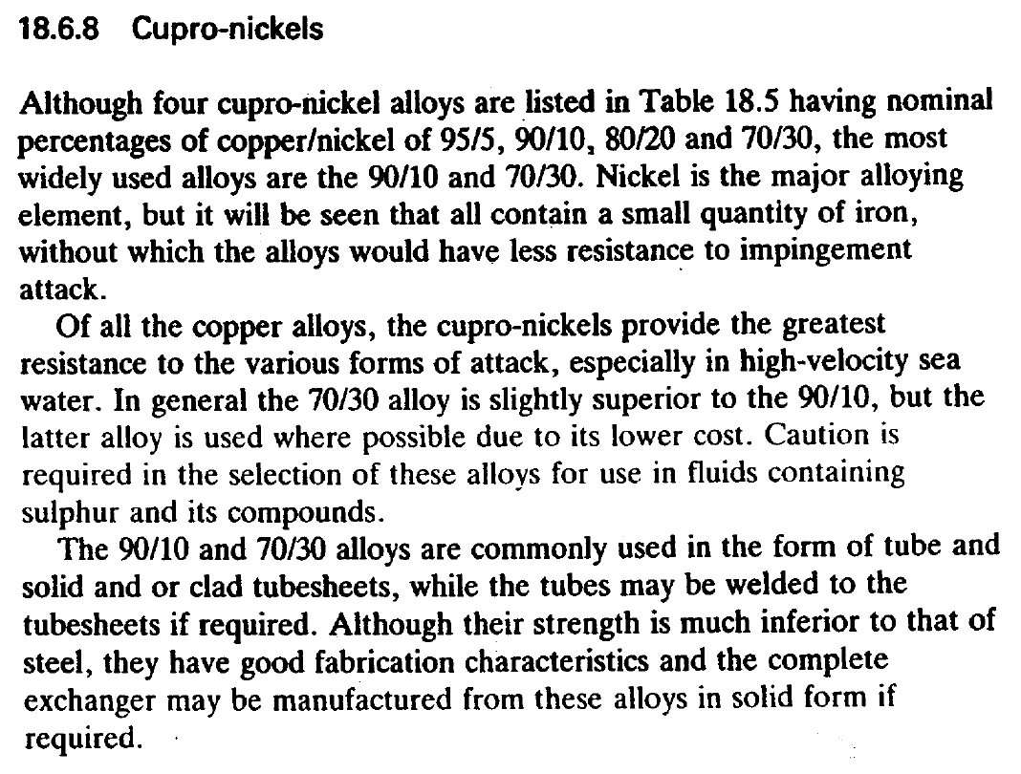

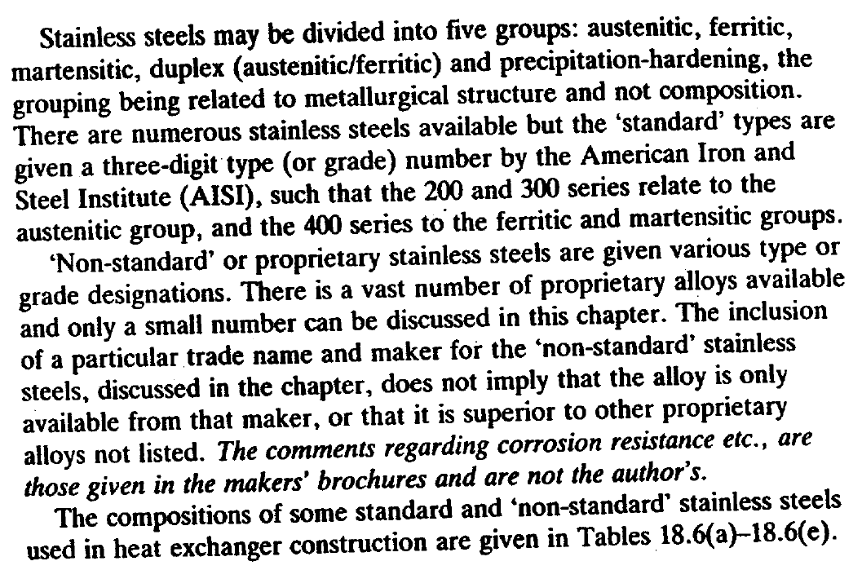
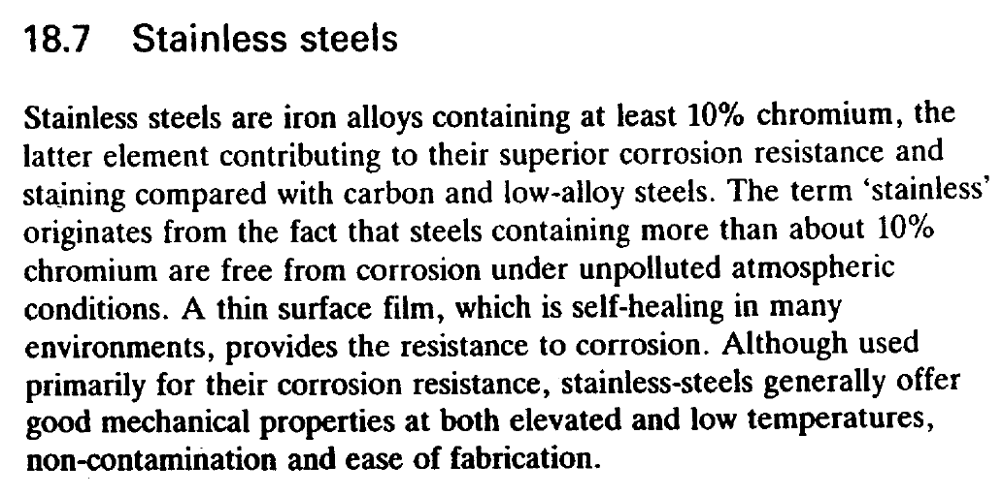
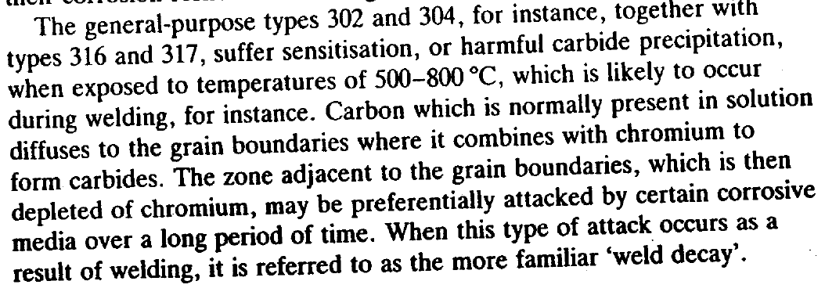
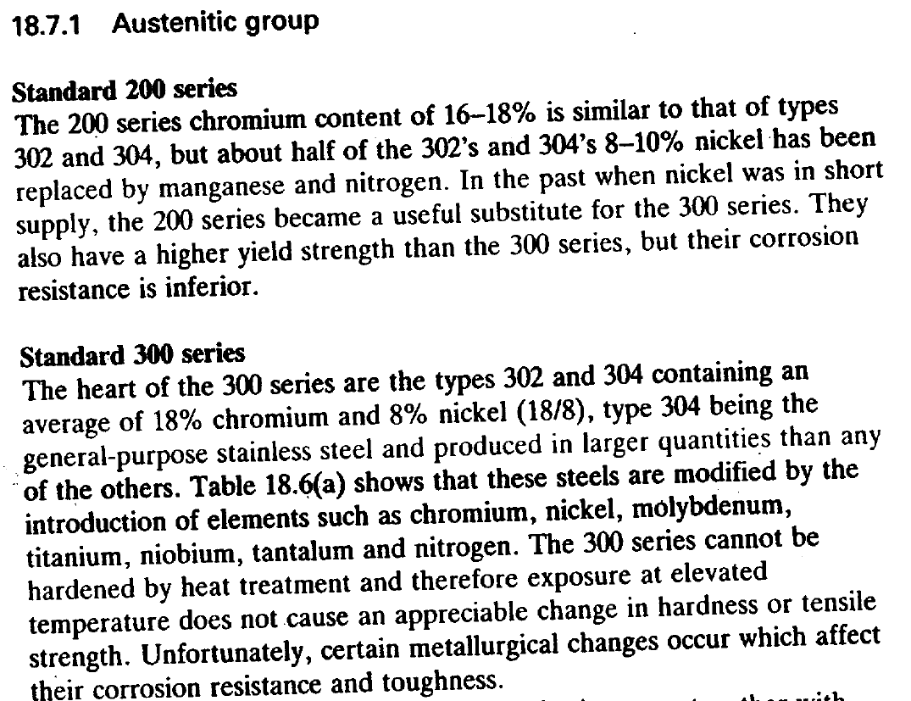

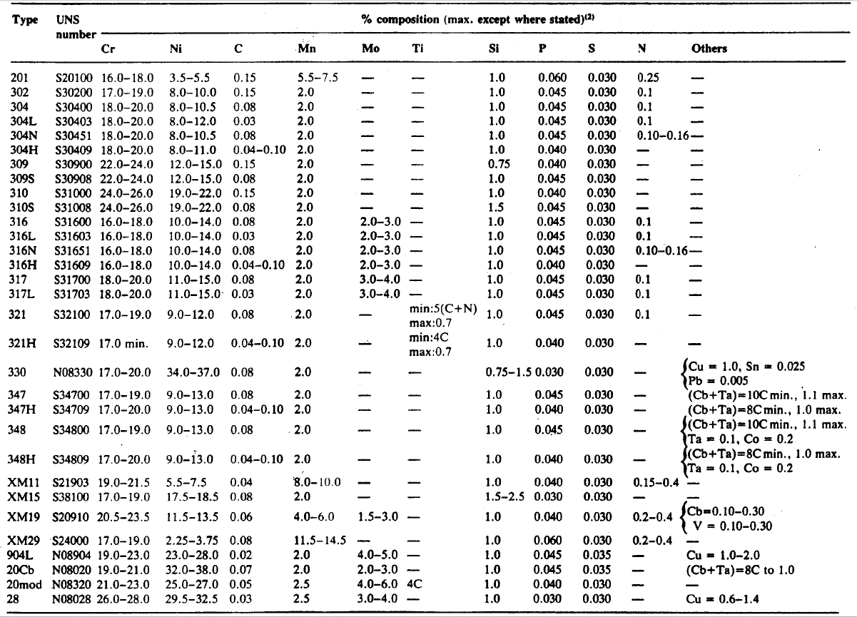

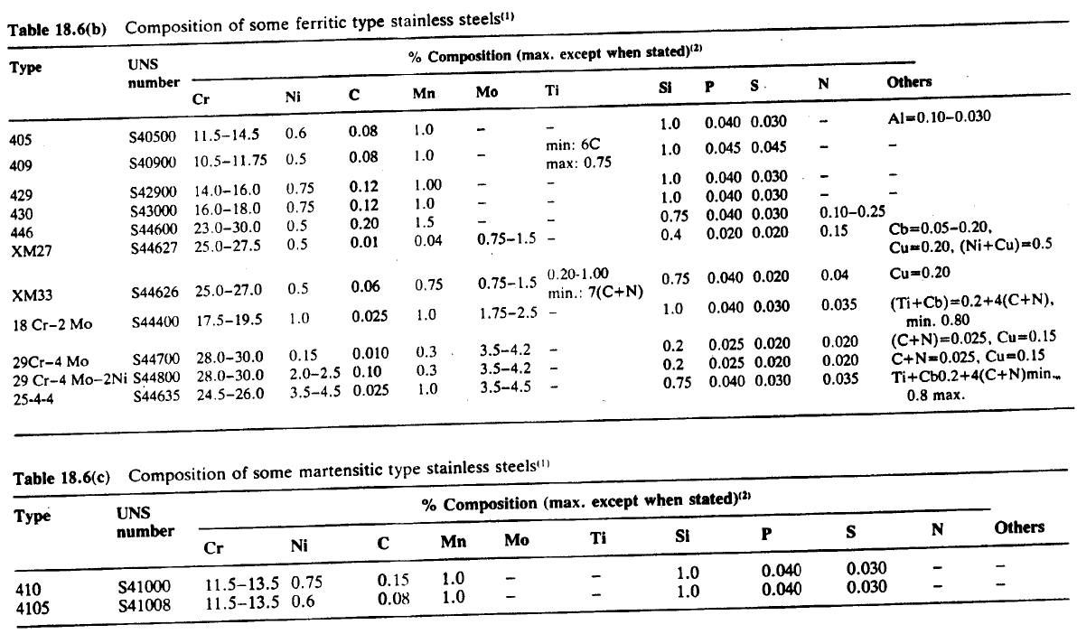
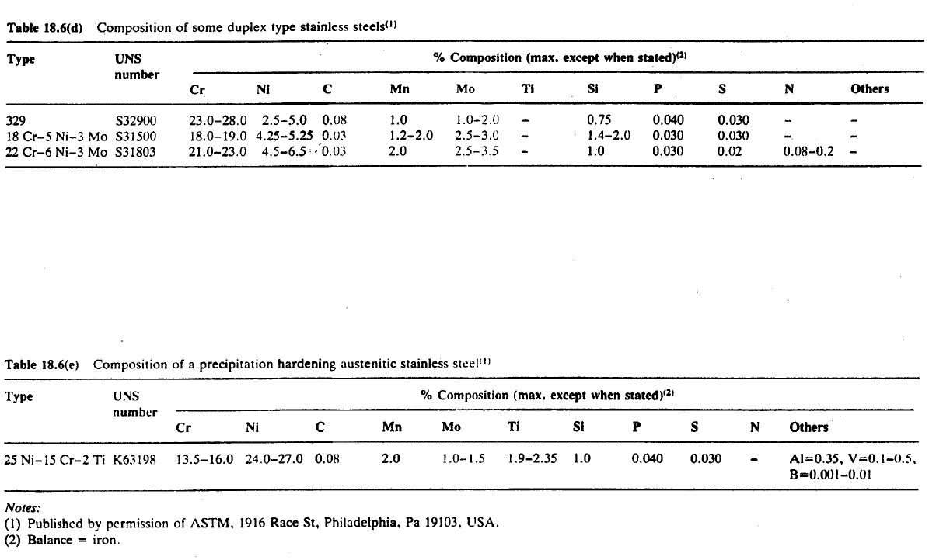
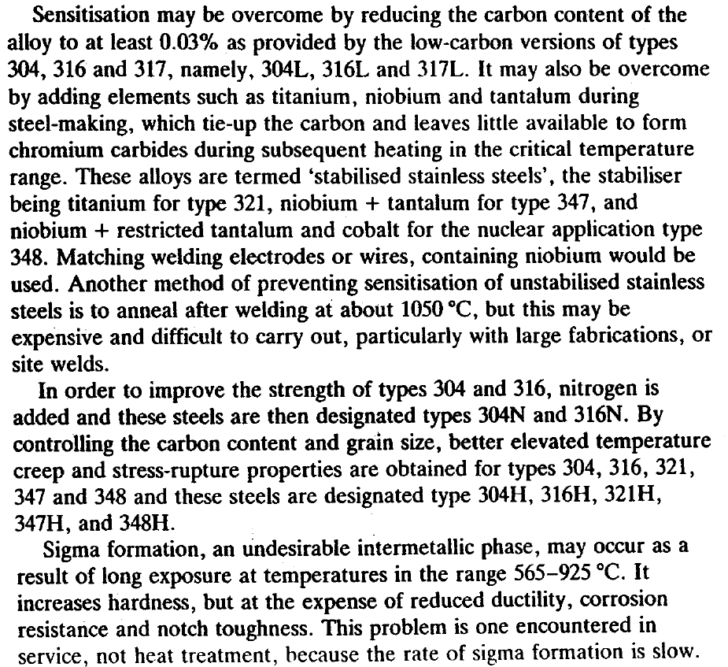
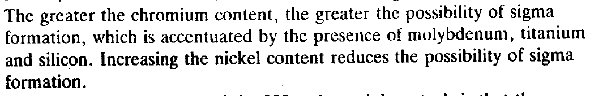

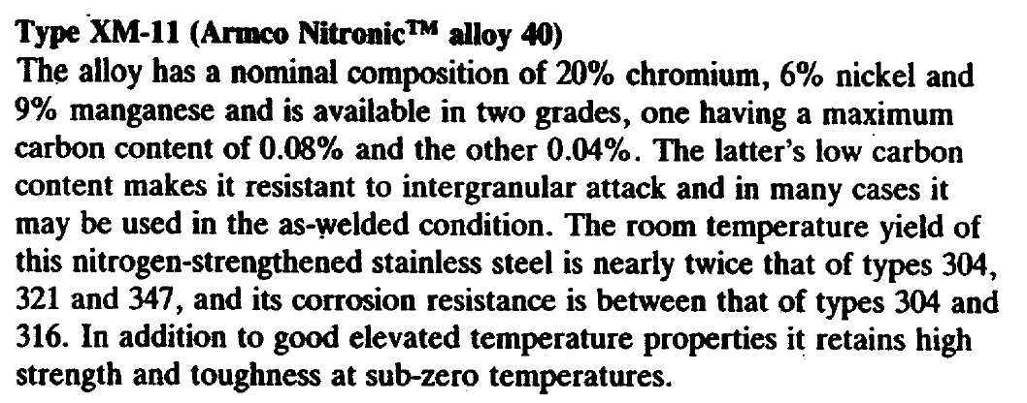
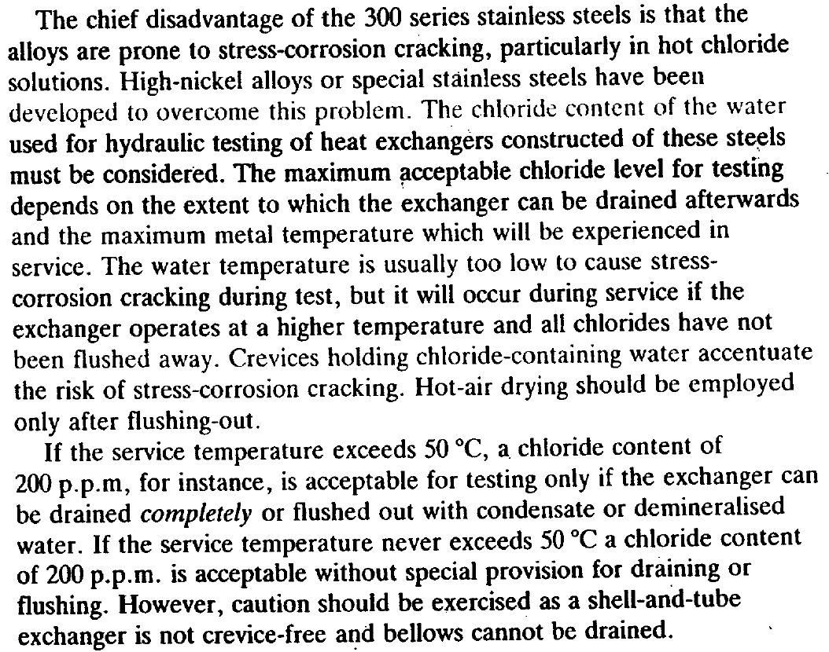
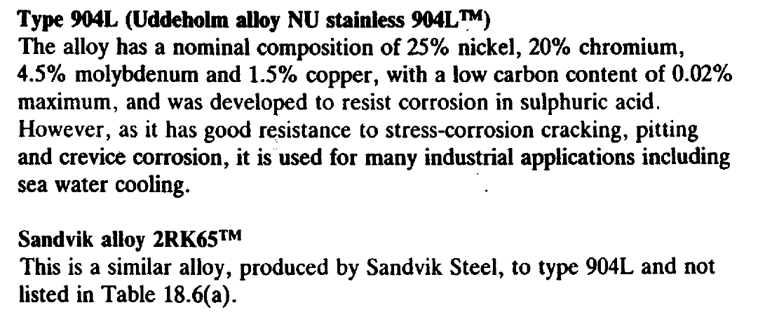
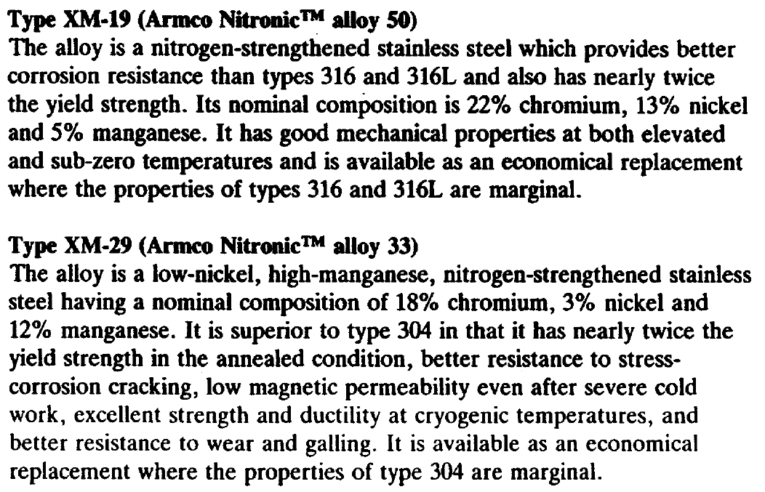

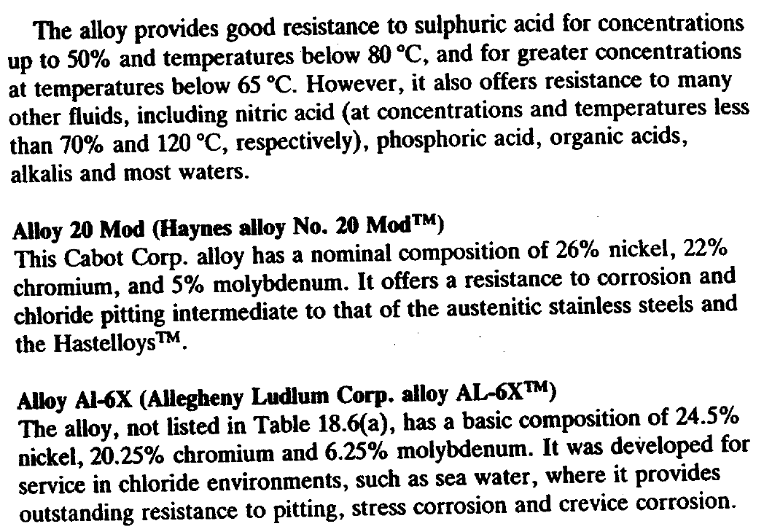
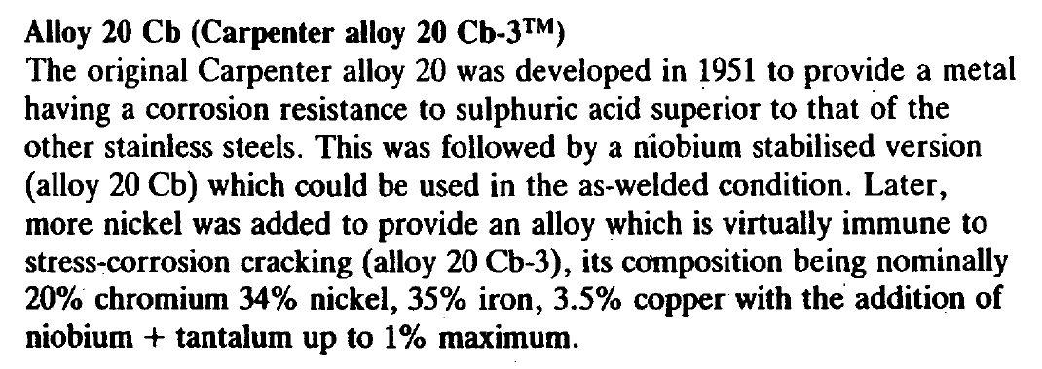

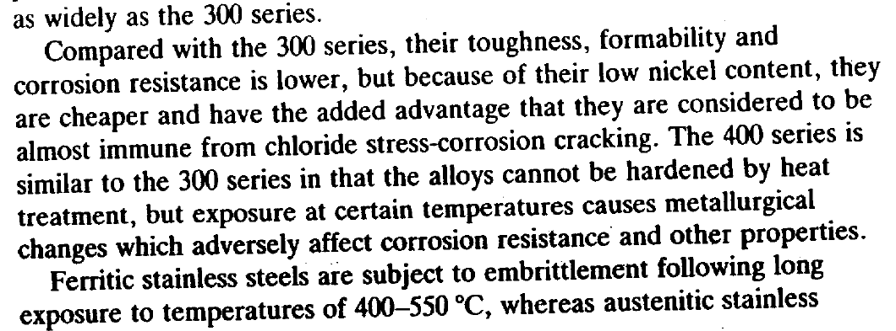
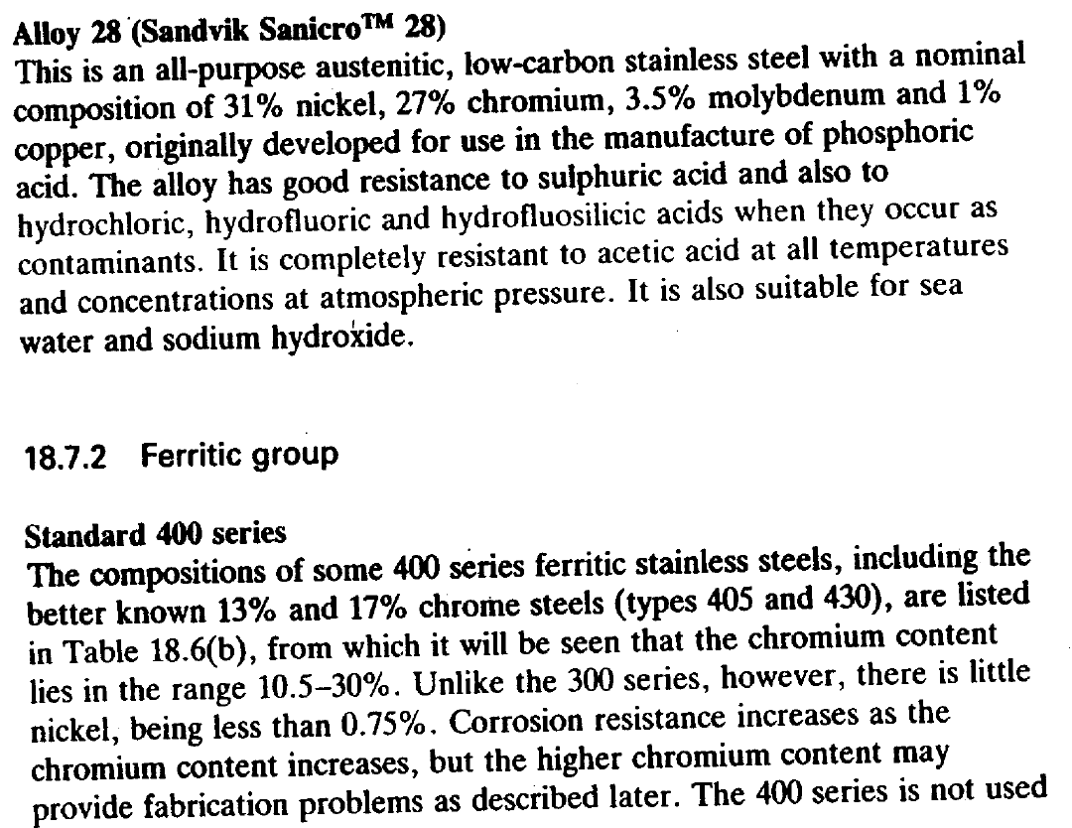
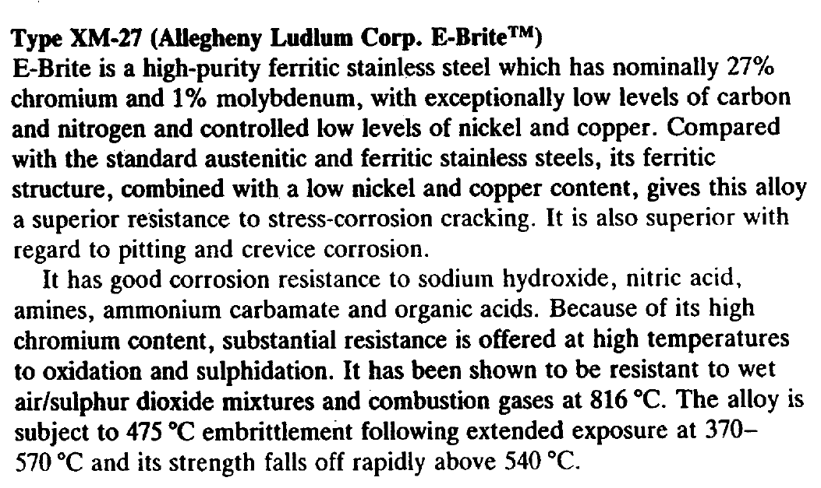
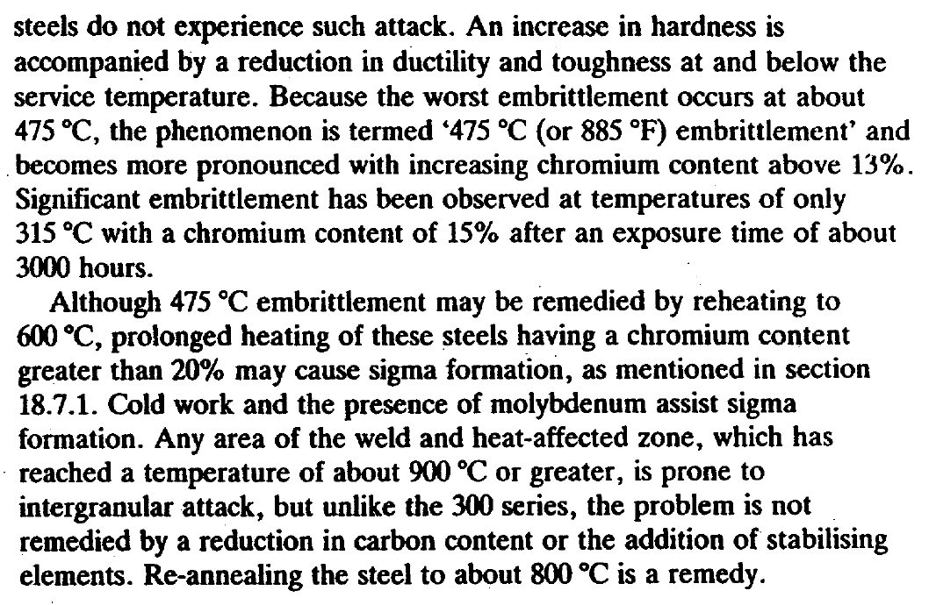
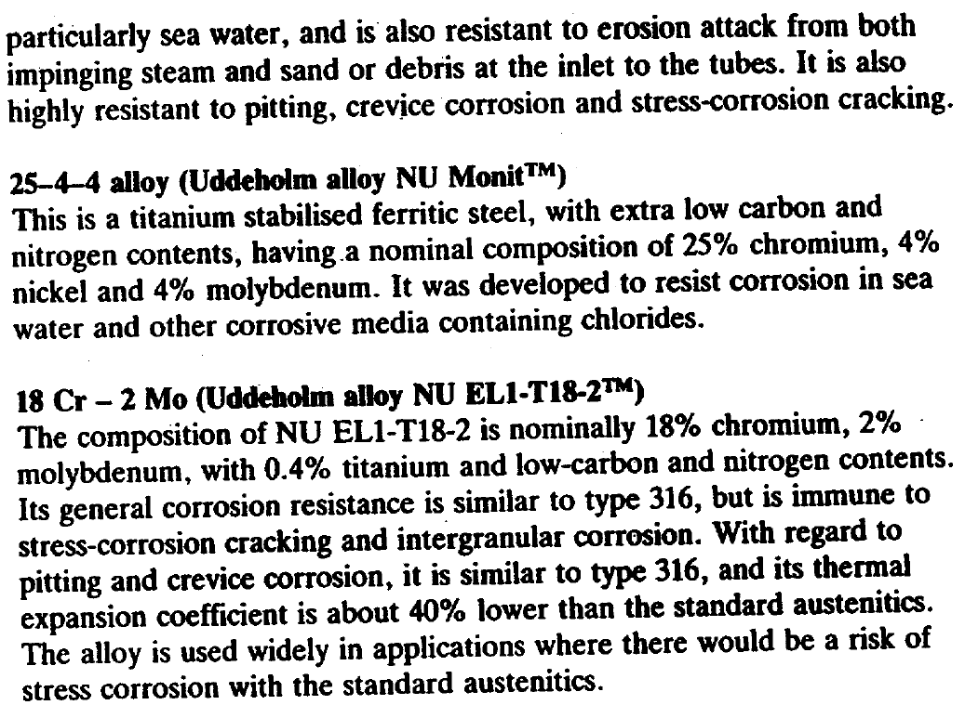
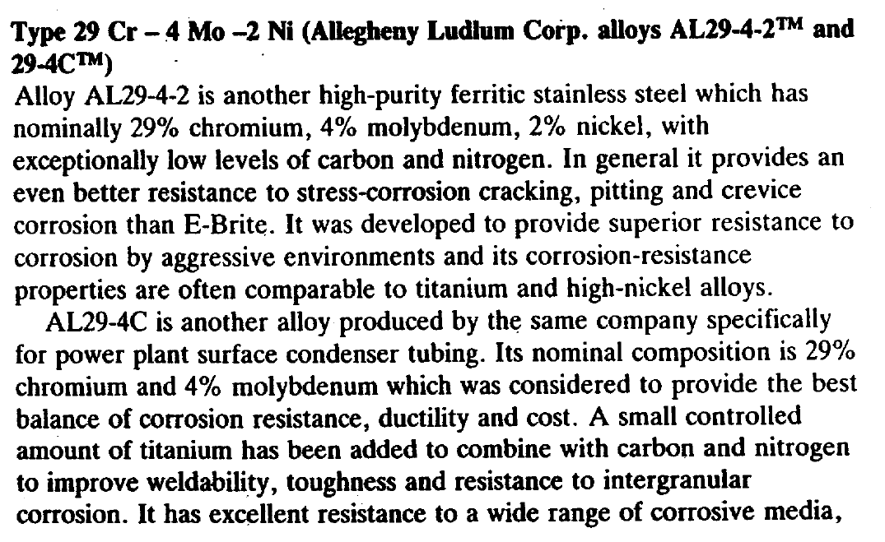
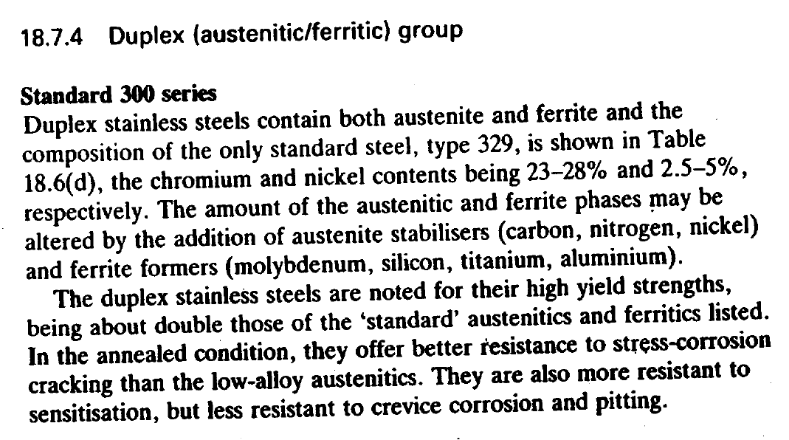
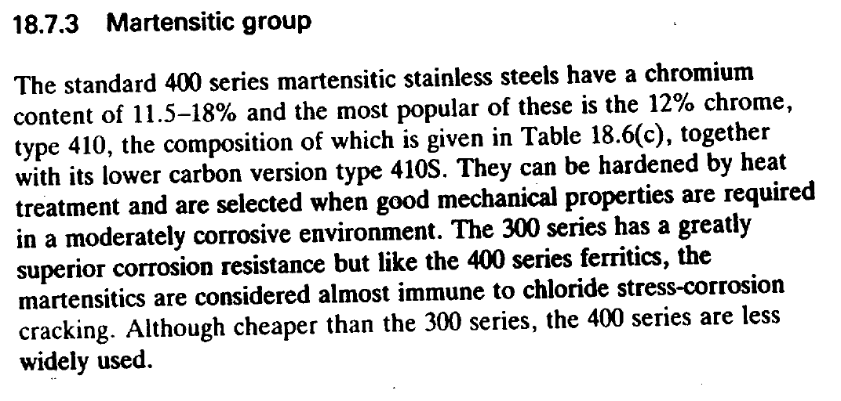

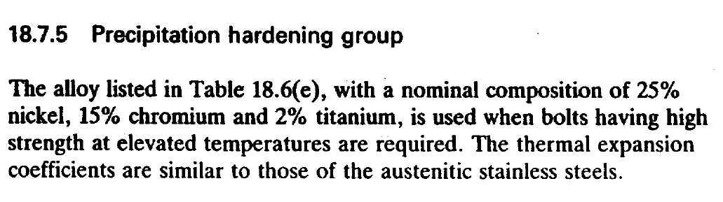
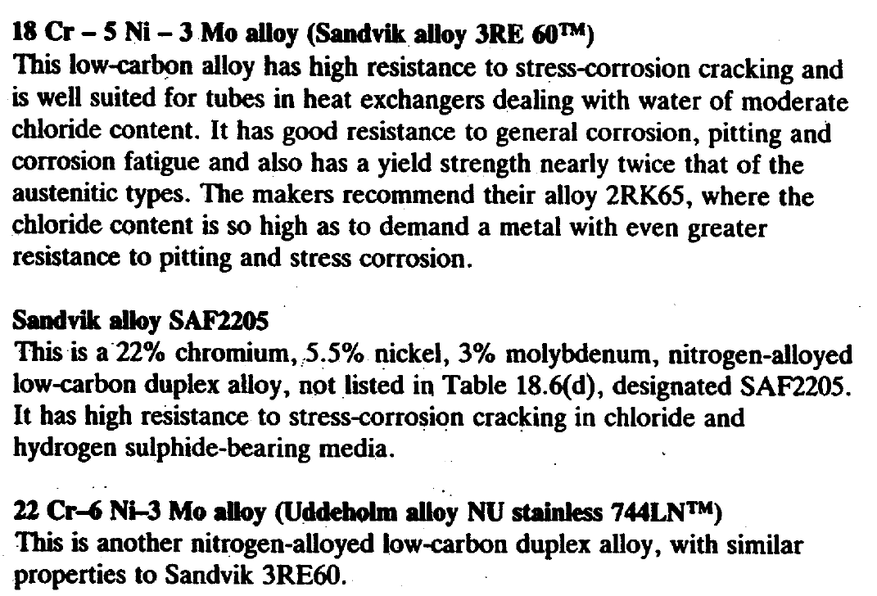

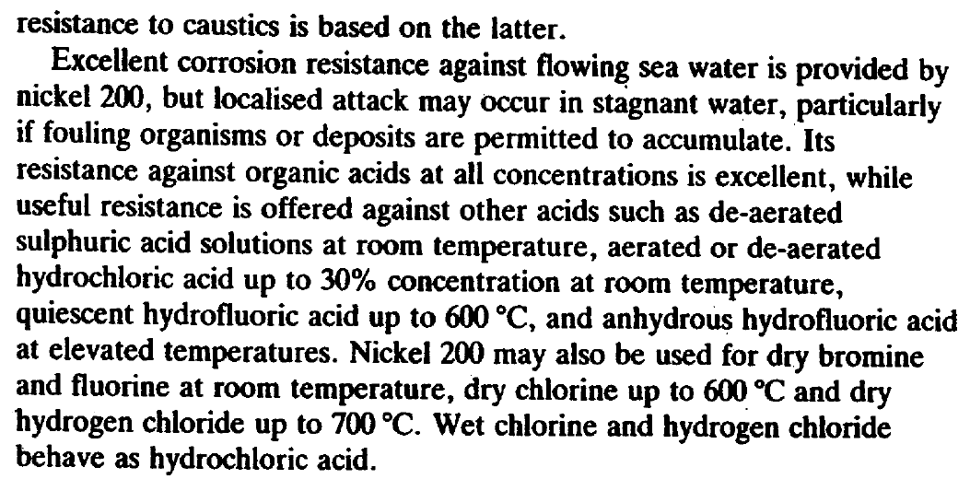
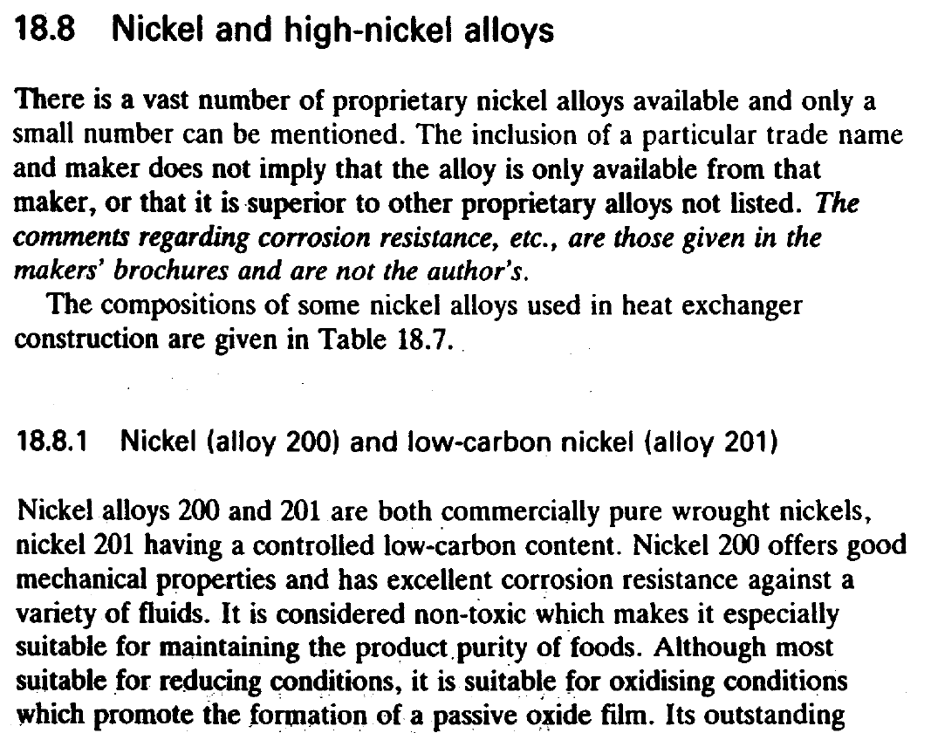
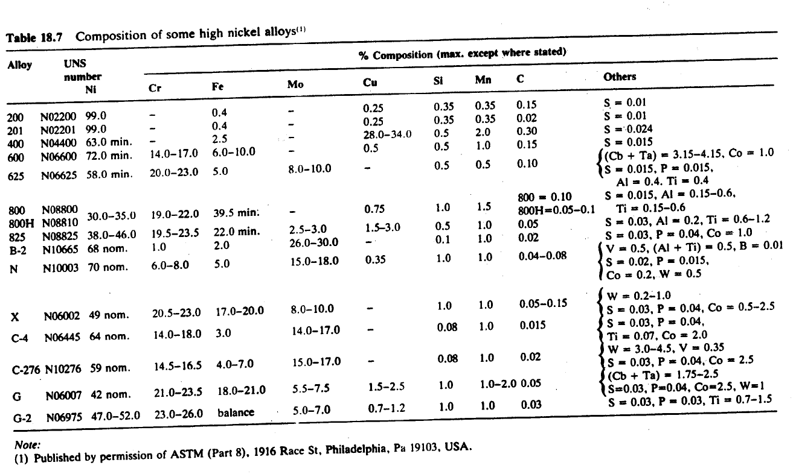
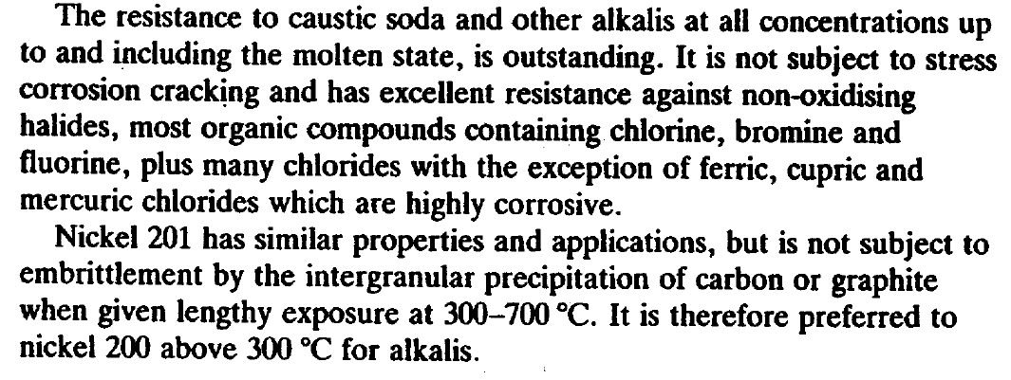
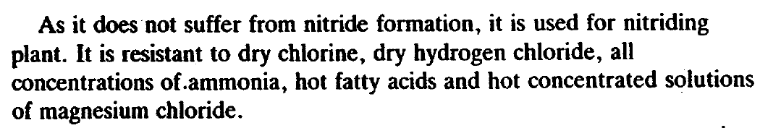
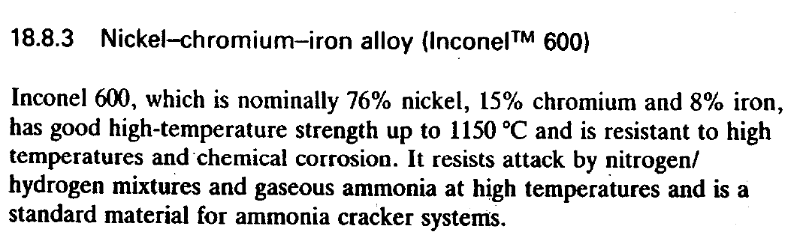
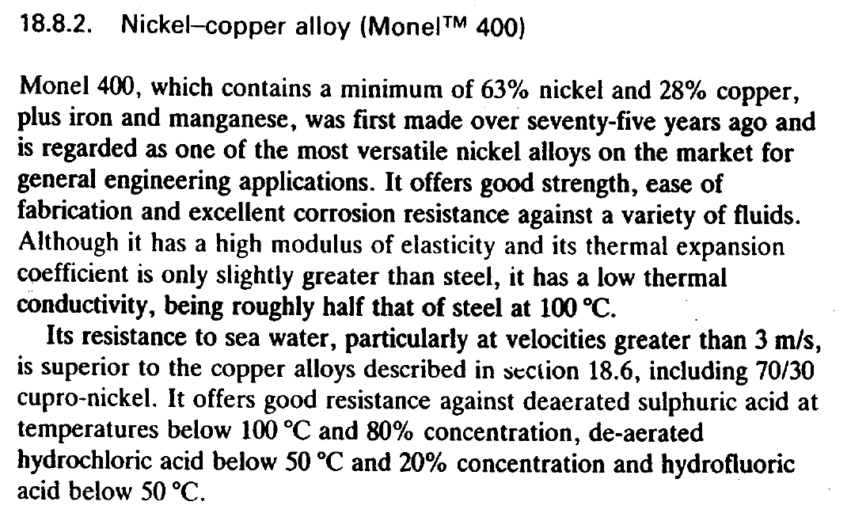

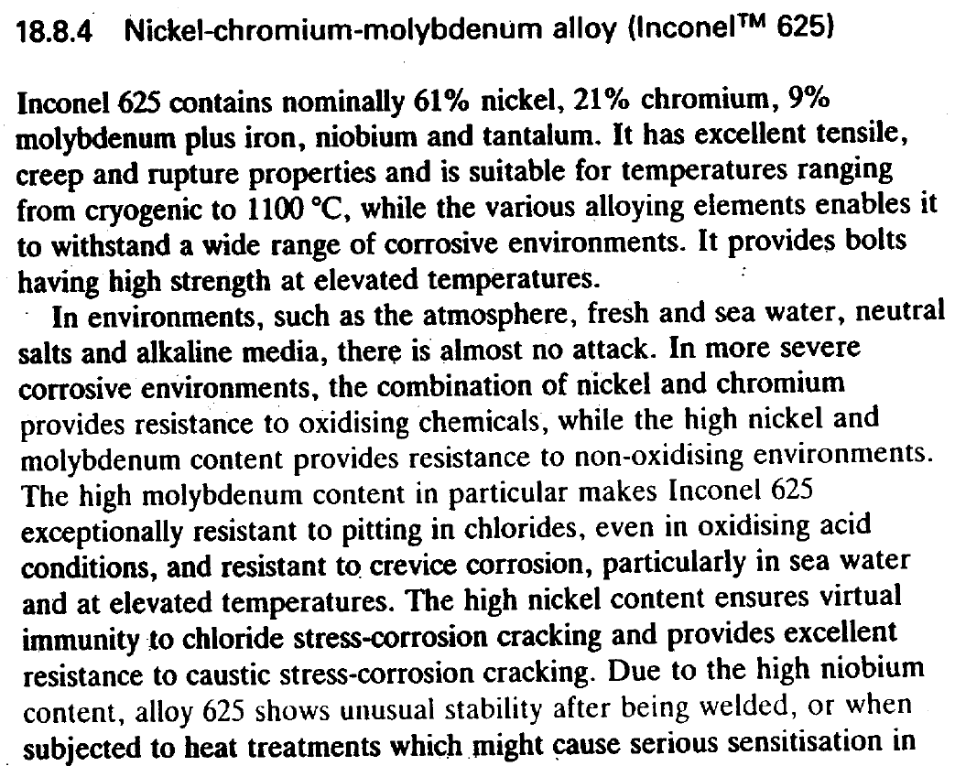
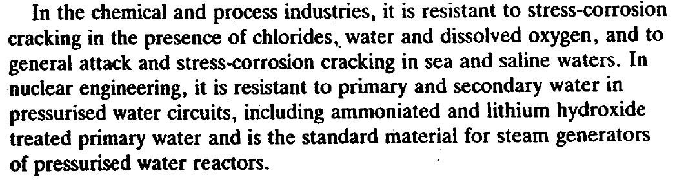

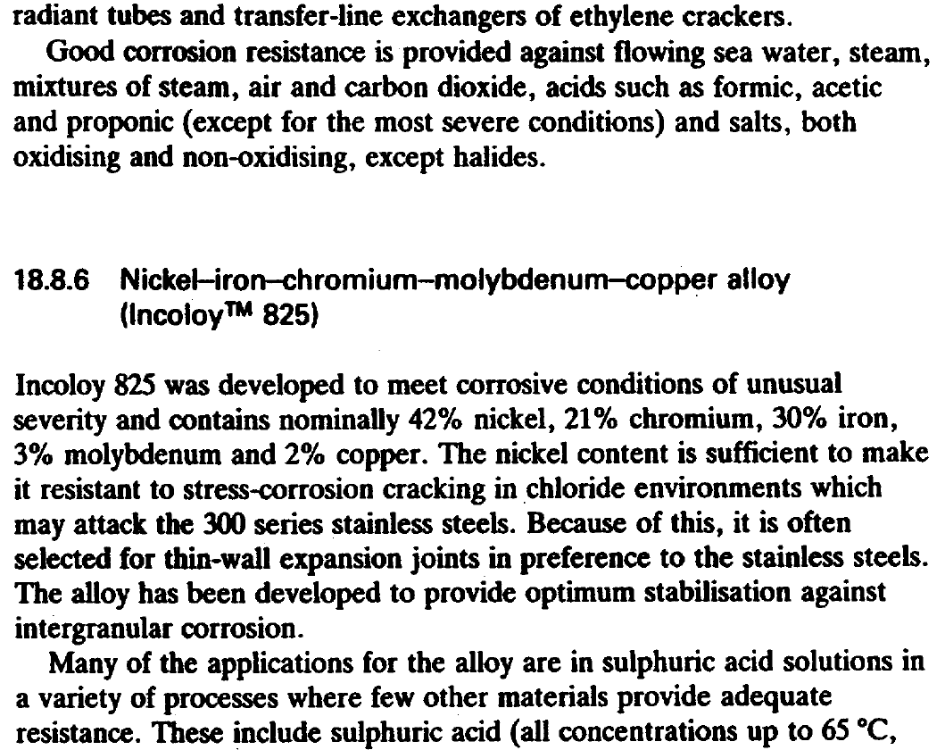
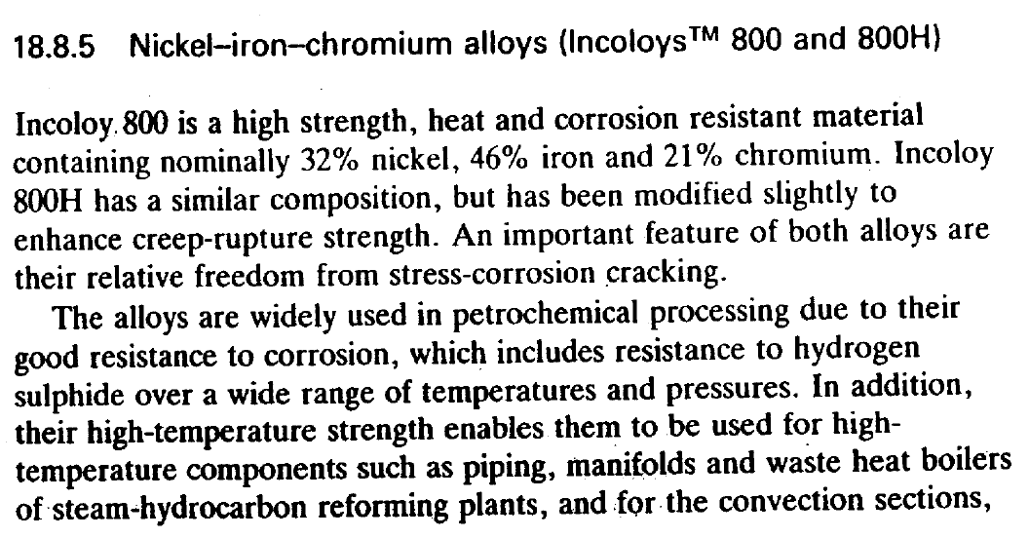
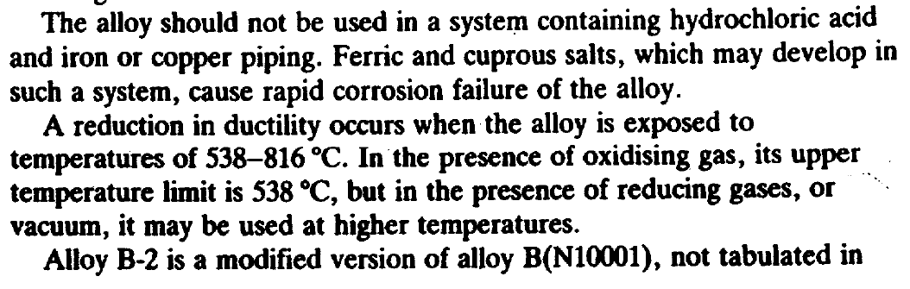
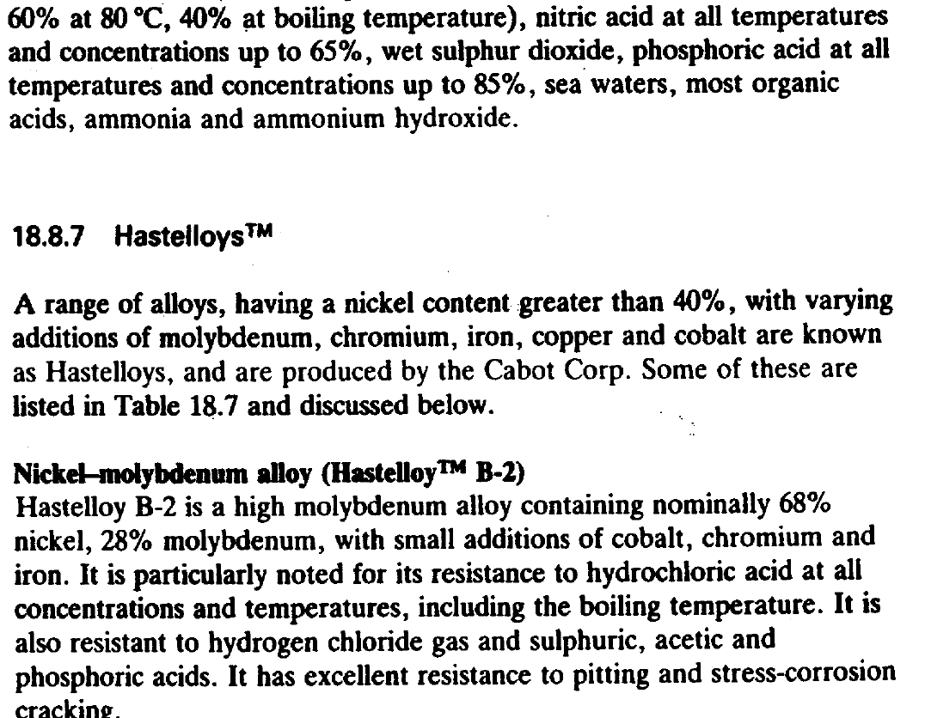

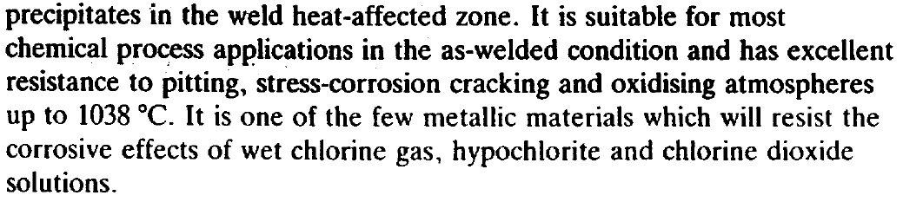
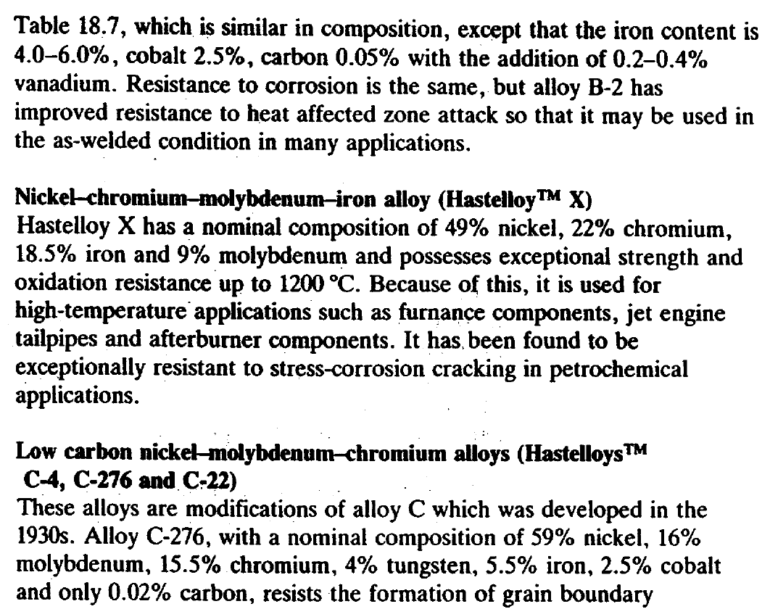

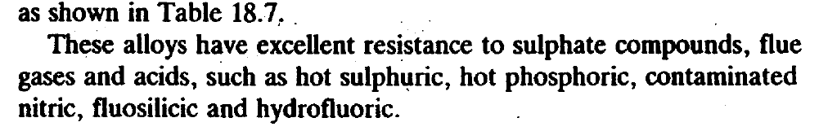
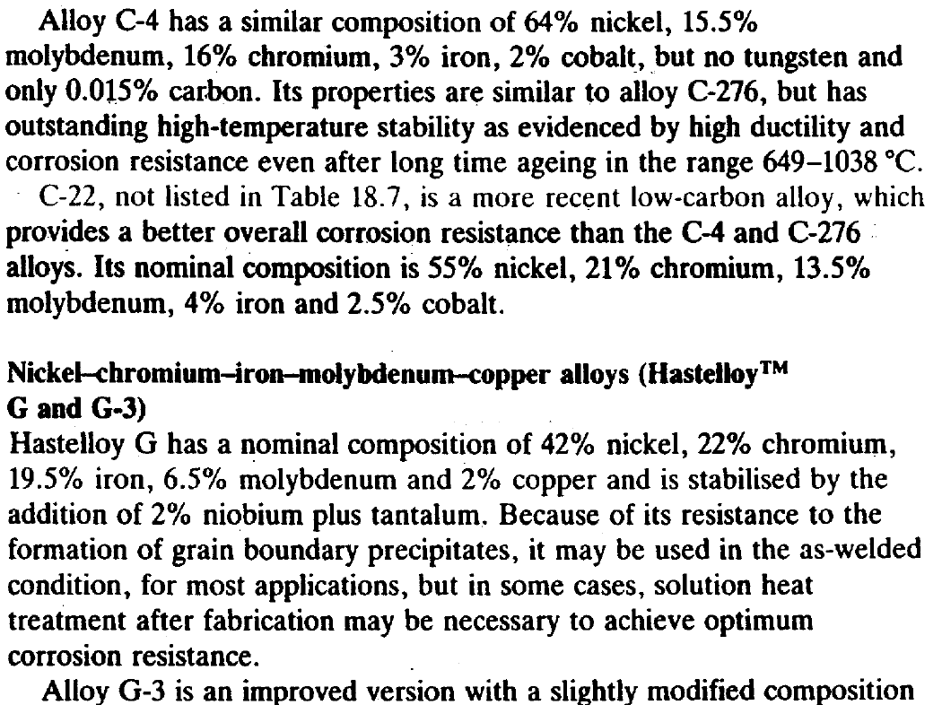

Recommended Material for Piping and Heat Exchanger

Utility | Material
Boiler Blow Down | A106 Gr.B/A672 Gr.B60
Boiler Feed Water | A106 Gr.B/A672 Gr.B60
Cooling Water | A106 Gr.B/A672 Gr.B60
LPS/LPC | A106 Gr.B/A672 Gr.B60
MPS/MPC | A106 Gr.B/A672 Gr.B60
Nitrogen | A106 Gr.B/A672 Gr.B60
Plant Air | A106 Gr.B/A672 Gr.B60
Service Water | A106 Gr.B/A672 Gr.B60
Fire Foam | A106 Gr.B/A672 Gr.B60
Fire Water (AG) | A106 Gr.B/A672 Gr.B60
Demineralized Water | A312 TP304
Instrument Air | A312 TP304
Fire Water (after filter) | A53 Gr. B/GALV
Potable Water (AG) | A53 Gr. B/GALV.
Potable Water (UG | A53 Gr. B/GALV.  PE Coated Externally

Chemicals | Material
Oxygen Scavenger | A312 TP304L
NAOH Solution | A312 TP304L
Phosphate Solution | A312 TP304L
Crossion Inhibitor (AG) | A312 TP316L
H2SO4 | A312 TP316L
HCL Solution (2~40%) (AG) | CPVC
NaClO Solution (10%) (AG) | CPVC
Lube Oil | A312 TP304

Process Fluids | Material
Fuel Gas | A106 Gr. B/A672 Gr.B60
Natural Gas | A106 Gr.B/A672 Gr.B60
Methanol Mixtures | A106 Gr.B/A672 Gr.B60
Process Oxygen | B165 N04400 /A312 TP304L
Process Condensate | A312 TP304L
Ammonia Water | A312 TP304L
Turbine Condensate | A312 TP304
Hydrogen Gas | A106 Gr.B/A672 Gr.B60/ A312 TP304
Syngas (H2+CO+CO2) | A312 TP304
Reformed Gas (H2+CO+CO2) | A312 TP321H/ A312 TP304L

Component of Channel Side | CS | SS
Head | SA-516 70N | SA-240 304L
Shell | SA-516 70N | SA-240 304L
Channel Flange | SA-266 2N | SA-965 F304L/SA-182 F304
Pass Partition | SA-516 70N
Nozzle | SA-105N | SA-182 F304L
Flange | SA-105N | SA-312 TP304L
Component of Heat Transfer
Tie Rod | SA-36 | SA-479 304
Spacer | SA-179 | SA-213 TP304/SA-789/SA-312
Baffle | SA-516 70N | SA-240 304
Support Plate | SA-516 70N | SA-240 304L
Partition Plate | SA-516 70N | SA-240 304L
Impingement Plate | SA-516 70N | SA-240 304
Tubesheet | SA-266 2N | SA-182 F304/SA-965
Roller | SA-36
Bonnet Flange Gasket | SS304+Flexible Gasket
Body Flange Gasket | SS304+Flexible Gasket
Hex Bolt | SA-193 B7 | SA-193 B7/A2-70
Hex Nut | SA-194 Gr 2H | SA-194 Gr 2H/A2-70
Body Flange | SA-266 2N | SA-965 F304/F304L
Shell Side Shell | SA-516 70N | SA-240 304/ SA-387
Saddle Support | SA-516 70N/70
Forged Nozzle | SA-105N
Flange | SA-105N
Tubes/U-Tubes | SA-179 | SA-213 TP304/SA-789
Sealing Strip | SA-516 70N | SA-240 304L
Suitable Fluid | Natural Gas  Cooling Water  Methanol | Demineralized Water  Reformed Gas  Process Condensate

Valves
Body material selection is usually based on the pressure, temperature, corrosive properties, and

erosive properties of the flow media. Sometimes a compromise must be reached in selecting a

material. For instance, a material with good erosion resistance may not be satisfactory because

of poor corrosion resistance when handling a particular fluid. Some service conditions require

use of exotic alloys and metals to withstand particular corrosive properties of the flowing fluid.

These materials are much more expensive than common metals, so economy may also be a

factor in material selection. Fortunately, the majority of control valve applications handle

relatively non-corrosive fluids at reasonable pressures and temperatures.

Therefore, cast carbon steel is the most commonly used valve body material and can provide

satisfactory service at much lower cost than the exotic alloy materials. Specifications have been

developed for ordering highly corrosion-resistant, high-alloy castings. These specifications

represent solutions to problems encountered with some of those alloys. These problems

included unacceptable corrosion resistance compared to the wrought materials, weldability

issues, and unacceptable lead times. These alloys are also difficult to cast.

The specifications include a foundry qualification process, dedicated pattern equipment, pattern

alloy qualification, heat qualification, and detailed controls on raw material, visual inspection,

weld repairs, heat treatment, and nondestructive testing. Designations for these exotic and

common grades are included in Table 5.36 Designations for Common Valve Body Materials.

The following descriptions and tables provide basic information on various popular casting

grades used for control valve bodies. ASTM material designations are included. Use of proper

ASTM designations is considered good practice and is encouraged in specifying materials,

particularly for pressure containing parts. Additional engineering

data on these and other materials is included in Chapter 13.
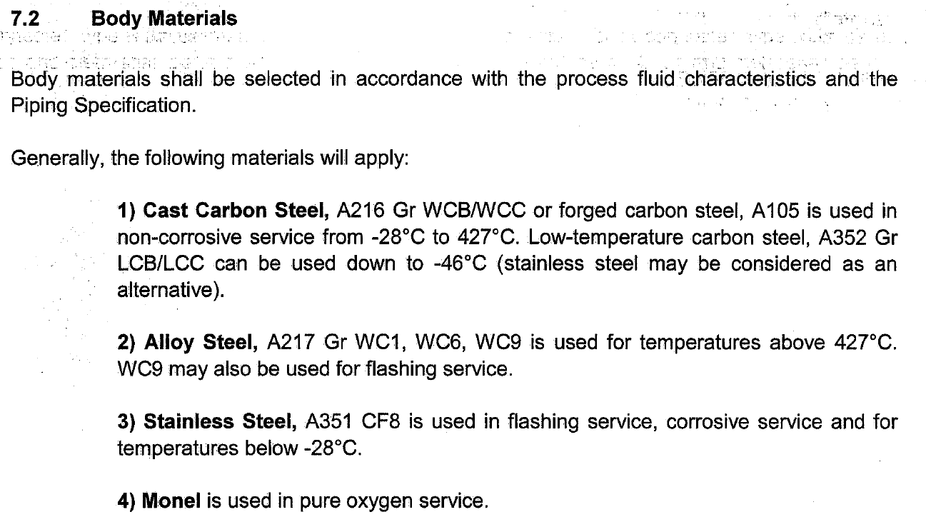

Cast Carbon Steel (ASTM A216 Grade WCC)—WCC is the most popular cast steel material used for valve bodies in moderate services such as air, saturated orsuperheated steam, non-corrosive liquidsand gases. WCC is not used above 425°C(800°F) as the carbon rich phase mightbe converted to graphite. It is generallywelded without post weld heat treatmentunless nominal thickness exceeds 1-1/4inches (32 mm). Major weld repairsalways receive post weld heat treatment.
Cast Chromium-Molybdenum Steel(ASTM A217 Grade WC9)—This is thestandard cast Cr-Mo grade. WC9 hasreplaced C5 as the standard because ofsuperior casting and welding properties.WC9 has successfully replaced C5 inmost applications, especially in steamand boiler feedwater service. Thechromium and molybdenum provideerosion-corrosion and creep resistance,making it useful to 595°C (1100°F). WC9is generally heat treated after welding.Major weld repairs always receive
postweld heat treatment.
Cast Type 304L Stainless Steel (ASTMA351 Grade CF3)— This is a commonmaterial offering for chemical servicevalves. Cast304L is often preferred fornitric acid and certain other chemicalservice applications. Optimumcorrosion resistance is retained even inthe as-welded condition when properwelding procedures are used. CF3 isnot rated for pressure boundary parts
above 425°C (800°F).
Cast Type 316 Stainless Steel (ASTM
A351 Grade CF8M)—This is the industrystandard stainless steel cast bodymaterial. The addition of molybdenumgives Type 316 greater resistance tocorrosion, pitting, creep, and oxidizingfluids compared to 304 or 304L. It has thewidest temperature range of any standard material: -254°C (-425°F ) to 816°C(1500°F). The castings are heat treated toprovide maximum corrosion resistance. At temperatures above 538°C (1000°F) the carbon content shall be 0.04% minimum.
Cast Type 317 Stainless Steel (ASTMA351 Grade CG8M)—S31700 isessentially S31600 with the nickel andmolybdenum contents increased 1%each. This affords greater resistance topitting than is obtained with S31600.Like S31600, S31700 is completelyaustenitic and non-magnetic. Becauseits strength is similar to that of S31600,it has the same pressure-temperature ratings. CG8M is the casting versionof S31700. It contains considerable amounts of ferrite (15 to 35%), and is,therefore, partially to strongly magnetic.In general, Type S31700 has bettercorrosion resistance than S31600 in certain environments because of its higher molybdenum content. It has good corrosion resistance in many applications such as digester liquor, dry chlorine dioxide and many other pulpand paper environments. For CG8M, the maximum temperature for pressureretaining
parts is 538°C (1000°F).

