Hydrogen, Ammonia, Methanol Plant

Material Selection

Syngas Department

INTRODUCTION

Hydrogen, methanol, and ammonia plants are very similar. Methane or naphtha feed stock is first desulfurized then combined with steam in a reformer furnace. Hydrogen and carbon dioxide are produced in the reformer furnace at about 820°C (1,500”F) as the starting point for all three processes. In a hydrogen plant (Figure 4.1),’ the process gas (hydrogen and carbon dioxide) from the reformer furnace is cooled to about 450°C (850°F) in a quench steam generator, then cooled further to about 370°C (700°F) and sent to a shift converter, where additional hydrogen is formed. The process gas is again cooled then fed to a pressure swing adsorption (PSA)TM unit, a hot potassium carbonate absorption system, a monoethanolamine (MEA) absorption system or a SulfinolTMun it to purify the hydrogen by removing the carbon dioxide.

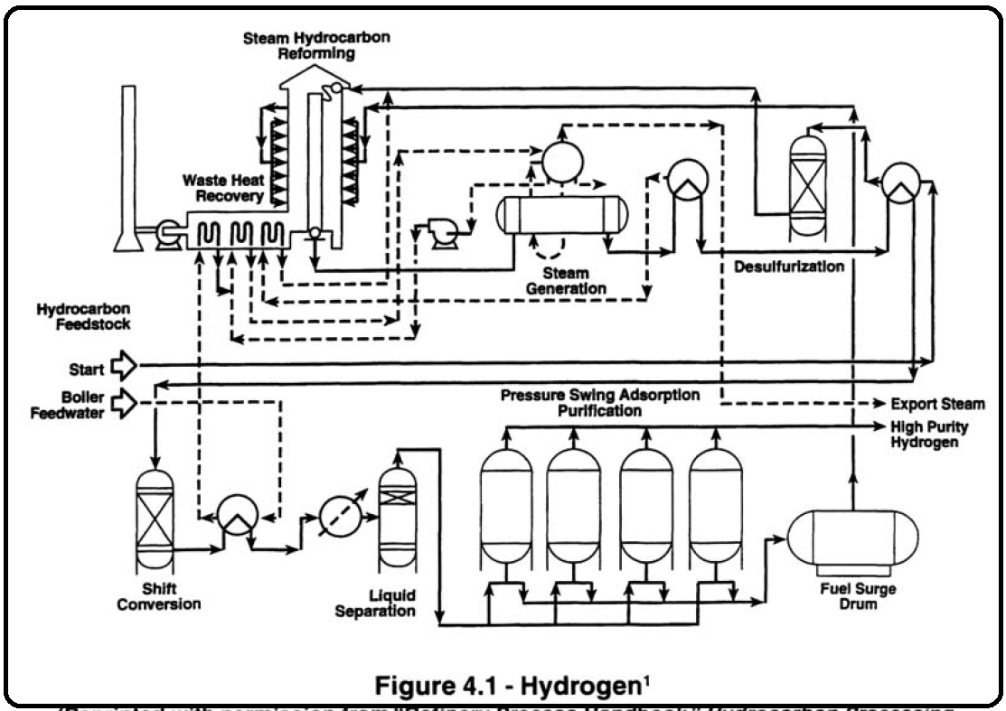

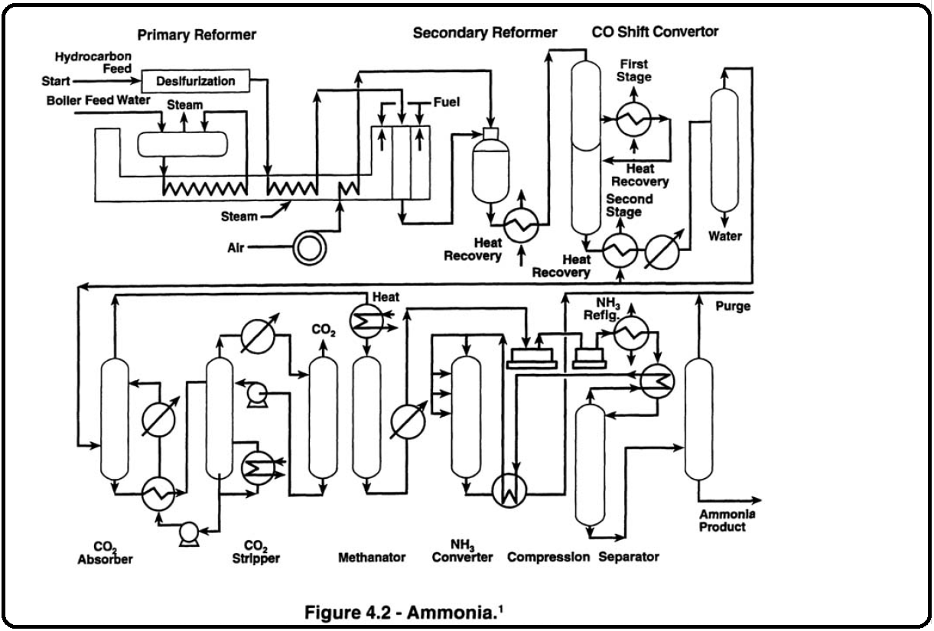

In an ammonia plant (Figure 4.2),’ the synthesis gas from the reformer furnace is fed into a secondary reformer vessel in which air is added through a burner to create outlet vessel temperatures in the order of 980°C (1,800”F). The outlet of the secondary reformer vessel is cooled in a quench steam generator and sent to a shift converter; this is followed by a carbon dioxide removal system. The purified nitrogen from the air added in the secondary reformer vessel and hydrogen synthesis gas is fed to a methanator to convert residual oxides of carbon back to methane (which is inert in the ammonia conversion); the gas is then compressed to about 20,700 kPaa (3,000 psia). The compressed synthesis gas is fed to an ammonia converter vessel. As the synthesis gas passes over catalyst beds, ammonia is formed. The ammonia product is then cooled and refrigerated to separate out impurities. In a methanol plant (Figure 4.3),’ the synthesis gas goes from the reformer furnace to a heat recovery section, where it is cooled to room temperature. The synthesis gas is then compressed from 5,170 kPaa to 10,345 kPaa (750 psia to 1,500 psia) and fed to the converter vessel through preheat exchangers. Methanol is formed as the gas passes over catalyst beds in the converter vessel at 205°C to 315°C (400°F to 600°F). The methanol product is then cooled and fed to separators, then to fractionators to complete the purification.

MATERIALS OF CONSTRUCTION

High-Temperature Front End

The front end section of hydrogen, methanol, and ammonia plants is shown in Figure 4.4.* The second***ary*** reformer is used only in an ammonia plant. The feed gas is desulfurized in carbon steel equipment. When the metal temperature exceeds 425°C to 455°C (800°F to 850"F), 1 Cr-1/2 Mo or 1-1/4 Cr-1/2 Mo is used to avoid long-term deterioration of the mechanical properties by graphitization. Preheat coils in the top of the reformer furnace usually are 2-1/4 Cr - 1 Mo up to 650°C (1,200"F) metal temperature and 304H (UNS S304009) for metal temperatures above 650°C ( 1,200"F). Caustic stress corrosion cracking from solids can occur in the steam preheat coils if solid carryover is excessive (see Chapter 1, Section 3.7). The inlet connections to the steam methane reformer furnace tubes are either 1 -1/4 Cr-1/2 Mo (595°C [ 1,10O"F] maximum) or 2-1/4 Cr-1 Mo (650°C [ 1,200"FI maximum).

The methane (or naphtha) and steam are converted to hydrogen and carbon monoxide along with some carbon dioxide over a nickel catalyst in the HK-40 (UNS 594204) or HP modified, also called CE20N (UNS 592802) primary reformer furnace tubes. CE20N (UNS 592802) has largely replaced HK-40 because of superior stress-to-rupture strength (e.g.. 12.55 MPa [ 1.82 ksi] vs 8.3 MPa [ 1.2 ksi] at 980°C [ 1 ,800"FI). Skin temperatures on these tubes are about 980°C ( 1,80O0F), and the outlet process temperature is about 820°C (1,500"F). Sulfur content in the fuel gas is limited to 2,000 ppm to 3,000 ppm hydrogen sulfide to avoid accelerated oxidation of the outside of the tubes. The tubes are centrifugally cast. They have been used in the as-cast condition which includes about 2.4 mm (3/32 in.) dross and unsoundness on the inside diameter.

Currently, most tubes are bored on the inside to remove the dross and unsoundness and machined on the outside. Since the tubes are operating in the range where sigma phase (a brittle Fe-Cr compound) forms, the Cr, Ni, and C are "balanced' to minimize sigma phase embrittlement. The welds must be blasted to remove all residual weld slag; otherwise, the residual weld slag can form a eutectic with the metal oxides, which results in catastrophic oxidation.

The outlets of the primary reformer furnace tubes are connected to either a refractory-lined steel or (occasionally) an alloy 800H (UNS N08810) outlet header with alloy 800H "pigtails." Pigtails are tubes (about 25.4 mm [l in.] in diameter) connected to a reducing cone or a side boss at the bottom of the centrifugally cast tube. They are called pigtails because they were originally made in a double loop configuration to compensate for thermal expansion. More advanced designs have eliminated the need for the loops. Premature failure of alloy 800 (UNS N08800) pigtails has occurred because of too fine a grain size (smaller in size than ASTM No. 5); however, these problems can be avoided by specifying alloy **800H.** Some refiners prefer single-row reformer tubes to minimize the thermal stresses on the pigtails.

For temperatures over 650°C ( 1,20O"F), 65 Ni-15Cr-Fe filler metal, such as INC082TM(U NS N06082) or INCO ATM(U NS W86133), should be used (although INCO A has a somewhat lower creep strength than INCO 82). Neither INCO 92TM( UNS N07092) nor INCO 182TM(U NS W86182) should be used above 480°C to 5 10°C (900°F to 950"F), because they embrittle when exposed to high temperatures. In addition, INCO 182 has a significantly lower creep strength than either INCO 82 or INCO A. Weld filler metal from other sources should be examined very carefully because some filler metals are subject to "green rot" (preferential oxidation of chromium that occurs about 730°C [ 1,35O"F], resulting in rapid deterioration). For the same reason, alloy 600 (UNS N06600), either wrought or cast, should not be used above 730°C (1,350"F) in this service.

A transfer line connects the primary reformer to the quench steam generator in a hydrogen plant and to the secondary reformer in an ammonia plant. The secondary reformer in an ammonia plant is connected to the quench steam generator by another transfer line. Transfer lines normally operate at 788°C to 980°C (1,450"F to 1,800"F) and usually are made of either alloy 800H (UNS NO88 10) or refractory-lined carbon steel. Above about 820°C ( 1,50O0F), the combination of low strength and high thermal expansion of metals makes refractory linings attractive; however, refractory linings can develop hot spots from cracks and sometimes can deteriorate due to condensation of corrosive gases at the metal wall.

The secondary reformer in an ammonia plant is a carbon steel vessel with a dual-layer refractory lining.

Internal temperatures reach about 1,090"C (i,OOO"F) from burning as a result of air added through a burner at the top of the vessel to the feed gas (hydrogen, carbon monoxide, carbon dioxide, and steam). The burner is a refractory-lined device subject to failure if not carefully designed. Quench steam generators have refractory-lined inlet channels and tube sheets. Tubes often are made of carbon steel because the heat transfer from the steam on the outside of the tube is markedly better than that from the synthesis gas inside the tube. As a result, the metal temperature closely approaches that of the steam. The inlet ends of the tubes are protected from the inlet gas by ferrules, usually 310 SS (UNS S31000) with insulation between the ferrule and the tube. The tube material should be selected according to the maximum anticipated metal temperature and to API 941. The outlet channels usually are made of low-alloy steel selected by using API 941.

Carbon Dioxide and Hydrogen Sulfide Removal

After the synthesis gas leaves the quench steam generator, it goes through a shift converter to convert more of the synthesis gas to hydrogen and the carbon monoxide to carbon dioxide. Some ammonia is formed in the shift converter when nitrogen is present. Alloy selection is based on API 941 until the synthesis gas is cooled below the dewpoint (usually about 160°C [325"F]). When wet carbon dioxide condenses out of the synthesis gas, severe corrosion of carbon and low alloy steel results, particularly in turbulent areas. Type 304L *SS* (UNS S30403) normally is used to resist this attack. Figure 4.5 shows the relationship between pH and carbon dioxide partial pressure.* The higher corrosion rates shown are calculated from the deWaard- Lotz equation, which was developed from laboratory data. The lower corrosion rates represent typical values experienced in the field after a corrosion film has formed and steady state conditions exist.

As can be seen in Figure 4.5, the corrosion rate of carbon steel at 38°C (100°F) increases as the carbon dioxide partial pressure increases.2 For temperatures below 60°C to 70°C (140°F to 160"F), the corrosion rate in wet carbon dioxide is activation-controlled and, therefore, not accelerated by turbulence. Above the 60°C to 70°C (140°F to 160°F) range, the corrosion rate is diffusion-controlled and, therefore, is significantly accelerated by turbulence. The following rates, measured in a two-phase, gas-water system containing carbon dioxide at a partial pressure of 125 kPaa (1 8 psia), illustrate the effect of turbulence and the effect of alloying elements in reducing corrosion caused by turbulence:

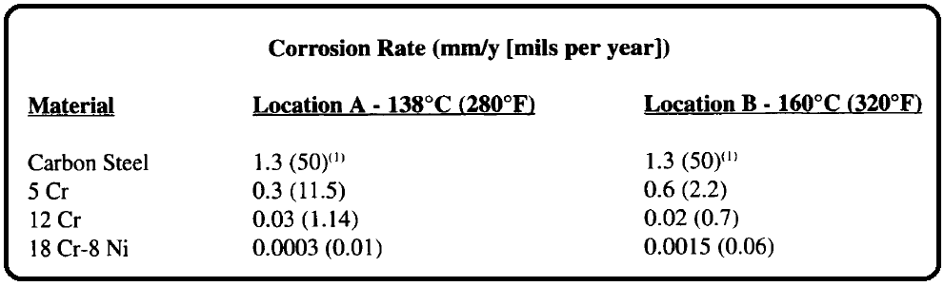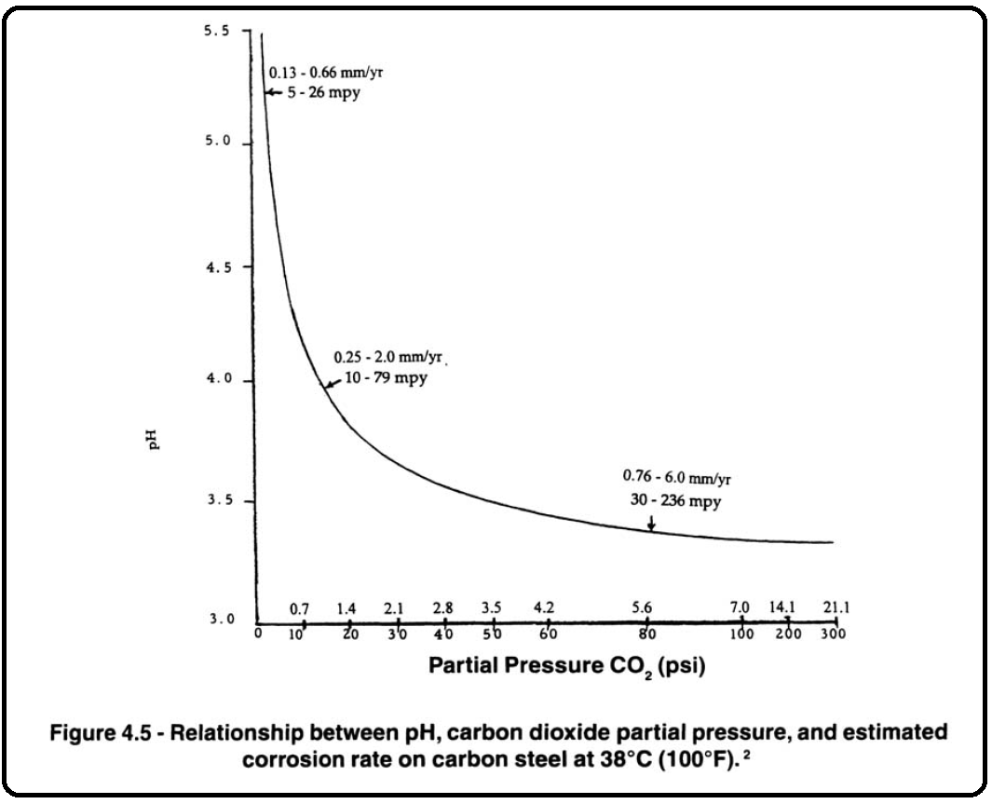

In ammonia and hydrogen plants, part of the carbon dioxide is removed in the condensate in the knockout pots, which are made of solid or clad 304L SS (UNS S30403) (Figure 4.6).' The overhead lines of these knockout pots may be made of carbon steel if no condensation occurs. This is particularly true in ammonia plants where some ammonia formed in the shift converter is present in the stream. In general, the overhead lines of knockout pots used in hydrogen plants are made of 304L SS. The remainder of the carbon dioxide is removed by absorption in a potassium carbonate solution, an amine solution, or in a low temperature PSATM

unit.

Carbonate and PSATMun its are used primarily for carbon dioxide removal. Amine units are used primarily for hydrogen sulfide removal. In refineries, the amine units are primarily used as part of the sulfur recovery system, which consists of a central amine unit, a sour water stripper, and a sulfur plant. The primary cause of corrosion in amine solutions is degradation products. Although all amines generally are treated the same with respect to materials selection, Dupart has shown that MEA is the most corrosive and MDEA is the least corrosive with DEA in between.3 This difference in corrosivity is directly related to the amount and type of degradation products formed. Carbon steel is the predominant material of construction for carbonate and amine solution equipment. Corrosion in the overhead lines (hydrogen sulfide or carbon dioxide plus water from the regenerator) is prevented by the addition of corrosion inhibitors. In amine units used in refineries for hydrogen sulfide removal, corrosion in the regenerator (stripper) overhead is caused by ammonium bisulfide, which results from the buildup of ammonia and hydrogen sulfide in the reflux loop when there is insufficient blowdown.

When ammonium bisulfide corrosion on carbon steel is severe, 304L (UNS S30403) or 316L (UNS S31603) often is used as a replacement. Copper and copper-base alloys should be avoided in amine service and are questionable in carbonate service. Nickel or cobalt-base alloys (e.g., alloy 400 [UNS N044001, alloy 600 [UNS N066001, alloy 625 [UNS N066251, etc.) should be avoided in carbonate service. The exception is StelliteTM6 [UNS R300061) which has performed well in carbonate service. Alloy 400 should be avoided in amine service if Union Carbide Corp. Amine Guard corrosion inhibitor is used. In amine units, absorption is typically at 55°C (130°F); in carbonate units, absorption typically is at 93°C (200°F). Absorption pressures typically are 690 kPaa to 2,760 kPaa (100 psia to 400 psia), although units can be designed to handle pressures at about 6,895 kPaa (1,000 psia). Amine and carbonate strippers (regenerators) typically run at 115°C (240°F) and 172 kPaa to 207 kPaa (25 psia to 30 psia). In the past, stress relief of carbon steel welds and cold bends usually was required when the process temperature exceeded 60°C (140°F) in both amine and carbonate solutions. Past practices for amine service varied from requiring stress relief when hydrogen sulfide was present to using 80°C to 93°C (176°F to 200°F) as the process temperature above which stress relief was required.

Russian work and later studies by Parkins and Foroulis revealed that stress corrosion cracking occurs in hot monoethanolamine solutions when the electrochemical potential of the steel surface is more negative than -700 mv vs a silver-silver chloride electrode.' The stress corrosion cracking tendency increases with an increase in solution concentration and an increase in temperature. Saturating the hot monoethanolamine solution with hydrogen sulfide makes the potential of the steel more positive (i.e., decreases the tendency for stress corrosion cracking). Conversely, carbon dioxide shifted the potential into the stress corrosion cracking range. Although need to stress relieve carbon steel equipment should be minimized by the inhibiting effect of hydrogen sulfide on amine stress corrosion cracking, there is the offsetting potential for sulfide stress

cracking in amine equipment containing hydrogen sulfide as discussed below.

A catastrophic failure in an amine absorber caused many operators to examine their equipment exposed to amine service. The 20-ton absorber exploded, landing 1 km (0.6 mile) away. Seventeen people were killed, and 59 homes within 1 km were damaged. The absorber vessel failure was determined to be caused by SOHIC and hard welds, not amine cracking. However, the examination of equipment in amine service that resulted before the cause finally was determined and revealed that amine stress corrosion cracking existed in many vessels. Cracking was found to be independent of process temperature. Therefore, most operators now

require stress relief for all equipment exposed to amine solutions regardless of process temperature. An amine solution is defined by API 945 as concentrations of amine over 2 wt%.

**A** study by Foroulis of stress corrosion cracking (SCC) of carbon steel in potassium carbonate solutions revealed that SSC does not occur in the absence of carbon dioxide but does occur in carbonatehicarbonate mixtures produced in carbon dioxide absorption.6 The strong tendency to stress corrode occurs in the -0.85 to -0.55V(SHE) potential range. Use of potassium metavanadate in concentrations greater than 0.5 wt% (as NaVO,) can prevent SCC. Conversely, arsenite inhibitor/activators promote SCC. Oxygen, usually added to maintain the inhibitor in the active (oxidized) state, will minimize the tendency for SCC. Even though proper

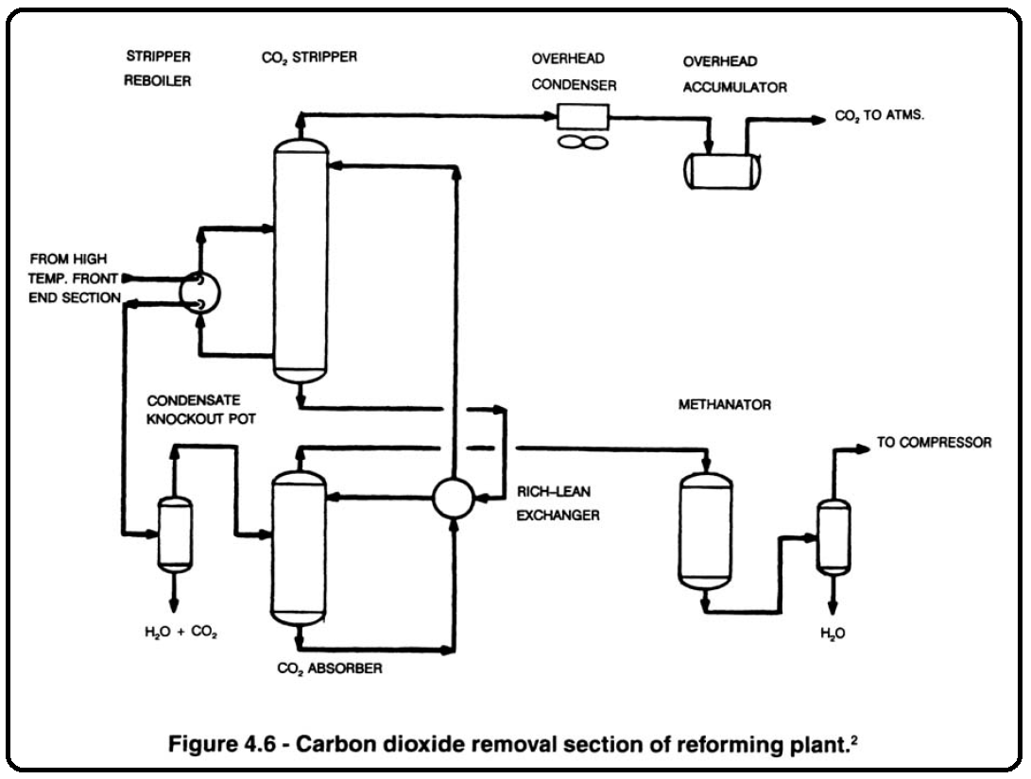inhibition theoretically prevents SSC, most operators require stress relief for process temperatures above 60°C (140°F). This is because SSC can occur rapidly if loss of passivity occurs due to loss of inhibitor or overheating.

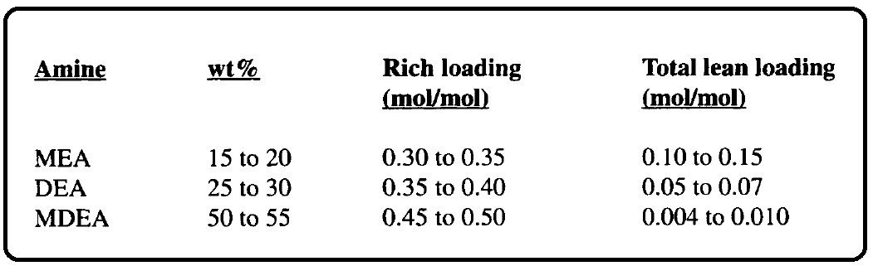Typical acid gas loading for amines are as follows:

Threaded connections should be avoided in acid gas amine solution because the turbulence created by the threaded area causes severe erosion-corrosion of the threads. Where turbulent areas cannot be avoided by design [e.g., pumps and control valves or equipment to be used where the velocity exceeds 2.4 **m/s** (8 ft/ s), 304L SS (UNS S30403) should be used. Reboiler tubes should be made of 304 (UNS S30400) or 316 (UNS S31600). If seal welding is required, 304L (UNS S30403) or 316L (UNS S31603) should be used.

Some operators limit the reboiler steam inlet temperature to 150°C (300°F).

Overheating of carbonates and amines in reboilers has resulted in violent gas evolution from the solution on the shell side leading to severe erosion-corrosion, particularly of carbon steel tube sheets and in the reboiler discharge (vapor) line. Although austenitic stainless-steel tubes also have been used in reclaimers.

there is at least one reported case of chloride SCC of these tubes. Regenerator overhead condensers often are carbon steel. In older units there often is sufficient amine carryover (at least 0.5%) so that corrosion in the overhead is inhibited. In newer units carryover is minimized and corrosion, when it occurs, is handled by addition of corrosion inhibitors or use of stainless steel tubes.

The PSATMu nit operates at 10°C to 38°C (50 "F to 100°F) and undergoes 14-minute pressure cycles as part of the normal operating cycle. The only material problem presently known is fatigue cracking, which is accelerated by the presence of hydrogen; this occurs as a result of the cycling of the vessels. Therefore, stress raisers should be avoided in the equipment design.

High Pressure Ammonia Conversion

After the hydrogen is purified, it is ready for use in a refinery hydrogenation process. In an ammonia

plant, the hydrogen-nitrogen mix is sent to an ammonia converter (Figure 4.7),* which requires a startup heater. Since the material in the heater will be exposed to hydrogen only for a short period, the time-dependent curves in API 941 should be consulted when selecting an alloy for the heater tubes. As mentioned in Chapter 3, section 2.2, because hydrogen attack is cumulative, the total time the material will be at temperature must be used as a basis for alloy selection.

The ammonia reaction takes place in an internal 304 SS (UNS S30400) basket in which the temperature is about 480°C (900°F). Even though the pressure is about 20.7 MPag (3,000 psig), the converter wall (usually multilayer) does not often require alloy materials to resist hydrogen because cool gas is circulated on the outside of the basket. Conversely, when the converter wall is solid alloy or the inner layer of a multilayer vessel is exposed to high temperature, alloy materials are required either for strength, to resist hydrogen attack, or both. The outer layers of a multilayer vessel are vented to the atmosphere so hydrogen attack is not a problem. The outlet connection usually is hot enough to require chrome steel alloys to resist hydrogen attack. Nitriding also should be considered above 400°C (750°F). Using a nitriding allowance (usually 1.5 mm to 3 mm [ 1/16 in. to 1/8 in.]) is all that is usually required; however, alloy 600 (UNS N06600), which is resistant to nitriding, is used for basket screens and occasionally for overlaying very high temperature parts.

After the ammonia leaves the converter, it is cooled and purified. Although stress corrosion cracking has occurred in liquid anhydrous ammonia, it has not been a problem in the process plant because no oxygen is introduced until the ammonia gets into the storage equipment. Ammonia is stored at -33°C (-28°F). It used to be thought that this temperature was too low to cause SCC; however, cracking has been observed recently in ammonia storage vessels. Therefore, stress relief of these vessels is being specified. To avoid SCC of carbon steel equipment used for shipment and subsequent storage, at least 0.2 wt% water is required.

Methonol Plants

Methanol plants are very similar to ammonia plants; high-temperature reformer furnaces and high-pressure (multilayer) converters are used. High corrosion rates on carbon steel occur in the 260°C (500°F) range in the carbon monoxide, carbon dioxide, and hydrogen environments found in methanol plants; therefore, corrosion-resistant alloys are required in this range. Figure 4.8 (page 100) shows corrosion rates of 11 alloys as a function of temperature in the 50-50 carbon dioxide-hydrogen mixtures common in methanol plants.' In addition, metal dusting has been reported in the process boiler of a methanol plant. See the following section for a discussion of metal dusting.

