Interlock & Logic Diagram

Action performed in the IS are called IS-group (Interlock Safety) and actions performed in the

DCS are called I-group (Interlock).

Due to a considerable higher cost of IS than DCS hardware, consideration has been given to

define which actions (groups) are to be performed in the IS system and which actions are to be

performed in the DCS. In order to establish guidelines for the distinction of those actions, the

following rules are applied:

Trips in IS groups are generally based on 2-out-of-3 voting.

IS-groups must protect:

- personnel against safety hazards

- critical plant equipment

- unit trips which will result in a significant production loss when initiated

I-groups must protect:

- auto start and stop of motors

- avoidance of PSV relief

- switching of operating mode

**Pumps**

**1.Typical pump**

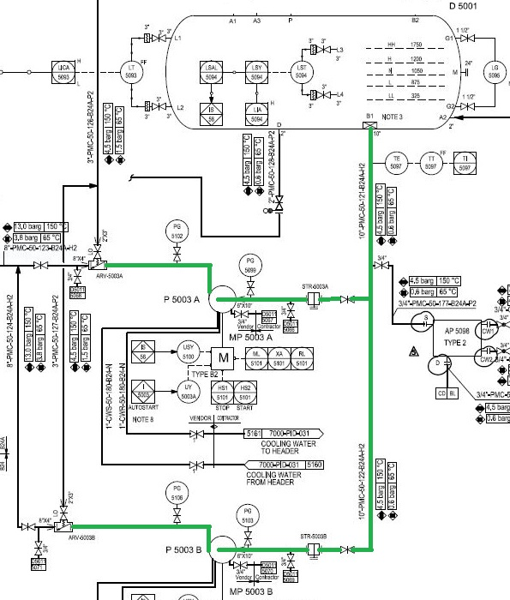

**IS-56: Trip of stabilizer column reflux pumps, P 5003 A/B**

The causes for IS-56 trip are:

- Manual panel trip

- Low level in stabilizer column OH accumulator D 5001, LSAL-5094

The following actions are carried out automatically:

- Stop stabilizer column reflux pump P 5003 A, stop MP-5003 A

- Stop stabilizer column reflux pump P 5003 B, stop MP-5003 B

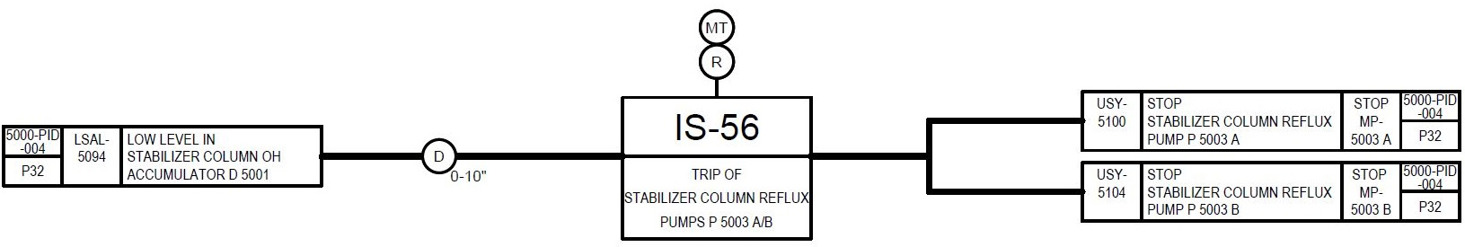Interlock Diagram

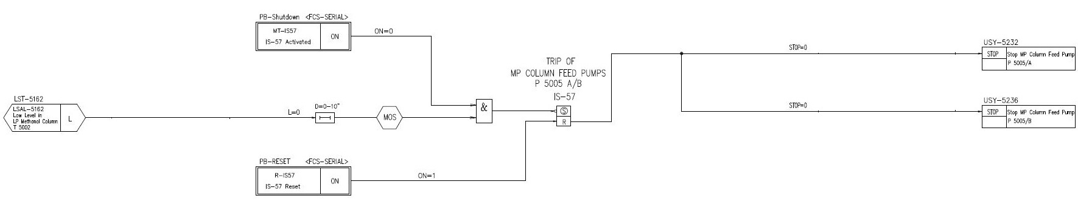

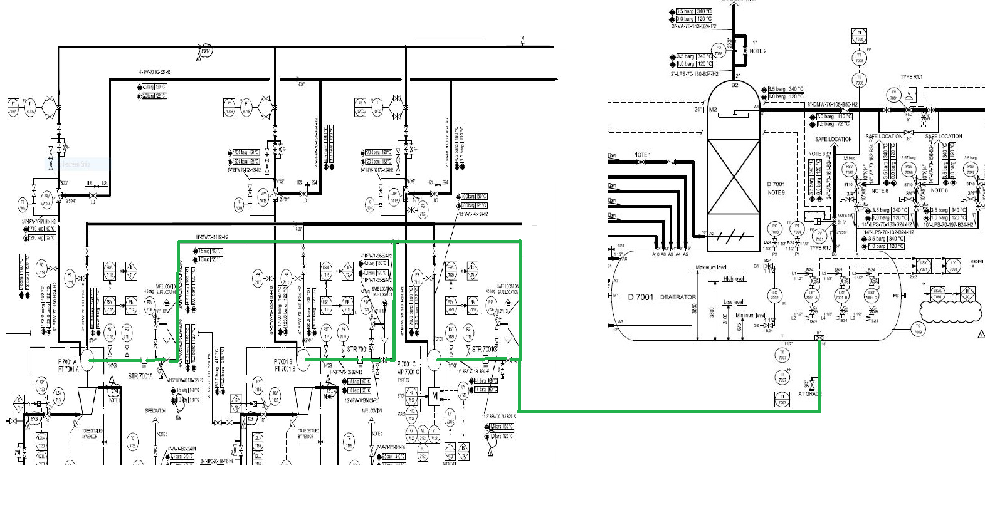**2. BFW pump**

**IS-70: Trip of BFW pumps, P 7001 A/B/C**

The causes for trip are:

- Manual panel trip

- Low level in deaerator D 7001, LSAL-7091

The following actions are carried out automatically:

- Stop BFW pump P 7001 A, IS-71

- Stop BFW pump P 7001 B, IS-72

- Stop BFW pump P 7001 C, IS-73

**IS-71: Trip of HP BFW pump, P 7001 A**

The causes for trip are:

- Manual panel trip

- Trip of BFW pumps P 7001 A/B/C, IS-70

- Low suction pressure of BFW pump P 7001 A, PSAL-7112

The following actions are carried out automatically:

- Stop steam to turbine FP 7001 A, close USV-7130

**IS-72: Trip of HP BFW pump, P 7001 B**

The causes for trip are:

- Manual panel trip

- Trip of BFW pumps P 7001 A/B/C, IS-70

- Low suction pressure of BFW pump P 7001 B, PSAL-7116

The following actions are carried out automatically:

- Stop steam to turbine FP 7001 B, close USV-7135

**IS-73: Trip of HP BFW pump, P 7001 C**

The causes for trip are:

- Manual panel trip

- Trip of BFW pumps P 7001 A/B/C, IS-70

- Low suction pressure of BFW pump P 7001 C, PSAL-7120

The following actions are carried out automatically:

- Stop BFW pump P 7001 C, stop MP-7001C

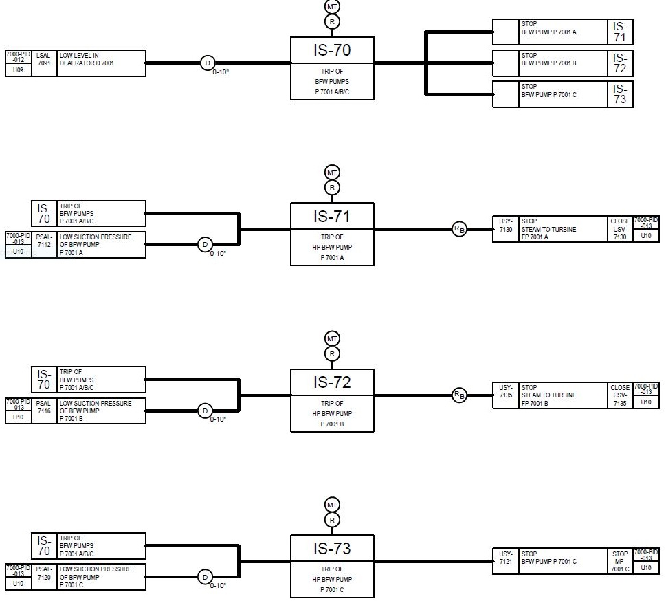Interlock Diagram

Logic Diagram

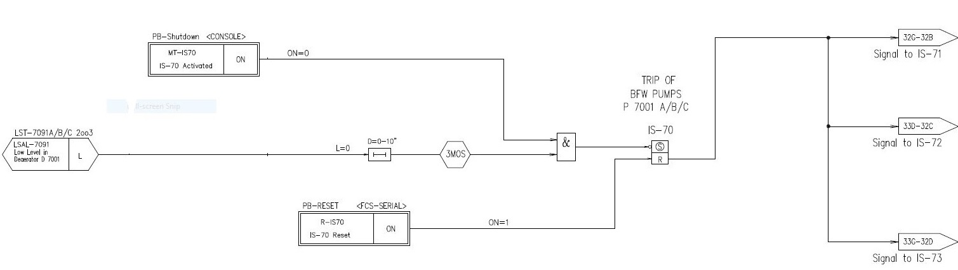

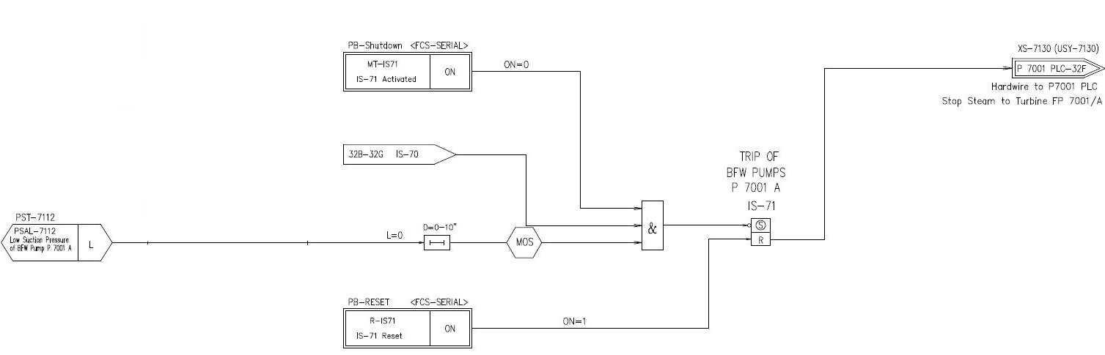

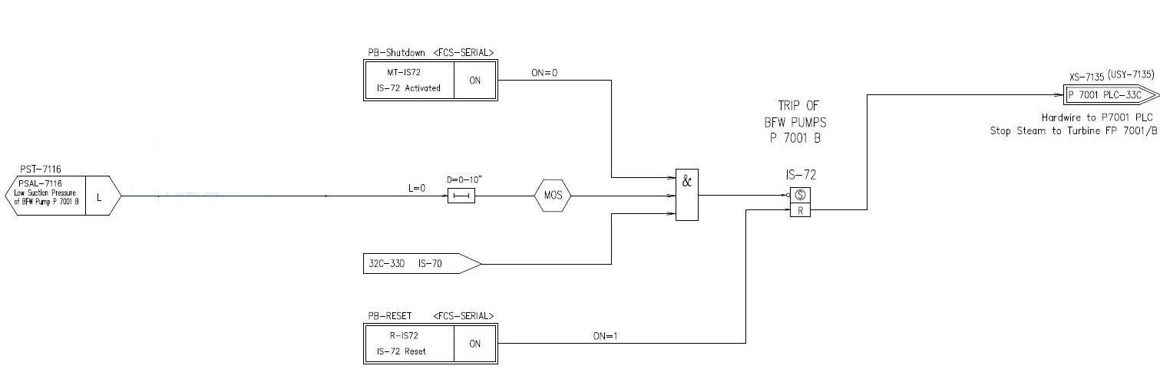

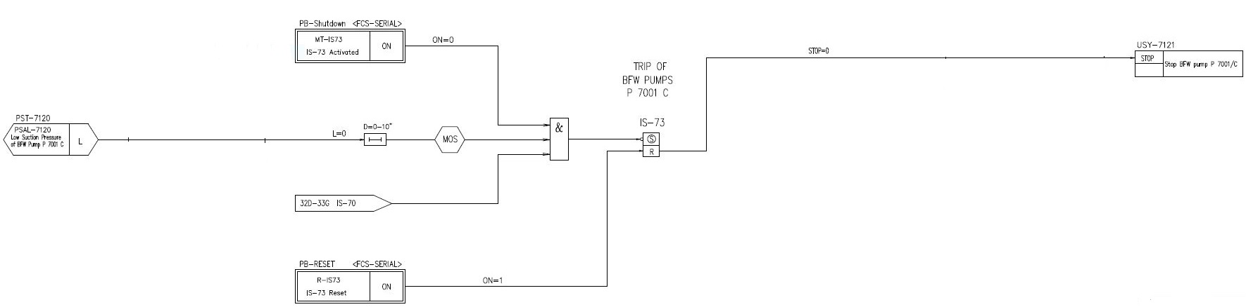

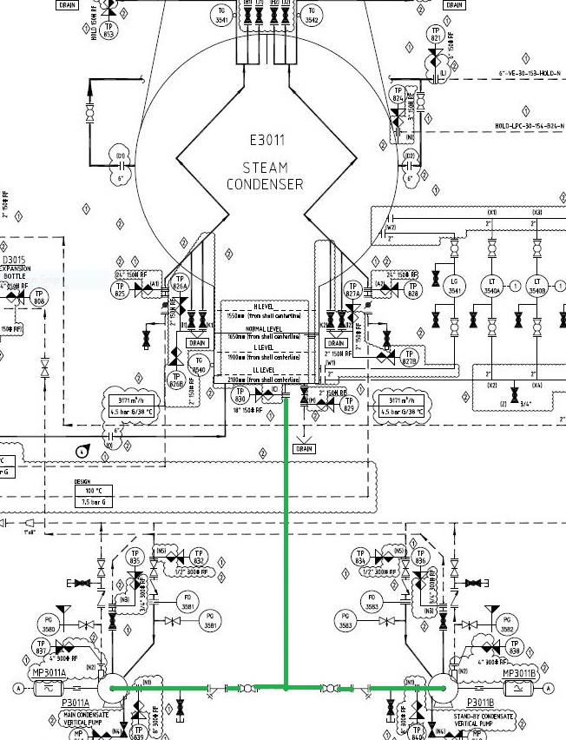3. Steam condensate pump

Saturated steam from the outlet of the steam turbine is recovered in the condenser and

maintained by means of a split range controller (**LIC-3540**) that operates the condensate

discharge valve (**LCV-3540A**) and the condensate recycle valve (**LCV-3540B**) to maintain

the liquid level constant in order to avoid eventual air to backflow inside the condenser

causing high pressure.

Two level thresholds on the condenser level transmitters (**LSH-3540** and **LSL-3540)** start and

stop the stand- by condensate pump if necessary, while another threshold of minimum level

(**LSLL-3540**) stops both the pumps.

Instrumentation for protection in case of high high exhaust pressure (**PSHH-3547**) is provided

on condenser steam inlet.

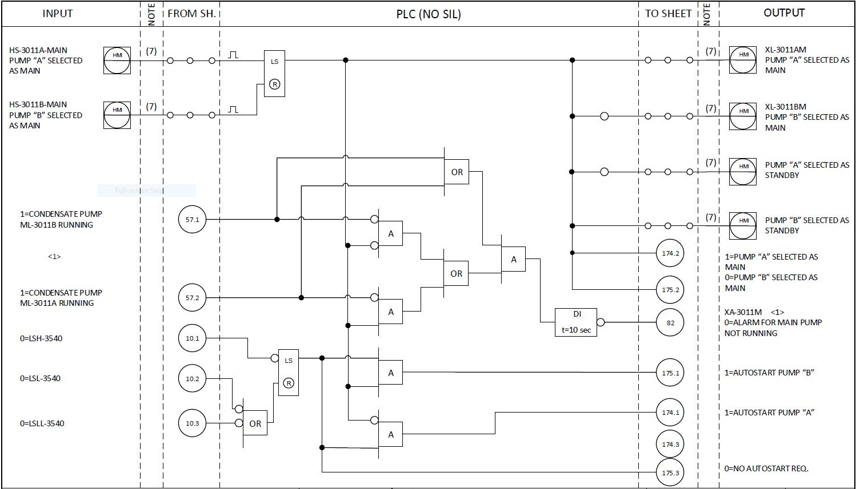

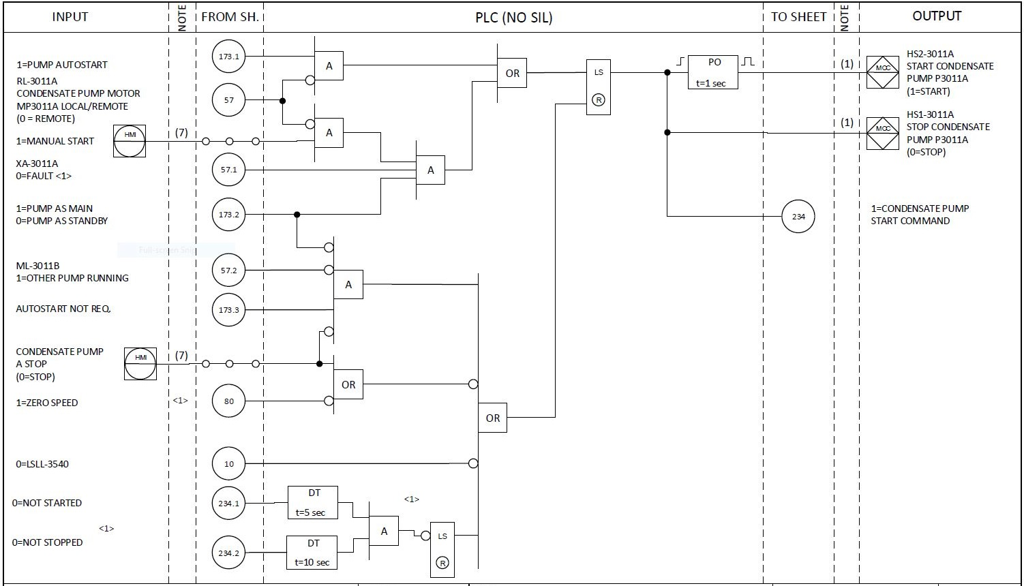

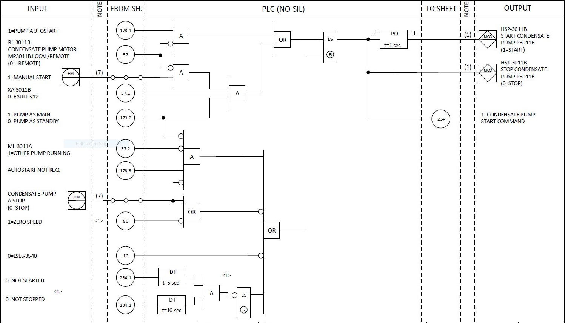

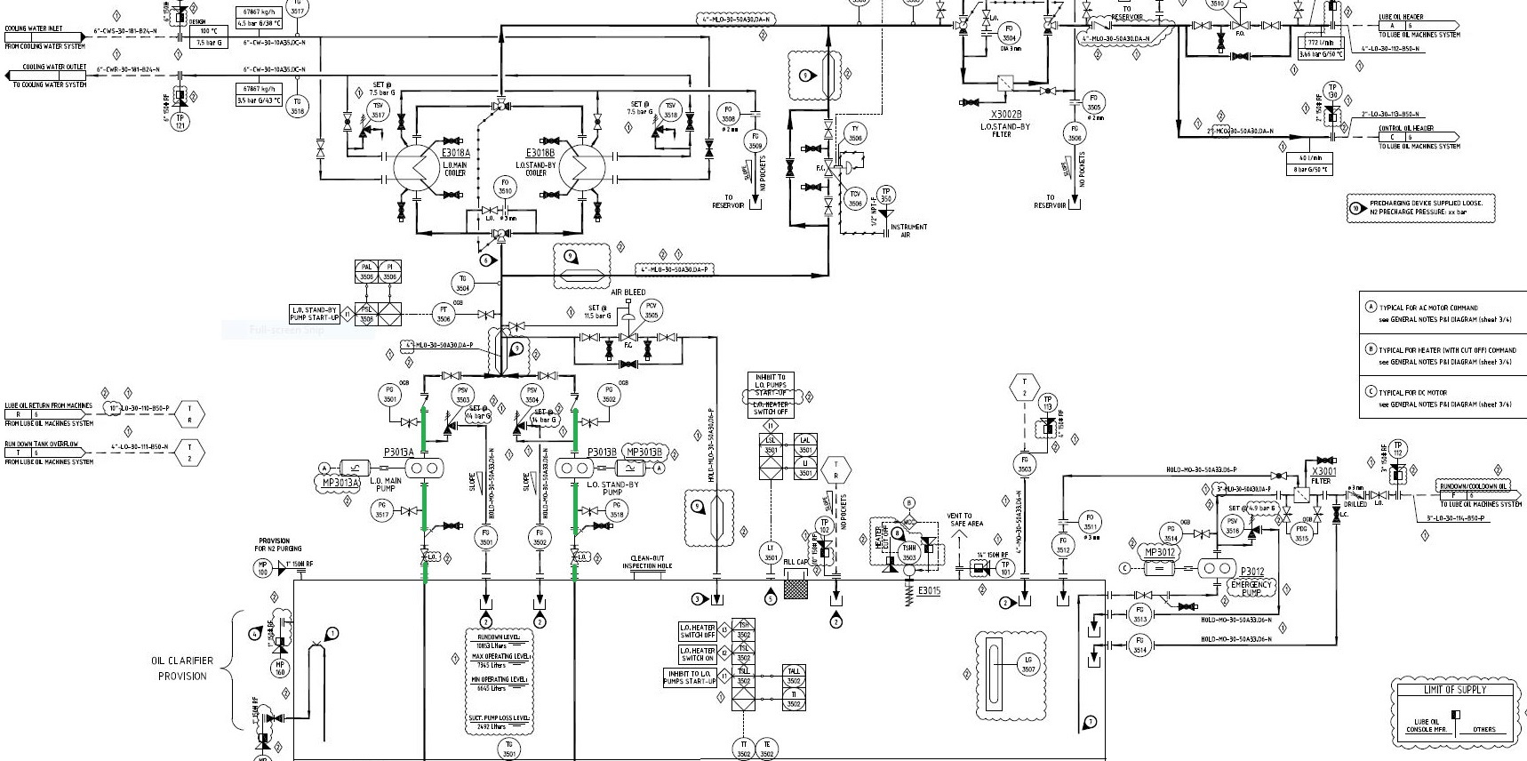4. Lube oil pump

**Lube oil system**

Lube oil is used to create lift by forming a film of oil between the shaft and bearing and to cool

the bearings to keep them at an optimum temperature as power is dissipated in the bearings,

causing them to heat up.

The oil is drawn from a lube oil reservoir (**TK3002**), equipped with an electric heater (**E3015**)

to give the oil the right viscosity for start-up, and sent to the system by two pumps (**P3013A**

and **P3013B**), one main and the other stand-by.

If main lube oil pump is running, stand-by pump is automatically started from the logic in case

of the following alarms:

**PSL-3506** Low lube oil pressure at the delivery of the pumps;

**PSL-3520** Low lube oil pressure at the end of lube oil header - this signal is also an inhibit to

start the compressor;

**PSL-3528** Low control oil pressure - this signal is also an inhibit to start the compressor.

At the end of the lube oil header is provided also a shutdown signal of the compressor in case of

low low lube oil pressure (**PSLL-3520**).

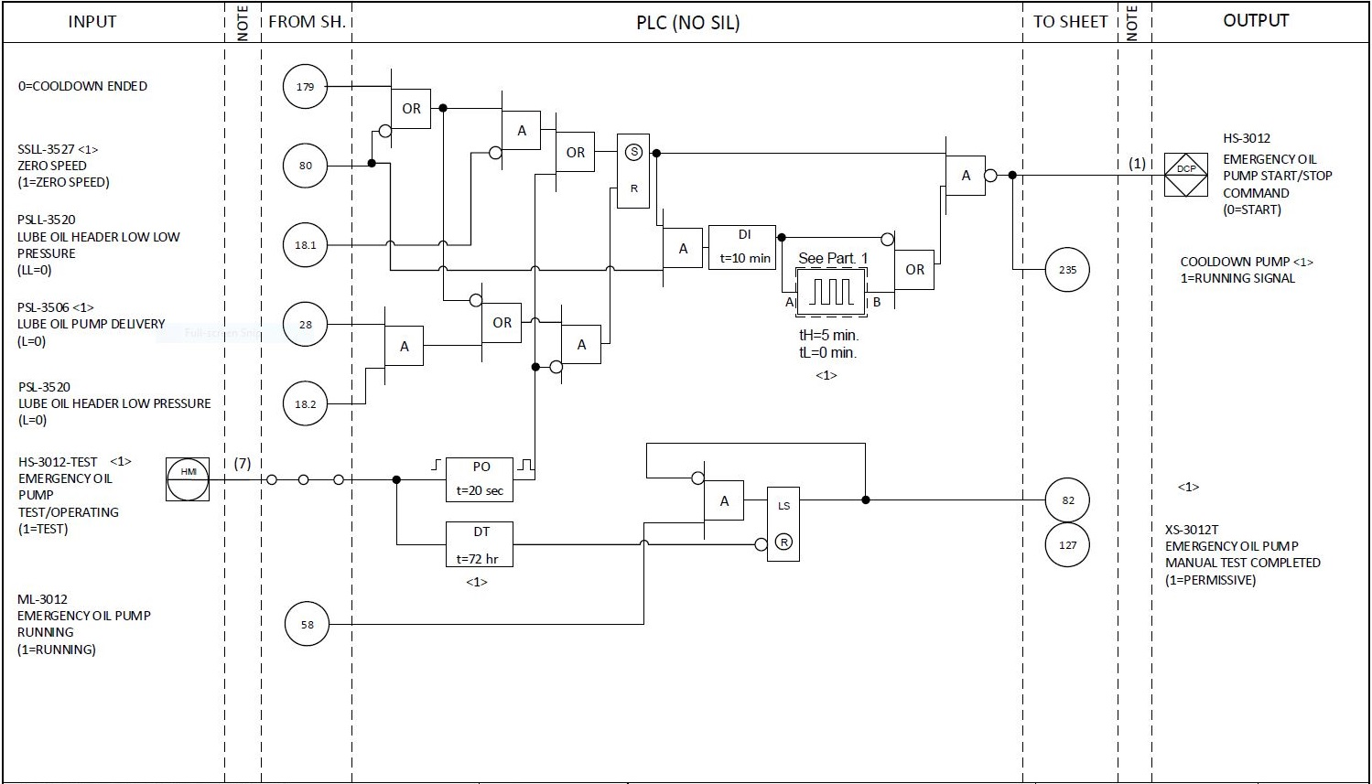

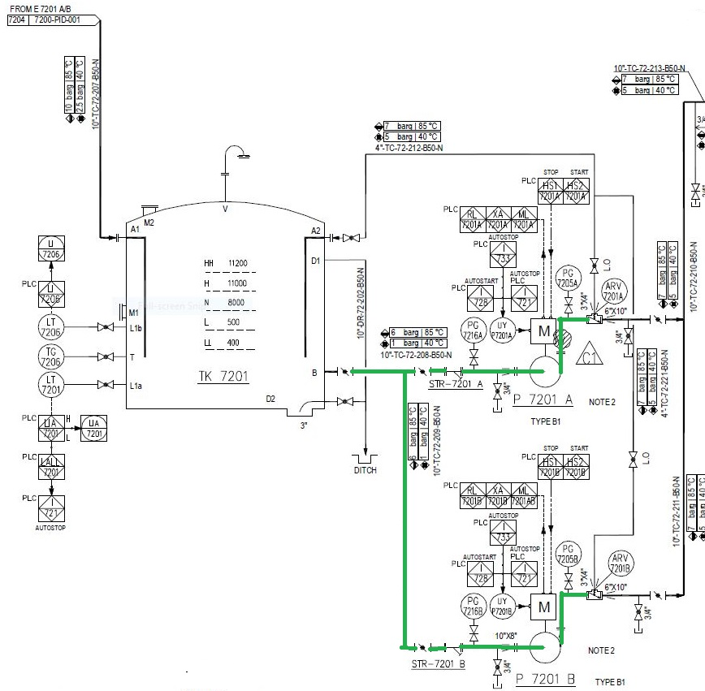**Polishing pump**

Two Intermediate pumps (P7201A/B), one in running and one on standby. P7201A is operated

at normal condition. When the pump (P7201A) is failure or the pump pressure drops to 1 bar,

the standby pump P7201B is running. When P7201A is continuously running for 48 hours,

switch to P7201B. In the same way, when P7201B is continuously running for 48 hours, switch

to P7201A. When the pressure value of PT7209 is greater than or equal to 5 bars, shut off the

standby pump.

When the liquid level of intermediate water tank rises to the set value (2m, adjustable), open the

intermediate pump (P7201A/B).

When the liquid level of intermediate water tank rises to the high level (11m, adjustable), alarm

at the high liquid level.

When the liquid level of intermediate water tank drops to the low liquid level (0.5m,

adjustable), alarm at the low liquid level.

When the liquid level of intermediate water tank continuously drops to the low- low liquid

level (0.4m, adjustable), automatically shut off the intermediate water pump (P7201A/B).

The LT7206 value is used for checking, when the difference value between LT7206 and LT7201

is greater than or equal to 0.2m (adjustable) and delay for 5 seconds, the system will be alarm

and operators will be disposing it.

Adopt protective measures as overloaded, short of phase, short circuit, electric leakage, etc. for

the pump.

**Logic Diagram**

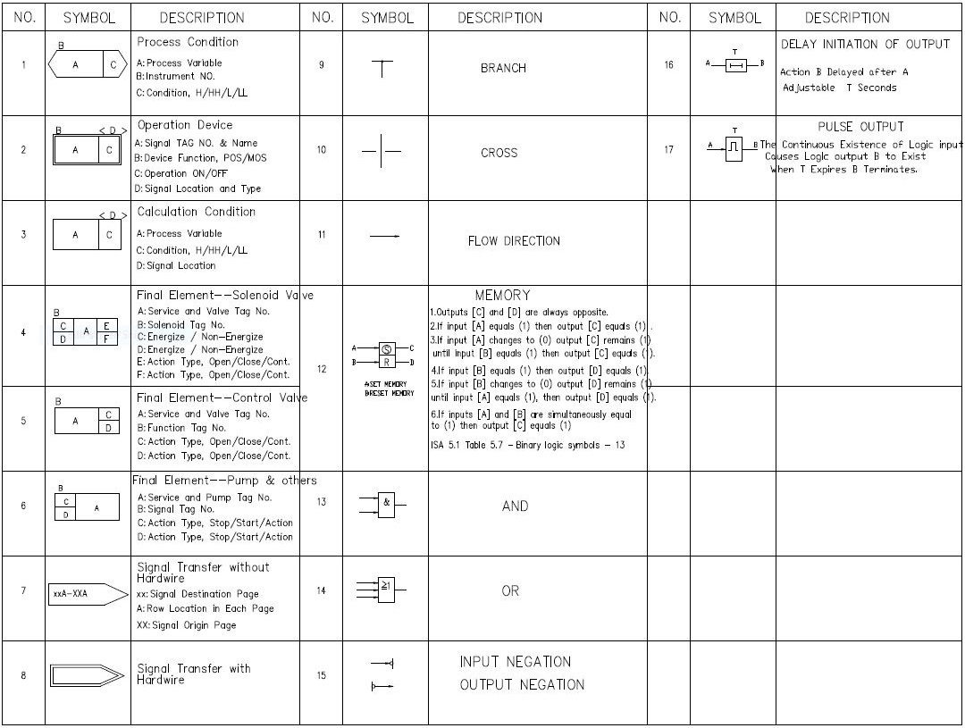

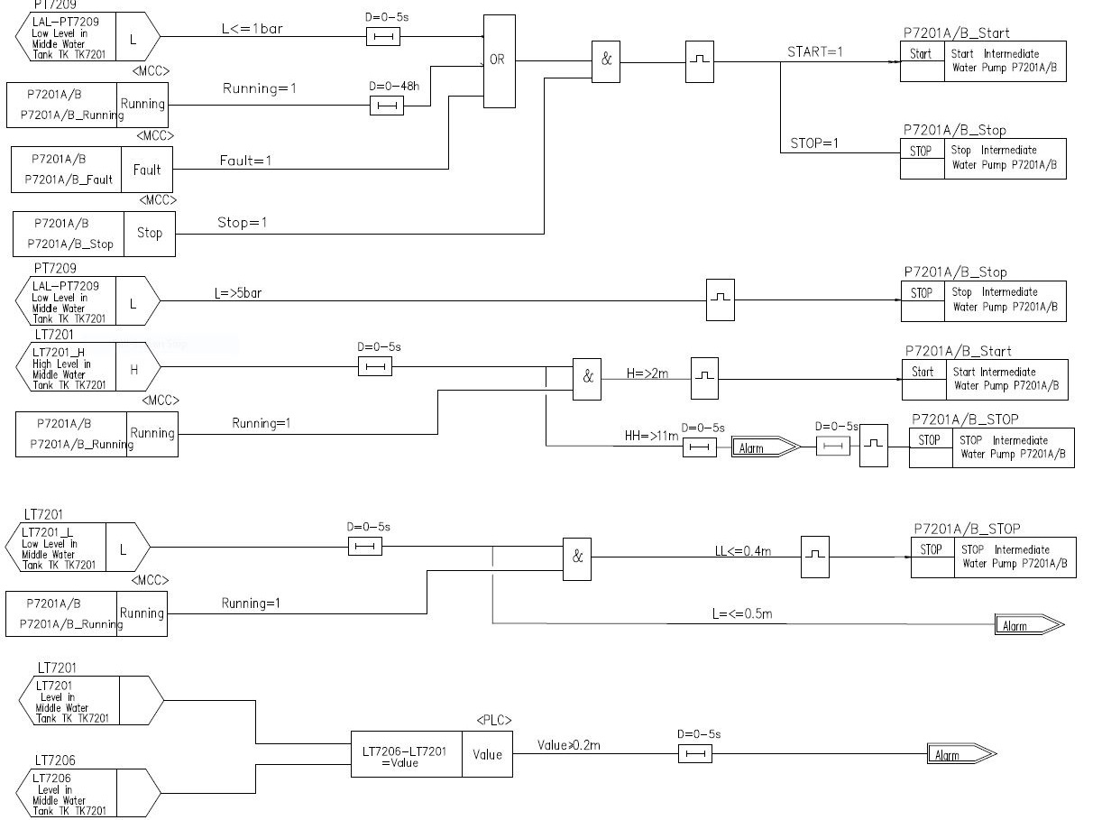

**Compressor**

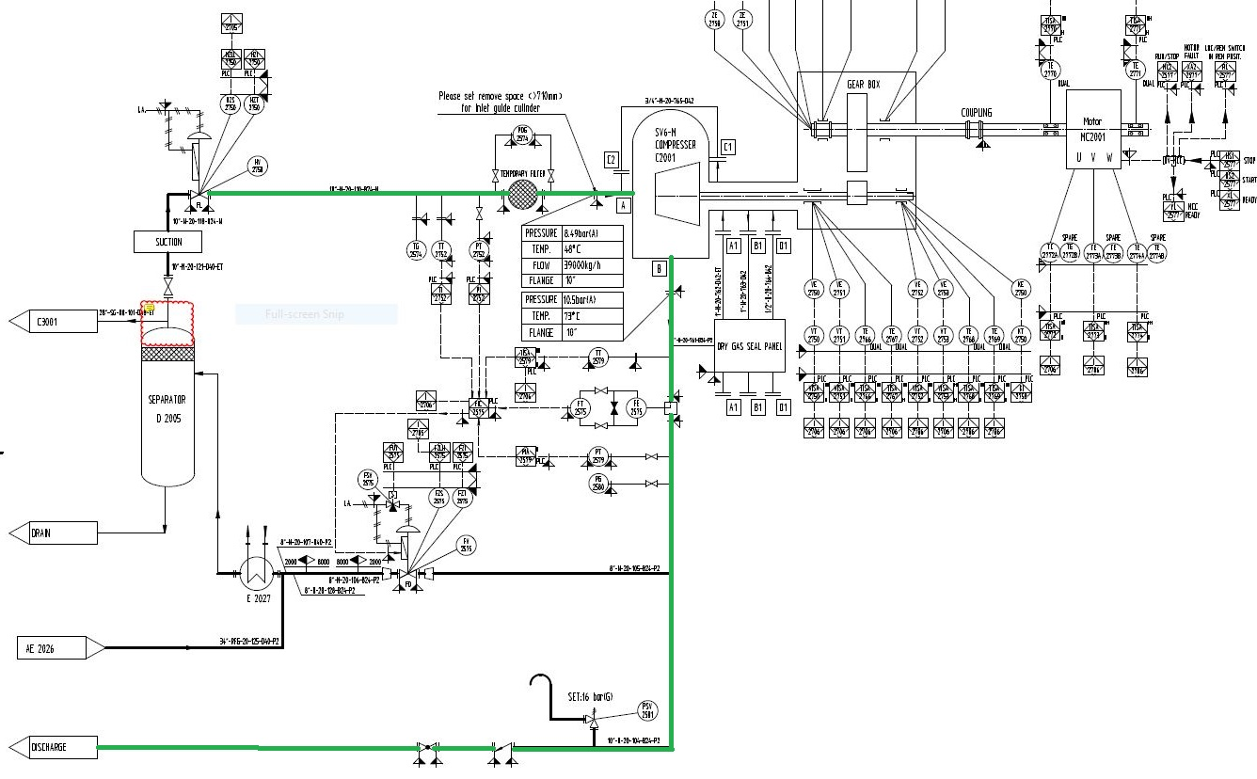**1.Nitrogen Compressor**

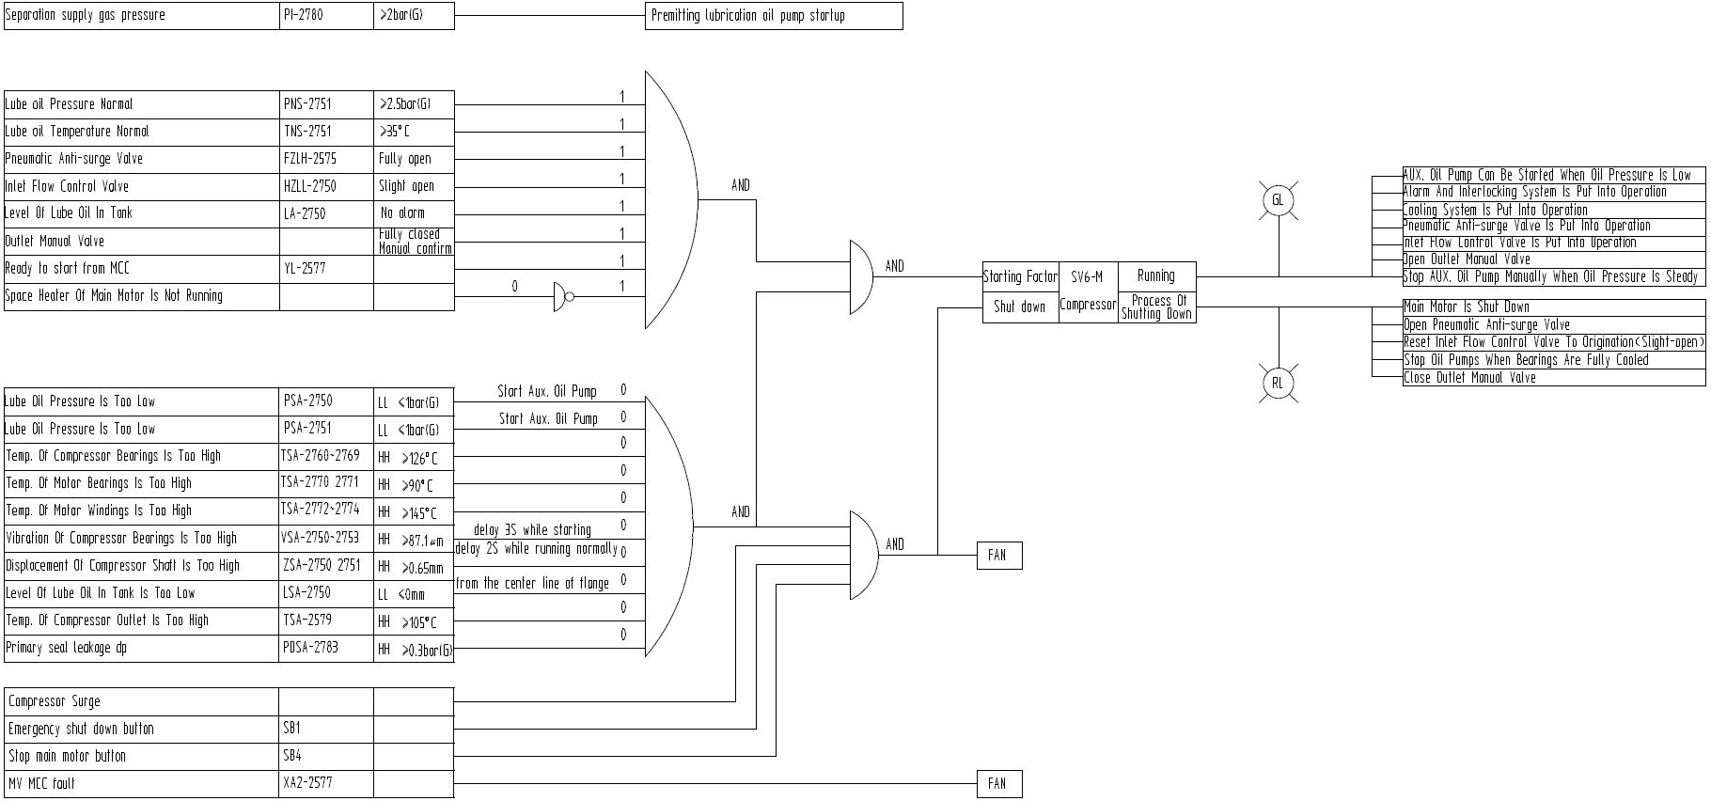Logic Diagram

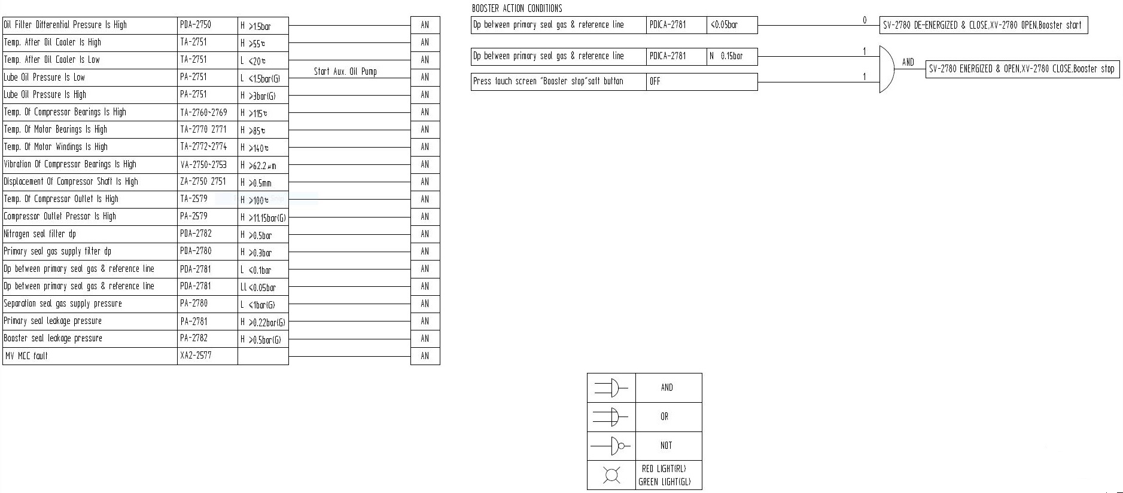

**Trip of primary reformer, H 2001**

Trip of primary reformer H2001 is caused by the following:

- Manual panel trip

- Trip of the interlock sequence IS-12 of the flue gas blower (F 2001). If the flue gas blower

shuts down, flue gas will accumulate in the furnace and create excessive over pressure.

- Trip of the interlock sequence IS-10 of the combustion air blower (F 2002). If the combustion

air blower shuts down, the burners may extinguish and natural gas leaks to the re-former

furnace leading to explosion risk. Stop of combustion air blower may also create excessive

vacuum in the furnace.

- Too high temperature of HHP steam from E 2021 1, (TSAH-2355) may overheat the

downstream turbines or damage E 2021 1.

- Too high temperature of HHP steam from E 2021 2, (TSAH-2356) may overheat the

downstream turbines or damage E 2021 2.

- Too high level in the natural gas KO drum, D 1001 (LSAH-1004). Liquid from D 1001 is of

unknown composition and is as such a potential hazard to the prereformer catalyst; furthermore,

liquid must be avoided in fuel piping.

- Too low natural gas flow to reformer (FSAL-6070). If the natural gas flow decreases, the heat

absorbed by the endothermic reforming reaction will drop correspondingly. As a result, the tubes

in the primary reformer and the primary reformer outlet system could overheat.

- Too high level in feed gas scrubber separator, D 6001, (LSAH-6051). Liquid may not be

evaporated in the prereformer feed preheat coil due to the high wall temperatures. Any liquid

entering the prereformer will cause damage to the catalyst.

- Low total flow of steam to feed gas, FSAL-2062

too low steam/carbon ratio (FFSAL-2064). If the steam/carbon ratio is too low, carbon may form

on the pre-reformer/reformer’ catalyst.

- Too low combustion air pressure (PSAL-2163). If the combustion air pressure is too low, the

burners may extinguish and natural gas leaks to the reformer furnace leading to explosion risk.

- Too low draught in furnace of H 2001 (PSAH-2224). If the pressure in the furnace in-creases

above ambient pressure, hot flue gas (up to approximately 1200ºC) will leak out in numerous

places. This presents a potential danger to personnel and/or damage to the steel casing of the

reformer.

- Too high draught in the furnace of H 2001 (PSAL-2224). Too high vacuum may damage the

furnace casing and refractory.

- Too high temperature of flue gas inlet H 2001 waste heat section (TSAH-2221) may damage

coils.

- Too high temperature of reformed gas exit H 2001 (TSAH-2305). If the reformer outlet

temperature is too high, the reformer tubes and outlet collector may be damaged due to

overheating.

- To high temperature in the chamber between the waste heat boiler and steam super heater

may damage the steam super heater, E 2021 1/ E 2021 2, (TSAH-2335/TSAH- 2336).

- Too low level in the HHP steam drum, D 2001, (LSAL-2372). If the level in the steam drum is

too low the boilers could run dry and thus be exposed to excessive temperatures.

- Too high fuel gas pressure to H 2001 (PSAH-2554), if the pressure in the fuel header gets too

high, the furnace and the reforming tubes may overheat.

- Too low fuel gas pressure to H 2001 (PSAL-2556), if the pressure in the fuel header gets too

low the burners may extinguish. Unburned natural gas may create an explosive mixture inside

the furnace.

- Too low flow of start-up nitrogen to E 2002 (FSAL-2582), if the nitrogen flow is too low during

heating the reforming tubes may overheat.

The following actions are carried out automatically:

- Trip of secondary reformer, IS-2

- Trip of methanol synthesis, IS-3

- Stop emergency methanol to reformer, IS-6

- Trip of combustion air blower F 2002, IS-10

- Trip of flue gas blower F 2001, IS-12

- Trip of purge gas to H 2001 burners, IS-14

- High pressure in reformer furnace box, I-15

- Oxygen ready to start, I-20

- Stop water to saturator T 6001, I-32

- Trip of synthesis gas compressor/recirculator C 3001/C 3002, IS-40

Interlock Diagram

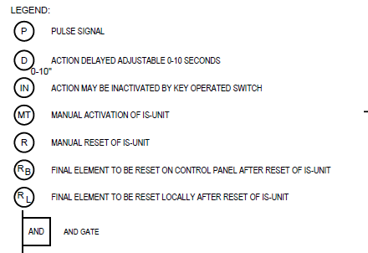

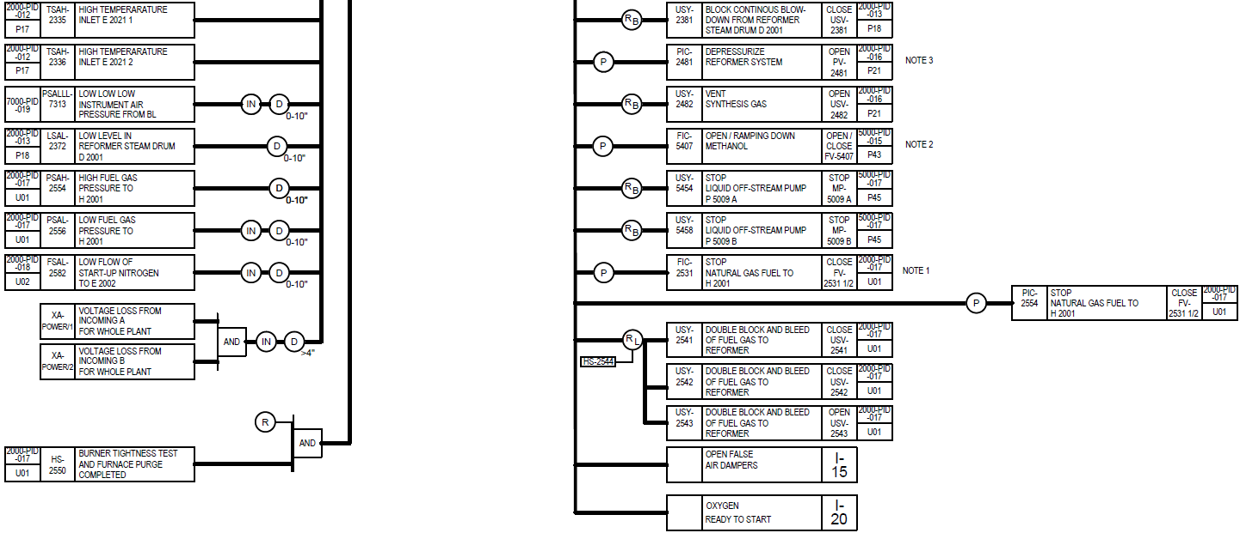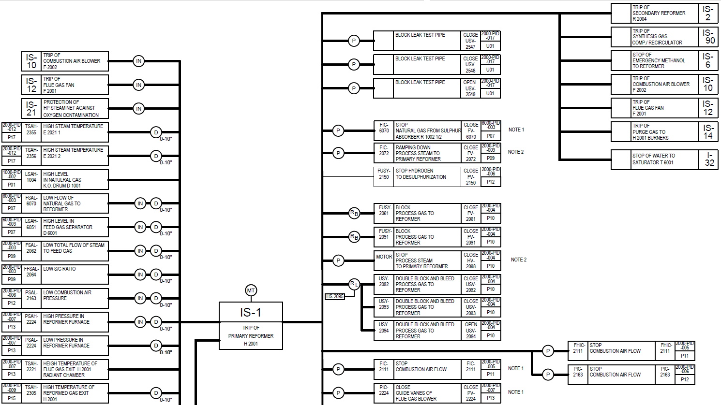

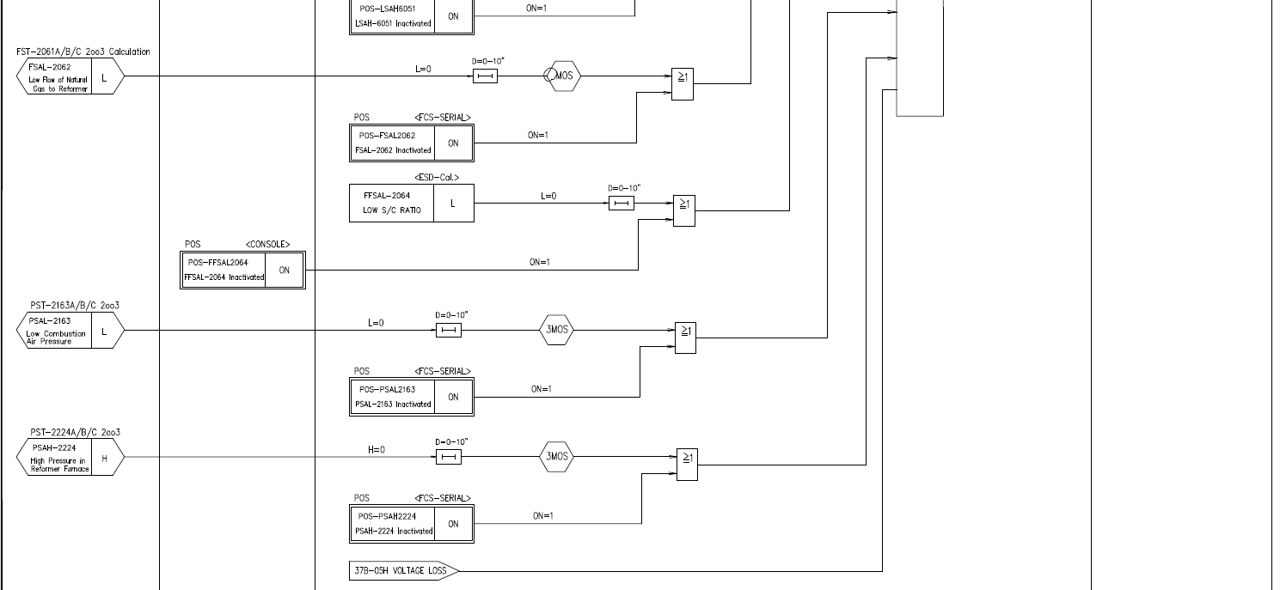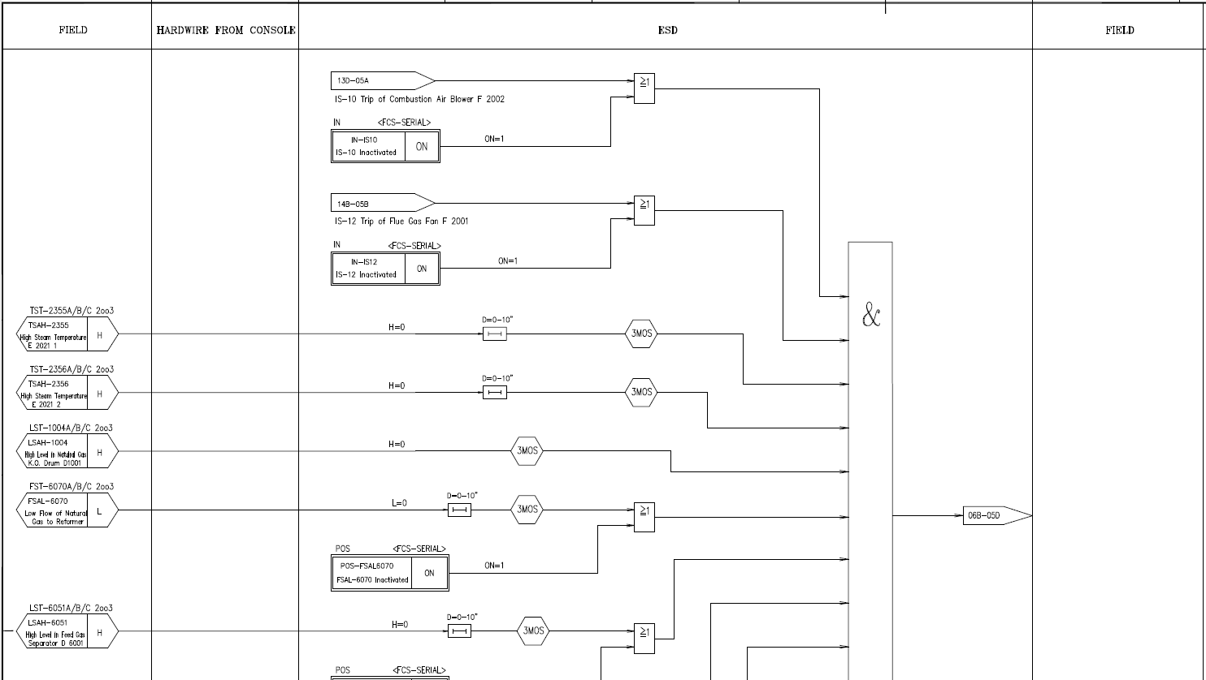Logic Diagram

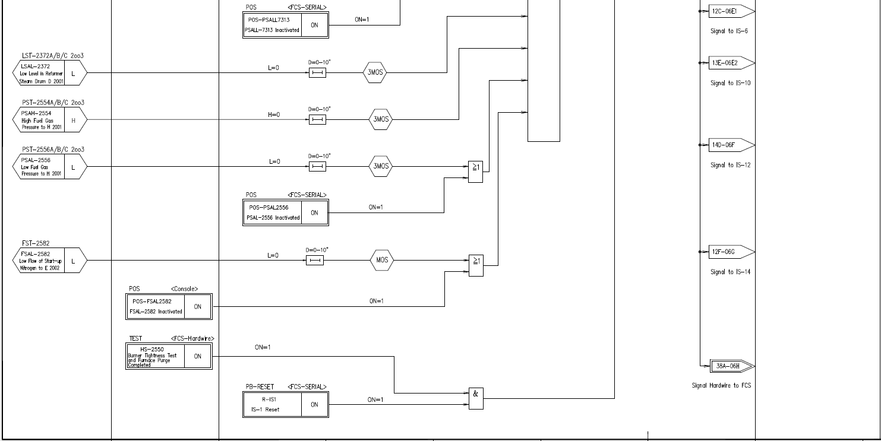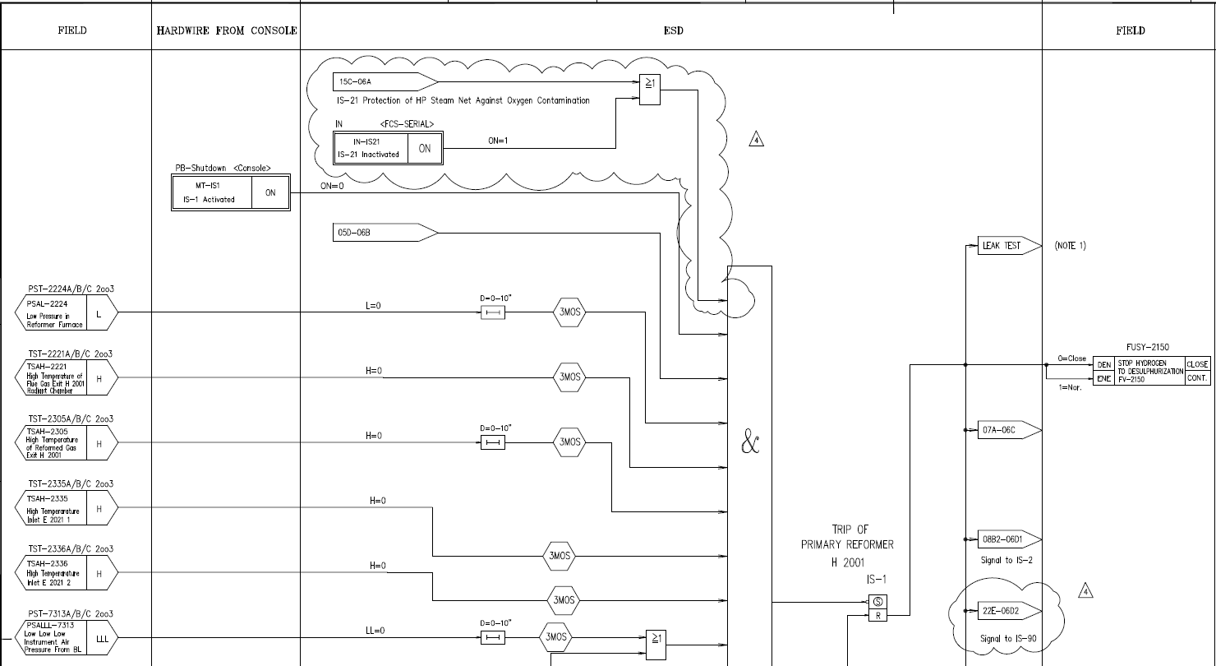

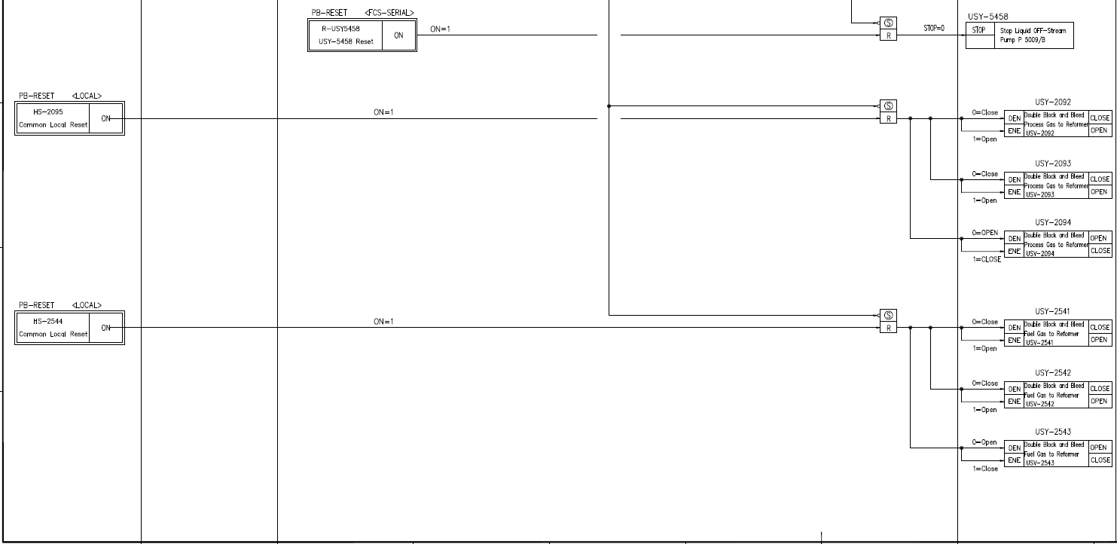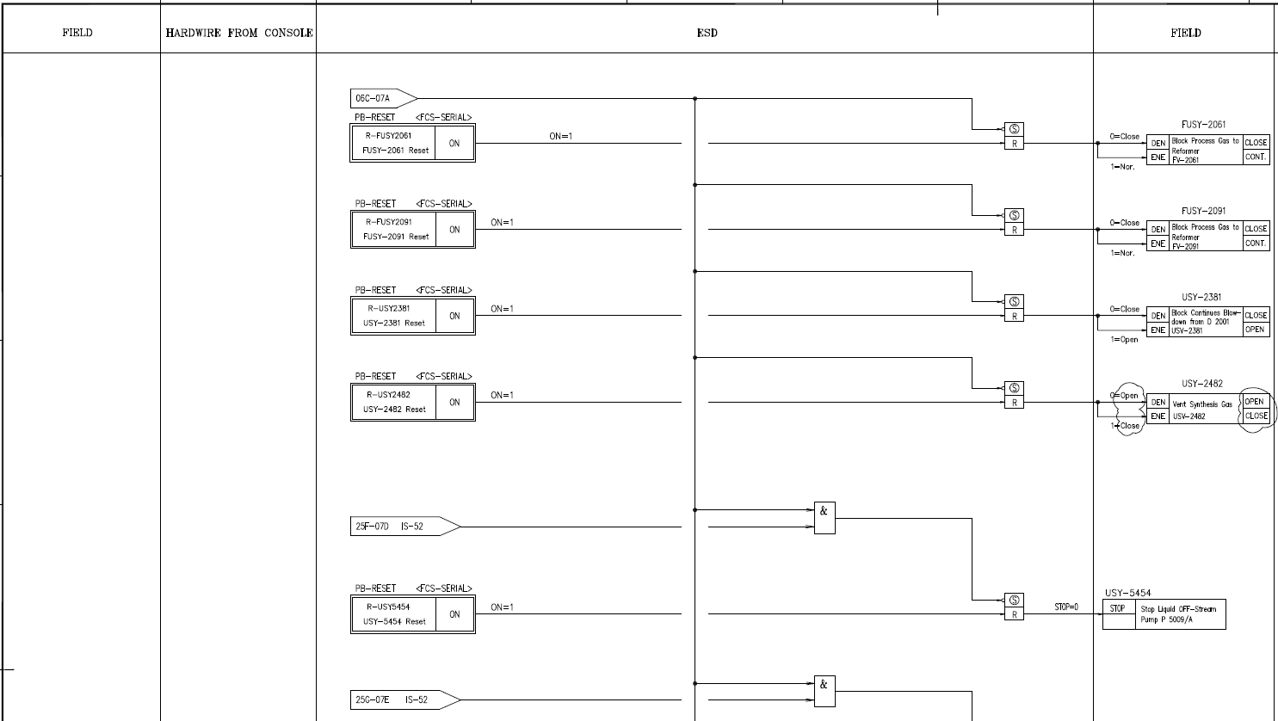

**IS-10: Trip of combustion air blower**

The causes for IS-10 trip are:

- Manual panel trip

- Trip of primary reformer H 2001, IS-1

- Trip of turbine FT-2002, IS-11 AND trip of motor MF 2002 for combustion air blower

- Trip signal from combustion air blower, F 2002

The following actions are carried out automatically:

- Trip of primary reformer H 2001, IS-1

- Trip of turbine for combustion air blower FT 2002, IS-11

- Trip of vent gas to reformer, I-61

- Stop motor MF 2002 for combustion air blower

It is possible to inactivate the IS-1 trip in order to perform the burner tightness test and furnace purge.

**8.11 IS-12: Trip of flue gas blower, F 2001**

The causes for trip are:

- Manual panel trip

- Trip of primary reformer H 2001, IS-1

- Trip of turbine FT-2001, IS-13 AND trip of motor MF 2001 for flue gas fan

- Trip signal from flue gas fan, F 2001

The following actions are carried out automatically:

- Trip of primary reformer H 2001, IS-1

- Trip of turbine FT 2001 for flue gas fan, IS-13

- Stop motor MF 2001 for flue gas fan

It is possible to inactivate the IS-1 trip in order to perform the burner tightness test and furnace purge.

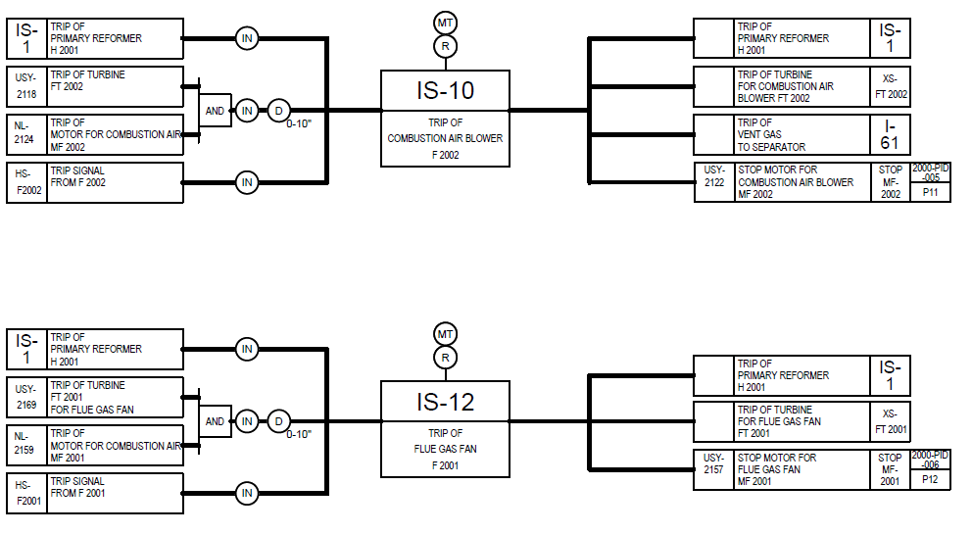**Interlock Diagram**

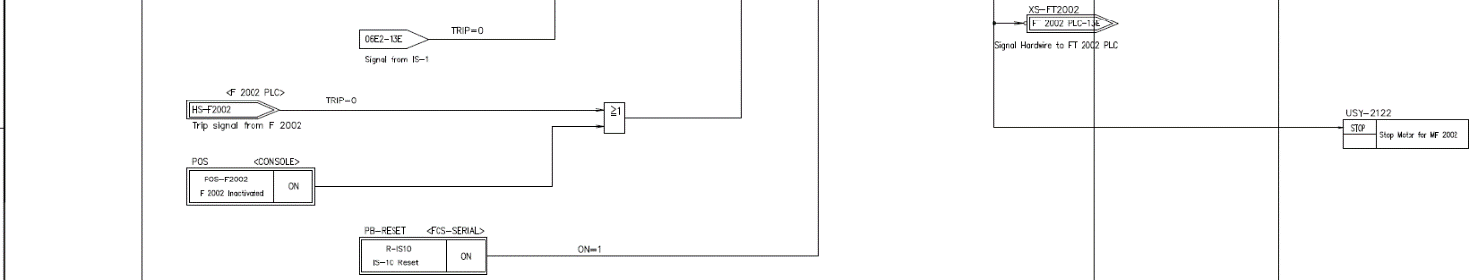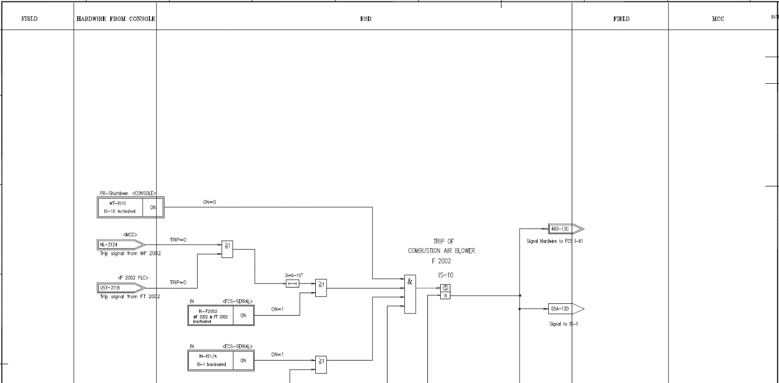

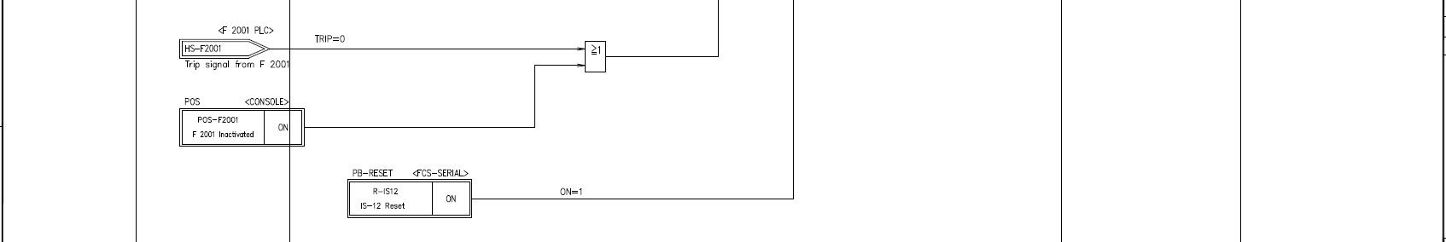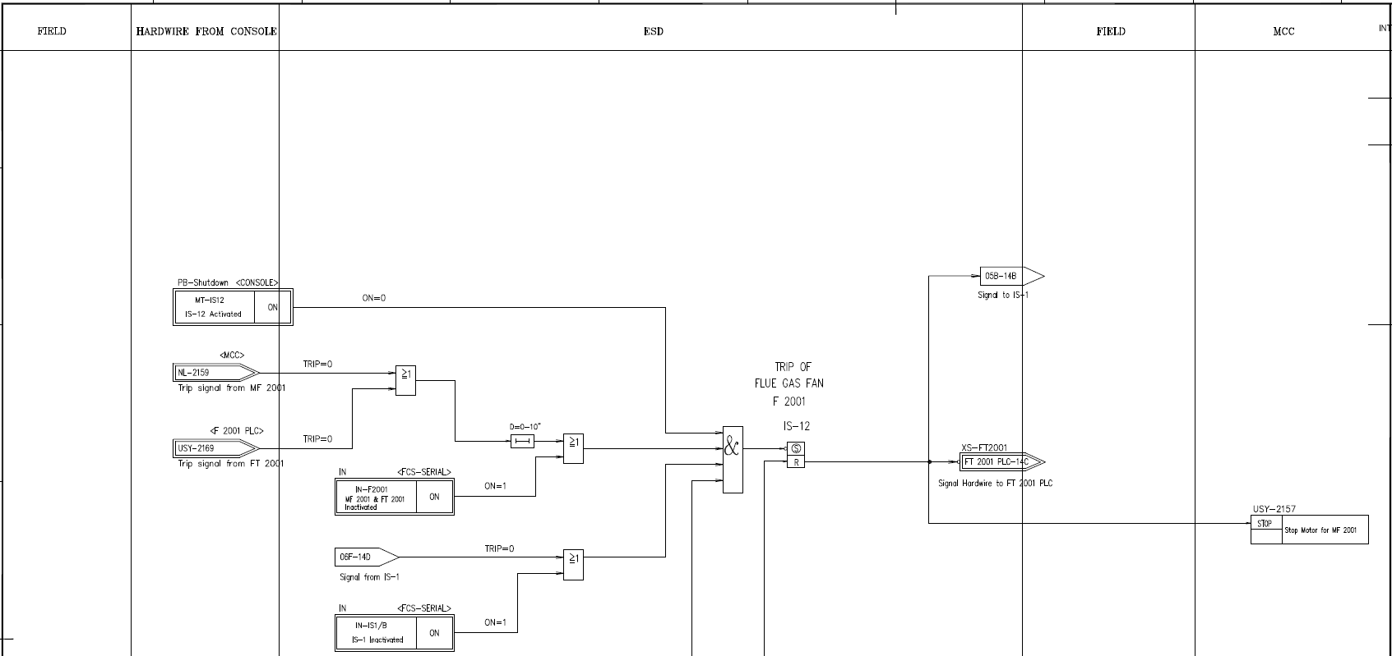

**8.13 IS-14: Trip of purge gas to H 2001 burners**

The causes for IS-14 trip are:

- Manual panel trip

- Trip of primary reformer H 2001, IS-1

- Low pressure of fuel gas to H 2001, PSAL-2554

The following actions are carried out automatically:

- Enable double block and bleed of purge gas to reformer, close USV-2544

- Enable double block and bleed of purge gas to reformer, open USV-2545

- Enable double block and bleed of purge gas to reformer, close FV-2536 - solenoid FUSY-2536 is de-energized

- Stop purge gas from synthesis, close FV-2536 - controller FIC-2536 is switched to manual mode with 0% output

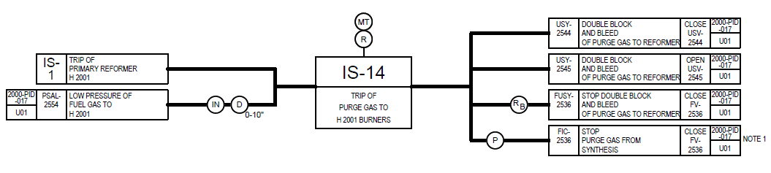Interlock Diagram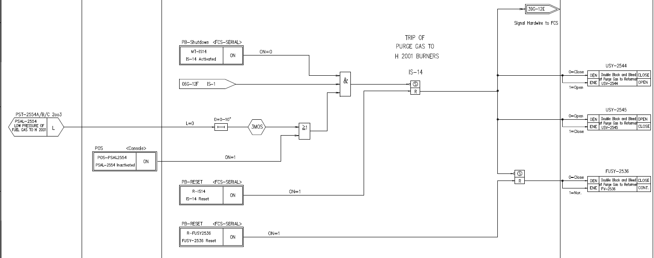

**8.14 I-15: High pressure in reformer furnace box**

The causes for I-15 trip are:

- Manual panel trip

- Trip of primary reformer H 2001, IS-1

- High pressure in reformer furnace box, PAHH-2224

The following actions are carried out automatically:

- Deleted

- Start reformer hazard flashers, XAL-2284

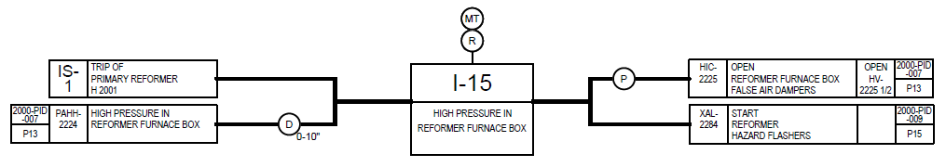

**IS-5: Trip of draining of D 1001**

The causes for IS-5 trip are:

- Manual panel trip

- Low level in natural gas K.O. drum D 1001, LSAL-1004

The following actions are carried out automatically:

- Stop draining from D 1001, close USV-1001

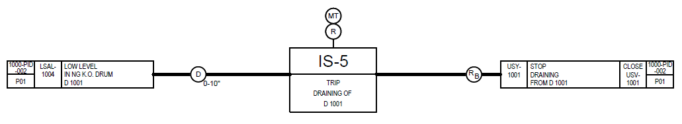Interlock Diagram

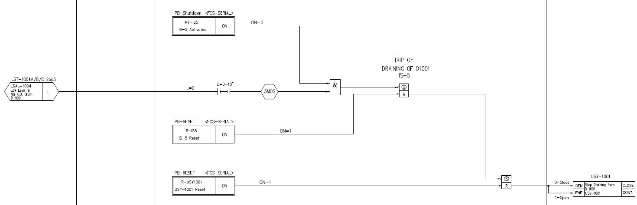Logic Diagram